Supplementary Material
Table S1. Full dataset in this study, with definitions and descriptions for each index. (provided in a separate excel file)
Table S2. Phylogenetic multiple stepwise regression analyses on flowering onset and reproductive period based on 18 climatic niche variables, photosynthetic pathway and life history.
Table S3. Relationships between reproductive phenology and key climatic niche variables.

Figure S1. Global distribution localities of 190 subtropical grasses.
Figure S2. A phylogenetic tree of 190 subtropical grasses, with corresponding information on photosynthetic pathway, life history and reproductive phenology.

Table S2. Phylogenetic multiple stepwise regression analyses on (a) flowering onset and (b) reproductive period based on 18 climatic niche variables, photosynthetic pathway and life history. Degree of freedom (df), R², P and Pagel’s λ values, AIC and significant factors in each model are listed. Abbreviations: pgls, phylogenetic generalized least square model; bio1, mean annual temperature; bio6, minimum temperature of the coldest month; bio5, maximum temperature of the warmest month; bio12, mean annual precipitation; bio4, temperature seasonality; sr, solar radiation; bio15, precipitation seasonality; bio16, precipitation of the wettest quarter; bio17, precipitation of the driest quarter; x.mean and x.r are mean and range values of each climatic niche variable; PT, photosynthetic type (C₃/C₄); AP, life history (annual/perennial). The best model is selected based on the smallest AIC values across models; please see details of model construction and comparison in the Methods.
Model | Equation | df | R² | P | λ | P  (λ=0) | P  (λ=1) | AIC | Significant factors in the model
(a) Flowering onset (ft1)
M1:  full model | pgls(ft1 ~ bio1.mean + bio1.r + log(bio4.mean) + bio4.r + bio5.mean + bio5.r + bio6.mean + bio6.r + bio12.mean + bio12.r + bio15.mean + bio15.r + bio16.mean + bio16.r + bio17.mean + bio17.r + sr.mean + sr.r + PT×AP, mydata, lambda = "ML") | 168 | 0.29 | 0.004 | 0.42 | 0.001 | <0.001 | 698.7 | bio6.r  bio12.r  bio17.r  PT×AP
M2:  mean based | pgls(ft1 ~ bio1.mean + bio5.mean + bio6.mean + bio12.mean + bio17.mean + PT×AP, mydata, lambda = "ML") | 181 | 0.19 | 0.045 | 0.40 | 0.001 | <0.001 | 705.6 | bio6.mean  PT×AP
M3:  range based | pgls(ft1 ~ bio1.r + bio6.r + bio12.r + bio15.r + bio17.r + PT×AP, mydata, lambda = "ML") | 181 | 0.24 | <0.001 | 0.40 | <0.001 | <0.001 | 675.8 | bio6.r  bio12.r  PT×AP
M4:  combined | pgls(ft1 ~ bio1.mean + bio6.r + bio1.r + bio12.mean + bio12.r + bio17.r + sr.mean + PT×AP, mydata, lambda = "ML") | 181 | 0.25 | 0.001 | 0.39 | <0.001 | <0.001 | 679.6 | bio12.r  bio17.r  PT×AP
(b) Reproductive period (ff)
M1:  full model | pgls(ff ~ bio1.mean + bio1.r + log(bio4.mean) + bio4.r + bio5.mean + bio5.r + bio6.mean + bio6.r + bio12.mean + bio12.r + bio15.mean + bio15.r + bio16.mean + bio16.r + bio17.mean + bio17.r + sr.mean + sr.r + PT×AP, mydata, lambda = "ML") | 168 | 0.33 | 0.002 | 0.00 | 1.000 | <0.001 | 667.6 | bio1.mean  bio1.r  bio12.r  bio16.r  bio17.r  PT×AP
M2:  mean based | pgls(ff ~ bio1.mean + log(bio4.mean) + bio5.mean + bio6.mean + bio12.mean + bio15.mean + sr.mean + PT×AP, mydata, lambda = "ML") | 179 | 0.25 | 0.003 | 0.00 | 1.000 | <0.001 | 666.7 | bio1.mean  bio6.mean  PT×AP
M3:  range based | pgls(ff ~ bio12.r + bio16.r + bio17.r + sr.r +PT×AP, mydata, lambda = "ML") | 182 | 0.28 | <0.001 | 0.00 | 1.000 | <0.001 | 652.6 | bio12.r  bio16.r  bio17.r  PT×AP
M4:  combined | pgls(ff ~ bio1.mean + log(bio4.mean) + bio5.mean + bio6.mean + bio15.mean + bio16.r + bio17.r + sr.mean + PT×AP, mydata, lambda = "ML") | 178 | 0.29 | <0.001 | 0.00 | 1.000 | <0.001 | 650.1 | bio1.mean  bio16.r  PT×AP

Table S3. Relationships between (a) flowering onset or (b) reproductive period and key climatic niche variables. Sample size (n), R², P, slope and intercept values for each model are reported. The four key climatic niches are significant factors of the best fitted models in Table 2, and corresponding to each panel in Figure 2. All, all data included; C₃A, C₃-annuals; C₃P, C₃-perennials; C₄A, C₄-annuals; and C₄P, C₄-perennials.
(a) Flowering onset (ft1) |  | n | R² | P |  | slope | intercept
ft1~Range of Tmin | All | 190 | 0.04 | 0.006 | ** | -0.12 | 9.93
 | C₃A | 19 | 0.01 | 0.728 | ns
 | C₃P | 23 | 0.01 | 0.890 | ns
 | C₄A | 53 | 0.02 | 0.278 | ns
 | C₄P | 95 | 0.06 | 0.015 | * | -0.14 | 10.38
ft1~Range of MAP | All | 190 | 0.11 | <0.001 | *** | -0.001 | 9.85
 | C₃A | 19 | 0.05 | 0.340 | ns
 | C₃P | 23 | 0.01 | 0.671 | ns
 | C₄A | 53 | 0.05 | 0.122 | ns
 | C₄P | 95 | 0.20 | <0.001 | *** | -0.001 | 10.02
(b) Reproductive period (ff)
ff~Mean of MAT | All | 190 | 0.05 | 0.006 | ** | 0.29 | -1.69
 | C₃A | 19 | 0.12 | 0.140 | ns
 | C₃P | 23 | 0.05 | 0.305 | ns
 | C₄A | 53 | 0.05 | 0.630 | ns
 | C₄P | 95 | 0.06 | 0.012 | * | 0.35 | -3.14
ff~Range of Pmax | All | 190 | 0.12 | <0.001 | *** | 0.83 | 0.0018
 | C₃A | 19 | 0.08 | 0.242 | ns
 | C₃P | 23 | 0.21 | 0.028 | * | 1.18 | 0.0012
 | C₄A | 53 | 0.00 | 0.991 | ns
 | C₄P | 95 | 0.17 | <0.001 | *** | 0.88 | 0.0019

Figure S1. Global distribution localities of 190 subtropical grasses, with mean annual temperature (MAT) as the background (n=393,266 for all the 190 species).

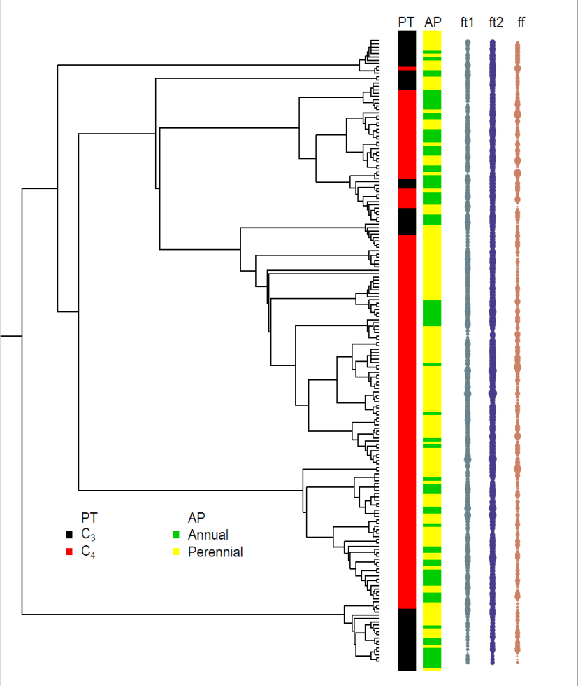
Figure S2. A phylogenetic tree of 190 subtropical grasses, with corresponding information on photosynthetic pathway, life history and reproductive phenology. PT (photosynthetic type: C₃, black; C₄, red), AP (life history type: annual, green; perennial, yellow), values of ft1 (flowering onset; grey), ft2 (flowering and fruiting end time; blue), and ff (reproductive period; brown) are mapped across the phylogenetic tree. A full list of species names in the phylogenetic tree is in Table S1. Dot sizes are proportionally scaled to fit the figure.

