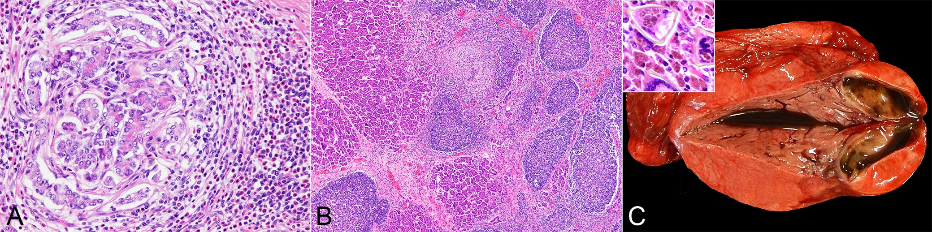
Supplementary Figure 1 | Campula oblonga-induced pathology, pancreas, harbor and Dall’s porpoises. (A) Severe eosinophil-rich inflammation in an area adjacent to the parasitized pancreatic duct. Note the inflammatory cells infiltrating into and effacing the pancreatic parenchyma. Case no. 8, harbor porpoise. (B) Variably sized lymphoid follicles are formed not only in the interlobular connective tissue but also frequently within the pancreatic parenchyma. Case no. 15, Dall’s porpoise. (C) Gross view of a granulomatous cyst in the pancreas, which contains dark green, mucoid material. Inset, histopathology of the cyst wall reveals abundant inflammatory cells primarily of pigment-laden macrophages, with intralesional triangular-shaped eggs. Case no. 9, Dall’s porpoise.

