Thematic Analysis of the COVID-19 related agendas by Pakistani English Newspapers

Hassan Siddique

Abstract
The world faces an extraordinary public health emergency and consequent massive socioeconomic impact due to the outbreak of novel type of coronavirus known as COVID-19. Literature suggests the significance of media, as this pandemic has forced a lot of people in lockdown, making masses dependent on media for vital information during this global crisis (Kumar, 2020). This study investigated the editorials of leading English newspapers, ‘The Dawn’ and ‘The Nation’ regarding COVID-19. This study explored the dominant editorial agendas of Pakistani newspapers and also drew comparison between The Dawn & The Nation in the editorial coverage of different agendas regarding this pandemic. To address research questions, this study conducted thematic analysis of the editorials of two Pakistani newspapers from February 27, 2020 to April 30th, 2020. It was found that Pakistani English press discussed the agendas related to health, criticism on government, government response, international impact, political issues, religious issues and the socioeconomic impact of the pandemic. It was noted that Pakistani newspapers discussed more or less similar agendas, as both newspapers highlighted government’s response, however The Dawn emphasized on government criticism, far more than The Nation.
Keywords: Covid-19, Pandemic, Agenda Setting, Coronavirus, Thematic Analysis, Pakistani English Newspapers

Introduction

Covid-19 pandemic has wreaked havoc by upsetting economic, social, religious and political orders all across the globe (Mahar, 2020). Global economy was the biggest victim of this pandemic, as Gopinath (2020) has projected global economic growth at -3 percent whereas during last global recession of 2009, global economic growth was at -0.1 percent. Pakistan’s case is no different than other nations, as Chohan (2020) has predicted five percent negative growth during fiscal year of 2020. During these testing times of severe Covid-19 spread, there are numerous debates taking place including facilities needed for healthcare workers, economic aids, industrial survival, public backlash due to lockdown and much more (Gallagher, 2020; Remuzzi & Remuzzi 2020; Gettlemen & Conway, 2020). When most of the people are locked up in homes, their principal source of information is media, therefore it is important to comprehend the role of media during these lockdowns.
In the midst of Covid-19, media is under fire due to various reasons. Singh (2020) has blamed India for spreading communal hatred. He also alleged media for creating ‘fear psychosis’ among the masses only to gain ratings. Professor of Journalism at Cardiff University Jorgensen (2020) claimed that media has been creating fear of the Covid-19 and overplaying the situation. While commenting what and how should media report on this pandemic, Powell (2020) from Future Science Group said that “it’s also important to communicate the story behind the numbers, what countries are doing to respond to the disease and what individuals can do too, ensuring stories have practical and actionable information.”
Stover (2020) lamented that United States media is not focusing on poorer communities and media is misreporting the international coverage of pandemic which is depriving masses of vivid picture of Covid-19. She further lamented that media has also spread panic by showing empty shelves of the store which subsequently spread panic across United States.
Owing to the above mentioned discussions regarding media’s significant role shaping up public opinion, this study involves editorials of two English Newspapers of Pakistan i-e The Dawn & The Nation.

Agenda Setting

The concept of Agenda Setting was pioneered by MCCombs & Shaw in 1972. A lot of literature has been authored on this theory which suggests that media sets the agenda for masses, research has revealed that there is an association between what the media deems important and salience among the masses (Uscinski, 2009; Nayyar, 2007). The media have a more powerful effect in influencing the public to think about particular issues than in influencing public opinion on those issues. (Fortner & Fackler, 2014)
Price & Tewksbury (1997) was of the view that print media has made issues more accessible to public not only through repetition but also by placing it in the printed form, secondly they also differentiated between framing and agenda setting, as the later just focuses on the selection of a particular issue whereas framing focuses on the portrayal of a certain issue.
This study has adopted a model developed by Safdar & Budiman (2018) based on the blueprint provided by Price & Tewksbury (1997) to evaluate the agenda setting by the print media.
The figure 1.1 elaborated the relationship between media agenda and its influence on public.

Issue 1

Influencing public opinion
Media Agenda Setting
Transferring specific agenda to public by mass media
Issue 2

Issue 3

Figure 1.1. The figure shows that media transfer its agenda to the public, resultantly affecting public opinion.
Source: Price & Tewksbury (1997) and Safdar & Budiman (2018)

Agenda Setting by Pakistani Press
COVID-19
Transferring certain media agendas

Figure 1.2 Agenda Setting Process

The figure 1.2 shows Pakistani press covering the issue of “Covid-19” and subsequent promotion of particular agendas and issues. This study is based on this structural model of agenda setting.

Pandemics and Media

While discussing the issue of framing regarding H1N1 flu in Malaysia during 2009, Kee, et al (2010) termed battling with pandemics like asymmetrical warfare due to the ‘onslaught’ of globalization. They also asked Malaysian Newspapers to use appropriate frames, especially while covering sensitive issues, as human lives are involved in such cases. On the other hand, Hilton & Hunt (2011) dispelled the ‘popular’ belief that the pandemic named as Swine Flu in 2019-10 was overhyped by the media. They welcomed the factual health reporting by the UK media on Swine Flu pandemic.
Similarly, Sandell et al, (2013) highlighted the media’s significance as an extremely important source for dissemination of public health awareness among the masses in Australia and Sweeden. They also admired the media for shaping risk perceptions of emerging health emergencies, while pressing the governments to more actively incorporate media in pandemic communication programs.
On the other hand, Olowokure et al, (2007) discussed media’s inability to spread awareness regarding an important public health issue of ‘mumps’ in United Kingdom. They lamented that if, “the intense newspaper coverage would have increased doctors' awareness of mumps… Similarly, the increased coverage may have led to parents and adolescents being more likely to present to general practices with symptoms described as "mumps" by the news media” (p.386)

Dorfman et al. (2005) emphasized the importance of framing, as frames had a huge impact on how Amercians comprehend and relate public issues. They proposed effective framing of Public Health initiatives in order to change corporate practices.

Pandemics and Pakistani Media

Pakistan has been facing various public health crises for decades including polio and dengue fever. Obregón et al, (2009) admired Pakistan’s efforts for lowering cases due to effective media strategies by, “mobilizing social networks and leaders, creating political will, increasing knowledge and changing attitudes, ensuring individual and community-level demand, overcoming gender barriers and resistance to vaccination.”
Ahmad et al, (2013) admired social media’s role to counter epidemic like dengue, they sketched a model, in which he compared the newspaper and Twitter’s coverage of the epidemic. They concluded that content on Twitter was more structured compared to the newspapers, although frequency was not low in newspaper at all. Whereas Begum et al (2012) regretted that media negatively contributes towards public health in Pakistan. Media triggers fear, desensitization and aggression among individuals. They blamed both, print and electronic media for promoting violence and proposed recruitment of educated human resource to address such issues.
Abidi et al (2015) stressed on the need to raise awareness of sexual health issues among villagers and potentially high risk populations. They also proposed to use visual media in order to spread the message among uneducated segments, in addition to the specific TV channels which are popular among high risk populations.

Research Questions

RQ1: What agendas were promoted by Pakistani newspapers editorials during first two months of Covid-19 in the country?
RQ2: Which issues were promoted by Pakistani newspapers editorials during first two months of Covid-19 in the country?
RQ3: What are the difference in the agendas on COVID-19 between The Dawn & The Nation?

Methodology

Qualitative approach has been employed in this study, as it provides in-depth context and also detailed interpretation of the research topics (Vasimoradi et al, 2013). Thematic methodology of qualitative content analysis has been used to comprehend repetitive ideas (Ryan & Bernard, 2003). Similarly thematic analysis allows deconstructing subthemes to capture heterogeneity in the data (Aronson, 1995).
Themes are more implicit and abstract, categories explicit context of the text whereas subthemes focus on a notable event with a central organizing context having implicit meanings like themes (Vasimoradi et al, 2013). Therefore this study coded major agendas through pilot study and then extracted subthemes/ or issues or notable events from the population of the study.

Rationale for the Newspapers

Talking about Dawn Newspaper, Khan & Safder (2010) claimed that “Mostly policy makers, foreign persons and elite class studies it. It has extensive circulation that is increasing day by day.” (p. 330). On the other hand, The Nation is considered as the “most conservative among the other English newspapers. This newspaper is mostly supportive of Muslim League and it strongly believes in the ideology of Pakistan” (Khan et al, 2014, p. 67). Owing to the aforementioned reasons two English newspapers, The Dawn & The Nation were selected for the study.

Population of the study & Unit of Analysis

Editorials from newspapers The Dawn & The Nation were selected from 27th February to 30th April, 2020. First Covid-19 patient in Pakistan was diagnosed on February 26, 2020, therefore editorials were selected from 27th February. All the editorials with the words “pandemic”, “public health”, “corona”, “coronavirus”, “Covid-19”, “lockdown”,”health” in the headlines or paragraphs of the selected newspapers were included in the population.
The whole newspaper editorial including title, headline, body text, and themes is taken as a unit of analysis. Only newspaper editorials were taken as they represent the official policy of the newspaper, opinions of the newspapers may not represent the specific newspaper.

Analytical strategy

Coverage of Covid-19 pandemic was investigated in top ten newspapers of Pakistan. Both, inductive and deductive thematic analysis was used to determine themes in the editorials of selected newspapers. Grounded theory approach was applied as some categories were derived from the literature review and pilot study of the population and subthemes were derived from data analysis.
By applying thematic analysis, the researcher investigated how the Pakistani press covered the COVID-19. For analyzing the content from newspapers, the study employed inductive and deductive thematic analysis. The editorials of the Pakistani newspapers were chosen as the unit of analysis. The researcher started to analyze data based on the prior categories derived from previous literature but during analysis new subthemes and categorizes emerged from data.
Grounded theory approach was followed and three types of coding were used including open coding, axial coding and selective coding (Strauss & Corbin, 1998).
Firstly data was broken down into separate units of meaning known as open coding (Goulding, 1999). Then secondly, “Through systematic analysis and constant comparison of data the next stage is to reduce the number of codes and to collect them together in a way that shows a relationship among them. This stage relates to axial coding and the creation of concepts.” (Moghaddam, 2006)
Third and last stage is selective coding, in which categories are related to the core category, providing basis for the core category. According to Straus & Corbin (1990), "the process of selecting the central or core category, systematically relating it to other categories, validating those relationships, and filling in categories that need further refinement and development" (p.116). Core category integrated the categories to a structure or theoretical framework and provided central idea to the research.
To analyze the agendas of Pakistani Newspapers’ editorials regarding Covid-19, a software named as NVIVO was used for qualitative thematic analysis. Finally after finding core categories from the data, the findings were presented.

Findings & Discussion

RQ1: What agendas were promoted by Pakistani newspapers editorials after the outbreak of Covid-19 regarding the Pandemic?
Figure 1.3 illustrates the major agendas toed by two newspapers of Pakistan regarding COVID-19 including health issues, criticism on government, government response, international impact, political issues, religious issues and the socioeconomic impact of the pandemic.

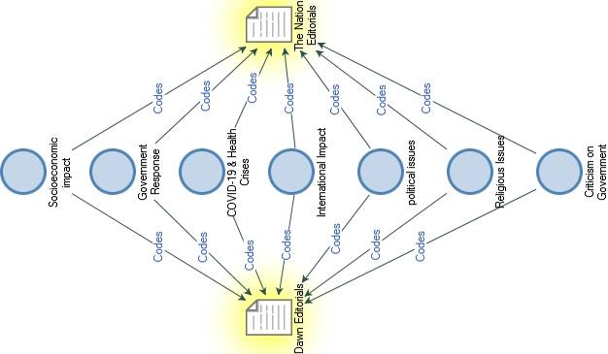

Figure 1.3 Thematic model on the prominent issues about COVID-19, covered by the editorials of The Dawn & The Nation
RQ2: Which issues were promoted by Pakistani newspapers editorials after the outbreak of Covid-19 regarding the Pandemic?
Table 1.1 shows the subthemes or issues covered by The Dawn and The Nation.
Table 1.1
Prominent agendas about the coverage of COVID-19
Major Agendas | Sub-Themes
COVID-19 & Health Crises | Childhood immunization, Shortage of Health Facilities, Spread of other diseases due to Covid-19, issues related to health staff
Criticism on Government | Lack of testing facilities, confusion on lockdown decision, criticism on incentives given by the government, quarantine lapses, questionable performance from health related government departments, criticism on political decisions of government during lockdown like witch-hunting opponents
Government Response | Economic relief for poor, helping stranded people come back to Pakistan, Government’s efforts to revive businesses, bailing out industry & interest rate cut, admiration of Sindh Government, Military’s efforts to curb the virus, establishment of teleschools
International Impact  Political Issues  Religious Issues  Socioeconomic Impact | Blaming muslims for COVID-19 spread in India, oil price and politics, tussle between Trump & WHO, International debt relief efforts, Ceasefire discussion in war-torn countries  Battle of words between provincial and federal government, efforts for better coordination between different governments, digitizing parliament  Congregational prayers & Tableeghi Ijtima worshipers  Inflation, education related issues, debt relief, domestic violence during lockdown, overcrowded prisons

RQ3: What are the difference in the agendas on COVID-19 between The Dawn & The Nation?
Figure 1.4 & 1.5 shows the difference in the agendas on COVID-19 between The Dawn & The Nation. The major difference is regarding criticism of the federal government by The Dawn, whereas The Nation criticized the government on negligible sum of editorials. The Dawn pointed out lack of testing facilities, confusion on lockdown decision, criticism on incentives given by the government, quarantine lapses, questionable performance from health related government departments, confused political decisions of government during lockdown like witch-hunting opponents.
While criticizing Government’s relief package for the construction industry The Dawn
commented that “The announcement is fraught with risks. At a time when the entire world is prioritising lockdowns so that people can stay indoors and away from each other in order to suppress the spread of the coronavirus, the prime minister’s policy will have the opposite effect.” (Daily Dawn, April 6, 2020)
On the other hand The Nation emphasized on the government response to the pandemic and avoided criticism on the Government.

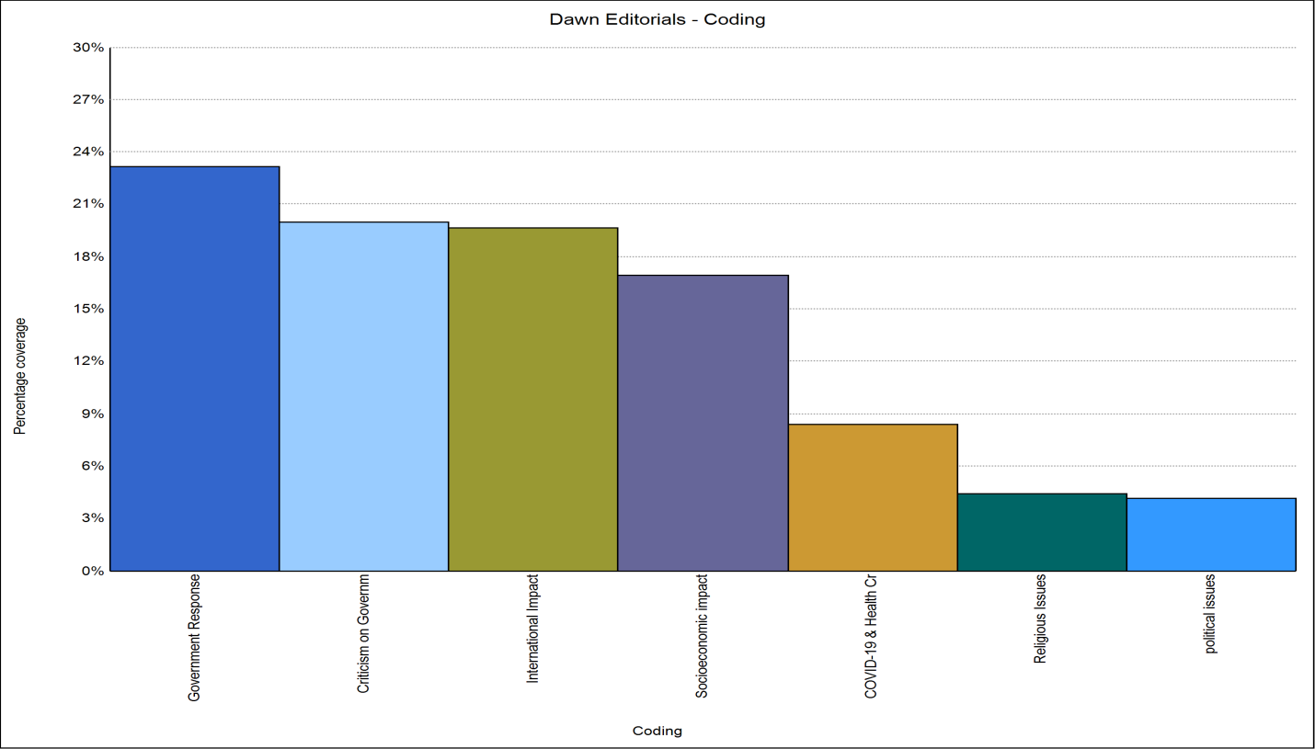
Figure 1.4 Comparative frequencies of the agendas covered by The Dawn regarding COVID-19
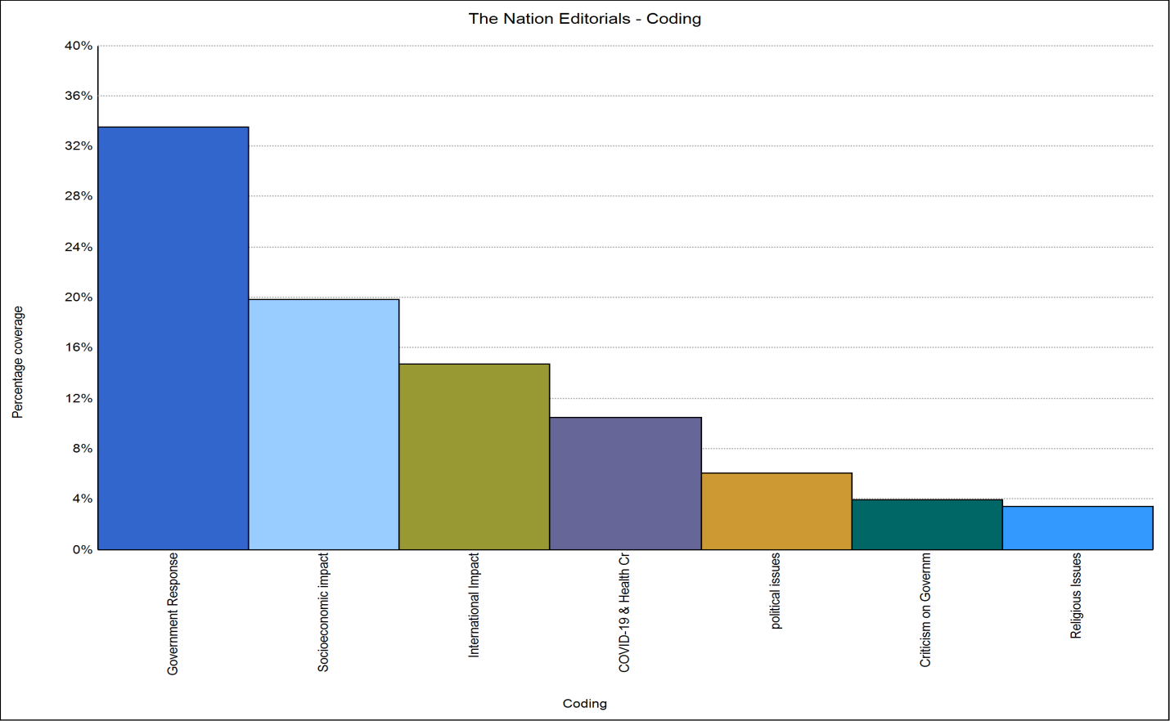
Figure 1.5 comparative frequencies of the agendas covered by The Nation regarding COVID-1

Conclusion

The major themes identified in the editorials of The Dawn & The Nation were regarding COVID-19 related health issues, criticism on government, government response, international impact, political issues, religious issues and the socioeconomic impact of the pandemic. As stated by Wanta & Ghanem (2007) “the amount of press coverage that issues receive gives individuals salience cues with which they learn the relative importance of these issues” (p. 37). This study examined the media content related to agenda definition, selection, and emphasis, which is basically linked to media agenda setting, unlike other forms of agenda setting theory like public and media agenda etc. (Shaw, 1979). This study has identified the themes (agendas) and sub-themes (issues) in both of the selected newspapers and has also compared The Dawn & The Nation, as figure 1.4 and 1.5 shows, there is more or less similar coverage in both of the selected newspaper i-e The Dawn & The Nation, but one stark difference was about the criticism on Government in which The Dawn was way ahead than The Nation. Figure 1.4 and 1.5 also illustrates the emphasis The Dawn & The Nation had put while covering the government response which included economic relief for poor, helping stranded people come back to Pakistan, bailing out industry & interest rate cut, admiration of Sindh Government, Military’s efforts to curb the virus, establishment of tele-schools.
Editorial coverage regarding innovations in Pakistani universities regarding Covid-19 was missing; secondly public education regarding COVID-19 should have been more frequent and persuasive. Constructive criticism at the time of crises is extremely important but sometimes criticism for the sake of it can lead to negativity and even panic. On the whole positive agenda setting by the both of these newspapers should be lauded, but at the same time, a lot of improvement regarding positive agenda setting by editorial boards of media organizations is imperative.
References

Abidi, S., Raees, M., & Ali, S. (2015). How Pakistan’s media spreads the message about reproductive and sexual health. BMJ: British Medical Journal, 350. Retrieved May 3, 2020, from www.jstor.org/stable/26520393
Ahmad, T., Rehman, N. A., Pervaiz, F., Kalyanaraman, S., Safeer, M. B., Chakraborty, S., ... & Subramanian, L. (2013, January). Characterizing dengue spread and severity using internet media sources. In Proceedings of the 3rd ACM Symposium on Computing for Development (pp. 1-2).
Aronson, J. (1995). A pragmatic view of thematic analysis. The qualitative report, 2(1), 1-3.
Begum, S., Khowaja, S. S., & Ali, G. (2012). Media created violence: a social determinant of mental health. JPMA. The Journal of the Pakistan Medical Association, 62(12), 1338.
Chohan, U. W. (2020, April 1). A model for coronavirus' economic impact. Retrieved May 3, 2020, from https://nation.com.pk/02-Apr-2020/a-model-for-coronavirus-economic-impact
Dawn (Ed.). (2020, April 6). Ill-conceived policy. DAWN.COM. Retrieved from https://www.dawn.com
Dorfman, L., Wallack, L., & Woodruff, K. (2005). More Than a Message: Framing Public Health Advocacy to Change Corporate Practices. Health Education & Behavior, 32(3), 320-336. Retrieved May 3, 2020, from www.jstor.org/stable/45055178
Fortner, R. S., & Fackler, P. M. (Eds.). (2014). The handbook of media and mass communication theory. John Wiley & Sons.
Gallagher, J. (2020, April 16). Coronavirus lockdown: How can we lift restrictions? Retrieved May 3, 2020, from https://www.bbc.com/news/health-52183295
Gettleman, J., & Conway, R. (2020, May 1). In a City Frozen in Fear, Time Freezes, Too. Retrieved May 3, 2020, from https://www.nytimes.com/2020/05/01/world/asia/india-coronavirus-delhi.html
Gopinath, G. (2020, April 21). The Great Lockdown: Worst Economic Downturn Since the Great Depression. Retrieved May 3, 2020, from https://blogs.imf.org/2020/04/14/the-great-lockdown-worst-economic-downturn-since-the-great-depression/
Goulding, C. (1999). Grounded Theory: some reflections on paradigm, procedures and misconceptions.
Hilton, S., & Hunt, K. (2011). UK newspapers' representations of the 2009–10 outbreak of swine flu: one health scare not over-hyped by the media?. J Epidemiol Community Health, 65(10), 941-946.
Jorgensen, K. W. (2020, April 20). Coronavirus: how media coverage of epidemics often stokes fear and panic. Retrieved May 3, 2020, from https://theconversation.com/coronavirus-how-media-coverage-of-epidemics-often-stokes-fear-and-panic-131844
Kee, C. P., Ibrahim, F., & Mustaffa, N. (2010). Framing a pandemic: Analysis of Malaysian mainstream newspapers in the H1N1 coverage. Journal of Media and Information Warfare Vol, 3, 105-122.
Khan, A. W., Ali, A., Adnan, M., & Jabeen, S. (2014). A comparative analysis of editorials of the Nation and the News: The case study of Pak-US relation issues duration: Sep 2001 to Sep 2003. IOSR Journal Of Humanities And Social Sciences, 19(8), 66-71.
Khan, A. W., Ali, A., Adnan, M., & Jabeen, S. (2014). A comparative analysis of editorials of the Nation and the News: The case study of Pak-US relation issues duration: Sep 2001 to Sep 2003. IOSR Journal Of Humanities And Social Sciences, 19(8), 66-71.
Khan, M. A., & Safder, A. (2010). Image of US in Pakistani Elite Newspaper Editorials after 9/11 Incident: A Comparative Study of The Dawn and Nawa-i-Waqt with Special Regard to Media Conformity Theory. Pakistan Journal of Social Sciences (PJSS), 30(2).
Kumar, S., Sharma, B., & Singh, V. (2020). Modelling the role of media induced fear conditioning in mitigating post-lockdown COVID-19 pandemic: perspectives on India. arXiv preprint arXiv:2004.13777.
Mahar, I. (2020, April 21). Impact of Covid-19 on Global Economy Structure. Retrieved May 3, 2020, from https://moderndiplomacy.eu/2020/04/22/impact-of-covid-19-on-global-economy-structure/
McCombs, M & Shaw, D. (1972). The Agenda-Setting Function of Mass Media. Public Opinion Quarterly,36, 176-187.
Moghaddam, A. (2006). Coding issues in grounded theory. Issues in educational research, 16(1), 52-66.

Nayyar, D. (2007). Modern Mass Communication Concepts and Processes. OXFORD,.
Obregón, R., Chitnis, K., Morry, C., Feek, W., Bates, J., Galway, M., & Ogden, E. (2009). Achieving polio eradication: a review of health communication evidence and lessons learned in India and Pakistan. Bulletin of the World Health Organization, 87, 624-630.
Olowokure, B., Clark, L., Elliot, A., Harding, D., & Fleming, A. (2007). EVIDENCE BASED PUBLIC HEALTH POLICY AND PRACTICE: Mumps and the media: Changes in the reporting of mumps in response to newspaper coverage. Journal of Epidemiology and Community Health (1979-), 61(5), 385-388. Retrieved May 3, 2020, from www.jstor.org/stable/40665807
Ozili, P. K., & Arun, T. (2020). Spillover of COVID-19: impact on the Global Economy. Available at SSRN 3562570. Not used yet
Powell, M. (2020, April 30). What role do the media play in managing the COVID-19 outbreak? – ID Hub. Retrieved May 3, 2020, from https://www.id-hub.com/2020/03/05/role-can-media-play-managing-covid-19-outbreak/
Remuzzi, A., & Remuzzi, G. (2020). COVID-19 and Italy: what next?. The Lancet.
Ryan, G. W., & Bernard, H. R. (2003). Techniques to identify themes. Field methods, 15(1), 85-109.
Safdar, A., & Budiman, A. M. (2018). Reportage of War on Terror by Pakistani Print Media: With Agenda setting perspective. Pakistan Journal of Social Sciences (PJSS), 38(1).
Sandell, T., Sebar, B., & Harris, N. (2013). Framing risk: Communication messages in the Australian and Swedish print media surrounding the 2009 H1N1 pandemic. Scandinavian Journal of Public Health, 41(8), 860-865. Retrieved May 3, 2020, from www.jstor.org/stable/45151091
Shaw, E. F. (1979). Agenda-setting and mass communication theory. Gazette (Leiden, Netherlands), 25(2), 96-105.
Singh, C. M. (2020, April 8). Amid Corona scare, Indian media races for TRP. Retrieved May 3, 2020, from https://dailytimes.com.pk/590961/insensitive-indian-media-politicizing-corona-virus/
Star, S. L. (1998). Grounded classification: Grounded theory and faceted classification. Library Trends, 47(2), 218-232.
Stover, D. (2020, March 26). Coronavirus coverage: where the media have gone wrong. Retrieved May 3, 2020, from https://thebulletin.org/2020/03/coronavirus-coverage-where-the-media-have-gone-wrong/
Uscinski, J. (2009). When Does the Public's Issue Agenda Affect the Media's Issue Agenda (and Vice-Versa)? Developing a Framework for Media-Public Influence. Social Science Quarterly, 90(4), 796-815. Retrieved May 3, 2020, from www.jstor.org/stable/42940641
Vaismoradi, M., Turunen, H., & Bondas, T. (2013). Content analysis and thematic analysis: Implications for conducting a qualitative descriptive study. Nursing & health sciences, 15(3), 398-405.
Wanta, W., & Ghanem, S. (2007). Effects of agenda setting. Mass media effects research: Advances through meta-analysis, 37-51.

Phd-Continue, Contact: siddique.hassan@gmail.com

