Additional File 1.
Supplementary Figure 1. Correlation between percentage of p-PERK+ or p-eIF2α+ neurons with age at death and post-mortem delay.
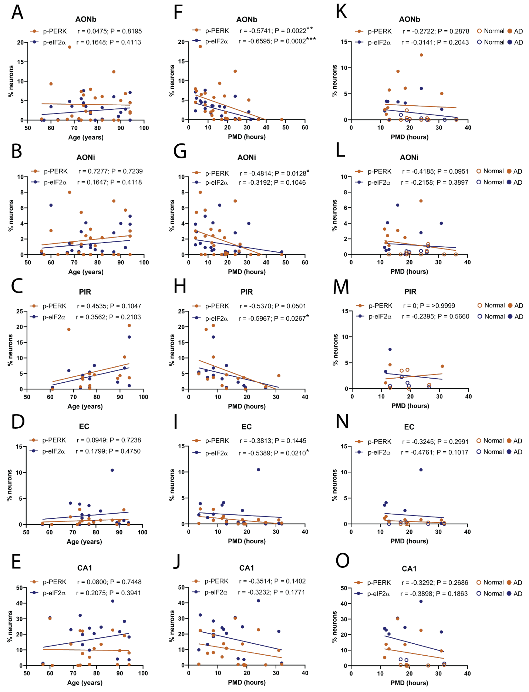
Supplementary Figure 1. Correlation between percentage of p-PERK+ or p-eIF2α+ neurons with age at death and post-mortem delay. For each region, the percentage of p-PERK+ or p-eIF2α+ neurons was plotted against age at death (A-E) and post-mortem delay (F-J) for each case. A non-parametric Spearman’s correlation test determined that there was no significant correlation between the percentage of p-PERK+ or p-eIF2α+ neurons and age at death in any of the regions assessed. There was also no significant correlation between the percentage of p-PERK+ or p-eIF2α+ neurons and post-mortem delay in the CA1 region. However, there were moderate inverse correlations between the percentage of p-PERK+ neurons and post-mortem delay in the AONb and AONi and between p-eIF2α+ neurons and post-mortem delay in the AONb, PIR and EC regions. As this is likely due to the difference in post-mortem delay between normal and AD cases, we investigated a partial correlation by plotting cases with a post-mortem delay between 11.5 and 36 hours (K-O). This range in post-mortem delay overlapped between the normal and AD groups and no significant correlation was observed for either p-PERK or p-eIF2α in any region. Abbreviations: PMD, post-mortem delay.

