Additional File 2.
Supplementary Figure 2. Distribution of p-PERK+ and p-eIF2α+ cells and beta-amyloid plaques in the AON.
Supplementary Figure 3. Fluorescent immunohistochemistry for p-IRE1α in the AON and CA1 region.
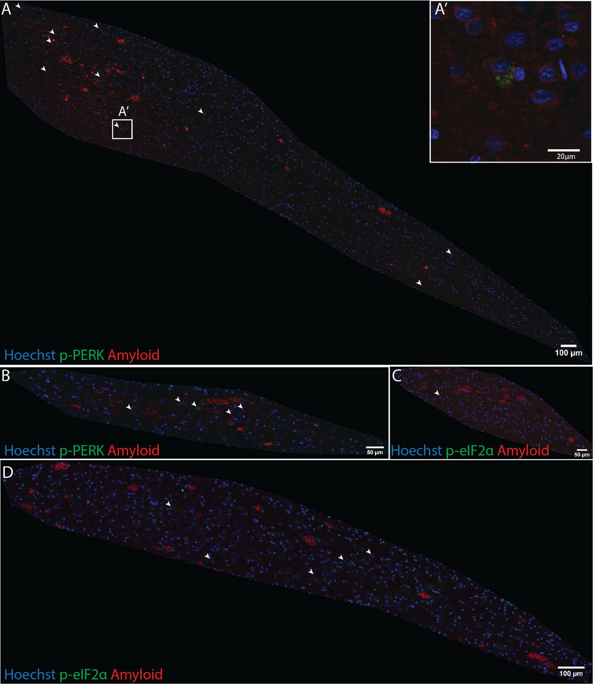
Supplementary Figure 2. Distribution of p-PERK+ or p-eIF2+ cells and beta-amyloid plaques in the AON. AON region of interest images from representative AD cases indicating the location of p-PERK+ (A-B) and p-eIF2α+ (C–D) cells (white arrows) relative to beta-amyloid plaques (red). No spatial relationship was qualitatively observed within the AON.
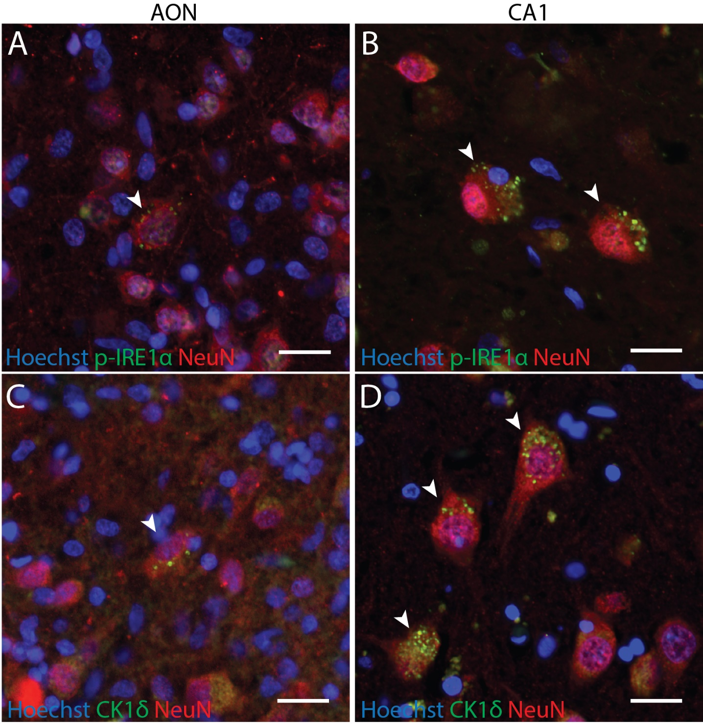
Supplementary Figure 3. Fluorescent immunohistochemistry for p-IRE1α and CK1δ in the AON and CA1 region. Some p-IRE1α+ neurons were detected in the AON (A), but p-IRE1α+ neurons were far more abundant in the CA1 region (B). CK1δ immunoreactivity was observed within AON (C) and CA1 (D) neurons. Arrows indicate p-IRE1α+ neurons. Scale bars = 20 μm.

