**Supplemental Information**

**Influence of Ash-Soot Interactions on the Reactivity of Soot from a Gasoline Direct Injection Engine**

Jordan Eastera, Stani Bohacb, John Hoarda, and Andre Boehmana

aMechanical Engineering, University of Michigan, Ann Arbor, Mi, USA; bUnited States Environmental Protection Agency, Ann Arbor, Mi, USA

CONTACT Jordan Easter [easterje@ornl.gov](mailto:easterje@ornl.gov), National Transportation Research Center, Oak Ridge National Lab, 2360 Cherahala Blvd, Knoxville, TN, 37932, USA.

Table S1. Test Fuel (tests by Paragon Laboratories, Livonia, MI)

|  |  |  |
| --- | --- | --- |
| Type | 93 AKI octane E10 pump fuel | Method |
| 10% evaporated temperature | 57.9°C | ASTM D86 |
| 50% evaporated temperature | 104.4°C | ASTM D86 |
| 90% evaporated temperature | 164.0°C | ASTM D86 |
| Carbon fraction | 81.69% v/v | ASTM D5291 |
| Hydrogen fraction | 14.52% v/v | ASTM D5291 |
| Oxygen fraction | 3.79% m/m | ASTM D5622 |
| Ethanol content | 9.67% v/v | ASTM D4815 |
| Saturates | 76.5% v/v | ASTM 1319 |
| Aromatics | 12.1% v/v | ASTM 1319 |
| Olefins | 1.7% v/v | ASTM 1319 |
| Density @ 15.56°C | 0.7303 g/mL | ASTM D4052 |
| Net heating value | 41.872 MJ/kg | ASTM D240 |

Figure S1. Concentration of Various Elements from a Sample of the Engine Oil

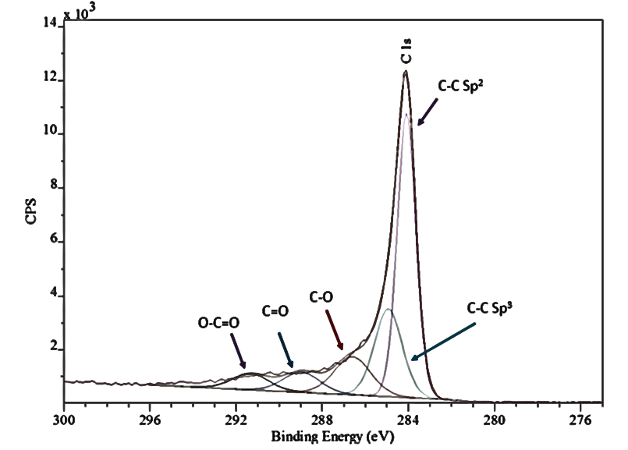

Figure S2. Peak Deconvolution for the C1s Peak (Early SOI Sample)

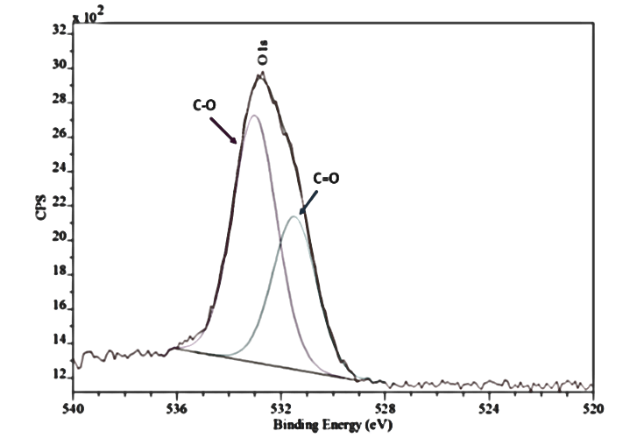

Figure S3. Peak Deconvolution for the O1s Peak (Early SOI Sample)

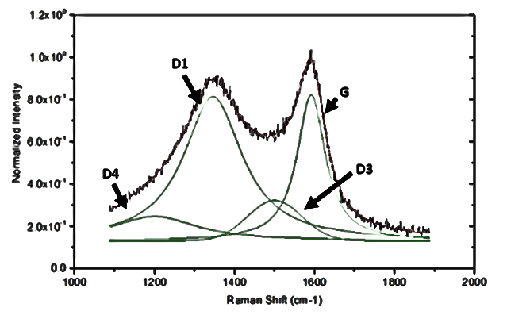

Figure S4. Peak Analysis Performed on Baseline Raman Spectra

 (a)  (b)

(c) (d)

(e) 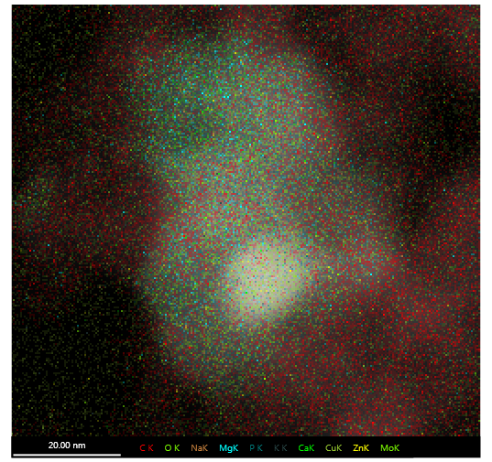(f)

Figure S5. STEM+EDS Elemental Mapping of Baseline Sample: (a) O, (b) Ca, (c) Cu, (d) Mg, (e) Zn, (f) Overlay

Figure S6. TEM Images Taken of the Soot Oxidation Process: (a) Baseline 0% - 65k, (b) Early SOI 0% - 65k, (c) Baseline 40% - 65k, (d) Early SOI 40% - 80k, (e) Baseline 75% - 80k, (f) Early SOI 75% - 80k

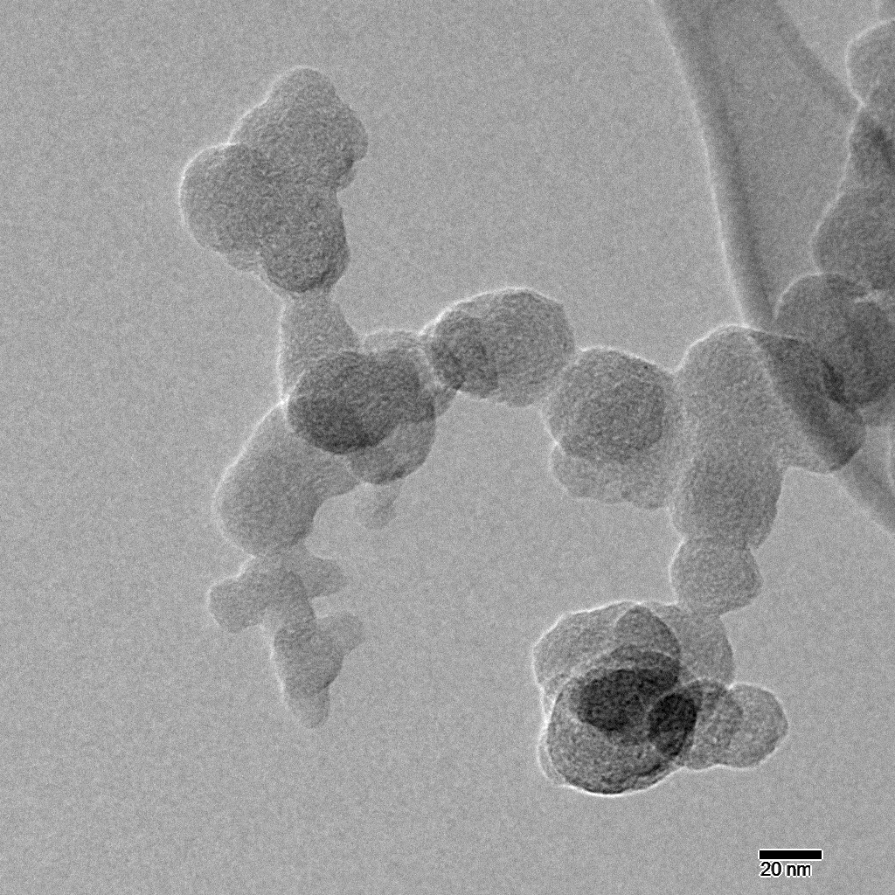 (a) 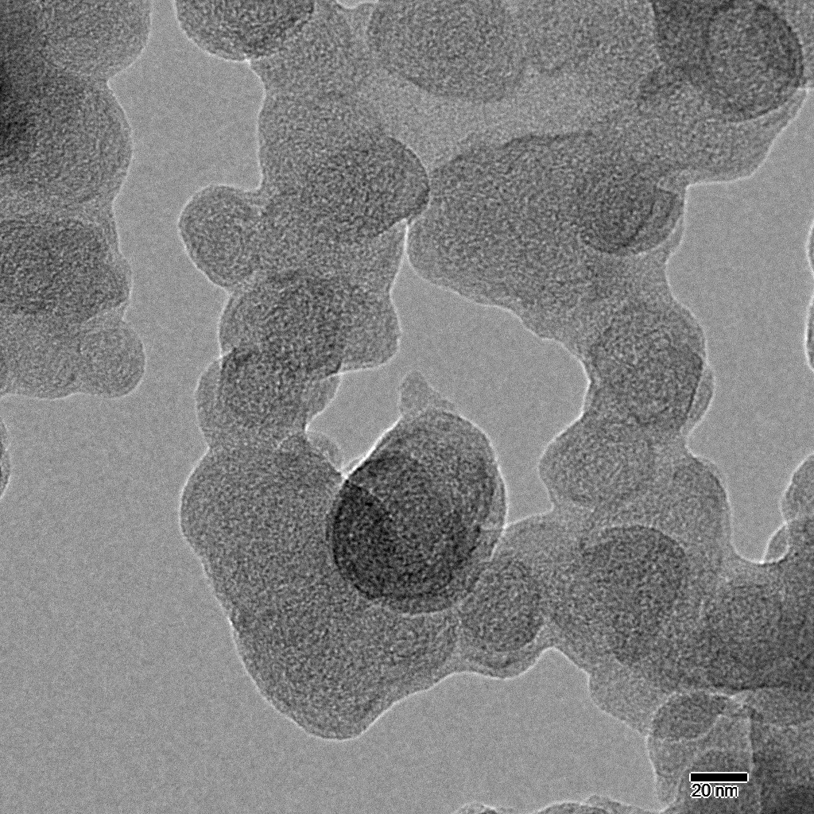 (b)

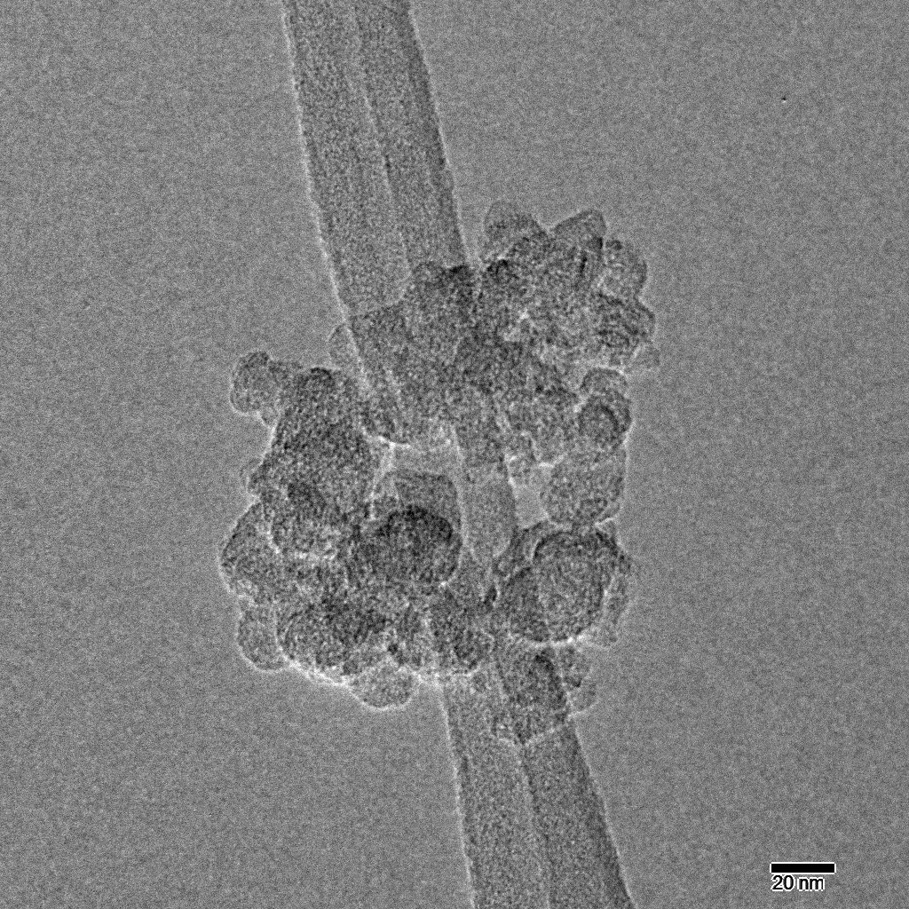 (c) 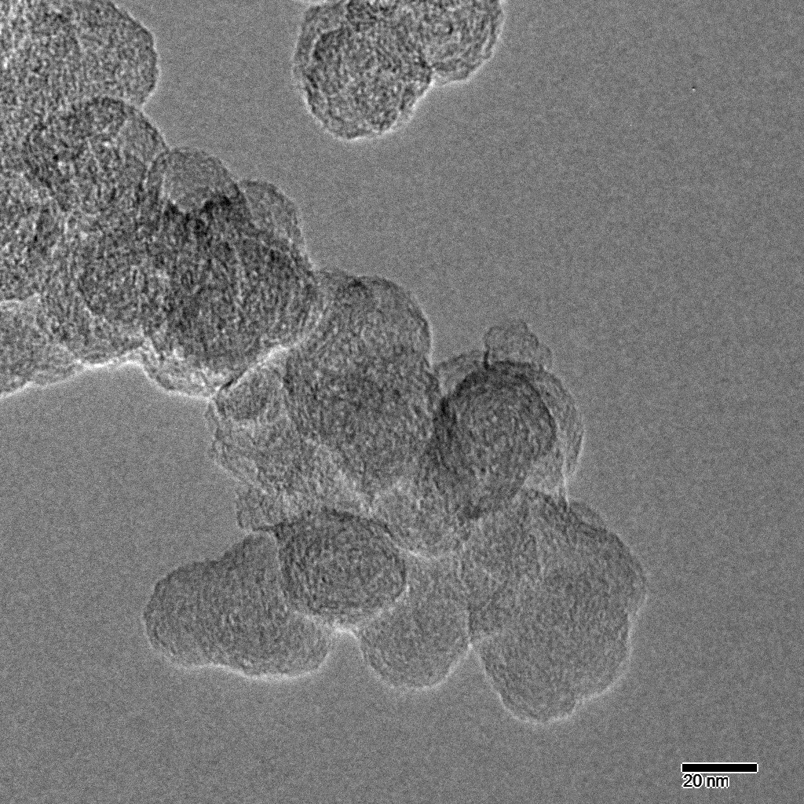 (d)

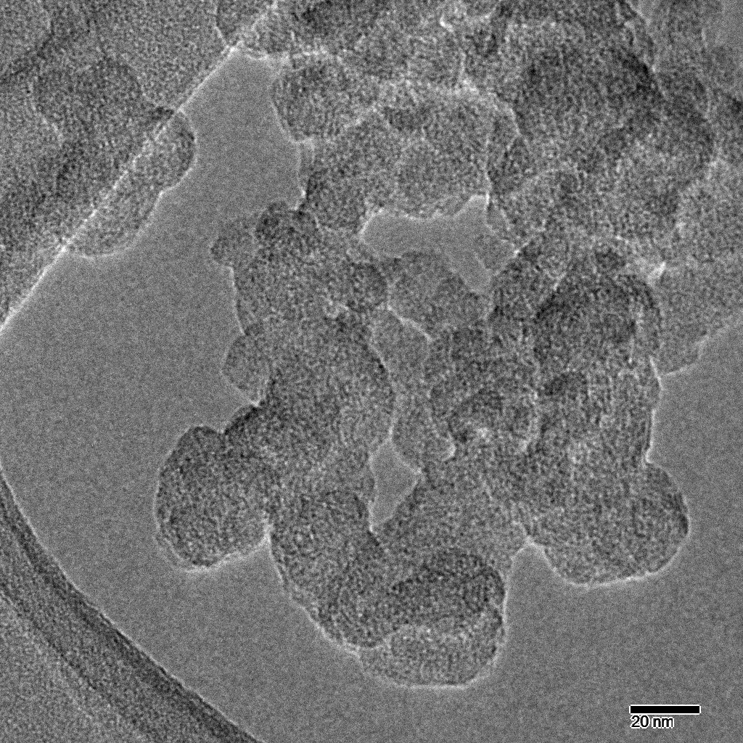 (e) 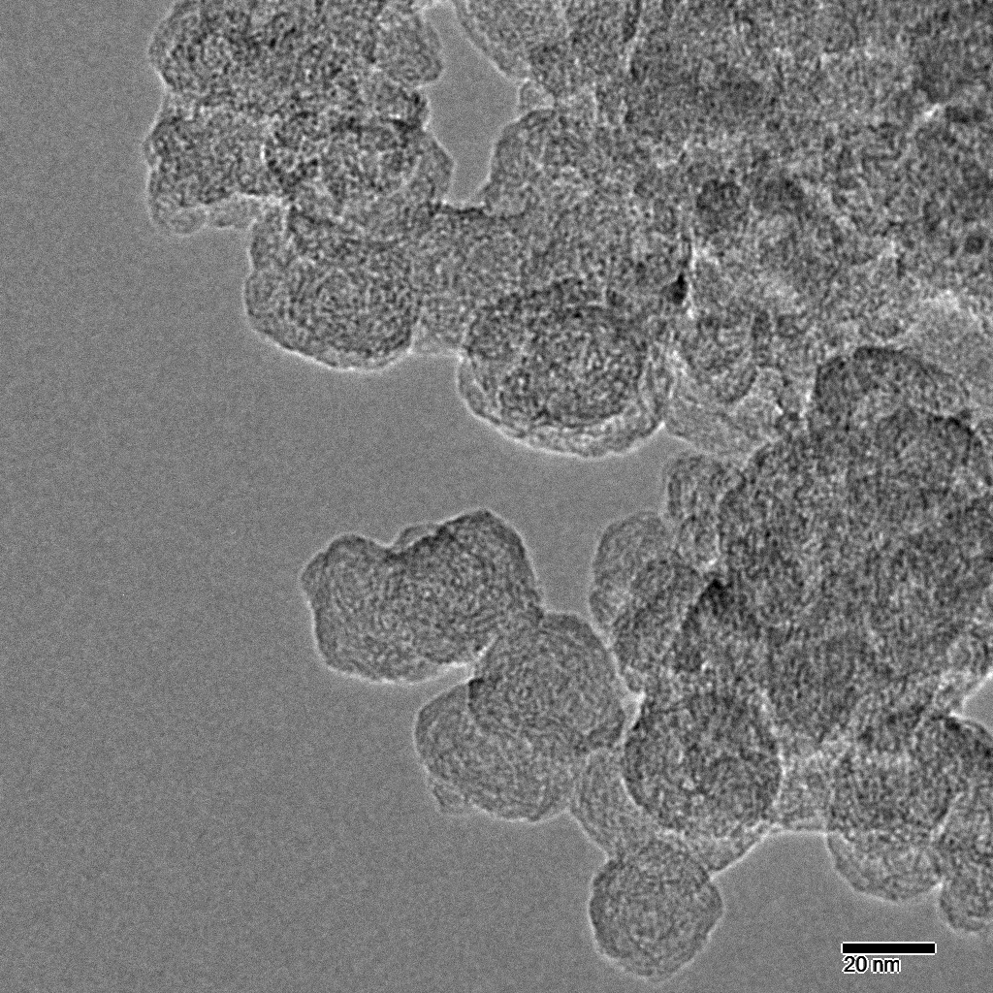 (f)

Figure S7. STEM+EDS Elemental Mapping of Baseline - 75% Oxidized Sample: (a) O, (b) Cu, (c) Na, (d) Zn, (e) Ca, (f) Overlay

(a) (b)(c) (d)

(e) 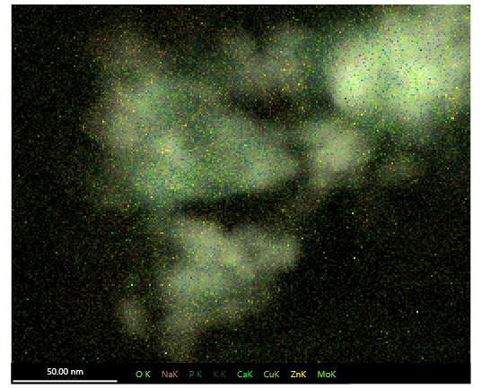(f)