Motivation for learning EFL in Tunisia: An eclectic theoretical approach and a structural equation modeling approach

Abstract. This article investigated the motivational set-up of 241 high school students of English as a foreign language using an eclectic theoretical approach and a structural equation modeling approach. The study relied on social psychological, self-determination and social cognitive theories to define the attitudinal, orientational, and criterion dimensions of L2 motivation. AMOS software was used in the study as a data analysis tool and yielded a model of L2 motivation with a good fit to the data. In this model self-efficacy, attitudes, and orientations interplayed to affect the indirect and direct criterion measures of L2 motivation, namely performance expectancy, motivational intensity, and L2 achievement. Social attitudes proved, however, to be the variable with the largest effect on motivational intensity and performance expectancy as indirect criterion measures. In contrast, intrinsic orientation, attitude towards L2 and L2 learning, and self-efficacy proved to have the largest effects on achievement as a direct measure of motivation. These findings proved that the relationship between self-efficacy, attitudes, and orientations and indirect criterion measures of L2 motivation is different from that between the same variables and achievement, as a direct criterion measure of L2 motivation.
Keywords: Motivation, Self-efficacy, Attitudes, Orientations, EFL, Structural equation modeling

Introduction
The role of motivation in L2 learning has become a central topic in applied linguistics and second/foreign language acquisition research since the late 1960s. Several paradigms, frameworks, and models have been elaborated to shed light on how motivation could explain variability in attainment level among L2 learners. Since the mid-2000s, L2 motivation research has been dominated by Second Language Self-System Model (L2SSM, Dörnyei, 2009) and several studies investigated how its three components, namely ideal L2 self, ought L2 self and L2 learning experience relate to learning styles or influence learners’ behavior and language attainment (See Boo, Dörnyei & Ryan, 2015 and Mendoza & Phung, 2019, for a review).
However, even before the surge in the number of studies relying on L2SSM, MacIntyre, MacKinnen, and Clément (2009) premonitorily called for “caution” with using possible selves as a theoretical framework to explore L2 motivation warning that “… if the social psychological and political dimensions of language are drained away as the bathwater, we must be careful not to lose the conceptual baby, which is the relevance of those individual differences in the motivations to communicate with people who speak the target language” (p. 7). In a similar vein, Hermessi (In press, p. 1) argued that “…the domination of L2SSM has brought L2 motivation research back to the so-called 1990s ‘reform articles’ period whose main claim had been that the domination of L2 motivation research by Gardner’s social psychological theory has potentially overshadowed valuable alternative paradigms. The same can be purported for L2SSM, which might have overshadowed other prominent L2 motivation paradigms…”
It is worth noting, however, that in spite of the domination of L2SSM, a number of studies, took a critical stance towards the adequacy of future self-guides theory alone to highlight the full picture of L2 motivation (e.g. Csisér and Kormos, 2008; Kormos, Kiddle and Csizér, 2011; Moskovsky, Racheva, Assulaimani, and Harkins, 2016, Sugita McEown, Sawaki, & Harada, 2017). Such stance is based on the assumption that theories, frameworks and models such as the Socio-Educational Model (SEML2, Gardner, 1985, 2010), the Self-Determination Theory (SDT, Deci and Ryan, 2000, 2012; Ryan and Deci, 2017), the Social-Cognitive Model (SCM, Bandura, 1986, 1997), and Expectancy-value model (EVM, Wigfield, Tonks, and Klauda, 2009)) are still adequate for explaining L2 motivation.
Methodologically speaking, L2 motivation research has heavily relied on quantitative design using correlational and regression analyses to explore how various motivation variables relate to direct and indirect criterion measures of motivation including motivated behavior, language choice, intended effort, and L2 attainment (Ushioda and Dörnyei, 2012). As far as the criterion measures of motivation are concerned, Moskovsky, et al. (2016) noted that research that attempted to validate the L2SSM investigated how its three components correlate or predict indirect measures of motivation, such as intended effort, rather than L2 proficiency or achievement per se. They argued, however, that research in psychology “…has shown that for over 30% of people, intentions do not match actions” (p, 4) and attempted, therefore, to test whether the predictive validity of L2SSM extends from indirect criterion measures of motivation such as ILE to direct ones such as L2 proficiency. Moskovsky et al. (2016) found that L2SSM failed to predict L2 proficiency.
The most seminal studies that adopted a theoretical eclectic approach to enquire into the dynamics of L2 motivation include Tremblay and Gardner (1995), Csizér and Dörnyei (2005), Csisér and Kormos (2008), Kormos et al. (2011), and Moskovsky et al. (2016). The present study, relying on this seminal research tradition, was meant to investigate the internal structure of motivation for learning English as a Foreign Language (EFL) by high school students in Tunisia. Theoretically speaking, it adopted an eclectic approach by relying on SEML2, SCT, SDT, and EVM to define L2 motivation. It was also meant to test Moskovsky et al. (2016) claim that the relationship between motivation and indirect criterion measures might be different from that between motivation and direct criterion measures (proficiency or achievement).

Theoretical framework
In the present study, motivation was defined as the inner force that initiates, energizes and directs behavior; it comprises four distinct dimensions namely, attitudes, orientations, self-efficacy, and criterion manifestations.

Attitudes
“Attitude” refers to the beliefs, thoughts, and feelings learners hold about the different aspects of language learning, mainly the target language and the task of learning it, the social group representative of L2, and the learning context. It has been considered in the most influential models of motivation with the exception of L2SSM to be an important motivational variable. However, attitude has been either subsumed in rather larger motivational constructs as it is the case in SEML2 or had its different components lumped together under the label of “L2 attitudes” as it is the case in Tremblay and Gardner (1995) and in Kormos et al. (2011). It is worth noting, however, that in Gardner, Tremblay and Masgoret’s 1997 model, “Attitude” has been treated as a latent construct, measured with five scales. In this study, in contrast, “attitude” is assumed to comprise three distinct constructs rather than three latent scales of the same factor: Social attitudes, linguistic attitudes, and contextual attitudes.
“Social attitudes” refers to beliefs, thoughts and feelings held by the L2 learner towards the L2 group. The most influential social attitudes construct in L2 motivation theory and research is Robert Gardner’s “integrativeness”. Although integrativeness was conceptually defined as “…an open and positive regard for other groups and for groups that speak the language” (Tremblay and Gardner, 1995, p. 506), it was operationally defined, in Gardner’s (1985) attitude motivation test battery (AMTB) by three scales namely Attitudes Toward the Target Language Group, (b) Interest in Foreign Languages, and (c) Integrative Orientation (see Gardner, 2012, p. 217). In the present study, social attitudes are labelled “attitude towards L2 group” and defined based on Csizér and Dörnyei’s (2005) conceptualization of the dimension as well as Gardner’s (1985, 2010) “attitudes towards the target language group” component of integrativeness. It specifically reflects the extent to which the L2 learner holds positive views about the country(ies) representative of the target language and their “international importance” for trade, technology, and science on the one hand and their degree of progress and wealth, on the other.
“Contextual attitudes” refers to the L2 learners’ thoughts and feelings about such classroom related variables as the teacher, the method of teaching, the teaching materials, and the classroom activities. In SEML2, it has been labelled attitudes toward the learning situation and assessed by two AMTB measures: Attitudes toward the Language Course and Attitudes toward the Language Teacher (see Gardner, 2012, p. 217) . In the present study, it was labeled attitude towards learning context (Tremblay and Gardner, 1995). The third attitudinal component considered in the present study is “linguistic attitudes”; it concerns the beliefs, thoughts and feelings the L2 learner holds about English as a language as well as the experience of learning English. It was defined in light of the “Desire to Learn L2” scale of SEML2.

Orientations
As far as orientation is concerned, there is a general agreement in motivation research on their definition as the reasons or antecedents for which individuals decide to engage in an activity. In L2 motivation research, the two dichotomies that have received most attention are SEML2 integrative/instrumental dichotomy (see Gardner, 1985, 2010) and SDT intrinsic/extrinsic dichotomy (see Noels, Clément, and Pelletier, 2001; Noels, 2003; McEown, Noels, and Saumure, 2014, Noels, Lou et al., 2019).
Integrative orientation has been singled out in several studies as a salient motivational variable even in EFL contexts where learners have little or no direct contact with L2 group (see Masgoret and Gardner, 2003, Dörnyei and Csizér, 2002, and Csizér and Dörnyei, 2005, among others). In the present study, this orientation was labelled the “openness for others orientation” and was defined in light of Gardner’s definition of the integrative orientation without the identification with L2 group and desire to “integrate such group” sub-components. Openness for others orientation was assumed to reflect an ethno-relativistic, open predisposition to discover other peoples and cultures through the English language along with a desire to meet native and nonnative speakers of English. In addition to the openness orientation, another orientation related to the social cultural dimension of L2 learning was considered in the present study, namely “the cultural interest orientation”. Suh construct was defined based on Dörnyei and Csizér (2002) and Csizér and Dörnyei (2005)’ definition of a similar construct as interest in the cultural and artistic artefacts of the target language and liking such cultural products as movies, magazines, music, and TV programs.
In addition to openness orientation and cultural interest orientation, two other orientations were considered, namely intrinsic orientation and extrinsic orientation. Intrinsic orientation “involves people freely engaging in activities that they find interesting, that provide novelty and optimal challenge” (Deci and Ryan, 2000. p. 235). In the Academic setting, it involves learning for the sake of accomplishment, mastery, knowledge, curiosity as well as “…aesthetic appreciation, fun and excitement” challenges. Extrinsic orientation, in contrast, involves other recognition, competition, and meeting compulsory requirements (Noels, Pelletier, Clément & Vallerand 2000, p. 61). In the academic setting, externally-oriented students find good reasons to learn in passing exams, satisfying parents, showing their competence to others as well as learning for professional and academic purposes. In SDT theory, intrinsic and extrinsic orientations are not mutually exclusive rather they lie along a continuum ranging from most self-determined to least self-determined. Nevertheless, intrinsically-oriented learners are assumed to be better achievers than extrinsically oriented ones (Noels et al, 2000; Noels, 2001).

Self-efficacy for L2 learning
Self-efficacy for language learning has been defined in light of Bandura’s (1997), Schunk’s (1989), and Clément’s (1980) definitions of the concept as self-appraisals of ability to complete a task or act in a particular situation. Bandura (1997, p. 3) purported that humans motivate themselves by forming beliefs about what they can do, anticipating likely outcomes, setting valued future goals and planning courses of action to realize them. The stronger the perceived self-efficacy, the firmer the commitment to expect and achieve “valued future” outcomes. The weaker the perceived self-efficacy and the higher perceived self-doubt, the more failure scenarios are visualized. In the academic setting, Schunk (1989) introduced the term “self-efficacy for learning” to refer to learners’ beliefs on their capabilities to effectively acquire new cognitive skills and process knowledge. Mills, Pajares, and Herron (2007) and Mills (2014) noted that research on the role of self-efficacy in learning, in general, and language learning in particular amply supports the claim that students who feel self-efficacious proved to be capable of capable organizing and executing courses of action in ways that significantly affect academic achievements.
In L2 motivation theory, the role of L2 ability self-evaluation has been first introduced in Clément 's (1980) Social Context Model under the label of “self-confidence” to involve lack of anxiety when speaking L2 and high self-ratings of proficiency (see Clément, 1980 and Clément & Kruidenier, 1985). In the present study, self-efficacy for L2 learning was defined in terms of three dimensions namely, appraisal of overall capacity to learn L2 as defined by Schunk (1989) and Clément (1980) as well as a lack of in-class language use anxiety component as defined by Clément (1980) and Gardner (1985). In addition, self-efficacy for L2 learning was defined in terms of two of the four components of Carroll’s (1981) language learning aptitude, namely the “inductive learning ability”, i.e. the ability to process and analyse linguistic input and learn out of it and the grammatical sensitivity, that is the ability to identify syntactic categories and arrange them in meaningful utterances.

The criterion manifestations of motivation
In the present study, three criterion manifestations of motivation have been considered., two indirect, namely outcome expectancy and motivational intensity and one direct, L2 achievement. Outcome expectancy was defined in light of Atkinson’s (1981), Wigfield, Tonks, and Klauda, (2009) as well as Trembly and Gardner’s (1995) definitions of the construct. Atkinson (1981) conceptualised motivation as the multiplicative function of three variables that are (1) the motive to achieve success, (2) the subjective probability of success, and (3) the incentive value and attractiveness of the expected outcome. Tremblay and Gardner (1995) claimed that, in L2 learning, it could be hypothesized that effort, attention and persistence to learn L2 might prove to be a function of the extent to which the learner believes that the goal of successfully acquiring L2 is achievable. Motivational intensity, the second motivational variable of the study, refers to amount of effort, degree of concentration and attention the L2 leaner is willing to expend in and outside class to learn. In the present study, it was defined in terms of the same construct identified by Gardner (1985) and Tremblay and Gardner (1995). In addition to the two indirect criterion manifestations of motivation, a direct criterion manifestation was considered, in this study, namely L2 achievement scores.

Research questions
In the present study, motivation for L2 learning was defined in terms of 8 components and three criterion manifestations. The 8 components include (1) Attitudes towards L2 and L2 learning, (2) attitudes towards L2 group, (3) attitudes towards, (4) openness to other cultures and people orientation, (5) cultural interest orientation, (6) intrinsic orientation, (7) extrinsic orientation, and (8) self-efficacy for L2 learning. The 3 criterion manifestations include (1) performance expectancy, (2) motivational intensity and L2 achievement. L2 achievement was considered as a direct criterion measure of L2 motivation. The study specifically addressed the following questions:
- What is the role of self-efficacy for L2 learning in defining motivation for learning English as a L2?
- What is the role of attitudes in defining motivation for learning English as a L2?
- What is the role of orientations in defining motivation for learning English as a L2?
- Is the relationship between motivational variables and indirect measures of motivation
similar or different from that between motivational variables and L2 achievement?

The study

Setting and participants
The study was conducted in the Tunisian EFL context where English is the second foreign language, the first being French. The Tunisian linguistic and cultural make-up is characterised by the critical influence of the French language and culture, legacies of colonialism. English is taught as a mandatory subject for six years starting from age 13 in high school. Tunisian EFL learners have, in principle, few or no extra-curricular contact with the English language or Anglophone communities. The contact is likely to be remote, by means of the media and the internet. The sample of the study was 241, aged 16 to 19. The sampling technique relied on was convenience sampling as regular classes in four high schools in the area of Tunis, the capital city of Tunisia, have been administered the questionnaire during their English class by the researcher with the help of their teachers.

Constructs and variables operationalization
In this study, motivation has been conceptually defined in terms of 11 variables. All variables, except L2 achievement have been operationally defined using a questionnaire with a five-point Likert scale format. L2 achievement was, however, based on the average score of the two first periods of the academic year 2016/2017. The questionnaire was originally written in Tunisian Arabic for the study (see appendix for the English version of the questionnaire). The alpha internal consistency coefficient was used to test their reliability and yielded satisfactory internal consistency coefficients ranging from .70 to .85. Table 1 below presents the variables of the study, their number of items, a sample item for each variable as well as its internal consistency coefficient.
Table 1.
The motivational variables of the study and their internal consistency coefficients
Motivational Variable | Number of items | Sample item | Alpha coefficient
Attitude towards L2 and L2 learning experience | 4 | I consider studying English a wonderful experience | .85
Attitude towards L2 group | 5 | English-speaking countries represent wealth and power | .79
Attitude towards learning context | 5 | All in all. I liked most of the English textbooks we used in class | .81
Intrinsic orientation | 3 | I study English because of the sense of pleasure and self-satisfaction such experience procures | .76
Extrinsic orientation | 3 | I study English because I will certainly need it in my future studies | .76
Openness orientation | 4 | English represents a tool to understand cultural groups that might be different from mine and establish contact with their members | .82
Cultural interest orientation | 4 | I am fond of the culture. art. and life style of English-speaking countries | .83
Self-efficacy for L2 learning | 6 | I think that I have a special sense for learning languages | .83
Outcome expectancy | 4 | I am quite certain that I will one day reach a native-like proficiency in English | .70
Motivational intensity | 5 | During English classes. I am so concentrated to the point that nothing can distract me | .80

Model specification
This study was meant to enquire into the dynamics of motivation for learning English as a foreign language in Tunisia using the structural equation modeling approach. In structural equation modeling, there are four stages, namely model specification, model testing, model re-specification and model identification (Schumacker & Lomax 1996). Model specification consists in deriving a model on theoretical grounds. In specifying a model for the present study, the 11 variables were combined into a full structural model. In this model, a distinction was established between L2 motivational variables, which include attitudes, orientations and self-efficacy and criterion motivational variables, which include two indirect ones, i.e. outcome expectancy and motivational intensity as well as one direct measure, that is L2 achievement. As for the interrelationships among variables, attitudes and self-efficacy were treated as independent variables, orientations as well as outcome expectancy and motivational intensity were treated as moderator variables that could mediate the relationship between attitudes and self-efficacy for L2 learning and L2 achievement. In addition, outcome expectancy and motivational intensity were treated as moderator variables between self-efficacy, attitudes, orientations and achievement (see Figure 1, below).

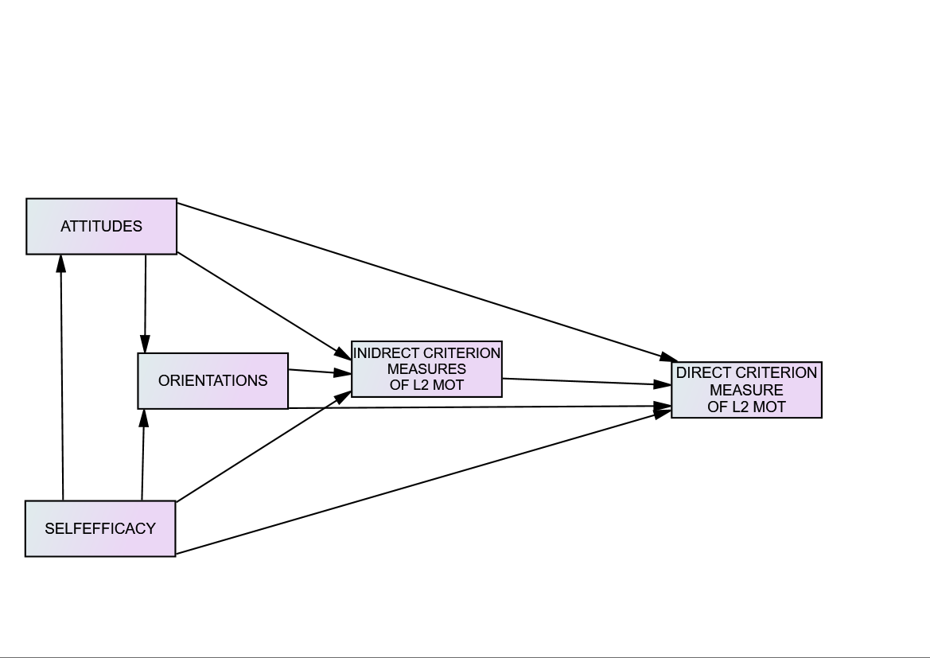
Figure 1. Raw model of motivation for EFL

After the combination of the variables of the study into a structural model, a set of hypotheses about the way they interplay have been formulated. Self-efficacy for L2 learning, which emerged as a determinant motivational variable in several studies (see Tremblay and Gardner, 1995 and Csizér and Dörnyei, 2005, for instance), was hypothesized to significantly affect all the attitudinal and orientational variables considered in the study. As for the relationship between attitudes and orientations, attitude towards learning context was hypothesized not to relate to any orientation. Attitude towards L2 and L2 learning experience and attitude toward context were, in contrast, hypothesized to relate to extrinsic orientation rather than intrinsic orientation. Besides, attitudes toward L2 group was hypothesized to relate more to openness to others and cultural interest orientations than extrinsic and intrinsic orientations.
As for the role of orientations in L2 motivation, it was hypothesized that the four orientations relate to the three criterion measures of the study. It was also hypothesized that openness to others is related to intrinsic orientation while cultural interest is related to extrinsic orientation. Regarding the relationship between motivational variables the criterion measures of motivation, it was hypothesized, based on Moskovsky et al. (2016), that the relationship between attitudes, orientation, self-efficacy and L2 achievement is different from that between the same variables and outcome expectancy and motivational intensity. It was however hypothesized, in contrast to Moskovskys et al. ‘s (2016) unexpected finding, that performance expectancy and motivational intensity significantly relate to L2 achievement (see Figure 2, below).
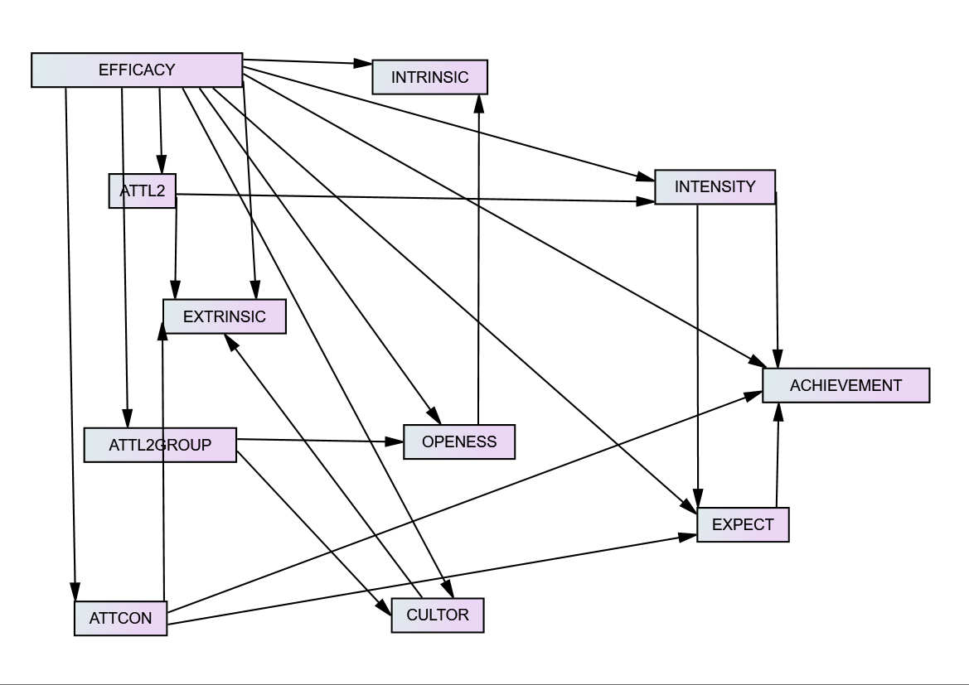
Figure 2. The detailed hypothetical model of EFL
LABEL | CONSTRUCT | LABEL | CONSTRUCT
EFFICACY | Self-efficacy for L2 learning
ATTCON | Attitudes towards learning context | EXTRINSIC | Extrinsic orientation
ATTL2  ATTL2group  OPENNESS  INTRINSIC | Attitudes towards L2  Attitudes towards L2 group  Openness orientation  Intrinsic orientation | CULTOR  INTENSITY  EXPECTANCY  ACHIEVEMENT | Cultural orientation  Motivational intensity  Expectancy of success  Achievement score in English

Results

Model re-specification, identification and interpretation
After model specification, the second step in structural equation modeling is model estimation, testing and re-specification. The software AMOS 23.0. was run to estimate the correlations and regression weights among the different motivational variables considered. Model estimation revealed that the initial model did not fit the data and given that the data has missing values, Amos “modification indices” tool could not be used to re-specify the model; rather the causal paths (single-headed arrows) with non-significant p-values have been eliminated one at a time till a model with a good fit was found.
To identify a model in AMOS program, Byrne (2001, p. 71-72) recommended to report Chi-square (labelled CMIN in AMOS), Root Mean Square Error of Approximation (RMSEA) as well as a parsimony measure such as Comparative Fit Index (CFI). “Chi-square, a measure of difference between what the actual relationships in the sample are and what would be expected if the model was assumed correct, must be interpreted in terms of its degrees of freedom (df)” (Schumacker & Lomax, 1996, p. 119). A model that represents the sample data well “would yield a ratio of CMIN/df close to 1 and most researchers would reject a model that was much over 2” (Hu & Bentler, 1995, p. 95). “CFI is an incremental, normed fit index”, which values range between zero to one, with higher values indicating better fit. RMSEA represents “how well a model fits a population, not just the sample used for estimation” (Hu & Bentler, 1995, p. 4). Lower RMSEA values indicate better fit and <0.05 is the recommended good fit indicator (Browne & Cudeck 1993, p. 144). Given that there is no model comparison in the present study, Chi-square and CMIN/df, RMSEA, and Comparative Fit Index (CFI) have been relied on to determine model fit. Table 2, below, reporting the recommended statistics for model specification along with the ones obtained in the present study, indicates that the obtained model (see Figure 1) has a perfect fit to the data with a low CMIN/df (.25) and RMSEA (.00) and a high CFI (1.0).
Table 2.
Recommended and obtained fit statistics of identified model
Fit statistic | Recommended | Obtained
CMIN/DF | < 2 | .256
CFI | > 0.90 | 1.00
RMSEA | < 0.05 | 0.00

Regarding the internal structure of motivation for learning English as a foreign language by high school students in Tunisia, that is the subject of questions 1, 2, and 3, Figure 1 and Table 3 lend support to the pertinence of treating self-efficacy and attitudes as independent variables and orientations and indirect criterion measures of motivation as moderator variables. In fact, all the motivational variables considered in the study contributed to the internal structure of motivation and either had a direct or indirect impact on the criterion measures of the study. To measure such impact, standardized path coefficients were used. Such estimates allow for the evaluation of the relative contribution of each predictor variable to each dependent or outcome variable. Standardized path coefficients represent “the amount of change in the dependent variable given a standard deviation unit change in the predictor variable” (Byrne, 2013, p. 10). In this respect, Kline (1998) suggested to consider path coefficients that ae greater than 0.10 to be indicative of a small effect, coefficients of 0.30 to be indicative of a medium effect, and coefficients 0.50 and more to be indicative of a large effect.

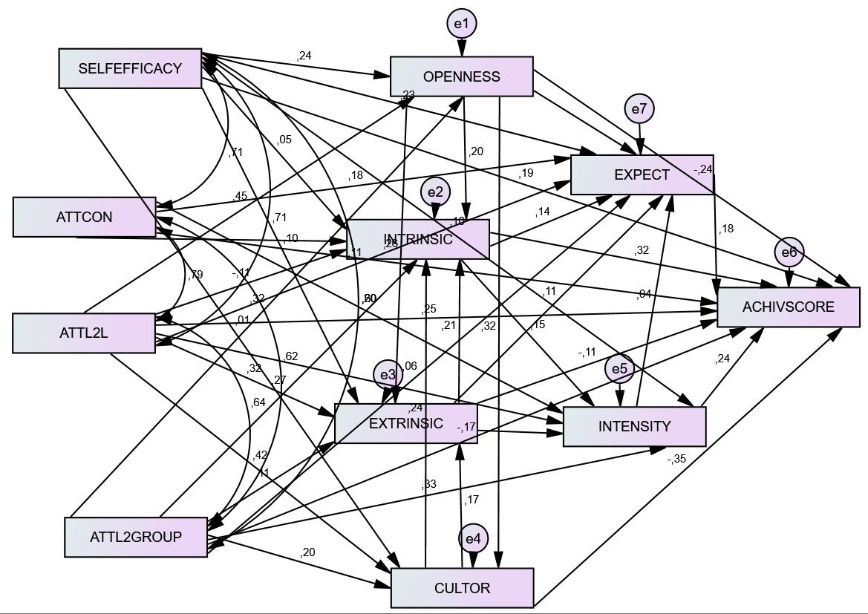
Figure 3. A model of motivation for learning English as a Foreign Language
LABEL | CONSTRUCT | LABEL | CONSTRUCT
EFFICACY | Self-efficacy for L2 learning
ATTCON | Attitudes towards learning context | EXTRINSIC | Extrinsic orientation
ATTL2  ATTL2group  OPENNESS  INTRINSIC | Attitudes towards L2 and L2 learning  Attitudes towards L2 group  Openness orientation  Intrinsic orientation | CULTOR  INTENSITY  EXPECTANCY  ACHIEVEMENT | Cultural orientation  Motivational intensity  Expectancy of success  Achievement score in English

Figure 3 and Table 3 present the effects among the different motivational i.e., self-efficacy, attitudes and orientations. They inform that self-efficacy has a rather medium effect on openness orientation and a small one on extrinsic orientation (.24 and .1). As for the role of attitudes in defining L2 motivation, attitude towards L2 and L2 experience has a rather large effect of .45 on openness and .41 on cultural interest orientations while attitude towards L2 group has a medium effect of .31 on openness orientation and a small effect of .19 on cultural interest orientation. As far as the relationship between attitudes and orientations is concerned attitude towards L2 and L2 experience proved to have a medium positive effect on extrinsic orientation of .31 and a negative effect on intrinsic orientation of -.1. Attitude towards L2 group proved to have a medium effect on intrinsic orientation of .26 and a small one (.1) on extrinsic orientation. Regarding the interrelationships among the four orientations of the study, openness has a medium effect on both intrinsic and extrinsic orientations at .3 while cultural interest has a small effect on both of them. Finally, extrinsic orientation has a rather medium effect on intrinsic orientation at .2.
Table 3.
Standardized direct effects among the variables of the study
 | SE | ATTL2G | ATTL2 | ATCON | OPEN | CULTOR | EXTR | INT | INTENS | EXPECT
OPENNESS | .235 | .317 | .452 | 0 | 0 | 0 | 0 | 0 | 0 | 0
CULTURALOR | .014 | .199 | .416 | 0 | .321 | 0 | 0 | 0 | 0 | 0
EXTRINSIC | .104 | .111 | .317 | 0 | .259 | .17 | 0 | 0 | 0 | 0
INTRINSIC | .054 | .269 | -.108 | .092 | .202 | .241 | .208 | 0 | 0 | 0
MOTINTENSITY | .098 | .329 | .078 | .197 | 0 | 0 | .087 | .152 | 0 | 0
EXPECTANCY | .229 | .063 | .108 | .178 | .124 | 0 | .114 | .137 | .039 | 0
ACHIEVEMENT | .195 | -.175 | .248 | -.128 | -.245 | -.346 | -.107 | .322 | .238 | .181

The 4th question of the study addressed the issue of whether the relationship between attitudes, orientations, and self-efficacy with achievement as a direct criterion measure of motivation is different from that between the same variables and performance expectancy and motivational intensity, as indirect criterion measures. Regarding the effect of attitudinal, orientational, and motivational variables on L2 achievement, Figure 3 and and Table 3 show that intrinsic orientation has the rather largest impact on achievement at .32. The variable with the second highest effect on achievement is attitude towards L2 and L2 learning at .25; the third is self-efficacy with an effect of .2. All the other attitudinal and orientational variables have negative effects on achievement: -.34 for cultural interest orientation, -.24 for openness orientation, -.17 for attitude towards L2 group, -.12 for attitude towards context of learning, and -1 for extrinsic orientation.
As for the relationship between self-efficacy, attitudes, orientations and the two indirect criterion measures of motivation, Tables 3 and Figure 3 reveal that, unlike their variable effect on achievement, self-efficacy and all attitudinal and orientational dimensions have positive effects on motivational intensity and outcome expectancy. The best predictors of motivational intensity are attitude towards L2 group at .32 and attitude towards context at .2. The best predictors of outcome expectancy are self-efficacy for L2 learning with an effect .22, attitude towards context at .17, and attitudes towards L2 group at .1 Openness, intrinsic orientation, and extrinsic orientation respectively have small effects on outcome expectancy of .12, .13, and .11. Finally, motivational intensity and performance expectancy have a medium effect on achievement of .24 for the former and .18 for the latter.

Discussion
This study investigated the dynamics of L2 motivation among high school teenage Tunisian students. Theoretically, it adopted an eclectic approach that drew upon three motivational paradigms, namely SEML2, SDT, SCM, and EVM. Methodologically, it used the structural equation model approach to shed light on how the interplay between self-efficacy, orientation and attitudes affect the direct and indirect criterion measures of motivation. The adoption of a theoretical eclectic approach and a structural equation modeling approach has yielded interesting findings regarding the dynamics of L2 motivation as well as the relationship between attitudes, orientations and self-efficacy and criterion manifestations of motivation.
The first finding of the study is that considering orientations to play a moderator role between self-efficacy and attitudes, on the one hand, and the criterion measures of motivation, on the other, was pertinent. In fact, self-efficacy proved to be an important motivational variable that determines the degree of openness to other cultures and peoples and to affect both intrinsic and extrinsic orientations. This finding is similar to those obtained in several other studies that relied on the internal structural equation modeling approach. Tremblay and Gardner (1995), for instance, found that self-efficacy was related to L2 attitudes and Csizér and Dörnyei (2005) found self-efficacy to be related to cultural interest.
Regarding the role of attitudes, linguistic attitudes and social attitudes had a greater impact on orientations, self-efficacy and the criterion measures of motivation than contextual attitudes. Social attitudes and linguistic attitudes proved to be determinant of the degree of openness to other cultures and peoples and interest in discovering they cultural products. This result is similar to that of Csizér and Dörnyei (2005) who found that vitality of L2 community was related to attitude towards L2 speakers, which was, in turn, related to integrativeness while attitude towards L2 speakers was related to cultural interest. Likewise, Csizér and Kormos (2008) and Kormos, Kiddle, & Csizér (2011) found that L2 learning attitudes, which subsumed attitude towards L2, L2 group and L2 learning, had a direct impact on motivated learning behavior. The present study interestingly found also that attitude towards L2 and L2 learning was an indicator of extrinsic orientation while attitude towards L2 group was an indicator of intrinsic orientation. In addition, it found that intrinsic orientation and extrinsic orientation were not mutually exclusive tendencies rather they proved to be interrelated. Such finding confirms the assumption made by SDT theorists (Noels, 2001; Noels et al., 2001; McEown, et al., 2014, among others) that intrinsic and extrinsic orientations should be treated as indicators of degree of self-determination rather than binary, mutually-exclusive tendencies.
As far as the relationship between attitudes, orientations, self-efficacy and L2 achievement is concerned, this study informs that the best predictors of achievement are intrinsic orientation, attitude towards L2 and L2 learning and self-efficacy for L2 learning. In fact, intrinsic orientation played a preponderant role in determining L2 achievement. Such finding highlights the fact that such intellectual reasons for learning L2 as knowledge appreciation represent a good reason to engage in L2 learning. It also raises questions about the fact that the intrinsic/extrinsic orientations dichotomy was overlooked in most of the studies that adopted a structural equation approach to L2 motivation as focus was rather put on the integrative/instrumental orientations dichotomy.
In addition to intrinsic orientation, attitude towards L2 and L2 learning defined in terms of the vitality, importance and beauty of L2 as well as enjoying the L2 learning experience proved to be a determinant of L2 achievement. This finding is quite close to that of Moskovsky et al. (2016) who found negative L2 learning experience to be negatively related to L2 proficiency. As for Self-efficacy for L2 learning, this motivational variable was found to have a rather large effect on L2 achievement; this finding is not line with Tremblay and Gardner’s (1995) that self-efficacy only indirectly affects achievement through motivated behavior. It is not in line either with Csizér and Dörnyei’s (2005) that self-confidence for L2 learning had no effect on language choice and Csizér and Kormos’s (2008) finding that there is no link between self-confidence and motivated learning behavior. The last finding of the study is that although social attitudes, extrinsic orientation as well as openness to others and cultural interest orientations were essential for determining the internal structure of L2 motivation, their impact on L2 achievement was either insignificant or negative.
One of the objectives of the present study was to see whether the relationship between self-efficacy, attitudes and orientations on the one hand and indirect criterion measures of motivation, namely performance expectancy and motivational intensity on the other, was similar or different from the relation of the same variables with a direct measure of motivation, i.e. L2 achievement. The study partially confirmed this claim as it found that although all attitudinal and orientational variables as well as self-efficacy had variable positive direct effects on the two indirect criterion measures of motivation, only intrinsic orientation, attitude towards L2 and L2 learning and self-efficacy had a significant positive impact on achievement. This finding confirms Moskovsky et al. ‘s (2016) contention that self-reported indirect indicators of motivation such as intended motivated behavior, language choice, motivational intensity, performance expectancy, which have been heavily relied on in L2 motivation research might not actually reflect real motivated behavior and consequently determine learning outcome. The study, however, showed that, unlike Moskovsky et al. ‘s (2016)’s unexpected, surprising finding that intended learning behavior, an indirect measure of motivation had a negative impact on proficiency, performance expectancy and motivational intensity proved to have a medium impact on L2 achievement.

Conclusion
This study opted for an eclectic theoretical approach bringing together motivational dimensions deriving from different models, frameworks and theories of motivation. In addition, it, for the sake of conceptual soundness and clarity, established a clear-cut distinction between attitudes, orientations and motivation. Methodologically, the study opted also for the structural equation modeling approach. These choices proved seminal for understanding the motivational set-up of EFL learners and allowed for obtaining an L2 motivation model that is theoretically sound and statistically fit. It can be argued that looking for THE L2 motivation paradigm that would cut across language leaning contexts and learner characteristics might prove unrealistic and that there is no single paradigm that would grasp the nature of the elusive construct of L2 motivation. Rather only an eclectic theoretical approach could allow for reaching such goal.
The study also considered at the same time direct and indirect criterion measures of motivation and revealed that the relationship between orientations, attitudes and self-efficacy and direct criterion measures of motivation is different from that between those variables and indirect criterion measures. It can therefore be argued that conclusions drawn on the basis of studies that investigated the relationship between motivation and indirect criterion measures such as (language choice and language motivated behavior, for instance), which have been widely used in L2 motivation research, should be taken with a lot of caution.
This study highlighted the central role played by intrinsic orientation, attitudes towards L2 and L2 learning, and self-efficacy for L2 learning in acquiring English as a foreign language. The pedagogical implications of such is curriculum designers and L2 teachers should realize that students do not learn languages necessarily for pragmatic reasons such as passing exams or say satisfying teachers or parents; rather they engage in L2 learning for intellectual pleasure, challenge and curiosity. Including a theme in the L2 syllabus on the different reasons for learning a L2 would make students more motivated to learn. In addition, curriculum designers and L2 teachers should realize that learning conditions, classroom activities, teaching materials and teaching method should meet the learner’s needs and expectations to be conducive of learning and achievement.
In spite of its interesting findings, the presents study has a number of limitations that can be remedied for in future research. The first of these limitations is that the study relied on achievement scores provided by the study participants’ teachers rather than a validated, objective measure of L2 proficiency. The second is that it used convenience as a sampling technique and studied intact pre-existing classes of English in Tunisian high schools. The third and last limitation is inherent to structural equation modeling technique itself which informs about the goodness of fit of a given model to its sample data and population and makes generalizations to other contexts and languages rather hazardous.
References
Atkinson, J. W. (1981). Thematic and perceptive measurement of motivation in 1950 and 1980. In G. d'Ydewalle & W. Lens (Eds.), Cognition in human motivation and learning (pp. 159-198).
Bandura, A. (1986). Social foundation of thought and action: A social cognitive theory. Englewood Cliffs, N. J.: Prentice-Hall.
Bandura, A. (1997). Self-efficacy: The exercise of control. New York: W. H. Freeman and Company.
Boo, Z., Dörnyei, Z., & Ryan, S. (2015). L2 motivation research 2005–2014: Understanding a publication surge and a changing landscape. System, 55, 145 - 157. doi: 10.1016/j.system.2015.10.006
Browne, M.W. & Cudeck, R. (1993). Alternative ways of assessing model fit. In Bollen, K.A., & Long, J.S. (Eds.) Testing structural equation models (pp. 136–162). Newbury Park, CA: Sage.
Byrne, B. M. (2001). Structural equation modeling with AMOS: Basic concept, applications, and programming. Mahwah, NJ: Lawrence Erlbaum Associates.
Carroll, J. B. 1981. Twenty-five years of research on foreign language aptitude. In K. C. Diller, (ed.), Individual differences and universals in language learning aptitude (pp, 83–118). Rowley, MA: Newbury House.
Clément, R. (1980). Ethnicity, contact and communicative competence in a second language. In H. Giles, W. P. Robinson, & P. Smith (Eds.), Language: Social psychological perspectives (pp. 147-154). Oxford, England: Pergamon Press.
Clément, R., & Kruidenier, B. G. (1985). Aptitude, attitude and motivation in second language proficiency: A test of Clément’s model. Journal of Language and Social Psychology, 4, 21-37.
Csizér, K., & Dörnyei, Z. (2005). The Internal Structure of Language Learning Motivation and Its Relationship with Language Choice and Learning Effort. The Modern Language Journal, 89(1).
Csizér, K., & Kormos, J. (2008). Modelling the role of inter-cultural contact in the motivation
of learning English as a foreign language. Applied Linguistics, 30, 166-185.
Deci, E. L., & Ryan, M. 2000. The ‘what’ and ‘why’ of goal pursuits: Human needs and the self-determination of behavior. Psychological Inquiry, 11(4): 227-268.
Deci, E. L., & Ryan, R. M. 2012. Self-determination theory. In P. A. M. Van Lange, A. W. Kruglanski, and E. T. Higgins (Eds.), Handbook of theories of social psychology: Vol. 1 (pp. 416-437). Thousand Oaks, CA: Sage.
Dörnyei, Z. (2003). Attitudes, orientations, and motivations in language learning: Advances in theory, research, and applications. In Z. Dörnyei (Ed.), Attitudes, orientations, and motivations in language learning: Advances in theory, research, and applications (pp. 3–32). Oxford, UK: Blackwell.
Dörnyei, Z. (2009). The L2 Motivational Self System. In Z. Dörnyei & E. Ushiod (Eds.), Motivation, language identity and the L2 self (pp. 9-42). Bristol: Multilingual Matters.
Dörnyei, Z., & Chan, L. (2013). Motivation and vision: an analysis of future L2 self images, sensory styles, and imagery capacity across two target languages. Language Learning, 63(3), 437-462.
Dörnyei, Z., & R. Clément. (2001). Motivational characteristics of learning different target languages: Results of a nationwide survey, in Z. Dörnyei and R. Schmidt (eds): Motivation and Second Language Acquisition. Honolulu: University of Hawai’i, pp. 399–432.
Dörnyei, Z., & Csizér, K. (2002). Some dynamics of language attitudes and motivation: Results of a longitudinal nationwide survey. Applied Linguistics, 23: 421-62.
Gardner, R. C. (1985). Social psychology and second language learning: The Role of attitudes and motivation. London: Edward Arnold Publishers.
Gardner, Robert. (2012). Integrative motivation and global language (English) acquisition in Poland. Studies in Second Language Learning and Teaching, 2(2): 215-226. DOI: 10.14746/ssllt.2012.2.2.5.
Gardner, R. C. (2010). Motivation and second language learning: The socio-educational model. New York, NY: Peter Lang.
Gardner, Tremblay & Masgoret. (1997). Towards a full model of second language learning: An empirical investigation. The Modern Language Journal 81(3), 344-362.
Hermessi, T. (In press). The role of attitudes, orientations and self-efficacy in learning Arabic as a less-commonly taught language: A structural equation modelling approach. Al-'Arabiyya, 53.
Hu, L. T., & Bentler, P. M. (1995). Evaluating model fit. In R. H. Hoyle (Ed.), Structural equation modeling: Concepts, issues, and applications (pp. 76-99). Thousand Oaks, CA: Sage.
Kormos, J., Kiddle, T., & Csizér, K. (2011). Systems of Goals, Attitudes, and Self-related Beliefs in Second-Language-Learning Motivation. Applied Linguistics, 32, 495-516. doi: 10.1093/applin/amr019.
MacIntyre, P. D., Mackinnon, S. P., & Clement, R. (2009). The baby, the bathwater, and the future of language learning motivation research. In Z. Dörnyei, & E. Ushioda (Eds.), Motivation, language identity and the L2 self (pp. 43-65). Bristol, UK: Multilingual Matters.
Masgoret, A. M., & Gardner, R. C. (2003). Attitudes, motivation, and second language learning: a meta-analysis of studies conducted by Gardner and associates. Language Learning, 53, 123-163.
Mendoza A, & Phung H. (2019). Motivation to learn languages other than English: A critical research synthesis. Foreign Language Annals,1–20. https://doi.org/10.1111/flan.12380
McEown, M. S., Noels, K. A, & Saumure, K. D. (2014). Students' self-determined and integrative orientations and teachers' motivational support in a Japanese as a foreign language context. System, 45, 227-241. doi: http://dx.doi.org/10.1016/j.system.2014.06.001
Mills N. 2014. Self-efficacy in second language acquisition. In Multiple Perspectives on the Self, Mercer, Sarah and Williams, Marion, 6-19. Bristol, UK: Multilingual Matters
Moskovsky, C., Racheva, S., Assulaimani, T., & Harkins, J. (20016). The L2 motivational self system and L2 achievement: A study of Saudi EFL learners. The Modern Language Journal, 100, 641-654. doi: 10.1111/modl.12340
Noels, K. A. (2001). New orientations in language learning motivation: towards a model of intrinsic, extrinsic and integrative orientations. In Z. Dörnyei, & R. Schmidt (Eds.), Motivation and second language acquisition (pp. 43-68). Honolulu, HI: University of Hawai'i Second Language Teaching and Curriculum Centre.
Noels, K. A., Clement, R., & Pelletier, L. (2001). Intrinsic, extrinsic, and integrative orientations of French Canadian learners of English. Canadian Modern Language Review, 57, 424-442.
Noels, K. A., Pelletier, L. G., Clement, R., & Vallerand, R. L. (2000). Why are you learning a second language? Motivational orientations and self-determination theory. Language Learning, 50, 57-85.
Noels, K. A., Lou, N. M., Lascano, D. I. V., Chaffee, K. E., Dincer, A., Zhang, Y. S. D., & Zhang, X. (2019). Self-determination and motivated engagement in language learning. In The Palgrave Handbook of Motivation for Language Learning (pp. 95-115). Palgrave Macmillan, Cham.
Pearl, J. (2000). Causality: models, reasoning, and inference. Cambridge: Cambridge University Press.
Ryan, R. M., & Deci, E. L. (2017). Self-determination theory: Basic psychological needs in motivation, development, and wellness. New York, NY: Guilford.
Schumacker, E. R., & Lomax, G. R. (1996). A beginner’s guide to structural equation modeling. Mahwah, NJ: Erlbaum.
Schunk, D. H. (1989). Self-efficacy and cognitive learning. In C. Ames and A. Ames (Eds.), Research on motivation in education: Goals and cognitions: Vol 1 (pp. 13-41). New York: Academic Press.
Tremblay P. F., & Gardner R. C. (1995) Expanding the motivation construct in language learning. The Modern Language Journal, 79: 505–518.
Ushioda, E. & Dörnyei, Z. (2012). Motivation. In S. Gass, & A. Mackey, (Eds.), The Routledge handbook of second language acquisition. (pp. 396-409). New York: Routledge.
Ushioda, E., and Z. Dörnyei. 2017. Beyond Global English: Motivation to Learn Languages in a Multicultural World: Introduction to the Special Issue. The Modern Language Journal 101 (3): 451–454.
Wigfield, A., Tonks, S., & Klauda, S. L. (2009). Expectancy-value theory. In K. R. Wenzel & A. Wigfield (Eds.), Educational psychology handbook series. Handbook of motivation at school (p. 55–75). Routledge/Taylor & Francis Group.

Appendix
The English version of the motivational questionnaire
Attitudes
Attitudes towards L2 and L2 learning experience
For me studying foreign languages is a pleasant, valuable experience
I consider English an important school subject
Honestly, studying English is a waste of time
I consider studying English a wonderful experience
Attitudes towards L2 group
I have negative attitudes towards people who speak English as a mother tongue
No one can deny that the people who represent the English language stand for civility, modernity and progress
The more I get to know the people who speak English as a mother tongue the more I respect them and become fond of them
English speaking countries represent a model that other countries should follow
English speaking countries represent wealth and power
Attitude towards context
I found the majority of English teachers professional and understanding
I find the method used in teaching English successful and interesting
All in all, I liked most of the English textbooks we used in class
Honestly, I find English classes boring and useless
I have always found the activities, topics and tasks we have in English classes varied, attractive and instructing
Orientations
Intrinsic orientation
I study English because knowing more than one language is a pleasurable experience
I study English because a knowledgeable person must speak foreign languages
I study English because of sense pleasure and self-satisfaction such experience procures
Extrinsic
I study English because those who speak it have better chances to find a good job in the future
I study English because I will certainly need it in my future studies
I study English because it is a compulsory school subject I have to take to avoid trouble
Cultural interest
I study English to understand the lyrics of English songs
I study English to read English books, newspapers, and magazines
I study English to watch English movies in their original version
I am fond of the culture, art, and life style of English speaking countries
Openness
Learning English will enable me to know new nations and cultures
I am eager to meet the English-speaking people and converse with them
English represents a tool to understand cultural groups that might be different from mine and establish contact with their members
I learn English to make English speaking friends
Motivation
Self-efficacy
I participate in English classes with a lot of confidence and ease
I have a special ability to analyze the structure of English sentences, identify their parts and use them in ne sentences
Without any doubt I will attain an advanced proficiency in any foreign language no matter how difficult it is if I work hard
I feel that I have a special capacity to learn English words and expressions
No language is difficult to me to learn
I think that I have a special sense for learning languages
Expectancy
Without any doubt, I will speak English fluently by the end of high school
Mastering the English language is of no value to me
I am quite certain that I will one day reach a native-like proficiency in English
Because I’m gifted for languages, I will certainly speak English fluently
Motivational intensity
During English classes, I am so concentrated to the point that nothing can distract me
I almost, every term, set up specific goals to reach in my English studies
I actively and seriously participate in English class activities
I am ready to volunteer for extra-class activities related to the English language
I often look for opportunities to practice my English outside class

