RESULTS OF SOIL ANALYSIS

Mixed Models

The factor land-use here is indigenous vs. nonindigenous. So, Model 1 compares these two states and ignores any effects of use of chemical fertilizer, with village as a random factor in the model. Model 2 incorporates use of land use (toss), chemical fertilizer, and their interaction into the model.

Notes: The abbreviations in the figures below describe the following land-uses: “indig.” is for indigenous; “indig-Fert.” for hybrid; “Conv.” for modern; and “Min.” for marginal fields.

Mixed Models for Heads per plant

Heads_plant

> model1 <- lme (heads_plant ~ land_use, random = ~1|village/land_use)
> summary(model1)
Linear mixed-effects model fit by REML
Data: NULL
AIC BIC logLik
212.8799 223.1822 -101.44

Random effects:
Formula: ~1 | village
(Intercept)
StdDev: 1.60311

Formula: ~1 | land_use %in% village
(Intercept) Residual
StdDev: 6.103936e-05 1.151974

Fixed effects: heads_plant ~ land_use
Value Std.Error DF t-value p-value
(Intercept) 5.533333 0.6874313 48 8.049289 0.0000
land_useindig 1.466667 0.2974384 5 4.930993 0.0044
Correlation:
(Intr)
land_useindig -0.216

Standardized Within-Group Residuals:
Min Q1 Med Q3 Max
-1.77128943 -0.62059511 -0.03649012 0.70506527 2.16398467

Number of Observations: 60
Number of Groups:
village land_use %in% village
6 12

> model2 <- lme(heads_plant ~ land_use * chem_fert, random = ~1|village/land_use)
> summary(model2)
Linear mixed-effects model fit by REML
Data: NULL
AIC BIC logLik
209.0578 223.2353 -97.52892

Random effects:
Formula: ~1 | village
(Intercept)
StdDev: 1.634996

Formula: ~1 | land_use %in% village
(Intercept) Residual
StdDev: 6.676568e-05 1.099347

Fixed effects: heads_plant ~ land_use * chem_fert
Value Std.Error DF t-value p-value
(Intercept) 5.366838 0.7034802 46 7.628983 0.0000
land_use 1.383523 0.3239749 5 4.270463 0.0079
chem_fert 0.998973 0.5712104 46 1.748870 0.0870
land_use:chem_fert -0.062825 0.7351111 46 -0.085463 0.9323
Correlation:
(Intr) lnd_sn chm_fr
land_useindig -0.216
chem_fertyes -0.135 0.291
land_useindig:chem_fertyes 0.105 -0.469 -0.773

Standardized Within-Group Residuals:
Min Q1 Med Q3 Max
-2.12895629 -0.68959970 -0.07001856 0.75268031 2.36111536

Number of Observations: 60
Number of Groups:
village land_use %in% village
6 12

Mixed Models for Heads weight^{0.05}

head_weight^-0.05
> Thead_weight <- head_weight^-0.5
> model1 <- lme (Thead_weight ~ land_use, random = ~1|village/land_use)
> summary(model1)
Linear mixed-effects model fit by REML
Data: NULL
AIC BIC logLik
-370.3478 -360.0455 190.1739

Random effects:
Formula: ~1 | village
(Intercept)
StdDev: 0.01397964

Formula: ~1 | land_use %in% village
(Intercept) Residual
StdDev: 0.007227798 0.006586246

Fixed effects: Thead_weight ~ land_use
Value Std.Error DF t-value p-value
(Intercept) 0.1122509 0.006135807 48 18.294394 0.0000
land_use1 0.0057733 0.002253087 5 2.562398 0.0505

Correlation:
(Intr)
land_use1 0

Standardized Within-Group Residuals:
Min Q1 Med Q3 Max
-2.58703764 -0.33821809 -0.02188925 0.27657080 3.70203136

Number of Observations: 60
Number of Groups:
village land_use %in% village
6 12

> plot(ranef(model1)) ##Plot of random effects
> plot(model1) ###Plot of residuals
> model2 <- lme(Thead_weight ~ land_use * chem_fert, random = ~1|village/land_use)
> summary(model2)
Linear mixed-effects model fit by REML
Data: NULL
AIC BIC logLik
-351.2102 -337.0327 182.6051

Random effects:
Formula: ~1 | village
(Intercept)
StdDev: 0.0148992

Formula: ~1 | land_use %in% village
(Intercept) Residual
StdDev: 0.006270338 0.006210155

Fixed effects: Thead_weight ~ land_use * chem_fert
Value Std.Error DF t-value p-value
(Intercept) 0.11029816 0.006429856 46 17.154063 0.0000
land_use1 0.00492779 0.002084344 5 2.364191 0.0644
chem_fert1 0.00328496 0.001092232 46 3.007565 0.0043
land_use1:chem_fert1 0.00091239 0.001090970 46 0.836307 0.4073

Correlation:
(Intr) lnd_s1 chm_f1
land_use1 0.017
chem_fert1 -0.100 -0.121
land_use1:chem_fert1 -0.039 -0.309 0.231

Standardized Within-Group Residuals:
Min Q1 Med Q3 Max
-1.91475065 -0.50211635 -0.02001681 0.15066029 3.40342047

Number of Observations: 60
Number of Groups:
village land_use %in% village
6 12

Mixed Models for Head weight per plant^{0.33}

Head_wt_per_plant^0.33
> THead_wt_per_plant <- (Head_wt_per_plant^0.33)
> model1 <- lme (THead_wt_per_plant ~ land_use, random = ~1|village/land_use)
> summary(model1)
Linear mixed-effects model fit by REML
Data: NULL
AIC BIC logLik
159.0302 169.3324 -74.51508

Random effects:
Formula: ~1 | village
(Intercept)
StdDev: 1.296323

Formula: ~1 | land_use %in% village
(Intercept) Residual
StdDev: 0.4089123 0.6630498

Fixed effects: THead_wt_per_plant ~ land_use
Value Std.Error DF t-value p-value
(Intercept) 7.821086 0.5489417 48 14.247570 0.0000
land_use1 -0.589188 0.1458127 5 -4.040719 0.0099
Correlation:
(Intr)
land_use1 0

Standardized Within-Group Residuals:
Min Q1 Med Q3 Max
-2.55986561 -0.49591485 -0.05951279 0.62354775 2.03430592

Number of Observations: 60
Number of Groups:
village land_use %in% village
6 12

> model2 <- lme(THead_wt_per_plant ~ land_use * chem_fert, random = ~1|village/land_use)
> summary(model2)
Linear mixed-effects model fit by REML
Data: NULL
AIC BIC logLik
157.8657 172.0431 -71.93283

Random effects:
Formula: ~1 | village
(Intercept)
StdDev: 1.369038

Formula: ~1 | land_use %in% village
(Intercept) Residual
StdDev: 0.3160657 0.6161757

Fixed effects: THead_wt_per_plant ~ land_use * chem_fert
Value Std.Error DF t-value p-value
(Intercept) 8.034216 0.5754064 46 13.962682 0.0000
land_use1 -0.505691 0.1367222 5 -3.698674 0.0140
chem_fert1 -0.361363 0.1068328 46 -3.382515 0.0015
land_use1:chem_fert1 -0.083578 0.1064982 46 -0.784785 0.4366
Correlation:
(Intr) lnd_s1 chm_f1
land_use1 0.027
chem_fert1 -0.109 -0.175
land_use1:chem_fert1 -0.042 -0.459 0.220

Standardized Within-Group Residuals:
Min Q1 Med Q3 Max
-2.33622651 -0.50293150 -0.03793404 0.63087988 1.70085602

Number of Observations: 60
Number of Groups:
village land_use %in% village
6 12

Mixed Models for Head weight per m²

ln Head Weight per m² (new)
> Theadwt_m2 <- log(headwt_m2)
> model1 <- lme (Theadwt_m2 ~ land_use, random = ~1|village/land_use)
> summary(model1)
Linear mixed-effects model fit by REML
Data: NULL
AIC BIC logLik
108.3299 118.6322 -49.16497

Random effects:
Formula: ~1 | village
(Intercept)
StdDev: 0.5183426

Formula: ~1 | land_use %in% village
(Intercept) Residual
StdDev: 0.06824984 0.4748449

Fixed effects: Theadwt_m2 ~ land_use
Value Std.Error DF t-value p-value
(Intercept) 4.494399 0.2303738 48 19.509157 0.000
land_useindig 0.589087 0.1287809 5 4.574332 0.006
Correlation:
(Intr)
land_useindig -0.28

Standardized Within-Group Residuals:
Min Q1 Med Q3 Max
-1.9094467 -0.6184534 -0.1115308 0.5075794 2.7844173

Number of Observations: 60
Number of Groups:
village land_use %in% village
6 12

> model2 <- lme(Theadwt_m2 ~ land_use * chem_fert, random = ~1|village/land_use)
> summary(model2)
Linear mixed-effects model fit by REML
Data: NULL
AIC BIC logLik
113.5402 127.7176 -49.77008

Random effects:
Formula: ~1 | village
(Intercept)
StdDev: 0.5329328

Formula: ~1 | land_use %in% village
(Intercept) Residual
StdDev: 8.088284e-05 0.4802023

Fixed effects: Theadwt_m2 ~ land_use * chem_fert
Value Std.Error DF t-value p-value
(Intercept) 4.451385 0.2382117 46 18.686674 0.0000
land_useindig 0.621637 0.1414736 5 4.394012 0.0071
chem_fertyes 0.258087 0.2489914 46 1.036531 0.3054
land_useindig:chem_fertyes -0.218845 0.3206195 46 -0.682568 0.4983
Correlation:
(Intr) lnd_sn chm_fr
land_useindig -0.279
chem_fertyes -0.174 0.291
land_useindig:chem_fertyes 0.135 -0.468 -0.772

Standardized Within-Group Residuals:
Min Q1 Med Q3 Max
-1.8285850 -0.5748473 -0.1022396 0.4518007 2.8240652

Number of Observations: 60
Number of Groups:
village land_use %in% village
6 12

Mixed Models for Tsand⁶

Sand^6
> Tsand <- sand^6
> model1 <- lme (Tsand ~ land_use, random = ~1|village/land_use)
> summary(model1)
Linear mixed-effects model fit by REML
Data: NULL
AIC BIC logLik
3174.476 3184.778 -1582.238

Random effects:
Formula: ~1 | village
(Intercept)
StdDev: 154731854960

Formula: ~1 | land_use %in% village
(Intercept) Residual
StdDev: 38113870170 139919157450

Fixed effects: Tsand ~ land_use
Value Std.Error DF t-value p-value
(Intercept) 638739401885 66615835894 48 9.588402 0.0000
land_use1 -58014566236 21150534319 5 -2.742936 0.0406

Correlation:
(Intr)
land_use1 0

Standardized Within-Group Residuals:
Min Q1 Med Q3 Max
-2.08907998 -0.58066298 -0.02453782 0.56007828 1.91153920

Number of Observations: 60
Number of Groups:
village land_use %in% village
6 12

> model2 <- lme(Tsand ~ land_use * chem_fert, random = ~1|village/land_use)
> summary(model2)
Linear mixed-effects model fit by REML
Data: NULL
AIC BIC logLik
3078.622 3092.799 -1532.311

Random effects:
Formula: ~1 | village
(Intercept)
StdDev: 156153280031

Formula: ~1 | land_use %in% village
(Intercept) Residual
StdDev: 32169011559 142289905054

Fixed effects: Tsand ~ land_use * chem_fert
Value Std.Error DF t-value p-value
(Intercept) 641763460302 68513535555 46 9.366959 0.0000
land_use1 -65939754639 25064434850 5 -2.630810 0.0465
chem_fert1 -8055488389 24144962107 46 -0.333630 0.7402
land_use1:chem_fert1 15407183367 24017881014 46 0.641488 0.5244

Correlation:
(Intr) lnd_s1 chm_f1
land_use1 0.061
chem_fert1 -0.207 -0.208
land_use1:chem_fert1 -0.076 -0.563 0.205

Standardized Within-Group Residuals:
Min Q1 Med Q3 Max
-2.04358332 -0.64767777 -0.01786862 0.54829667 1.83736764

Number of Observations: 60
Number of Groups:
village land_use %in% village
6 12

Mixed Models for Total Clay^{0.33}

clay^.33
> Tclay <- clay^-.33
> model1 <- lme (Tclay ~ land_use, random = ~1|village/land_use)
> summary(model1)
Linear mixed-effects model fit by REML
Data: NULL
AIC BIC logLik
243.2521 253.5543 -116.626

Random effects:
Formula: ~1 | village
(Intercept)
StdDev: 0.792376

Formula: ~1 | land_use %in% village
(Intercept) Residual
StdDev: 5.801635e-05 1.596338

Fixed effects: Tclay ~ land_use
Value Std.Error DF t-value p-value
(Intercept) 1.7094895 0.3835556 48 4.456954 0.0000
land_use1 -0.0224938 0.2060864 5 -0.109148 0.9173

Correlation:
(Intr)
land_use1 0

Standardized Within-Group Residuals:
Min Q1 Med Q3 Max
-1.1304840 -0.8524159 -0.2389072 1.3628834 1.9005576

Number of Observations: 60
Number of Groups:
village land_use %in% village
6 12
> model2 <- lme(Tclay ~ land_use * chem_fert, random = ~1|village/land_use)
> summary(model2)
Linear mixed-effects model fit by REML
Data: NULL
AIC BIC logLik
248.1648 262.3422 -117.0824

Random effects:
Formula: ~1 | village
(Intercept)
StdDev: 0.7667753

Formula: ~1 | land_use %in% village
(Intercept) Residual
StdDev: 5.624011e-05 1.618666

Fixed effects: Tclay ~ land_use * chem_fert
Value Std.Error DF t-value p-value
(Intercept) 1.8283294 0.4087623 46 4.472842 0.0001
land_use1 -0.0224632 0.2624468 5 -0.085591 0.9351
chem_fert1 -0.2164485 0.2685815 46 -0.805895 0.4244
land_use1:chem_fert1 0.0381427 0.2672765 46 0.142709 0.8871

Correlation:
(Intr) lnd_s1 chm_f1
land_use1 0.118
chem_fert1 -0.385 -0.212
land_use1:chem_fert1 -0.136 -0.597 0.191

Standardized Within-Group Residuals:
Min Q1 Med Q3 Max
-1.2838453 -0.7509095 -0.2424780 1.1342250 1.8861709

Number of Observations: 60
Number of Groups:
village land_use %in% village
6 12

Mixed Models for Total Silt^{.5}

silt^0.5
> Tsilt <- silt^-.5
> model1 <- lme (Tsilt ~ land_use, random = ~1|village/land_use)
> summary(model1)
Linear mixed-effects model fit by REML
Data: NULL
AIC BIC logLik
317.9033 328.2055 -153.9517

Random effects:
Formula: ~1 | village
(Intercept)
StdDev: 1.153312

Formula: ~1 | land_use %in% village
(Intercept) Residual
StdDev: 0.0005384465 3.086833

Fixed effects: Tsilt ~ land_use
Value Std.Error DF t-value p-value
(Intercept) 1.898019 0.6168444 48 3.076981 0.0034
land_use1 -1.132619 0.3985084 5 -2.842145 0.0362

Correlation:
(Intr)
land_use1 0

Standardized Within-Group Residuals:
Min Q1 Med Q3 Max
-1.2634431 -0.5768476 -0.2195432 0.1460100 2.5317533

Number of Observations: 60
Number of Groups:
village land_use %in% village
6 12
> plot(ranef(model1)) ##Plot of random effects
> plot(model1) ###Plot of residuals
> model2 <- lme(Tsilt ~ land_use * chem_fert, random = ~1|village/land_use)
> summary(model2)
Linear mixed-effects model fit by REML
Data: NULL
AIC BIC logLik
320.1187 334.2961 -153.0593

Random effects:
Formula: ~1 | village
(Intercept)
StdDev: 1.012826

Formula: ~1 | land_use %in% village
(Intercept) Residual
StdDev: 0.4678749 3.118012

Fixed effects: Tsilt ~ land_use * chem_fert
Value Std.Error DF t-value p-value
(Intercept) 2.0963920 0.6670197 46 3.1429236 0.0029
land_use1 -0.8513362 0.5229152 5 -1.6280578 0.1644
chem_fert1 -0.2709109 0.5155750 46 -0.5254538 0.6018
land_use1:chem_fert1 -0.4485730 0.5139964 46 -0.8727163 0.3874

Correlation:
(Intr) lnd_s1 chm_f1
land_use1 0.134
chem_fert1 -0.453 -0.204
land_use1:chem_fert1 -0.160 -0.576 0.189

Standardized Within-Group Residuals:
Min Q1 Med Q3 Max
-1.2431362 -0.6002703 -0.1471900 0.1378980 2.2827799

Number of Observations: 60
Number of Groups:
village land_use %in% village
6 12
Mixed Models for Total Nitrogen⁻¹

nitrogen^-1
> Tnitrogen <- nitrogen^-1
> model1 <- lme (Tnitrogen ~ land_use, random = ~1|village/land_use)
> summary(model1)
Linear mixed-effects model fit by REML
Data: NULL
AIC BIC logLik
520.5535 530.8558 -255.2768

Random effects:
Formula: ~1 | village
(Intercept)
StdDev: 0.0009813079

Formula: ~1 | land_use %in% village
(Intercept) Residual
StdDev: 0.0003422653 18.38974

Fixed effects: Tnitrogen ~ land_use
Value Std.Error DF t-value p-value
(Intercept) 58.20641 2.374105 48 24.517197 0.0000
land_use1 3.58293 2.374105 5 1.509171 0.1916

Correlation:
(Intr)
land_use1 0

Standardized Within-Group Residuals:
Min Q1 Med Q3 Max
-1.81898128 -0.54666917 0.02320794 0.55436701 2.03843217

Number of Observations: 60
Number of Groups:
village land_use %in% village
6 12

> model2 <- lme(Tnitrogen ~ land_use * chem_fert, random = ~1|village/land_use)
> summary(model2)
Linear mixed-effects model fit by REML
Data: NULL
AIC BIC logLik
512.7744 526.9519 -249.3872

Random effects:
Formula: ~1 | village
(Intercept)
StdDev: 0.0007204377

Formula: ~1 | land_use %in% village
(Intercept) Residual
StdDev: 0.0006252837 18.0947

Fixed effects: Tnitrogen ~ land_use * chem_fert
Value Std.Error DF t-value p-value
(Intercept) 57.12001 2.898171 46 19.708988 0.0000
land_use1 5.86856 2.898171 5 2.024919 0.0987
chem_fert1 2.71346 2.898171 46 0.936265 0.3540
land_use1:chem_fert1 -4.51231 2.898171 46 -1.556952 0.1263

Correlation:
(Intr) lnd_s1 chm_f1
land_use1 0.169
chem_fert1 -0.584 -0.196
land_use1:chem_fert1 -0.196 -0.584 0.169

Standardized Within-Group Residuals:
Min Q1 Med Q3 Max
-2.01349256 -0.52244493 -0.05798919 0.77441715 1.85869296

Number of Observations: 60
Number of Groups:
village land_use %in% village
6 12

Mixed Models for Total Carbon^{0.33}

carbon^0.33
> Tcarbon <- carbon^.33
> model1 <- lme (Tcarbon ~ land_use, random = ~1|village/land_use)
> summary(model1)
Linear mixed-effects model fit by REML
Data: NULL
AIC BIC logLik
-132.3435 -122.0413 71.17177

Random effects:
Formula: ~1 | village
(Intercept)
StdDev: 0.02810372

Formula: ~1 | land_use %in% village
(Intercept) Residual
StdDev: 0.03218951 0.05947539

Fixed effects: Tcarbon ~ land_use
Value Std.Error DF t-value p-value
(Intercept) 0.6029349 0.01664148 48 36.23084 0.0000
land_use1 -0.0061126 0.01205415 5 -0.50710 0.6337

Correlation:
(Intr)
land_use1 0

Standardized Within-Group Residuals:
Min Q1 Med Q3 Max
-2.0570498 -0.7096901 0.1303071 0.5808691 2.1981874

Number of Observations: 60
Number of Groups:
village land_use %in% village
6 12

> plot(ranef(model1)) ##Plot of random effects
> plot(model1) ###Plot of residuals
> model2 <- lme(Tcarbon ~ land_use * chem_fert, random = ~1|village/land_use)
> summary(model2)
Linear mixed-effects model fit by REML
Data: NULL
AIC BIC logLik
-118.2142 -104.0368 66.10711

Random effects:
Formula: ~1 | village
(Intercept)
StdDev: 0.03008717

Formula: ~1 | land_use %in% village
(Intercept) Residual
StdDev: 0.03458038 0.05734304

Fixed effects: Tcarbon ~ land_use * chem_fert
Value Std.Error DF t-value p-value
(Intercept) 0.5953730 0.018441832 46 32.28383 0.0000
land_use1 -0.0190843 0.013753105 5 -1.38763 0.2239
chem_fert1 0.0096040 0.009887850 46 0.97129 0.3365
land_use1:chem_fert1 0.0211963 0.009874779 46 2.14651 0.0371

Correlation:
(Intr) lnd_s1 chm_f1
land_use1 0.071
chem_fert1 -0.315 -0.160
land_use1:chem_fert1 -0.120 -0.422 0.217

Standardized Within-Group Residuals:
Min Q1 Med Q3 Max
-1.8019998 -0.6524219 0.1891977 0.5277959 2.2152698

Number of Observations: 60
Number of Groups:
village land_use %in% village
6 12

No Fertilization Fields
> model3 <- lme (Tcarbon ~ land_use, random = ~1|village/land_use, data = datafile_nofert)
> summary(model3)
Linear mixed-effects model fit by REML
Data: datafile_nofert
AIC BIC logLik
-105.119 -96.08573 57.55952

Random effects:
Formula: ~1 | village
(Intercept)
StdDev: 0.02246675

Formula: ~1 | land_use %in% village
(Intercept) Residual
StdDev: 0.04206269 0.05292584

Fixed effects: Tcarbon ~ land_use
Value Std.Error DF t-value p-value
(Intercept) 0.6046841 0.01713012 35 35.29947 0.0000
land_use1 0.0021875 0.01446741 5 0.15120 0.8857

Correlation:
(Intr)
land_use1 -0.015

Standardized Within-Group Residuals:
Min Q1 Med Q3 Max
-2.0489489 -0.5394126 0.1639755 0.5583436 2.2585077

Number of Observations: 47
Number of Groups:
village land_use %in% village
6 12
1-way ANOVA across all of the villages:
> options(contrasts=c("contr.sum", "contr.poly"))
> model4 <- lm(Tcarbon ~ land_use, data = datafile_nofert)
> Anova.out<-Anova(model4, type="III")
> Anova.out
Anova Table (Type III tests)

Response: Tcarbon
Sum Sq Df F value Pr(>F)
(Intercept) 17.072 1 3460.3 <2e-16 ***
land_use 0.000 1 0.0 0.9976
Residuals 0.222 45
---
Signif. codes: 0 ‘***’ 0.001 ‘**’ 0.01 ‘*’ 0.05 ‘.’ 0.1 ‘ ’ 1

Fertilized fields
> model5 <- lme (Tcarbon ~ land_use, random = ~1|village/land_use, data = datafile_fert)
> summary(model5)
Linear mixed-effects model fit by REML
Data: datafile_fert
AIC BIC logLik
-10.44754 -8.458064 10.22377

Random effects:
Formula: ~1 | village
(Intercept)
StdDev: 0.0311188

Formula: ~1 | land_use %in% village
(Intercept) Residual
StdDev: 2.886757e-06 0.07090464

Fixed effects: Tcarbon ~ land_use
Value Std.Error DF t-value p-value
(Intercept) 0.5872541 0.02497470 5 23.513956 0.0000
land_use1 -0.0359070 0.02121777 2 -1.692309 0.2327

Correlation:
(Intr)
land_use1 0.225

Standardized Within-Group Residuals:
Min Q1 Med Q3 Max
-1.7196798 -0.3358459 0.1024771 0.4060253 1.4839857

Number of Observations: 13
Number of Groups:
village land_use %in% village
5 8

Mixed Models for Total pH⁻¹

pH^-1
> model1 <- lme (TpH ~ land_use, random = ~1|village/land_use)
> summary(model1)
Linear mixed-effects model fit by REML
Data: NULL
AIC BIC logLik
-297.5452 -287.243 153.7726

Random effects:
Formula: ~1 | village
(Intercept)
StdDev: 6.328087e-07

Formula: ~1 | land_use %in% village
(Intercept) Residual
StdDev: 0.002401759 0.01576043

Fixed effects: TpH ~ land_use
Value Std.Error DF t-value p-value
(Intercept) 0.17374602 0.002149548 48 80.82909 0.0000
land_use1 0.00951549 0.002149548 5 4.42674 0.0068

Correlation:
(Intr)
land_use1 0

Standardized Within-Group Residuals:
Min Q1 Med Q3 Max
-3.438876206 -0.605281420 0.001498836 0.575168442 2.266851647

Number of Observations: 60
Number of Groups:
village land_use %in% village
6 12
> View(datafile)
> model2 <- lme(TpH ~ land_use * chem_fert, random = ~1|village/land_use)
> summary(model2)
Linear mixed-effects model fit by REML
Data: NULL
AIC BIC logLik
-273.4749 -259.2974 143.7374

Random effects:
Formula: ~1 | village
(Intercept)
StdDev: 7.650177e-07

Formula: ~1 | land_use %in% village
(Intercept) Residual
StdDev: 0.00254562 0.01600674

Fixed effects: TpH ~ land_use * chem_fert
Value Std.Error DF t-value p-value
(Intercept) 0.17426357 0.002676972 46 65.09728 0.0000
land_use1 0.00998467 0.002676972 5 3.72984 0.0136
chem_fert1 -0.00079187 0.002590530 46 -0.30568 0.7612
land_use1:chem_fert1 -0.00068823 0.002590530 46 -0.26567 0.7917

Correlation:
(Intr) lnd_s1 chm_f1
land_use1 0.161
chem_fert1 -0.565 -0.193
land_use1:chem_fert1 -0.193 -0.565 0.176

Standardized Within-Group Residuals:
Min Q1 Med Q3 Max
-3.354358435 -0.592096638 -0.005957158 0.544616735 2.254170808

Number of Observations: 60
Number of Groups:
village land_use %in% village
6 12

Mixed Models for Total Sas trees^{.25}

sas_trees^0.25 (new)
> Tsas_trees <- sas_trees^.25
> model1 <- lme (Tsas_trees ~ land_use, random = ~1|village/land_use)
> summary(model1)
Linear mixed-effects model fit by REML
Data: NULL
AIC BIC logLik
103.4472 113.7494 -46.7236

Random effects:
Formula: ~1 | village
(Intercept)
StdDev: 0.2734509

Formula: ~1 | land_use %in% village
(Intercept) Residual
StdDev: 2.957642e-05 0.4798189

Fixed effects: Tsas_trees ~ land_use
Value Std.Error DF t-value p-value
(Intercept) 1.3581911 0.1419041 48 9.571190 0.0000
land_useindig 0.0055335 0.1238887 5 0.044665 0.9661
Correlation:
(Intr)
land_useindig -0.437

Standardized Within-Group Residuals:
Min Q1 Med Q3 Max
-2.15677083 -0.56042912 0.08989799 0.69979376 1.66704446

Number of Observations: 60
Number of Groups:
village land_use %in% village
6 12

> model2 <- lme(Tsas_trees ~ land_use * chem_fert, random = ~1|village/land_use)
> summary(model2)
Linear mixed-effects model fit by REML
Data: NULL
AIC BIC logLik
104.3269 118.5043 -45.16344

Random effects:
Formula: ~1 | village
(Intercept)
StdDev: 0.2051522

Formula: ~1 | land_use %in% village
(Intercept) Residual
StdDev: 0.1621165 0.4588482

Fixed effects: Tsas_trees ~ land_use * chem_fert
Value Std.Error DF t-value p-value
(Intercept) 1.4511047 0.1415048 46 10.254807 0.0000
land_useindig -0.0294466 0.1646825 5 -0.178808 0.8651
chem_fertyes -0.5574812 0.2408007 46 -2.315115 0.0251
land_useindig:chem_fertyes 0.3402307 0.3099127 46 1.097828 0.2780
Correlation:
(Intr) lnd_sn chm_fr
land_useindig -0.558
chem_fertyes -0.284 0.243
land_useindig:chem_fertyes 0.220 -0.388 -0.775

Standardized Within-Group Residuals:
Min Q1 Med Q3 Max
-2.24109177 -0.51709706 -0.05583944 0.65133293 1.53565646

Number of Observations: 60
Number of Groups:
village land_use %in% village
6 12

Mixed Models for Total trees^{.25}

total_trees^0.25 (new)
> Ttotal_trees <- total_trees^.25
> model1 <- lme (Ttotal_trees ~ land_use, random = ~1|village/land_use)
> summary(model1)
Linear mixed-effects model fit by REML
Data: NULL
AIC BIC logLik
96.42317 106.7254 -43.21158

Random effects:
Formula: ~1 | village
(Intercept)
StdDev: 0.2712019

Formula: ~1 | land_use %in% village
(Intercept) Residual
StdDev: 2.401826e-05 0.4499406

Fixed effects: Ttotal_trees ~ land_use
Value Std.Error DF t-value p-value
(Intercept) 1.760851 0.1378645 48 12.772328 0.0000
land_useindig 0.029745 0.1161742 5 0.256038 0.8081
Correlation:
(Intr)
land_useindig -0.421

Standardized Within-Group Residuals:
Min Q1 Med Q3 Max
-3.05421122 -0.44657905 -0.02325816 0.44030816 3.97832969

Number of Observations: 60
Number of Groups:
village land_use %in% village
6 12

> model2 <- lme(Ttotal_trees ~ land_use * chem_fert, random = ~1|village/land_use)
> summary(model2)
Linear mixed-effects model fit by REML
Data: NULL
AIC BIC logLik
101.1287 115.3061 -43.56434

Random effects:
Formula: ~1 | village
(Intercept)
StdDev: 0.2646084

Formula: ~1 | land_use %in% village
(Intercept) Residual
StdDev: 2.373057e-05 0.4513302

Fixed effects: Ttotal_trees ~ land_use * chem_fert
Value Std.Error DF t-value p-value
(Intercept) 1.7722189 0.1412504 46 12.546644 0.0000
land_useindig -0.0492670 0.1327889 5 -0.371017 0.7258
chem_fertyes -0.0682079 0.2317674 46 -0.294295 0.7699
land_useindig:chem_fertyes 0.3218727 0.2992367 46 1.075646 0.2877
Correlation:
(Intr) lnd_sn chm_fr
land_useindig -0.441
chem_fertyes -0.273 0.289
land_useindig:chem_fertyes 0.211 -0.466 -0.771

Standardized Within-Group Residuals:
Min Q1 Med Q3 Max
-3.1135621 -0.4221735 -0.1139157 0.4455772 3.8973261

Number of Observations: 60
Number of Groups:
village land_use %in% village
6 12

One-Way ANOVAs ignoring Village

One-Way ANOVAs: Head per Plant

Heads_per_plant

> options(contrasts=c("contr.sum", "contr.poly"))
> model1 <- lm(Heads_per_plant ~ Treat)
> Anova.out<-Anova(model1, type="III")
> Anova.out
Anova Table (Type III tests)

Response: Heads_per_plant
Sum Sq Df F value Pr(>F)
(Intercept) 1596.22 1 459.695 < 2.2e-16 ***
Treat 43.28 3 4.155 0.009965 **
Residuals 194.45 56
Here, “treat” = “land use” or fields under toss
---
Signif. codes: 0 ‘***’ 0.001 ‘**’ 0.01 ‘*’ 0.05 ‘.’ 0.1 ‘ ’ 1
Pairwise comparison using least square means because of the unbalanced design.

> result.lsm1 <- lsmeans(model1, "Treat")
> contrast (result.lsm1, method = "pairwise", adjust = "tukey")
contrast estimate SE df t.ratio p.value
conv - indig -1.236364 0.9232015 56 -1.339 0.5423
conv - indig_fert -2.600000 1.0623134 56 -2.447 0.0798
conv - min -0.160000 0.9128861 56 -0.175 0.9981
indig - indig_fert -1.363636 0.7693346 56 -1.772 0.2972
indig - min 1.076364 0.5447266 56 1.976 0.2093
indig_fert - min 2.440000 0.7569252 56 3.224 0.0110

P value adjustment: tukey method for comparing a family of 4 estimates

Figure 1: Boxplot of ANOVA result for heads per plant
> boxplot (Heads_per_plant ~ Treat, main = "Heads per Plant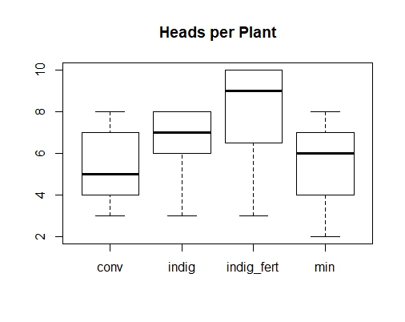
One Way ANOVA of Head Weight per plant

##Head Weight per Plant

> THead_wt_per_plant <- Head_wt_per_plant^0.33
> options(contrasts=c("contr.sum", "contr.poly"))
> model3 <- lm(THead_wt_per_plant ~ Treat)
> Anova.out<-Anova(model3, type="III")
> Anova.out
Anova Table (Type III tests)

Response: THead_wt_per_plant
Sum Sq Df F value Pr(>F)
(Intercept) 2414.71 1 1178.2466 < 2e-16 ***
Treat 23.94 3 3.8944 0.01344 *
Residuals 114.77 56
---
Signif. codes: 0 ‘***’ 0.001 ‘**’ 0.01 ‘*’ 0.05 ‘.’ 0.1 ‘ ’ 1
> result.lsm1 <- lsmeans(model3, "Treat")
> contrast (result.lsm1, method = "pairwise", adjust = "tukey")
contrast estimate SE df t.ratio p.value
conv - indig -1.1555672 0.7092511 56 -1.629 0.3708
conv - indig_fert -1.8645639 0.8161240 56 -2.285 0.1139
conv - min -0.1995078 0.7013263 56 -0.284 0.9919
indig - indig_fert -0.7089967 0.5910426 56 -1.200 0.6297
indig - min 0.9560595 0.4184871 56 2.285 0.1139
indig_fert - min 1.6650562 0.5815090 56 2.863 0.0292

P value adjustment: tukey method for comparing a family of 4 estimates
> boxplot (Head_wt_per_plant ~ Treat, main = "Head Weight per plant")

Figure 2: Boxplot of ANOVA result for head weight per plant
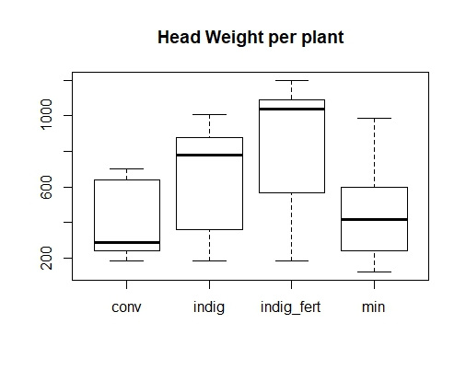

One Way ANOVA for Head Weight per m²

###Head_wt_m2

> THead_wt_m2 <- log(Head_wt_m2)
> options(contrasts=c("contr.sum", "contr.poly"))
> model4 <- lm(THead_wt_m2 ~ Treat)
> Anova.out<-Anova(model4, type="III")
> Anova.out
Anova Table (Type III tests)

Response: THead_wt_m2
Sum Sq Df F value Pr(>F)
(Intercept) 900.35 1 1913.1994 < 2e-16 ***
Treat 5.60 3 3.9639 0.01241 *
Residuals 26.35 56
---
Signif. codes: 0 ‘***’ 0.001 ‘**’ 0.01 ‘*’ 0.05 ‘.’ 0.1 ‘ ’ 1
> result.lsm1 <- lsmeans(model4, "Treat")
> contrast (result.lsm1, method = "pairwise", adjust = "tukey")
contrast estimate SE df t.ratio p.value
conv - indig -0.58344253 0.3398690 56 -1.717 0.3248
conv - indig_fert -0.83405246 0.3910819 56 -2.133 0.1554
conv - min -0.07342222 0.3360715 56 -0.218 0.9963
indig - indig_fert -0.25060993 0.2832242 56 -0.885 0.8127
indig - min 0.51002030 0.2005366 56 2.543 0.0641
indig_fert - min 0.76063024 0.2786557 56 2.730 0.0409

P value adjustment: tukey method for comparing a family of 4 estimates
> boxplot (Head_wt_m2 ~ Treat, main = "Head Weight per m^2")

Figure 3: Boxplot of ANOVA result for head weight per m²
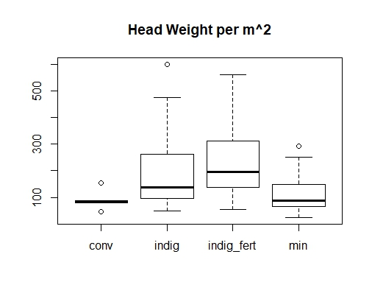

One Way ANOVA of %Sand

Sand^6

> TSand <- (Sand)^6
> options(contrasts=c("contr.sum", "contr.poly"))
> model5 <- lm(TSand ~ Treat)
> Anova.out<-Anova(model5, type="III")
> Anova.out
Anova Table (Type III tests)

Response: TSand
Sum Sq Df F value Pr(>F)
(Intercept) 1.6759e+25 1 395.6142 <2e-16 ***
Treat 2.3493e+23 3 1.8487 0.1489
Residuals 2.3722e+24 56
---
Signif. codes: 0 ‘***’ 0.001 ‘**’ 0.01 ‘*’ 0.05 ‘.’ 0.1 ‘ ’ 1
> result.lsm1 <- lsmeans(model5, "Treat")
> contrast (result.lsm1, method = "pairwise", adjust = "tukey")
contrast estimate SE df t.ratio p.value
conv - indig -46844830505 101969401367 56 -0.459 0.9675
conv - indig_fert -95872583664 117334576641 56 -0.817 0.8461
conv - min 67332281351 100830042687 56 0.668 0.9088
indig - indig_fert -49027753159 84974501139 56 -0.577 0.9386
indig - min 114177111855 60166107373 56 1.898 0.2407
indig_fert - min 163204865015 83603854797 56 1.952 0.2186

P value adjustment: tukey method for comparing a family of 4 estimates
> boxplot (Sand ~ Treat, main = "Percent Sand")

Figure 4: Boxplot of ANOVA result for percent Sand

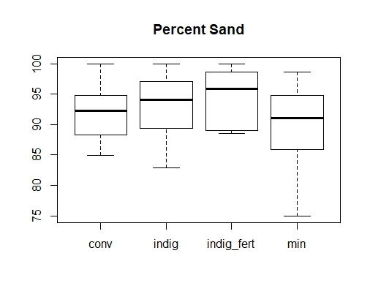

One Way ANOVA of %Clay

%Clay^0.33

> TClay <- (Clay)^.33
> options(contrasts=c("contr.sum", "contr.poly"))
> model5 <- lm(TClay ~ Treat)
> Anova.out<-Anova(model5, type="III")
> Anova.out
Anova Table (Type III tests)

Response: TClay
Sum Sq Df F value Pr(>F)
(Intercept) 42.890 1 79.3798 2.526e-12 ***
Treat 0.993 3 0.6125 0.6097
Residuals 30.258 56
---
Signif. codes: 0 ‘***’ 0.001 ‘**’ 0.01 ‘*’ 0.05 ‘.’ 0.1 ‘ ’ 1
> result.lsm1 <- lsmeans(model5, "Treat")
> contrast (result.lsm1, method = "pairwise", adjust = "tukey")
contrast estimate SE df t.ratio p.value
conv - indig -0.20658510 0.3641757 56 -0.567 0.9414
conv - indig_fert 0.03880541 0.4190512 56 0.093 0.9997
conv - min -0.31593417 0.3601065 56 -0.877 0.8165
indig - indig_fert 0.24539052 0.3034797 56 0.809 0.8501
indig - min -0.10934907 0.2148785 56 -0.509 0.9566
indig_fert - min -0.35473959 0.2985846 56 -1.188 0.6368

P value adjustment: tukey method for comparing a family of 4 estimates
> boxplot (Clay ~ Treat, main = "Percent Clay")

Figure 5: Boxplot of ANOVA result for percent Clay

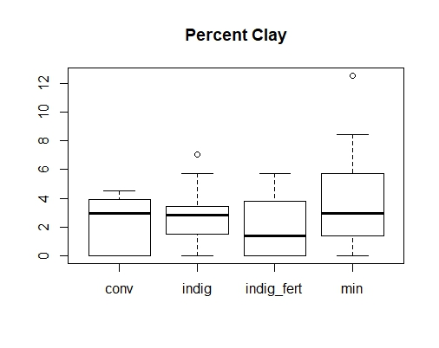

One Way ANOVA of %Silt

Silt^0.5

> TSilt <- (Silt)^.5
> options(contrasts=c("contr.sum", "contr.poly"))
> model5 <- lm(TSilt ~ Treat)
> Anova.out<-Anova(model5, type="III")
> Anova.out
Anova Table (Type III tests)

Response: TSilt
Sum Sq Df F value Pr(>F)
(Intercept) 144.053 1 143.8991 <2e-16 ***
Treat 7.884 3 2.6251 0.0593 .
Residuals 56.060 56
---
Signif. codes: 0 ‘***’ 0.001 ‘**’ 0.01 ‘*’ 0.05 ‘.’ 0.1 ‘ ’ 1
> result.lsm1 <- lsmeans(model5, "Treat")
> contrast (result.lsm1, method = "pairwise", adjust = "tukey")
contrast estimate SE df t.ratio p.value
conv - indig 0.4394757 0.4956988 56 0.887 0.8118
conv - indig_fert 0.5473813 0.5703928 56 0.960 0.7727
conv - min -0.2852840 0.4901601 56 -0.582 0.9371
indig - indig_fert 0.1079056 0.4130824 56 0.261 0.9937
indig - min -0.7247597 0.2924825 56 -2.478 0.0745
indig_fert - min -0.8326652 0.4064193 56 -2.049 0.1828

P value adjustment: tukey method for comparing a family of 4 estimates
> boxplot (Silt ~ Treat, main = "Percent Silt")

Figure 6: Boxplot of ANOVA result for percent Silt

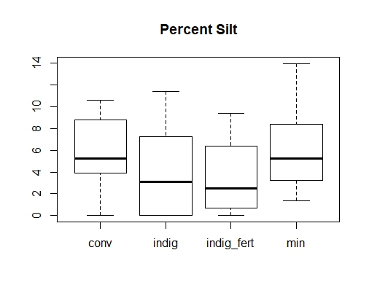

One Way ANOVA of Total Nitrogen

Nitrogen^-1
> TNitrogen <- (Nitrogen)^-1
> options(contrasts=c("contr.sum", "contr.poly"))
> model5 <- lm(TNitrogen ~ Treat)
> Anova.out<-Anova(model5, type="III")
> Anova.out
Anova Table (Type III tests)

Response: TNitrogen
Sum Sq Df F value Pr(>F)
(Intercept) 127184 1 388.4442 <2e-16 ***
Treat 2049 3 2.0864 0.1123
Residuals 18335 56
---
Signif. codes: 0 ‘***’ 0.001 ‘**’ 0.01 ‘*’ 0.05 ‘.’ 0.1 ‘ ’ 1
> result.lsm1 <- lsmeans(model5, "Treat")
> contrast (result.lsm1, method = "pairwise", adjust = "tukey")
contrast estimate SE df t.ratio p.value
conv - indig 6.310211 8.964725 56 0.704 0.8951
conv - indig_fert 20.761750 10.315567 56 2.013 0.1956
conv - min 3.597714 8.864557 56 0.406 0.9772
indig - indig_fert 14.451539 7.470604 56 1.934 0.2256
indig - min -2.712497 5.289554 56 -0.513 0.9557
indig_fert - min -17.164036 7.350103 56 -2.335 0.1023

P value adjustment: tukey method for comparing a family of 4 estimates
> boxplot (Nitrogen ~ Treat, main = "Percent Nitrogen")

Figure 7: Boxplot of ANOVA result for percent Nitrogen
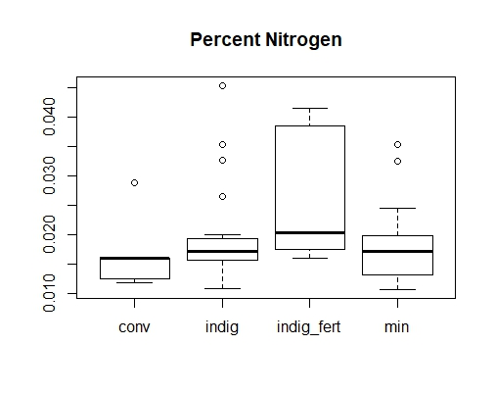
One Way ANOVA of Total Carbon

Carbon^0.33
> TCarbon <- (Carbon)^0.33
> options(contrasts=c("contr.sum", "contr.poly"))
> model5 <- lm(TCarbon ~ Treat)
> Anova.out<-Anova(model5, type="III")
> Anova.out
Anova Table (Type III tests)

Response: TCarbon
Sum Sq Df F value Pr(>F)
(Intercept) 13.9431 1 2723.8998 <2e-16 ***
Treat 0.0121 3 0.7849 0.5074
Residuals 0.2867 56
---
Signif. codes: 0 ‘***’ 0.001 ‘**’ 0.01 ‘*’ 0.05 ‘.’ 0.1 ‘ ’ 1
> result.lsm1 <- lsmeans(model5, "Treat")
> contrast (result.lsm1, method = "pairwise", adjust = "tukey")
contrast estimate SE df t.ratio p.value
conv - indig -4.268041e-02 0.03544619 56 -1.204 0.6269
conv - indig_fert -6.204219e-02 0.04078737 56 -1.521 0.4319
conv - min -4.274191e-02 0.03505013 56 -1.219 0.6173
indig - indig_fert -1.936178e-02 0.02953849 56 -0.655 0.9132
indig - min -6.149887e-05 0.02091470 56 -0.003 1.0000
indig_fert - min 1.930028e-02 0.02906203 56 0.664 0.9101

P value adjustment: tukey method for comparing a family of 4 estimates
> boxplot (Carbon ~ Treat, main = "Percent Carrbon")

Figure 8: Boxplot of ANOVA result for percent Carbon
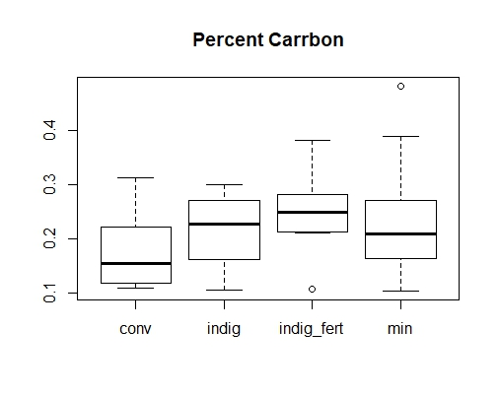
One Way ANOVA of pH

pH^-1
> TpH <- (pH)^-1
> options(contrasts=c("contr.sum", "contr.poly"))
> model5 <- lm(TpH ~ Treat)
> Anova.out<-Anova(model5, type="III")
> Anova.out
Anova Table (Type III tests)

Response: TpH
Sum Sq Df F value Pr(>F)
(Intercept) 1.18380 1 4521.5836 < 2.2e-16 ***
Treat 0.00547 3 6.9597 0.0004616 ***
Residuals 0.01466 56
---
Signif. codes: 0 ‘***’ 0.001 ‘**’ 0.01 ‘*’ 0.05 ‘.’ 0.1 ‘ ’ 1
> result.lsm1 <- lsmeans(model5, "Treat")
> contrast (result.lsm1, method = "pairwise", adjust = "tukey")
contrast estimate SE df t.ratio p.value
conv - indig 0.0214805513 0.008016399 56 2.680 0.0463
conv - indig_fert 0.0210125907 0.009224343 56 2.278 0.1155
conv - min 0.0027897446 0.007926827 56 0.352 0.9849
indig - indig_fert -0.0004679606 0.006680332 56 -0.070 0.9999
indig - min -0.0186908067 0.004730002 56 -3.952 0.0012
indig_fert - min -0.0182228461 0.006572578 56 -2.773 0.0368

P value adjustment: tukey method for comparing a family of 4 estimates
> boxplot (pH ~ Treat, main = "pH")

Figure 9: Boxplot of ANOVA result for pH
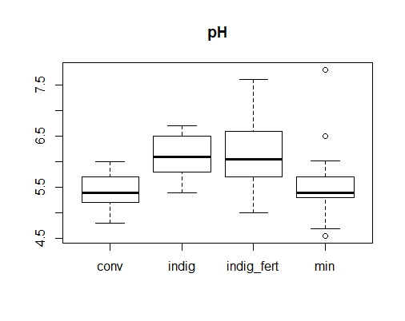
One Way ANOVA of Sas-tree

Sas_trees^0.25
> Tsas_trees <- Sas_trees^.25
> options(contrasts=c("contr.sum", "contr.poly"))
> model6 <- lm(Tsas_trees ~ Treat)
> Anova.out<-Anova(model6, type="III")
> Anova.out
Anova Table (Type III tests)

Response: Tsas_trees
Sum Sq Df F value Pr(>F)
(Intercept) 42.063 1 85.7925 6.811e-13 ***
Treat 4.533 3 3.0819 0.0346 *
Residuals 27.456 56
---
Signif. codes: 0 ‘***’ 0.001 ‘**’ 0.01 ‘*’ 0.05 ‘.’ 0.1 ‘ ’ 1
> result.lsm1 <- lsmeans(model6, "Treat")
> contrast (result.lsm1, method = "pairwise", adjust = "tukey")
contrast estimate SE df t.ratio p.value
conv - indig -0.8295536 0.3469052 56 -2.391 0.0905
conv - indig_fert -0.4460414 0.3991783 56 -1.117 0.6804
conv - min -0.9335811 0.3430290 56 -2.722 0.0418
indig - indig_fert 0.3835121 0.2890877 56 1.327 0.5502
indig - min -0.1040276 0.2046882 56 -0.508 0.9568
indig_fert - min -0.4875397 0.2844246 56 -1.714 0.3261

P value adjustment: tukey method for comparing a family of 4 estimates
> boxplot (Sas_trees ~ Treat, main = "Sas Trees / Ha")

Figure 10: Boxplot of ANOVA result for Sas-trees

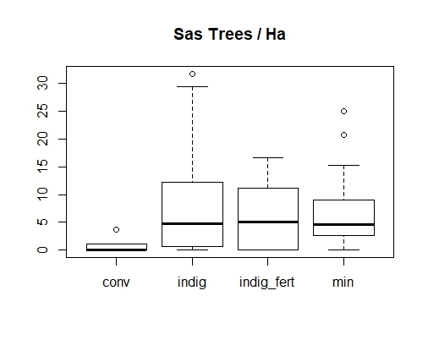

One Way ANOVA of total tree

Total trees^0.25
> Ttotal_trees <- total.trees^.25
> options(contrasts=c("contr.sum", "contr.poly"))
> model7 <- lm(Ttotal_trees ~ Treat)
> Anova.out<-Anova(model7, type="III")
> Anova.out
Anova Table (Type III tests)

Response: Ttotal_trees
Sum Sq Df F value Pr(>F)
(Intercept) 121.082 1 374.801 <2e-16 ***
Treat 0.682 3 0.704 0.5537
Residuals 18.091 56
---
Signif. codes: 0 ‘***’ 0.001 ‘**’ 0.01 ‘*’ 0.05 ‘.’ 0.1 ‘ ’ 1
> result.lsm1 <- lsmeans(model7, "Treat")
> contrast (result.lsm1, method = "pairwise", adjust = "tukey")
contrast estimate SE df t.ratio p.value
conv - indig -0.09818153 0.2815947 56 -0.349 0.9853
conv - indig_fert -0.40037565 0.3240266 56 -1.236 0.6071
conv - min -0.17882601 0.2784483 56 -0.642 0.9178
indig - indig_fert -0.30219412 0.2346623 56 -1.288 0.5745
indig - min -0.08064448 0.1661524 56 -0.485 0.9620
indig_fert - min 0.22154964 0.2308771 56 0.960 0.7727

P value adjustment: tukey method for comparing a family of 4 estimates
> boxplot (Total_trees ~ Treat, main = "Total Trees / Ha")
Error in eval(expr, envir, enclos) : object 'Total_trees' not found
> boxplot (total.trees ~ Treat, main = "Total Trees / Ha")

Figure 11: Boxplot of ANOVA result for total-trees
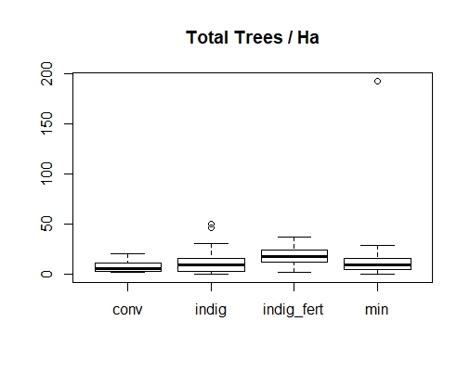
without large outlier, didn’t make a difference.

> View(datafile_no_outlier)
> Ttotal_trees <- total.trees^.25
> options(contrasts=c("contr.sum", "contr.poly"))
> model8 <- lm(Ttotal_trees ~ Treat)
> Anova.out<-Anova(model8, type="III")
> Anova.out
Anova Table (Type III tests)

Response: Ttotal_trees
Sum Sq Df F value Pr(>F)
(Intercept) 117.822 1 459.2220 <2e-16 ***
Treat 0.717 3 0.9317 0.4317
Residuals 14.111 55
---
Signif. codes: 0 ‘***’ 0.001 ‘**’ 0.01 ‘*’ 0.05 ‘.’ 0.1 ‘ ’ 1
> result.lsm1 <- lsmeans(model8, "Treat")
> contrast (result.lsm1, method = "pairwise", adjust = "tukey")
contrast estimate SE df t.ratio p.value
conv - indig -0.0981815333 0.2509500 55 -0.391 0.9795
conv - indig_fert -0.4003756507 0.2887641 55 -1.387 0.5131
conv - min -0.0973819938 0.2490061 55 -0.391 0.9795
indig - indig_fert -0.3021941174 0.2091250 55 -1.445 0.4773
indig - min 0.0007995395 0.1495077 55 0.005 1.0000
indig_fert - min 0.3029936569 0.2067883 55 1.465 0.4651

P value adjustment: tukey method for comparing a family of 4 estimates

Stepwise Regressions (new)

Head Weight m-2

> Theadwt_m2 <- log(headwt_m2)

The full model we started with:
> summary(lm1 <- lm(Theadwt_m2 ~ land_use + chem_fert + Tclay + Tsilt + Tnitrogen + Tcarbon + TpH +
+ Tsas_trees + Ttotal_trees, data = datafile))

This is the final model:
> summary(slm1)

Call:
lm(formula = Theadwt_m2 ~ land_use + Tcarbon + Ttotal_trees,
data = datafile)

Residuals:
Min 1Q Median 3Q Max
-1.1097 -0.4300 -0.1095 0.3832 1.2267

Coefficients:
Estimate Std. Error t value Pr(>|t|)
(Intercept) 4.8708 0.7483 6.509 2.23e-08 ***
land_use1 -0.2972 0.0776 -3.830 0.000326 ***
Tcarbon -1.8489 1.1046 -1.674 0.099733 .
Ttotal_trees 0.5817 0.1532 3.798 0.000361 ***
---
Signif. codes: 0 ‘***’ 0.001 ‘**’ 0.01 ‘*’ 0.05 ‘.’ 0.1 ‘ ’ 1

Residual standard error: 0.5984 on 56 degrees of freedom
Multiple R-squared: 0.3724, Adjusted R-squared: 0.3388
F-statistic: 11.08 on 3 and 56 DF, p-value: 8.203e-06

Without land use and fertilization in model
> summary(slm2)

Call:
lm(formula = Theadwt_m2 ~ Tcarbon + TpH + Ttotal_trees, data = datafile)

Residuals:
Min 1Q Median 3Q Max
-1.29133 -0.46026 -0.07918 0.47918 1.60158

Coefficients:
Estimate Std. Error t value Pr(>|t|)
(Intercept) 7.0007 1.4523 4.820 1.14e-05 ***
Tcarbon -2.5881 1.3204 -1.960 0.054971 .
TpH -10.1110 5.0840 -1.989 0.051617 .
Ttotal_trees 0.6225 0.1664 3.741 0.000434 ***
---
Signif. codes: 0 ‘***’ 0.001 ‘**’ 0.01 ‘*’ 0.05 ‘.’ 0.1 ‘ ’ 1

Residual standard error: 0.6496 on 56 degrees of freedom
Multiple R-squared: 0.2603, Adjusted R-squared: 0.2207
F-statistic: 6.569 on 3 and 56 DF, p-value: 0.0006968

The same analysis but without the large outlier for total_trees:

> summary(slm1)

Call:
lm(formula = Theadwt_m2 ~ land_use + Tcarbon + Ttotal_trees,
data = datafile)

Residuals:
Min 1Q Median 3Q Max
-1.11218 -0.43284 -0.09807 0.40306 1.22641

Coefficients:
Estimate Std. Error t value Pr(>|t|)
(Intercept) 4.85787 0.75618 6.424 3.3e-08 ***
land_use1 -0.29396 0.07922 -3.711 0.000483 ***
Tcarbon -1.89142 1.12564 -1.680 0.098569 .
Ttotal_trees 0.60517 0.17856 3.389 0.001303 **
---
Signif. codes: 0 ‘***’ 0.001 ‘**’ 0.01 ‘*’ 0.05 ‘.’ 0.1 ‘ ’ 1

Residual standard error: 0.6034 on 55 degrees of freedom
(1 observation deleted due to missingness)
Multiple R-squared: 0.357, Adjusted R-squared: 0.3219
F-statistic: 10.18 on 3 and 55 DF, p-value: 1.963e-05

Without the outlier and land use and fertilization in model

> summary(slm2)

Call:
lm(formula = Theadwt_m2 ~ Tcarbon + TpH + Ttotal_trees, data = datafile)

Residuals:
Min 1Q Median 3Q Max
-1.28035 -0.49263 -0.07141 0.47571 1.59067

Coefficients:
Estimate Std. Error t value Pr(>|t|)
(Intercept) 6.9044 1.4699 4.697 1.8e-05 ***
Tcarbon -2.6674 1.3349 -1.998 0.05065 .
TpH -9.8068 5.1397 -1.908 0.06161 .
Ttotal_trees 0.6783 0.1922 3.529 0.00085 ***
---
Signif. codes: 0 ‘***’ 0.001 ‘**’ 0.01 ‘*’ 0.05 ‘.’ 0.1 ‘ ’ 1

Residual standard error: 0.6534 on 55 degrees of freedom
(1 observation deleted due to missingness)
Multiple R-squared: 0.246, Adjusted R-squared: 0.2048
F-statistic: 5.98 on 3 and 55 DF, p-value: 0.001329

Head_wt_per_plant^0.33

This is the final model:
> summary(slm1)

Call:
lm(formula = THead_wt_per_plant ~ land_use + TCarbon + Ttotal.trees,
data = datafile)

Residuals:
Min 1Q Median 3Q Max
-2.8387 -1.1712 0.1148 1.0242 3.2417

Coefficients:
Estimate Std. Error t value Pr(>|t|)
(Intercept) 8.6535 1.6308 5.306 1.98e-06 ***
land_use1 -0.5999 0.1746 -3.437 0.00112 **
TCarbon -3.6667 2.4775 -1.480 0.14447
Ttotal.trees 0.7845 0.3114 2.519 0.01465 *
---
Signif. codes: 0 ‘***’ 0.001 ‘**’ 0.01 ‘*’ 0.05 ‘.’ 0.1 ‘ ’ 1

Residual standard error: 1.346 on 56 degrees of freedom
Multiple R-squared: 0.268, Adjusted R-squared: 0.2288
F-statistic: 6.835 on 3 and 56 DF, p-value: 0.0005258

Without land use and fertilization in model
> summary(slm2)

Call:
lm(formula = THead_wt_per_plant ~ TCarbon + TpH + Ttotal.trees,
data = datafile)

Residuals:
Min 1Q Median 3Q Max
-2.3903 -1.3200 0.1661 1.1367 2.7158

Coefficients:
Estimate Std. Error t value Pr(>|t|)
(Intercept) 14.8218 3.1043 4.775 1.33e-05 ***
TCarbon -6.0442 2.8435 -2.126 0.03796 *
TpH -28.1687 10.9768 -2.566 0.01298 *
Ttotal.trees 0.8752 0.3248 2.695 0.00928 **
---
Signif. codes: 0 ‘***’ 0.001 ‘**’ 0.01 ‘*’ 0.05 ‘.’ 0.1 ‘ ’ 1

Residual standard error: 1.402 on 56 degrees of freedom
Multiple R-squared: 0.2069, Adjusted R-squared: 0.1644
F-statistic: 4.871 on 3 and 56 DF, p-value: 0.004433

The same analysis but without the large outlier for totaltrees:

> summary(slm1)

Call:
lm(formula = THead_wt_per_plant ~ land_use + TCarbon + Ttotal.trees,
data = datafile)

Residuals:
Min 1Q Median 3Q Max
-2.8508 -1.1655 0.0994 0.9854 3.3891

Coefficients:
Estimate Std. Error t value Pr(>|t|)
(Intercept) 8.6473 1.6380 5.279 2.27e-06 ***
land_use1 -0.5812 0.1773 -3.279 0.00181 **
TCarbon -3.9664 2.5234 -1.572 0.12172
Ttotal.trees 0.9016 0.3530 2.554 0.01345 *
---
Signif. codes: 0 ‘***’ 0.001 ‘**’ 0.01 ‘*’ 0.05 ‘.’ 0.1 ‘ ’ 1

Residual standard error: 1.352 on 55 degrees of freedom
(1 observation deleted due to missingness)
Multiple R-squared: 0.2736, Adjusted R-squared: 0.2339
F-statistic: 6.904 on 3 and 55 DF, p-value: 0.0004995

Without the outlier and land use and fertilization in model
> summary(slm2)

Call:
lm(formula = THead_wt_per_plant ~ TNitrogen + TCarbon + TpH +
Ttotal.trees, data = datafile)

Residuals:
Min 1Q Median 3Q Max
-2.0332 -1.3284 0.1633 1.0949 2.7721

Coefficients:
Estimate Std. Error t value Pr(>|t|)
(Intercept) 16.10354 3.23753 4.974 7.03e-06 ***
TNitrogen -0.01684 0.01117 -1.507 0.1375
TCarbon -7.72419 2.97462 -2.597 0.0121 *
TpH -24.21056 11.09220 -2.183 0.0334 *
Ttotal.trees 0.90727 0.36940 2.456 0.0173 *
---
Signif. codes: 0 ‘***’ 0.001 ‘**’ 0.01 ‘*’ 0.05 ‘.’ 0.1 ‘ ’ 1

Residual standard error: 1.387 on 54 degrees of freedom
(1 observation deleted due to missingness)
Multiple R-squared: 0.2495, Adjusted R-squared: 0.1939
F-statistic: 4.488 on 4 and 54 DF, p-value: 0.003334

