Electronic Supplementary Materials
Baculum shape and paternity success in house mice: evidence for genital coevolution

Gonçalo I. André *, Renée C. Firman, Leigh W. Simmons
Centre for Evolutionary Biology, School of Biological Sciences (M092), The University of Western Australia, Crawley, 6009, WA, Australia

Correspondence: goncalo.igrejaandre@research.uwa.edu.au

This file contains, supplementary figures (Figure S1, S2, S3 and S4) and supplementary tables (Table S1, S2, S3, S4, S5 and S6)

Figure S1. Variation in baculum shape of second-generation laboratory reared house mice derived from the extremes of baculum shape (Wide/Narrow). (a) Mean (± 95% CI) score of the first relative warp (RW1). (b) Mean (± 95% CI) score of the second relative warp (RW2). Baculum shape thin-plate splines: left– wide background, right– narrow background.
(a)
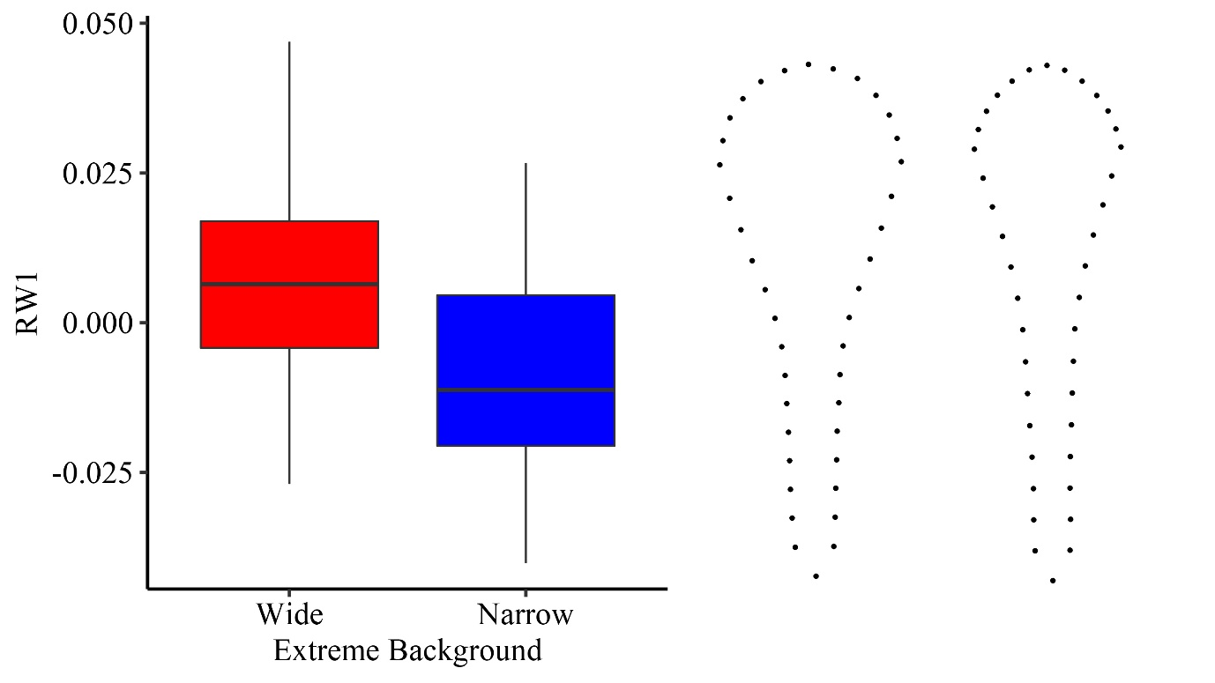
(b)

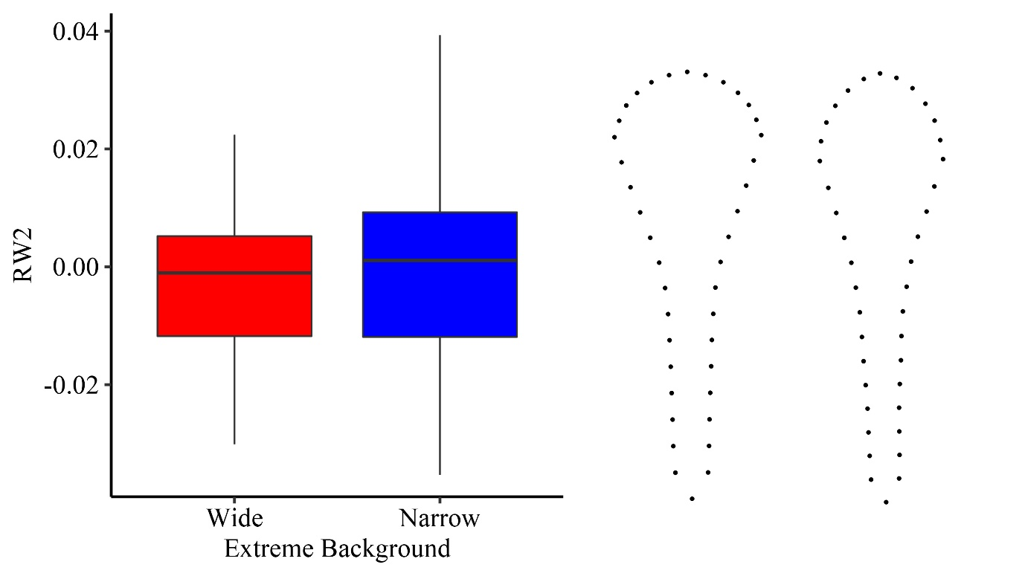
Figure S2. Variation in baculum shape of third-generation laboratory reared house mice descended from families from the extremes of baculum shape (Wide/Narrow). (a) Mean (± 95% CI) score of the first relative warp (RW1). (b) Mean (± 95% CI) score of the second relative warp (RW2). Baculum shape thin-plate splines: left– wide background, right– narrow background.
(a)

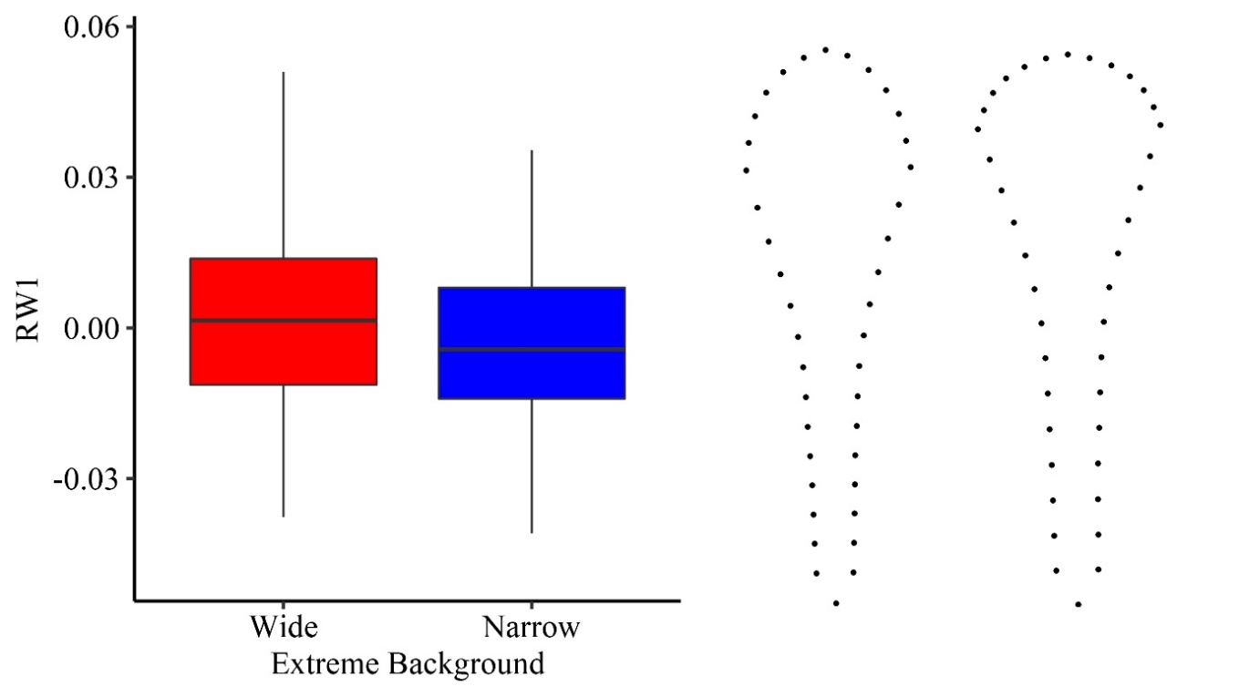
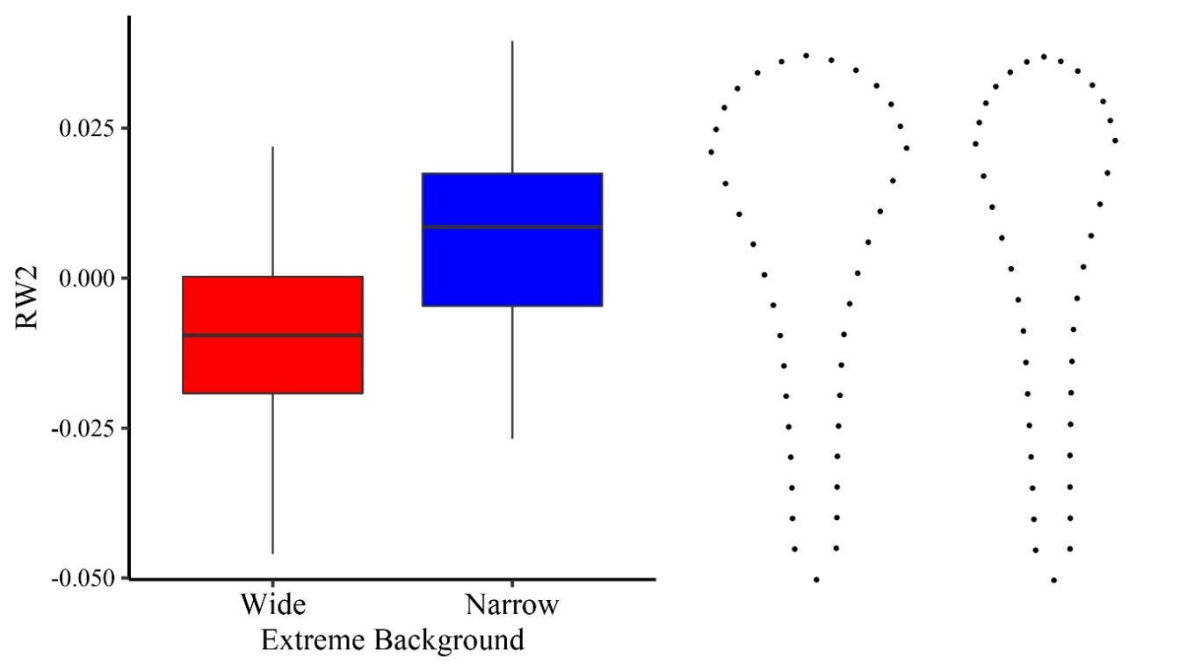
(b)
Table S1. Linear mixed model (LMM) of baculum shape of F₂ and F₃ house mice descended from families from the extremes of baculum shape. (a) Second generation (n= 104); (b) Third generation (n=214). Values in italics are significant at p < 0.05.
fixed effects | estimate ± (se) | type II, Wald χ2 | p | random effects | variance | ±sd
- 2nd Generation
RW1
intercept | -0.071 (0.042) |  |  | family | <0.0001 | 0.0006
extreme background | -0.013 (0.004) | 8.37 | 0.003
body weight | 0.027 (0.015) | 3.43 | 0.06
RW2
intercept | 0.031 (0.036) |  |  | family | <0.0001 | 0.0027
extreme background | 0.002 (0.003) | 0.27 | 0.61
body weight | -0.012 (0.013) | 0.83 | 0.36
Centroid Size
intercept | 0.423 (1.209) |  |  | family | 0.0502 | 0.2241
extreme background | -0.084 (0.149) | 0.31 | 0.57
body weight | -0.135 (0.425) | 0.11 | 0.75
(b) 3rd Generation
RW1
intercept | -0.058 (0.032) |  |  | family | <0.0001 | 0.0051
extreme background | -0.004 (0.003) | 1.92 | 0.16
body weight | 0.021 (0.011) | 3.55 | 0.06
RW2
intercept | 0.039 (0.025) |  |  | family | <0.0001 | 0.0069
extreme background | 0.014 (0.003) | 14.69 | 0.0001
body weight | -0.016 (0.008) | 3.48 | 0.06
Centroid Size
intercept | -3.382 (0.814) |  |  | family | 0.0581 | 0.2411
extreme background | 0.053 (0.121) | 0.19 | 0.66
body weight | 1.182 (0.289) | 16.64 | <0.001

Figure S3. Mating design. a) Monandrous matings – Males and females from different families and from similar or opposite baculum extreme backgrounds (wide and narrow) were coupled in a multifactorial way (n = 77 mating pairs); b) Polyandrous matings – Females from different baculum extreme backgrounds (wide and narrow) were coupled sequentially with males from different baculum extreme backgrounds in a multifactorial way ( n = 74 mating trios).
Wide
Narrow
Wide
Narrow
Narrow
Wide
Wide
Narrow
Narrow
Narrow
Wide
Wide
X
X
X
X
X
X
X
X
1st mating
2nd mating
b)
Narrow
Wide
Narrow
Narrow
Wide
Wide
Narrow
Wide
X
X
X
X
a)

Table S2. Microsatellite loci used to assign embryo parentage. Microsatellite loci were divided into two multiplexes (a & b).
Locus Name | Left (5' - 3') | Right (5'-3')
(a) Multiplex 1
D1Mit17 | GTGTCTGCCTTTGCACCTTT | CTGCTGTCTTTCCATCCACA
D10Mit14 | AGAGGGGACAAGGAGAGACC | AAGGTTTGGGTTCAGTTCCCAG
D11Mit4 | CAGTGGGTCATCAGTACAGCA | AAGCCAGCCCAGTCTTCATA
D14Mit132 | GAACAGCACCATCCACACACC | GTGGGGTTATATGCAGATAC
D18Mit17 | TCAGGCAGATTCCAAGCAG | CTGTGGGTAGCCCAAGTCAT
(b) Multiplex 2
D2Mit1 | CTTTTTCGTATGTGGTGGGG | AACATTGGGCCTCTATGCAC
D4Mit22 | GCAGTTAAACTGTACTTTCTG | CTCAGACATGATTTTTTCCAA
D6Mit138 | CAAAGAAAGCATTTCAAGAC | GCTCTTATTAATGAAGAAGA
D13Mit1 | GTCTGTTTGATTCCTGACCTCC | TCAACTCTTCTGTAAACCAGATG
D15Mit13 | GGAGACAAAAATGAACTCCTGG | TTGTAAGACAAGCATAGCTCAAC

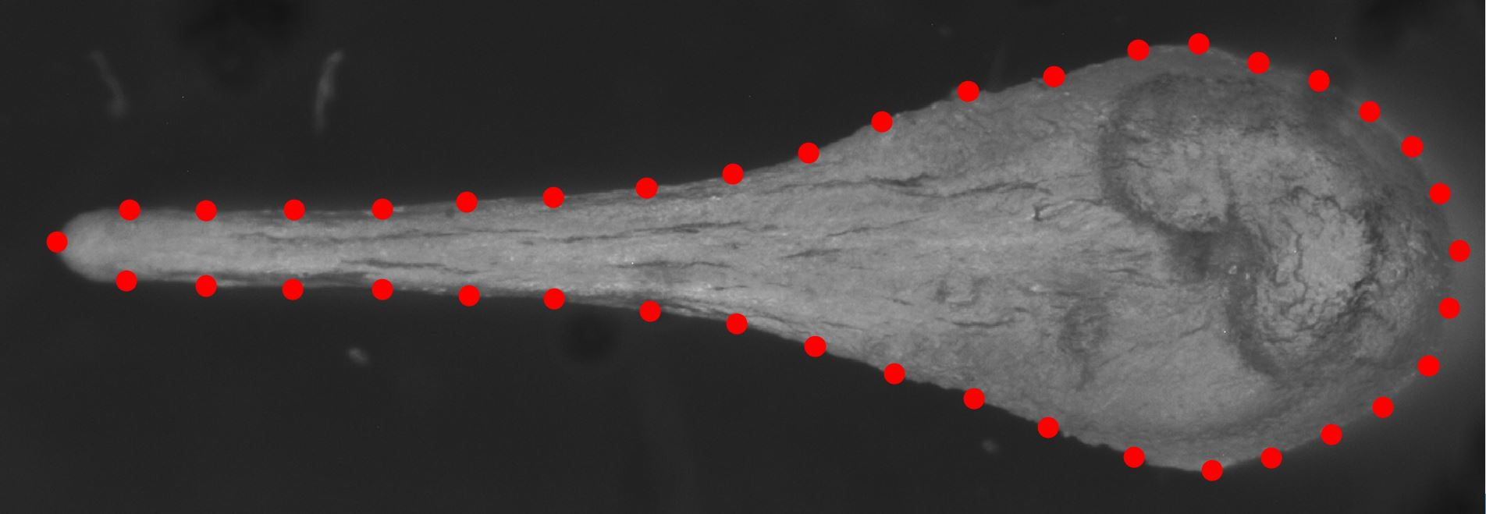
Figure S4. Landmark placement on images of the baculum of the house mouse, Mus musculus domesticus. The placement of 40 landmarks are shown, 4 fixed landmarks (white, numbers: 1, 7, 21 and 35) and 36 semi-sliding landmarks (red) placed evenly between fixed landmarks around its periphery.
1
7
21
35

Landmark placement details: For the baculum, fixed landmarks demarked the most lateral, anterior and posterior positions of the baculum, homologous structures across all specimens. Sliding semi-landmarks were spaced evenly between the fixed landmarks (Zelditch et al. 2012).

Table S3. Repeatability analysis. (a) Second generation, (b) Third generation. We used intra-class correlation coefficient analysis (ICC) with the one-way random effects model to estimate the reliability of measurement for landmark placement. Values in italics are significant at p < 0.05.
 | n | ICC | Confidence Interval | F | p
(a)2nd Generation
RW1 | 21 | 0.992 | 0.982 - 0.997 | 266 | <0.0001
RW2 | 21 | 0.982 | 0.958 - 0.993 | 113 | <0.0001
Centroid Size | 21 | 0.996 | 0.991 - 0.998 | 537 | <0.0001
(b) 3rd Generation
RW1 | 42 | 0.974 | 0.953 - 0.986 | 76.2 | <0.0001
RW2 | 42 | 0.979 | 0.961 - 0.989 | 93.6 | <0.0001
Centroid Size | 42 | 0.998 | 0.996 - 0.999 | 915 | <0.0001

Table S4. General Linear Mixed Model (GLMM) of the effect of baculum morphology and its interaction with female genetic background on the number of embryos. Values in italics are significant at p < 0.05.
fixed effects | estimate ± (se) |  | type III, Wald χ2 | p | random effects | variance | ±sd
intercept |  | 2.059 (0.059) |  |  | ♂ Family | <0.0001 | <0.0001
RW1 |  | 0.408 (2.725) | 0.022 | 0.88 | ♀ Family | <0.0001 | <0.0001
RW2 |  | 1.447 (3.493) | 0.172 | 0.68
Baculum Size |  | 0.052 (0.109) | 0.228 | 0.63
♀ Extreme |  | -0.043 (0.083) | 0.267 | 0.61
RW1 × ♀Extreme |  | -0.275 (4.338) | 0.004 | 0.95
RW2 × ♀Extreme |  | -5.975 (5.750) | 1.079 | 0.29
Baculum Size × ♀Extreme |  | -0.024 (0.171) | 0.019 | 0.88

Table S5. General Linear Mixed Model (GLMM) of the effect of baculum morphology and its interaction with female genetic background on embryo viability. Values in italics are significant at p < 0.05.
fixed effects | estimate ± (se) | type III, Wald χ2 | p | random effects | variance | ±sd
intercept | 2.874 (0.318) |  |  | ♂ Family | <0.0001 | <0.0001
RW1 | 4.631 (11.741) | 0.156 | 0.69 | ♀ Family | 0.227 | 0.477
RW2 | 0.923 (14.699) | 0.004 | 0.95
Baculum Size | 0.885 (0.511) | 3.006 | 0.08
♀ Extreme | -0.354 (0.347) | 1.044 | 0.18
RW1 × ♀Extreme | -10.11 (17.11) | 0.349 | 0.54
RW2 × ♀Extreme | 6.531 (21.766) | 0.090 | 0.62
Baculum Size × ♀Extreme | -0.272 (0.707) | 0.148 | 0.44

Table S6. General Linear Mixed Model (GLMM) of the effect of baculum shape of the first male relative to the second male and its interaction with the female’s genetic background on second male parentage for the reduced sample of mating trios in which paternity could be assigned to 80% or more of the embryos (males = 132; females = 66; total embryos = 491). Values in italics are significant at p < 0.05.
fixed effects | estimate ± (se) | type III, Wald χ2 | p | random effects | variance | ± s.d.
intercept | -0.588 (0.344) |  |  | 1st ♂ Family | 0.782 | 0.884
RW1 | -3.188 (8.345) | 0.833 | 0.36 | 2nd ♂ Family | 0.674 | 0.812
RW2 | 7.541 (8.266) | 0.456 | 0.49 | ♀ Family | <0.0001 | <0.0001
Baculum Size | 1.163 (2.001) | 0.877 | 0.35
♀ Extreme | 0.611 (0.288) | 3.272 | 0.07
RW1 × ♀ Extreme | -3.871 (10.290) | 0.141 | 0.71
RW2 × ♀ Extreme | -26.17 (12.847) | 4.151 | 0.04
Baculum Size × ♀ Extreme | 0.663 (3.068) | 0.046 | 0.83

