Enhanced CO Evolution for Photocatalytic Conversion of CO₂ by H₂O over Ca Modified Ga₂O₃

Rui Pang†, Kentaro Teramura†,‡*, Masashige Morishita†, Hiroyuki Asakura†,‡, Saburo Hosokawa†,‡, Tsunehiro Tanaka†,‡*

†Department of Molecular Engineering, Graduate School of Engineering, Kyoto University, Kyotodaigaku Katsura, Nishikyo-ku, Kyoto 615-8510, Japan
‡Element Strategy Initiative for Catalysts & Batteries (ESICB), Kyoto University, 1-30 Goryo-Ohara, Nishikyo-ku, Kyoto 615-8245, Japan
E-mail address: teramura@moleng.kyoto-u.ac.jp; tanakat@moleng.kyoto-u.ac.jp

Abstract
Artificial photosynthesis is a desirable critical technology for the conversion of CO₂ and H₂O, which are abundant raw materials, into fuels and chemical feedstocks. Similar to plant photosynthesis, artificial photosynthesis can produce CO, CH₃OH, CH₄, and preferably higher hydrocarbons from CO₂ using H₂O as an electron donor and solar light. At present, only insufficient amounts of CO₂-reduction products such as CO, CH₃OH, and CH₄ have been obtained using such a photocatalytic and photoelectrochemical conversion process. Here, we demonstrate that photocatalytic CO₂ conversion with a Ag@Cr-decorated mixture of CaGa₄O₇-loaded Ga₂O₃ and the CaO photocatalyst leads to a satisfactory CO formation rate (>835 µmol h^{–1}) and excellent selectivity toward CO evolution (95%), with O₂ as the stoichiometric oxidation product of H₂O. Our photocatalytic system can convert CO₂ gas into CO at >1% CO₂ conversion (>11531 ppm CO) at ambient temperatures and pressures.
Introduction
Carbon dioxide (CO₂) concentrations in the atmosphere have increased drastically over the past few centuries owing to the combustion of carbon-rich fossil fuels such as coal, oil, and natural gas. As a major anthropogenic greenhouse gas, these ever-increasing CO₂ emissions are detrimental to the environment and will affect both ecosystems and the global climate.¹ Therefore, there is a critical requirement of mitigating CO₂ emissions to achieve sustainable development. Since the pioneering work on the photocatalytic conversion of CO₂ into formic acid (HCOOH) and methyl alcohol (CH₃OH) over semiconductors reported by Halmann and Inoue et al.,^{2,3} the photocatalytic conversion of CO₂ into other valuable feedstocks at ambient temperatures and pressures has attracted considerable attention from the scientific community as a feasible strategy for CO₂ storage and conversion.⁴⁻⁸
In general, the photocatalytic conversion of CO₂ over an excited semiconductor-based catalyst involves three main steps. First, CO₂ molecules are adsorbed on the photocatalyst surface.⁹⁻¹¹ Second, the photogenerated electrons react with the adsorbed CO₂ species and protons (H⁺) to yield products such as carbon monoxide (CO), methane (CH₄), CH₃OH, and HCOOH. Among these possible reduction products, CO is one of the most useful because it is widely combined with H₂ to provide synthetic gas for use in many chemical processes, such as methanol synthesis^{12,13} and the industrial Fischer–Tropsch process that produce various chemicals and synthetic fuels.^{14,15} Third, the products are desorbed from the photocatalyst surface. However, as the H/H₂ redox potential (−0.41 V vs. NHE at pH 7) is more positive than that for CO₂/CO (−0.52 V vs. NHE at pH 7), the generation of H₂ from H⁺ is preferable for the photocatalytic conversion of CO₂ into CO, where H₂O acts as the electron donor.¹⁶⁻¹⁸ Moreover, because of the high thermodynamic stability of the linear CO₂ molecule, the fixation and activation of CO₂ are also immense challenges in the photocatalytic conversion of CO₂ by H₂O.^{4,19} Thus, although various heterogeneous photocatalysts have been reported for the photocatalytic conversion of CO₂ into CO with H₂O as the electron donor,²⁰⁻²⁴ the photocatalytic activity for CO evolution remains limited to a few micromoles, while the photocatalytic conversion rate of CO₂ into CO is <0.15%.
Based on the processes involved in the photocatalytic conversion of CO₂ described previously, we deduce that the photocatalytic activity of the photocatalyst for CO₂ conversion can be improved by increasing CO₂ adsorption, charge separation, and product desorption. Due to the fact that CO₂ acts as a Lewis acid that bonds easily with Lewis bases,²⁵ many studies have focused on improving CO₂ adsorption by modifying the photocatalyst surface with a CO₂ adsorbent, such as NaOH,²⁶ amino groups,²⁷ and rare earth species,²⁸ to increase the photocatalytic activity and selectivity for CO₂ conversion by H₂O. Our group reported that modifying the photocatalyst surface with alkaline earth metals (e.g., Ca, Sr, and Ba) enhanced the conversion of CO₂ and the selectivity toward CO evolution.²⁹ Moreover, we found that a Ag@Cr core/shell cocatalyst suppresses the backward reaction from CO and O₂ to CO₂, and enhances the adsorption of CO₂, resulting in a highly selective photocatalytic CO₂ conversion.^{30,31}
In this study, we exploited the above techniques and successfully fabricated a Ag@Cr-decorated mixture of CaGa₄O₇-loaded Ga₂O₃ and CaO photocatalyst, which exhibits a high CO formation rate (>835 µmol h⁻¹) per 0.5 g of catalyst, in addition to high selectivity toward CO evolution (>95%) with the stoichiometric production of O₂ as the oxidation product of H₂O during the photocatalytic conversion of CO₂ by H₂O. Approximately 1.2% of the CO₂ in the gas phase was transformed into CO (11531 ppm) as a product. The results reported in this study represent almost an order of magnitude higher than most previously published results, as summarized in Supplementary Table 1.
Results and discussion
Photocatalytic reduction of CO₂ by H₂O
Table 1 shows the formation rates of CO, H₂, and O₂, selectivity toward CO evolution, and the balance between consumed electrons and holes over the bare Ga₂O₃, Ag-modified Ga₂O₃ (Ag/Ga₂O₃), Ag@Cr-modified Ga₂O₃ (Ag@Cr/Ga₂O₃), and Ag@Cr-modified Ca-loaded Ga₂O₃ (Ag@Cr/Ga₂O₃_Ca) photocatalysts during the photocatalytic conversion of CO₂ by H₂O. No liquid products were detected in the reaction solutions in these photocatalytic systems, and H₂, O₂, and CO were detected as gaseous products. As no reduction products other than H₂ and CO were generated, the selectivity toward CO evolution and the balance between the consumed electrons and holes were calculated as follows:
Selectivity toward CO evolution (%) = 2R_{CO}/(2R_{CO} + 2R_{H2}) × 100, (1)
Consumed e⁻/h⁺ = (2R_{CO} + 2R_{H2}) / 4R_{O2}, (2)
where R_{CO} and R_{H2} represent the formation rates of CO and H₂, respectively. If H₂O acts as an electron donor, the value of e⁻/h⁺ should be equal to 1.
We obtained stoichiometric amounts of H₂ and CO as reduction products in addition to O₂ as the oxidation product, indicating that H₂O serves as the electron donor. Bare Ga₂O₃ exhibited a particularly low selectivity toward CO evolution (4%) as the electrons generated by charge transfer were not consumed in the reduction of CO₂, but rather in the production of H₂ from H⁺. Modifying Ga₂O₃ with a Ag cocatalyst enhanced the selectivity toward CO evolution (29%); however, this was not sufficient to obtain a selectivity >50%. In contrast, we succeeded in the selective photocatalytic conversion of CO₂ by H₂O over Ag@Cr/Ga₂O₃. A relatively high CO formation rate (499.6 µmol h⁻¹) was achieved with 77% selectivity toward CO evolution. The photocatalytic reaction for the conversion of CO₂ by H₂O over Ag@Cr/Ga₂O₃ and Ag@Cr/Ga₂O₃_Ca was carried out for at least four times, and errors in the product formation rates (H₂, O₂, and CO) were smaller than 5%. Controlling both, the bulk and surface of the photocatalysts, is highly important for achieving a considerably high CO formation rate and selectivity toward CO evolution. We found that the amount of Ca species significantly affected the H₂ and CO formation rates (for the product formation rates and selectivity over various Ag@Cr/Ga₂O₃_Ca photocatalysts see Supplementary Figure 1). The formation rate of CO increased first and then decreased as the Ca content increased (Supplementary Figures 1a–1g). In contrast, the formation rate of H₂ over the Ag-Cr/Ga₂O₃_Ca_x samples increased monotonically with increasing amount of Ca species. The Ag-Cr/CaGa₄O₇ photocatalyst was only active for H₂ evolution derived from water splitting (Supplementary Figure 1h). The Ag@Cr/Ga₂O₃_Ca photocatalyst exhibited the highest CO formation rate (794.2 µmol h⁻¹), and the selectivity toward CO evolution was approximately 82%. Additionally, CO production from the photocatalytic conversion of CO₂ after photoirradiation for 15 h over Ag@Cr/Ga₂O₃_Ca was more stable than that over Ag@Cr/Ga₂O₃ (for the product formation rates for 15 h see Supplementary Figure 2), which indicates that the presence of Ca species is not only beneficial for improving the photocatalytic activity and selectivity, but also for improving stability during the photocatalytic conversion of CO₂ to CO.

Table 1 Photocatalytic conversions of CO₂ by H₂O using various photocatalysts.^{[a]}
Catalyst | Formation rates of products / µmol h⁻¹ |  |  | Selec. toward CO (%) | Consumed e⁻ / h ⁺
 | H₂ | O₂ | CO
Bare Ga₂O₃ | 240.9 | 122.8 | 9.8 | 4 | 1.02
Ag/Ga₂O₃ | 248.3 | 172.7 | 102.1 | 29 | 1.01
Ag@Cr/Ga₂O₃ | 148.5 | 316.4 | 499.6 | 77 | 1.02
Ag@Cr/Ga₂O₃_Ca | 176.5 | 448.2 | 794.2 | 82 | 1.08
^{[a]} Photocatalyst powder: 0.5 g, reaction solution volume: 1.0 L, additive: 0.1 M NaHCO₃, CO₂ flow rate: 30 mL min⁻¹, light source: 400-W high-pressure Hg lamp.

Various control experiments were carried out to confirm the source of CO during the photocatalytic conversion of CO₂ by H₂O, the results of which are shown in Supplementary Figure 3. We did not detect any appreciable amounts of products under dark conditions or in the absence of a photocatalyst. In addition, H₂ was the main product formed when Ar gas was used instead of CO₂ or in the absence of NaHCO₃. The control experiments confirmed that the evolved CO originated from the CO₂ gas introduced into the samples and not from carbon contaminants.
Photocatalyst characterization
The actual amounts of the Ca species loaded into Ga₂O₃ at different CaCl₂ concentrations were measured using inductively coupled plasma optical emission spectrometry (ICP-OES) (Supplementary Table 2). We found that almost all the Ca species were loaded into the Ga₂O₃ photocatalyst when the CaCl₂ concentration was <0.001 mol L⁻¹. However, not all the Ca species could be loaded into Ga₂O₃ at higher CaCl₂ concentrations. Note that even when no CaCl₂ was added during the preparation of Ga₂O₃, trace amounts of Ca were detected in Ga₂O₃, which is likely due to Ca impurities present in the experimental vessels or precursor reagents. Hereinafter, we refer to the Ca-loaded Ga₂O₃ photocatalysts as Ga₂O₃_Ca_x (x = 0.32, 0.62, 1.1, 1.6, 2.1, 3.3 mol%) based on the Ca/Ga molar ratio determined by ICP-OES. Fig. 1a shows the X-ray diffraction (XRD) patterns of the bare Ga₂O₃, Ga₂O₃_Ca_x, and CaGa₄O₇ photocatalysts. As indicated, gradual changes in the diffraction peaks assigned to the (020), (311), (400), (002), and (330) facets of CaGa₄O₇ (JSPDS 01-071-1613) were observed as the amount of Ca species was increased. In general, a high Ca loading is favorable for the formation of CaGa₄O₇. We observed no distinct shifts in the diffraction peaks for the Ga₂O₃_Ca_x samples compared with those of bare Ga₂O₃. As the ionic radius of Ca²⁺ (0.099 nm)³² is larger than that of Ga³⁺ (0.062 nm),³³ the unshifted XRD peaks imply that Ca²⁺ does not act as a dopant in the bulk Ga₂O₃ lattice. However, there was a clear increase in the peak intensity at 2θ = 30.1° and an apparent decrease in that at 2θ = 30.5° with increasing amount of Ca species (Fig. 1b), which are possibly ascribed to the formation of CaGa₄O₇ species on Ga₂O₃. The increased intensity of the Ca 2p X-ray photoelectron spectroscopy (XPS) peak (Fig. 1c) also indicates that the amount of Ca species on the Ga₂O₃ surface increased with increasing Ca levels. In addition, the XPS peak locations in the Ca 2p spectra of the Ga₂O₃_Ca_x photocatalysts are similar to those of CaGa₄O₇, but different from those of CaO. The Ca 2p XPS profiles suggest that a thin CaGa₄O₇ layer forms on the Ga₂O₃ surface and that the amount of CaGa₄O₇ increases as the amount of Ca is increased. We further confirmed the morphological changes in the Ga₂O₃_Ca sample by field-emission scanning electron microscopy (SEM), as shown in Fig. 1d. Both ends of the Ga₂O₃ nanoparticles gradually sharpened and their surfaces became smoother as the amount of Ca species increased, especially when the Ca amount was higher than 1.1 mol%. This smoothing of the Ga₂O₃ surfaces with increasing Ca/Ga molar ratio resulted in a decrease in the Brunauer–Emmett–Teller (BET) specific surface area of Ga₂O₃_Ca_x (Supplementary Figure 4), which is attributable to the modification of CaGa₄O₇, as we confirmed from the XRD patterns and the XPS results that a CaGa₄O₇ layer was formed on the Ga₂O₃ surface.

Fig. 1. Photocatalyst characterization.
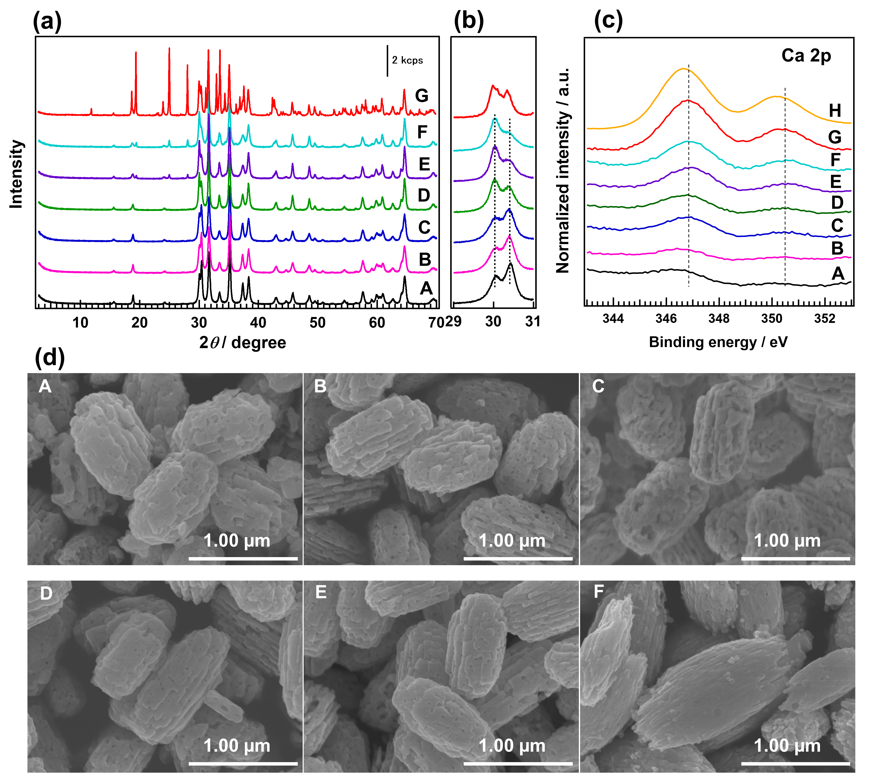
(a) X-ray diffractograms; (b) enlarged X-ray diffractograms at 2θ = 29–31°; (c) Ca 2p X-ray photoelectron spectroscopy profiles; and (d) field-emission scanning electron microscopy images of (A) bare Ga₂O₃; Ga₂O₃_Ca_x with a Ca/Ga molar ratio x of (B) 0.32 mol%, (C) 0.62 mol%, (D) 1.1 mol%, (E) 2.1 mol%, and (F) 3.3 mol%; (G) CaGa₄O₇ (in (a) and (b)), and (H) CaO (in (b)).

Fig. 2. Transmission electron microscopy (TEM) images of the photocatalysts.
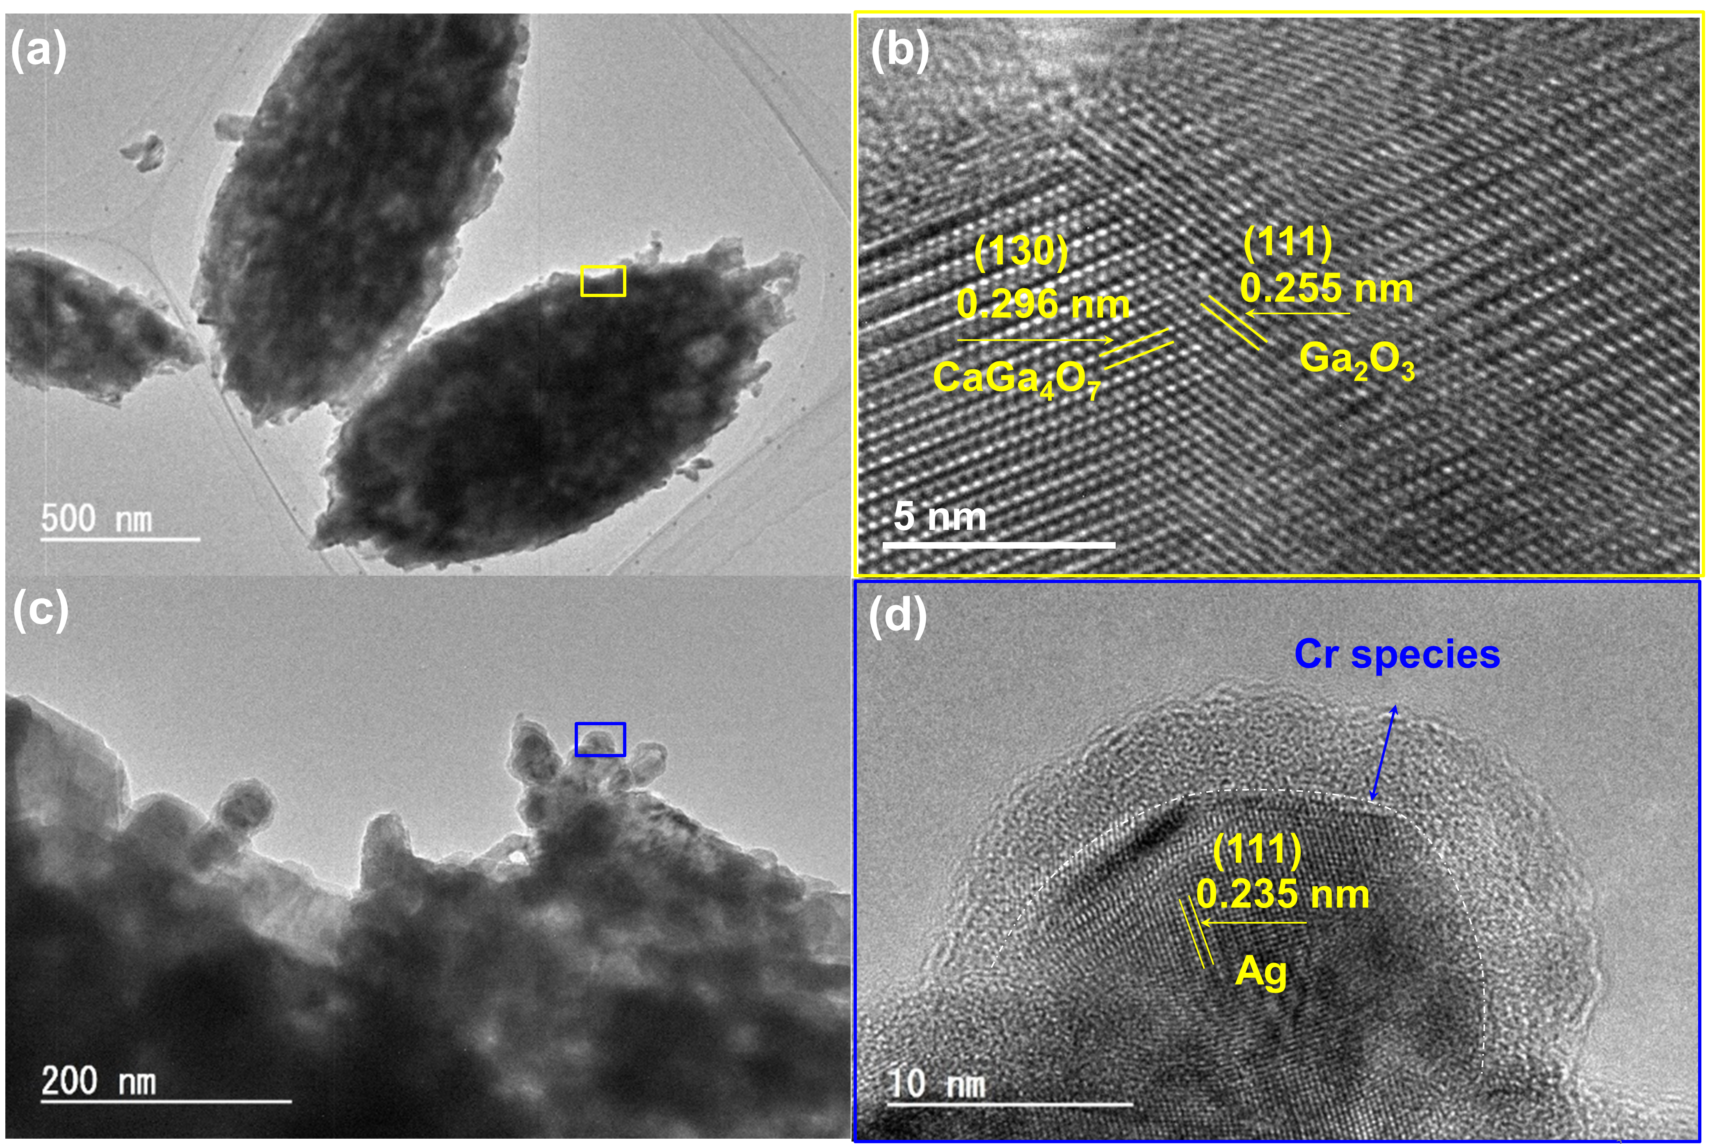
TEM images of (a) Ga₂O₃_Ca and (c) Ag@Cr/Ga₂O₃_Ca. High-resolution TEM images of (b) Ga₂O₃_Ca and (d) Ag@Cr/ Ga₂O₃_Ca. Note that (b) and (d) are enlarged TEM images of the marked areas in (a) and (c) indicated by yellow and blue boxes, respectively.

The close linkage between CaGa₄O₇ and Ga₂O₃ on the Ga₂O₃ surface was confirmed by field-emission transmission electron microscopy (TEM) and high-resolution TEM (HRTEM) (Fig. 2). The marked lattice spacings (0.296 and 0.255 nm) in Fig. 2b correspond to the (130) and (111) planes of CaGa₄O₇ and Ga₂O₃, respectively. The core–shell-structured Ag@Cr cocatalyst was successfully loaded onto the Ga₂O₃_Ca surface using the photodeposition method (Fig. 2c and 2d), as reported previously by us.³¹

Role of the Ca species

Fig. 3. Fourier transform infrared spectra of CO₂ adsorption.
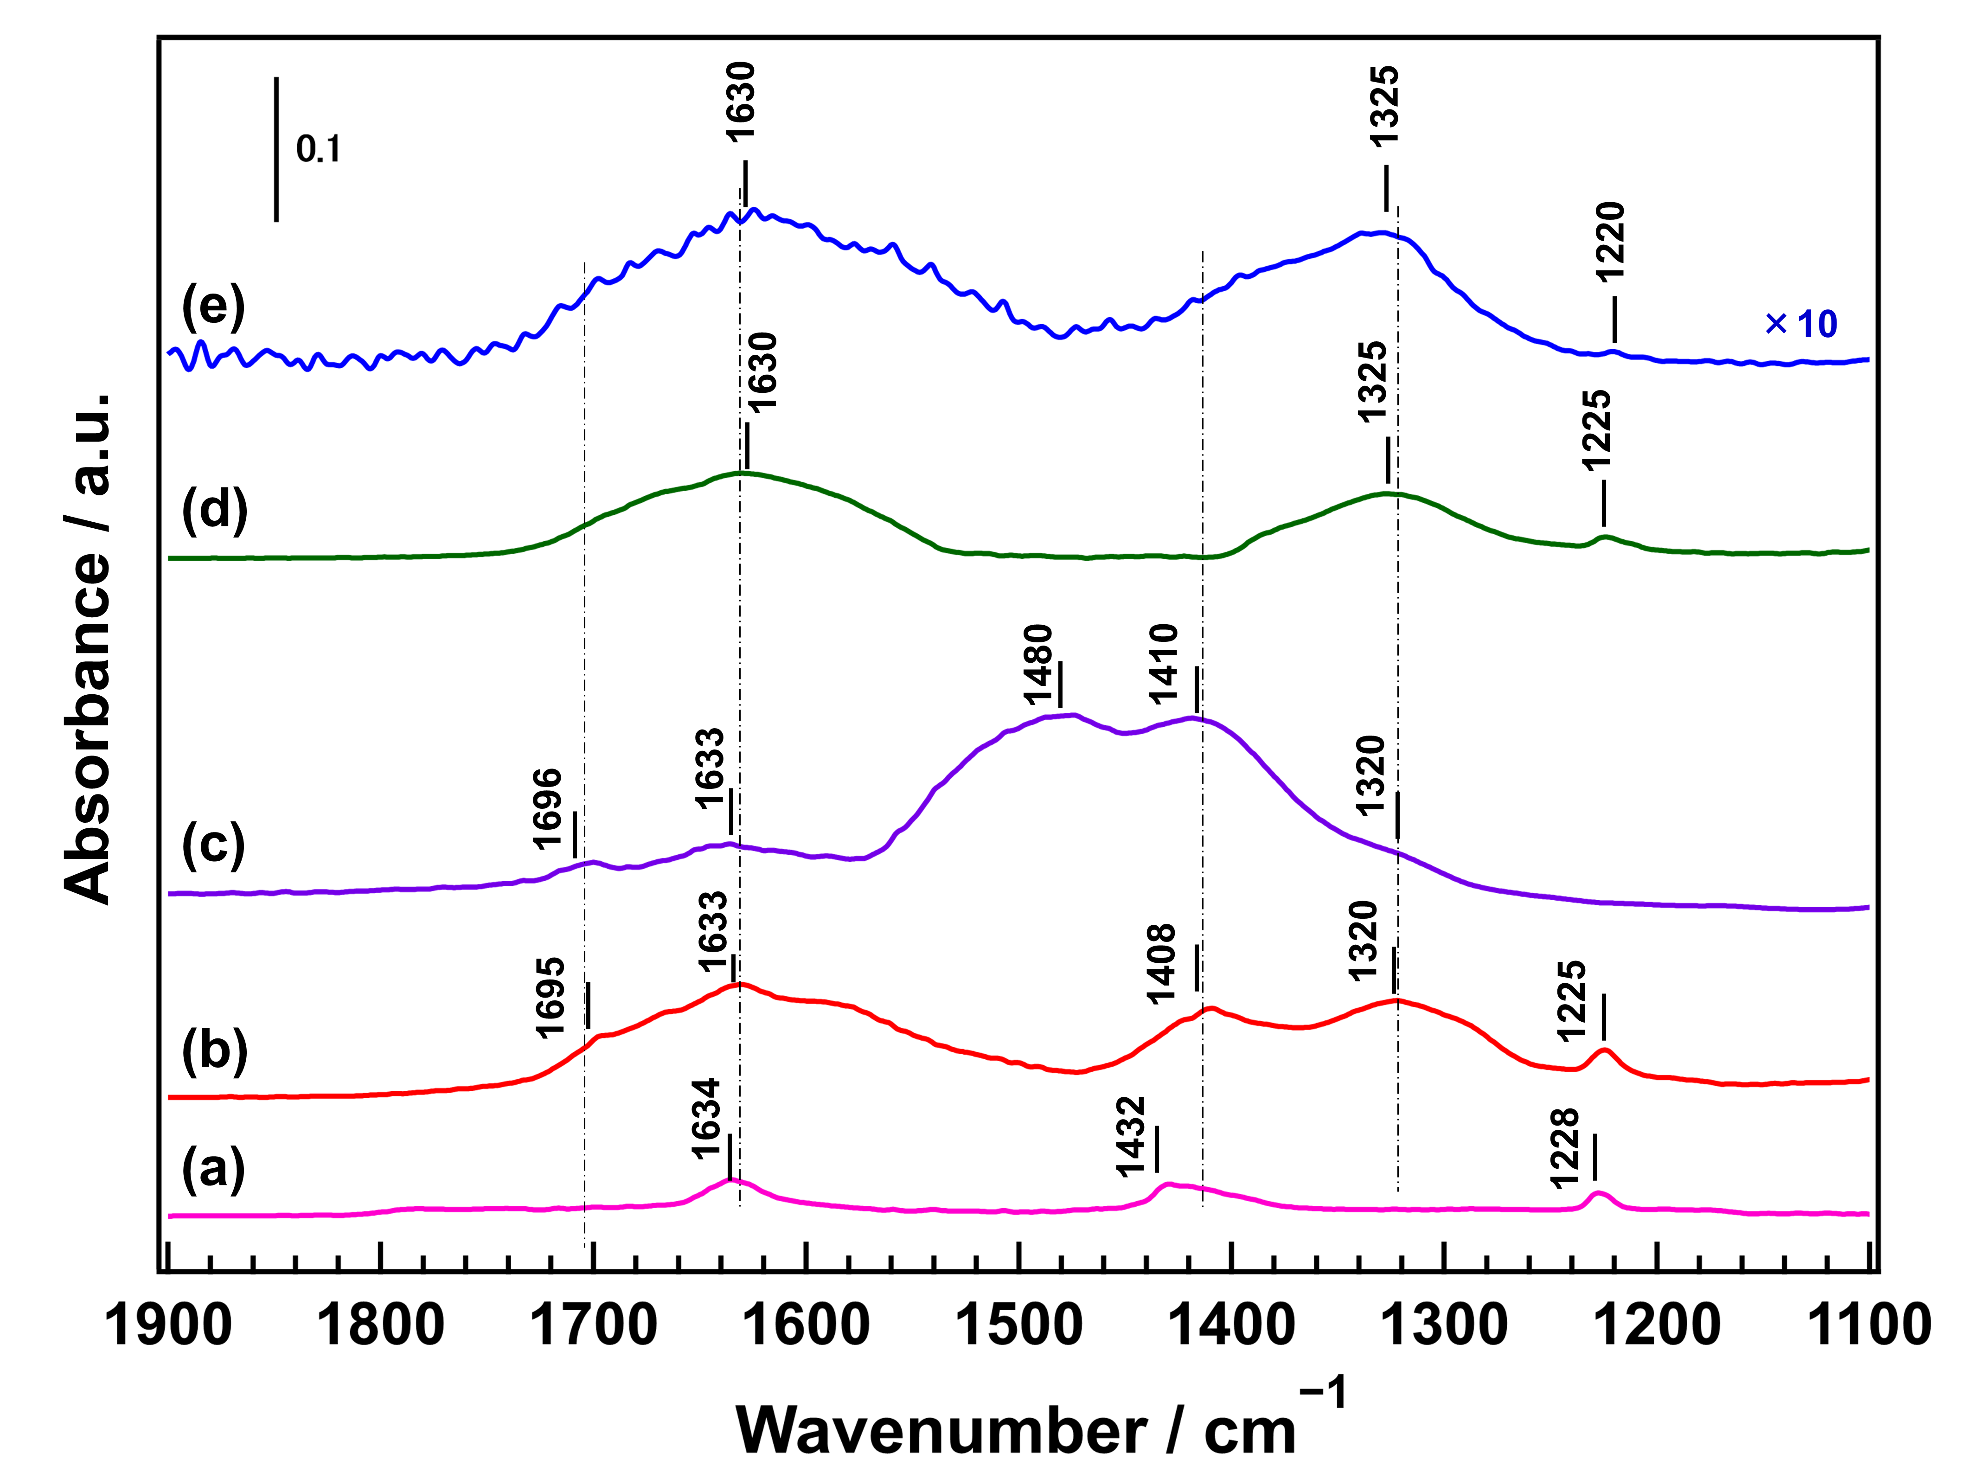
CO₂ adsorbed on: (a) Ga₂O₃, (b) Ga₂O₃_Ca_1.1, (c) CaO, (d) Ga₂O₃_Ca_3.3, and (e) CaGa₄O₇ after introducing ~0.2 Torr of CO₂.

Fig. 3 shows the Fourier transform infrared (FTIR) spectra of the CO₂-adsorbed samples after introducing CO₂ at ~0.2 Torr. When CO₂ was introduced into the Ga₂O₃ sample, three absorbance peaks were observed at 1634, 1432, and 1225 cm^{–1}, which can be ascribed to asymmetric CO₃ stretching vibrations [ν_{as}(CO₃)], symmetric CO₃ stretching vibrations [ν_{s}(CO₃)] of monodentate bicarbonate species (m-HCO₃-Ga), and OH deformation vibrations [δ(OH)], respectively.³⁴⁻³⁶ The absorbance peaks at 1699 and 1636 cm^{–1} for the CO₂-adsorbed CaO sample can be attributed to bridging carbonate stretching and asymmetric CO₃ stretching vibrations [ν_{as}(CO₃)] of the bicarbonate species, respectively. The broad structureless absorbance peaks between 1480 and 1318 cm^{–1} can be attributed to the symmetric and asymmetric CO₃ stretching of unidentate carbonate, as well as the symmetric CO₃ stretching [ν_{s}(CO₃)] of bicarbonate.³⁷⁻⁴¹ When the Ga₂O₃ surface was modified with a small amount of Ca species, absorbance peaks attributable to CO₂ adsorption by both Ga₂O₃ and CaO were observed after CO₂ was introduced into the Ga₂O₃_Ca_1.1 sample. However, when the Ga₂O₃ surface was modified with large amounts of Ca species, the absorbance peaks attributed to CO₂ adsorption on Ga₂O₃ had low intensity and mainly corresponded to the broad peaks derived from the adsorption of CO₂ on CaGa₄O₇. Supplementary Figure 5 shows the FTIR spectra of CO₂-adsorbed Ga₂O₃, Ga₂O₃_Ca_1.1, Ga₂O₃_Ca_3.3, and CaGa₄O₇ samples after introducing the same amount of CO₂ at various pressures in the 0.1–40.0 Torr range. CO₂ was adsorbed significantly more on the Ga₂O₃_Ca_1.1 surface than on the Ga₂O₃ surface due to its adsorption at both Ga and Ca sites. However, the CaGa₄O₇ surface was not conducive to CO₂ adsorption; therefore, CO₂ adsorbed less onto the Ga₂O₃_Ca_3.3 surface than the Ga₂O₃_Ca_1.1 surface.

Fig. 4. FTIR spectra of CO₂ adsorption under photoirradiation.
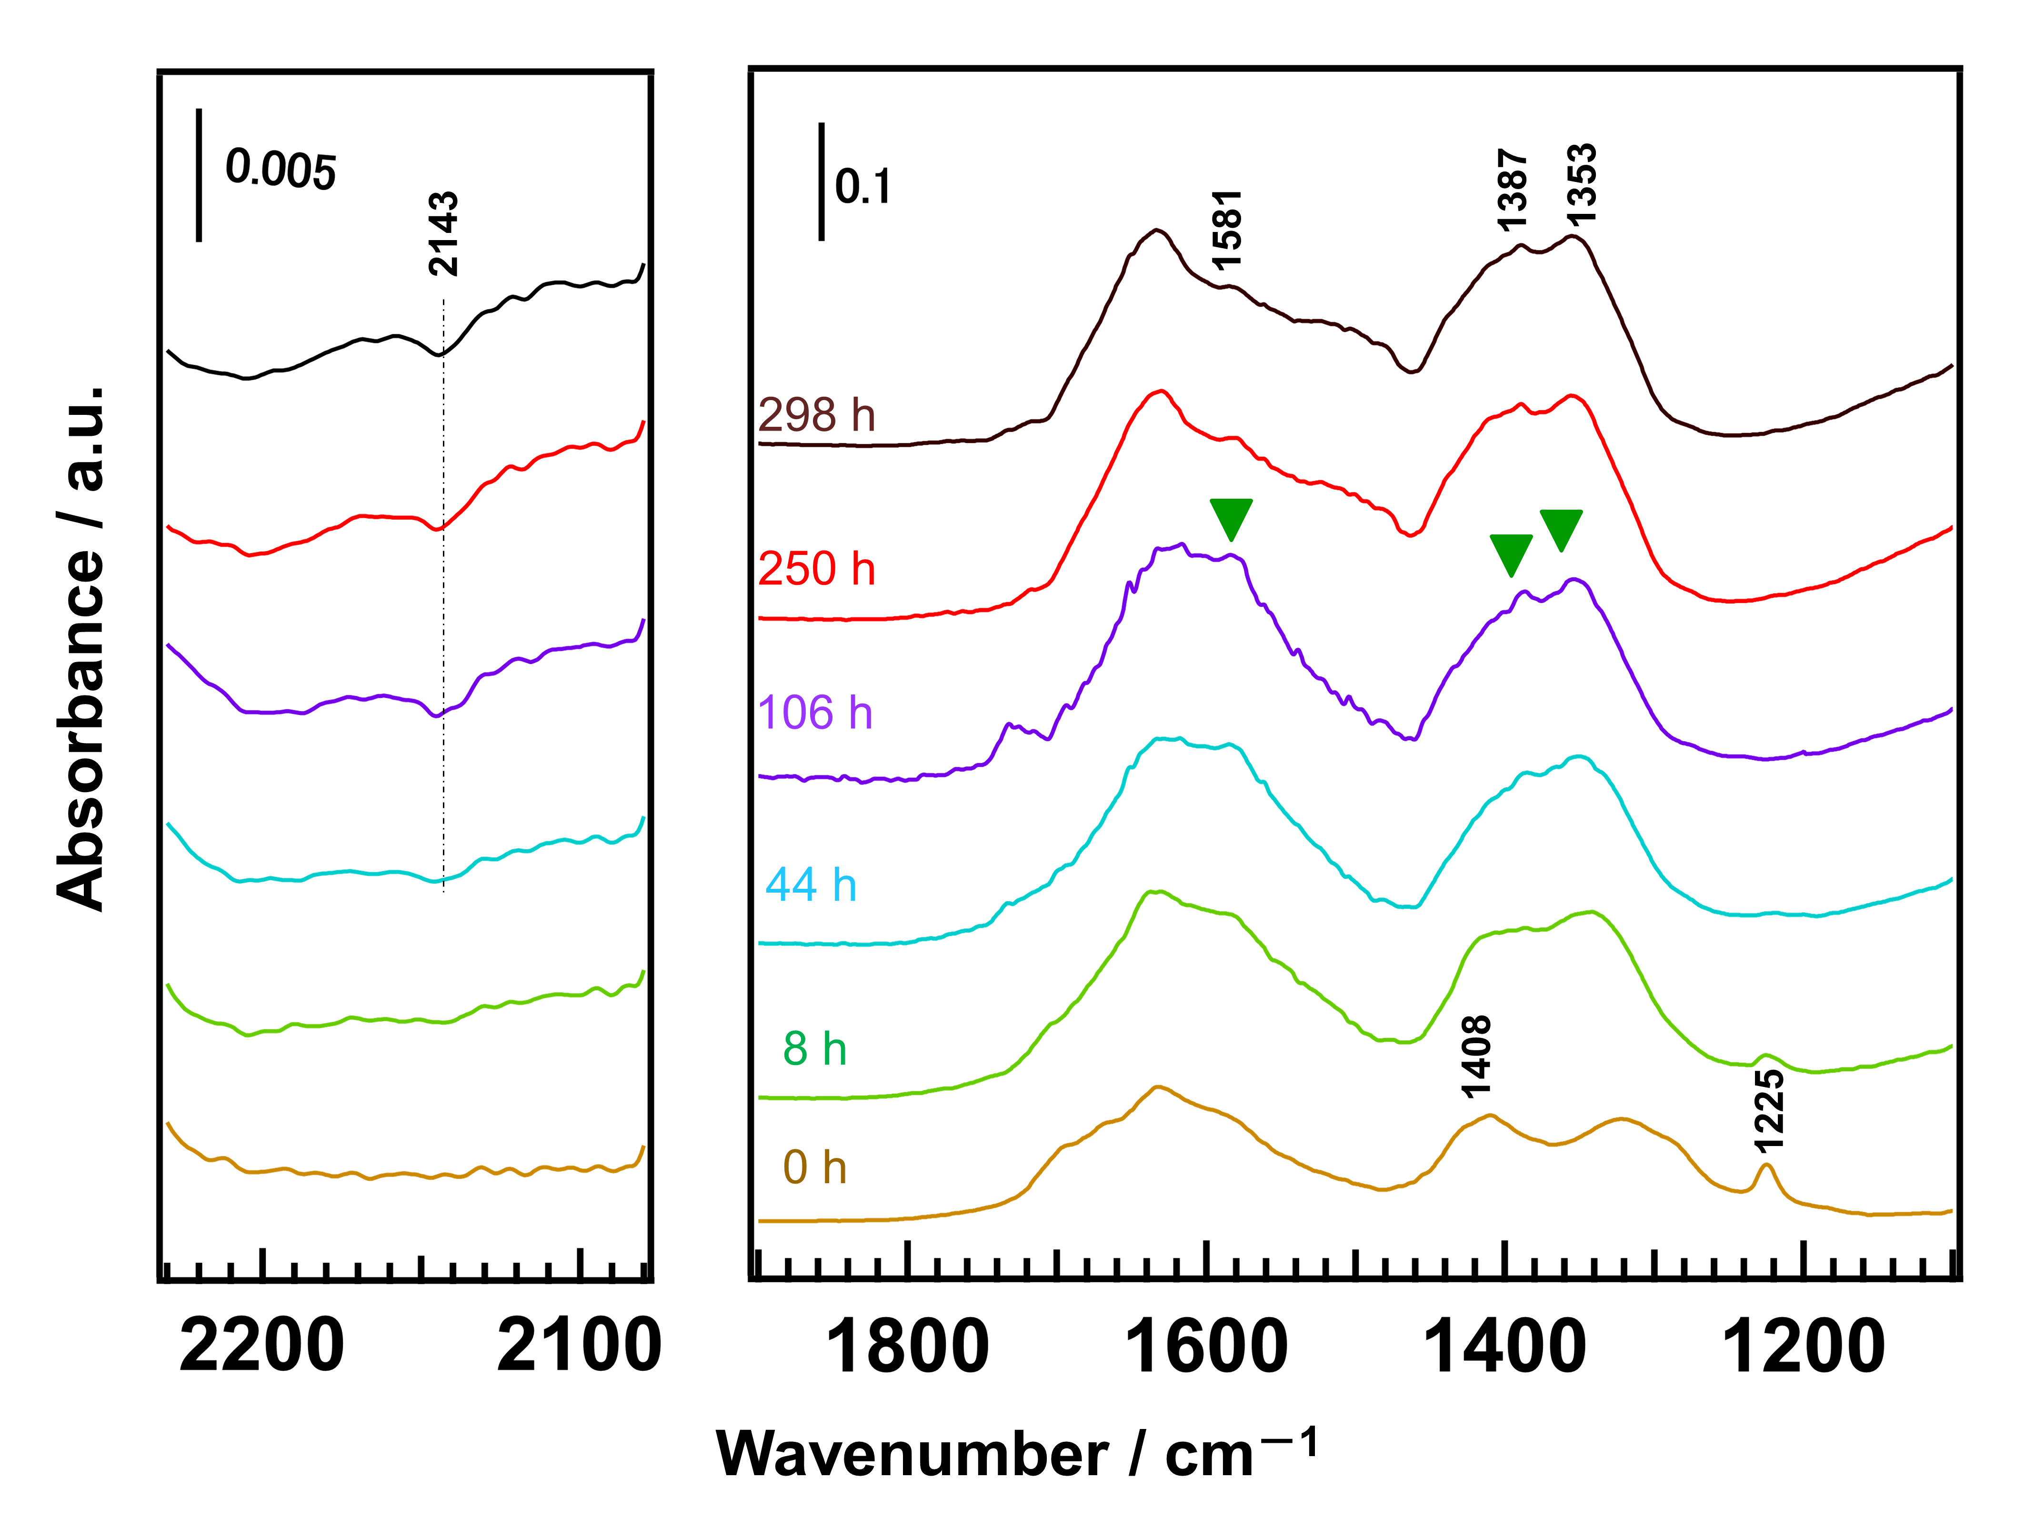
Difference FTIR spectra of the adsorbed CO₂ species on Ga₂O₃_Ca_1.1 under photoirradiation for different hours. ~2.0 Torr of CO₂ was introduced into the instrument.

Fig. 4 shows the FTIR spectra of the adsorbed CO₂ species on Ga₂O₃_Ca_1.1 after different durations of photoirradiation. As the photoirradiation time increased from 0 to 106 h, the bands at 1225 [δ(OH)-Ga] and 1408 cm^{–1} [ν_{s}(CO₃)-Ca] decreased and vanished after 104 h. At the same time, new bands gradually appeared at 1581, 1388, and 1353 cm^{–1} (asymmetric CO₂ stretching [ν_{as}(CO₂)], CH deformation [δ(CH)], and symmetric CO₂ stretching [ν_{s}(CO₂)] assigned to formate species (HCOO−Ga/Ca), respectively).³⁴⁻³⁶ As the photoirradiation continued, the formate species were consumed and gaseous CO (fundamental vibration band at 2143 cm⁻¹)⁴² was formed simultaneously. This result indicates that the bicarbonate species is the intermediate during the photocatalytic conversion of CO₂, and the formates transform into CO with photoirradiation, which is consistent with our previous results.^{43,44} It is worth mentioning that in addition to the presence of intermediate species on the Ga₂O₃ surface ([δ(OH)-Ga]), the modification by Ca species further increased the amount of intermediate on Ga₂O₃_Ca_1.1. As the photocatalytic conversion of H⁺ into H₂ and the conversion of CO₂ into CO are two competing processes in an aqueous solution, the high adsorption of CO₂ at the base site leads to high photocatalytic activity and selectivity toward CO evolution during the photocatalytic conversion of CO₂ by H₂O.
In order to demonstrate that the presence of CaO on the Ga₂O₃ surface enhances the photocatalytic activity and selectivity during the photocatalytic conversion of CO₂ into CO, we investigated the photocatalytic performance during the conversion of CO₂ by H₂O over various Ag@Cr/CaO/Ga₂O₃ photocatalysts, the results of which are shown in Fig. 5. We found that the Ag@Cr/Ga₂O₃_Ca_1.1 photocatalyst (with a low amount of CaO generated on the Ga₂O₃ surface) significantly enhanced the rate of CO formation during the photocatalytic conversion of CO₂ by H₂O compared with bare Ag@Cr/Ga₂O₃ (Fig. 5a and 5b). However, no significant change in the rate of CO formation and selectivity toward CO evolution was observed for the sample labeled “Ag@Cr/(1.1mol%CaO/Ga₂O₃)” (in which 1.1 mol% CaO was physically loaded onto Ga₂O₃ by grinding before loading Ag@Cr cocatalyst onto the CaO/Ga₂O₃ surface) as compared to bare Ga₂O₃ (Fig. 5c). Because uncalcined CaO-loaded Ga₂O₃ easily dissolves in H₂O, we increased the CaO loading on the Ga₂O₃ surface to 30 mol% using the same grinding method (labeled “Ag@Cr/(30mol%CaO/Ga₂O₃)”), which resulted in an increased rate of CO formation and a decrease in H₂ formation (Fig. 5d). However, no improvement in photocatalytic activity and selectivity was observed when 30 mol% CaO was mixed with the prepared Ag@Cr/Ga₂O₃ and ground together (Fig. 5e) or when they were directly mixed in the reaction solution (Fig. 5f). These results clearly reveal that the addition of CaO on the Ga₂O₃ surface enhances the rate of CO formation and suppresses that of H₂ during the photocatalytic conversion of CO₂ by H₂O. In addition, the tight junction between Ga₂O₃, CaO, and the Ag@Cr cocatalyst is crucial for the superior photocatalytic activity and selectivity of the photocatalyst for the conversion of CO₂ into CO. In our previous work, we confirmed that Ag acts as an active site while the Cr(OH)₃·H₂O layer exterior to the Ag core increases CO₂ adsorption.^{30,31} Hence, the Ag@Cr cocatalyst should be loaded at the CaO/Ga₂O₃ interface in order to facilitate contact between the CaO-adsorbed CO₂ species and the Ag active sites.

Fig. 5. Product formation rates and selectivity.
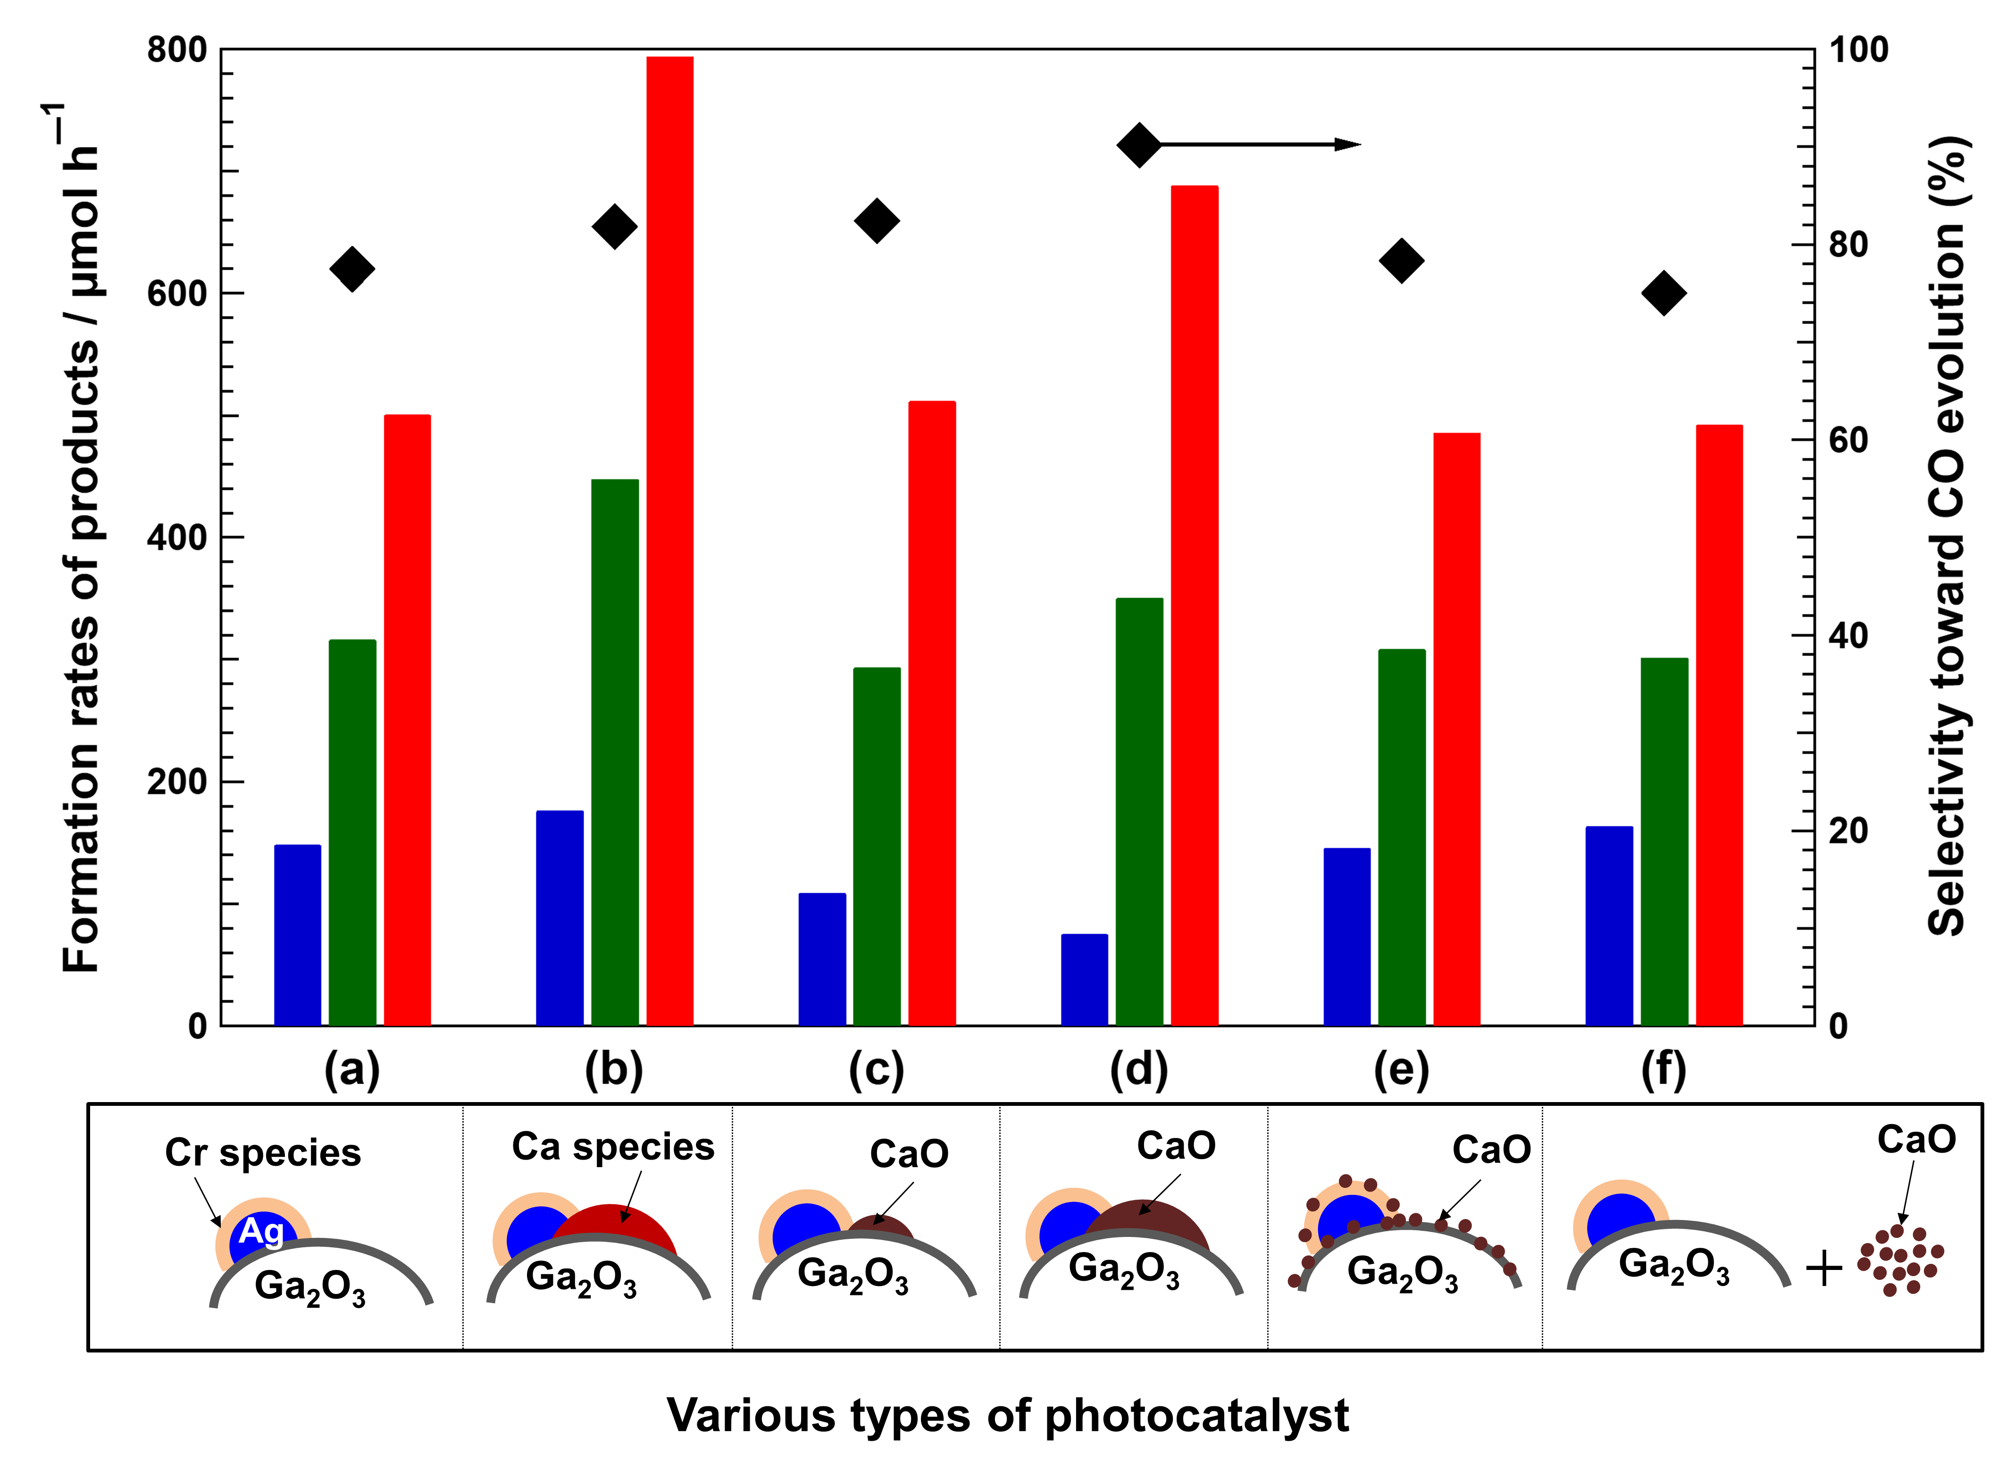
Rates of formation of H₂ (blue bars), O₂ (green bars), and CO (red bars), as well as selectivity toward CO evolution (black diamonds) for various photocatalysts: (a) Ag@Cr/Ga₂O₃; (b) Ag@Cr/Ga₂O₃_Ca_1.1; (c) Ag@Cr/(1.1mol%CaO/Ga₂O₃), namely Ga₂O₃ physically mixed with 1.1 mol% of CaO by grinding before loading the Ag@Cr cocatalyst; (d) Ag@Cr/(30mol%CaO/Ga₂O₃), which is similar to (c) except for using 30 mol% of CaO; (e) Ag@Cr/Ga₂O₃ + 30mol%CaO, namely Ag@Cr/Ga₂O₃ physically mixed with 30 mol% of CaO by grinding; and (f) Ag@Cr/Ga₂O₃ and 30 mol% of CaO without mixing before adding into the reaction solution. Schematic structures of the photocatalysts are shown at bottom. Photocatalyst powder: 0.5 g, reaction solution volume: 1.0 L, additive: 0.1 M NaHCO₃, CO₂ flow rate: 30 mL min⁻¹, light source: 400 W high-pressure Hg lamp.

Notably, although CaGa₄O₇ exhibited high selectivity toward H₂ evolution, the H₂ formation rate for CaGa₄O₇ was significantly lower than that for Ga₂O₃_Ca_3.3 (for the product formation rates over Ag-Cr/Ga₂O₃_Ca_3,3 see Supplementary Figure 6). This indicates that the presence of CaGa₄O₇ on the Ga₂O₃ surface enhances the overall photocatalytic efficiency during the photocatalytic reaction, including CO₂ conversion and water splitting. The Mott–Schottky plot (Supplementary Figure 7) and the absorption spectra converted from the diffuse reflectance spectra using the Kubelka–Munk equation (Supplementary Figure 8) enabled us to estimate the conduction band (CB) and valence band (VB) positions of Ga₂O₃, Ga₂O₃_Ca_0.62, and CaGa₂O₇, as shown in Supplementary Figure 9. Since the CB and VB of Ga₂O₃ are both more positive than those of CaGa₄O₇, a heterojunction system between Ga₂O₃ and CaGa₄O₇ can be formed that greatly improves the spatial separation efficiency of the photogenerated carriers.⁴⁵ Therefore, CaGa₄O₇/Ga₂O₃ exhibited a much higher photocatalytic efficiency than bare Ga₂O₃ and CaGa₄O₇.
We expect that by exploiting the high CO₂ adsorption of CaO and the high photocatalytic efficiency of CaGa₄O₇/Ga₂O₃, we can further improve the photocatalytic activity and selectivity of the photocatalyst to maximize the conversion of CO₂ into CO by H₂O. Fig. 6a shows the formation rates of H₂, O₂, and CO during the photocatalytic conversion of CO₂ by H₂O for the Ga₂O₃_Ca_3.3 photocatalyst physically mixed with 30 mol% of CaO and Ag@Cr as the cocatalyst. As indicated, a high formation rate of CO (>835 µmol h^{–1}) was achieved, in addition to an excellent selectivity toward CO evolution (>95%), with a stoichiometric amount of evolved O₂. Both ¹²CO and ¹³CO were detected using quadrupole mass spectrometry (MS), and the peaks at m/z = 28 and m/z = 29 were located at the same positions as those detected by gas chromatography (GC) during the photocatalytic conversion of ¹³CO₂ (for the isotopic lead experiments see Supplementary Figure 10). Indeed, our results indicate that the detected ¹²CO was produced from the reduction of ¹²CO₂ derived from the NaHCO₃ additive in the solution.⁴³ As shown in Fig. 6b, with the consumption of ¹²CO₂ derived from NaHCO₃, the amount of generated ¹²CO gradually decreased, while the ¹³CO content increased under continuous bubbling of ¹³CO₂. The total amounts of ¹³CO and ¹²CO detected by MS were consistent with the amount of CO detected by GC (Fig. 6c), which indicates that the CO was generated as the reduction product of either CO₂ introduced in the gas phase or from NaHCO₃, rather than from any organic contaminants on the photocatalyst surface. The converted concentration of CO based on the CO formation rate was found to be 11531 ppm, indicating that ~1.2% of CO₂ in the gas phase was transformed into CO (see Supplementary Information for the calculation details. The actual amounts of CO detected are shown in Supplementary Movie 1).

Fig. 6. CO, O₂, and H₂ formation data.
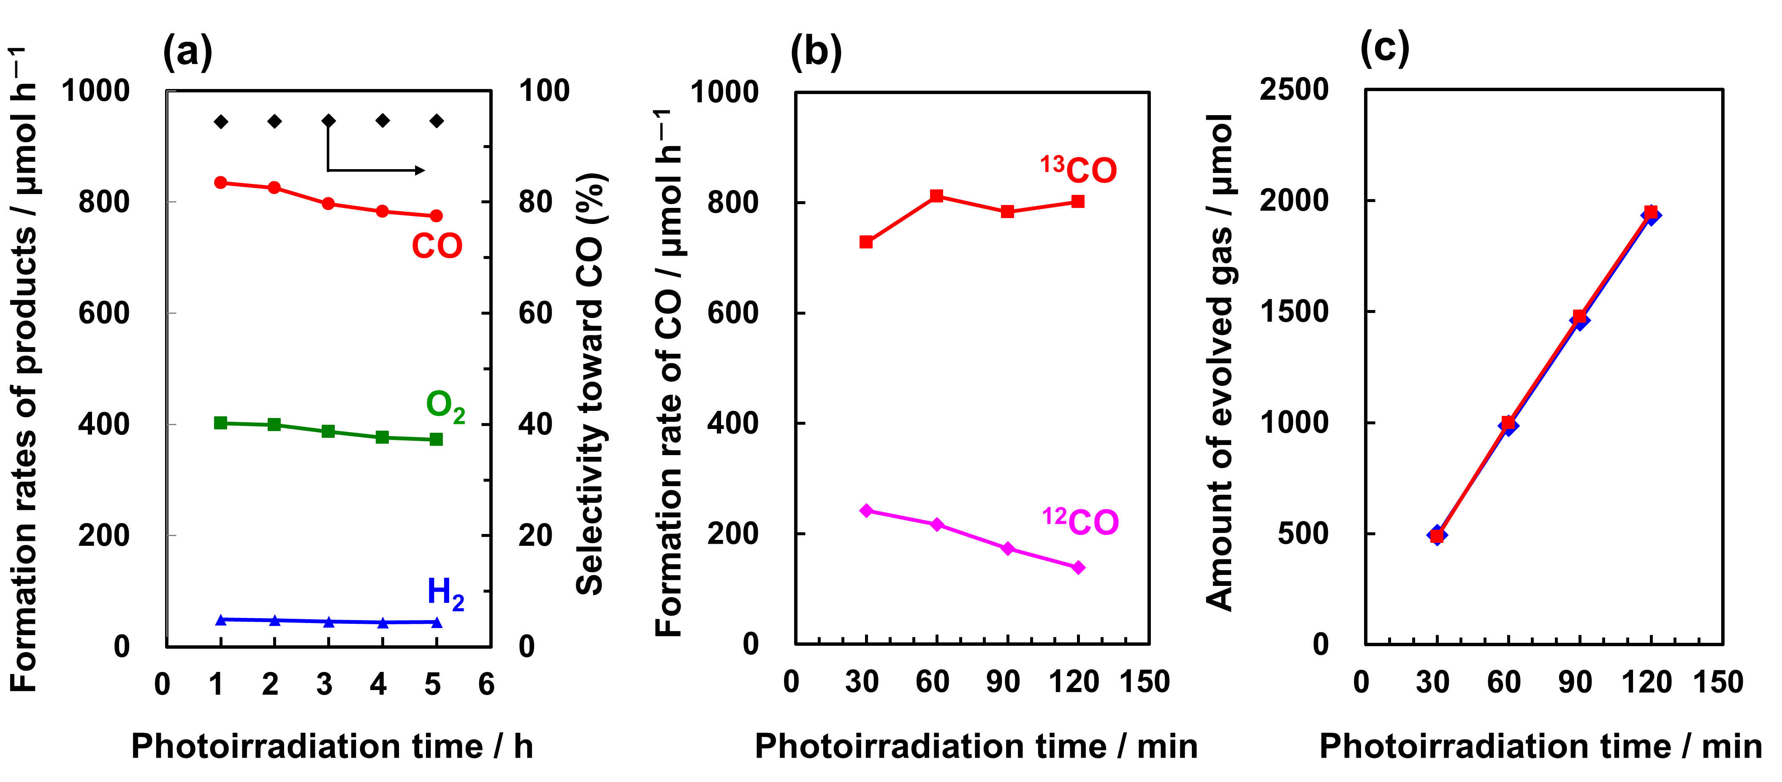
(a) Formation rates of H₂ (blue triangles), O₂ (green squares), and CO (red circles), and selectivity toward CO evolution (black diamonds) for the photocatalytic conversion of CO₂ by H₂O; (b) ¹²CO and ¹³CO detected by MS (m/z = 28 and 29) from the photocatalytic conversion of ¹³CO₂ by H₂O; (c) CO time-course as determined by MS (red squares) and GC (blue diamonds) for the photocatalytic conversion of ¹³CO₂ by H₂O.

Fig. 7. A plausible reaction mechanism.
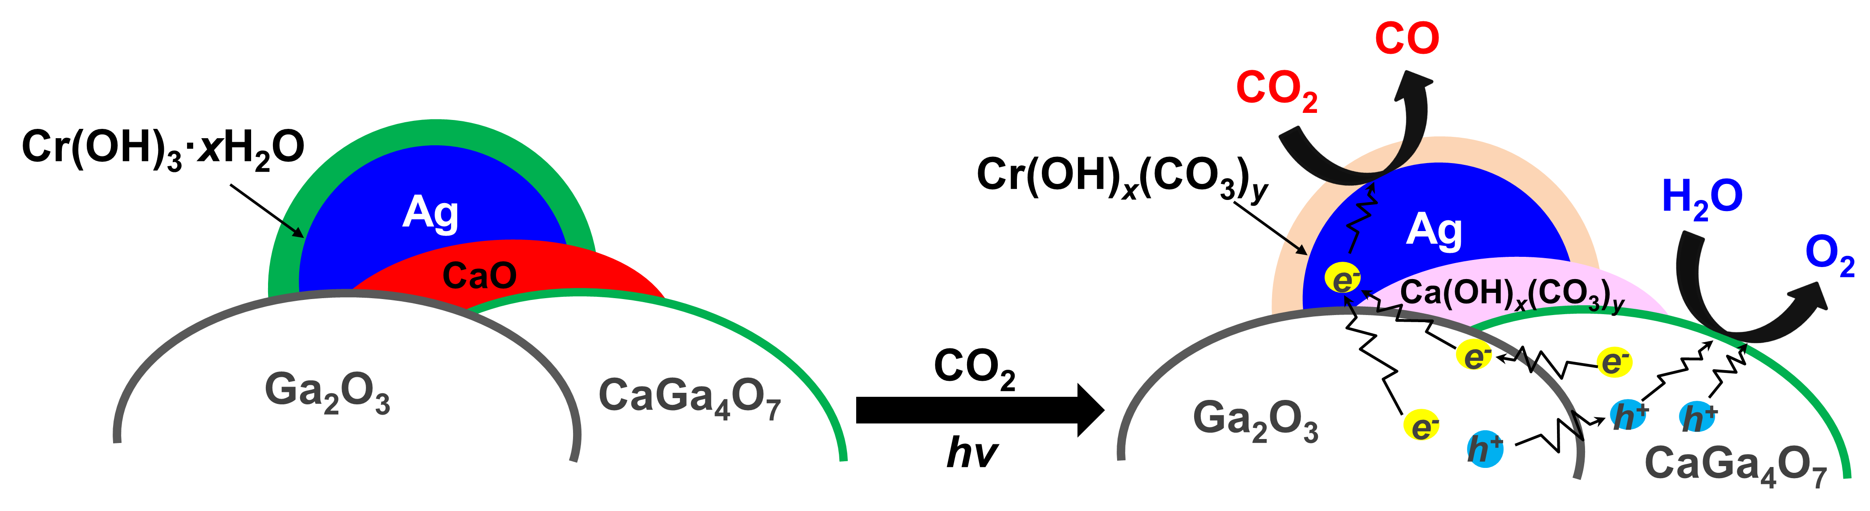
Schematic illustration of the mechanism for the photocatalytic conversion of CO₂ into CO over Ag@Cr/CaO/CaGa₄O₇/Ga₂O₃.

In our previous work, we had found that basic oxides and hydroxides such as Cr(OH)₃,³¹ SrO,⁴⁴ and rare earth (RE) hydrates and oxides²⁸ function as good CO₂ storage materials by generating the corresponding (hydroxy)carbonate compounds (e.g. Cr(OH)_{x}(CO₃)_{y} and RE₂(OH)_{2(3-x)}(CO₃)_{x}), and they improve the photocatalytic activity and selectivity toward CO evolution. Now, we propose a possible mechanism for the photocatalytic conversion of CO₂ by H₂O over Ag@Cr/CaO/CaGa₂O₇/Ga₂O₃, as shown in Fig. 7. During the photocatalytic conversion of CO₂ in an aqueous solution of NaHCO₃, the Cr(OH)₃·H₂O and CaO species that are in close contact with Ag particles easily form (hydroxy)carbonate species (named M(OH)_{x}(CO₃)_{y}, M = Cr or Ca),³¹ which greatly increase the concentration of CO₂-related species around the Ag active sites, thereby improving selectivity for the photocatalytic conversion of CO₂ into CO instead of water splitting. On the other hand, the Ga₂O₃/CaGa₄O₇ heterojunction improves the efficiency for spatial separation of the photogenerated carriers, which also increases the photocatalytic activity for the conversion of CO₂ into CO. Moreover, while the Cr(OH)₃·xH₂O shell outside the Ag particle can be oxidized to Cr⁶⁺ and dissolve into the solution during the photocatalytic conversion of CO₂,⁴⁶ the presence of CaO around the Ag active site compensates for the reduced activity from the dissolution of Cr species. As a result, Ag@Cr/Ga₂O₃_Ca is photocatalytically much more stable than Ag@Cr/Ga₂O₃.
Herein, we reported the photocatalytic conversion of CO₂ using a Ag@Cr/CaO/CaGa₄O₇/Ga₂O₃ photocatalyst, in which a satisfactory CO formation rate (>835 µmol h⁻¹) and an excellent selectivity toward CO evolution (95%) were achieved with the stoichiometric production of O₂ as the oxidation product of H₂O. Through the use of various characterization techniques, we found that the CaO and CaGa₄O₇ formed on the Ga₂O₃ surface improved the adsorption of CO₂ at basic sites in addition to enhancing the total photocatalytic efficiency. In addition, the physical mixing of CaGa₄O₇/Ga₂O₃ with CaO was a particularly simple and convenient technique for exploiting the high CO₂ adsorption ability of CaO and the high photocatalytic efficiency of CaGa₄O₇/Ga₂O₃. These results are of particular interest, considering that previously, only insufficient amounts of CO₂ reduction products were produced during artificial photosynthesis.

Methods
Ca-modified Ga₂O₃ (Ga₂O₃_Ca) was prepared using the ammonia precipitation method reported by Sakata et al.⁴⁷ In this method, Ga(NO₃)₃∙nH₂O (12.6 g) was dissolved in 200 mL of deionized water or CaCl₂ solution in ultrapure water at various concentrations. Hydroxylation was carried out by dripping an ammonium hydroxide solution until the pH level reached 9.1. The obtained hydroxides were centrifuged and dried overnight. The Ga₂O₃_Ca sample was obtained by calcining the precursor at 1273 K for 10 h. Ag@Cr/Ga₂O₃_Ca was synthesized using the photodeposition method reported in our previous work.³⁰ In this method, the as-prepared Ga₂O₃_Ca powder (1.0 g) was dispersed in ultrapure water (1.0 L) containing the necessary amounts of silver nitrate (AgNO₃) and chromium (III) nitrate (Cr(NO₃)₃). The suspension was purged with Ar gas and irradiated under a 400 W high-pressure Hg lamp with Ar gas flowing for 1.0 h, followed by filtration and drying at room temperature (~298 K). The Ag/Ga and Cr/Ga molar ratios were both 1.0 mol%.
Characterization
The as-prepared Ga₂O₃_Ca samples were characterized using the following techniques: XRD (Model: Multiflex, Rigaku Corporation, Japan) with Cu Kα radiation (λ = 0.154 nm); XPS (Model: ESCA 3400, Shimadzu Corporation, Japan) with Mg Kα radiation; SEM (Model: SU-8220, Hitachi High-Technologies Corporation, Japan); TEM (Model: JEM-2100F, JEOL Ltd, Japan); and UV-Visible spectroscopy (V-650, JASCO) with an integrated sphere accessory. The BET surface areas of the photocatalyst samples were determined from their N₂-adsorption isotherms at 77 K using a volumetric gas-adsorption measuring instrument (Model: BELSORP-miniII, MicrotracBEL Corp. (formerly BEL Japan, Inc.), Japan). Prior to these measurements, each sample was evacuated at 473 K for 1 h using a sample pretreatment system (Model: BELPREP-vacII, MicrotracBEL Corp. (formerly BEL Japan, Inc.), Japan). ICP-OES (Model: iCAP7400, Thermo Fisher Scientific, USA) was used to determine the actual amounts of Ca modified on the Ga₂O₃ surface. The FTIR spectra of the adsorbed carbon species were recorded using an FTIR spectrometer (Model: FT/IR-4700, JASCO International Co., Ltd., Japan) equipped with a mercury-cadmium-tellurium (MCT) detector and cooled with liquid N₂ in the transmission mode at 303 K. Each sample (~30 mg) was pressed into a wafer (diameter: 10 mm) and introduced into the instrument in a cylindrical glass cell with calcium fluoride (CaF₂) windows. The wafer was evacuated at 673 K for 30 min before being examined, followed by treatment with O₂ at ~40 Torr for 30 min, after which the wafer was evacuated for 30 min and cooled to 303 K. The data for each FTIR spectrum were obtained from 128 scans with a resolution of 4 cm⁻¹. The energy gap of the band structure and flat band potential of the Ga₂O₃_Ca samples were determined using the Davis–Mott and Mott–Schottky equations, respectively; the experimental details are provided in the Supplementary Information.

Photocatalytic reaction
The photocatalytic reduction of CO₂ was carried out using a flow system with an inner irradiation-type reaction vessel. The synthesized photocatalyst (0.5 g) was dispersed in ultrapure water (1.0 L) containing 0.1 M sodium bicarbonate (NaHCO₃). The CO₂ was bubbled into the solution at a flow rate of 30 mL min⁻¹. The suspension was illuminated using a 400 W high-pressure Hg lamp with a quartz filter, and the assembly was connected to a water-cooling system. The amounts of evolved H₂ and O₂ were detected using a gas chromatography system fitted with a thermal conductivity detector (TCD-GC, Model: GC-8A, Shimadzu Corporation, Japan) and a 5A molecular sieve (MS 5A) column, and Ar was used as the carrier gas. The amount of evolved CO was analyzed using a gas chromatography system fitted with a flame ionization detector (FID-GC, Model: GC-8A, Shimadzu Corporation, Japan), a methanizer, and a ShinCarbon ST column, and N₂ was used as the carrier gas. High-performance liquid chromatography (HPLC, Model: LC-4000, JASCO, USA) was used to detect the presence of liquid products.
In the isotope experiment, ¹²CO₂ was replaced by ¹³CO₂. The formation rates of H₂, O₂, ¹²CO, and ¹³CO under photoirradiation were detected using a quadrupole mass spectrometer (BELMASS, Microtrac BEL) combined with a TCD-GC detector.
Data availability
The datasets generated during and/or analysed during the current study are available in the [figshare] repository, [URL: https://figshare.com/s/84a5d675a273e507fb55 and/or DOI: 10.6084/m9.figshare.12927422].
References
1 IPCC; Pachauri, R. K. & Meyer, L. A., eds. Climate Change 2014: Synthesis Report. Contribution of Working Groups I, II and III to the Fifth Assessment Report of the Intergovernmental Panel on Climate Change. (IPCC, Geneva, Switzerland, 2014).
2 Halmann, M. Photoelectrochemical reduction of aqueous carbon dioxide on p-type gallium phosphide in liquid junction solar cells. Nature 275, 115-116 (1978).
3 Inoue, T., Fujishima, A., Konishi, S. & Honda, K. Photoelectrocatalytic reduction of carbon dioxide in aqueous suspensions of semiconductor powders. Nature 277, 637-638 (1979).
4 Li, K., Peng, B. & Peng, T. Recent advances in heterogeneous photocatalytic CO₂ conversion to solar fuels. ACS Catal. 6, 7485-7527 (2016).
5 Mikkelsen, M., Jørgensen, M. & Krebs, F. C. The teraton challenge. A review of fixation and transformation of carbon dioxide. Energy Environ. Sci. 3, 43-81 (2010).
6 Barber, J. Photosynthetic energy conversion: natural and artificial. Chem. Soc. Rev. 38, 185-196 (2009).
7 Cokoja, M., Bruckmeier, C., Rieger, B., Herrmann, W. A. & Kühn, F. E. Transformation of carbon dioxide with homogeneous transition‐metal catalysts: a molecular solution to a global challenge? Angew. Chem. Int. Ed. 50, 8510-8537 (2011).
8 Wu, L. Y. et al. Encapsulating perovskite quantum dots in iron‐based metal–organic frameworks (MOFs) for efficient photocatalytic CO₂ reduction. Angew. Chem. Int. Ed. 58, 9491-9495 (2019).
9 Tu, W., Zhou, Y. & Zou, Z. Photocatalytic conversion of CO₂ into renewable hydrocarbon fuels: state‐of‐the‐art accomplishment, challenges, and prospects. Adv. Mater. 26, 4607-4626 (2014).
10 Linsebigler, A. L., Lu, G. & Yates Jr., J. T. Photocatalysis on TiO₂ surfaces: principles, mechanisms, and selected results. Chem. Rev. 95, 735-758 (1995).
11 Vu, N.-N., Kaliaguine, S. & Do, T.-O. Critical aspects and recent advances in structural engineering of photocatalysts for sunlight-driven photocatalytic reduction of CO₂ into fuels. Adv. Funct. Mater. 29, 1901825 (2019).
12 Stöcker, M. Methanol-to-hydrocarbons: catalytic materials and their behavior. Micropor. Mesopor. Mater. 29, 3-48 (1999).
13 Tian, P., Wei, Y., Ye, M. & Liu, Z. Methanol to olefins (MTO): from fundamentals to commercialization. ACS Catal. 5, 1922-1938 (2015).
14 Khodakov, A. Y., Chu, W. & Fongarland, P. Advances in the development of novel cobalt Fischer−Tropsch catalysts for synthesis of long-chain hydrocarbons and clean fuels. Chem. Rev. 107, 1692-1744 (2007).
15 Dry, M. E. The Fischer–Tropsch process: 1950–2000. Catal. Today 71, 227-241 (2002).
16 White, J. L. et al. Light-driven heterogeneous reduction of carbon dioxide: photocatalysts and photoelectrodes. Chem. Rev. 115, 12888-12935 (2015).
17 Surdhar, P. S., Mezyk, S. P. & Armstrong, D. A. Reduction potential of the carboxyl radical anion in aqueous solutions. J. Phys. Chem. 93, 3360-3363 (1989).
18 Hisatomi, T., Kubota, J. & Domen, K. Recent advances in semiconductors for photocatalytic and photoelectrochemical water splitting. Chem. Soc. Rev. 43, 7520-7535 (2014).
19 Morris, A. J., McGibbon, R. T. & Bocarsly, A. B. Electrocatalytic carbon dioxide activation: The rate-determining step of pyridinium-catalyzed CO₂ reduction. ChemSusChem 4, 191-196 (2011).
20 Iizuka, K., Wato, T., Miseki, Y., Saito, K. & Kudo, A. Photocatalytic reduction of carbon dioxide over Ag cocatalyst-loaded ALa₄Ti₄O₁₅ (A = Ca, Sr, and Ba) using water as a reducing reagent. J. Am. Chem. Soc. 133, 20863-20868 (2011).
21 Nakanishi, H., Iizuka, K., Takayama, T., Iwase, A. & Kudo, A. Highly active NaTaO₃‐based photocatalysts for CO₂ reduction to form CO using water as the electron donor. ChemSusChem 10, 112-118 (2017).
22 Yoshida, H. et al. Calcium titanate photocatalyst prepared by a flux method for reduction of carbon dioxide with water. Catal. Today 251, 132-139 (2015).
23 Huang, Z., Teramura, K., Hosokawa, S. & Tanaka, T. Fabrication of well-shaped Sr₂KTa₅O₁₅ nanorods with a tetragonal tungsten bronze structure by a flux method for artificial photosynthesis. Appl. Catal. B 199, 272-281 (2016).
24 Pang, R., Teramura, K., Asakura, H., Hosokawa, S. & Tanaka, T. Highly selective photocatalytic conversion of CO₂ by water over Ag-loaded SrNb₂O₆ nanorods. Appl. Catal. B 218, 770-778 (2017).
25 Bhugun, I., Lexa, D. & Savéant, J.-M. Catalysis of the electrochemical reduction of carbon dioxide by iron (0) porphyrins. Synergistic effect of Lewis acid cations. J. Phys. Chem. 100, 19981-19985 (1996).
26 Meng, X. et al. Photocatalytic CO₂ conversion over alkali modified TiO₂ without loading noble metal cocatalyst. Chem. Commun. 50, 11517-11519 (2014).
27 Liao, Y. et al. Efficient CO₂ capture and photoreduction by amine‐functionalized TiO₂. Chem. Eur. J. 20, 10220-10222 (2014).
28 Huang, Z., Teramura, K., Asakura, H., Hosokawa, S. & Tanaka, T. CO₂ capture, storage, and conversion using a praseodymium-modified Ga₂O₃ photocatalyst. J. Mater. Chem. A 5, 19351-19357 (2017).
29 Teramura, K., Tatsumi, H., Wang, Z., Hosokawa, S. & Tanaka, T. Photocatalytic conversion of CO₂ by H₂O over Ag-loaded SrO-modified Ta₂O₅. Bull. Chem. Soc. Jpn. 88, 431-437 (2015).
30 Pang, R. et al. Modification of Ga₂O₃ by an Ag–Cr core–shell cocatalyst enhances photocatalytic CO evolution for the conversion of CO₂ by H₂O. Chem. Commun. 54, 1053-1056 (2018).
31 Pang, R., Teramura, K., Asakura, H., Hosokawa, S. & Tanaka, T. Effect of thickness of chromium hydroxide layer on Ag cocatalyst surface for highly selective photocatalytic conversion of CO₂ by H₂O. ACS Sustain. Chem. Eng. 7, 2083-2090 (2018).
32 Ogata, M., Fujimoto, K. & Shinkai, S. Molecular design of calix[4]arene-based extractants which show high Ca²⁺ selectivity. J. Am. Chem. Soc. 116, 4505-4506 (1994).
33 Moriga, T., Kammler, D. R., Mason, T. O., Palmer, G. B. & Poeppelmeier, K. R. Electrical and optical properties of transparent conducting homologous compounds in the indium–gallium–zinc oxide system. J. Am. Ceram. Soc. 82, 2705-2710 (1999).
34 Tsuneoka, H., Teramura, K., Shishido, T. & Tanaka, T. Adsorbed species of CO₂ and H₂ on Ga₂O₃ for the photocatalytic reduction of CO₂. J. Phys. Chem. C 114, 8892-8898 (2010).
35 Collins, S. E., Baltanás, M. A. & Bonivardi, A. L. An infrared study of the intermediates of methanol synthesis from carbon dioxide over Pd/β-Ga₂O₃. J. Catal. 226, 410-421 (2004).
36 Collins, S. E., Baltanás, M. A. & Bonivardi, A. L. Infrared spectroscopic study of the carbon dioxide adsorption on the surface of Ga₂O₃ polymorphs. J. Phys. Chem. B 110, 5498-5507 (2006).
37 Fukuda, Y. & Tanabe, K. Infrared study of carbon dioxide adsorbed on magnesium and calcium oxides. Bull. Chem. Soc. Jpn. 46, 1616-1619 (1973).
38 Philipp, R. & Fujimoto, K. FTIR spectroscopic study of carbon dioxide adsorption/desorption on magnesia/calcium oxide catalysts. J. Phys. Chem. 96, 9035-9038 (1992).
39 Busca, G. & Lorenzelli, V. Infrared spectroscopic identification of species arising from reactive adsorption of carbon oxides on metal oxide surfaces. Mater. Chem. 7, 89-126 (1982).
40 Tsyganenko, A. & Filimonov, V. Infrared spectra of surface hydroxyl groups and crystalline structure of oxides. J. Mol. Struct. 19, 579-589 (1973).
41 Busca, G., Lamotte, J., Lavalley, J. C. & Lorenzelli, V. FT-IR study of the adsorption and transformation of formaldehyde on oxide surfaces. J. Am. Chem. Soc. 109, 5197-5202 (1987).
42 Wenig, R. W. & Schrader, G. L. In situ FTIR (Fourier transform IR) spectroscopy of 1-butene and 1, 3-butadiene. Selective oxidation to maleic anhydride on vanadium-phosphorus-oxygen catalysts. J. Phys. Chem. 91, 1911-1918 (1987).
43 Teramura, K. et al. Which is an intermediate species for photocatalytic conversion of CO₂ by H₂O as the electron donor: CO₂ molecule, carbonic acid, bicarbonate, or carbonate ions? J. Phys. Chem. C 121, 8711-8721 (2017).
44 Yoshizawa, S. et al. Important role of strontium atom on the surface of Sr₂KTa₅O₁₅ with a tetragonal tungsten bronze structure to improve adsorption of CO₂ for photocatalytic conversion of CO₂ by H₂O. ACS Appl. Mater. Interfaces 11, 37875-37884 (2019).
45 Habisreutinger, S. N., Schmidt‐Mende, L. & Stolarczyk, J. K. Photocatalytic reduction of CO₂ on TiO₂ and other semiconductors. Angew. Chem. Int. Ed. 52, 7372-7408 (2013).
46 Pang, R., Teramura, K., Asakura, H., Hosokawa, S. & Tanaka, T. Effect of Cr species on photocatalytic stability during the conversion of CO₂ by H₂O. J. Phys. Chem. C 123, 2894-2899 (2019).
47 Sakata, Y., Hayashi, T., Yasunaga, R., Yanaga, N. & Imamura, H. Remarkably high apparent quantum yield of the overall photocatalytic H₂O splitting achieved by utilizing Zn ion added Ga₂O₃ prepared using dilute CaCl₂ solution. Chem. Commun. 51, 12935-12938 (2015).

Acknowledgements
This study was partially supported by a Grant-in-Aid for Scientific Research on Innovative Areas, “All Nippon Artificial Photosynthesis Project for Living Earth” [grant number 2406] of the Ministry of Education, Culture, Sports, Science, and Technology (MEXT) of Japan and the Program for Element Strategy Initiative for Catalysts & Batteries (ESICB) [No. JPMXP0112101003], commissioned by the MEXT of Japan.
Author information
Affiliations
Department of Molecular Engineering, Graduate School of Engineering, Kyoto University, Kyotodaigaku Katsura, Nishikyo-ku, Kyoto 615-8510, Japan
Rui Pang & Kentaro Teramura & Masashige Morishita &Hiroyuki Asakura & Saburo Hosokawa &Tsunehiro Tanaka
Element Strategy Initiative for Catalysts & Batteries (ESICB), Kyoto University, 1-30 Goryo-Ohara, Nishikyo-ku, Kyoto 615-8245, Japan
Kentaro Teramura &Hiroyuki Asakura & Saburo Hosokawa &Tsunehiro Tanaka
Contributions
R.P. and K.T. designed the research. R.P. prepared the photocatalyst powder and conducted XRD, BET, XPS, SEM, TEM, ICP-OES, UV-vis, and FTIR studies, electrochemical measurements, and the photocatalytic CO₂-conversion experiments. M.M. carried out the isotopic labelling experiment. R.P., K.T., M.M., H.A., S.H. and T.T. discussed the results. R.P. and K.T. wrote the manuscript with contributions from the other authors.
Corresponding authors
Correspondence to Kentaro Teramura and Tsunehiro Tanaka.
Competing interests
The authors declare no competing interests.
Additional information
Supplementary information is available for this paper at xxxx.

