Supplementary Material

Items of the questionnaires used in Study 1

The items are actually used in Chinese. The following English translation is only for readers to understand the research contents.

The following items are all responded on a 5-point Likert scale from 1 (not at all) to 5 (very much in line)
Perceived severity of COVID-19.
- I am worried that my family and I will be infected with the new coronavirus.
- During the pandemic, I sometimes thought, "will there be a virus on this thing?"
- I believe the pandemic will breakout again.
- Things around me always remind that the pandemic is never far away.
- I often suspect that people around me may be infected by the coronavirus.
- I will avoid contact with others, believing that contact increases the risk of infection.
Boredom from limited activities.
- During the pandemic, I was bored by restrictions on movement.
- During the pandemic, I was frustrated by restrictions on movement.
- During the pandemic, I felt empty because of restrictions on movement.
- During the pandemic, everything was monotonous and repetitive and boring for me because of the restrictions on my activities
Sensation seeking expressions
- During the pandemic, I was interested in almost every new thing.
- During the pandemic, I always liked to do things I had not done before
- During the pandemic, I would feel uncomfortable for staying in the same place for too long.
- During the pandemic, if I do the same thing for a long time, I will be restless.
- During the pandemic, I prefer to interact with friends in a variety of ways.
- During the pandemic, new stimulation always makes me very happy.
- During the pandemic, I was willing to do anything as long as it was exciting and stimulating.
- During the pandemic, in order to alleviate boredom, I am willing to take some risks.
Post-pandemic consumption willingness
- When the pandemic is over, I want to go out and eat some delicious food.
- When the pandemic is over, I want to have more shopping and buying.
- When the pandemic is over, I will compensate for my pent-up spend desire and satisfy myself by buying more things.
- When the pandemic is over, my consumption desire will increase significantly than before the pandemic
- When the pandemic is over, I want to buy something that I haven’t bought before.
- When the pandemic is over, I will spend more and have fun in time.

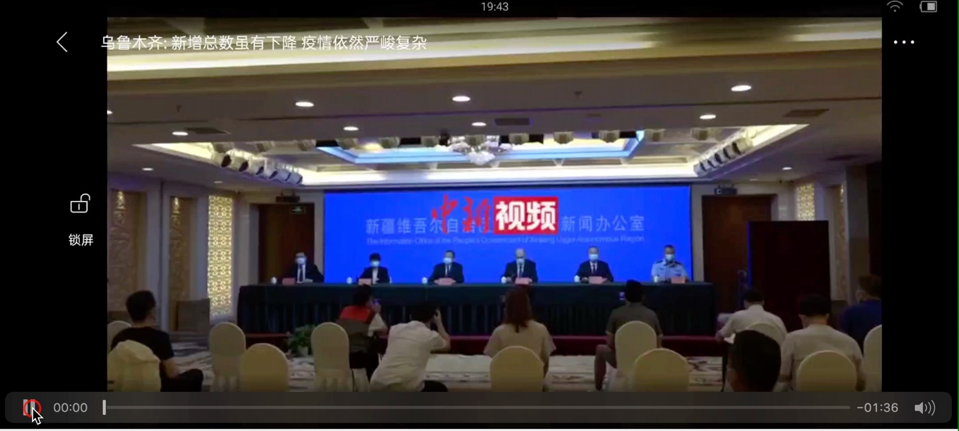
Videos for manipulating the perceived severity of COVID-19

News video about the COVID-19 pandemic had already effectively controlled in China
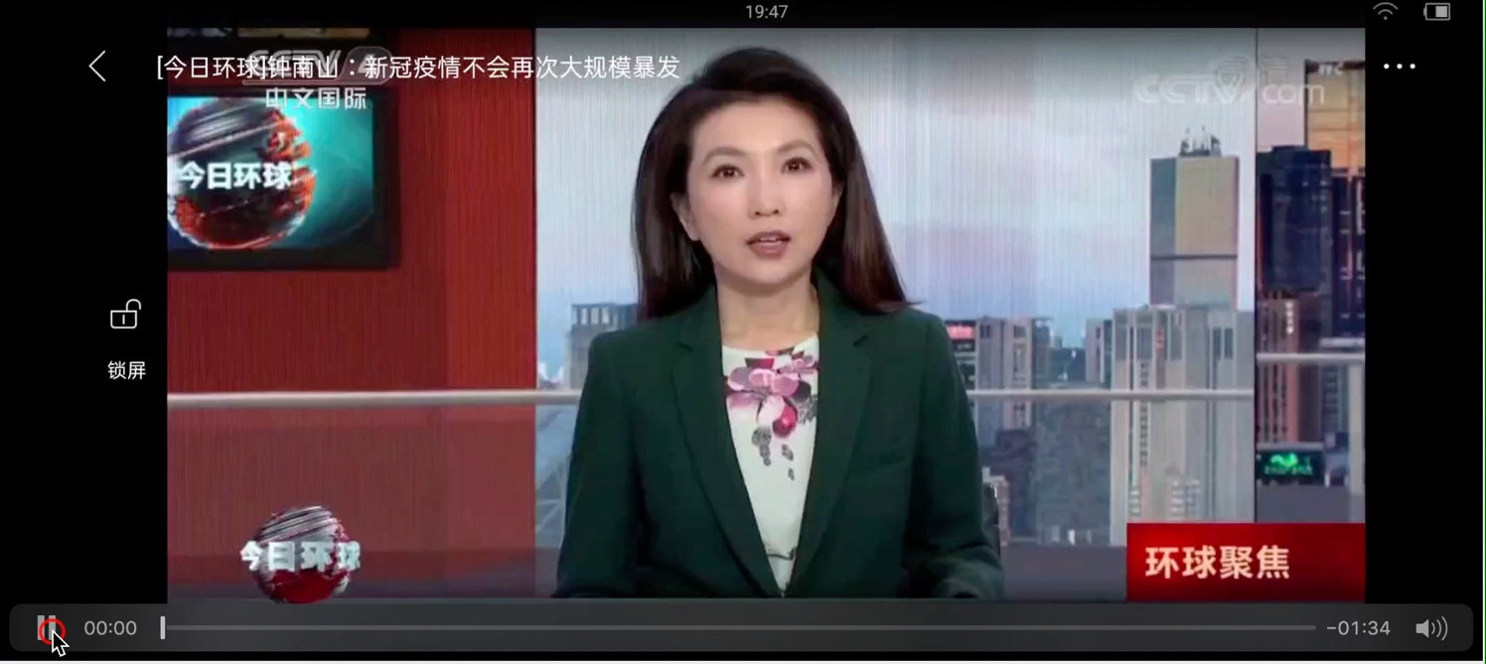
Video title: 钟南山：新冠疫情不会再次大规模暴发 (Dr. Zhong Nanshan: COVID-19 pandemic will not break out again on a large scale)

News video about the COVID-19 pandemic is still severe in China
Video title: 乌鲁木齐：新增总数虽有下降，疫情依然严峻复杂 (Urumqi: although the total number of new increases in COVID-19 infection has declined, the pandemic situation is still grim and complicated)

