An Embedded Gene Selection Method Using Knockoffs Optimizing Neural Network
Juncheng Guo^{1,2,3}, Min Jin⁴, Yuanyuan Chen⁴, Jianxiao Liu^{1,4,*}
¹Hubei Key Laboratory of Agricultural Bioinformatics, College of Informatics, Huazhong Agricultural University, Wuhan, 430070
²Institute of Information Engineering, Chinese Academy of Sciences, Beijing 100093, China
³School of Cyber Security, University of Chinese Academy of Sciences, Beijing 100093, China
⁴National Key Laboratory of Crop Genetic Improvement, Huazhong Agricultural University, Wuhan, 430070

E-mail addresses:
Juncheng Guo: yuexiaozhuoke@gmail.com (J. Guo)
Min Jin: 834245464@qq.com (M. Jin)
Yuanyuan Chen: yychentamu@163.com (Y. Chen)
Jianxiao Liu: liujianxiao321@163.com (J. Liu)

*Correspondence: Jianxiao Liu (liujianxiao321@163.com)

The file includes seven figures (Figure 1 – Figure 7) and seven tables (Table 1 –Table 7). All the data is available at http://122.205.95.139/Knockoffs-NN/Dataset.rar. All the source code is available at http://122.205.95.139/Knockoffs-NN/Knockoffs-NN.rar.

Figures
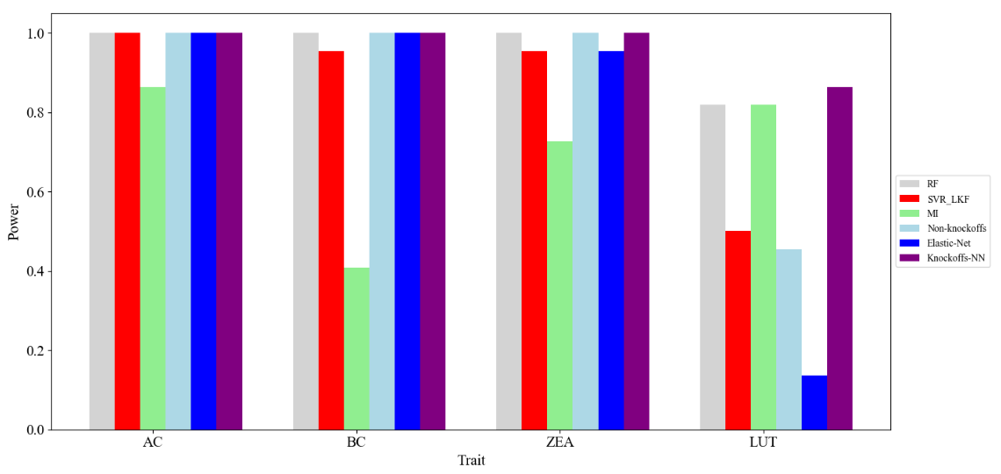
Figure 1. Result of gene crtRB1(GRMZM2G152135) for maize carotenoids

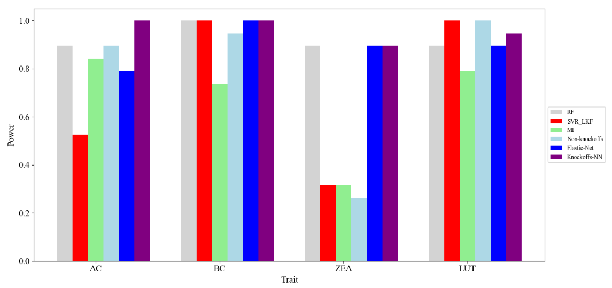
Figure 2. Result of gene lcyE(GRMZM2G012966) for maize carotenoids

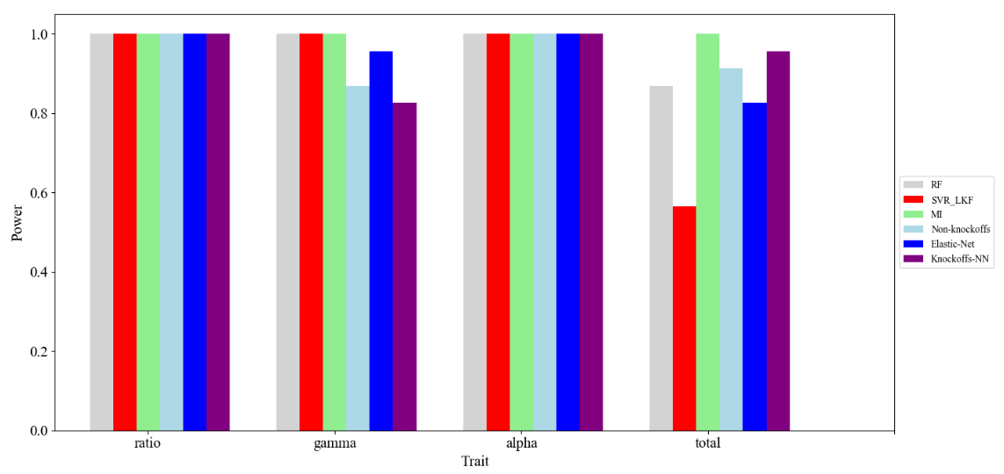
Figure 3. Result of gene VTE4(GRMZM2G035213) for maize tocopherol

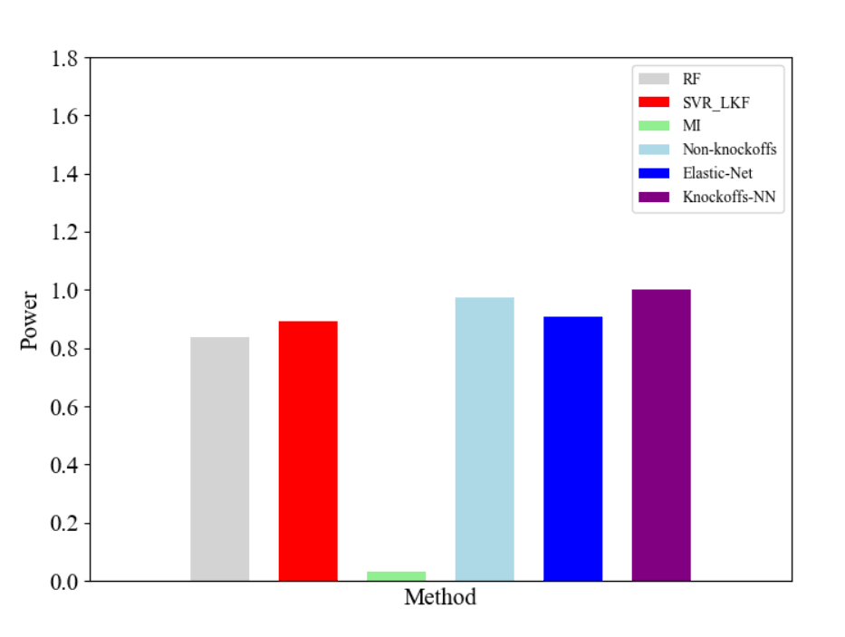
Figure 4. Result of gene ZmGOL (GRMZM5G872256) for maize raffinose

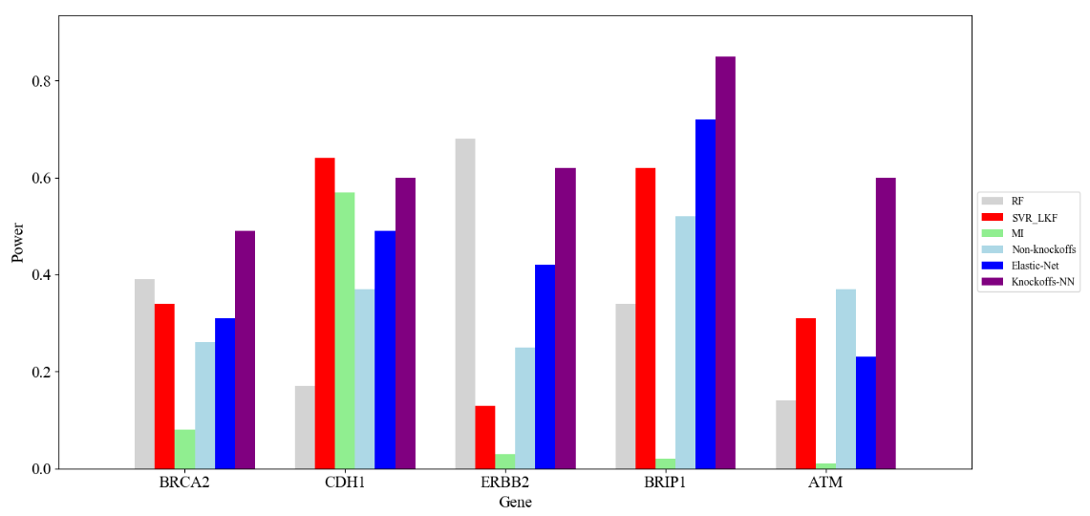
Figure 5. Results of human breast cancer dataset

Figure 6. The framework of our method

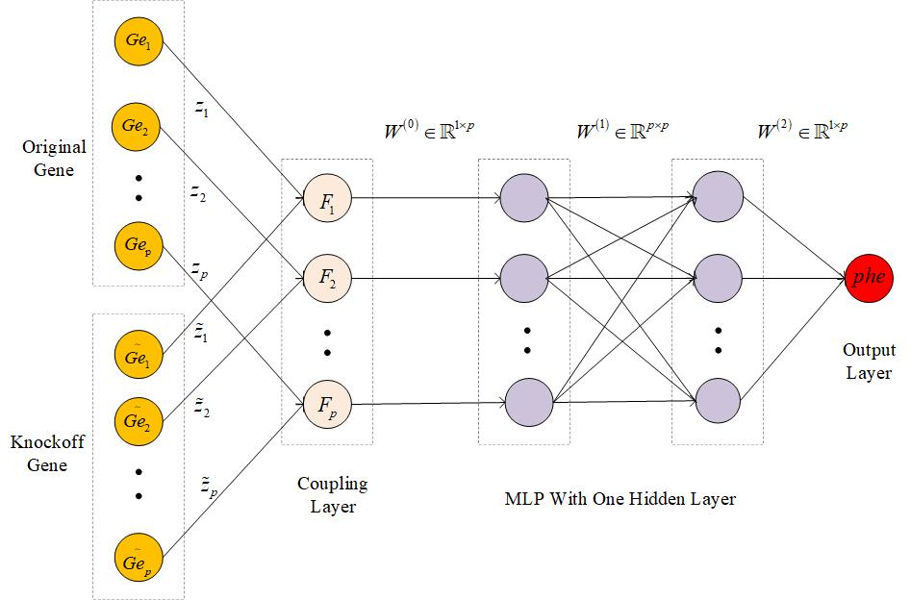
Figure 7. The gene selection framework of knockoff optimizing neural network

Tables
Table 1. Parameters setting in the experiment
Parameter setting | Value
Activation function | ReLU
Regularization | L1
Loss function | Mean square error (MSE)
Optimization | Batch gradient descent and Adam (recommend mini-batch for large samples)
Number of hidden layer | 1
Number of hidden layer neurons (genes) | Number of genes
Learning rate | 0.0001

Table 2. The ranking of crtRB1(GRMZM2G152135) about different phenotypes
Methods  Traits | RF | SVR_LKF | MI | Elastic-Net | Non-Knockoffs | Knockoffs-NN
AC | 1 | 1 | 4 | 1 | 1 | 1
BC | 1 | 2 | 14 | 1 | 1 | 1
ZEA | 1 | 2 | 7 | 2 | 1 | 1
LUT | 5 | 12 | 5 | 20 | 13 | 4

Table 3. The ranking of lcyE(GRMZM2G012966) about different phenotypes
Methods  Traits | RF | SVR_LKF | MI | Elastic-Net | Non-Knockoffs | Knockoffs-NN
AC | 3 | 10 | 4 | 5 | 3 | 1
BC | 1 | 1 | 6 | 1 | 2 | 1
ZEA | 3 | 14 | 1 | 3 | 15 | 3
LUT | 3 | 1 | 5 | 3 | 1 | 2

Table 4. The ranking of VTE4(GRMZM2G035213) about different phenotypes
Methods  Traits | RF | SVR_LKF | MI | Elastic-Net | Non-Knockoffs | Knockoffs-NN
ratio | 1 | 1 | 1 | 1 | 1 | 1
gamma | 1 | 1 | 1 | 2 | 4 | 5
alpha | 1 | 1 | 1 | 1 | 1 | 1
total | 4 | 11 | 1 | 5 | 3 | 2

Table 5. The ranking of ZmGOL(GRMZM5G872256) about maize raffinose
Methods  Trait | RF | SVR_LKF | MI | Elastic-Net | Non-Knockoffs | Knockoffs-NN
M71 | 36 | 24 | 209 | 21 | 7 | 1

Table 6. The results of ZmGOL(GRMZM5G872256) about top-5 genes
Methods  Number | RF | SVR_LKF | MI | Non-  Knockoffs | Elsatic-  Net | Knockoffs-NN
1 | GRMZM2G092174  (0.048) | GRMZM2G005984  (0.396) | GRMZM2G043295  (0.126) | GRMZM2G121360  (0.529) | GRMZM2G121360  (0.420) | GRMZM5G872256  (0.00358520178299)
2 | GRMZM2G060842  (0.033) | GRMZM2G022686  (0.221) | GRMZM2G092174  (0.108) | GRMZM5G875954  (0.411) | GRMZM2G102382  (0.377 | GRMZM5G877547  (0.00290219524756)
3 | GRMZM2G129815  (0.027) | GRMZM2G121360  (0.205) | GRMZM2G129815  (0.090) | GRMZM2G134107  (0.390) | GRMZM2G005984  (0.376) | GRMZM2G134471  (0.0028602059655)
4 | GRMZM2G022398  (0.022) | GRMZM2G040268  (0.164) | GRMZM2G121360  (0.088) | GRMZM5G850567  (0.323) | GRMZM2G134107  (0.359) | GRMZM2G700004  (0.00263825481301)
5 | GRMZM5G875954  (0.022) | GRMZM2G181551  (0.161) | GRMZM2G317262  (0.087) | GRMZM5G872256  (0.304) | GRMZM2G415117  (0.320) | GRMZM5G875954  (0.00259085517355)

Table 7. The gene ranking of human breast cancer dataset
Methods  Ranking | RF | SVR_LKF | MI | Elastic-Net | Non-Knockoffs | Knockoffs-NN
RCA2 | 62 | 67 | 62 | 70 | 75 | 52
DH1 | 84 | 37 | 84 | 52 | 64 | 41
RBB2 | 33 | 88 | 33 | 59 | 76 | 39
BRIP1 | 67 | 39 | 67 | 29 | 49 | 16
ATM | 87 | 70 | 87 | 78 | 64 | 41

