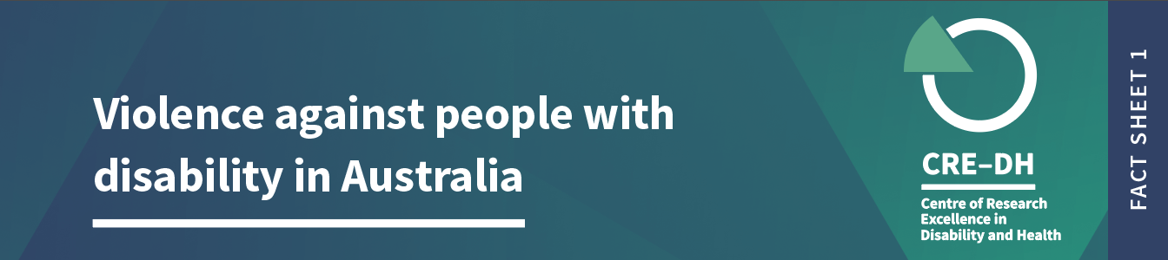

Plain language summary

In Australia people with disability are more likely to experience violence than people without disability. This is the first fact sheet in a series about violence against people with disability in Australia. We use data from national surveys where people reported their experience of violence in the last 12 months and since the age of 15. We report on people aged 18-64 only. Not all people with disability are represented in the surveys, and reports of violence may be under-reported.
When we refer to violence, it includes physical or sexual violence, emotional abuse, intimate partner violence, stalking and harassment.

Key facts

- 65% of people with disability have experienced some form of violence since the age of 15, compared to 45% of people without disability.

- In the last 12 months, 18% of people with disability experienced some form of violence compared to 10% of people without disability.

Physical Violence

Since the age of 15, 52% of people with disability experienced physical violence, compared to 34% without disability.
People with disability (8%) are twice as likely to report experiences of violence, compared to people without disability (4%) in the last 12 months.

Men and women with and without disability report different experiences of violence
- 55% of men with disability report at least one incident of physical violence in their lifetime, compared with 40% of men without disability.
- 48% of women with disability report experiencing physical violence since the age of 15, compared to 28% of women without disability.

- 9% of men with disability report experiencing physical violence compared to 6% of men without disability.

- Similarly, 8% women with disability report some form of physical violence in the last 12 months compared to 3% of women without disability.

Sexual Violence
- 21% of people with disability report at least one incident of sexual violence since the age of 15, compared to 10% of people without disability.
- People with disability are twice as likely than those without disability to report sexual violence in the last year.

- 9% of men with disability have report experiencing sexual violence since the age of 15, compared to 4% of men without disability. Men with disability were more than twice as likely to have report sexual violence.

- 33% of women with disability report experiencing sexual violence since the age of 15, compared to 16% of women without disability. Women with disability were more than twice as likely as women without disability to report sexually assault since the age of 15.

Stalking and Harassment
- 21% of people with disability report at least one incident of stalking and harassment since the age of 15, compared to 11% of people without disability. People with disability are two and a half times more likely than people without disability to report being stalked or harassed in the last year.

- Men with disability are two and a half times more likely (13%) than men without disability (5%) to have been stalked or harassed.

- 27% of women with disability report being stalked or harassed since the age of 15, compared to 16% of women with no disability.

Physical Violence – Measuring trends over time
Using a survey in Australia (known as HILDA) and looking at reports of physical violence over a long period (2002-2017), we found that rates of physical violence had decreased over time for people with and without disability.
Notes on data and definitions

Violence against people with disability is a significant human rights issue. We acknowledge the strength and resilience of people with disability who have survived violence. We thank those who have disclosed their experiences for making this work possible.
We have used data from the Personal Safety Survey 2016 for most of this fact sheet. We are aware that there is no support available for people who need assistance to complete the survey and therefore does not represent the experiences of all people with disability.
We report on experiences of violence in the last 12 months which provides an indication of recent experience. We also report on violence across the lifespan from the age of 15, which estimates the total number of people affected by violence.
In this fact sheet we refer to men and women, and not to other gender identities. This is because of the way gender is labeled in the data sources we have reported on.
In the data, violence refers to events and threat. It includes violence used by people who are strangers, and by people who know each other.
Estimates are directly age-adjusted to the June 2018 Australian population. Age adjusting is a statistical technique that helps make fairer comparisons between groups with different age distributions.
In the data, violence refers to events and threat. It includes violence used by people who are strangers, and by people who know each other. Violence includes physical or sexual violence, emotional abuse, intimate partner violence, stalking and/or harassment. Intimate Partner Violence refers to a current or previous partner with whom the respondent lived, or current or former boyfriend, girlfriend, or dating partner with whom the respondent did not live.
For more information on how disability is collected in the survey, go to this website
Further information
The Violence against People with Disability Fact Sheets were produced by the team at the Centre of Research Excellence in Disability and Health (CRE-DH) and funded by the Melbourne Disability Institute.
Data source: ABS (Australian Bureau of Statistics) 2017. Microdata: Personal Safety, Australia, 2016. ABS cat. No.4906.0.55.001 Canberra: ABS. CRE-DH analysis of Datalab. Household Income and Labour Dynamics in Australia (HILDA) Survey for trends over time. Note: Figures are rounded.

www.credh.org.au

