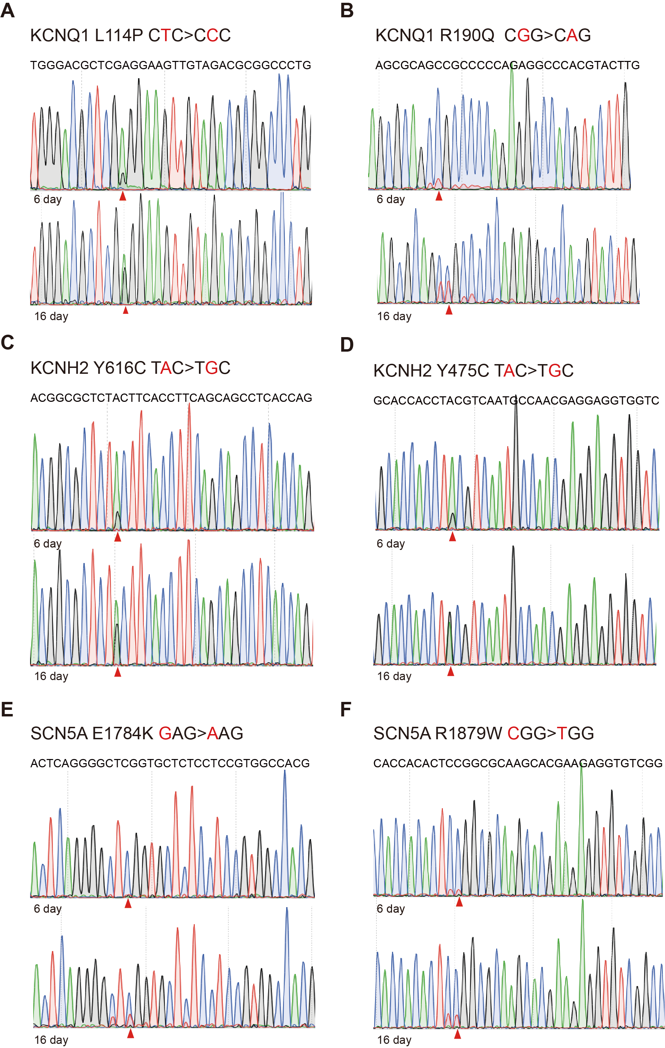

Supplementary Figure 1. Base editing efficiency on day 6 and day 16 in H9 cells. The mutated nucleotide is shown in red; the mutated nucleotide is indicated by the red triangle.

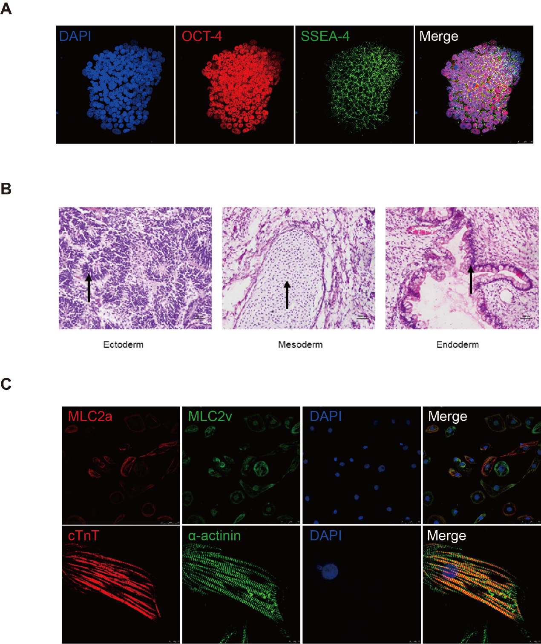

Supplementary Figure 2. Pluripotency assessment after base editing and success of cardiac differentiation. (A) Base editing did not influence expression of pluripotency markers OCT-4 and SSEA-4. (B) After base editing, the cells can differentiate into three germ layer lineages including ectoderm, endoderm and mesoderm. (C) All derived cardiomyocytes were stained with cardiac markers cTnT and α-actinin and ventricular/ atrial-specific marker MLC2v/a. The results showed the success of cardiac differentation.

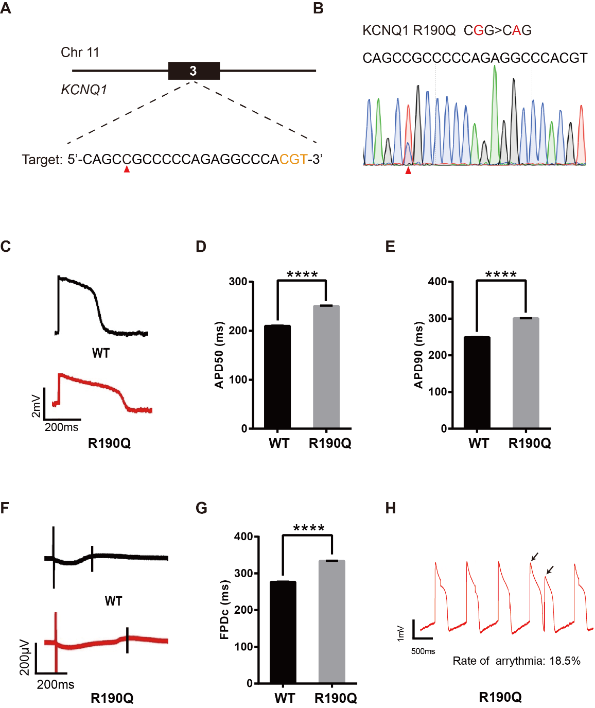

Supplementary Figure 3. Base editing of KCNQ1-R190Q for LQT1 modeling. (A) R190Q target site on KCNQ1. “CGT” PAM sequence is shown in orange; target nucleotide is indicated by the red triangle. (B) A heterozygous clone is confirmed by Sanger sequencing. The mutated nucleotide is shown in red; the mutated nucleotide is indicated by the red triangle. (C) Single trace of action potentials in WT-CMs and R190Q-CMs. (D-E) Quantification of action potential at APD50 and APD90. n= 3 independent experiments., unpaired t-test, P<0.0001. (F) Signals of Field Potential Duration recorded by the MEA machine. (G) Quantification of corrected Field Potential Durations (FPDc). n= 3 independent experiments., unpaired t-test, P<0.0001. (H) Respective traces of action potentials. The abnormal AP signals were labeled by black arrows.
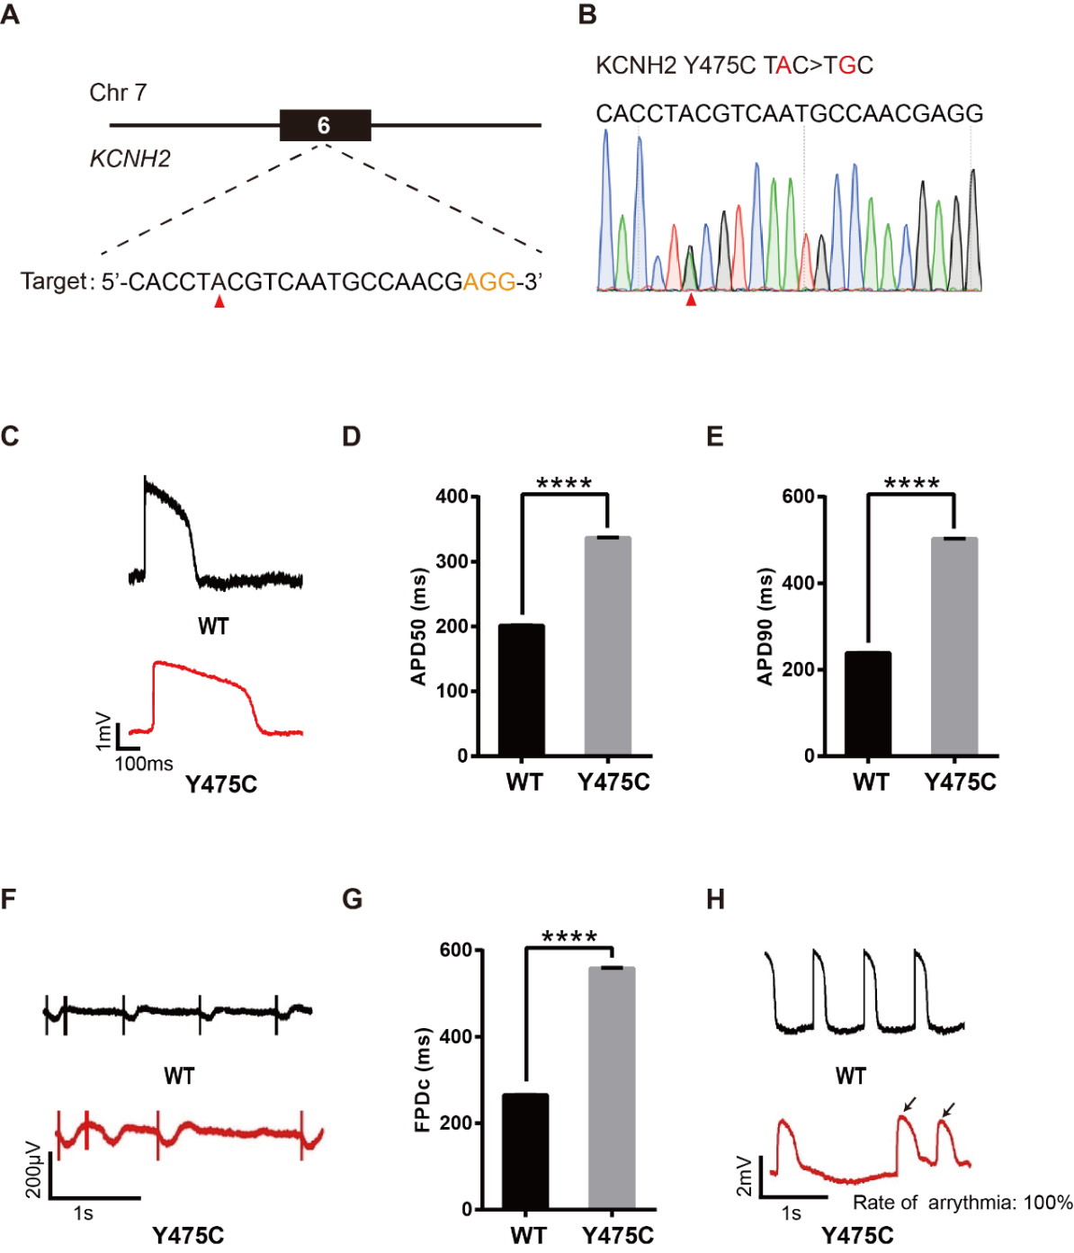

Supplementary Figure 4. Base editing of KCNH2-Y475C for LQT2 modeling. (A) Y475C target site on KCNH2. “AGG” PAM sequence is shown in orange; target nucleotide is indicated by the red triangle. (B) A heterozygous clone is confirmed by Sanger sequencing. The mutated nucleotide is shown in red; the mutated nucleotide is indicated by the red triangle. (C) Single trace of action potentials in WT-CMs and Y475C-CMs. (D-E) Quantification of action potential at APD50 and APD90. n= 3 independent experiments., unpaired t-test, P<0.0001. (F) Signals of Field Potential Duration recorded by the MEA machine. (G) Quantification of corrected Field Potential Durations (FPDc). n= 3 independent experiments., unpaired t-test, P<0.0001. (H) Representative traces of action potentials. The abnormal AP signals were labeled by black arrows.
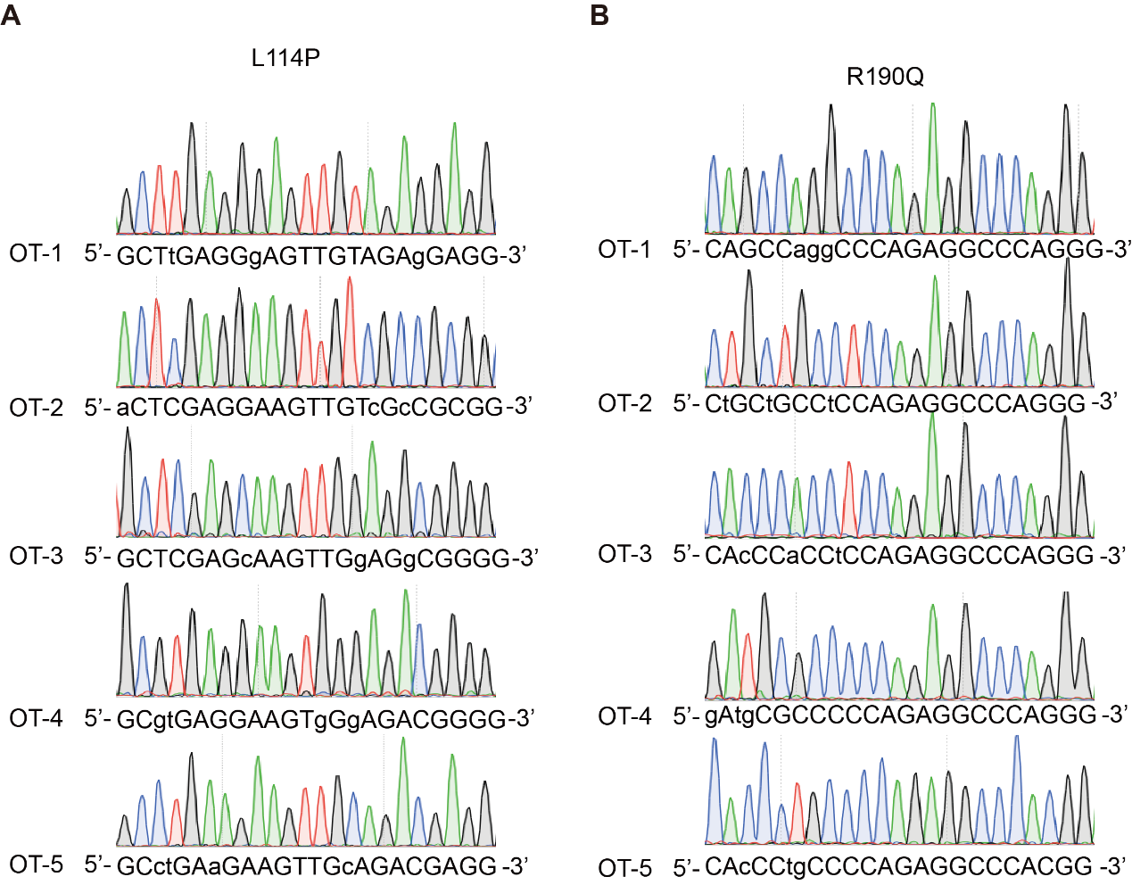

Supplementary Figure 5. Off-target analysis of the target sites on KCNQ1 in H9 cells.

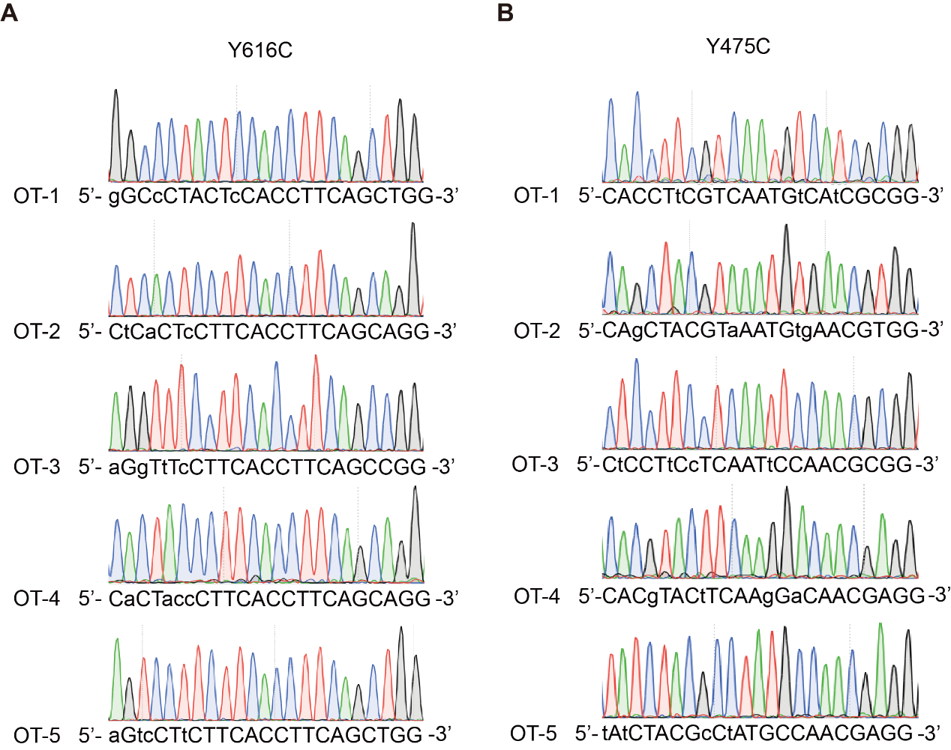

Supplementary Figure 6. Off-target analysis of the target sites on KCNH2 in H9 cells.

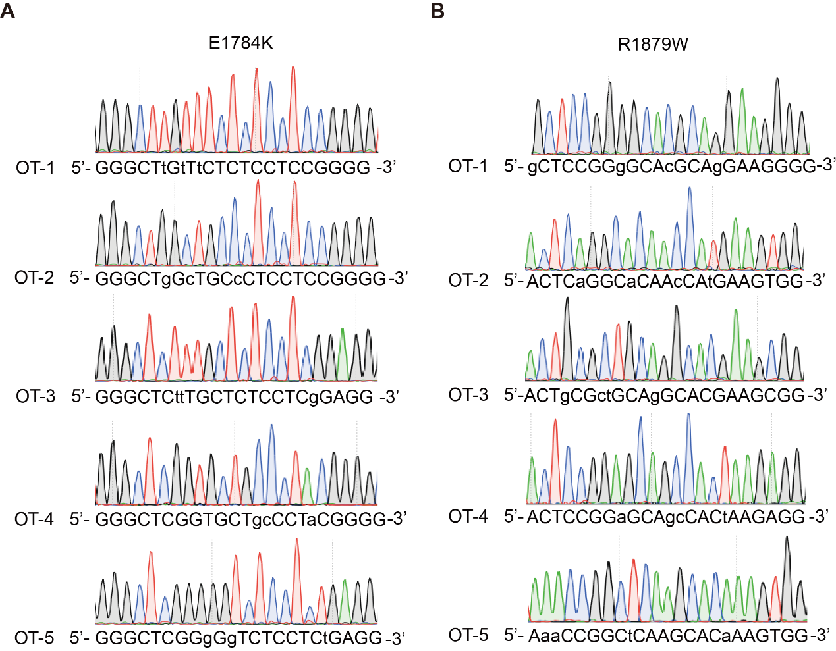

Supplementary Figure 7. Off-target analysis of the target sites on SCN5A in H9 cells.

Supplementary Table 1. Oligo sequences

Name | Sequence (5’→3’)
gRNA sequence of target site
114-gRNA-F | tttgctcgaggaagttgtagacg
114-gRNA-R | aaccgtctacaacttcctcgagc
190-gRNA-F | tttgcagccgcccccagaggccca
190-gRNA-R | aactgggcctctgggggcggctgc
616-gRNA-F | tttgcgctctacttcaccttcagc
616-gRNA-R | aacgctgaaggtgaagtagagcgc
475-gRNA-F | tttgcacctacgtcaatgccaacg
475-gRNA-R | aaccgttggcattgacgtaggtgc
1784-gRNA-F | tttgggctcggtgctctcctccg
1784-gRNA-R | aaccggaggagagcaccgagccc
1879-gRNA-F | tttactccggcgcaagcacgaag
1879-gRNA-R | aaccttcgtgcttgcgccggagt
Site1-gRNA-F | tttgatgagataatgatgagtca
Site1-gRNA-R | aactgactcatcattatctcatc
Site2-gRNA-F | tttgaagatagagaatagactgc
Site2-gRNA-R | aacgcagtctattctctatcttc
Site3-gRNA-F | tttggcccagactgagcacgtga
Site3-gRNA-R | aactcacgtgctcagtctgggcc
Site4-gRNA-F | tttggaatcccttctgcagcacc
Site4-gRNA-R | aacggtgctgcagaagggattcc
Primers used for PCR
KCNQ1-114-F | cctggccaagaagtgcc
KCNQ1-114-R | gcgagaagatgcgcacc
KCNQ1-190-F | tcaccatccgcagcagg
KCNQ1-190-R | cccctacccccaacacc
KCNH2-616-F | atgagacacctgtgctggg
KCNH2-616-R | cagtagtccccgccctg
KCNH2-475-F | gcattacagccccttcaagg
KCNH2-475-R | ctgtcctcctcgccacc
SCN5A-1784-F | atgtcaagtgggaggctgg
SCN5A-1784-R | ggtgaaggcaaagagaatgtcc
SCN5A-1879-F | gccgatgccctgtctgag
SCN5A-1879-R | cgctggtggctctagtgac
Site1-F | cattccatgctacactatctgcc
Site1-R | agcctcctgagtagctgg
Site2-F | gtccagaccaatgtcctgg
Site2-R | ctcatcaataaatggtgctggg
Site3-F | gtcacagtggcaaatgaggc
Site3-R | ttcatgcaggtgctgaaagc
Site4-F | ggatgccctacatctgctctc
Site4-R | ctggaagttcgctaatcccg
Primers used for plasmid construction
EBV-F | ggagacggtcacagcttg
EBV-R | gctgtccgtttcatggtggcggatcccgcg
EBV-2-F | agaagagcgatgctcttcg
EBV-2-R | gccggatcatctagttcgac
ABEmax-F | gccaccatgaaacggacagc
ABEmax-R | ctagaaggcacagtcgaggcttagactttcctcttcttcttgggctcg
AncBE4-F | gccaccatgaaacggacagc
AncBE4-R | ctagaaggcacagtcgaggc
BSD-F | agcctcgactgtgccttctag
BSD-R | caagctgtgaccgtctcc
mU6-F | gtcgaactagatgatccggc
mU6-R | cgaagagcatcgctcttct
1111-UP-F | tgccccaagtgaatatcgtg
1111-DOWN-R | cggtgatgctctggtggatc
epi-backbone-F | gatccaccagagcatcaccg
epi-backbone-R | cacgatattcacttggggca

Supplementary Table 2. Summary of base editing efficiency used in this study. All results were analyzed by EditR, n= 3 independent experiments.

Target | Day | 293T | HeLa | H9 | iPS
Site 1 | 6 | 43.7% | 37.3% | 12.7% | 10.3%
 | 11 | 44% | 84.7% | 20% | 23.7%
 | 16 | 43% | 84% | 37% | 49.7%
Site 2 | 6 | 43.3% | 46% | 15.7% | 24.7%
 | 11 | 45.3% | 89% | 30% | 46%
 | 16 | 44.7% | 89.3% | 50.7% | 59.3%
Site 3 | 6 | 44% | 40.3% | 13.3% | 18%
 | 11 | 39.3% | 72.7% | 23.7% | 27.7%
 | 16 | 49.7% | 86% | 39.3% | 37.3%
Site 4 | 6 | 31% | 45.7% | 11% | 8.7%
 | 11 | 31.3% | 81% | 28% | 25%
 | 16 | 42% | 88% | 33.3% | 39.3%
114 | 6 | n/a | n/a | 15.3% | n/a
 | 16 | n/a | n/a | 34% | n/a
190 | 6 | n/a | n/a | 10% | n/a
 | 16 | n/a | n/a | 31% | n/a
616 | 6 | n/a | n/a | 15.3% | n/a
 | 16 | n/a | n/a | 37% | n/a
475 | 6 | n/a | n/a | 18.7% | n/a
 | 16 | n/a | n/a | 53% | n/a
1784 | 6 | n/a | n/a | 5.7% | n/a
 | 16 | n/a | n/a | 21% | n/a
1879 | 6 | n/a | n/a | 10% | n/a
 | 16 | n/a | n/a | 18% | n/a

Supplementary Table 3. gRNA sequence (with PAM) of potential off-target sites.

Target site | Gene | Sequence
L114P | KCNQ1 | on-target | GCTCGAGGAAGTTGTAGACGCGG
 |  | off-target-1 | GCTtGAGGgAGTTGTAGAgGAGG
 |  | off-target-2 | aCTCGAGGAAGTTGTcGcCGCGG
 |  | off-target-3 | GCTCGAGcAAGTTGgAGgCGGGG
 |  | off-target-4 | GCgtGAGGAAGTgGgAGACGGGG
 |  | off-target-5 | GCctGAaGAAGTTGcAGACGAGG
R190Q | KCNQ1 | on-target | CAGCCGCCCCCAGAGGCCCACGT
 |  | off-target-1 | CAGCCaggCCCAGAGGCCCAGGG
 |  | off-target-2 | CtGCtGCCtCCAGAGGCCCAGGG
 |  | off-target-3 | CAcCCaCCtCCAGAGGCCCAGGG
 |  | off-target-4 | gAtgCGCCCCCAGAGGCCCAGGG
 |  | off-target-5 | CAcCCtgCCCCAGAGGCCCACGG
Y616C | KCNH2 | on-target | CGCTCTACTTCACCTTCAGC
 |  | off-target-1 | gGCcCTACTcCACCTTCAGCTGG
 |  | off-target-2 | CtCaCTcCTTCACCTTCAGCAGG
 |  | off-target-3 | aGgTtTcCTTCACCTTCAGCCGG
 |  | off-target-4 | CaCTaccCTTCACCTTCAGCAGG
 |  | off-target-5 | aGtcCTtCTTCACCTTCAGCTGG
Y475C | KCNH2 | on-target | CACCTACGTCAATGCCAACGAGG
 |  | off-target-1 | CACCTtCGTCAATGtCAtCGCGG
 |  | off-target-2 | CAgCTACGTaAATGtgAACGTGG
 |  | off-target-3 | CtCCTtCcTCAATtCCAACGCGG
 |  | off-target-4 | CACgTACtTCAAgGaCAACGAGG
 |  | off-target-5 | tAtCTACGcCtATGCCAACGAGG
E1784K | SCN5A | on-target | GGGCTCGGTGCTCTCCTCCGTGG
 |  | off-target-1 | GGGCTtGtTtCTCTCCTCCGGGG
 |  | off-target-2 | GGGCTgGcTGCcCTCCTCCGGGG
 |  | off-target-3 | GGGCTCttTGCTCTCCTCgGAGG
 |  | off-target-4 | GGGCTCGGTGCTgcCCTaCGGGG
 |  | off-target-5 | GGGCTCGGgGgTCTCCTCtGAGG
R1879W | SCN5A | on-target | ACTCCGGCGCAAGCACGAAGAGG
 |  | off-target-1 | gCTCCGGgGCAcGCAgGAAGGGG
 |  | off-target-2 | ACTCaGGCaCAAcCAtGAAGTGG
 |  | off-target-3 | ACTgCGctGCAgGCACGAAGCGG
 |  | off-target-4 | ACTCCGGaGCAgcCACtAAGAGG
 |  | off-target-5 | AaaCCGGCtCAAGCACaAAGTGG

