ADDITIONAL DATA
Additional Table S1 Univariate and multivariate linear regression analysis of the plasma LDL-TG levels with Gensini score
Variables | Univariate linear regression |  | Multivariate linear regression
 | Standardized coefficients | p-value | Standardized coefficients | p-value
TG | -0.009 | 0.531 | 0.003 | 0.863
LDL-C | 0.043 | 0.004 | 0.067 | <0.001
HDL-C | -0.059 | <0.001 | -0.057 | <0.001
Non-HDL-C | 0.034 | 0.023 | 0.047 | 0.002
ApoB | 0.049 | 0.001 | 0.065 | <0.001
LDL-TG | 0.040 | 0.007 | 0.048 | 0.002
Bold values indicate statistically significant.
Multivariate adjustments include age, sex, body mass index, smoking, hypertension, diabetes mellitus, family history of early coronary artery disease, and baseline statin use.

ADDITIONAL DATA
Additional Table S2 Univariate and multivariate Cox proportional hazards regression analysis of the plasma LDL-TG levels with occurrence of MACEs
Variables | Univariate Cox regression |  | Multivariate Cox regression
 | HR (95%CI) | P | HR (95%CI) | P
Age | 1.021(1.012-1.030) | <0.001 | 1.018(1.008-1.028) | <0.001
Male Sex | 0.854 (0.709-1.030) | 0.099 | -
BMI | 1.003(0.975-1.032) | 0.821 | - | -
LVEF | 0.975(0.964-0.985) | <0.001 | 0.979(0.968-0.989) | <0.001
Hypertension | 1.218(1.008-1.470) | 0.041 | - | -
DM | 1.305(1.096-1.554) | 0.003 | - | -
Smoking | 0.884(0.743-1.052) | 0.164 | - | -
FH | 0.848(0.652-1.105) | 0.222 | - | -
TG (Per-SD) | 1.087(1.002-1.180) | 0.046 | - | -
HDL-C(per-SD) | 0.976(0.893-1.067) | 0.599 | - | -
LDL-C(per-SD) | 1.116(1.027-1.212) | 0.009 | - | -
GS | 1.007(1.004-1.011) | <0.001 | 1.006(1.002-1.009) | 0.002
LDL-TG (per-SD) | 1.268(1.174-1.370) | <0.001 | 1.328(1.202-1.467) | <0.001
Baseline Statin use | 0.772(0.638-0.933) | 0.008 | 0.774(0.636-0.941) | 0.010
Bold values indicate statistically significant.
BMI: body mass index; DM: diabetes mellitus; FH: family history of CAD; TG: triglyceride; LDL-C: LDL-cholesterol; HDL-C: HDL-cholesterol; LVEF: left ventricular ejection fraction; GS: Gensini score.

ADDITIONAL DATA
Additional Table S3 Cox regression analysis according to different glucose metabolism
Diabetic status | HR(95%CI)
(n, events/subjects) | Crude model | model 1 | model 2
NGR (85/926) | Ref | Ref | Ref
Pre-DM (193/1789) | 1.156(0.896-1.492) | 1.091(0.844-1.409) | 1.099(0.846-1.427)
DM (229/1666) | *1.529(1.192-1.957) | *1.417(1.102-1.822) | *1.328(1.025-1.721)
* for p<0.05
NGR: normal glucose regulation; Pre-DM: pre-diabetes mellitus; DM: diabetes mellitus;
Model 1 adjusted for age and sex; model 2 adjusted for age, sex, body mass index, smoking, hypertension, family history of coronary artery disease, Gensini score, left ventricular ejection fraction, LDL-cholesterol, HDL-cholesterol, triglyceride, and baseline statin use.

ADDITIONAL DATA
Additional Table S4 C-statistics of LDL-TG for predicting cardiovascular outcomes in pre-diabetes and diabetes groups

Models | C-statistics (95%CI) | ∆C-statistics (95%CI) | P
NGR Original Model | 0.715(0.659-0.770) | Ref
NGR Original Model +LDL-TG | 0.715(0.660-0.771) | 0.001(-0.006-0.005) | 0.824
Pre-DM Original Model | 0.687(0.648-0.727) | Ref | -
Pre-DM Original Model +LDL-TG | 0.704(0.664-0.742) | 0.016(0.004-0.033) | 0.028
DM Original Model | 0.734(0.701-0.769) | Ref | -
DM Original Model +LDL-TG | 0.749(0.715-0.783) | 0.014(0.006-0.024) | 0.002
Bold values indicate statistically significant.
Variables include age, sex, body mass index, smoking, hypertension, family history of coronary artery disease, Gensini score, left ventricular ejection fraction, LDL-cholesterol, HDL-cholesterol, triglyceride, baseline statin use, and antidiabetic drugs (for DM only).

ADDITIONAL DATA
Additional Figure
Additional Figure S1 Flowchart of the study

ADDITIONAL DATA
Additional Figure
Additional Figure S2 coronary severity according to glucose metabolism status and LDL-TG levels
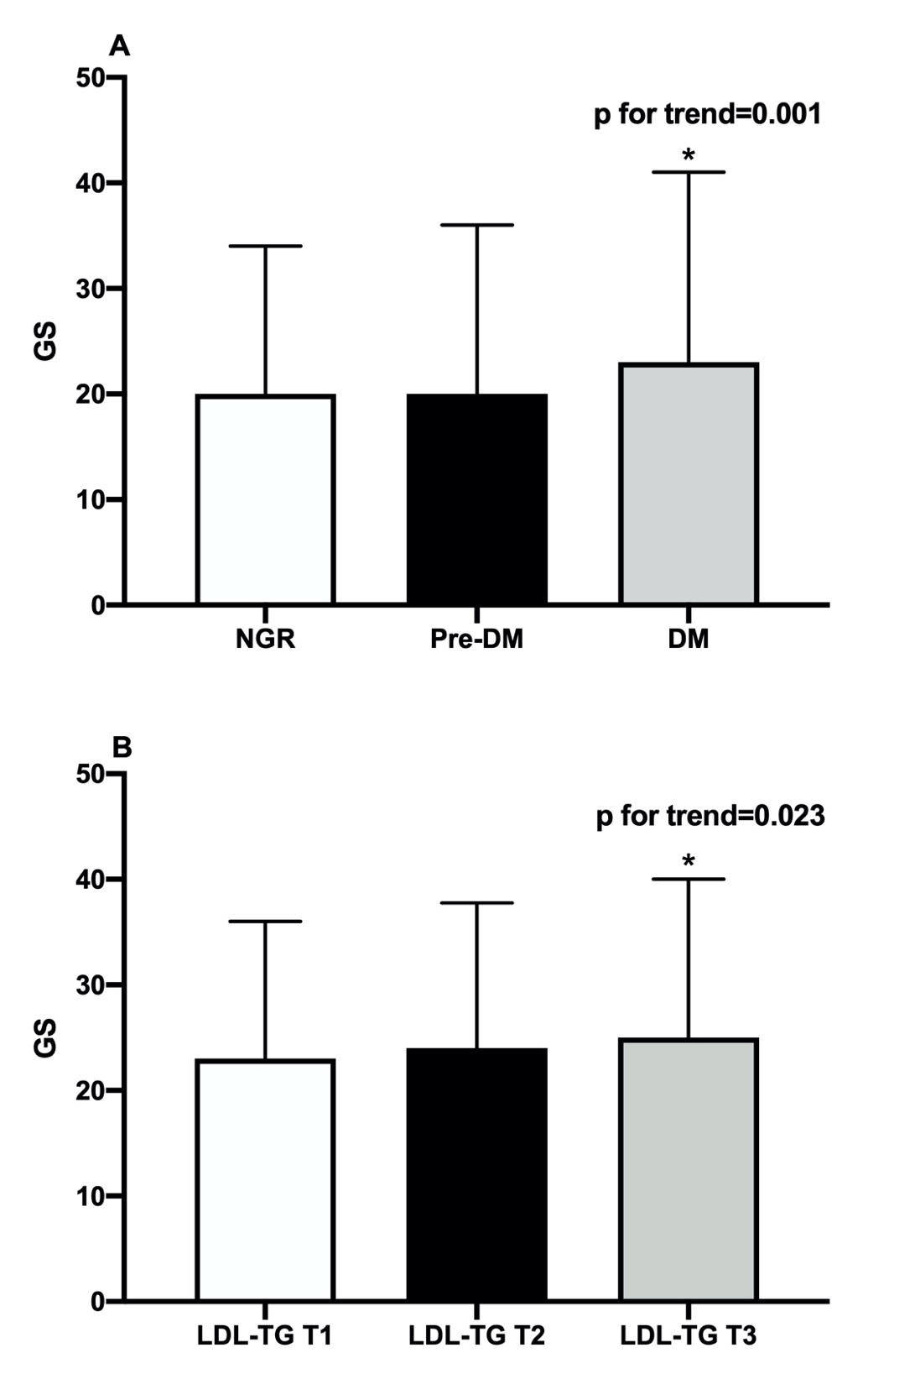
*for p<0.05

