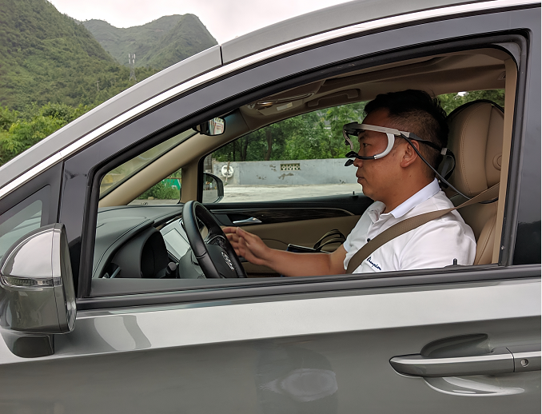
Figure A1 The eye tracker and vehicle

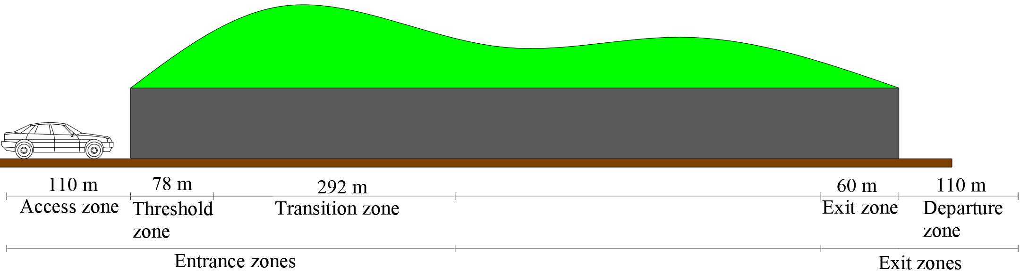

Figure A2. Schematic figure of each zone
Table A1. The information of the tunnel
Structure | Divided; two-way four lanes
Length | 4048 m
Speed limit | 80 km/h
Width | 11.10 m
Height | 7.27 m
Maximum longitudinal gradient | 0.6%

Table A2. The details of the participants
The number of participants |  | Age |  | Driving age
20 |  | 22 - 46 years old |  | 3 - 20 years
6 women | 14 men | M =34.55 | S.D. =7.28 | M = 7.40 | S.D. = 4.29

Table A3. Mean and SD of MTVV values in different zones at different time periods (mm²).
Time Periods  Zones | Daytime |  | Twilight |  | Nighttime |  | ANOVA
 | Mean | SD | Mean | SD | Mean | SD
Access | 7.492 | 4.474 | 32.678 | 11.024 | 44.175 | 18.100 | F = 839.816,  P ≤ 0.001
Threshold | 14.226 | 8.243 | 66.393 | 40.609 | 71.691 | 37.787 | F = 209.047,  P ≤ 0.001
Transition | 21.418 | 25.015 | 34.557 | 28.031 | 57.956 | 35.726 | F = 389.128,  P ≤ 0.001
Exit | 33.921 | 28.897 | 40.410 | 30.249 | 55.416 | 39.454 | F = 26.814,  P ≤ 5.575E-12
Departure | 3.812 | 2.637 | 20.009 | 23.645 | 109.777 | 38.723 | F = 1572.999,  P ≤ 0.001
ANOVA | F = 113.728, P ≤ 0.001 |  | F = 117.371, P ≤ 0.001 |  | F = 196.506, P ≤ 0.001

Table A4. Two-Way ANOVA of MTVV values.
Index  Factors | F | P
Zones | 88.657 | ≤ 0.001
Time periods | 1386.704 | ≤ 0.001
Interaction | 185.746 | ≤ 0.001

Table A5. Comparative analysis of the overall visual load in entrance and exit zones.
MTVV (mm²/s) |  |  | <31.5 | 31.5–56.5 | 56.5–90 | 90–142.5 | 142.5–225 | >225
Daytime | Entrance zones | Distance (m) | 410 | 35 | 30 | 5 | 0 | 0
 |  | Proportion (%) | 85.42 | 7.29 | 6.25 | 1.04 | 0 | 0
 |  | Conversion values | 22.349
 | Exit zones | Distance (m) | 145 | 20 | 5 | 0 | 0 | 0
 |  | Proportion (%) | 85.30 | 11.76 | 2.94 | 0 | 0 | 0
 |  | Conversion values | 20.654
Twilight | Entrance zones | Distance (m) | 235 | 150 | 60 | 35 | 0 | 0
 |  | Proportion (%) | 48.96 | 31.25 | 12.50 | 7.29 | 0 | 0
 |  | Conversion values | 38.766
 | Exit zones | Distance (m) | 140 | 25 | 0 | 5 | 0 | 0
 |  | Proportion (%) | 82.35 | 14.71 | 0 | 2.94 | 0 | 0
 |  | Conversion values | 22.750
Nighttime | Entrance zones | Distance (m) | 115 | 175 | 110 | 70 | 10 | 0
 |  | Proportion (%) | 23.96 | 36.46 | 22.92 | 14.58 | 2.08 | 0
 |  | Conversion values | 56.938
 | Exit zones | Distance (m) | 30 | 10 | 50 | 60 | 20 | 0
 |  | Proportion (%) | 17.65 | 5.88 | 29.41 | 35.29 | 11.76 | 0
 |  | Conversion values | 89.294
Figure A3. Changes in drivers’ pupil area at different time periods in the entrance zones

Figure A4. Changes in drivers’ pupil area at different time periods in the exit zones

Table A6 Mean and standard deviation (SD) of drivers’ pupil area (mm²)
Times periods  Zones | Daytime |  | Twilight |  | Nighttime |  | ANOVA
 | Mean | SD | Mean | SD | Mean | SD
Access | 3.969 | 0.340 | 7.749 | 0.787 | 17.839 | 2.230 | F = 8822.408,  P ≤ 0.001
Threshold | 8.945 | 3.074 | 11.464 | 1.693 | 16.531 | 2.123 | F = 661.803,  P ≤ 0.001
Transition | 16.628 | 1.454 | 15.035 | 1.109 | 15.441 | 1.997 | F = 65.563,  P ≤ 0.001
Exit | 9.026 | 1.940 | 9.713 | 1.686 | 16.790 | 1.745 | F = 1942.122,  P ≤ 0.001
Departure | 3.981 | 0.255 | 5.337 | 0.764 | 16.026 | 2.018 | F = 8002.150,  P ≤ 0.001
ANOVA | F = 2492.3548,  P ≤ 0.001 |  | F = 2611.516,  P ≤ 0.001 |  | F = 238.261,  P ≤ 0.001

