Application of Empirical Methods on Worldview 3 Imagery for Mapping Shallow Water Depth
(A Case Study Around Karimunjawa Harbor, Central Java)

Luhur Moekti Prayogo, Abdul Basith

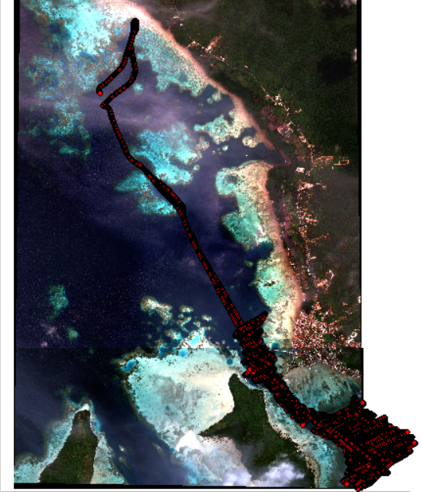
Fig. 2. Bathymetry survey view using SBES on Worldview 3 imagery.
The yellow box represents the research location

