Supervised Machine Learning for Aiding Diagnosis of Knee Osteoarthritis: A Systematic Review and Meta-Analysis

Luca Parisi^{1*,2}, Narrendar RaviChandran², Matteo Lanzillotta^{2,3}
¹Faculty of Business and Law (Artificial Intelligence Specialism), Coventry University, Priory Street, Coventry, CV1 5FB, United Kingdom
²University of Auckland Rehabilitative Technologies Association (UARTA), University of Auckland, Auckland, New Zealand
³Department of Counselling Psychology, Institute of Systemic Psychotherapy "Centro Studi Eteropoiesi", Corso Francia 98, Turin, 10143, Italy

Disclosure of interest: none.

Contributors: All authors directly participated in the planning, execution, and analysis in the study. Each of the authors has read and concurs with the content in the final manuscript. All authors also approved this submission.

Funding: This research did not receive any specific grant from funding agencies in the public, commercial, or not-for-profit sectors.

————
* Corresponding author.
E-mail address: luca.parisi@ieee.org (L. Parisi). ORCID: 0000-0002-5865-8708.
E-mail address: narrendar@ieee.org (N. RaviChandran). ORCID: 0000-0001-7365-0053.
E-mail address: amatt.do@gmail.com (M. Lanzillotta). ORCID: 0000-0001-9591-3299.

Abstract
Background
Knee osteoarthritis (OA) remains a leading aetiology of disability worldwide. Clinical assessment of such knee-related conditions has improved with recent advances in gait analysis. Despite being a gold standard method, gait data acquired by motion capture (mocap) technology are highly non-linear and dimensional, which make traditional gait analysis challenging. Thus, extrinsic algorithms need to be used to make sense of gait data. Supervised Machine Learning (ML)-based classifiers outperform conventional statistical methods in revealing intrinsic patterns that can discern gait abnormalities when using mocap data, making them a suitable tool for aiding diagnosis of knee OA.
Research question
Studies have demonstrated the accuracy of supervised ML-based classifiers in gait analysis. However, these techniques have not gained wide acceptance amongst biomechanists for two reasons: the reliability of such methods has not been assessed and there is no consensus on which classifier or group of classifiers to select. Specifically, it is not clear whether classifiers that leverage optimal separating hyperplanes (OSH) or artificial neural networks (ANN) are more accurate and reliable.
Methods
A systematic review and meta-analysis were conducted to assess the capability of such algorithms to predict pathological kinematic and kinetic gait patterns as indicators of knee OA. With 153 eligible studies, 6 studies met the inclusion criteria for a subsequent meta-analysis, accounting for 273 healthy subjects and 313 patients with symptomatic knee OA. The classification performance of supervised ML classifiers (OSH- or ANN-based) used in these studies was quantitatively assessed and compared across four following performance metrics: classification accuracy on the test set (ACC), sensitivity (SN), specificity (SP), and area under the receiver operating characteristic curve (AUC).
Results
There was no statistically significant discrepancy in the ACC between OSH- and ANN-based classifiers when dealing with kinetic and kinematic data concurrently, as well as when considering only kinematic data. However, there was a statistically significant difference in their SN and SP, with the ANN-based classifiers having higher SN and SP than OSH-based algorithms. As only one of the eligible studies reported AUC, this metric could not be assessed statistically across studies.
Significance
This study supports the use of ANN-based algorithms for classifying knee OA-related gait patterns as having a higher sensitivity and specificity than OSH-based classifiers. Considering their higher reliability, leveraging supervised ANN-based methods can aid biomechanists to diagnose knee OA objectively.
Keywords – Biomechanical Phenomena; Gait Analysis; Knee; Neural Networks, Computer; Osteoarthritis, Knee; Supervised Machine Learning.

Introduction
Gait analysis involves the assessment of human motion, typically performed via motion capture (mocap) technology. Deemed the gold standard method for gait data acquisition, mocap involves the use of reflective markers and infrared cameras to estimate the position of the human body in three dimensions (3D). Kinematic parameters (joint angles) describing the movement of the human body are inferred from mocap data. Moreover, by integrating instrumented force platforms, kinetic data (forces and moments) can also be measured. These technologies are integral to gait analysis, which aid with the diagnosis of knee-related disorders. Amongst such disorders, knee osteoarthritis (OA) is a prevalent joint disorder worldwide [3, 4], commonly requires surgical intervention and months of rehabilitation. The disruption of the anterior cruciate ligament is a common injury amongst athletes [1], which leads to a higher risk of developing knee OA [1, 2]. Furthermore, the incidence of knee OA is increasing due to the ageing population and obesity, particularly in developed countries [3]. Thus, detecting these conditions is crucial to early diagnosis and provides a tool for risk stratification. Deviations from physiological gait are often recognised by quantifying pathophysiological variations such as the knee adduction moment (KAM) [5, 6]. Despite being a robust and non-invasive assessment, gait data acquired via mocap are highly non-linear and dimensional, thus impairing the accuracy and reliability of such a diagnosis [7]. Considering the classification task involved in discriminating between physiological and knee OA-related gait, this underlying, complex nature of gait data limits the predictive capability of conventional methods to generalise to unseen data [8, 9].

As opposed to analytical methods, supervised learning-based classifiers can overcome the above-mentioned limitations by recognising the underlying patterns. Such classifiers can discriminate pathological features and generalise in their predictions [8]. Furthermore, these techniques have been effective in real-life scenarios [9, 10]. Learning-based classifiers can be either supervised or unsupervised [8]. The analysis of pathological gait data typically involves training data with known output classes, thus supervised learning-based classifiers are selected. Such classifiers have accurate predictions when dealing with knee OA-related gait data [2, 5, 6, 7, 11-14]. To discriminate between physiological and pathophysiological (knee OA) patterns, supervised ML-based classifiers adopt optimal separating hyperplanes (OSH) [7, 11-13] or Artificial Neural Networks (ANN) [2, 5, 6, 14]. While OSH-based methods, e.g., SVM [15], apply a decision surface boundary as an OSH for classification [16], ANN, e.g., the Multi-Layer Perceptron (MLP), enable classification by iterative learning [17]. Further to using learning-based classifiers, gait-related indices can be derived as subject-specific metrics not only to help in diagnosing knee OA but also to assess the impact of gait-driven rehabilitation in patients with this joint disorder [9]. Due to the lack of a meta-analysis on the accuracy and reliability of these algorithms, the use of such supervised ML-based classifiers in clinical gait analysis is still limited [18]. Moreover, none of the studies published so far, such as the seminal review of ANN for gait analysis [19], has been able to offer a comprehensive and quantitative analysis to inform decision making regarding suitable classifiers. Let alone to select an algorithm for aiding diagnosis of knee OA; biomechanists currently do not have any objective ground truth whereby they could choose amongst several algorithms, as well as the time and expertise involved in understanding the tools in question.

Thus, this study aims to perform a systematic review and meta-analysis on studies applying supervised ML-based classifiers for aiding diagnosis of knee OA and to facilitate an informed application of such tools.

Methods
The high-level objectives of this systematic review and meta-analysis are the following:

- To identify eligible studies that have used supervised OSH- or ANN-based classifiers for gait analysis to help in diagnosing knee OA and conduct a methodological quality assessment for their inclusion in a meta-analysis.
- To compare such selected studies via a quantitative, meta-analysis approach, for the test classification accuracy (ACC) and clinical gold-standard performance measures of reliability, such as the sensitivity (SN), the specificity (SP), and the area under the curve (AUC).

A meta-analysis with random-effect Mantel-Haenszel (M-H) model and odds ratios with 95% confidence intervals of sub-sets of results pooled from published studies was performed by comparing the:
- ACC between OSH- and ANN-based algorithms when considering studies dealing with both kinetic and kinematic data.
- ACC between OSH- and ANN-based algorithms when considering studies dealing with kinematic data only.
- SN and SP between OSH- and ANN-based algorithms when considering studies dealing with kinematic data only.
- SN and SP between OSH- and ANN-based algorithms when considering studies dealing with both kinetic and kinematic data.
- AUC between OSH- and ANN-based classifiers when considering studies dealing with kinematic data.
- AUC between OSH- and ANN-based classifiers when considering studies dealing with both kinetic and kinematic data.
This quantitative analysis was sought to investigate any potentially significant discrepancies in their classification performance, based on the different relative weights in each of the three sub-sets of results.
The meta-analysis was carried out via Review Manager (RevMan) (Version 5.3. Copenhagen: The Nordic Cochrane Centre, The Cochrane Collaboration, 2014). The I² test was used to assess the heterogeneity amongst the findings from selected studies [20]. Furthermore, a statistical analysis on the accuracy and reliability measures of the algorithms included in this study was performed via IBM SPSS Statistics for validating the results attained (IBM Corp. Released 2016. IBM SPSS Statistics, Version 24.0. Armonk, NY: IBM Corp.). Publication bias was assessed via Funnel plots. Although gait data include spatio-temporal and metabolic data more broadly, only kinetic and kinematic data were considered in this study, as they are easily accessible variables to quantify human motion in clinical gait analysis.

Inclusion and exclusion criteria
Full-length papers and conference articles were initially screened, and their titles and abstracts were assessed for eligibility against the aims and high-level objectives of this study by all four authors independently. All major electronic databases including PubMed, Web of Science, MEDLINE, ScienceDirect, Scopus, Google Scholar, IEEE Xplore, Springer, Wiley, O'Reilly, SAGE, Cochrane, and Embase were parsed using the following relevant keywords of interest: “machine learning,” “knee osteoarthritis,” “gait,” “motion capture,” “artificial neural networks,” “multi-layer perceptron” and “support vector machine.” The full code of the query for the PubMed database is the following: ‘(((gait) OR (motion capture)) OR (knee osteoarthritis)) AND ((machine learning) OR (artificial neural networks) OR (multi-layer perceptron) OR (support vector machine))’. Thus, articles published in the literature from 1984 (since when optometric mocap systems were first introduced) until mid-April 2020 were searched. However, no relevant articles were found in MEDLINE, Cochrane, O’Reilly, Embase, and Sage databases, which were thus discarded.

Articles that reported gait-related data on human participants with knee OA and a healthy cohort of subjects as controls regardless of any other demographic factor except for the age (older than 12 but younger than 75) were identified. Studies reporting gait-related data on human subjects with neurotrauma or with neurodegenerative disorders, such as Parkinson's Disease, Cerebral Palsy, or Huntington's Disease, were discarded from this review. Studies in which kinematic data collected only using optoelectronic systems that use RGB-D sensors (e.g., Vicon, Qualysis, and Asus Xtion) were considered for inclusion. Moreover, body segments must have been identified via passive markers, and any other methods for measuring or estimating such gait metrics were not considered. Articles reported data walking gait (speed lower than that of a healthy human subject, approximately less than 5 km/h, due to knee OA) were considered. Any studies involving walking on instrumented treadmills (with embedded force platforms) and fall detection systems were discarded.

An initial search was performed only based on the title, using the above-mentioned keywords. Subsequently, a second and final search was carried out, after which relevant key articles were selected for inclusion based on their abstract and full-text content. All bibliographies from the retrieved key articles were also searched for potential articles that might not have been considered previously. The findings from the bibliographic searches were carried out independently and then compared amongst the three investigators/authors. It was considered to contact the authors of studies reporting vague information, but this was not performed, as all required data could be retrieved from the selected papers. The “Preferred Reporting Items for Systematic reviews and Meta-Analysis” (PRISMA) guidelines [21] were followed throughout this study. The full checklist is provided in Supplement 1. 194 studies were identified following further screening. By applying the above-mentioned inclusion and exclusion criteria, 187 articles were excluded, and 7 were thus selected. A methodological quality assessment was performed on these studies for their inclusion in the meta-analysis, as outlined in 2.2.

Methodological quality assessment: The UARTA star-rating system
Due to the limited applicability of existing methodological assessment scales to supervised learning-based classifiers, adapted from the MQAS scale [27], “The University of Auckland Rehabilitative Technologies Association (UARTA) star-rating system” was developed. This rating system is intended to aid the quality assessment of studies that deployed supervised learning-based classifiers. Due to its comprehensiveness, it is also deemed applicable to any research articles dealing with supervised learning-based classifiers applied to any healthcare-related data [26]. When using the rating system, the following points correspond to a star (★) attributed to selected papers for meeting the described criteria. A maximum of twelve stars was attributed to each of the selected articles. Articles carrying less than five stars were not considered for the review and meta-analysis.
- Selected articles must have included supervised OSH- or ANN-based learning classifiers and outlined a clear purpose for the classification task, specifying inputs and outputs. Such studies must have also reported any data pre-processing steps undertaken to ensure accuracy and consistency of the results presented, and to enable their reproducibility. If data pre-processing were not performed, the authors of the selected articles must have justified why such a pre-processing stage was not applicable.
- Selected articles must have reported any data post-processing steps undertaken to ensure accuracy and consistency of the results presented, and to enable their reproducibility. If those were not applicable, the authors of the selected articles must have justified why they were not.
- Selected articles must have reported a measure (number or percentage of the whole dataset) quantifying the training set of the data used.
- Selected articles must have reported a measure (number or percentage of the whole dataset) quantifying the cross-validation set of the data used.
- Selected articles must have reported a measure (number or percentage of the whole dataset) quantifying the testing set of the data used.
- Selected articles must have reported the name of the cross-validation algorithm (e.g., holdout validation, leave-one-out (LOO), nested or k-fold cross-validation, specifying the number k of partitions made where applicable) to avoid overfitting and ensure reproducibility of the results attained.
- Selected articles must have reported any outputs showing the training- and cross-validation-related mean squared error (MSE) curves against the number of iterations or epochs to illustrate at which iteration/epoch overfitting occurs if any.
- Selected articles must have reported testing or out-of-sample classification accuracy.
- Selected articles must have reported at least one measure of error, e.g., the mean squared error (MSE), or it should be inferable from the performance measures reported.
- Selected articles must have reported the sensitivity (SN).
- Selected articles must have reported the specificity (SP).
- Selected articles must have reported the area under the receiver operating characteristic curve (AUC).

Based on the inclusion and exclusion criteria in 2.1 and the quality assessment performed via the UARTA star-rating scale, six (n=6) eligible articles were retrieved, as per the selection procedure outlined in Fig. 1.

Figure 1. PRISMA flowchart showing the selection procedure adopted in this study to select suitable articles for the systematic review and the meta-analysis.

Table 1 shows the stars attributed to each of the selected articles for meeting the UARTA star-rating scale-related criteria, as outlined above.

Table 1. Stars attributed to each of the selected articles for meeting the UARTA start-rating scale-related criteria.

Scoring attributes | [7] |  | [11] |  | [12] | [13] | [14] | [24] | [25]
Pre-processing | ★ |  | ★ |  | ★ |  | ★ | ★ | ★
Post-processing | ★ |  | ★
Training dataset | ★ |  | ★ |  | ★ | ★ | ★ | ★ | ★
Cross-validation dataset | ★ |  | ★ |  | ★ |  |  |  | ★
Testing dataset | ★ |  | ★ |  | ★ | ★ | ★ | ★ | ★
Cross-validation algorithm | ★ |  | ★ |  | ★ | ★ |  |  | ★
Learning/training measures |  |  | ★ |  |  | ★
Classification accuracy | ★ |  | ★ |  | ★ | ★ | ★ | ★ | ★
Measure of error |  |  |  |  | ★ |  | ★ | ★
SN |  |  | ★ |  | ★ | ★ |  | ★ | ★
SP |  |  | ★ |  | ★ | ★ |  | ★ | ★
AUC |  |  | ★ |  |  | ★ |  | ★
Total | 7 |  | 11 |  | 9 | 8 | 5 | 8 | 8

Table 2 summarises the main elements derived from a comprehensive review of the selected studies, as per the UARTA star-rating quality assessment scale described above.

As in Table 2, since one study [11] deals with a gait data type that is not common in any other selected studies (spatio-temporal and symmetry indices), such a study cannot be included in the meta-analysis. Thus, out of the remaining six studies selected, two sub-groups of studies can be analysed via a meta-analysis approach with those involving kinematic data only [7], [12], [14], [25] and those including both kinematic and kinetic data [13], [24].

The purpose of the two above-mentioned sub-group analyses is the same: to understand whether there is a statistically significant difference between the classification performance of OSH- and ANN-based algorithms in detecting knee OA and, if so, which class of supervised learning-based algorithms should be preferred for such an application based on the type of data available (kinematic data only; both kinematic and kinetic data).

Considering that only one of the two studies dealing with both kinetic and kinematic data reports both accuracy and reliability (SN and SP) metrics [24], solely the classification accuracy on the testing set (ACC) could be compared statistically, as it is the only classification performance metric common to both studies [13], [24].

Instead, only three studies involving kinematic data only report both ACC and reliability metrics (SN and SP) [12], [14], [25]. However, all four of them, including [7], reported ACC, the ACC could be compared for all four studies, but the SN and SP could only be evaluated for the three relevant studies.

Table 2. Comprehensive review of included studies aimed at classifying pathological gait patterns.
 |  |  | [13] | [12] | [14] | [11] | [7] | [24] | [25]
Condition |  |  | Knee OA | Knee OA | Knee OA | Knee OA | Knee OA | Knee OA | Knee OA
Type of study |  |  | Classification | Classification | Classification | Classification | Classification | Classification | Classification
Healthy subjects (N) |  |  | 12 | 15 | 91 | 12 | 43 | 84 | 28
Patients with knee OA |  |  | 11 | 32 | 110 | 11 | 100 | 41 | 19
Data | Training set  (N, %) |  | 51 trials  (73.91%) | 21 subjects (44.68%) | 138 subjects (66.8%) | 69 trials  (100%) | 112 subjects  (80%) | 88 subjects  (70%) | 24 subjects  (51%)
 | Cross-validation (CV) set |  | LOO | 5-fold | - | LOO | 10-fold | - | LOO
 | Testing set  (N, %) |  | 18 trials  (26.09%) | 21 subjects  (44.68%) | 63 subjects  (31.3%) | 69 trials  (100%) | 14 subjects  (10%) | 37 subjects  (30%) | 23 subjects  (49%)
Mocap technology and sampling rate |  |  | - | Vicon  (200 Hz) | - | Vicon  (50 Hz) | Vicon  (120 Hz) | Vicon  (100 Hz) | Opti_Knee®  (60 Hz)
Force platform technology and sampling rate |  |  | Kistler force plate (400 Hz) | - | - | Kistler force plate (400 Hz) and GAITRite | Bertec instrumented treadmill | Kistler force plate  (1000 Hz) | -
Gait data type |  |  | Kinetics and Kinematics | Kinematics | Kinematics | Spatio-temporal and symmetry indices | Kinematics | Kinetics and  Kinematics | Kinematics
Data pre-processing |  |  | - | Normalisation per gait cycle | Removal of missing values | - | Normalisation per gait cycle | Kinetics normalised to stance phase.  Kinematics normalised to gait cycle | Min-max normalisation ([− 1, 1] range)
Gait-related input features (N) |  |  | Twelve (N=12) features: walking velocity, cadence, stride length, stride time, step time, step length, single support time, double support time. | Two (N=2) features: gait phase deviation and the joint function deviation reference-based indices (GCD-RBI and JFD-RBI) | Five (N=5) feature vectors: four for temporal changes of knee joint angle (KFlex, KMFlex, KMVal, KPTot), one for time-distance parameters | Four (N=4) spatio-temporal parameters: speed, cadence, stride length, stride time. Four (N=4) symmetry indices: step length, step time, single and double support time. | For each of the groups, two feature vectors were created based on the original discrete variables and a principal component analysis (PCA). | Three (N=3) kinetics features (ground reaction force, maximum vertical force, maximum vertical loading rate)  Twelve (N=12) kinematics features (N=6 knee-related, N=6 hip-related) | Twelve (N=12) kinematic features (IE rotation, ROM of IE rotation, FE rotation, ROM of FE rotation, VV rotation. ROM of VV rotation, PD translation, ROM of PD translation, AP translation, ROM of AP translation, MLT translation, ROM of MLT translation)
Attributes of the classifiers | Algorithm |  | SVM | Quadratic SVM | MLP | SVM | SVM | KNN | RBF
 | Type of learning/training |  | SVMs were trained over the range C = {0.1, 1, 10, 100, 1000} | - | - | SVM (kernel width s=0.5, penalty parameter C=10). | - | Twelve (N=12) KNN models were created, each including one of the ranked parameters. | Deterministic
 | Transfer function | Hidden Layer | Linear, polynomial and Gaussian kernels | SVM: quadratic kernel | Tangent sigmoid | Gaussian  kernel | Linear kernel | Nearest neighbour | Gaussian kernel
 |  | Output layer | - | - | Tangent sigmoid | - | - | - | -
 | Input vectors (N) |  | 12 | 2 | 207* | 69 | 8 | 1-15 | 3
 | Hidden layers (N) |  | - | - | 2* | - | - | - | 1
 | Hidden neurons in the first layer (N) |  | - | - | 150* | - | - | - | 4913
 | Hidden neurons in the second layer (N) |  | - | - | 40* | - | - | - | -
 | Output vectors (N) |  | 1 | 1 | 1* | 1 | 1 | 1 | 1
 | Training algorithm | Type | - | - | - | - | - | - | -
 |  | Learning rate | - | - | - | - | - | - | -
 |  | Momentum | - | - | - | - | - | - | -
 |  | Epochs | - | - | - | - | - | - | -
Post-processing |  |  | - | - | - | - | - | - | -
Software deployed |  |  | - | - | MATLAB (Mathworks, MA) | - | - | MATLAB  (Mathworks, MA) | MATLAB  (Mathworks, MA)
Classifier performance | Accuracy  (%) |  | 88.89 | 85 | 90.48 | 94.2 | 99 | 100 | 97.9
 | Sensitivity  (SN, %) |  | - | 91 | 96.55 | 100 | - | 100 | 94.7
 | Specificity  (SP, %) |  | - | 75 | 85.29 | 97 | - | 100 | 100
 | AUC  (0-1) |  | - | - | - | - | - | 1 | -
Limitations/  lack of reporting on |  |  | Pre-processing; post-processing; cross-validation dataset; learning performance; measures of error; CI. | Post processing; Learning/training measures; Learning performance; AUC; CI; ROC. | Cross-validation set; cross-validation algorithm; learning/training measures; learning performance; AUC; CI; ROC. | Learning performance; measures of error; CI; ROC. | Learning measures; learning performance; measures of error; SN; SP; AUC; CI; ROC. | Cross-validation set; cross-validation algorithm; post-processing; Learning/training measures; Learning performance; CI; ROC. | Learning measures; learning performance; measures of error; AUC; CI; ROC; post-processing.
*data pertains to the MLP6 classifier, which was the most accurate individual MLP tested using the lowest number of hidden layers and hidden neurons amongst the multiple MLPs tested. OA: knee osteoarthritis; MLP: multi-layer perceptron; LOO: leave-one-out cross-validation; SVM: support vector machine; KNN: k-nearest neighbour; SN: sensitivity; SP: specificity; ROC: receiver operating characteristic curve; AUC: area under the receiver operating characteristic curve; CI: confidence interval; IE: internal-external; FE: flexion-extension; VV: varus-valgus; PD: proximal-distal; AP: anterior-posterior; MLT: medial-lateral; RBF: radial basis function neural network.

Results
The Forest plot in Fig. 2 indicates that, when considering kinematic data only, there was no statistically significant discrepancy in the classification accuracy on the testing set (ACC) between supervised OSH- (Karg 2015 [12], Phinyomark 2016 [7]) and ANN-based algorithms (Koktas 2006 [14], Zeng 2019 [25]) (odds ratio (OR): 0.94, 95% CI: 0.44, 2.03, p=0.88). Furthermore, there was no statistically significant heterogeneity (I²=0%, p=0.92), which further supports the reliability of the results.

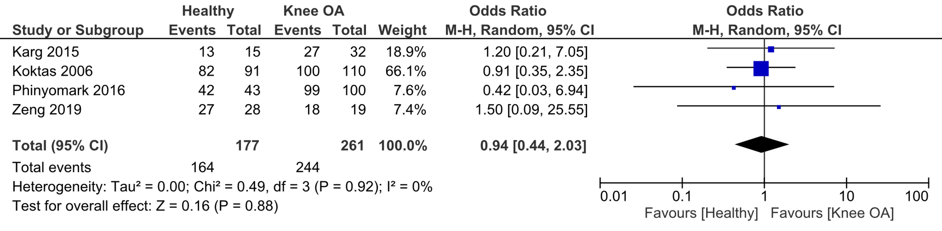
Figure 2. Forest plot comparing the classification accuracy on the testing set (ACC) of supervised OSH- and ANN-based algorithms in clinical gait analysis from selected studies considering kinematic data only, eligible for the meta-analysis.

The Forest plot in Fig. 3 indicates that, when considering kinetic and kinematic data, there was also no statistically significant discrepancy in the classification accuracy on the testing set (ACC) between supervised OSH- (Levinger 2009 [13]) and ANN-based (Long 2017 [24]) algorithms (odds ratio (OR): 1.53, 95% CI: 0.20, 11.45, p=0.68). Furthermore, there was no statistically significant heterogeneity (I²=0%, p=0.76), which further supports the reliability of the results.

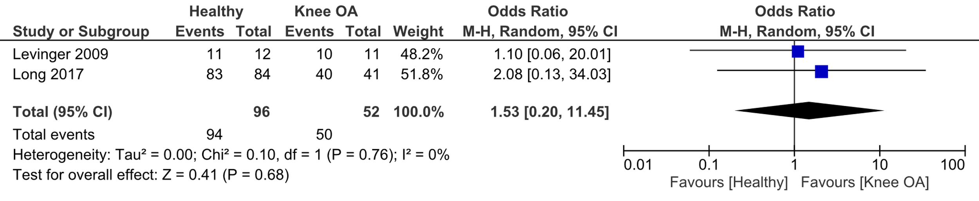
Figure 3. Forest plot comparing the classification accuracy on the testing set (ACC) of supervised OSH- and ANN-based algorithms in clinical gait analysis from selected studies considering both kinetic and kinematic data, eligible for the meta-analysis.

The Forest plot in Fig. 4 indicates that, when considering kinematic data, there was a statistically significant difference in the sensitivity and the specificity between ANN- and OSH-based algorithms and, in particular, those of ANN-based classifiers (Koktas 2006 [14]; Zeng 2019 [25]) were higher than those of OSH-based classifiers (Karg 2015 [12]) when assessed on the testing set (odds ratio (OR): 3.87, 95% CI: 1.37, 10.92, p=0.01). Furthermore, there was no statistically significant heterogeneity (I²=0%, p=0.41), which further supports the reliability of the results.
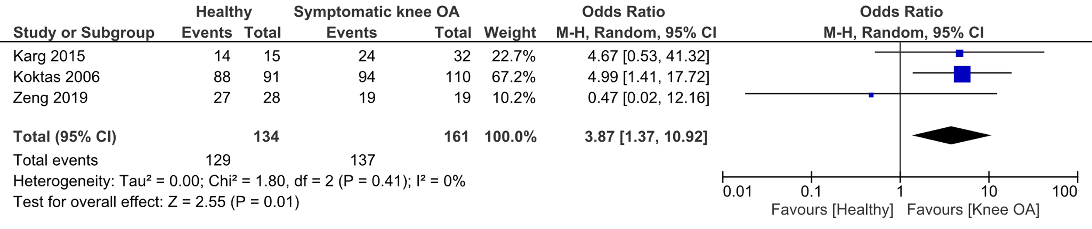
Figure 4. Forest plot comparing the classification accuracy on the testing set (ACC) of supervised OSH- and ANN-based algorithms in clinical gait analysis from selected studies considering both kinetic and kinematic data, eligible for the meta-analysis.
Figs. 5-7 shows the corresponding Funnel plots to Figs. 2-4 indicating that, since the studies, overall, are plotted near the mid-line representing the average OR, there was no statistically significant publication bias in the results obtained.

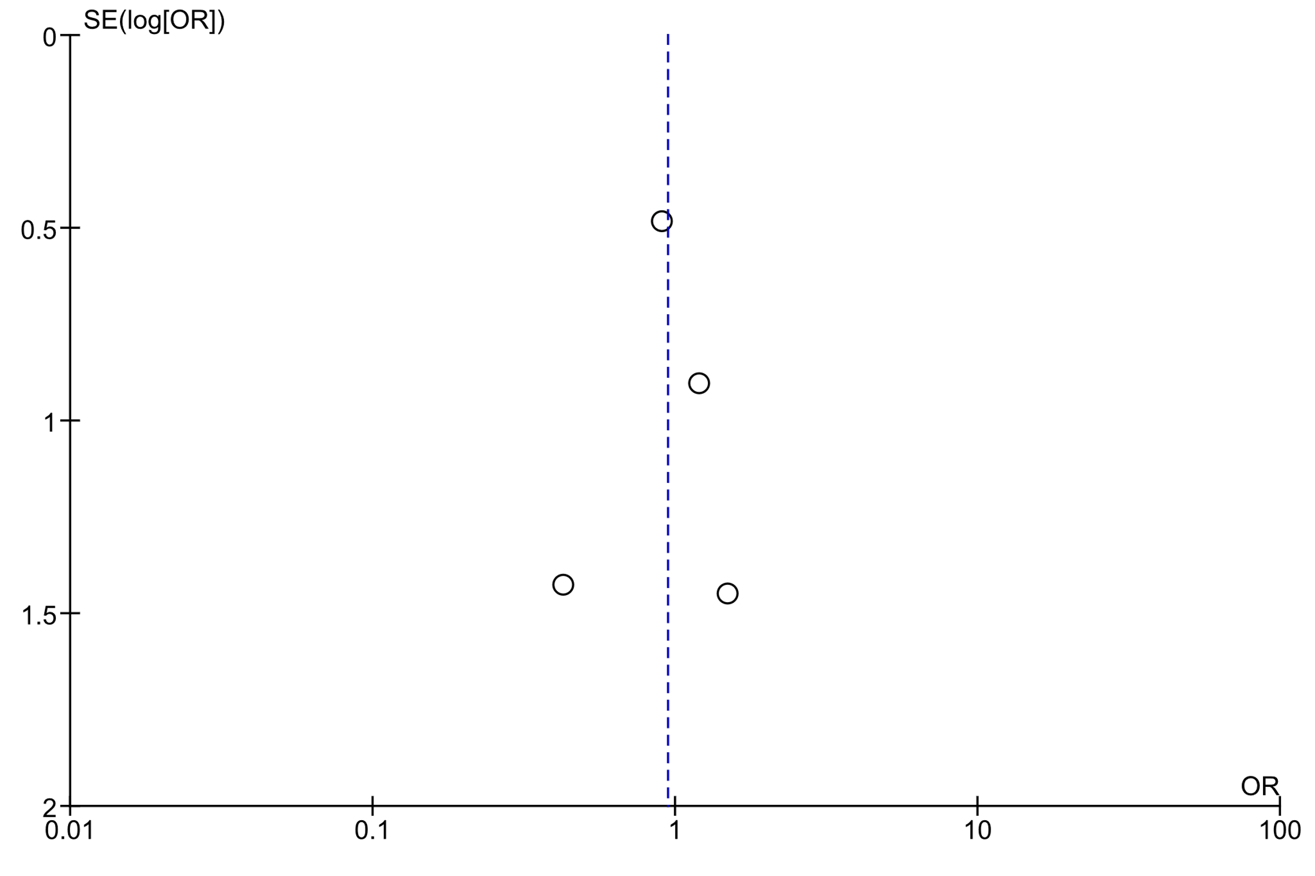
Figure 5. Funnel plot indicating no publication bias in the results comparing the classification accuracy on the testing set (ACC) of supervised OSH- and ANN-based algorithms in clinical gait analysis from selected studies considering kinematic data only, eligible for the meta-analysis in Fig. 2.

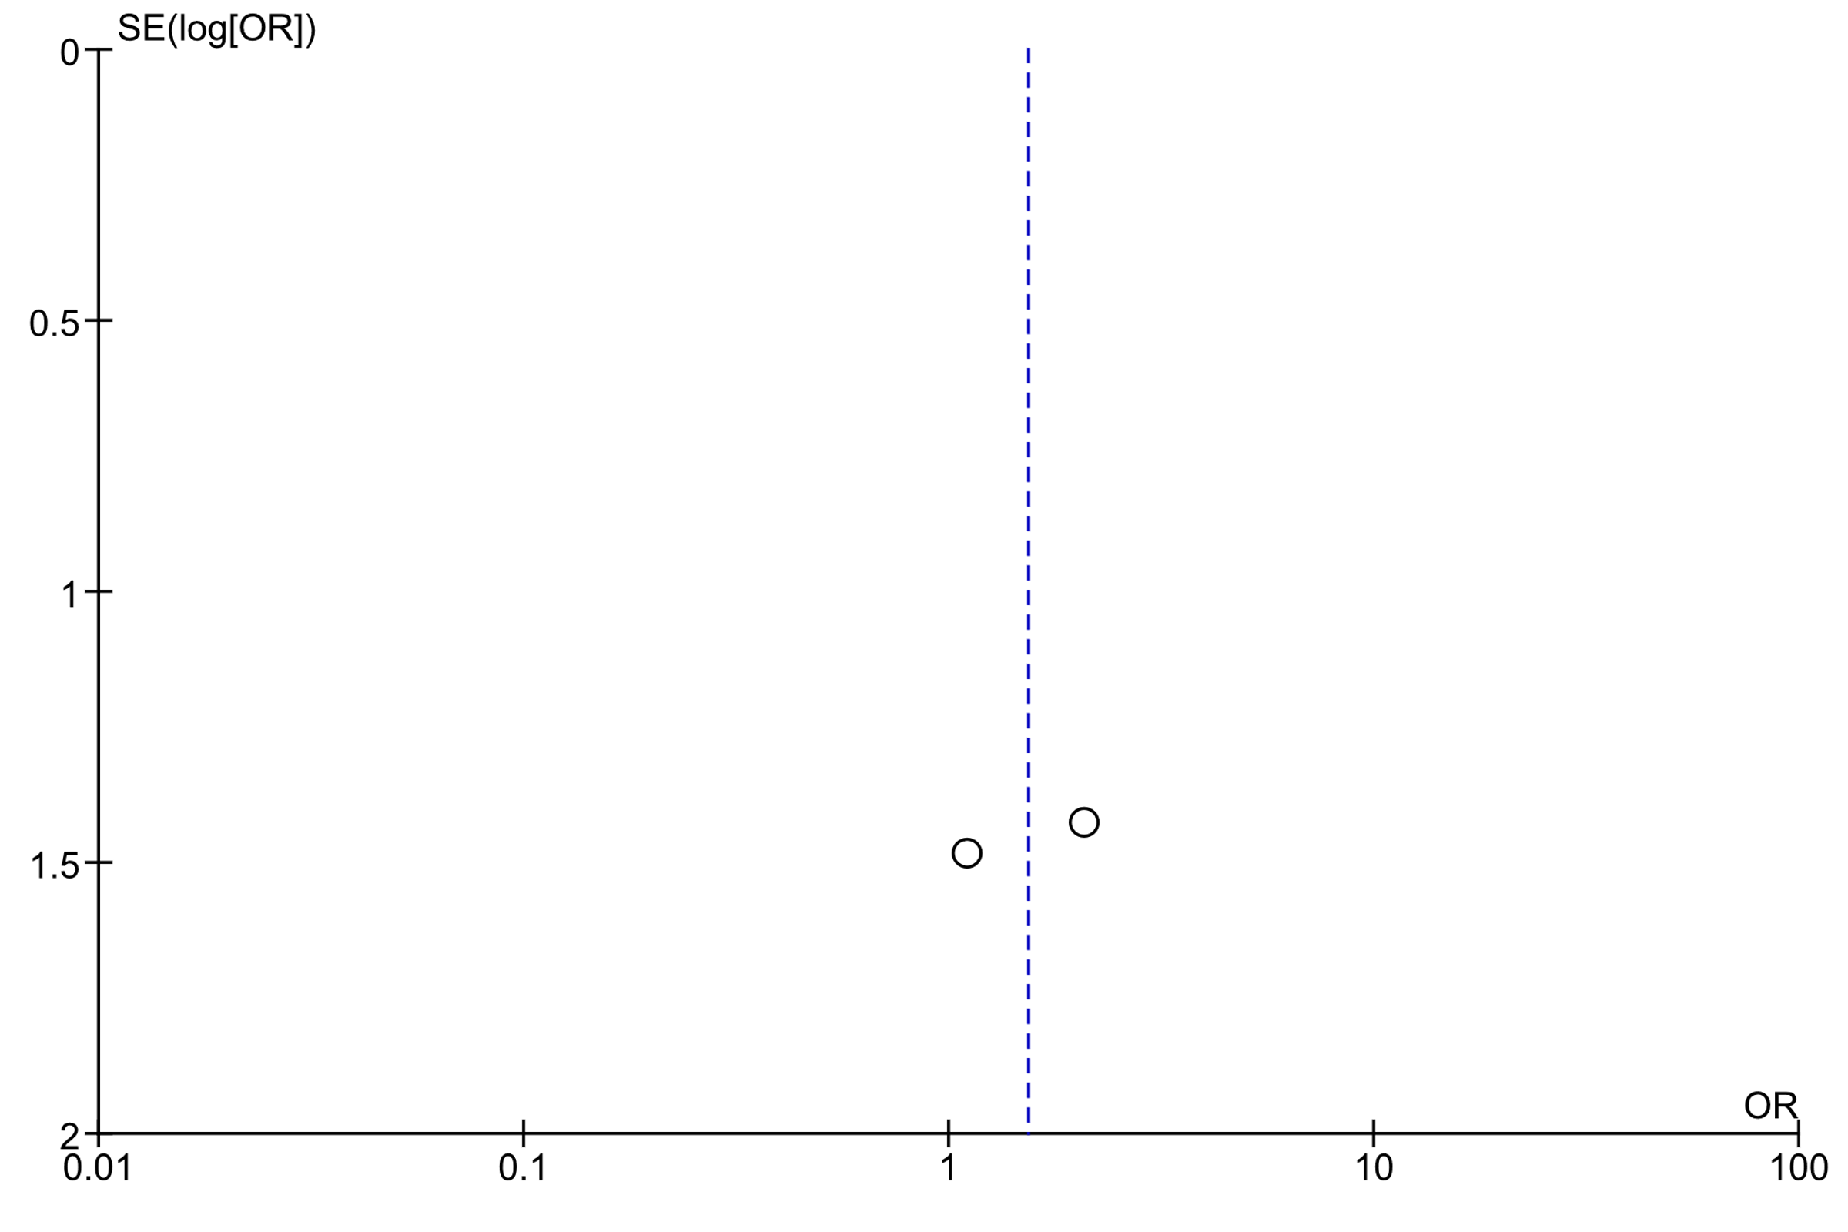
Figure 6. Funnel plot indicating no publication bias in the results comparing the classification accuracy on the testing set (ACC) of supervised OSH- and ANN-based algorithms in clinical gait analysis from selected studies that used both kinetic and kinematic data, eligible for the meta-analysis in Fig. 3.

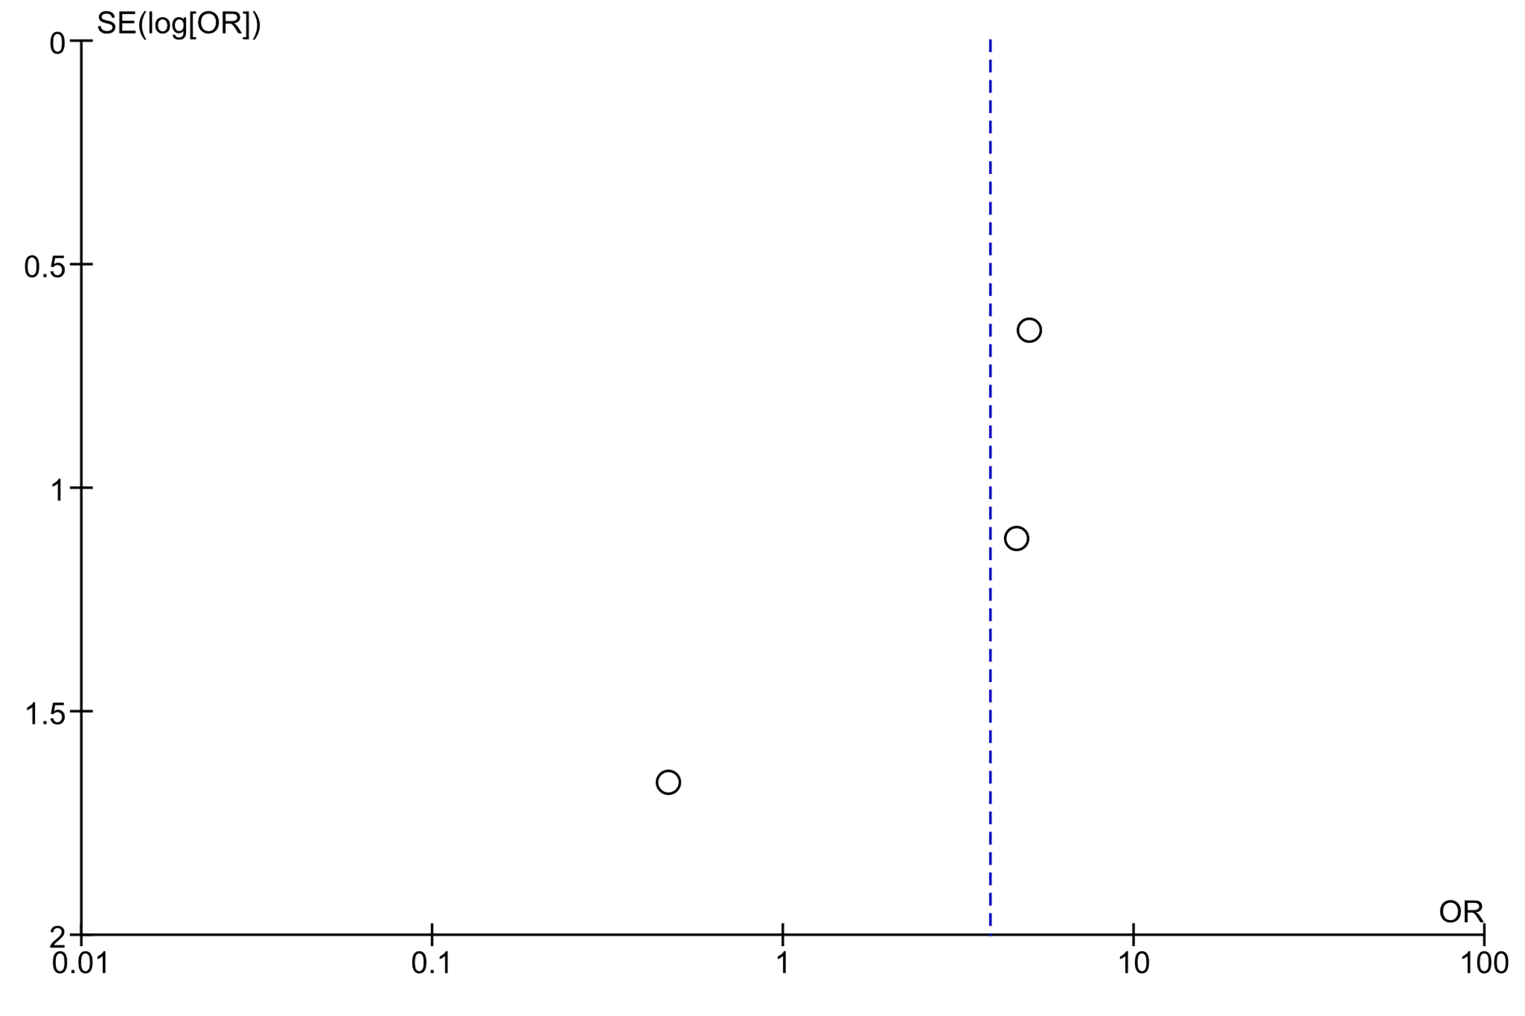
Figure 7. Funnel plot indicating no publication bias in the results comparing the sensitivity and specificity on the testing set (ACC) of supervised OSH- and ANN-based algorithms in clinical gait analysis from selected studies that used kinematic data, eligible for the meta-analysis in Fig. 4.

Discussion
Previous reviews on the use of supervised learning-based classifiers [28-37] in clinical gait analysis were qualitative [19]. Instead, in this study, in addition to a qualitative analysis of previous research findings, a quantitative one was performed using a novel meta-analysis approach to compare the accuracy (ACC) and reliability (SN, SP, and AUC) between supervised OSH- and ANN-based classifiers in helping in diagnosing knee OA from gait data.

Seven studies from the literature were deemed eligible for inclusion in this study; however, one study [11], although it met the quality assessment criteria to be included in the meta-analysis as per the UARTA star rating, it dealt with the classification of spatio-temporal and symmetry indices instead of the type of data of interest in this systematic review and meta-analysis (kinetic and kinematic data). Thus, it was excluded from the meta-analyses, and only six studies were analysed further. Studies included for meta-analysis as in Table 2 are discussed as follows. The methodological and performance-related limitations of these studies can be inferred from Table 2.

Studies that applied OSH-based (e.g., SVM) to classify knee OA included [7], [11], [12],[13], [14]. Here, Phinyomark et al. [7] leveraged SVM on gait data after applying principal component analysis (PCA) which returned an ACC of 99%. Levinger et al. [11] applied SVM for detecting knee recovery using quantitative gait measures, such as spatio-temporal parameters and speed, and classified the relevant gait data with an ACC of 94.2%, SN of 100% and SP of 97%. Similarly, Karg et al. [12] applied a quadratic SVM to quantify pathological discrepancies in gait phases and joint angles deploying spatio-temporal parameters yielding an ACC of 85%. Furthermore, Levinger et al. [13] applied SVM for detecting recovery from knee replacement surgery using spatio-temporal gait parameters, such as stride length, time and velocity, with an ACC of 89%.

Studies that leveraged ANN-based classifiers (MLP, RBF and KNN) to detect knee OA included [14], [24], [25]. Here, Koktas et al. [14] applied MLP on gait-related feature vectors with an ACC of 90.5%, an SN of 96.5% and an SP of 85.3%. Long et al. [24] applied k-nearest neighbours (KNN) for predicting knee OA-related risk in injured populations based on three kinetic features and twelve kinematic features, with an ACC 100%, SN of 100%, SP of 100% and AUC of 1. Zeng et al. [25] applied deterministic-based radial basis function (RBF) for classification of pathological gait patterns based on twelve kinematic features, such as rotation and range of motion (ROM) of internal-external (IE) rotation, with an ACC of 98%, SN of 94.7%, and SP of 100%.

It can also be inferred that published studies lack consistency in reporting ML-based research findings (Table 2). Only three (N=3) studies dealing with kinematic data [12, 14, 25] reported the SN and SP of the supervised learning-based classifiers tested (Table 2), which are two of the most important performance measures for supervised algorithms, especially when considering their reliability in a control setting. Thus, the statistical comparison of SN and SP could only be performed on such three relevant studies.

In such three selected papers that directly compared such classification outcomes (SN, SP) involving either supervised OSH- or ANN-based algorithms [12, 14, 25], supervised ANN-based classifiers were found to have consistently higher SN and SP than those of supervised OSH-based algorithms, thus being more stable in dealing with knee OA-related gait data (Fig. 4), although the slightly uneven sample distribution in this meta-analysis may impair the generalisation of the results from this study (Figs. 4, 7). Nevertheless, there was no statistically significant discrepancy in ACC when considering kinematic data only (Fig. 2), and when dealing with both kinetic and kinematic data (Fig. 3).

The increased performance in supervised ANN-based algorithms may be partly explained by the re-sampling occurring within supervised ANN-based architectures, such as the MLP, where weights and biases are adjusted iteratively; thus, the data are continuously resampled until the MSE drops below a pre-set threshold that is deemed acceptable to stop training the ANN [9, 10]. These results support the further development and a wide application of the UARTA star-rating quality assessment scale for clinical gait analysis-related studies using supervised OSH and/or ANN for qualitatively evaluating the scientific rigour and quality of such studies, as well as to facilitate a more objective qualitative assessment of published studies for knowledge discovery in subsequent meta-analyses, such as this study.

Figs. 5-7 show no publication bias, as the ORs from the selected studies, overall, they are close to the midline of the graph indicating the mean OR. Therefore, the lack of publication bias supports the reliability of the above-mentioned conclusions derived from analysing the results reported in Figs. 2-4. Moreover, Figs. 2-4 suggest that OSH can be used when dealing with gait data collected on healthy subjects [14], whilst ANN-based classifiers seem to generalise to patients with knee OA better, as Figs. 4 and 7 show [11, 12].

The ACC was reported in all selected studies (N=7) [7, 11-14, 24, 25]; however, the SN and SP were mentioned in only five studies (N=5) [11, 12, 14, 24, 25], with the AUC was only reported in one (N=1) of the included studies [24]. The size of the data available for the meta-analysis (273 healthy subjects and 313 symptomatic patients with knee OA) is a limitation of this study, also with regards to the assessment of publication bias; however, such studies were the only ones that met the eligibility criteria and, therefore, were quantitatively analysed too. This shortcoming highlights an even greater limitation amongst published studies that fail to report relevant results thoroughly. Nevertheless, this study is still a founding one when it comes to assessing eligible studies for a meta-analysis to understand whether OSH or ANN could be applied to aid the diagnosis of knee OA based on the literature and was aimed to provide the first meta-analysis-based approach on ML-related studies to help biomechanists in adopting ANN techniques for translational applications – from bench to bedside.

To summarise, with respect to applications in clinical gait analysis, whilst both ANN- and OSH-based algorithms attempt to mimic the learning-related mechanisms and can handle nonlinear and highly dimensional data, ANN-based algorithms have a higher classification performance, in particular, reliability as measured via SN and SP, in diagnosing knee OA from gait data, i.e., to predict pathological gait patterns typical of knee OA based on kinematic data [12, 14, 25].

The UARTA-star rating quality assessment scale represents the first clinical gait analysis-equivalent (when dealing with learning-based classifiers for clinical decision making) of the Newcastle-Ottawa quality assessment scale [22] that, conversely, is used to assess findings from cohort studies (prospective and/or retrospective) published in the medical literature. Moreover, the development and validation of the UARTA star-rating quality assessment scale seeks to change such the status quo in clinical gait analysis and obviate the lack of appropriate and consistent reporting on OSH- and ANN-related findings in the Biomechanics literature. The implementation of the proposed scale is also intended to guide the development and testing of supervised learning-based algorithms in clinical gait analysis, such that progress in OSH- and ANN-related research can be promptly translated in readily available and rigorously validated tools that biomechanists can use to aid diagnosis of knee OA and other knee disorders worldwide.

Conclusion
This study comprehensively reviewed and reported a quantitative analysis on the test classification accuracy (ACC) and reliability metrics (SN, SP, and AUC) of supervised ML classifiers on knee OA when using mocap data. Findings suggest that the classification performance of ANN-based algorithms was higher and more reliable than that obtained via OSH-based algorithms. These conclusions encourage the adoption of ANN-based algorithms as a reliable tool for the classification of pathological gait associated with knee OA in a control setting. The development and validation of the UARTA star-rating quality assessment scale for supervised ML-based studies in clinical gait analysis define a set of initial standards and guidelines to promote a thorough and prompt translational application of previous research findings for meta-analysis approaches.

Acknowledgment
The authors would like to thank the University of Auckland Rehabilitative Technologies Association (UARTA) for giving them a chance for this collaborative research work. Additionally, the authors would like to thank Professor Tom Chau from the University of Toronto, Canada, for his assistance in reviewing and improving the scientific rigour and quality of this manuscript.

REFERENCES

- Moustakidis, S. P., Theocharis, J. B., & Giakas, G. (2010). A fuzzy decision tree-based SVM classifier for assessing osteoarthritis severity using ground reaction force measurements. Medical Engineering and Physics, 32(10), 1145-1160.
- Kusakunniran, W., Prachasri, N., Dirakbussarakom, N., & Yangchaem, D. (2017, February). Distinguishing ACL patients from healthy individuals using multilayer perceptron on motion patterns. In Knowledge and Smart Technology (KST), 2017 9th International Conference on (pp. 1-5). IEEE.
- Sowers, M. R., & Karvonen-Gutierrez, C. A. (2010). The evolving role of obesity in knee osteoarthritis. Current opinion in rheumatology, 22(5), 533.
- Neogi, T. (2013). The epidemiology and impact of pain in osteoarthritis. Osteoarthritis and Cartilage, 21(9), 1145-1153.
- Favre, J., Hayoz, M., Erhart-Hledik, J. C., & Andriacchi, T. P. (2012). A neural network model to predict knee adduction moment during walking based on ground reaction force and anthropometric measurements. Journal of biomechanics, 45(4), 692-698.
- Aljaaf, A. J., Hussain, A. J., Fergus, P., Przybyla, A., & Barton, G. J. (2016, July). Evaluation of machine learning methods to predict knee loading from the movement of body segments. In Neural Networks (IJCNN), 2016 International Joint Conference on (pp. 5168-5173). IEEE.
- Phinyomark, A., Osis, S. T., Hettinga, B. A., Kobsar, D., & Ferber, R. (2016). Gender differences in gait kinematics for patients with knee osteoarthritis. BMC musculoskeletal disorders, 17(1), 157.
- Parisi, L., Biggs, P. R., Whatling, G. M., & Holt, C. A. (2015). A Novel Comparison of Artificial Intelligence Methods for Diagnosing Knee Osteoarthritis. In XXV Congress of the International Society of Biomechanics, 1227-1229.
- Parisi, L. (2014a). Exploiting Kinetic and Kinematic Data to Plot Cyclograms for Managing the Rehabilitation Process of BKAs by Applying Neural Networks. Int. J. Biomed. Biol. Eng., 8(10), 664–668.
- Parisi, L. (2014b). Neural Networks for Distinguishing the Performance of Two Hip Joint Implants on the Basis of Hip Implant Side and Ground Reaction Force. Int. J. Medical, Heal. Pharm. Biomed. Eng., 8(10), 659–663.
- Levinger, P., Lai, D. T., Webster, K., Begg, R. K., & Feller, J. (2007, August). Support Vector Machines for detecting recovery from knee replacement surgery using quantitative gait measures. In Engineering in Medicine and Biology Society, 2007. EMBS 2007. 29th Annual International Conference of the IEEE (pp. 4875-4878). IEEE.
- Karg, M., Seiberl, W., Kreuzpointner, F., Haas, J. P., & Kulić, D. (2015). Clinical gait analysis: Comparing explicit state duration HMMs using a reference-based index. IEEE Transactions on Neural Systems and Rehabilitation Engineering, 23(2), 319-331.
- Levinger, P., Lai, D. T., Begg, R. K., Webster, K. E., & Feller, J. A. (2009). The application of support vector machines for detecting recovery from knee replacement surgery using spatio-temporal gait parameters. Gait & posture, 29(1), 91-96.
- Koktas, N. S., Yalabik, N., & Yavuzer, G. (2006). Ensemble classifiers for medical diagnosis of knee osteoarthritis using gait data. In Machine Learning and Applications, 2006. ICMLA'06. 5th International Conference on (pp. 225-230). IEEE.
- Vapnik, V. (1998). Statistical learning theory. 1998. Wiley, New York.
- Begg, R., & Kamruzzaman, J. (2005). A machine learning approach for automated recognition of movement patterns using basic, kinetic and kinematic gait data. Journal of biomechanics, 38(3), 401-408.
- Rumelhart, D. E., Hinton, G. E., & Williams, R. J. (1986). Learning representations by back-propagating errors. Nature, 323(6088), 533.
- Benedetti, M. G., Beghi, E., De Tanti, A., Cappozzo, A., Basaglia, N., Cutti, A. G., & Fantozzi, S. (2017). SIAMOC position paper on gait analysis in clinical practice: General requirements, methods and appropriateness. Results of an Italian consensus conference. Gait & posture, 58, 252-260.
- Chau, T. (2001). A review of analytical techniques for gait data. Part 2: neural network and wavelet methods. Gait & posture, 13(2), 102-120.
- Higgins, J. P., Thompson, S. G., Deeks, J. J., & Altman, D. G. (2003). Measuring inconsistency in meta-analyses. BMJ: British Medical Journal, 327(7414), 557.
- Moher, D., Liberati, A., Tetzlaff, J., Altman, D. G., & Prisma Group. (2009). Preferred reporting items for systematic reviews and meta-analyses: the PRISMA statement. PLoS medicine, 6(7), e1000097.
- Stang, A. (2010). Critical evaluation of the Newcastle-Ottawa scale for the assessment of the quality of nonrandomized studies in meta-analyses. European journal of epidemiology, 25(9), 603-605.
- Dechartres, A., Trinquart, L., Boutron, I., & Ravaud, P. (2013). Influence of trial sample size on treatment effect estimates: meta-epidemiological study. British Medical Journal, 346, f2304.
- Long, M. J., Papi, E., Duffell, L. D., & McGregor, A. H. (2017). Predicting knee osteoarthritis risk in injured populations. Clinical biomechanics, 47, 87-95.
- Zeng, W., Ma, L., Yuan, C., Liu, F., Wang, Q., Wang, Y., & Zhang, Y. (2019). Classification of asymptomatic and osteoarthritic knee gait patterns using gait analysis via deterministic learning. Artificial Intelligence Review, 52(1), 449-467.
- Parisi, L., Ravichandran, N., & Lanzillotta, M. (2020). Artificial Intelligence for Clinical Gait Diagnostics of Knee Osteoarthritis: An Evidence-based Review and Analysis. TechrXiv.
- Parisi, L., RaviChandran, N., & Manaog, M. L. (2019). A novel hybrid algorithm for aiding prediction of prognosis in patients with hepatitis. Neural Computing and Applications, 1-14.
- Parisi, L., & RaviChandran, N. (2018, April). Genetic algorithms and unsupervised machine learning for predicting robotic manipulation failures for force-sensitive tasks. In 2018 4th International Conference on Control, Automation and Robotics (ICCAR) (pp. 22-25). IEEE.
- Parisi, L., & Manaog, M. L. (2017). The importance of selecting appropriate k-fold cross-validation and training algorithms in improving postoperative discharge decision-making via artificial intelligence. In 2017 AUT Mathematical Sciences Symposium (Vol. 1, p. 2017).
- Parisi, L., & Manaog, M. L. (2017). A minimum viable machine learning-based speech processing solution for facilitating early diagnosis of Parkinson's disease. In MATLAB Conference 2017, Auckland, New Zealand.
- Parisi, L., & Manaog, M. L. (2016). Preliminary validation of the lagrangian support vector machine learning classifier as clinical decision-making support tool to aid prediction of prognosis in patients with hepatitis. In The 16th International Conference on Biomedical Engineering, National University of Singapore (NUS).
- Parisi, L., RaviChandran, N., & Manaog, M. L. (2018). Decision support system to improve postoperative discharge: A novel multi-class classification approach. Knowledge-Based Systems, 152, 1-10.
- Parisi, L., & Ravichandran, N. (2017). Genetic Algorithms and Artificial Neural Networks for Optimising User Control in Hand Prosthetic Devices. In AUT Mathematical Sciences Symposium (p. 16).
- Parisi, L., & RaviChandran, N. (2020). Evolutionary feature transformation to improve prognostic prediction of hepatitis. Knowledge-Based Systems, 200, 106012.
- Parisi, L., Neagu, D., Ma, R., Campean, F. (2020). QReLU and m-QReLU: Two novel quantum activation functions to aid medical diagnostics. arXiv preprint. arXiv:2010.08031.
- Parisi, L., & RaviChandran, N. (2020). Evolutionary Denoising-Based Machine Learning for Detecting Knee Disorders. Neural Processing Letters, 1-17.
- Parisi, L. (2020). m-arcsinh: An Efficient and Reliable Function for SVM and MLP in scikit-learn. arXiv preprint. arXiv:2009.07530.

