**SUPPLEMENTARY MATERIAL**

**Ricicomin A, a new alkaloid from the leaves of *Ricinus communis* Linn.**

Nguyen Kim Tuyen Phama, Thi Thao Linh Trana, Thuc Huy Duongb, Nguyen Tien Trungc, Dang Cam Tu Phanc, Dinh Tri Maid,e, Van Kieu Nguyenf,g,Bui Linh ChiHuynhh, Thi Anh Tuyet Nguyenb, Trong Duc Trani, Thi Ngoc Mai Tranj,*, Tan Phat Nguyend,e*

*aFaculty of Environmental Science,* *Sai Gon University, 273 An Duong Vuong, Ho Chi Minh City, Vietnam*

*bFaculty of Chemistry, University of Education, Ho Chi Minh City 748342, Vietnam*

*cLaboratory of Computational Chemistry and Modeling, Faculty of Natural Sciences, Quy Nhon University, Quy Nhon City 590000, Vietnam*

*dFaculty of Chemistry, Graduate University of Science and Technology, Vietnam Academy of Science and Technology, 18 Hoang Quoc Viet, Cau Giay, Hanoi, Vietnam*

*eBioactive Compounds Laboratory, Institute of Chemical Technology, Vietnam Academy of Science and Technology, Thanh Loc 29, Thanh Loc, District 12, Ho Chi Minh City, Vietnam*

*fInstitute of Fundamental and Applied Sciences, Duy Tan University, Ho Chi Minh City 700000, Vietnam.*

*gFaculty of Natural Sciences, Duy Tan University, Da Nang, 550000, Vietnam.*

*hDepartment of Nature, Dong Nai University, Dong Nai Province, Vietnam*

*iGeneCology Research Centre, University of the Sunshine Coast, Maroochydore DC, Queensland 4558, Australia*

*jHo Chi Minh City University of Technology (HUTECH), Ho Chi Minh City, Vietnam*

Corresponding author. Tel.: +84 916.360.751 Email: [ntphat@ict.vast.vn](mailto:ntphat@ict.vast.vn) or [ttn.mai79@hutech.edu.vn](mailto:ttn.mai79@hutech.edu.vn)

ORCID ID: https://orcid.org/0000-0001-9672-2785

From the leaves of *Ricinus communis* Linn., one new alkaloid, named ricicomin A (**1**) together with three known ones, ricinine (**2**), *N*-demethylricinine (**3**) and 4-[2-formyl-5-(methoxymethyl)-1H-pyrrol-1-yl]butanoic acid (**4**) were justified by repeated chromatographic methods. Their structures were determined by comprehensive IR, HR-ESI-MS and NMR analyses. Compound **4** was identified for the first time from the genus *Ricinus*. DFT-NMR chemical shift calculations and subsequent DP4+ probability methods were applied to confirm the chemical structure of **1**. Compounds **1-3** did not display cytotoxic effect againstthree human cancer cell lines (MCF-7, HepG2 and HeLa)using SRB assay.

**Keywords:** *Ricinus communis*;Euphorbiaceae; alkaloid; ricicomin A.

**List of supporting information**

Table S1. NMR spectroscopic data for **1** recorded in DMSO-*d6* and acetone-*d*6.

Table S2.Cytotoxic activity of alkaloids **1-3** at the concentration of 100 μg/mL.

Table S3. Relative energy at B3LYP/6-311++G(2d,2p).

Figure S1. Key COSY, HMBC and NOESY correlations of 1.

Figure S2. 1H-NMR spectrum (500 MHz) of compound **1** in DMSO-*d6*.

Figure S3. 13C-NMR spectrum (125 MHz) of compound **1** in DMSO-*d6*.

Figure S4. COSY spectrum of compound **1** in DMSO-*d6*.

Figure S5. HSQC spectrum of compound **1** in DMSO-*d6*.

Figure S6. HMBC spectrum of compound **1** in DMSO-*d6*.

Figure S7. NOESY spectrum of compound **1** in DMSO-*d6*.

Figure S8. 1H-NMR spectrum (500 MHz) of compound **1** in acetone-*d*6.

Figure S9. 13C-NMR spectrum (125 MHz) of compound **1** in acetone-*d*6.

Figure S10. DEPT spectrum of compound **1** in acetone-*d*6.

Figure S11. HSQC spectrum of compound **1** in acetone-*d*6.

Figure S12. HMBC spectrum of compound **1** in acetone-*d*6.

Figure S13. HR-ESI-MS spectrum (negative) of compound **1**.

Figure S14. IR spectrum of compound **1**.

Figure S15. Optimized structures at B3LYP/6-311++G(2d,2p) level of theory.

Table S1. NMR spectroscopic data for **1** recorded in DMSO-*d6* and acetone-*d*6.

|  |  |  |  |  |  |  |
| --- | --- | --- | --- | --- | --- | --- |
| Pos. | *δ*C, type *a* | *δ*H,multi. *a* | *δ*C, type *b* | *δ*H, multi. *b* | NOESY *a* | HMBC *a* |
| 1 | 168.2, C |  | 170.0, C |  |  |  |
| 2 | 109.1, C |  | 109.3, C |  |  |  |
| 3 | 164.1, C |  | 165.6, C |  |  |  |
| 4 | 100.8, CH | 6.60, s | 101.3, CH | 6.60, s | 10 | 1, 2, 3, 5, 6, 8 |
| 5 | 164.1, C |  | 168.3, C |  |  |  |
| 6 | 90.2, C |  | 93.0, C |  |  |  |
| 7 | 134.0, CH | 8.20, s | 134.2, CH | 8.09, s | NH | 1, 3, 5, 8, 4 *d*, 6 *d* |
| 8 | 116.5, C |  | 116.7, C |  |  |  |
| 9 | 25.8, CH3 | 2.79, d (4.5) | 26.3, CH3 | 2.91, s |  | 1 |
| 10 | 56.5, CH3 | 3.89, s | 57.0, CH3 | 3.96, s | 4 | 3, 4*d* |
| NH |  | 9.05, br.s |  | 8.42, br.s | 7 |  |
| OH |  | *c* |  | *c* |  |  |

*a  Recorded in DMSO-d6*

*b  Recorded in acetone-d6*

*c Not observed*

*d Weak signal*

Table S2.Cytotoxic activity of alkaloids **1-3** at the concentration of 100 μg/mL.

|  |  |  |
| --- | --- | --- |
| **Cell line** | **Fraction** | **Inhibition (%)** |
| HeLa | **1** | 2.67 ± 2.57 |
| Camptothecin* | 65.08 ± 2.59 |
| HepG2 | **2** | 9.24 ± 1.39 |
| **3** | 5.03 ± 2.56 |
| Camptothecin# | 51.85 ± 0.32 |
| MCF-7 | **2** | 19.47 ± 1.76 |
| **3** | 12.29 ± 0.64 |
| Camptothecin$ | 51.85 ± 1.32 |
| *\*at the concentration of 1.00 (µg/mL)*  *#at the concentration of 0.07 (µg/mL)*  *$at the concentration of 0.01 (µg/mL)* | | |

Table S3. Relative energy at B3LYP/6-311++G(2d,2p).

|  |  |  |  |
| --- | --- | --- | --- |
|  | **Relative Energy (with ZPE correction) (in kcal.mol-1)** | **Percentage according to Boltzmann analysis (%)** | **Note** |
| 1a_1 | 12.3 | 0.003 |  |
| 1a_2 | 6.2 | 99.997 | Isomer 1 in DP4+ |
| 1b_1 | 0.0 | 99.999 | Isomer 2 in DP4+ |
| 1b_2 | 5.7 | 0.001 |  |

**DP4+ results**

* **Type a (relative to the NMR data recorded in DMSO-d6)**

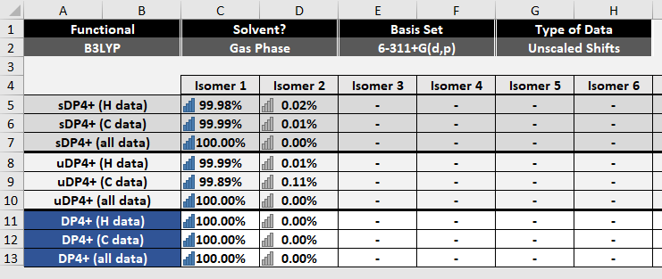

* **Type b (relative to the NMR data recorded in acetone-d6)**

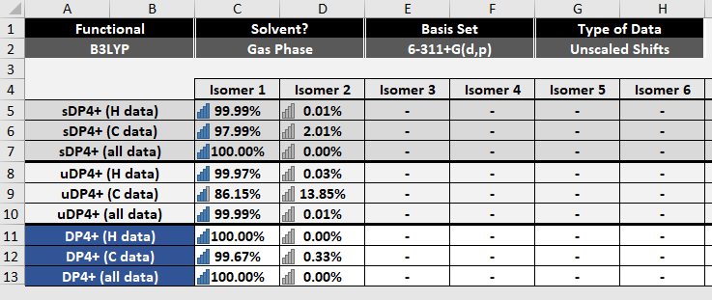

**Cartesian coordinates at** B3LYP/6-311++G(2d,2p)

**1a_1**

C -0.713412 -1.208219 -0.126693

C -1.915237 -0.507535 0.030178

C -1.886692 0.897568 0.066453

C -0.677107 1.572195 -0.054323

C 0.509347 0.856588 -0.193470

C 0.500965 -0.554662 -0.214785

H -0.734257 -2.286271 -0.189517

H -0.696265 2.649434 -0.043738

O -3.004631 1.644840 0.209532

H -3.784014 1.076694 0.272398

C -3.171793 -1.165215 0.148883

N -4.230427 -1.615222 0.256446

C 1.732610 -1.389812 -0.460696

O 1.773634 -2.150812 -1.417268

N 2.761243 -1.308521 0.424727

H 3.546946 -1.885894 0.168845

C 2.836915 -0.566068 1.669501

H 3.281131 -1.193651 2.441635

H 3.431400 0.342839 1.567520

H 1.838878 -0.289763 1.997703

O 1.717874 1.448113 -0.338024

C 1.787994 2.870563 -0.415310

H 1.208321 3.245390 -1.259849

H 1.438086 3.334343 0.508400

H 2.837497 3.103538 -0.563956

**1a_2**

C 0.660720 -1.193135 0.000000

C 1.951482 -0.664378 0.000000

C 2.116180 0.731566 0.000001

C 0.998554 1.556119 0.000000

C -0.281657 1.009335 0.000000

C -0.473221 -0.394344 0.000000

H 0.509683 -2.262344 0.000000

H 1.162412 2.620611 0.000000

O 3.330075 1.323904 0.000000

H 4.029834 0.656807 0.000007

C 3.116901 -1.483465 -0.000001

N 4.116904 -2.061495 -0.000001

C -1.783854 -1.149331 0.000000

O -1.785790 -2.375435 0.000000

N -2.937689 -0.441839 0.000001

O -1.389293 1.800387 -0.000001

C -1.241006 3.221147 -0.000001

H -0.715349 3.559018 0.893343

H -0.715351 3.559018 -0.893345

H -2.250497 3.619937 0.000000

C -4.222877 -1.118528 0.000001

H -5.010066 -0.368459 0.000001

H -4.330786 -1.751411 -0.880503

H -4.330786 -1.751412 0.880504

H -2.890859 0.560807 0.000000

**1b_1**

C 0.133684 1.035548 -0.000073

C 0.897927 -0.131049 -0.000050

C 0.204979 -1.370045 -0.000017

C -1.194332 -1.402728 0.000031

C -1.928003 -0.229050 0.000025

C -1.254655 1.019876 -0.000036

H 0.605445 2.007234 -0.000149

H -1.668132 -2.370612 0.000063

O 0.844368 -2.538141 -0.000029

H 1.818027 -2.321922 -0.000111

O -3.271065 -0.167337 0.000064

C -4.019654 -1.382526 0.000110

H -3.807612 -1.971712 -0.892981

H -3.807572 -1.971668 0.893221

H -5.061721 -1.080689 0.000126

C -1.986322 2.243544 -0.000066

N -2.546120 3.252347 -0.000089

C 2.379655 -0.147085 -0.000059

O 3.007085 -1.222772 -0.000187

N 3.057696 1.020417 0.000049

H 2.559065 1.889452 0.000443

C 4.513369 1.053051 0.000182

H 4.912133 0.553776 -0.881623

H 4.834305 2.091209 -0.000147

H 4.912037 0.554360 0.882373

**1b_2**

C 0.297762 0.934978 -0.224675

C 1.028880 -0.249087 -0.118018

C 0.297102 -1.462591 0.004526

C -1.096977 -1.444794 0.113702

C -1.794931 -0.250823 0.041738

C -1.089058 0.963615 -0.152983

H 0.802238 1.870754 -0.396589

H -1.598566 -2.391945 0.225208

O 0.895926 -2.652156 0.019120

H 1.854196 -2.481550 -0.190333

O -3.132042 -0.142633 0.125556

C -3.913308 -1.322682 0.311265

H -3.789484 -2.009128 -0.527258

H -3.649379 -1.823311 1.243701

H -4.942926 -0.983833 0.356837

C -1.787186 2.201065 -0.273934

N -2.320666 3.219334 -0.372059

C 2.504391 -0.329906 -0.190150

O 3.054840 -1.413823 -0.465342

N 3.297860 0.750725 0.034797

C 3.016891 1.996970 0.737921

H 2.749536 2.807596 0.058610

H 2.218408 1.865144 1.463624

H 3.914230 2.293126 1.277098

H 4.270220 0.511145 -0.081092

**Calculated NMR data**

**Isotropic value based on GIAO calculations at B3LYP/6-311+G(d,p)**

|  |  |  |
| --- | --- | --- |
| **Position** | **Isomer 1** | **Isomer 2** |
| C7 | 39.0635 | 46.3733 |
| C6 | 87.7286 | 73.0310 |
| C5 | 13.4695 | 8.0452 |
| C4 | 84.2035 | 81.1347 |
| C3 | 14.8318 | 10.6055 |
| C2 | 63.1115 | 85.5206 |
| C8 | 64.5859 | 64.0833 |
| C1 | 16.8081 | 9.3343 |
| C10 | 127.0527 | 127.4358 |
| C9 | 155.8089 | 155.6801 |
| H7 | 23.0026 | 24.7996 |
| H4 | 25.6418 | 25.7663 |
| H10 | 28.2670  28.2670  27.8620 | 28.3901  28.3901  27.8212 |
|
|
| H9 | 29.6160  28.9005  28.9005 | 28.8895  29.5098  28.8907 |
| H(NH) | 24.9807 | 26.6495 |
| H(OH) | 26.3694 | 18.2529 |



Figure S1. Key COSY, HMBC and NOESY correlations of **1.**

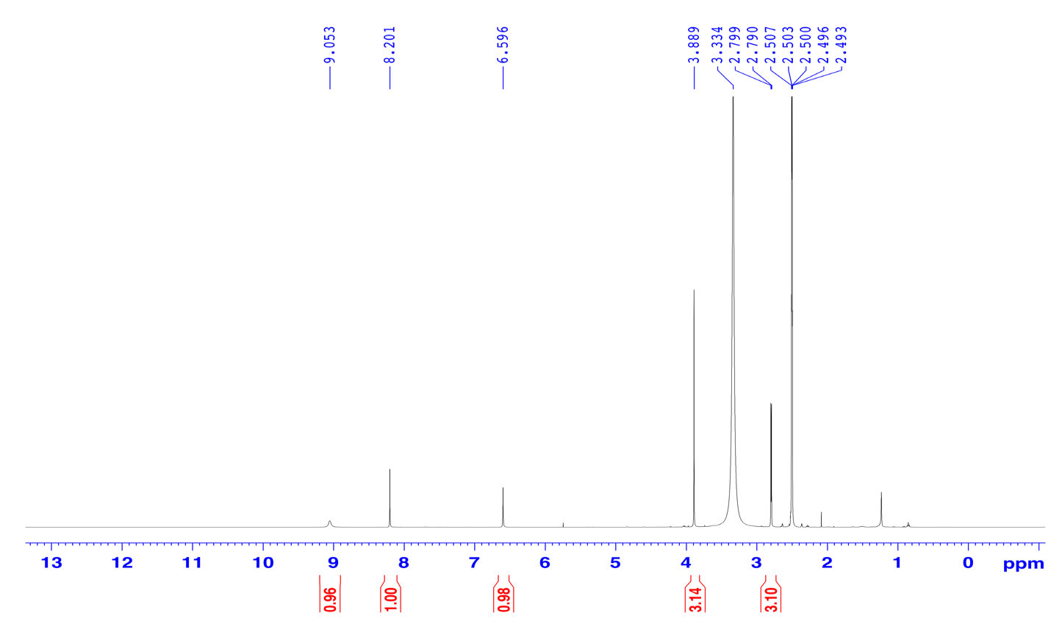

Figure S2. 1H-NMR spectrum (500 MHz) of compound **1** in DMSO-*d6*.

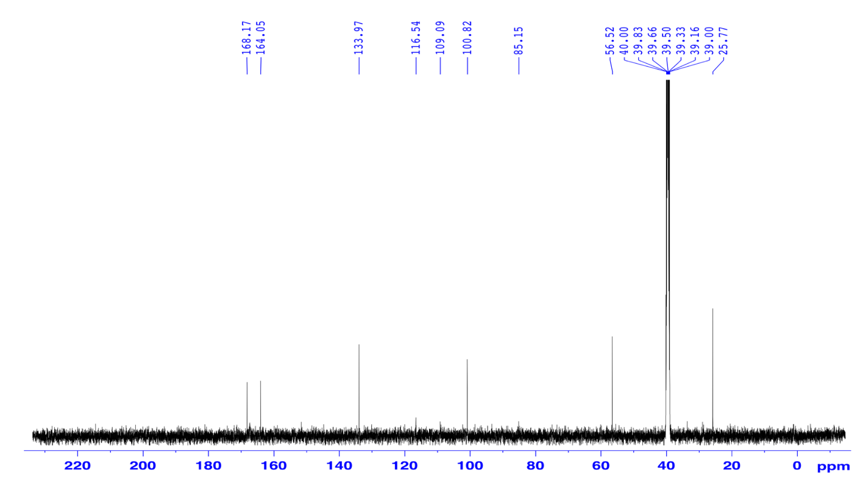

Figure S3. 13C-NMR spectrum (125 MHz) of compound **1** in DMSO-*d6*.

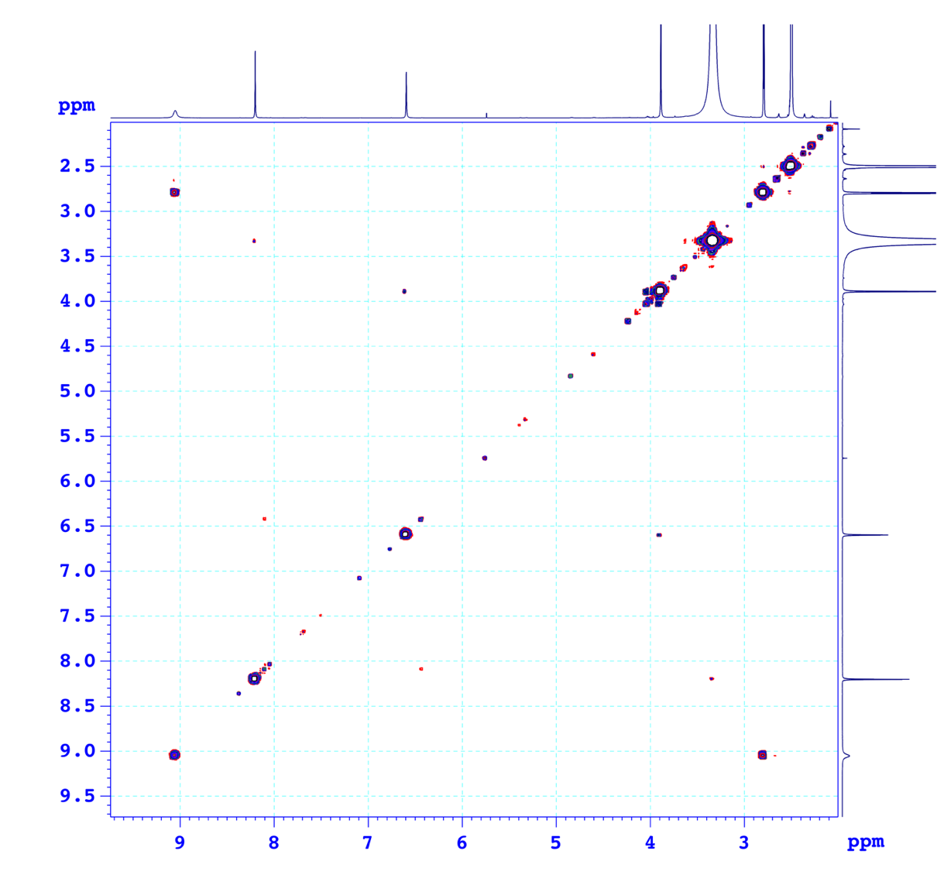

Figure S4. COSY spectrum of compound **1** in DMSO-*d6*.

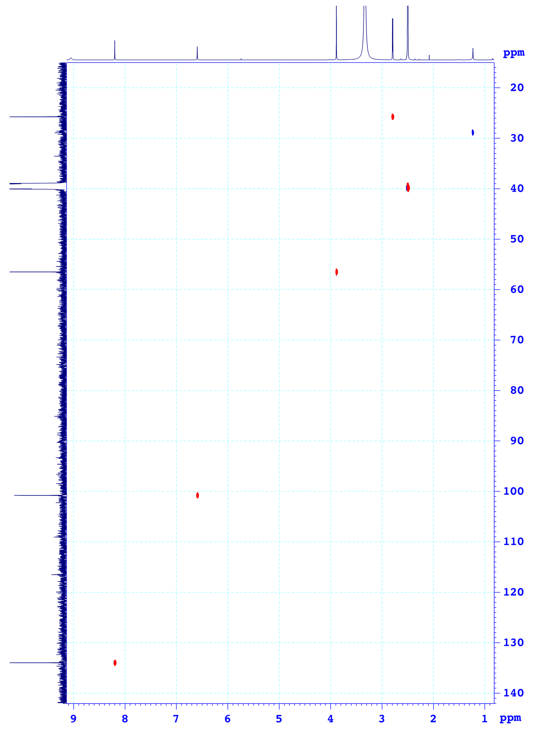

Figure S5. HSQC spectrum of compound **1** in DMSO-*d6*.

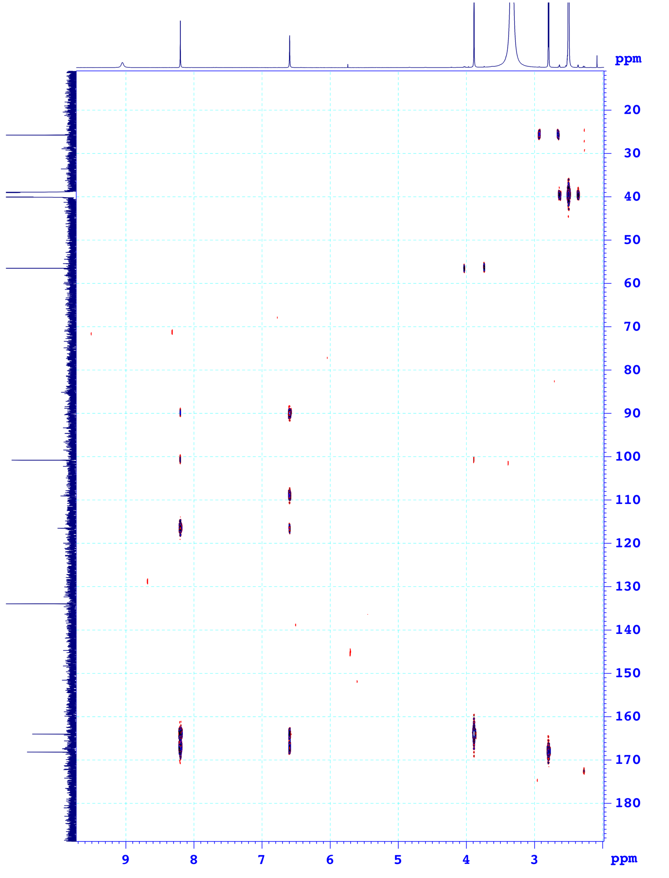

Figure S6. HMBC spectrum of compound **1** in DMSO-*d6*.

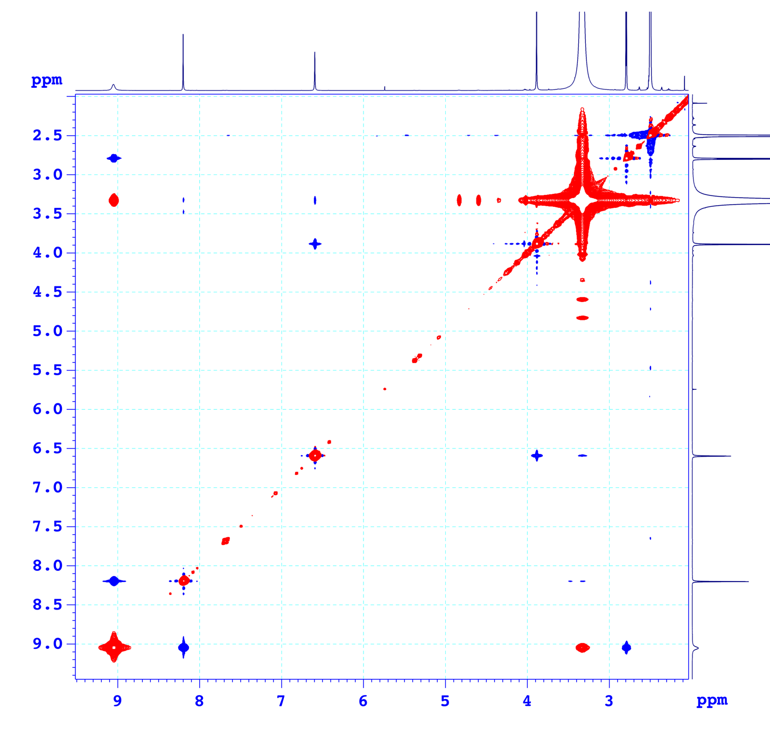

Figure S7. NOESY spectrum of compound **1** in DMSO-*d6*.

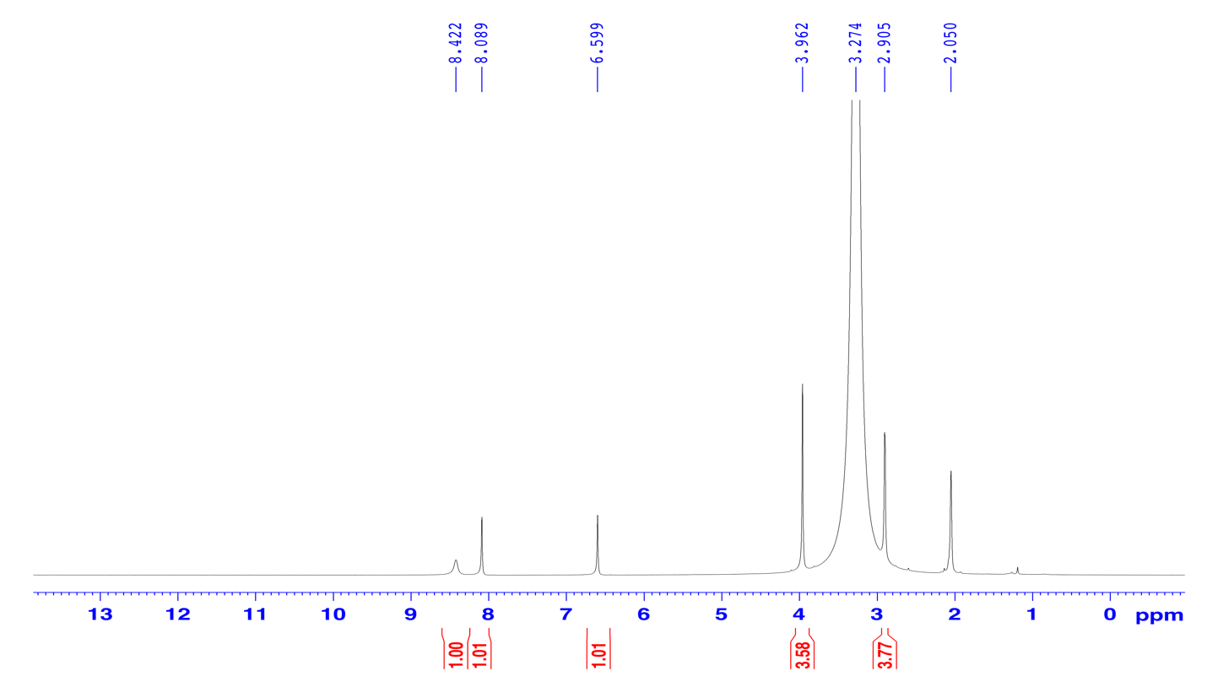

Figure S8. 1H-NMR spectrum (500 MHz) of compound **1** in acetone-*d*6.

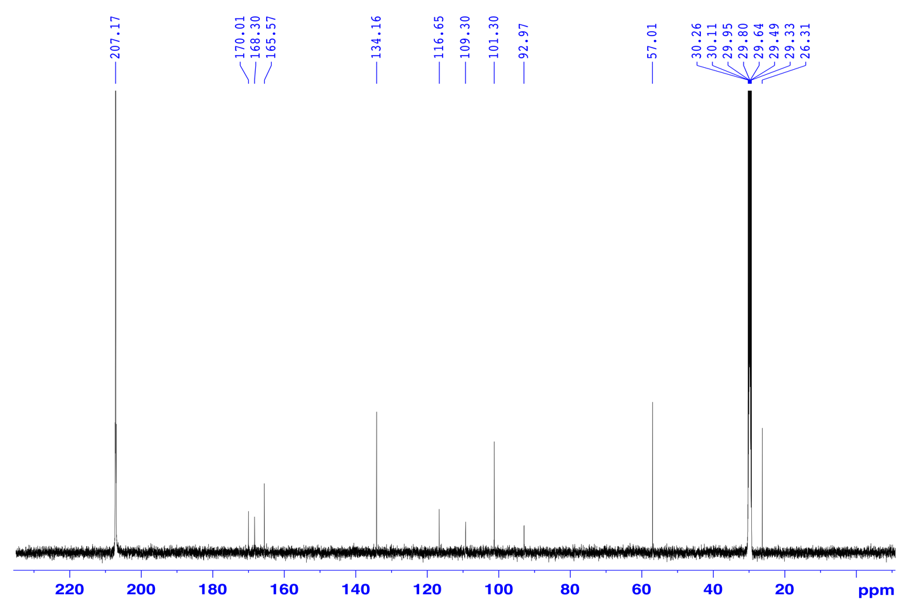

Figure S9. 13C-NMR spectrum (125 MHz) of compound **1** in acetone-*d*6.

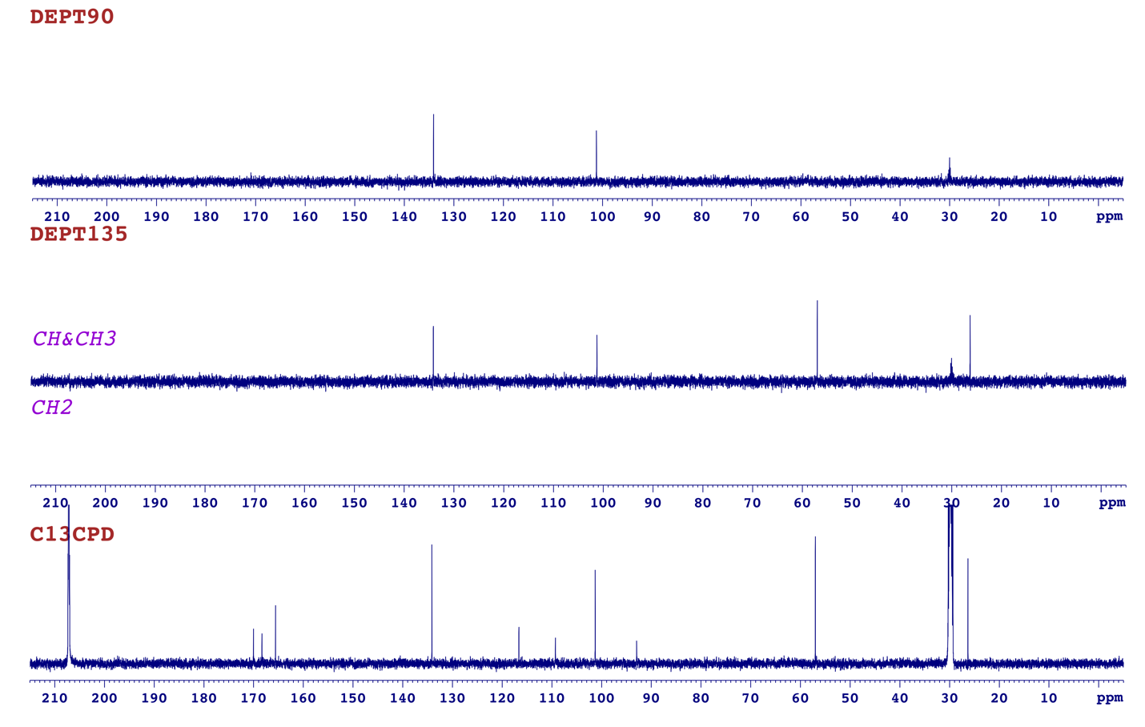

Figure S10. DEPT spectrum of compound **1** in acetone-*d*6.

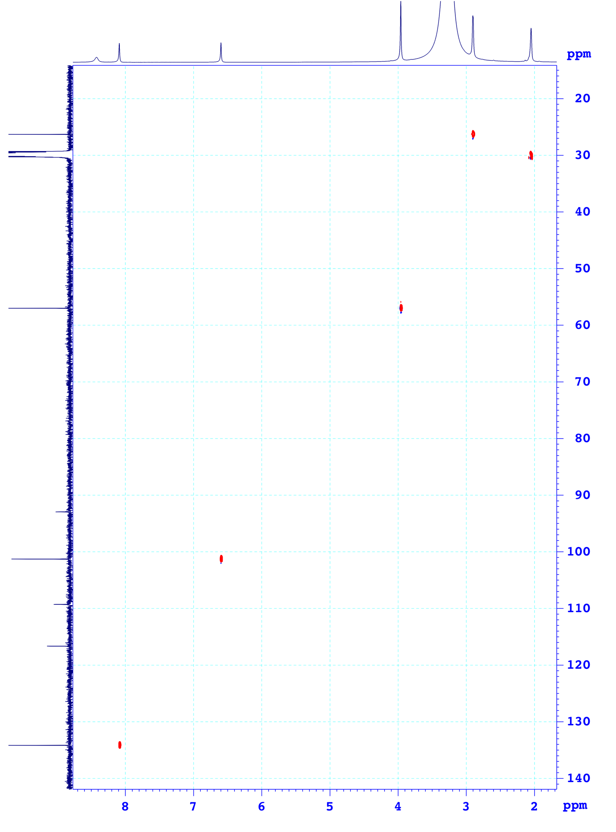

Figure S11. HSQC spectrum of compound **1** in acetone-*d*6.

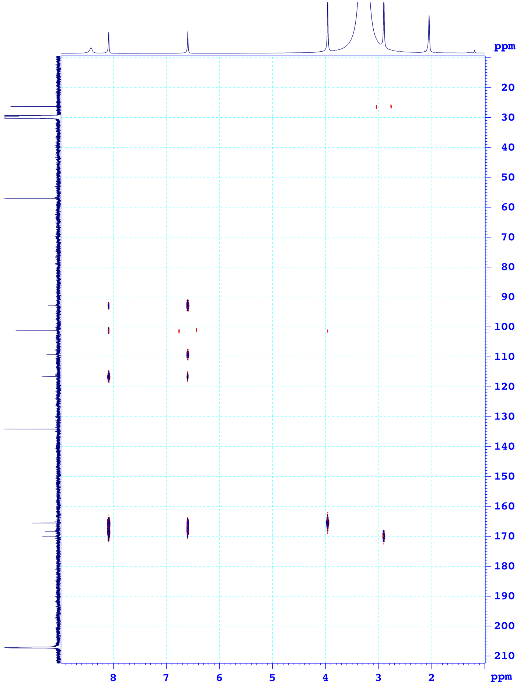

Figure S12. HMBC spectrum of compound **1** in acetone-*d*6.



Figure S13. HR-ESI-MS spectrum (negative) of compound **1**.



Figure S14. IR spectrum of compound **1**.

|  |  |
| --- | --- |
|  |  |
| 1a_1 | 1a_2 |
|  |  |
| 1b_1 | 1b_2 |

Figure S15. Optimized structures at B3LYP/6-311++G(2d,2p) level of theory.