Supporting Information
Inclusion of Neutral Guests by Water-Soluble Macrocyclic Hosts – A Comparative Thermodynamic Investigation with Cyclodextrins, Calixarenes, and Cucurbiturils

Dong-Sheng Guo,^{1,2,}* Vanya D. Uzunova,¹ Khaleel I. Assaf,¹ Alexandra I. Lazar,¹ Yu Liu,² Werner M. Nau^{1,}*

¹ Department of Life Sciences and Chemistry, Jacobs University Bremen, Campus Ring 1, D-28759 Bremen, Germany. E-mail: w.nau@jacobs-university.de; Tel: (49)4212003233 and Fax: (49)4212003229
² Department of Chemistry, State Key Laboratory of Elemento-Organic Chemistry, Collaborative Innovation Center of Chemical Science and Engineering, Nankai University, Tianjin 300071, China. E-mail: dshguo@nankai.edu.cn; Tel: (86)2223498949

a.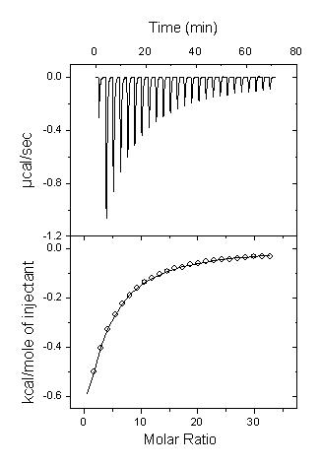b.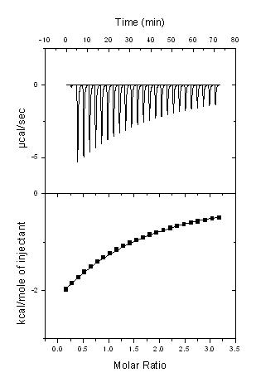c.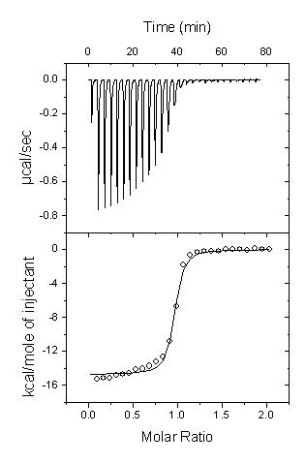
Figure S1. ITC isotherm for the titration of 7.91, 9.63 and 0.15 mM DBN into 0.045 mM β-CD (a), 0.56 mM CX4 (b) and 0.015 mM CB7 (c) aqueous solution, respectively.

Figure S2. ¹H NMR spectra of a) free and complexed DBO with CB7, b) free and complexed DBN with CB7.

Figure S3. Distribution functions of free host diameter; see Figure S4 for the diameter definition.
Figure S4. Definition of the diameters used to determine the flexibility of the free hosts.

Table S1. Water-guest intermolecular Hydrogen bond analysis^{[a]}, obtained from the MD trajectories.
Number | free | @β-CD | @CX4 | @CB7
DBH | 0.70 | 0.53 | 0.85 | 0.53
DBO | 0.70 | 0.59 | 0.90 | 0.68
DBN | 0.70 | 0.59 | 1.02 | 0.79
^{[a]} A hydrogen bond cut distance ≤ 2.8 Å and an angle ≥ 120° were used.

