What is the relationship of economic output and youth unemployment with mortality from COVID-19?

Author: Golo Henseke (g.henseke@ucl.ac.uk)

Data sources
- COVID-19 dataset: European Centre for Disease Prevention and Control
- Quarterly Gross Domestic Product (chain linked volumes, seasonally and calendar year adjusted): Eurostat, OECD, National Bureau of Statistics of China, Philippine Statistics Authority
- Monthly Unemployment rate of under 25 year-olds: Eurostat, OECD

Sample
- Restricted to countries with more than 4.5m inhabitants including Ireland.

Figures
Figure 1: Correlation of COVID-19 mortality with GDP growth
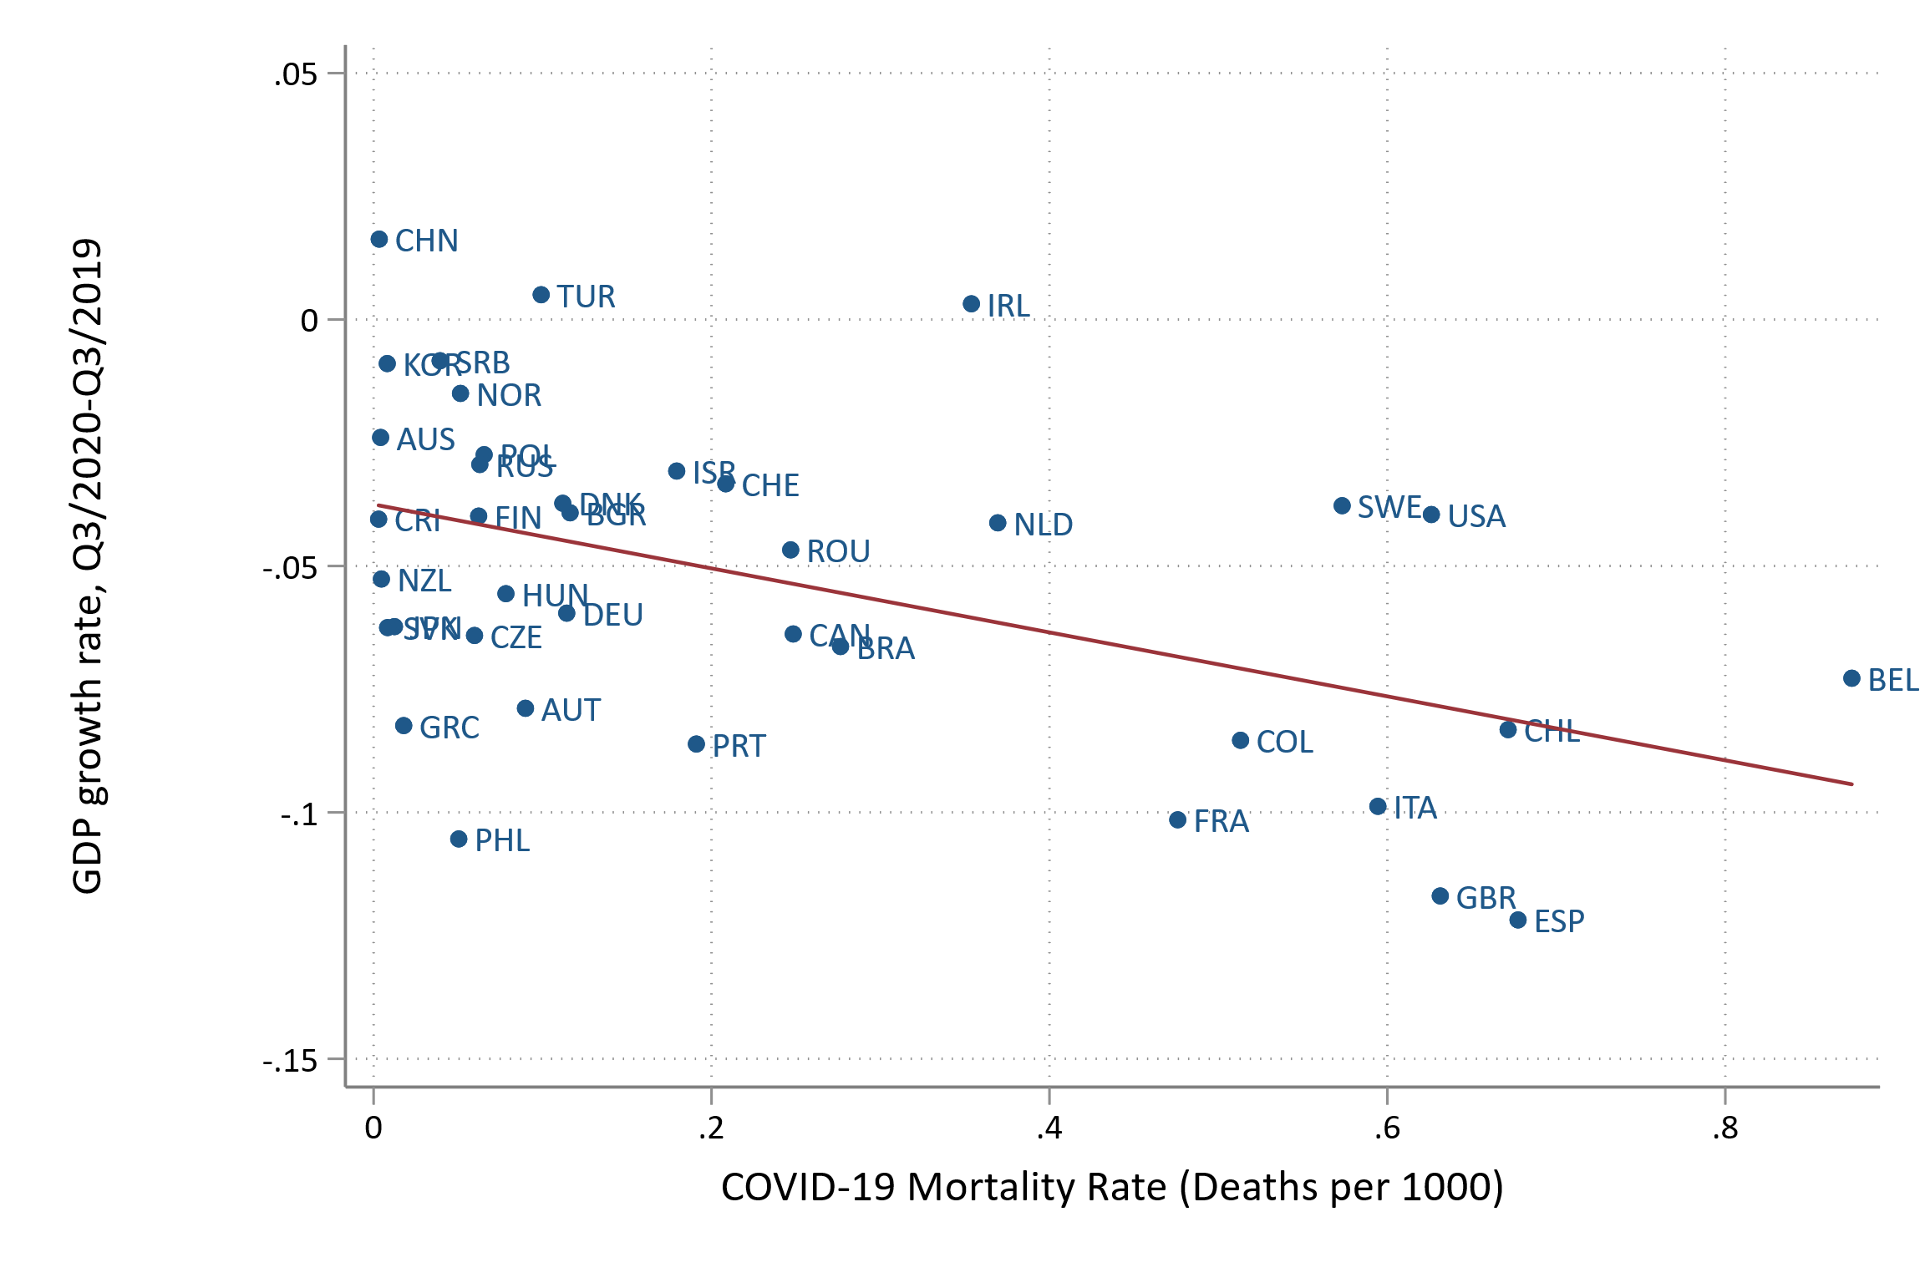
Figure 2: Correlation of COVID-19 mortality with youth unemployment.
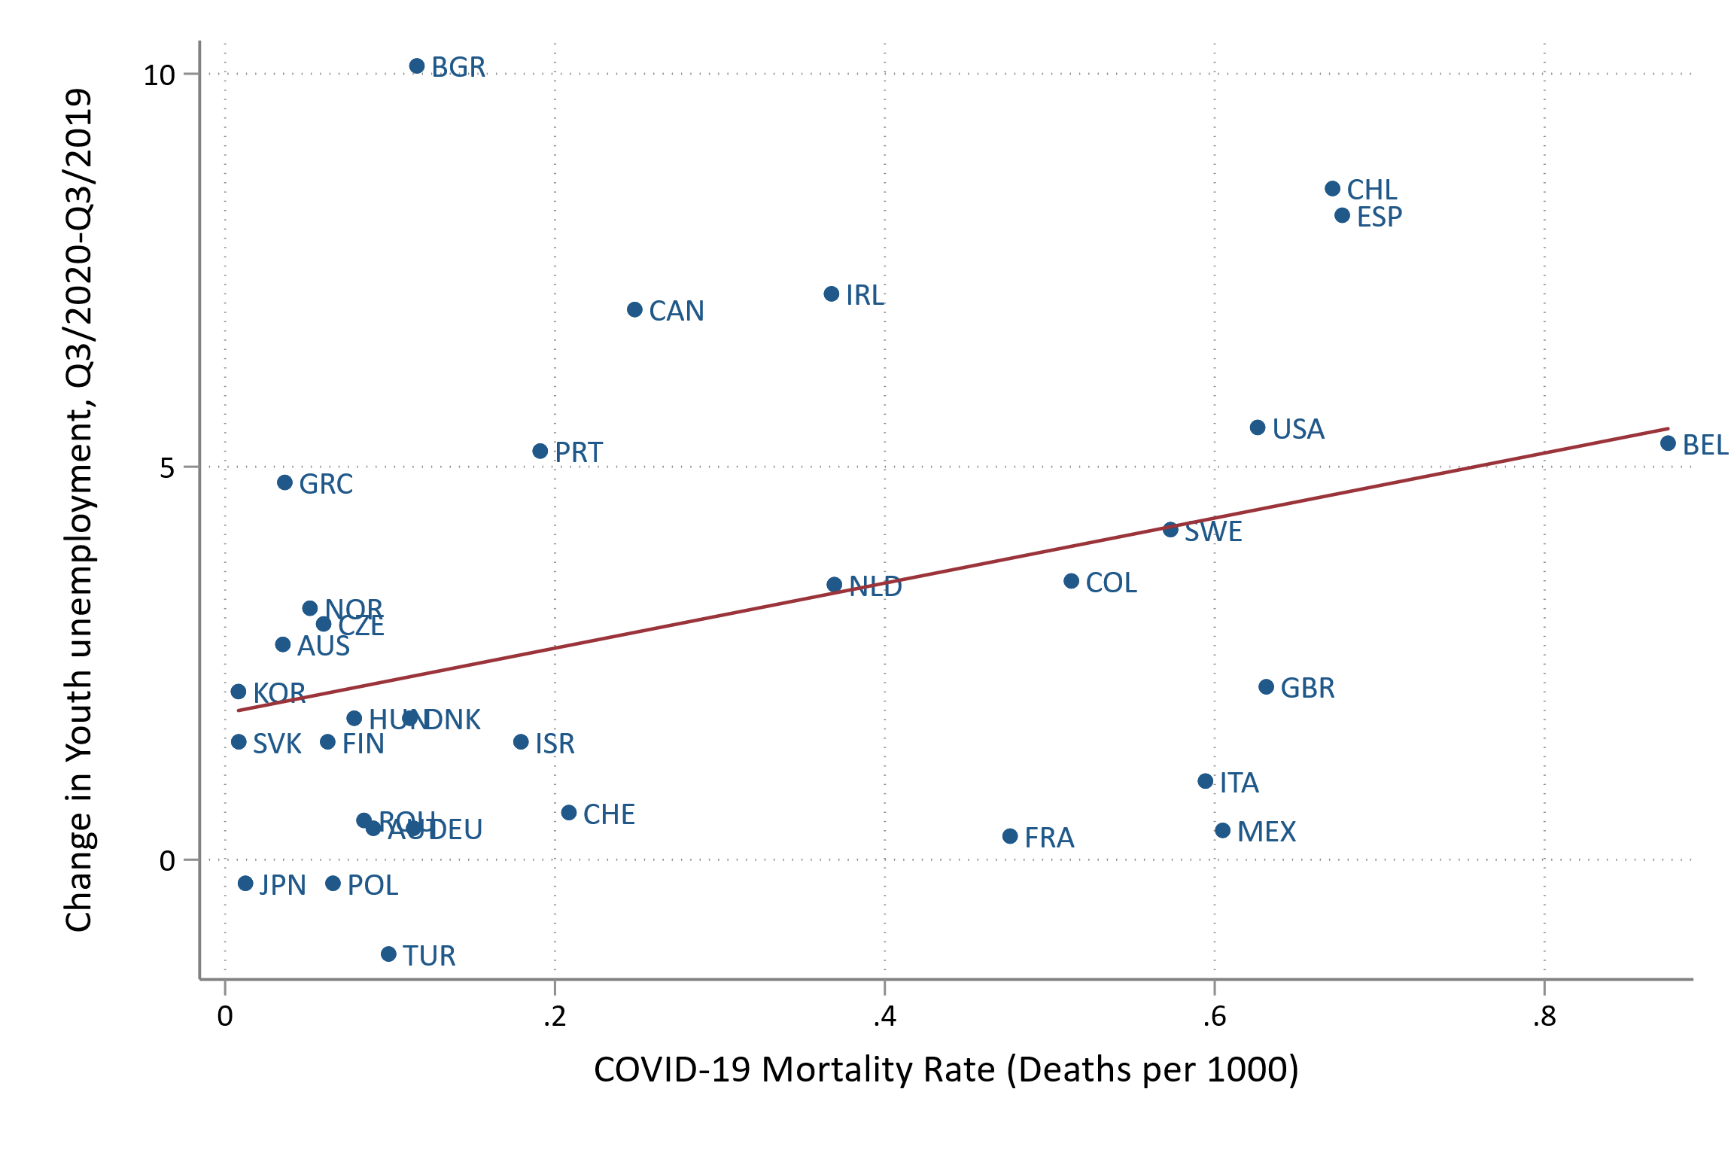
Figure 3: Correlation of GDP growth with changes in youth unemployment
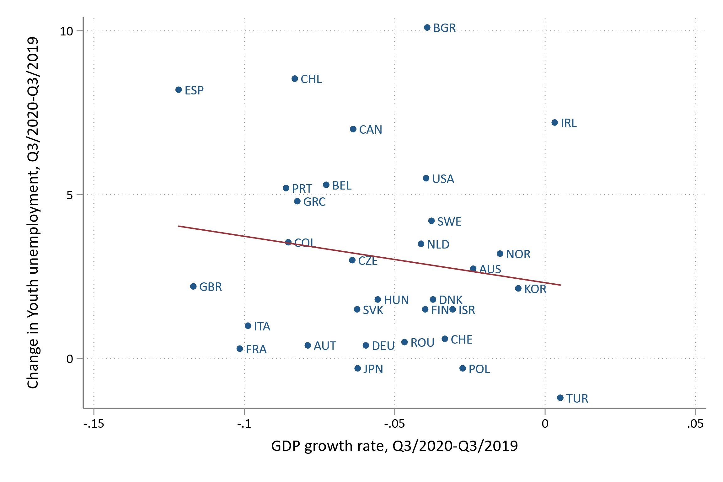
Table 1: Correlation coefficients between COVID-19 mortality rate, GDP growth rate, Change in Youth unemployment
 | COVID-19 mortality rate | GDP growth rate | Change in Youth unemployment
COVID-19 mortality rate | 1
GDP growth rate | -0.47 | 1
Change in Youth unemployment | 0.41 | -0.16 | 1

