**Supporting Information**

**Air toxics exposures in an area impacted by industrial sources: source attribution and impact of averaging time**

Albert A. Presto, Timothy R. Dallmann, Peishi Gu, Unnati Rao

Summary: This document is 8 pages, and contains 7 figures and 3 tables.

**GC analysis**

The details of the GC time-temperature program are presented in Table S1. Both GCs operated under the same program.

**Table S1.** Details of GC-FID sampling and analysis. Both GCs used an activated carbon trap to concentrate ambient samples. One sample was collected on the trap while the previous sample was analyzed.

|  |  |  |  |
| --- | --- | --- | --- |
| Activated carbon trap | | GC column and FID | |
| Time (min) | Event | Time (min) | Event |
| 0 - 2 | Trap desorption at 360 C. | 0 - 3 | Oven held at 45 C |
| 2 - 2.2 (10 sec) | Sample injection to column head | 3 - 11 | Oven ramp to 160 C at 15 C/min |
| 2.2 - 5 | Trap cools to ambient temperature | 11 - 13 | Oven holds at 160 C |
| 5 - 30 | Trap collects next sample | 13 - 30 | Oven cools to 45 C |

Twenty peaks were identified in at least 50% of the chromatograms collected at Whitehall and Squirrel Hill (Table 1 in the manuscript, Table S1 below). As noted in the text, nine species were positively identified: acetone, benzene, heptane, toluene, m+p-xylene, o-xylene, and three isomers of trimethyl benzene (1,3,5; 1,2,4; and 1,2,3). The response and retention times of these species were identified with an authenticated gas standard.

The carbon number of three other peaks was identified (C6 hydrocarbons, C5 carbonyl, and C9 hydrocarbons) but specific isomers were not identified. These species were quantified using the corresponding n-alkane (C6 and C9 hydrocarbons) and 2-pentanone (C5 carbonyl).

The remaining peaks were unidentified. Unidentified peaks are indicated in Table S1 by their retention time (in seconds). These peaks appear to primarily consist of oxygenated species. Brief notes on the unidentified species are included below.

-Peaks appearing at 207 and 224 seconds could be hydrocarbons lighter than butane (RT = 229 sec) or, more likely, oxygen-containing molecules that elute before acetone (RT = 290 sec).

-Peaks appearing at 670, 715, 830, 879, and 1236 sec all display afternoon maxima. The retention times of these peaks do not match with any n-alkanes or single-ring aromatics. Thus these peaks all seem to be associated with secondary (oxygenated) species, and are enriched in the secondary and secondary/regional PMF factors.

-The peak at 1122 sec may be dodecane (RT = 1120 sec), but the time series of this peak indicates it may also contain contributions from unidentified oxygenated species.

**Table S2.** Percent contribution of each species in each of five PMF factors. VOC species are listed in order of increasing retention time. Retention time is indicated in parenthesis for identified species, and in the peak name for unidentified species.

|  |  |  |  |  |  |
| --- | --- | --- | --- | --- | --- |
| Species and retention time | Gasoline vehicles | Secondary | Industrial emissions | Secondary/Area | Diesel vehicles |
| Peak 207 (unknown) | 0.0 | 1.6 | 2.3 | 9.1 | 6.6 |
| Peak 224 (unknown) | 2.3 | 2.8 | 0.2 | 3.1 | 4.5 |
| Acetone (249 sec) | 0.0 | 2.2 | 2.3 | 12.2 | 1.2 |
| C6 hydrocarbons (290 sec) | 7.3 | 0.0 | 0.0 | 0.0 | 38.3 |
| C5 carbonyl (340 sec) | 11.2 | 60.1 | 0.0 | 0.0 | 7.8 |
| Heptane (386 sec) | 0.0 | 1.7 | 3.7 | 2.1 | 6.0 |
| Toluene (456 sec) | 10.9 | 0.0 | 26.5 | 6.0 | 0.2 |
| C9 hydrocarbons (540 sec) | 9.7 | 0.0 | 0.7 | 0.0 | 0.0 |
| m+p Xylene (571 sec) | 12.0 | 2.3 | 16.1 | 3.2 | 1.6 |
| o-xylene (605 sec) | 4.4 | 0.0 | 7.2 | 0.0 | 0.0 |
| Peak 670 (unknown) | 7.6 | 4.5 | 0.4 | 12.6 | 3.7 |
| 1,3,5-trimethyl benzene (690 sec) | 3.2 | 0.6 | 4.9 | 0.3 | 1.0 |
| Peak 715 (unknown) | 4.5 | 0.0 | 1.5 | 6.1 | 0.9 |
| 1,2,4-trimethyl benzene (733 sec) | 4.8 | 0.7 | 6.9 | 0.0 | 0.8 |
| 1,2,3-trimethyl benzene (775 sec) | 0.0 | 12.6 | 2.3 | 1.4 | 0.0 |
| Peak 830 (unknown) | 7.6 | 1.9 | 0.0 | 13.3 | 0.0 |
| Peak 879 (unknown) | 5.4 | 5.1 | 0.2 | 6.0 | 0.6 |
| Peak 1122 (unknown) | 2.0 | 3.9 | 4.2 | 6.0 | 5.9 |
| Peak 1236 (unknown) | 4.5 | 0.0 | 1.8 | 18.6 | 2.8 |
| BC | 2.5 | 0.0 | 18.8 | 0.1 | 18.1 |

**Table S3.** Sources modeled using the AERMOD dispersion model. Coordinates of each source are given in the Universal Transverse Mercator (UTM) coordinate system, zone 17. UTM is the default coordinate system for AERMOD.

|  |  |  |  |  |
| --- | --- | --- | --- | --- |
| Source Name | SO2 (tons/yr) | toluene (tons/yr) | UTM Easting | UTM Northing |
| Allegheny Energy Mitchell Station | 1536 | 0.06 | 587838 | 4452754 |
| Arcelor Mittal Coke Oven | 0.07 | 0.0004 | 594973 | 4446474 |
| Bay Valley Foods | 209 | 0.0006 | 585589 | 4478789 |
| Chase Corp Coatings | 0.002 | 4.2 | 596168 | 4482459 |
| Cheswick Power Plant | 1686 | 5.2 | 602375 | 4488256 |
| U.S. Steel Clairton Coke | 1637 | 5.2 | 595956 | 4461738 |
| Eastman Chemical Resins | 0.15 | 11.9 | 593305 | 4458043 |
| U.S. Steel Edgar Thompson | 1454 | <0.0001 | 597057 | 4471990 |
| Flexsys | 4.8 | <0.0001 | 590756 | 4448729 |
| Guardian Industries | 70.4 | <0.0001 | 592119 | 4456541 |
| Harsco Materials Recovery | 7.1 | <0.0001 | 597415 | 4471857 |
| U.S. Steel Irvin Works | 507 | 0.08 | 593150 | 4465476 |
| Kelly Run Sanitation | 1.99 | 0.45 | 594649 | 4456398 |
| PPG Springdale | 0.061 | 1.0 | 602806 | 4488111 |
| Shenango coke | 285 | 2.2 | 577813 | 4483309 |

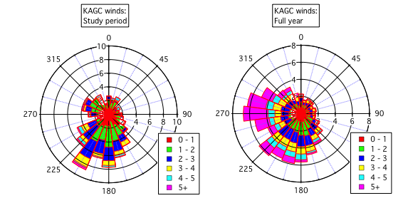

**Figure S1.** Wind roses from the Allegheny County Airport (KAGC) for the study period and a full year (Mar 1 2014 – Feb 28 2015). Wind speeds are in miles per hour.

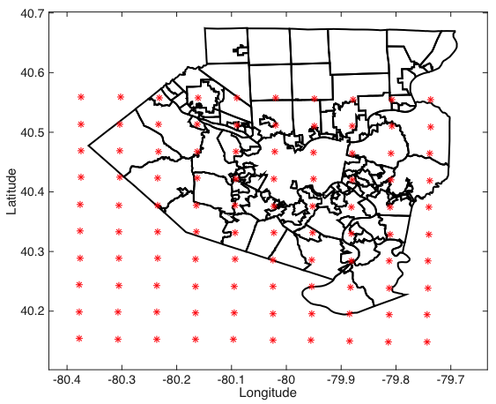

**Figure S2.** Receptor grid used in AERMOD.

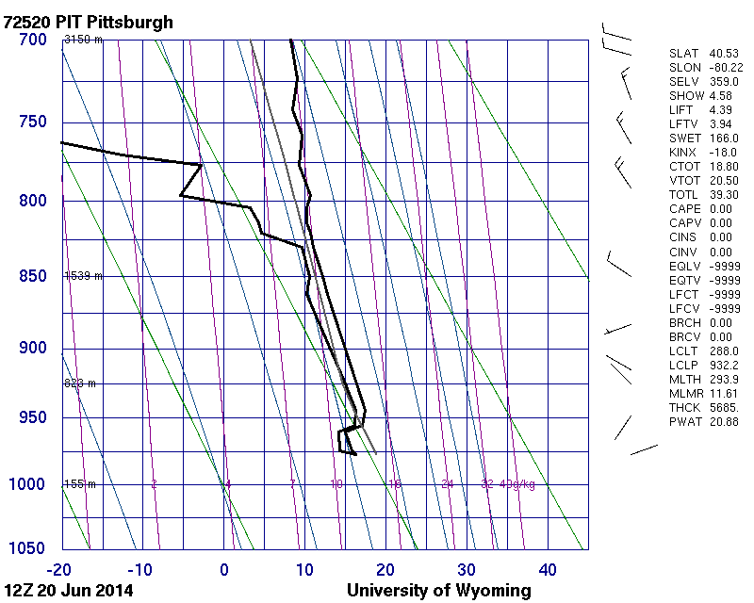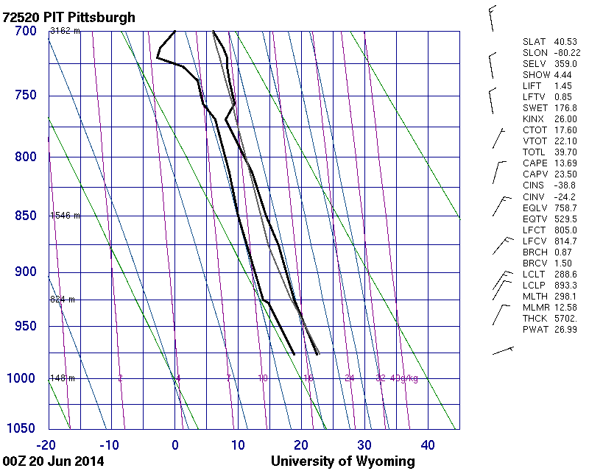

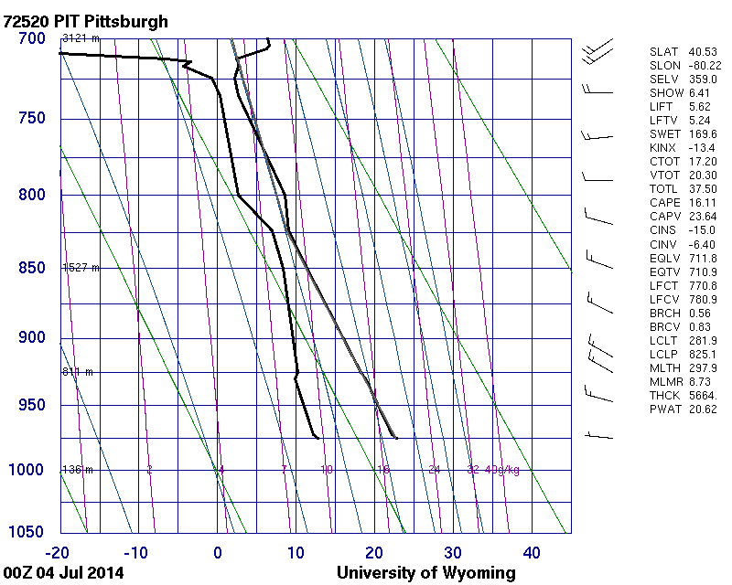**Figure S3.** Atmospheric soundings collected on June 20, 2014 at 00Z (left panel, 7pm June 19, local time) and 12Z (right panel, 7am June 20, local time). The morning sounding shows a clear inversion, and therefore a low mixing height, at approximately 500 m above ground level. No such inversion is evident in the evening sounding, indicating that the inversion formed during the overnight period. A pollutant plume was evident the morning of June 20 at the Whitehall site. Soundings were obtained from http://weather.uwyo.edu/upperair/sounding.html.

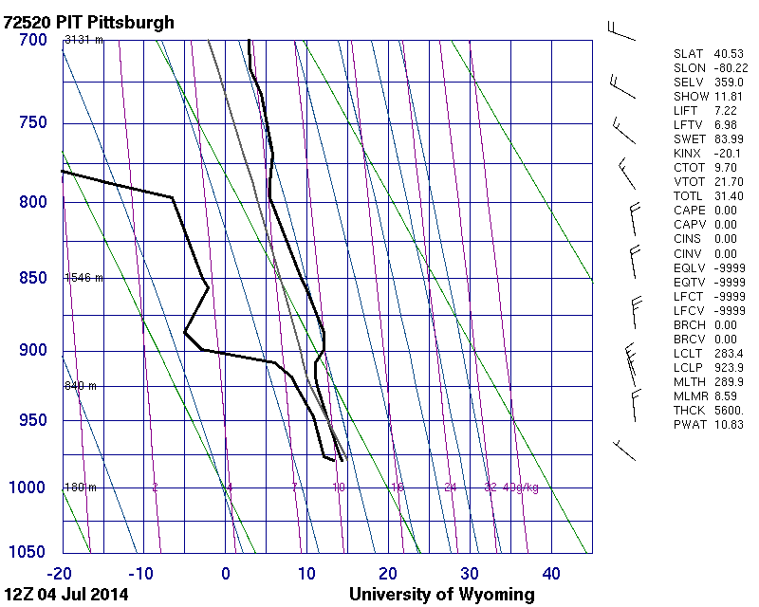

**Figure S4.** Atmospheric soundings collected on July 4, 2014 at 00Z (left panel, 7pm July 3, local time) and 12Z (right panel, 7am July 4, local time). The evening sounding shows a high mixing height and no obvious inversion. The morning sounding shows a weak inversion at approximately 900 mbar. A strong BTEX/BC plume was not observed at Squirrel Hill the morning of July 4. Soundings were obtained from <http://weather.uwyo.edu/upperair/sounding.html>.

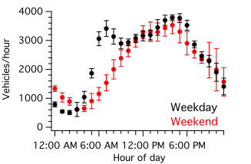

**Figure S5.** Traffic volumes measured in the Ft. Pitt tunnel (I-376) in Pittsburgh, PA. Total traffic volume on weekends is 88% of total traffic volume on weekdays, with specific reductions during the morning rush hour (5-9 am) and the evening rush hour (5-6 pm).

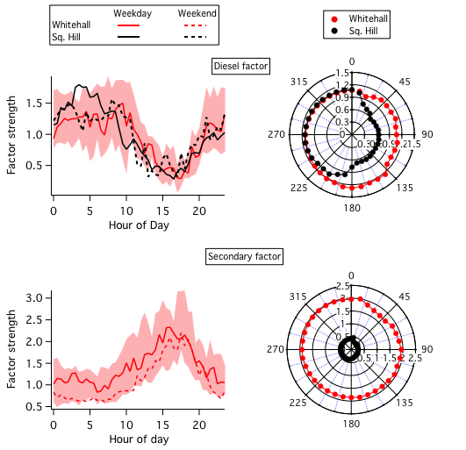

**Figure S6.** Diurnal and wind patterns for the diesel and secondary factors determined from PMF.

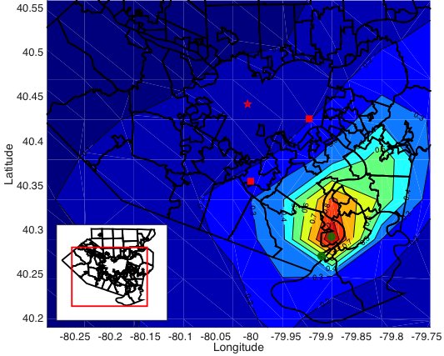

**Figure S7.** Normalized total contributions of sources in the Monongahela River valley to toluene concentrations in Allegheny County. Concentrations are normalized by the area of maximum impact, located near Clairton. Black lines indicate the boundaries of Allegheny County and municipalities within the county. The inset shows the outline of the county, and the red box shows the domain presented in the main figure. The Whitehall and Squirrel Hill sampling sites are indicated by red squares, and downtown Pittsburgh by a red star. The area of largest impact is predicted near the source region in the Monongahela River Valley. The predicted plumes impact areas well outside of the river valley, as well as areas in adjacent counties. AERMOD predicts similar total impacts at the Whitehall and Squirrel Hill measurement locations, in line with our measurements. Predicted impacts at Whitehall and Squirrel Hill are approximately 20% of the predicted maximum impact near Clairton. Large plume impacts are predicted north-northeast of Clairton, outside of the sampling domain for this study and outside of the Monongahela River valley. Plume impacts are also predicted as far north and west as downtown Pittsburgh with approximately 10% of the total impact as in Clairton.