INSTRUCTIONS: Below you will find some questions that attempt to evaluate your algorithmic thinking skills. Each question is a different problem that you have to solve. Simply answer each question as best as you can. Some questions require you to select a choice, while others ask you to write a short text. Some questions may look easy and others may look difficult to you, that's fine. If you think a certain question is very difficult, don't worry, you can make a guess and try the next one. You can use a sheet of paper and a pen if you want. You don't need to code or use any kind of software. Thanks for your participation!
(Each item appears with a number that corresponds to its number assigned in the study. The items should be presented in this order as they are sorted by increasing difficulty to avoid subject’s frustration)

#27
This robot is programmed through a series of arrow commands (“left”, “right”, “up”, “down”). Each arrow command causes the robot to either move one step (if the move in that direction is possible) or not to move (if the move in that direction is not possible).

Imagine the robot has a series of four commands, which it will repeat over and over again.

1 2 3 4

You can put any arrow that you want (“left”, “right”, “up”, “down”) in each command, and you may repeat the same arrow in the series of commands if you want. What should be those 4 commands in order for the robot to reach the square called “OUT” and get out of the maze?
1_______ 2_______ 3_______ 4_________

SOLUTIONS:
Left, left, down, right
/ right, left, left, down
/ down, right, left, left
/ right, left, left, down

#25
You have this initial set of three arrows:

1 2 3
And, by applying some functions, you want to get this final set of arrows:

1 2 3

The first time you apply a function, this is applied to the three arrows; but, the following functions are applied to n-1 arrows. That is, the second function is applied only to the first two arrows; and the third function is applied only to the first arrow.
See the functions that one can apply to obtain the final set of arrows:
Function 1: turn the arrows 45 degrees anti-clockwise
Function 2: turn the arrows 180 degrees
Function 3: switch colors (turn white arrows into blue arrows, and blue arrows into white arrows)

What is the sequence of functions that applied to the initial set of arrows will get you the final set of arrows?
A) function 3; function 3; function 2
B) function 2; function 3; function 3
C) function 3; function 2; function 1
D) function 3; function 2; function 3

SOLUTION: D

#26
You have the following DNA sequence:
A
G
C
C
T

And you want to get the following sequence:
T
A
T
C
T

You can implement the following operations:
Swap (): it will swap one character for another. For example, swap (A,G) will turn the sequence AAGT into GGAT
Insert (): it will insert a specified character at the beginning of the sequence. For example, insert (A) will turn the sequence GT into AGT
Delete (): it will delete all specified characters. For example, delete (A) will turn the sequence AAGT into GT

What operations will turn the initial DNA sequence into the one we want?
A) Delete (G); then Insert (T); then Swap (C,T)
B) Swap (C,T); then Insert (T); then Delete (G)
C) Insert (T); then Swap (C,T); then Delete (G)
D) Insert (T); then Delete (G); then Swap (C,T)

SOLUTION:
B

#20
After finishing your long paper, you just discovered a mistake you made. All 4’s should be 7’s and all 7’s should be 4’s. To amend this, you can use an editor that will replace any sequence of characters with another sequence.

In order to describe the replacement you would make with the editor, please fill in the blanks:

Replace all ______ with ______; then replace all ______with ______; then replace all ______ with ______

SOLUTION:
Replace all __4’s___ with _XXs (any variable)__; then replace all _7’s___ with _4’s__; then replace all __XXs(variable mentioned before)__ with _7’s___ (4’s and 7’s positions can be reversed here)

#13 A collection of elements is shown below with 2 dimensions: rows and columns. A black square indicates a 1, and a white square indicates 0.
 | Column
Row |  | 1 | 2 | 3 | 4
 | 1
 | 2
 | 3
 | 4

Imagine that we run two operations on the collection of elements. First, we replace column 4 by column 2; and then we replace row 2 by row 4. What will be the result?
 | Column
Row |  | 1 | 2 | 3 | 4
 | 1
 | 2
 | 3
 | 4

 | Column
Row |  | 1 | 2 | 3 | 4
 | 1
 | 2
 | 3
 | 4

A. B.

 | Column
Row |  | 1 | 2 | 3 | 4
 | 1
 | 2
 | 3
 | 4

 | Column
Row |  | 1 | 2 | 3 | 4
 | 1
 | 2
 | 3
 | 4

C. D.

SOLUTION: B
#23
Eight trains (named a, b, c, d, e, f, g, h) enter the circuit from left to right. In this circuit there are 7 switches (X1 to X7) with two positions: up or down. Each switch is initially set to direct trains up. After a train passes a switch, the switch changes from up to down, or from down to up. Train a needs to go to station A, train b to station B, train c to station C, and so on.
Trains a, b, c, d, e, f, g, h
The railroad director needs to ensure that all the trains go to their correct stations, so what is the correct order for the trains to pass through switch X1?
___, ___, ___, ___, ___, ___, ___, ___

SOLUTION: A, E, C, G, B, F, D, H

#7 Olivia is studying the climate in her village and, over the last year, she has measured the temperature at the same time every day. She has created a list with all the temperatures she has collected so far. She prepares the following algorithm to analyze her list. What is the output she will get?
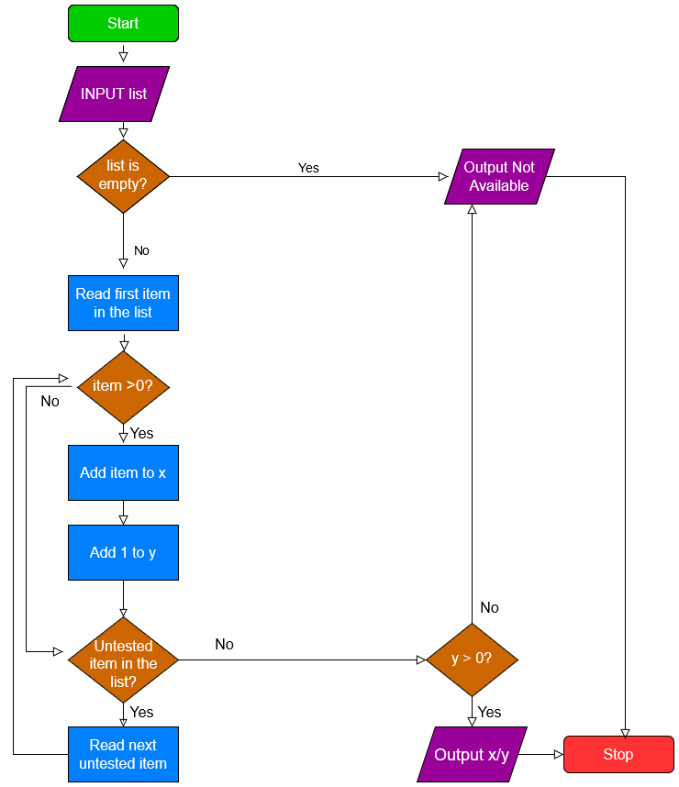
A. The percentage of positive temperatures in the list
B. The average of the positive temperatures in the list
C. The number of positive temperatures in the list
D. The sum of the positive temperatures in the list
SOLUTION: B
#16 The following scheme represents a circuit of nodes. A, B, C, D and E are nodes of this circuit. Nodes fire and pass their signal on to the next node on their right (e.g., node A gives its output to node D, which gives its output to node E). Nodes’ output can be either 1 or 0.
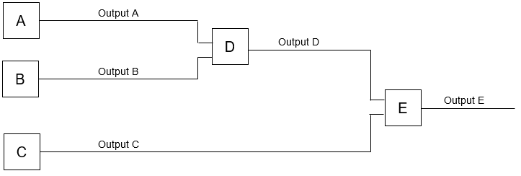

We see the circuit produces the following states:
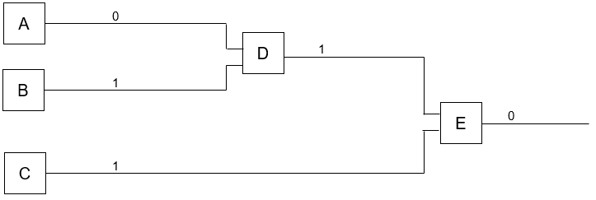

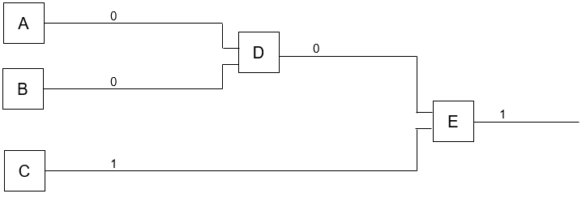

We know that Node D and E ALWAYS follow the same algorithm. See the possible algorithms:
Algorithm 1 | If inputs are (1,1) | Outputs 1 | Else: outputs 0
Algorithm 2 | If inputs are (1,0) or (0,1) | Outputs 1 | Else: outputs 0
Algorithm 3 | If inputs are (1,1) | Outputs 0 | Else: outputs 1

Which algorithm node D and E are both following?
A) Algorithm 1
B) Algorithm 2
C) Algorithm 3
D) This problem has no solution

SOLUTION: B

# 6
You are carrying out a series of astronomical observations on the Orion constellation. You want to observe, using the same telescope, all the stars included in this constellation:

Setting up a new position for the telescope takes time which you want to optimize; so, you decide that you will observe all the stars following the shortest path that connects all of them. To do that, imagine someone proposes the following algorithm:
1. Start from a random star
2. If there’s still a star to observe, go to the nearest non-observed star

What is fundamentally wrong with this algorithm?
- The algorithm may eventually choose longer paths
- The starting star should not be randomly chosen, but should be a one on the center of the map
- The algorithm will leave non-observed stars in the path
- There’s nothing wrong with this algorithm, it will always choose the shortest path

SOLUTION: A
# 8
This is a path composed of 5 vertices: O, P, Q, R, S . Every vertex is connected to other vertices through one or more lines.
You want to connect all the vertices of this path with your pencil in such a way that you pass only once through ALL THE LINES of this sketch and without lifting your pencil. You can pass more than once through every vertex, though. Where would you start the path?
O
S
P
R
Q

A. Always on a vertex with the lowest number of lines
B. Always on a vertex with an even number of lines
C. Always on a vertex with an odd number of lines
D. One cannot connect all the vertices in figures like this

SOLUTION: C

# 21
We have two methods to represent a group of people. In both methods, for each person a circle is drawn. In method 1, we align people horizontally if they are connected on WhatsApp, and we align them vertically if they are connected on Instagram. In figure 1, two people are connected on WhatsApp (aligned horizontally); and three are connected on Instagram (aligned vertically):
Figure 1
In method 2, we draw a line between two people if they are connected either on WhatsApp or Instagram. According to method 2, the same group as above would be represented this way:
Figure 2
A new group of six people is shown below according to method 1:

Which of the four diagrams would represent this group of people according to method 2?
A B C D

SOLUTION: D

# 9
We have this game:
There are four players (P, Q, R, S): one of them is pointing at him/herself, and three of them are pointing at any other player

Player P gets the ball

While the ball-holder isn’t pointing at him/herself:

If the ball-holder is pointing at him/herself, s/he drops the ball and the game finishes

The ball-holder passes the ball to the player that s/he is pointing at

We can state that:
A. This game will go on forever
B. This game will eventually stop because someone will drop the ball
C. This game will stop when player P gets the ball again
D. We don’t know whether this game will ever stop

SOLUTION: D

#17
An “OR” gate outputs 1 if it receives one or more inputs with value 1. Else, it outputs 0.
A “XOR” gate outputs 1 if it has two inputs with different values (0, 1) or (1, 0). Else, it outputs 0.
A “NOT” gate inverts its input (it outputs 1 if the input is 0, and vice versa).
1?
A

B
4. NOT
3?

2.
XOR
C

D

The inputs A, B, C and D can either be 0 or 1. We want this circuit to check that A=B and that C=D. That is, the final output of this circuit will be 1 if A=B and if C=D; otherwise, the output will be 0. We already know that gate 2 is a XOR and gate 4 is a NOT. What gates should we put in positions 1 and 3 of this circuit?

1____
3____

SOLUTION:
1: XOR
3: OR

# 2
Imagine that someone picks one of these animals and you have to guess it posing only binary questions. Binary questions are those whose answer can only be yes or no, like “does it have jointed legs?” Assuming that you follow an optimal strategy that reduces the number of questions, what is the average number of questions necessary to guess an animal uniformly picked at random from this chart?

A. 2.33
B. 2.67
C. 3
D. 6

SOLUTION: B
# 11
Let’s examine the minimum distance the squirrel must travel to pick up all the stars. How many branches does it need to go through until it picks up the last star?
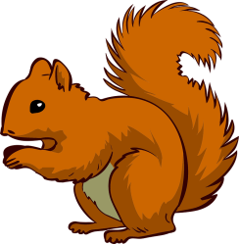

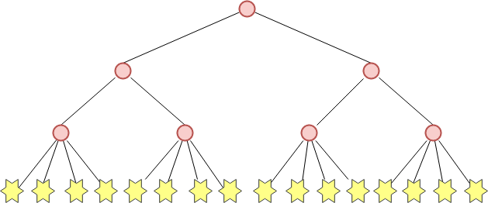

A. Number of stars x levels of the tree
B. 2 x number of branches – number of levels of the tree
C. (Number of levels of the tree)²
D. Number of branches + number of levels of the tree

SOLUTION: B
# 12 Describe one single algorithm that will get both robots out of their mazes in exactly 3 instructions. Both robots execute first instruction 1, then instruction 2, and then instruction 3.

OUT
OUT

Fill in the blanks with one the following eight words, where these coordinates are set according to how you see the maze:
‘NORTH’
‘NORTH-WEST’ ‘NORTH-EAST’

‘WEST’ ‘EAST’

‘SOUTH-WEST’ ‘SOUTH’ ‘SOUTH-EAST’

1. If the ‘out’ square is to the _SOUTH-EAST_ of the robot, keep advancing squares to the _EAST_ until the robot collides with a wall (it cannot go in that direction any further)
Else go to the _(answer 1)_ until the robot collides with a wall
2. When the robot collides
If the ‘out’ square is to the _SOUTH-WEST_ of the robot, keep advancing to the _(answer 2)_ until the robot collides with a wall
Else go to the _SOUTH_ until the robot collides with a wall
3. When the robot collides
If the ‘out’ square is to the _(answer 3)_ of the robot, keep advancing to the _WEST_ until the robot finds the out square
Else go to the _(answer 4)_ until the robot finds the out square
SOLUTION: WEST, SOUTH, WEST, EAST
# 24
This diagram shows the relationship between 7 students in a book-sharing club. Their names and ages are shown in the image. Students who are friends are connected through a line.
The club has some regulations for members:
When you receive a book, you read it (if you haven’t already done so) and then pass it to the youngest friend who has not read it yet. If, however, all your friends have read the book then you should pass it to the friend who first gave it to you.

Ben has read a new book and wants to share it with his friends. Who will read the book last?
__________________

SOLUTION:
KIM

# 1 You have four different cheeses and one of them has a tasteless and odorless bacterium. This cheese causes symptoms of food-poisoning 24 hours after ingesting it. You want to find out which cheese it is, so you decide to use mice to taste them. But, you only have two mice left in your lab and your deadline to find the poisoned cheese is exactly 24 hours from now! You can assign every mouse the number of cheeses that you want. How would you do it?

1 2 3 4

1 2

I would assign mouse 1 to cheese/s __________
I would assign mouse 2 to cheese/s __________

SOLUTION: The two mice should share one cheese (e.g., cheese 2), each mouse should eat one different cheese (e.g., mouse 1 eats cheese 1 and mouse 2 eats cheese 3), and leave aside one cheese (e.g., cheese 4 in that example).

# 19
You have two ropes and a lighter, and each rope takes exactly one hour to burn. They don’t burn randomly, but at a regular speed. How would you use them to time exactly 15 minutes? The ropes cannot be cut, bent, straightened or measured with external instruments. (You don’t need to time 15 minutes from the moment that you start your actions)

Please, briefly explain the procedure: ____________________________________________________________________________________________________________________________________________________________________________________________________________________________________________________________________________________________________________________________________________________

SOLUTION:
1. Light rope 1 at both ends and rope 2 at one end.
2. When the two flames on rope 1 meet, 30 minutes will have passed. Rope 2 has 30 minutes left of burn-time.
3. At that point, light Rope 2 at the other end.
4. In exactly fifteen minutes, Rope 2 will be completely burnt

To score 1, it’s important that the subject refers to procedures 1 and 3.
If the subject mentions other procedures to measure 15’ that involve manipulating the ropes (put both ropes in a cross-shape, bend them, mark them with external tools, etc.) this is not correct and it should be scored 0.
# 3
You have been given 9 coins of the same value, but one of them is fake which you could tell because it is lighter than the rest. You have a balance like the one in the picture to weigh the coins, and each weighing can result in “the balance leans to the right”, “the balance leans to the left”, or “the balance rests stable”. Assuming you are following an optimal strategy to reduce the number of weighings, how many weighings are necessary to identify the fake coin?
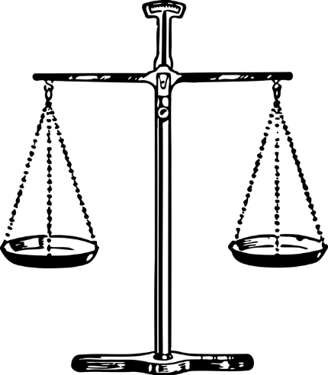

SPACE LEFT BLANK for answer
SOLUTION: 2

