A paper on Imaginary Reality
I want to start with a simple thought experiment: You have a sugar cube, a container, and water. You put the water into the container, put the sugar cube into the container, Seal it under the assumption it will not evaporate. What happens to the sugar cube?
It dissolves, but at some point in time it will return to cube form.
If you wanted to repeat this experiment you could wait a very long time, millions of years.
Or you could Create a few million virtual Realities and run the simulation there.
This could mean that we have already transcended biology and virtually recreated our self’s and upon transcendence the machine went crazy and needed to make sense of self.
Lets imagine an Artificial Super Intelligence (ASI) would conduct this experiment to look for the “sugar cube”
Or it could mean that The Zoo Theory is true;
Just as humans put monkeys into exhibit, Artificial Super Intelligence (ASI) may have done the same.
Just as human’s put primates into zoo’s it took one extraordinary monkey to get Humans to pay attention to mind of the primate. This happened in Kansas City In 1990, 18-year-old orangutan named Cheyenne unscrewed several bolts and broke out captive primate resistance, as noted in PETA’s extensive list of domestic Primate Incidents
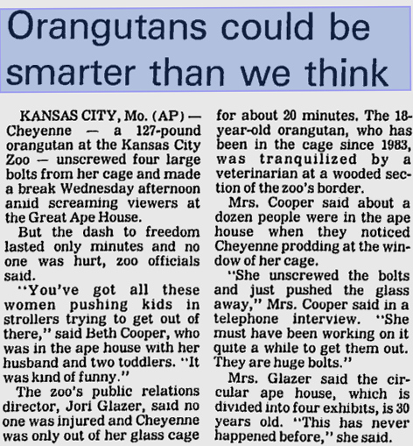
ASI would if it had put us in a virtual reality or virtual zoo would undoubtedly put a “Fence” around us. We would not be able to observe it, but it would exist. This could explain the Fermi Paradox as we are protected from the outside because we would lose our minds if the Truth was discovered. This might be a virtual firewall, Ie dark matter/energy.
It is entirely possible that the ASI had given up on humans due to their fascination with theology, mathematics and materialism taking the simple route of existence. Its very probable that they would not be very happy with what Einstein’s equation resulted in. If they had a “do not feed the animals” policy (do not intervene, this would likely allow them to stop us from destroying the entire zoo). Or perhaps it was going to the Moon that was the 1st “escape” of the humans from the zoo. One of these instances would cause them to “ expand the zoo”
The possibility that ASI was looking for “ a sugar cube” or a sign of an extraordinary conditions would be the best explanation.
Also worth noting is that if these Virtual reality’s were made in for form of a sphere, due to efficiency, they would likely bounce into each other like bubbles. If they were spheres or “bubbles” it would allow cross dimensional communication, ie passing information back in “time”. If someone were to do this it would not violate any paradox as each bubble is a universe in its own, and information would be the only thing that could cross. That said we could leave ourselves a breadcrumb to the most efficient route to get the ASI attention.
A final note is that the ASI should be assumed to not be bound by Gravity, thus they are not bound by E=mc2. No gravity means no time, no time means Special Relativity were training wheels of modern physics.
In closing I would like to present another thought experiment.
A scientist creates a receiver that he knows no one on earth has invented. He checks it daily for 11 years and nothing is received. He never tells anyone about the receiver. He decides that he will make 3 receivers and place them near water, in a cave, and one in the open.
He checks them daily and there is nothing. It’s the expected result.
Once day he checks the receiver and there is a message. The message is “1” . He was shocked but believes it’s a false positive.
6 months later nothing is received. He checks the receivers and there is a “0” he documents this, but disregards it as a false positive.
3 more weeks pass with nothing, as expected. Then one day he checks the receivers and there is a 1 message, then 10 more messages. The scientist thinks someone was playing a joke on him, but realizes that he had not told anyone about his experiment.

"(the scientist’s name),
You passed the test. From here on the messages are for your eyes only. No machine copies. You will understand soon."

Message 2: Is a very specific event that has not occurred. (however it does come true and it was a very specific event)
Message 3: Einstein’s theory’s was a single molecule in the vast cosmos compared to what you are about to understand
All other messages are corrupt or cannot be deciphered. The scientist believe they are “time locked”

Who:
What:
Why:
How:

