RDM Support Project

Are you ready for RDM support?

Questionnaire for information specialists

This questionnaire is a tool that can be used to tailor a basic training course in research data management for information specialists to what the participants already know and to what they consider important to learn. The questionnaire can be used in two ways.
21 questions
The participants give questions 1 to 20 scores on a scale of 0 (= I have no idea what the answer to the question is) to 4 (= I can easily answer the question). For question 21 the participant describes in his or her own words what he or she would like to learn or be able to do after completing the training course.
40 questions
Question 21 is dropped from the questionnaire, and questions 1 to 20 are scored twice. In the first round, for each question the participants rate the extent of their current knowledge on the subject (0 = I have no idea what the answer is, 4 = I can easily answer the question). In the second round, for each question the participants indicate how important it is for them to know the answer to the question, in view of their supportive role in research data management (0 = unimportant, 4 = crucial). The scores from the two rounds can be weighted against each other: aspects with low scores in the first round and high scores in the second round should be included in a training course; aspects with high scores in the first round and low scores in the second round should be given less priority in the training course.
Processing (21 questions)
If the questionnaire is presented to the participants using a Google form, for example, a graph of the scores (see figure) can be made on the basis of the spreadsheet. This makes it possible to see at a glance what aspects of (supporting) research data management should be given the most attention in the training course.
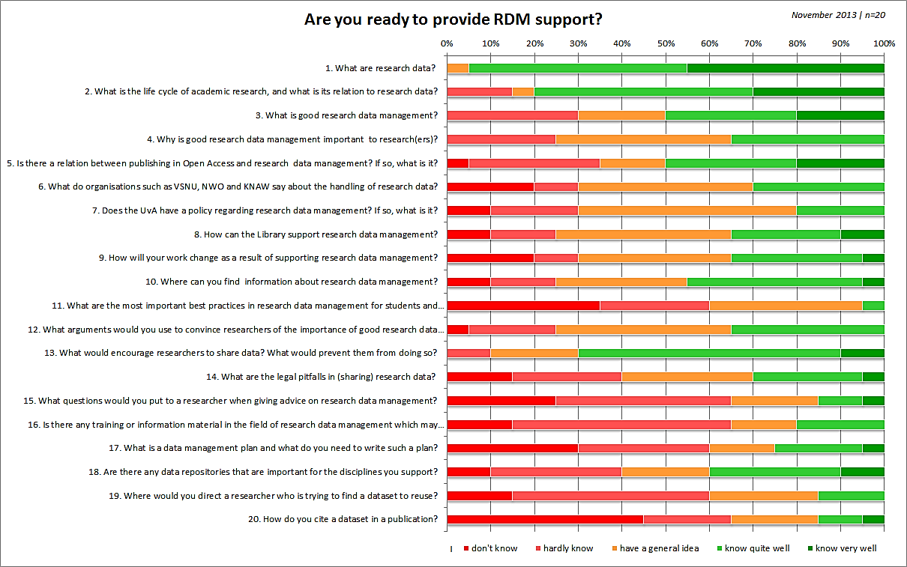
The results of the open question (question 21) provide insight into the participants' expectations with regard to the training course.
The questions to which the course material used during the training course relates can be indicated in the course material. The questions can also be used to formulate educational objectives.
The questionnaire can be presented to the participants again after the course as part of an evaluation.

Sources
RDM Rose (University of Sheffield), RU RDM Ready self evaluation tool. Retrieved on 22-10-2013 via http://rdmrose.group.shef.ac.uk/wp-content/uploads/Resource-0-RURDMReady-RDMRose.docx
RDM Rose, Activity sheet 1.1: Identifying current knowledge/experience and importance of RDM Topics. Retrieved on 22-10-2013 via http://rdmrose.group.shef.ac.uk/wp-content/uploads/Activity-1-1-RDMRose.docx
University of Edinburgh, DIY Research Data Management Training Kit for Librarians. Consulted on 22-10-2013 via http://datalib.edina.ac.uk/mantra/libtraining.html
3TU.Datacentrum/DANS, Data Intelligence 4 Librarians. Consulted on 22-10-2013 via http://dataintelligence.3tu.nl/home/
Association of Universities in the Netherlands (VSNU), Functieprofiel Specialist Wetenschappelijke Informatie ('Job profile for Scientific Information Specialist') (version 6.0, January 2013)
Questions

- What are research data?

- What does the life cycle of scientific research look like, and how does this relate to research data?

- What is good research data management?

- Why is good research data management important for research/researchers?

- Is there a relationship between Open Access publishing and research data management? If so, what is the relationship?

- What do institutions such as VSNU, NWO and KNAW have to say about handling research data?

- Does the UvA have a policy with regard to research data management? If so, what does this policy entail?

- How can the Library support research data management?

- How does supporting research data management change your own work?

- Where can you find information on research data management?

- What are the most important best practices in research data management for students and researchers?

- What arguments would you use to convince researchers of the importance of good research data management?

- What encourages researchers to share data? What discourages them from doing so?

- What legal issues are associated with research data and the sharing thereof?

- What questions do you ask a researcher in order to be able to advise him/her on research data management?

- Is there course material or informational material on research data management that can help you in supporting (early career) researchers?

- What is a data management plan and what is involved in drawing up such a plan?

- Are there data repositories that are important for the fields you support?

- Where do you send a researcher who is looking for a dataset for reuse?

- How do you refer to a dataset in a publication?

- Numerous aspects of research data management (support) were addressed in the previous 20 questions. Which aspects are most important for you? What would you like to know or be able to do after completing the training course? What do you need in order to provide the best possible support to your researchers?

