An Analysis for Improving Serendipity in Academic YouTube Video Recommendations

Abstract

YouTube is known as one of the largest online video repositories and is used in many domains. However, even though it is commonly used for educational purposes, the aims of an educator and YouTube may not coincide. The educator wants learners to watch only what is needed and proceed to their practical work. YouTube, on the other hand, focuses on maximizing revenue. Therefore, videos with low popularity are generally not being recommended. Such low-popularity videos may actually be helpful to the learner had they been recommended. This is known as serendipity or long-tail recommendation. This paper aims to first understand how serendipitous YouTube recommendations are. Second, to analyze how sentiment polarity affects recommendations. Third, to provide a clustering and video recommendation as an alternative to YouTube recommendations, focusing on learning. The result of this research shows that, first, YouTube recommendations lack serendipity but include sentiment along with other factors. Second, the sentiment polarity has an effect on serendipity. The exclusion of dislike counts would make the recommendation favor view counts. The inclusion of dislike counts increases the serendipity factor in the recommendation list. Third, the research utilizes k-means for video clustering with like-to-dislike ratios. This feature recommends more serendipitous videos than the default YouTube recommendation. These results improve academic video recommendations on YouTube.

Keywords K-Means; Serendipity; Sentiment; Recommender System; Clustering

Introduction

YouTube and recommender systems have been used in various applications. Recommender systems aim to reduce information overload by suggesting only the most relevant content to the users. For educational content, the creators of recommender systems mainly use private repositories as the source of their videos (Cabada, Estrada, Hernández, et al., 2018). While private repositories may be excellent as they are created by experts in tertiary institutions, students who have different levels of existing knowledge often require simpler explanations to fortify their understanding. For this, YouTube is a good source. Learners could search for YouTube videos on their own (Kadriu, Abazi-Bexheti, Abazi-alili, et al., 2020), or the learning management system (LMS) could incorporate them directly (Staziaki, Santo, Skobodzinski, et al., 2021). The recommendations in LMS are normally made via either collaborative filtering (CF) (Cabada, et al., 2018), item-based (Jeong, Sohn, & Kwon, 2019), or hybrid (Yang, Xu, Wang, et al., 2018). While CF has its advantages, it comes with its own weaknesses, namely the cold-start problem, and lack of serendipity or surprise factor in its suggestions (Yang, et al., 2018). Serendipity, also known as the surprise factor, involves lesser-known videos that could interest users (Fan, & Niu, 2018). Hybrid recommendation techniques can tackle these problems, and serendipity improves the recommendation results (Yang, et al., 2018). Studies that utilize YouTube normally follow YouTube recommendations (Kadriu, et al., 2020; Staziaki, et al., 2021). However, YouTube recommendations YouTube cater for user stickiness, where the priority is to encourage users to watch as many videos as possible. This does not usually line up with academic goals. YouTube recommendations are normally skewed to popularity. Less popular videos are less likely to be recommended. This results in high numbers of serendipitous videos in the repository, waiting to be discovered.
To test this assumption, a preliminary search was conducted on YouTube. Three phrases related to basic knowledge gathering were used: “Introduction to HTML”, “introduction to Python”, and “introduction to computer”. Search results on “introduction to html” reveal only 1 video with less than 1000 views, 1 video with between 1000 to 50,000 views, and only 1 video between 50,000 to 100,000 views out of the 12 results in the default setting. Similarly, searching for “introduction to Python” reveals no results from videos with fewer than 10,000 views. Only 2 videos between 10,000 to 100,000 views were recommended. Searching for “introduction to computer” yields similar results. While the results are relevant, it supports our assumption that YouTube is likely prioritizing videos that would most likely make users stay longer than those that have greater serendipity value. Searching for academic papers on Google Scholar for “YouTube” and “Academi* recommender system” yield low results, with only 20 articles and 1 review from Scopus and 1 article in WoS, that actually talked about academic recommender systems on YouTube when accessed on 10th September 2021.

This has become the motivation of this paper. First, even though the impact of YouTube in academia is humongous, there are not many publications on its utilization. Second, the default YouTube recommender does not favor serendipitous videos. This paper reports the results of our experimental method to increase the number of serendipitous academic video recommendations. Aside from serendipity, another factor that is normally taken into consideration is sentiment polarity (Kadriu, et al., 2020; Salazar, Aguilar, Monsalve-Pulido, et al., 2021). Sentiment polarity is reported to affect online interactions (Rosenbusch, Evans, & Zeelenberg, 2019; Salazar, et al., 2021), affect the viewers (Rosenbusch, et al., 2019) and shape their perception (Ray, Bala, & Jain, 2020; Rosenbusch, et al., 2019). As sentiment polarity plays a huge role in determining user acceptance, this paper tests the impact of positive and negative sentiments towards serendipitous video recommendations. This is also done in response to the decision of YouTube to hide the dislike count information on both their web query and API call function.

This paper starts with a theoretical background of YouTube implementation in academic recommender systems, and techniques to determine the order in alternative recommendations. Section 3 presents the methodology of the experiment to developing the alternative video recommendation list. Section 4 presents the findings of the experiment. Section 5 analyzes the results and section 6 presents the limitations, plans for future studies, and conclusion of this research.

Theoretical Background

YouTube Implementation in Academic Recommender Systems

YouTube videos have been used to convey information in many fields, for example, programming (Kadriu, et al., 2020). While YouTube houses a huge number of videos, educational content is less than other categories (Chelaru, Orellana-Rodriguez, & Altingovde, 2014). While content has grown tremendously since the aforementioned study, videos are still skewed to prioritizes the popular few. For better or for worse, YouTube recommendations may not be neutral (Abul-Fottouh, Song, & Gruzd, 2020; Alfano, Fard, Carter, et al. Klien, 2020; Gutiérrez-Martín, Torrego-González, & Vicente-Mariño, 2019; Tang, Fujimoto, Amith, et al, 2021; Tollon, 2021). Some studies show the recommendations focus on videos that would induce stickiness (Kaiser, & Rauchfleisch, 2020; Zhou, Khemmarat, Gao, et al., 2016). It is also difficult to break the recommendation ranking, even if the videos are made by an expert (Fernandez-Llatas, Traver, Borras-Morell, et al., 2017). Factors such as user preference, geographical location, and topics affect the recommendation (Kaiser, & Rauchfleisch, 2020; Zhou, et al., 2016). User satisfaction on recommended YouTube videos varies according to their purpose (Kaiser, & Rauchfleisch, 2020). In spite of these drawbacks, YouTube has been shown to assist learners by including their preferences and recommending related videos. This is reported in a study on the effectiveness of YouTube to disseminate information on dementia (Lam, & Woo, 2019). However, the study by Lam and Woo emphasizes video engagement and focuses only on video viewing, without including activities that learners need to conduct. In other words, to integrate YouTube in education, careful selection needs to be done if YouTube recommendations are to be included in an academic recommender system. This can be done via manual filtration by subject matter experts (Staziaki, et al., 2021) social features such as share rate (Chelaru, et al., 2014), hosting platform for tailored content made by experts (Moliner, Lorenzo-Valentin, & Alegre, 2021), or uploaded by experts (Dascalu, Antohe, Zegan, et al., 2021). Yen-Liang, & Chia Ling (2019) conducted a study to predict popularity of videos on YouTube. Although sentiment is frequently studied in social science, it is not prominent in the YouTube default prioritization.

Serendipity

Popular content does not play a significant role in determining user satisfaction (Jeong, et al., 2019). Jeong and his colleague (2019) highlighted that user satisfaction depends on the purpose of viewing and a variety of configurations in the recommender. One of the elements that could increase user satisfaction is by inclusion of serendipity. Saat, Noah, and Mohd (2018) conducted a study to explore implementation of serendipity in recommender systems. Liu, Qin, Ma, and Liang (2021), and Ziarani, and Ravanmehr, (2021) have also conducted reviews to define serendipity, its application, and methods of implementation. These reviews provide a basis to understand the concept of serendipity – videos that are lesser-known but useful to users. These reviews highlight that serendipity leads to exciting results, resulting in higher engagement, where users are emotionally affected by the recommendations (Saat, et al., 2018), or specifically calculated relatedness (Amal, Tsai, Brusilovsky, et al., 2019), interestingness, and unexpectedness in serendipitous recommendations (Huang, Ding, Wang, et al., 2018). It is important to note that not all benefit from serendipitous recommendation equally (Nguyen, Harper, Terveen, et al., 2018). Their research show how personality needs to be taken into consideration when deciding to include serendipity during recommendations. People with different level of introversion, conscientiousness, and openness react differently to serendipitous recommendations. These three traits are among the popular personality traits studied in psychology. In the same paper, Nguyen and his colleagues report that people with high emotional stability have a different rate of enjoyment of serendipitous recommendations from people with low emotional stability.

Sentiment

Sentiment is widely used in other domains (Ray, et al., 2020). However, its utilization in recommender systems for education is still limited (Salazar, et al., 2021). Salazar and his colleagues also report that implementation of emotions in educational recommender systems are lacking, with few studies, and most studies having small sample set. They report that emotions are important in learning and is well-studied. This is also supported by (Murthy, & Sharma, 2019), which shows that sentiment can pass from one video to related videos. The finding that sentiments transfer online is important, as it is shown that the sentiment of a user could affect others’ opinions (Rosenbusch, et al., 2019). As the sentiment of individuals could affect others, it would also affect the general acceptance of videos. The Rosenbusch (2019) finding is supported by Kaiser and Rauchfleisch (2020) which shows how sentiment significantly affect video recommendations for similar sets of users across US and Germany. Another study shows that the inclusion of sentiment results in better recommendations (Tomeo, Fernández-Tobías, Cantador, et al., 2017). However, when sentiment is used, it is mainly gathered during experimentation (Cabada, Estrada, Hernández, et al., 2018), and not during content recommendation (Salazar, et al, 2021).

Methodology

In order to increase the serendipitous videos in the video recommendation list, the like-to-dislike ratio is used as sentiment polarity. This feature is added to gauge the acceptance rate of the recommended videos. To increase the chances that the videos are related, interesting, and unexpected, the view count is taken as a second feature. The research is divided into two stages. The first stage is further divided to two steps. The first step gathers results from anonymous YouTube searches. The second step compares the results the first step with the results from an API call, where the identity of the searcher, along with historical viewing data is included during the search process. The second stage compares a recommended list of videos with a dislike count with a recommended list that does not take into account the dislike count. The purpose of the second stage is to see the significance of the dislike count in creating the order of recommended video. This is done in response to YouTube’s recent decision to remove the dislike count in both web and API call functions.

Stage 1 – step 1: Comparison of anonymous YouTube searches with API searches. How user preferences affect serendipity in YouTube searches.

In the first stage, the list of recommendations in an anonymous YouTube search is created by searching for three categories of educational videos related to basic Information Technology knowledge. The three search phrases are “introduction to HTML”, “introduction to Python”, and “introduction to computer”. The YouTube search page is accessed with Google Chrome in incognito mode to hide the identity of the searcher to remove any possible algorithm bias from individual preferences to affect the recommendation by YouTube.
Search results on “introduction to HTML” reveals only 1 video with less than 1000 views, 1 video within 1000 to 50,000 views, and only 1 video within 50,000 to 100,000 views out of 12 results in the default setting (see fig.1 and lines 1-12 in table 2). Similarly, searching for “introduction to Python” reveals no results from videos that have less than 10,000 views. Only 2 videos between 10,000 to 100,000 views are recommended. A search on “introduction to computer” yields similar results. Other than these, the rest of the videos listed have more than 100,000 views. While the results are relevant, it supports the assumption that YouTube is likely prioritizing videos that would most likely make users spend more time on YouTube (Gutiérrez-Martín, et al., 2019) which in turn, translate to less emphasis on serendipity.

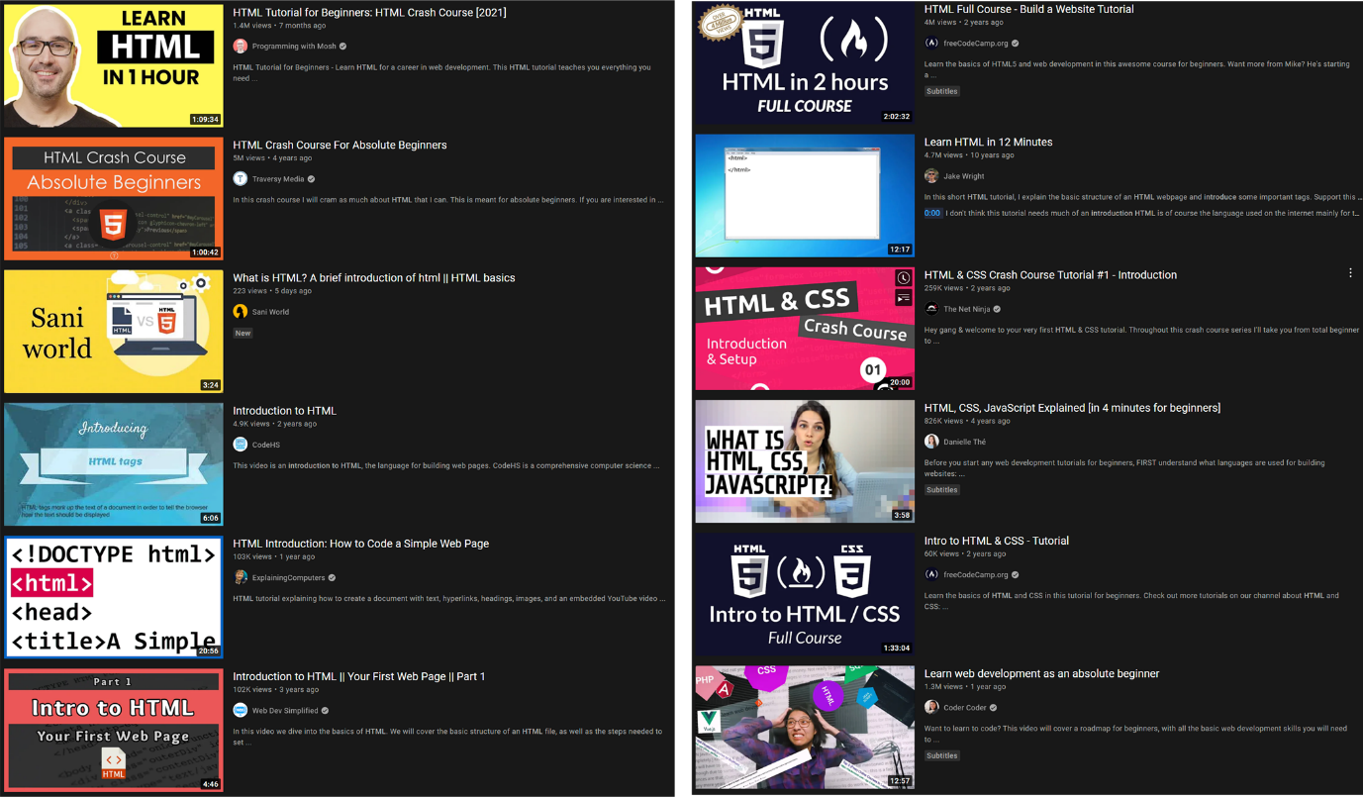
Fig. 1 Screenshot of “Introduction to HTML” search results

In the second step, an API call is used to generate the YouTube recommendations for “Introduction to HTML”. Since the API call requires an API key at minimum, and the API key is tied to the registered Google user account, it means the searcher’s information could affect the recommendations. Table 1 shows the results of the API call made. The results of the API call are then compared to the results from the anonymous YouTube search and the differences between the order of the recommended videos are highlighted (see table 2). In table 2, the video IDs from API call results from table 1 is compared to the video IDs that appear in the anonymous YouTube search. In the anonymous YouTube search, only 12 videos are recommended but 20 videos are used in the API call. This is because some of the top 12 results from the API call are not recommended in the anonymous YouTube search. The highlighted results show the different order of video appearances when anonymous, as compared to the order of videos when individual information exist in the API call. The search was conducted on Aug 2021 when the dislike count was still available both on web and API calls. The results of both API call and web search are similar in that only 1 video with less than 10,000 views is listed in the top 12. In the third stage, a custom recommendation list is generated based on the video description.

Table 1 API call return for “Introduction to HTML”.
Order | Video ID | View Count | Like Count | Dislike Count | Comment Count
1 | qz0aGYrrlhU | 1540329 | 44722 | 591 | 2196
2 | UB1O30fR-EE | 5027626 | 126428 | 1247 | 5556
3 | WwNuvGLblJU | 106044 | 4344 | 55 | 664
4 | bWPMSSsVdPk | 4729228 | 67471 | 2074 | 4351
5 | BvJYXl2ywUE | 103559 | 2228 | 22 | 81
6 | pQN-pnXPaVg | 4094093 | 107450 | 1369 | 4954
7 | 9p-YLfGWC68 | 5057 | 41 | 20 | 17
8 | gT0Lh1eYk78 | 841822 | 11911 | 254 | 759
9 | 8JQaedsB2qI | 47814 | 1261 | 38 | 74
10 | hu-q2zYwEYs | 261686 | 4926 | 35 | 216
11 | kLO4X_3VYdg | 60661 | 1313 | 49 | 62
12 | NAEHbzXMNpA | 118345 | 1697 | 81 | 90
 | Y1BlT4_c_SU | 143745 | 1830 | 13 | 50
 | LGQuIIv2RVA | 49573 | 1519 | 4 | 51
 | fS7w-TXinPE | 1281581 | 11128 | 427 | 1784
 | x9bTBcron78 | 318694 | 5761 | 297 | 247
 | DGVXXW6xEnc | 4920 | 124 | 0 | 10
 | g6Lfy1Y8oLo | 9354 | 34 | 2 | 1
 | BsDoLVMnmZs | 1826982 | 70968 | 1030 | 10702
 | MDLn5-zSQQI | 39132 | 985 | 28 | 34

Table 2 Differences between API call and anonymous Web Search results. Priority based on Web.
Prori | Video ID | View Count | Like Count | Dislike Count | Comment Count
1 | qz0aGYrrlhU | 1540329 | 44722 | 591 | 2196
2 | UB1O30fR-EE | 5027626 | 126428 | 1247 | 5556
3 | BvJYXl2ywUE | 103559 | 2228 | 22 | 81
4 | pQN-pnXPaVg | 4094093 | 107450 | 1369 | 4954
5 | WwNuvGLblJU | 106044 | 4344 | 55 | 664
6 | bWPMSSsVdPk | 4729228 | 67471 | 2074 | 4351
7 | 9p-YLfGWC68 | 5057 | 41 | 20 | 17
8 | gT0Lh1eYk78 | 841822 | 11911 | 254 | 759
9 | kLO4X_3VYdg | 60661 | 1313 | 49 | 62
10 | hu-q2zYwEYs | 261686 | 4926 | 35 | 216
11 | NAEHbzXMNpA | 118345 | 1697 | 81 | 90
12 | LGQuIIv2RVA | 49573 | 1519 | 4 | 51
 | 8JQaedsB2qI | 47814 | 1261 | 38 | 74
 | Y1BlT4_c_SU | 143745 | 1830 | 13 | 50
 | fS7w-TXinPE | 1281581 | 11128 | 427 | 1784
 | x9bTBcron78 | 318694 | 5761 | 297 | 247
 | DGVXXW6xEnc | 4920 | 124 | 0 | 10
 | g6Lfy1Y8oLo | 9354 | 34 | 2 | 1
 | BsDoLVMnmZs | 1826982 | 70968 | 1030 | 10702
 | MDLn5-zSQQI | 39132 | 985 | 28 | 34

Stage 1 – Step 2: The impact of sentiment on YouTube recommendation for multiple educational IT related topics

To analyze the similarity between the YouTube search algorithm across various educational IT topics, the second stage begins with an API call for the three search terms, “introduction to HTML”, “introduction to Python”, and “introduction to computer”. The top 200 results from the API calls are then analyzed. The results are plotted as view count (VC) vs. like count (LC). The results shows that the data is skewed, with most of the videos ending up in the lower left quadrant. The relevancy of the results after the first 50 videos are mixed, and not all are relevant to the topic during a random check of videos after the first 50 results. However, the YouTube recommendation heavily favor only at most 1/5th of the relevant videos. The other videos end up never appearing in YouTube recommendations, and only the few videos that gain large view counts and like counts end up being recommended (see fig.2 – fig. 4). As a result, there are many videos that may potentially excite the viewer but are hidden due to viewer preferences and the YouTube algorithm.

The second stage takes a collection of three weeks of daily snapshots for new videos for each keyword found with an API call. The results are then normalized and cleaned up to reduce the data skew. This is to prepare for video clustering that takes sentiment polarity and serendipity as features. For the sentiment polarity, the like count is compared to the like-to-dislike count to see the differences in the order of the recommended video.

Fig. 2 View Count vs Like Count for Introduction to Computer

Fig. 3 View Count vs Like Count for Introduction to HTML

Fig. 4 View Count vs Like Count for Introduction to Python

Fig. 2 to fig. 4, show that the results from the first 200 most relevant videos found with the YouTube API skewed with only a few videos that had large view counts and like counts. To create an alternative clustering that emphasizes on serendipity based on sentiment polarity, the results need to be normalized. This is important as fig.2-4 show that the YouTube recommendation is heavily skewed. The study by Nakatsuji, Toda, Sawada, Zheng, and Hendler (2016) normalized the distribution in the frequencies of objects in their datasets using Log₁₀. We followed suit and utilize Log₁₀ to distribute the data to retain the original distribution while reducing the distance between nodes (fig. 5 - fig. 7). Fig.5 to fig. 7 show that Log₁₀ is sufficient to improve the distributions and the plot distribution of the three topic are similar when the view count is compared to the like count. Because of the similarity, we decided to move to the next phase with only one keyword, “introduction to HTML”. Two cleanup activities are done prior to normalization and another five clean up steps conducted after the normalization.

Fig. 5 Log₁₀ View Count vs Like Count for Introduction to Computer

Fig. 6 Log₁₀ View Count vs Like Count for Introduction to HTML

Fig. 7 Log₁₀ View Count vs Like Count for Introduction to Python

Stage 2: Proposed Video Clustering

The first stage shows that view counts and like counts play roles in the YouTube algorithm. The second stage proposes alternative features for video clustering to increase serendipitous videos inclusion. The second stage first compares clusters with and without dislike rates. This shows how dislike rates could affect video clustering. Inclusion of dislike rate is proposed as it is significant in determining the quality of the video from the user’s point of view (Sader, Kulkarni, Eagles, et al., 2020).

Data clean-up

The clean-up process involves seven steps to removes invalid results before and after Log₁₀ implementation. The videos are then clustered into two sets of clusters – one set of clusters based on view count and like count, and another set of clusters based on view count and like-to-dislike rate (LD). The seven steps are as follows:
- Removal of entries with 0 View Count values.
- Removal of entries with 0 likes.
- Normalization with Log₁₀ (view count, like count, like:dislike).
- Removal of view count = 0, and like count = 0 after normalization.
- View Count reversal (max – value) – dislike ignored.
- View Count to Like ratio reversal – dislike considered.
- Removal of non-English videos.

In the second stage, videos were collected based on relevancy to topic selection, using the API call based on view count. Subsequently, rating and collection of 3 weeks’ worth of new videos were collected and compiled to create a single dataset for clustering. We compared two 2-features clusters. The first set of clusters is based on view count and like count. The second set of clusters is based on view count and like-to-dislike rate (LD). The clusters were set to three based on the elbow method. After the clustering, videos were prioritized based on the normalized like-to-dislike rate (LDn). The clustering is to reduce the number of videos that need to be filtered by a human expert, as manual intervention is still crucial to filter YouTube videos for educational purposes (Staziaki, et al., 2021). The largest LDn is taken into consideration for video prioritization. The results are then examined to see the population of videos based on normalized VC (VCn). The goal for this step is to include serendipitous videos that would normally not be recommended by YouTube. Next, the impact of the videos is measured by considering the ratio of normalized VC and normalised LC (VnLn). This ratio means the smaller the VnLn, the better. To improves readability, we reverse the ratio and seek the highest value of VnLnr, where:

$$VnLnr= MAX(VnLn) - VnLnri$$
i denotes a video $VnLn$ value

Results

We measured the serendipity and sentiment polarity in YouTube recommendations, then introduced an alternative recommendation that improves the serendipity. The anonymous YouTube search and API call show that YouTube does not prioritize serendipity. Fig. 2 to fig. 7 shows that YouTube considers sentiment polarity. We also compared including and excluding dislike in coming up with the recommendations.

Alternative clustering based on sentiment polarity

Our recommender starts with the 200 videos obtained from the YouTube API call. The videos are then normalized based on Log₁₀, and the elbow method is used to determine the optimum number of clusters. Fig 8 shows the clusters when VC and LC are used as clusters and fig 9 shows the clusters when VC and LD are used as features. After clustering with both VC and LC for the first sets of clusters and VC and LD for the second sets of clusters, the results show that the k-means clustering method yield 95% relevancy to keyword (“introduction to HTML”) for the top 20 results of video prioritization based on the LDn. Fig. 8 and 9 show that Log₁₀ is suitable to normalize videos from YouTube as it retains the relative distance between the most viewed videos to most of the other videos.
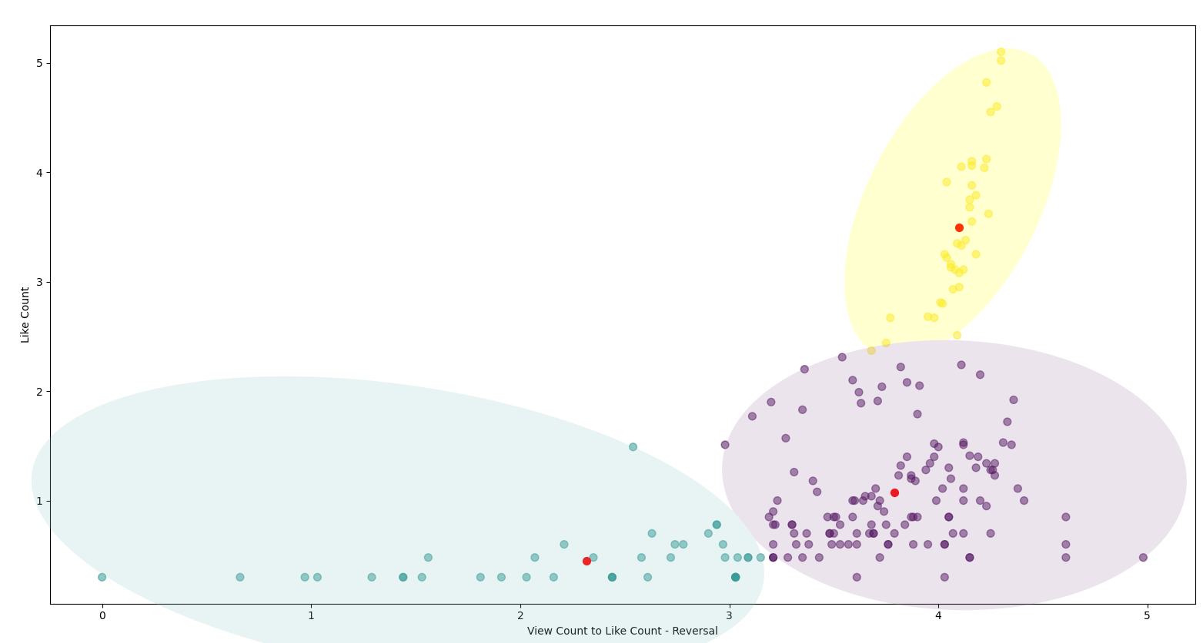
Fig. 8 View count-to-like count – reversal vs like count for introduction to HTML

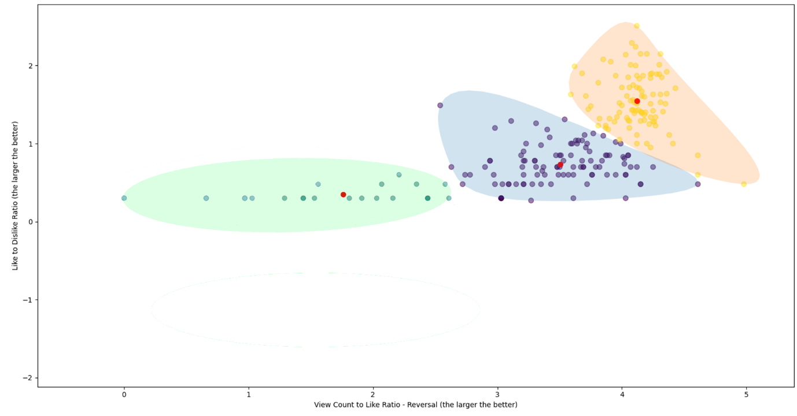
Fig. 9 View count-to-like count – reversal vs like-to-dislike ratio for introduction to HTML

Fig.8 and fig. 9 show that both clusters are prioritized according to the normalized like-to-dislike ratio (LDn). The intra-cluster videos are not similar if the dislike is not taken into consideration during the clustering (table 3). Table 3 shows that when only view count and like count are taken into consideration, the cluster will likely follow the view count (see lines 1-3, 5-7, and 8-11). This is because videos with low view counts end up in a different cluster (lines 2, 3, 6, 7, 10, 11, 19, and 20). If the clusters are used to filter videos prior to recommendation, cluster 2 (see table 3) will be recommended. As a result, the recommendations will lack serendipity. Furthermore, based on the sentiments of the videos based on the like to dislike ratio, many of these low view count videos may have a greater positive sentiment polarity than more popular videos. This can be seen from lines 2, 3, 6, and 7. The dislikes need to be taken into consideration, and not only the like count, as they show the perceived sentiments of the videos. The two tables show that the like-to-dislike ratio is suitable to prioritize videos (table 4). Table 4 shows that when dislike ratio is taken into consideration during clustering, all the top-20 videos are in the same cluster (cluster 2). Cluster 2 will then be used to generate the recommendations. The inclusion of the dislike rate during clustering improves the serendipity as it manages to cluster all video with similar sentiment polarity, regardless of the view count. As a result, the recommendation provides videos with higher positive sentiment polarity during recommendation.

Table 3 Video Prioritisation without dislike consideration (3 clusters)
Priori | Video ID | Vn | Ln | LDn | VnLn | VnLnr | cluster | View Count
1 | LGQuIIv2RVA | 4.64 | 3.11 | 2.51 | 1.49 | 4.12 | 2 | 47,571
2 | Pf5TOXW9GPM | 3.37 | 2.24 | 2.24 | 1.51 | 4.11 | 0 | 2,350
3 | QtANljkXjRI | 3.05 | 2.15 | 2.15 | 1.42 | 4.2 | 0 | 1,120
4 | hu-q2zYwEYs | 5.4 | 3.68 | 2.15 | 1.47 | 4.15 | 2 | 259,762
5 | Y1BlT4_c_SU | 5.15 | 3.25 | 2.14 | 1.58 | 4.03 | 2 | 143,309
6 | DGVXXW6xEnc | 3.68 | 2.08 | 2.08 | 1.77 | 3.85 | 0 | 4,887
7 | md2hMtFJqKI | 3.5 | 2.05 | 2.05 | 1.71 | 3.91 | 0 | 3,194
8 | UB1O30fR-EE | 6.69 | 5.1 | 2.01 | 1.31 | 4.3 | 2 | 5,012,995
9 | BvJYXl2ywUE | 4.99 | 3.33 | 2 | 1.5 | 4.11 | 2 | 102,566
10 | OZeoiotzPFg | 3.97 | 1.99 | 1.99 | 2 | 3.62 | 0 | 9,281
11 | BvSTiqvm7sM | 2.42 | 1.92 | 1.92 | 1.26 | 4.36 | 0 | 270
12 | Ncy6LDjSiX4 | 4.6 | 2.37 | 1.9 | 1.94 | 3.68 | 2 | 104,395
13 | WwNuvGLblJU | 4.99 | 3.62 | 1.9 | 1.38 | 4.24 | 2 | 39,929
14 | qz0aGYrrlhU | 6.13 | 4.6 | 1.89 | 1.33 | 4.28 | 2 | 4,070,499
15 | pQN-pnXPaVg | 6.6 | 5.02 | 1.89 | 1.32 | 4.3 | 2 | 1,498,308
16 | 1PnVor36_40 | 5.71 | 4.12 | 1.84 | 1.39 | 4.23 | 2 | 533,797
17 | 4bg2AUp6Y8w | 4.91 | 3.16 | 1.72 | 1.55 | 4.06 | 2 | 88,736
18 | gT0Lh1eYk78 | 5.9 | 4.06 | 1.67 | 1.45 | 4.16 | 2 | 830,950
19 | 5JbBOfYjMhs | 4.25 | 2.1 | 1.63 | 2.02 | 3.59 | 0 | 17,873
20 | 5gVxlxwBcCU | 3.64 | 1.91 | 1.61 | 1.9 | 3.71 | 0 | 4,505

Table 4 Video Prioritisation with dislike consideration (3 clusters)
Priori | Video ID | Vn | Ln | LDn | VnLn | VnLnr | cluster | View Count
1 | LGQuIIv2RVA | 4.64 | 3.11 | 2.51 | 1.49 | 4.12 | 2 | 47,571
2 | Pf5TOXW9GPM | 3.37 | 2.24 | 2.24 | 1.51 | 4.11 | 2 | 2,350
3 | QtANljkXjRI | 3.05 | 2.15 | 2.15 | 1.42 | 4.2 | 2 | 1,120
4 | hu-q2zYwEYs | 5.4 | 3.68 | 2.15 | 1.47 | 4.15 | 2 | 259,762
5 | Y1BlT4_c_SU | 5.15 | 3.25 | 2.14 | 1.58 | 4.03 | 2 | 143,309
6 | DGVXXW6xEnc | 3.68 | 2.08 | 2.08 | 1.77 | 3.85 | 2 | 4,887
7 | md2hMtFJqKI | 3.5 | 2.05 | 2.05 | 1.71 | 3.91 | 2 | 3,194
8 | UB1O30fR-EE | 6.69 | 5.1 | 2.01 | 1.31 | 4.3 | 2 | 5,012,995
9 | BvJYXl2ywUE | 4.99 | 3.33 | 2 | 1.5 | 4.11 | 2 | 102,566
10 | OZeoiotzPFg | 3.97 | 1.99 | 1.99 | 2 | 3.62 | 2 | 9,281
11 | BvSTiqvm7sM | 2.42 | 1.92 | 1.92 | 1.26 | 4.36 | 2 | 270
12 | WwNuvGLblJU | 4.99 | 3.62 | 1.9 | 1.38 | 4.24 | 2 | 104,395
13 | Ncy6LDjSiX4 | 4.6 | 2.37 | 1.9 | 1.94 | 3.68 | 2 | 39,929
14 | pQN-pnXPaVg | 6.6 | 5.02 | 1.89 | 1.32 | 4.3 | 2 | 4,070,499
15 | qz0aGYrrlhU | 6.13 | 4.6 | 1.89 | 1.33 | 4.28 | 2 | 1,498,308
16 | 1PnVor36_40 | 5.71 | 4.12 | 1.84 | 1.39 | 4.23 | 2 | 533,797
17 | 4bg2AUp6Y8w | 4.91 | 3.16 | 1.72 | 1.55 | 4.06 | 2 | 88,736
18 | gT0Lh1eYk78 | 5.9 | 4.06 | 1.67 | 1.45 | 4.16 | 2 | 830,950
19 | 5JbBOfYjMhs | 4.25 | 2.1 | 1.63 | 2.02 | 3.59 | 2 | 17,873
20 | 5gVxlxwBcCU | 3.64 | 1.91 | 1.61 | 1.9 | 3.71 | 2 | 4,505

In summary, the first finding is that k-means can be used to cluster results from a YouTube API call. Different features (VC and LC vs. VC and LD) yield to different sets of clusters (2 clusters from VC-LC and 1 cluster from VC-LD). The second finding is that Log₁₀ normalization is suitable to reduce the data skewness by retaining the relative distance between each node. The third finding is that dislike rate is crucial in video recommendation as the omission of dislike rate from clustering may produce different recommendations, as it is likely that only one of the clusters will be handed to human experts to reduce the loading to check video accuracy, as seen in table 3. Furthermore, the results in table 3 shows that the omission of the dislike rate would make recommendations incline towards VC as all the top 20 videos with significantly fewer VC end up in another cluster. Ultimately, this means less serendipity in recommendations if the dislike rate is discarded during clustering.

Discussion

Serendipity in YouTube recommendations

The results show that the YouTube recommendations do not emphasis serendipity. YouTube recommendations do, however, factor in sentiment polarity. The sentiment polarity, denote by like count and dislike count is made available both on web search and in API call. However, On Dec 13, 2021, YouTube decided to make the dislike count private from all searches including API calls unless specially requested. The request processes are tedious and may hinder researchers and practitioner from completing it. This would make the sentiment polarity calculation unnecessarily complicated as the dislike need to be omitted from sentiment calculation, or the recommender systems creator need to go through lengthy email and audit processes to request for dislike count inclusion in their recommender systems project.

Sentiment polarity on serendipity in video recommendation

The results show the importance of sentiment polarity in improving serendipity in recommendations. Table 3 shows that the omission of dislike counts results in the separation of videos based on VC into different clusters. If the clusters are used as baseline for recommendation, a single cluster (cluster 2) will likely be used as it contains mostly videos that are popular and still have positive sentiment. However, this leads to lower serendipity in the recommendations. Furthermore, the exclusion of dislike rate shows that cluster 2 in table 3 may not have the higher positive sentiment that can only be calculated based on the like-to-YouTube started hiding dislike counts, but we show the importance of making the dislike count available, at least for API calls. Regardless of their view counts, videos that have high impact on users (based on view-to-like ratio) have similar sentiment polarity (based on like-to-dislike ratio). It is important to remember that in academia, the purpose is not to make the users watch many videos, but to get them started as soon as possible. To disregard YouTube would be a huge loss as it contains huge numbers of relevant videos, but the implementation needs to be fine-tuned so it would cater for education. Perhaps, with enough studies, the academic community could persuade YouTube to create a platform similar to YouTube for kids, with educational content that utilizes sentiment polarity and serendipity-based recommendation. The inclusion of serendipitous video would reduce the popularity race that is normally associated with videos for entertainment.

Limitations

This research, while providing data that shows the importance of dislike counts and a method to increase the serendipitous results for recommendations, has its own limitations. First, the dataset is snapshot of the time they were published, and not throughout the 3 weeks duration. As such, many videos with extremely small view counts had like and dislike count which had to be discarded before and after normalization. Second, this test was conducted only on the introduction to IT topic. The relevancy and the accuracy of the recommended videos may vary for other fields, for example, medical education. As such, the need for an expert to evaluate the videos is still crucial and plays a significant role. Furthermore, this research only shows the quantitative results from the inclusion of sentiment polarity and serendipity during item recommendation. More studies are needed to test the user acceptance of the recommended videos. Future studies could focus on sentiment polarity, serendipity, and relevancy of YouTube videos as supplements to formal classes.

Conclusions

We wanted to first understand how serendipitous YouTube recommendations are. Second, to analyze how sentiment polarity affects recommendations. Third, to optimize clustering and video recommendations for education, as an alternative to YouTube recommendations. Step 1 in stage 1 shows that the YouTube recommendation algorithm does not prioritize serendipitous videos. Step 2 in stage one shows that sentiment polarity is taken into consideration for YouTube recommendations. This further emphasizes the importance of making the dislike count available, which was recently disabled by YouTube. In stage 2, the proposed recommendation algorithm manages to improve the inclusion of serendipitous videos in the recommendation list using the like-to-dislike rate. The results also show that the inclusion of the dislike weightage during regression for recommendation tallies with like-to-dislike-based clustering. This would allow prefiltering when the dataset becomes huge. This, in turn, reduces the number of videos for experts to review before final recommendation. The dislike rate would also allow for sentiment polarity with sentiment weightage, and not only the like count. Both clusters and prioritization techniques can be done with basic algorithms and can be implemented easily with basic programming knowledge. Hence, this would be beneficial to experts in other fields if they choose to create an alternative to YouTube recommendations for content in their respective fields. This is important as the YouTube default recommendation may not be the best method as it shows that the lowest-scored videos by medical experts the rank highest in popularity (King, Davison, Benjenk, et al., 2021). Future work could expand the findings and suggestions from this paper to find user acceptance to the recommendations made with dislike counts. However, since YouTube no longer provides this data, future studies would need to discover other features that can be used to mine the dislike counts of videos.

Acknowledgement

Removed for review

References

Abul-Fottouh D, Song MY, and Gruzd A (2020) Examining algorithmic biases in YouTube’s recommendations of vaccine videos. International Journal of Medical Informatics 140: 104175.
Alfano M, Fard AE, Carter JA, Clutton P, and Klein C (2020) Technologically scaffolded atypical cognition: the case of YouTube’s recommender system. Synthese 199: 835–858.
Amal S, Tsai CH, Brusilovsky P, Kuflik T, & Minkov E (2019) Relational social recommendation: Application to the academic domain. Expert Systems with Applications 124: 182-195.
Cabada RZ, Estrada MLB, Hernández FG, Bustillos RO, and Reyes-García CA (2018) An affective and Web 3.0-based learning environment for a programming language. Telematics and Informatics 35(3): 611-628.
Chelaru S, Orellana-Rodriguez C, and Altingovde IS (2014) How useful is social feedback for learning to rank YouTube videos? World Wide Web 17: 997-1025.
Fan X, and Niu X (2018) Implementing and Evaluating Serendipity in Delivering Personalized Health Information. ACM Transactions on Management Information Systems: 9(2): 1-19.
Dascalu CG, Antohe ME, Zegan G, Burlea SL, Carausu EM, Ciubara A, & Purcarea VL (2021) Blended Learning - The Efficiency Of Video Resources And Youtube In The Modern Dental Education. Revista De Cercetare Și Intervenție Social 72: 288-310.
Fernandez-Llatas C, Traver V, Borras-Morell JE, Martinez-Millana A, and Karlsen, R (2017) Are Health Videos from Hospitals, Health Organizations, and Active Users Available to Health Consumers? An Analysis of Diabetes Health Video Ranking in YouTube. Computational and Mathematical Methods in Medicine 2017: 8194940.
Gutiérrez-Martín A, Torrego-González A, & Vicente-Mariño M (2019) Media education with the monetization of YouTube: the loss of truth as an exchange value /Educación mediática frente a la monetización en YouTube: la pérdida de la verdad como valor de cambio. Cultura y Educación 31(2): 267-295.
Huang J, Ding S, Wang H, and Liu T (2018) Learning to Recommend Related Entities with Serendipity for Web Search Users. ACM Transactions on Asian and Low-Resource Language Information Processing 17(3): 1-22.
Jeong J, Sohn K, and Kwon O (2019) The Effects of Content and Distribution of Recommended Items on User Satisfaction: Focus on YouTube. The Journal for Information Professionals 29(4): 856-874.
Kadriu A, Abazi-Bexheti L, Abazi-alili H, and Ramadani V (2020) Investigating trends in learning programming using YouTube tutorials. International Journal of Learning and Change 12(2): 190 - 208.
Kaiser J, and Rauchfleisch A (2020) Birds of a Feather Get Recommended Together: Algorithmic Homophily in YouTube’s Channel Recommendations in the United States and Germany. Social Media + Society. Epub ahead of print Oct 2020. DOI:10.1177/2056305120969914
King D, Davison D, Benjenk I, Heinz E, Vaziri K, Hawkins K, and Yamane D (2021) YouTube to Teach Central Lines, The Expert vs Learner Perspective. Journal of Intensive Care Medicine 37(4): 528–534.
Lam NHT, and Woo BKP (2019) YouTube as a New Medium for Dementia Education Among Chinese Americans. Community Mental Health Journal 56: 435-439.
Liu Y, Qin C, Ma X, & Liang H (2021) Serendipity in human information behavior: a systematic review. Journal of Documentation 78(2): 435-462.
Moliner L, Lorenzo-Valentin G, and Alegre F (2021) E-Learning during the Covid-19 Pandemic in Spain: A Case Study with High School Mathematics Students. Journal of Education and E-Learning Research 8(2): 179-184.
Nakatsuji M, Toda H, Sawada H, Zheng JG, and Hendler JA (2016) Semantic sensitive tensor factorization. Artificial Intelligence 230: 224-245.
Ray A, Bala PK, & Jain R (2020) Utilizing emotion scores for improving classifier performance for predicting customer's intended ratings from social media posts. Benchmarking: An International Journal 28(2): 438-464.
Rosenbusch H, Evans AM, and Zeelenberg M (2019) Multilevel Emotion Transfer on YouTube: Disentangling the Effects of Emotional Contagion and Homophily on Video Audiences. Social Psychological and Personality Science 10(8): 1028-1035.
Saat NIY, Noah SAM, and Mohd M (2018) Towards Serendipity for Content–Based Recommender Systems. International Journal on Advanced Science, Engineering and Information Technology 8(4-2): 1762-1769.
Sader N, Kulkarni AV, Eagles ME, Ahmed S, Koschnitzsky JE, and Riva-Cambrin J (2020) The quality of YouTube videos on endoscopic third ventriculostomy and endoscopic third ventriculostomy with choroid plexus cauterization procedures available to families of patients with pediatric hydrocephalus. Journal of Neurosurgery: Pediatrics 25(6): 653–658.
Salazar C, Aguilar J, Monsalve-Pulido J, and Montoya E (2021) Affective recommender systems in the educational field. A systematic literature review. Computer Science Review 40: 100377.
Staziaki PD, Santo IDO, Skobodzinski AA, Park LK, & Bedi HS (2021) How to Use YouTube for Radiology Education. Current Problems in Diagnostic Radiology 50: 461-468.
Tang L, Fujimoto K, Amith M, Cunningham R, Costantini RA, York F et al. (2021) “Down the Rabbit Hole” of Vaccine Misinformation on YouTube: Network Exposure Study. Journal of Medical Internet Research 23(1): e23262.
Tollon F (2021) Designed to Seduce: Epistemically Retrograde Ideation and YouTube's Recommender System. International Journal of Technoethics 12(2): 60-71.
Tomeo P, Fernández-Tobías I, Cantador I, and Di Noia T (2017) Addressing the Cold Start with Positive-Only Feedback Through Semantic-Based Recommendations. International Journal of Uncertainty, Fuzziness and Knowledge-Based Systems 25(2): 57-78.
Yang Y, Xu Y, Wang E, Han J, and Yu Z (2018) Improving Existing Collaborative Filtering Recommendations via Serendipity-Based Algorithm. IEEE Transactions on Multimedia 20(7): 1888 – 1900.
Yen-Liang C, & Chia-Ling C (2019) Early prediction of the future popularity of uploaded videos. Expert Systems with Applications 133: 59-74.
Zhou R, Khemmarat S, Gao L, Wan J, Zhang J, Yin Y, and Yu J (2016) Boosting video popularity through keyword suggestion and recommendation systems. Neurocomputing 205: 529-541.
Ziarani RJ, and Ravanmehr R (2021) Serendipity in Recommender Systems: A Systematic Literature Review. Journal of Computer Science and Technology 36: 375-396.

