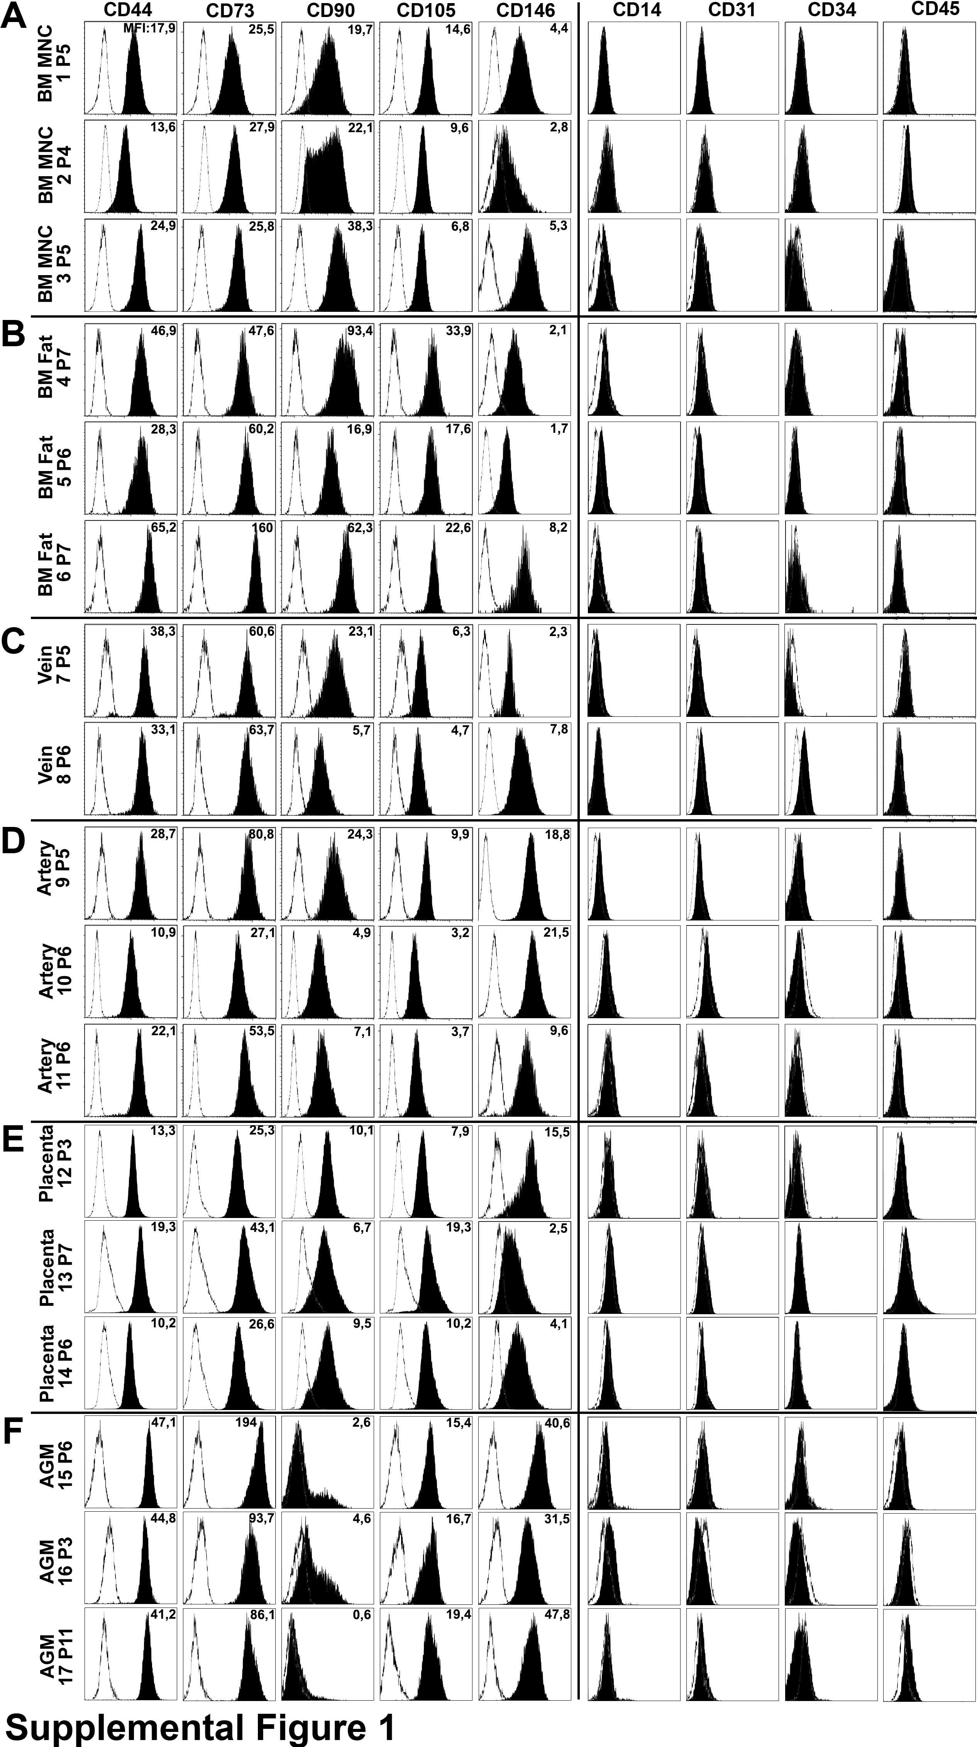
Supplemental Figure 1: Cell surface phenotype of human mesenchymal stromal cells
Open histograms reflect the intensity of isotype controls, black histograms the intensity of given cell surface antigens. Numbers indicate the mean fluorescence intensity (MFI) of the antibody staining.
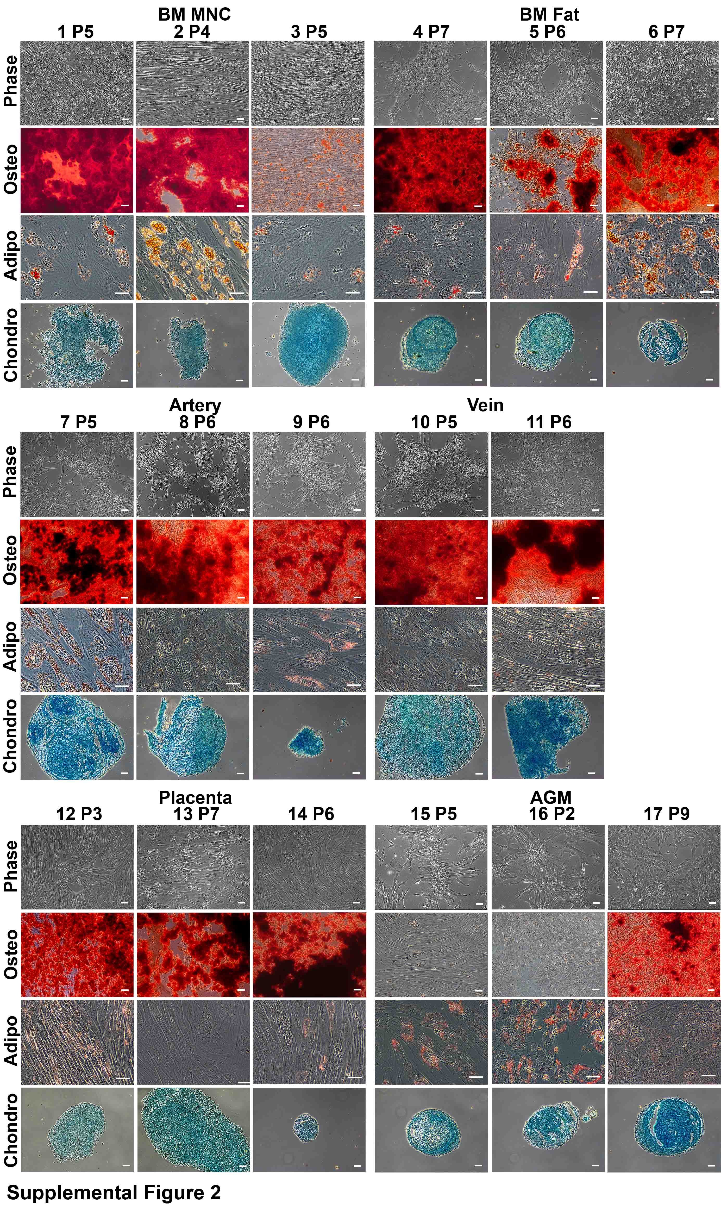
Supplemental Figure 2: Functional characterisation of human mesenchymal stromal cells
Confimation of tri-lineage differentiation potential into Osteocytes (Osteo), Adipocytes (Adipo) and Chondrocytes (Chondro). (Scale-bar: 50µm)

Supplemental Tables:

Supplemental Table 1
[fold-expansion] | CD45⁺ | CD34⁺ | CD133⁺CD34⁺ | CD133^{low}CD34⁺
Sus | 280.4 ± 72.5 | 23.0 ± 6.4 | 16.5 ± 4.7 | 6.5 ± 2.0
AFT024 | 1376.3 ± 487.7 | 403.5 ± 185.7 | 146.4 ± 69.2 | 257.1 ± 116.6
OP9 | 966.9 ± 593.9 | 369.7 ± 176.5 | 135.9 ± 55.0 | 233.7 ± 121.5
MS-5 | 1054.0 ± 308.4 | 249.2 ± 85.3 | 61.7 ± 18.6 | 187.5 ± 68.2
Fold-expansion of CD45⁺, CD34⁺, CD133⁺CD34⁺ and CD133^{low}CD34⁺ populations in suspension (w/o stromal cells) and in co-culture with murine stromal cell line cells. Mean ± SEM; n=3 for all values

Supplemental Table 2
[fold-expansion] | LTC-IC | NK-IC | CFC 133⁺ | CFC 133^{low}
Sus | 0.78 ± 0.36 | 0.56 ± 0.38 | 1.76 ± 0.34 | 0.52 ± 0.38
AFT024 | 3.26 ± 1.77 | 13.86 ± 6.26 | 6.53 ± 1.72 | 47.88 ± 10.77
OP9 | 4.68 ± 2.26 | 14.46 ± 6.91 | 27.91 ± 3.07 | 25.70 ± 4.97
MS-5 | 2.01 ± 0.99 | 4.51 ± 2.53 | 18.31 ± 6.65 | 26.10 ± 1.67
Fold-expansion of progenitor cells with LTC-IC, NK-IC and CFC potential after culture in suspension (w/o stromal cells) and in co-culture with murine stromal cell line cells. Mean ± SEM; n=3 for all values

Supplemental Table 3
Antigen | Flurochrome | Company | Clone | Cells
CD14 | PE | BD Heidelberg, Germany | M5E2 | M
CD31 | PE | BD Heidelberg, Germany | WM59 | M
CD34 | ECD | Beckman Coulter, Krefeld, Germany | 581 | H
CD38 | FITC | BD Heidelberg, Germany | HIT2 | H
CD45 | PE-Cy7 | Beckman Coulter, Krefeld, Germany | J33 | H
CD45 | APC | Beckman Coulter, Krefeld, Germany | J33 | M
CD73 | PE | BD Heidelberg, Germany | AD2 | M
CD90 | FITC | Beckman Coulter, Krefeld, Germany | 2G5 | M
CD105 | FITC | Ancell, Bayport, USA | SN6/N1-3A1 | M
CD133 | PE | Miltenyi Biotech, Bergisch Gladbach, Germany | AC133 | H
CD146 | PE | Beckman Coulter, Krefeld, Germany | TEA1134 | M
Abbreviations: H = hematopoietic cells; M = mesenchymal cells; FITC = Fluorescein Isothiocyanate; PE = Phycoerythrine; PE-Cy7 = PE-Cyanine 7; APC = Allophycocyanin; ECD = Electron-coupled Dye.

Supplemental Table 4
[fold-expansion] | CD45⁺ | CD34⁺ | CD133⁺CD34⁺ | CD133^{low}CD34⁺
Sus | 179 ± 37 | 6.8 ± 1.4 | 4.1 ± 1.1 | 3.3 ± 0.6
AFT024 | 2226 ± 532 | 829.3 ± 284.4 | 253.8 ± 89.0 | 664.7 ± 255.1
BM MNC 1 | 1904 ± 289 | 192.5 ± 33.2 | 132.2 ± 38.5 | 61.2 ± 12.0
BM MNC 2 | 2777 ± 306 | 447.8 ± 104.1 | 292.7 ± 94.3 | 178.4 ± 35.8
BM MNC 3 | 1556 ± 229 | 189.1 ± 38.1 | 128.3 ± 27.1 | 65.0 ± 10.8
BM Fat 4 | 1139 ± 127 | 146.7 ± 31.5 | 108.0 ± 30.3 | 45.4 ± 8.9
BM Fat 5 | 1411 ± 320 | 194.0 ± 41.1 | 166.8 ± 43.8 | 51.4 ± 13.8
BM Fat 6 | 2649 ± 363 | 289.7 ± 87.1 | 217.5 ± 78.6 | 97.8 ± 29.1
Vein 7 | 1479 ± 130 | 92.4 ± 23.6 | 52.7 ± 15.8 | 38.3 ± 16.1
Vein 8 | 1797 ± 176 | 99.6 ± 17.2 | 71.0 ± 17.5 | 30.9 ± 9.9
Artery 9 | 1501 ± 141 | 108.5 ± 21.1 | 85.7 ± 21.3 | 25.4 ± 4.9
Artery 10 | 1724 ± 804 | 76.6 ± 27.2 | 45.8 ± 16.4 | 40.7 ± 24.1
Artery 11 | 1592 ± 205 | 105.1 ± 19.6 | 76.7 ± 19.7 | 40.4 ± 6.4
Placenta 12 | 1098 ± 300 | 38.5 ± 11.2 | 13.9 ± 6.3 | 24.6 ± 7.1
Placenta 13 | 721 ± 147 | 28.1 ± 8.9 | 18.7 ± 5.8 | 9.4 ± 4.3
Placenta 14 | 1352 ± 309 | 37.1 ± 6.8 | 9.4 ± 2.2 | 27.8 ± 5.9
AGM 15 | 324 ± 56 | 19.6 ± 3.5 | 10.7 ± 2.9 | 8.8 ± 1.3
AGM 16 | 358 ± 58 | 16.9 ± 2.9 | 9.9 ± 1.8 | 6.9 ± 1.8
AGM 17 | 304 ± 54 | 15.2 ± 3.3 | 10.5 ± 2.6 | 4.6 ± 1.3
Fold-expansion of CD45⁺, CD34⁺, CD133⁺CD34⁺ and CD133^{low}CD34⁺ populations in suspension culture (w/o stromal cells) and in co-culture with AFT024 or primary human mesenchymal stromal cells. Mean ± SEM; n=5 for all values

Supplemental Table 5
[fold-expansion] | LTC-IC | NK-IC | CFC 133⁺ | CFC 133^{low}
Sus | 1.4 ± 0.6 | 0.2 ± 0.1 | 3.3 ± 1.2 | 0.5 ± 0.4
AFT024 | 3.3 ± 1.4 | 9.2 ± 4.7 | 47.5 ± 4.5 | 96.9 ± 22.6
BM MNC 1 | 10.0 ± 3.8 | 6.0 ± 1.8 | 84.3 ± 24.8 | 9.0 ± 4.2
BM MNC 2 | 26.9 ± 9.5 | 6.9 ± 1.7 | 239.9 ± 107.1 | 38.5 ± 17.8
BM MNC 3 | 13.2 ± 4.3 | 5.7 ± 2.8 | 72.6 ± 14.9 | 15.3 ± 7.4
BM Fat 4 | 13.9 ± 4.4 | 5.9 ± 2.0 | 70.5 ± 19.3 | 16.9 ± 4.2
BM Fat 5 | 28.9 ± 22.9 | 6.6 ± 3.6 | 72.4 ± 28.3 | 20.6 ± 8.5
BM Fat 6 | 12.6 ± 7.0 | 5.8 ± 1.9 | 88.1 ± 32.1 | 6.7 ± 5.3
Vein 7 | 13.0 ± 6.8 | 3.0 ± 1.0 | 32.4 ± 7.8 | 7.9 ± 6.3
Vein 8 | 11.3 ± 3.7 | 2.3 ± 0.6 | 40.6 ± 7.2 | 5.4 ± 3.0
Artery 9 | 20.5 ± 6.5 | 4.1 ± 1.5 | 61.4 ± 12.5 | 2.4 ± 1.3
Artery 10 | 8.6 ± 3.2 | 1.5 ± 1.0 | 38.8 ± 7.1 | 2.7 ± 1.6
Artery 11 | 12.4 ± 6.2 | 4.0 ± 1.3 | 47.3 ± 9.4 | 6.3 ± 2.9
Placenta 12 | 1.4 ± 0.6 | 7.1 ± 3.4 | 21.9 ± 8.7 | 2.9 ± 1.8
Placenta 13 | 0.7 ± 0.3 | 4.6 ± 0.6 | 26.8 ± 8.9 | 2.2 ± 1.5
Placenta 14 | 1.7 ± 1.1 | 5.6 ± 1.6 | 20.1 ± 9.3 | 4.3 ± 1.6
AGM 15 | 0.4 ± 0.2 | 2.9 ± 0.8 | 23.1 ± 9.6 | 1.6 ± 0.5
AGM 16 | 0.3 ± 0.1 | 2.8 ± 0.7 | 16.9 ± 4.3 | 1.8 ± 0.7
AGM 17 | 1.0 ± 0.5 | 2.0 ± 0.1 | 22.9 ± 8.8 | 2.3 ± 1.0
Fold-expansion of progenitor cells with LTC-IC, NK-IC and CFC potential after culture in suspension culture (w/o stromal cells) and in co-culture with AFT024 or primary human mesenchymal stromal cells. Mean ± SEM; n=5 for all values

