Supporting Information

SI1. Interindividual variability in toxicokinetics – calculations
Allometric adjustment of AUC values
Data that were reported as arithmetic means and standard deviations on the normal scale were transformed into geometric means (GMs) and geometric standard deviations (GSDs) on the log-scale (Slob, 1994), i.e., ln(GM_{AUC}) and ln(GSD_{AUC}), assuming that interindividual variability in toxicokinetics follows a lognormal distribution. The study-specific reported bodyweight values were transformed into GMs and GSDs on the log-scale (Slob, 1994), i.e., ln(GM_{BW}) and ln(GSD_{BW}), assuming that bodyweight follows a lognormal distribution and that it is independent from the adjusted AUC (i.e., their covariance is 0).
$\ln\left({GM}_{AUC,adj}\right)=\ln\left({GM}_{AUC}\right)-\ln\left(D\right)+\left(α-β\right)∙\ln\left({GM}_{BW}\right)$ (SI1)
$\ln\left({GSD}_{AUC,adj}\right)=\sqrt{{\ln\left({GSD}_{AUC}\right)}^{2}-{\left(α-β\right)}^{2}∙{\ln\left({GSD}_{BW}\right)}^{2}}$ (SI2)
with ln(GM_{AUC,adj}) and ln(GSD_{AUC,adj}) being the allometrically adjusted ln(GM_{AUC}) and ln(GSD_{AUC}); α being the allometric scaling factor; and β being a constant that depends on the definition of dose D. The allometric scaling factor α was sampled from the same distribution as used for the allometric interspecies extrapolation (Step 3a).
The constant β has a value of 0 when the dose is administered as a fixed amount (mg), and a value of 1 when the dose is administered as an amount per bodyweight (mg*kg⁻¹). When the dose is administered as an amount per BSA (mg*m⁻²), β is assigned the same value as the allometric scaling factor α. It must be noted, however, that values derived from studies that administer an amount per BSA are not directly comparable with values derived from studies that administer a fixed amount or an amount per bodyweight. Since only part of the studies collected for methotrexate administered an amount per BSA, we estimated BSAs for the other studies based on the reported bodyweights (via Costeff, 1966), and transformed these into GMs and GSDs on the log-scale (Slob, 1994), i.e., ln(GM_{BSA}) and ln(GSD_{BSA}). Subsequently, the ln(GM_{AUC,adj}) and ln(GSD_{AUC,adj}) values were derived via Equations SI3 and SI4:
$\ln\left({GM}_{AUC,adj}\right)=\ln\left({GM}_{AUC}\right)-\ln\left(D\right)+\ln\left({GM}_{BSA}\right)$ (SI3)
$\ln\left({GSD}_{AUC,adj}\right)=\sqrt{{\ln\left({GSD}_{AUC}\right)}^{2}-{\ln\left({GSD}_{BSA}\right)}^{2}}$ (SI4)
Aggregation of individual studies into distributions
For each subpopulation, the aggregated ln(GM_{agg}) was calculated from the ln(GM_{AUC}) values of the individual studies according to Equation SI5. Subsequently, the aggregated ln(GSD_{agg}) was calculated from the ln(GSD_{AUC}) values of the individual studies and the aggregated ln(GM_{agg}).
$\ln\left({GM}_{agg}\right)={\sum_{x=1}^{x=n}{\left(N_{x}∙\ln\left({GM}_{x}\right)\right)}}/{\sum_{x=1}^{x=n}{N_{x}}}$ (SI5)
$\ln\left({GSD}_{agg}\right)=\sqrt{\frac{\sum_{x=1}^{x=n}{ \left(N_{x}-1\right)∙{\ln\left({GSD}_{x}\right)}^{2}+N_{x}∙{\ln\left({GM}_{x}\right)}^{2}-2∙N_{x}∙\ln\left({GM}_{x}\right)∙\ln\left({GM}_{agg}\right)+N_{x}∙{\ln\left({GM}_{agg}\right)}^{2}}}{\left(\sum_{x=1}^{x=n}{N_{x}}\right)-1}}$ (SI6)
with ln(GM_{agg}) and ln(GSD_{agg}) being the aggregated ln(GM_{AUC}) and ln(GSD_{AUC}) values, respectively; n being the number of individual studies available; and N_{x} being the number of participants in study x.
With a similar approach, the median AUC value in the general population is calculated from the aggregated ln(GM_{agg}) and ln(GSD_{agg}) values of the subpopulations. The ln(GM) for the general population is calculated via Equation SI5, and subsequently back-transformed to the normal scale to represent the median AUC value. In this case, n represents the number of subpopulations defined and N_{x} represents the contribution of subpopulation x to the total population. In our case study, we used the demographics of the Dutch population to derive these contributions (CBS, 2012).

SI2. Interindividual variability in toxicodynamics – calculations
For each of the studies reported by Renwick and Lazarus (1998), a log(GSD) was calculated, describing the interindividual variability in toxicodynamics. Then, each of these log(GSD)s was assigned to an AOP derived via the Small Molecule Pathway Database (at http://www.smpdb.ca). We assume that substances sharing the same AOP, i.e., with the same human (drug) target and physiological effect, also show the same extent of interindividual variability in their toxicodynamics. Therefore, when multiple log(GSD)s are assigned to one AOP, they should theoretically have the same value. In practice, this is not always the case. We then used the GM of these multiple log(GSD)s, i.e., GM_{log(GSD)}, to describe the interindividual variability in toxicodynamics for that specific AOP. The GSD of the log(GSD)s, i.e., GSD_{log(GSD)}, then describes the variation between these multiple log(GSD)s.
According to Hattis and Lynch (2007), the log(GSD)s of multiple substances follow a lognormal distribution. Therefore, the natural logarithms of the AOP-specific GM_{log(GSD)} and GSD_{log(GSD)} values were used to aggregate uncertainties into this lognormal distribution (Equations SI7 and SI8). The resulting GM_{agg} and GSD_{agg} describe the distribution that reflects both the variation between AOPs in their log(GSD)s, and the uncertainty in these log(GSD)s due to limited data availability. As such, the distribution reflects the additional uncertainty that is introduced when the interindividual variability in toxicodynamics is estimated for any unspecified AOP.
$\ln\left({GM}_{agg}\right)={\sum_{x=1}^{x=n}{\ln\left({GM}_{\log\left(GSD\right),x}\right)}}/n$ (SI7)
$\ln\left({GSD}_{agg}\right)=\frac{\sum_{x=1}^{x=n}{{\left({\ln\left({GSD}_{\log\left(GSD\right),x}\right)}/{\sqrt{N_{x}}}\right)}^{2}+{\left(\ln\left({GM}_{\log\left(GSD\right)}\right)-\ln\left({GM}_{agg}\right)\right)}^{2}}}{n-1}$ (SI8)
with ln(GM_{agg}) and ln(GSD_{agg}) being the aggregated ln(GM_{log(GSD)}) and ln(GSD_{log(GSD)}), respectively; n being the number of AOPs defined; and N_{x} being the number of studies available per AOP x.

SI3. Additional results
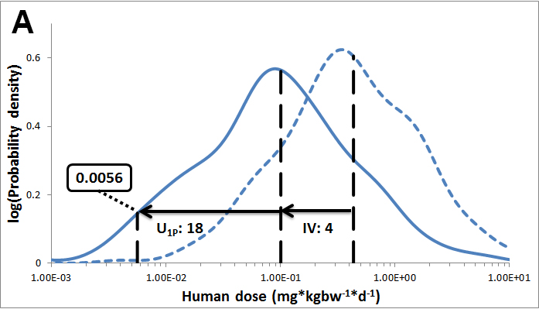
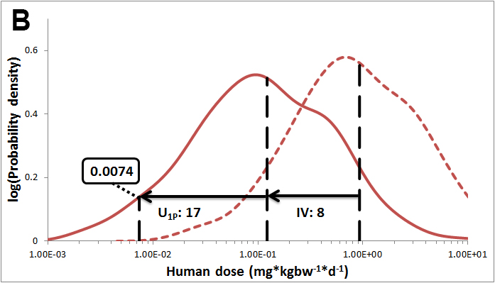
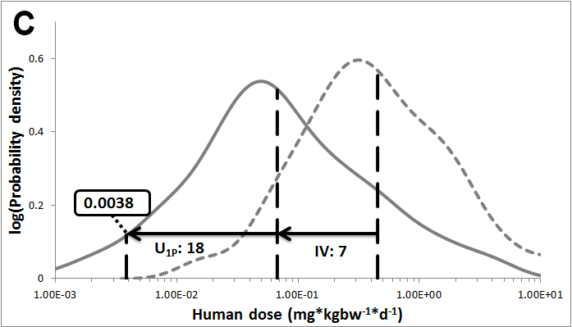
Figure SI1. Derivation of a HEL for methotrexate (endpoint: white blood cell count, exponential dose-response model, CES of 5% decrease) at a protection level of 99% and a confidence level of 95%, based on either the adult (A; blue lines) or children subpopulation (B; red lines), or based on default uncertainty distributions only (C: grey lines) (WHO, 2014). Solid line: kernel probability density function (PDF) of uncertainty distribution of HD_{M}^{0.01}; dotted lines: kernel PDF of uncertainty distribution of HD_{M}^{0.5}. These kernel PDFs represent 92% of all possible HD_{M}s, because 8% of the iterations resulted in an infinitely large PoD (see Section 2.2.1). IV: interindividual variability as the ratio between median HD_{M}^{0.5} and median HD_{M}^{0.01}; U_{1P}: uncertainty as the ratio between median HD_{M}^{0.01} and 1st percentile of HD_{M}^{0.01} kernel PDF.
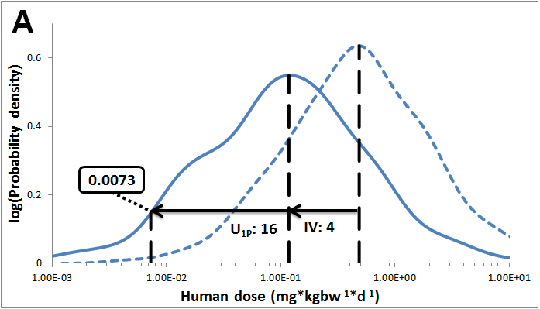
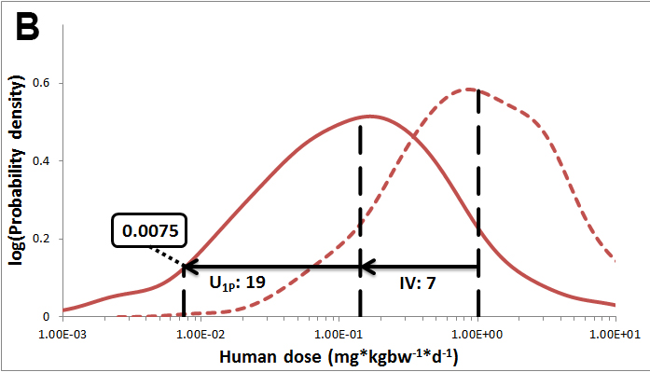
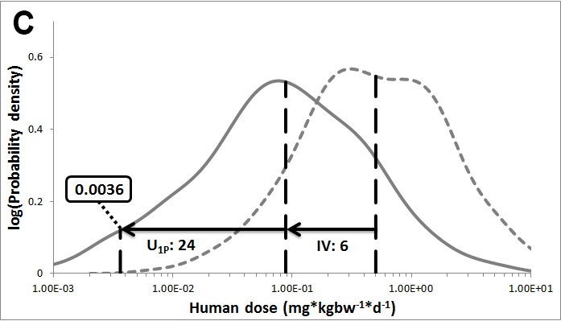
Figure SI2. Derivation of a HEL for methotrexate (endpoint: red blood cell count, Hill dose-response model, CES of 5% decrease) at a protection level of 99% and a confidence level of 95%, based on either the adult (A; blue lines) or children subpopulation (B; red lines), or based on default uncertainty distributions only (C: grey lines) (WHO, 2014). Solid line: kernel probability density function (PDF) of uncertainty distribution of HD_{M}^{0.01}; dotted lines: kernel PDF of uncertainty distribution of HD_{M}^{0.5}. These kernel PDFs represent 97% of all possible HD_{M}s, because 3% of the iterations resulted in an infinitely large PoD (see Section 2.2.1). IV: interindividual variability as the ratio between median HD_{M}^{0.5} and median HD_{M}^{0.01}; U_{1P}: uncertainty as the ratio between median HD_{M}^{0.01} and 1st percentile of HD_{M}^{0.01} kernel PDF.
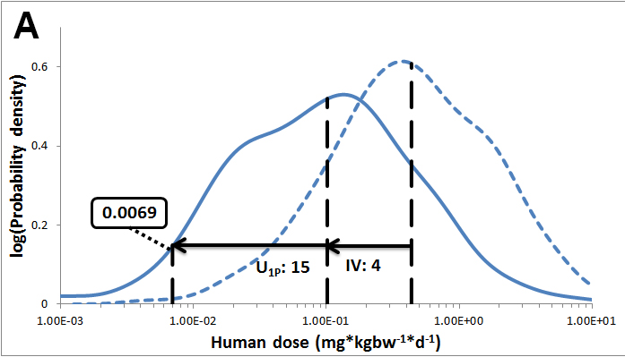
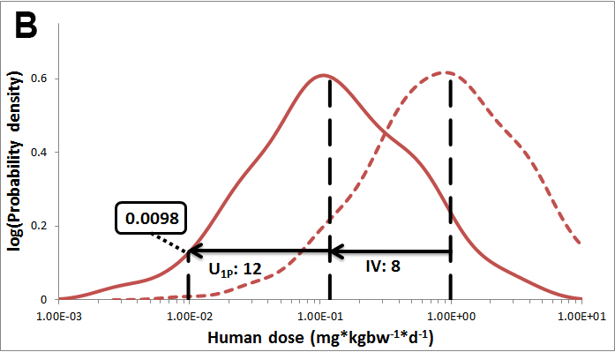
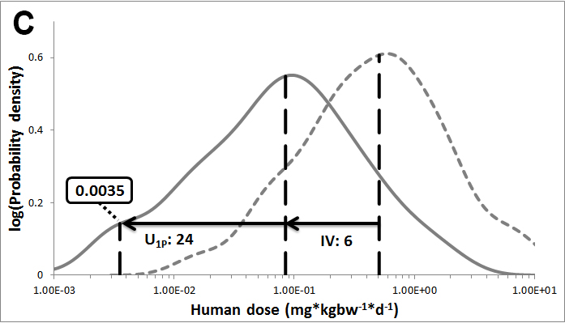
Figure SI3. Derivation of a HEL for methotrexate (endpoint: red blood cell count, exponential dose-response model, CES of 5% decrease) at a protection level of 99% and a confidence level of 95%, based on either the adult (A; blue lines) or children subpopulation (B; red lines), or based on default uncertainty distributions only (C: grey lines) (WHO, 2014). Solid line: kernel probability density function (PDF) of uncertainty distribution of HD_{M}^{0.01}; dotted lines: kernel PDF of uncertainty distribution of HD_{M}^{0.5}. These kernel PDFs represent 97% of all possible HD_{M}s, because 3% of the iterations resulted in an infinitely large PoD (see Section 2.2.1). IV: interindividual variability as the ratio between median HD_{M}^{0.5} and median HD_{M}^{0.01}; U_{1P}: uncertainty as the ratio between median HD_{M}^{0.01} and 1st percentile of HD_{M}^{0.01} kernel PDF.
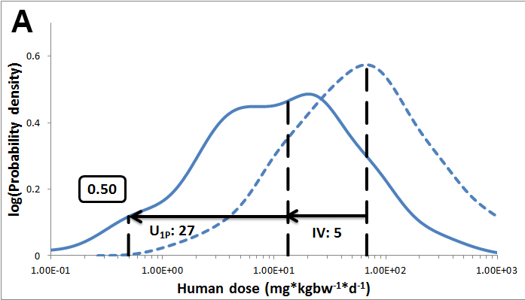
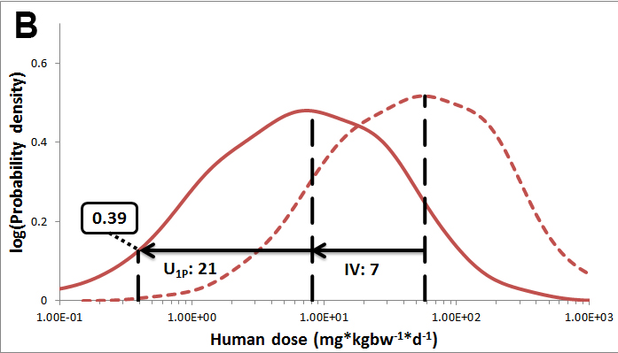
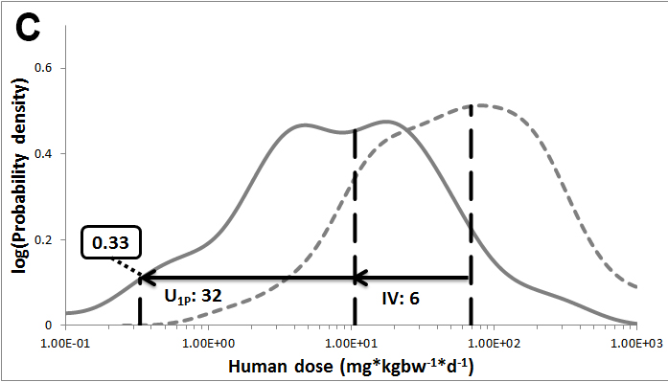
Figure SI4. Derivation of a HEL for ciprofloxacin (endpoint: femoral articular cartilage thickness, exponential dose-response model, CES of 5% decrease) at a protection level of 99% and a confidence level of 95%, based on either the adult (A; blue lines) or children subpopulation (B; red lines), or based on default uncertainty distributions only (C: grey lines) (WHO, 2014). Solid line: kernel probability density function (PDF) of uncertainty distribution of HD_{M}^{0.01}; dotted lines: kernel PDF of uncertainty distribution of HD_{M}^{0.5}. These kernel PDFs represent 93% of all possible HD_{M}s, because 7% of the iterations resulted in an infinitely large PoD (see Section 2.2.1). IV: interindividual variability as the ratio between median HD_{M}^{0.5} and median HD_{M}^{0.01}; U_{1P}: uncertainty as the ratio between median HD_{M}^{0.01} and 1st percentile of HD_{M}^{0.01} kernel PDF.

Table SI1. Contribution of the extrapolation steps to the total variance in the human dose distributions; methotrexate endpoint: white blood cell count; exponential dose-response models. First percentages: contribution to total HD_{M} distribution; second percentages: contribution to lowest 10% of HD_{M}s.
 |  | Contribution to variance in HD_{M} distribution
 |  | Methotrexate |  |  | Ciprofloxacin
Extrapolation step | Type | Adult | Children | Default | Adult | Children | Default
1. PoD derivation | U | 2%; 2% | 2%; 1% | 2%; 1% | 6%; 23% | 6%; 16% | 5%; 22%
2. Sub-acute/chronic | U | 66%; 39% | 58%; 38% | 61%; 39% | 61%; 33% | 56%; 33% | 57%; 35%
3a. Allometric scaling factor | U | <1%; 1% | <1%; <1% | <1%; <1% | <1%; <1% | <1%; <1% | <1%; <1%
3b. Remaining interspecies diff. | U | 17%; 9% | 15%; 16% | 16%; 5% | 17%; 6% | 16%; 6% | 16%; 4%
4a. Toxicokinetics | U | <1%; 1% | <1%; 2% | <1%; 1% | <1%; 2% | <1%; 1% | <1%; 3%
 | IV | 4%; <1% | 14%; 3% | 7%; 4% | 7%; 1% | 14%; 13% | 7%; 3%
4b. Toxicodynamics | U | <1%; 10% | <1%; 19% | <1%; 25% | <1%; 16% | <1%; 14% | <1%; 8%
 | IV | 11%; 39% | 10%; 21% | 14%; 24% | 9%; 18% | 8%; 19% | 15%; 23%
Total contribution U |  | 86%; 61% | 76%; 76% | 80%; 72% | 84%; 81% | 78%; 68% | 78%; 74%
Total contribution IV |  | 14%; 39% | 24%; 24% | 20%; 28% | 16%; 19% | 22%; 32% | 22%; 26%

Table SI2. Contribution of the extrapolation steps to the total variance in the human dose distributions; methotrexate endpoint: red blood cell count; Hill dose-response models. First percentages: contribution to total HD_{M} distribution; second percentages: contribution to lowest 10% of HD_{M}s.
 |  | Contribution to variance in HD_{M} distribution
 |  | Methotrexate |  |  | Ciprofloxacin
Extrapolation step | Type | Adult | Children | Default | Adult | Children | Default
1. PoD derivation | U | 6%; 4% | 5%; 3% | 5%; 4% | 10%; 67% | 10%; 64% | 9%; 69%
2. Sub-acute/chronic | U | 64%; 42% | 56%; 40% | 59%; 42% | 58%; 4% | 53%; 8% | 54%; 8%
3a. Allometric scaling factor | U | <1%; 2% | <1%; <1% | <1%; <1% | <1%; <0% | <1%; <1% | <1%; <1%
3b. Remaining interspecies diff. | U | 16%; 14% | 15%; 18% | 16%; 6% | 17%; 3% | 15%; 3% | 15%; 1%
4a. Toxicokinetics | U | <1%; 1% | <1%; 1% | <1%; 2% | <1%; 1% | <1%; 1% | <1%; 1%
 | IV | 4%; <1% | 14%; 3% | 7%; 5% | 7%; <1% | 14%; 6% | 7%; 1%
4b. Toxicodynamics | U | <1%; 13% | <1%; 18% | <1%; 20% | <1%; 14% | <1%; 8% | <1%; 4%
 | IV | 10%; 24% | 10%; 18% | 13%; 21% | 8%; 11% | 8%; 10% | 14%; 15%
Total contribution U |  | 86%; 76% | 76%; 79% | 80%; 74% | 85%; 89% | 78%; 84% | 79%; 84%
Total contribution IV |  | 14%; 24% | 24%; 21% | 20%; 26% | 15%; 11% | 22%; 16% | 21%; 16%

Table SI3. Contribution of the extrapolation steps to the total variance in the human dose distributions; methotrexate endpoint: red blood cell count; exponential dose-response models. First percentages: contribution to total HD_{M} distribution; second percentages: contribution to lowest 10% of HD_{M}s.
 |  | Contribution to variance in HD_{M} distribution
 |  | Methotrexate |  |  | Ciprofloxacin
Extrapolation step | Type | Adult | Children | Default | Adult | Children | Default
1. PoD derivation | U | 4%; 6% | 4%; 1% | 3%; 1% | 6%; 23% | 6%; 16% | 5%; 22%
2. Sub-acute/chronic | U | 65%; 43% | 57%; 40% | 60%; 44% | 61%; 33% | 56%; 33% | 57%; 35%
3a. Allometric scaling factor | U | <1%; 2% | <1%; <1% | <1%; <1% | <1%; <1% | <1%; <1% | <1%; <1%
3b. Remaining interspecies diff. | U | 17%; 13% | 15%; 16% | 16%; 4% | 17%; 6% | 16%; 6% | 16%; 4%
4a. Toxicokinetics | U | <1%; 1% | <1%; <1% | <1%; 1% | <1%; 2% | <1%; 1% | <1%; 3%
 | IV | 4%; <1% | 14%; 4% | 7%; 4% | 7%; 1% | 14%; 13% | 7%; 3%
4b. Toxicodynamics | U | <1%; 14% | <1%; 19% | <1%; 23% | <1%; 16% | <1%; 14% | <1%; 8%
 | IV | 11%; 21% | 10%; 19% | 13%; 22% | 9%; 18% | 8%; 19% | 15%; 23%
Total contribution U |  | 86%; 79% | 76%; 77% | 80%; 74% | 84%; 81% | 78%; 68% | 78%; 74%
Total contribution IV |  | 14%; 21% | 24%; 23% | 20%; 26% | 16%; 19% | 22%; 32% | 22%; 26%

