Supplementary Data
Protein cofactor competition regulates the action of a multifunctional RNA helicase in different pathways
Annika U. Heininger, Philipp Hackert, Alexandra Z. Andreou, Kum-Loong Boon, Indira Memet, Mira Prior, Anne Clancy, Bernhard Schmidt, Henning Urlaub, Enrico Schleiff, Katherine E. Sloan, Markus Deckers, Reinhard Lührmann, Jörg Enderlein, Dagmar Klostermeier, Peter Rehling, Markus T. Bohnsack

Fig. S1. Stimulation of the ATPase activity of Prp43 by Cmg1 is strongly reduced when Prp43 is truncated at either its N- or C-terminus. (A) Input samples of His-MBP tagged Cmg1 and Cmg1 1-85 and His-ZZ-tagged Prp43, Prp43 1-657 and Prp43 92-767 used in the binding assay (Fig. 1D) were separated by SDS PAGE and analysed by Comassie staining. (B) The ATPase activity of Prp43, Prp43 1-657, Prp43 92-767, Cmg1 or Cmg1 1-85 in the presence of 2 μM RNA and either no cofactor, with Cmg1 or Cmg1 1-85 as indicated is shown. Data from three independent experiments are presented as mean +/- SEM.

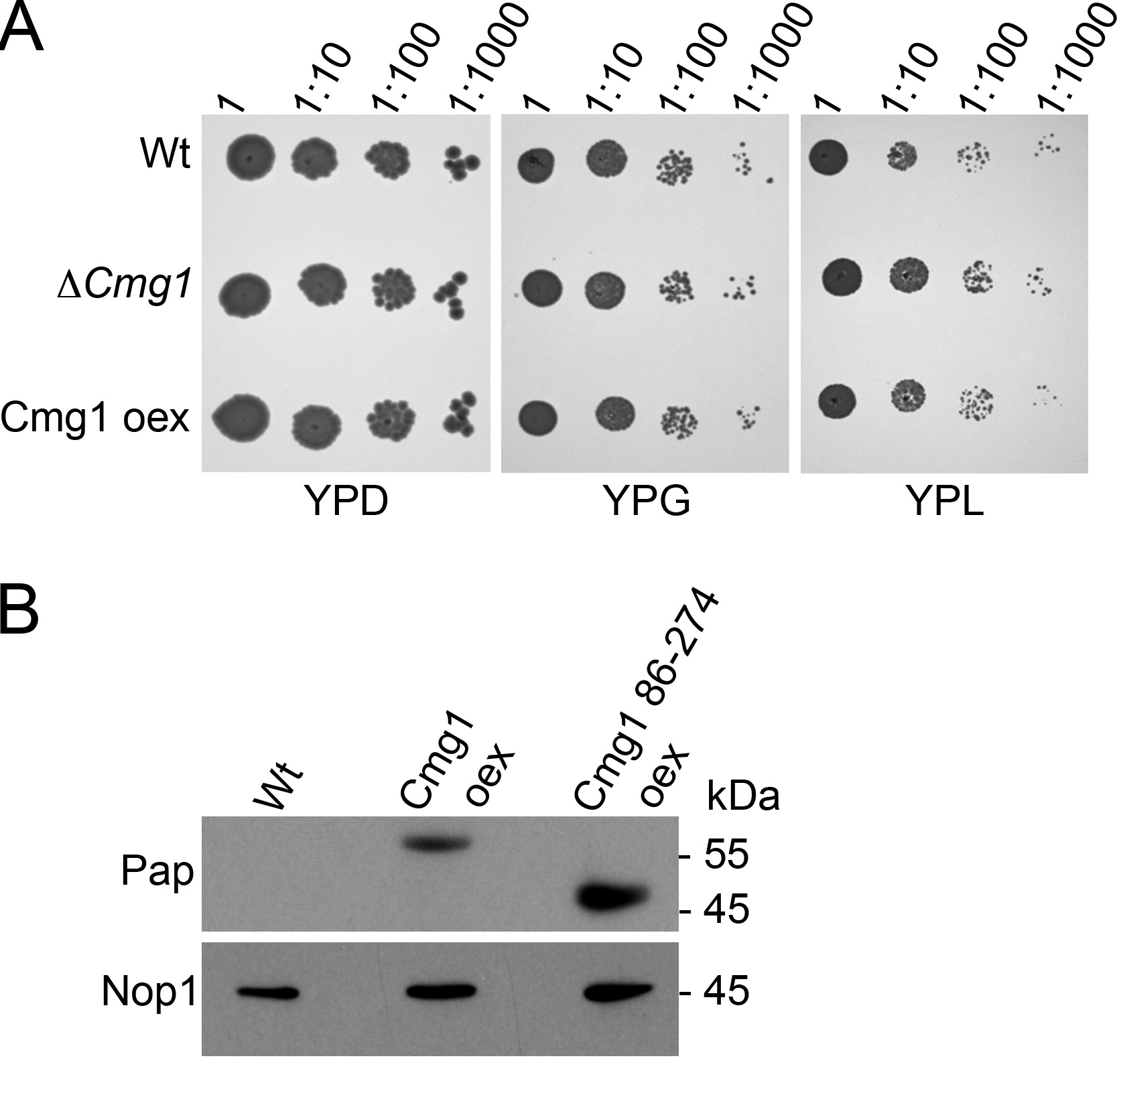

Fig. S2. Cmg1 is not required for mitochondrial energy metabolism. (A) Serial dilutions of cmg1 deletion (∆cmg1), Cmg1 overexpression (Cmg1 oex) or wildtype yeast strains were spotted for growth analysis on plates in which the carbon sources were glucose (YPD), glycerol (YPG) or lactate (YPL). Growth was documented after 2-4 days. (B) Proteins were extracted from strains overexpressing full-length Cmg1 (Cmg1 oex) or Cmg1 without its G-patch domain (Cmg1 86-274 oex) or wildtype yeast, and separated by SDS-PAGE followed by Western blotting. Cmg1 was detected using an antibody against the ProteinA-tag (Pap) and Nop1 served as a loading control.

Fig. S3. Expression of G-patch proteins under the control of a pGAL1 promoter leads to overexpression. (A) Yeast strains expressing HA-tagged G-patch proteins from their endogenous promoter (Endog) or expressing HA-tagged G-patch proteins under the control of the pGAL1 promoter (pGAL1) were grown to exponential phase in YPGal. Proteins were extracted and analysed by SDS-PAGE followed by Western blotting using the indicated antibodies. (B) Yeast cells expressing Sqs1 under the control of the pGAL1 or truncated pGALS promoter were grown in minimal media containing galactose and the localisation of GFP-tagged Sqs1 was determined by fluorescence microscopy. Brightfield images (POL) are shown on the right. Scale bar represents 2 µm for the main images. A two-fold zoom of a representative cell is shown.

Fig. S4. Alignment of the G-patch domain sequences of yeast G-patch proteins.
The amino acid sequences of the G-patch domains of the five yeast G-patch proteins were aligned using ClustralW. Conserved glycine residues are highlighted in grey and the consensus motif for G-patch domains is shown above the alignment. Below the alignment an asterisk marks residues that are conserved between all yeast G-patch proteins, a colon indicates positions where the amino acids of all the G-patch proteins have strongly similar properties and a full stop denotes residues that possess weakly similar properties.

Strain | Genotype | Reference
BY4741 | MATa; his3Δ1; leu2Δ0, met15Δ0; ura3Δ0 | (1)
YMB824 | Mat a; his3Δ1; leu2Δ0; met15Δ0; ura3Δ0; YLR271w::KanMX4 | Euroscarf
YMB884 | BY4741 with P_{TEF1}-TAP-cmg1 (His3MX6) | This study
YMB886 | BY4741 with prp43-HTP (Ura3); P_{GAL1}-3HA-spp2 (His3MX6) | This study
YMB890 | BY4741 with prp43-HTP (Ura3); P_{GAL1}-3HA-spp382 (His3MX6) | This study
YMB894 | BY4741 with prp43-HTP (Ura3); P_{GAL1}-3HA-pxr1 (His3MX6) | This study
YMB900 | BY4741 with prp43-HTP (Ura3); P_{GAL1}-3HA-cmg1 (His3MX6) | This study
YMB936 | BY4741 with prp43-HTP (Ura3); P_{GAL1}-3HA-sqs1 (His3MX6) | This study
YMB858 | prp43-GFP (His3MX6) | (2)
YMB950 | YMB858 with P_{GAL1}-3HA-spp382 (KanMX6); pRS415 RFP-Nop1 (Leu2) | This study
YMB952 | YMB858 with P_{GAL1}-3HA-spp2 (KanMX6); pRS415 RFP-Nop1 (Leu2) | This study
YMB954 | YMB858 with P_{GAL1}-3HA-pxr1 (KanMX6); pRS415 RFP-Nop1 (Leu2) | This study
YMB932 | YMB858 with P_{GAL1}-3HA-cmg1 (KanMX6); pRS415 RFP-Nop1 (Leu2) | This study
YMB948 | YMB858 with P_{GAL1}-3HA-sqs1 (KanMX6); pRS415 RFP-Nop1 (Leu2) | This study
YMB1038  YMB1153  YMB1155  YMB1157  YMB1159  YMB1161  YMB1163  YMB1165 | BY4741 with P_{TEF1}-TAP-cmg1Δ1-85 (His3MX6)  BY4741 with spp2-3HA (His3MX6)  BY4741 with sqs1-3HA (His3MX6)  BY4741 with pxr1-3HA (His3MX6)  BY4741 with spp382-3HA (His3MX6)  BY4741 with cmg1-3HA (His3MX6)  BY4741 with P_{GALS}-GFP-sqs1 (Nat)  BY4741 with P_{GAL1}-GFP-sqs1 (Nat) | This study  This study  This study  This study  This study  This study  This study  This study

Table S1. Yeast strains used in this study.

 | Anisotropy | ATPase activity
 | K_{d} [nM] | K_{M} [µM] | k_{cat} [s⁻¹]
Prp43 | 60, SD 5 | 1.41, SD 0.14 | 3.61, SD 0.14
Prp43 + Cmg1 | 2.3, SD 1.6 | 0.23, SD 0.05 | 5.09, SD 0.26
Prp43 + Spp382 51-110 | 2.5, SD 1.3 | 0.22, SD 0.04 | 3.44, SD 0.13

Table S2. Dissociation, Michaelis-Menten and rate constants for the anisotropy measurements and ATPase assays.

Supplementary References
1. Brachmann CB, Davies A, Cost GJ, Caputo E, Li J, Hieter P, Boeke JD. Designer deletion strains derived from Saccharomyces cerevisiae S288C: a useful set of strains and plasmids for PCR-mediated gene disruption and other applications. Yeast 1998; 14: 115-132.
2. Ghaemmaghami S, Huh WK, Bower K, Howson RW, Belle A, Dephoure N, O'Shea EK, Weissman JS. Global analysis of protein expression in yeast. Nature 2003; 425: 737-741.

