Calix[4]pyrroles bearing quinolinium moiety for halide sensing in aqueous solution
Evgeny A. Kataev, Nanett Backmann, Tobias Rüffer and Heinrich Lang

Institute of Chemistry, Faculty of Natural Sciences, Technische Universität Chemnitz, 09107 Chemnitz, Germany E-mail: evgeny.kataev@chemie.tu-chemnitz.de

NMR data
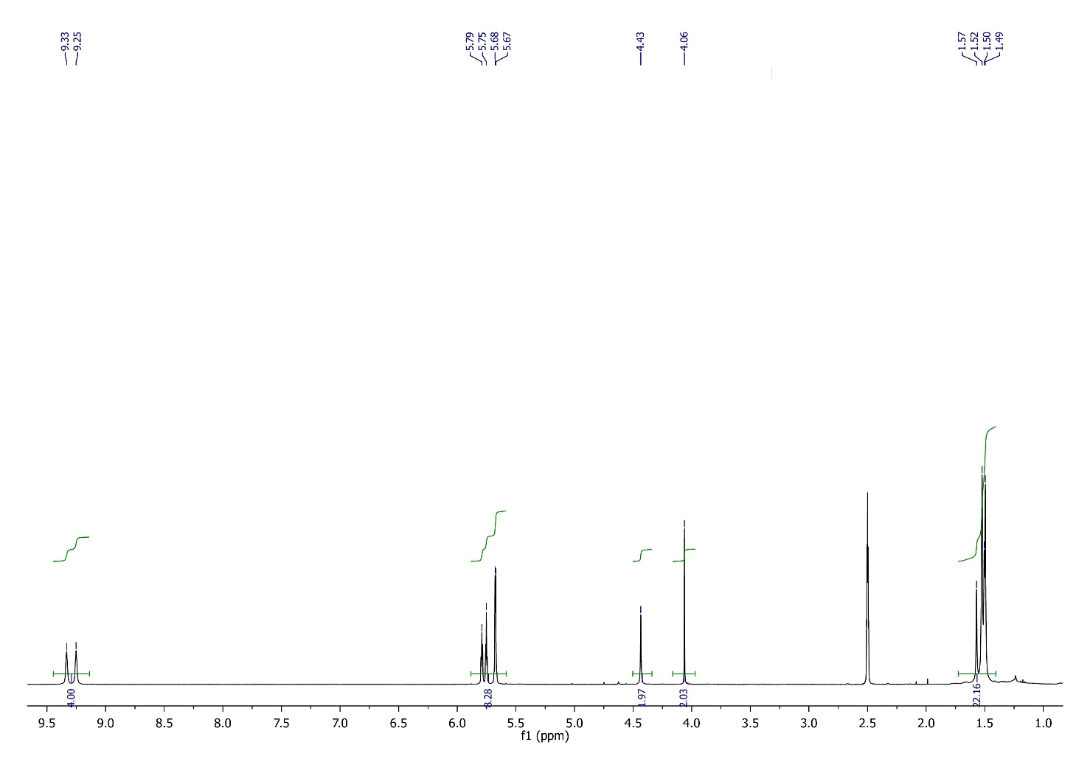
Figure S1. ¹H NMR spectrum of monohydroxy-meso-octamethylCalix[4]pyrrole 2-bromacetate measured in DMSO-d6.
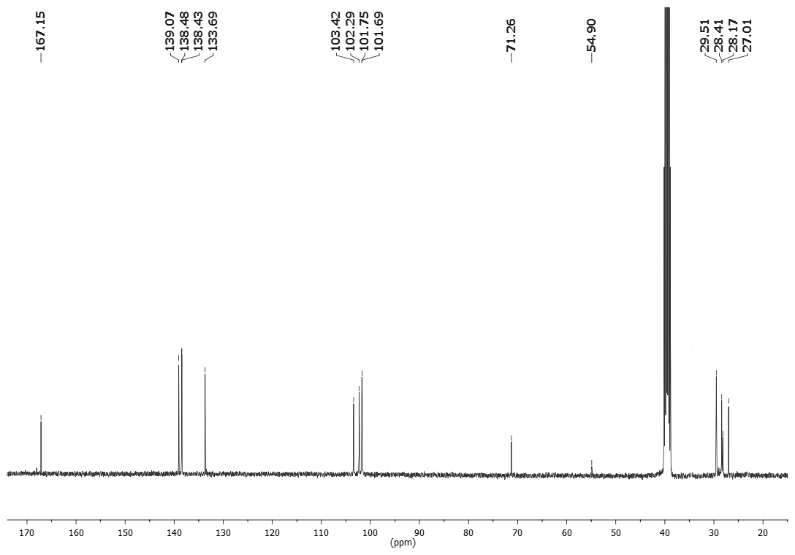
Figure S2. ¹³C NMR spectrum of monohydroxy-meso-octamethylCalix[4]pyrrole 2-bromacetate measured in DMSO-d6.
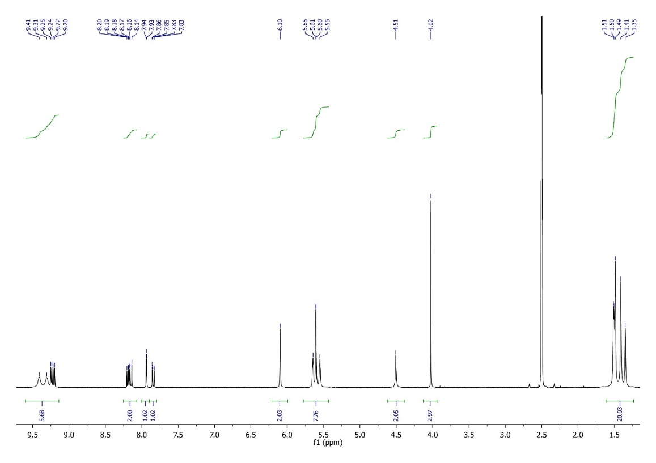
Figure S3. ¹H NMR spectrum of 1 measured in DMSO-d6.
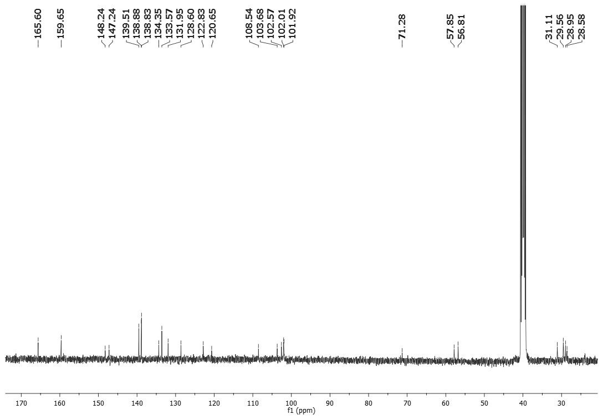
Figure S4. ¹³C NMR spectrum of 1 measured in DMSO-d6.
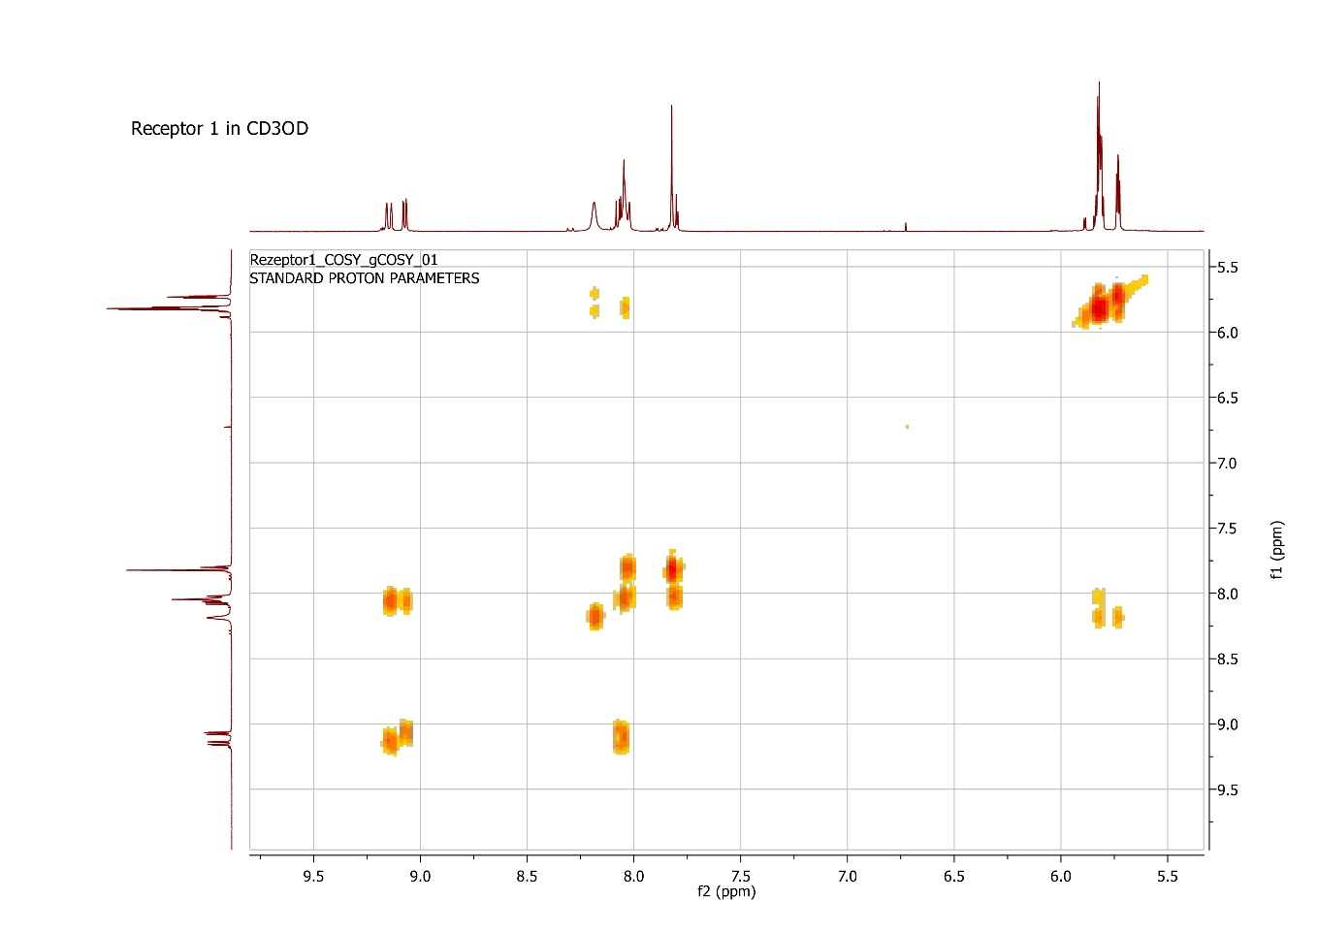
Figure S5. COSY spectrum of 1 in CD₃OD.
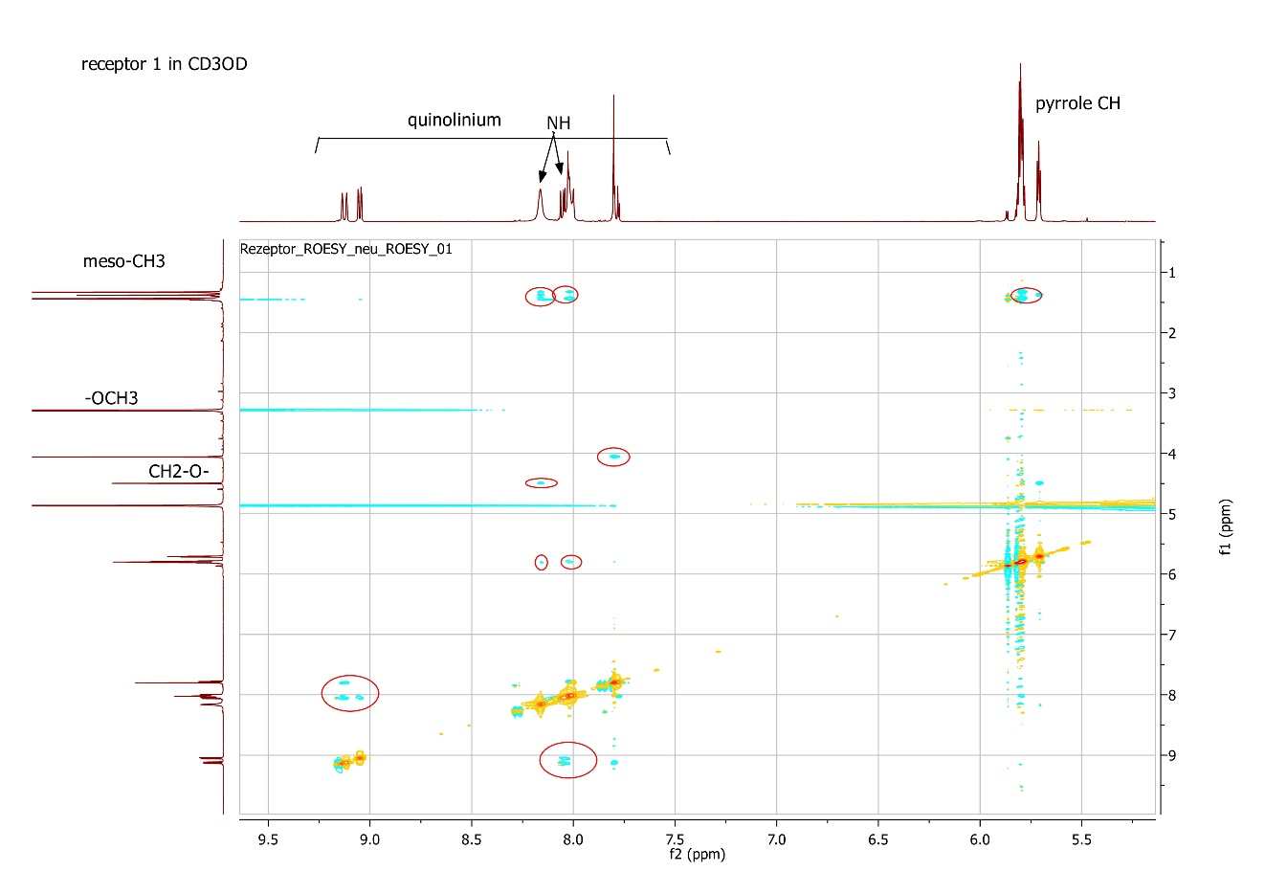
Figure S6. ROESY spectrum of 1 in CD₃OD.
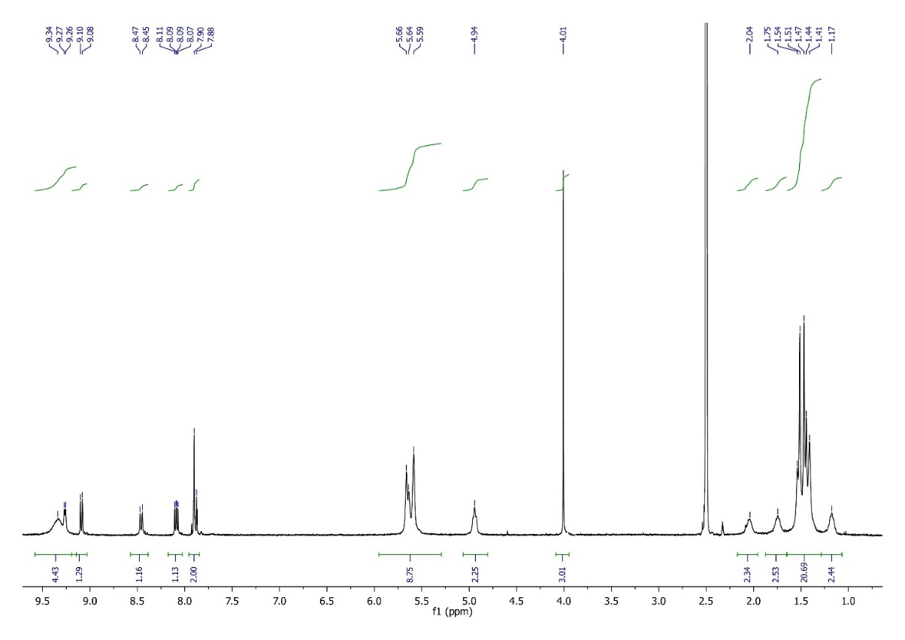
Figure S7. ¹H NMR spectrum of 2 measured in DMSO-d6
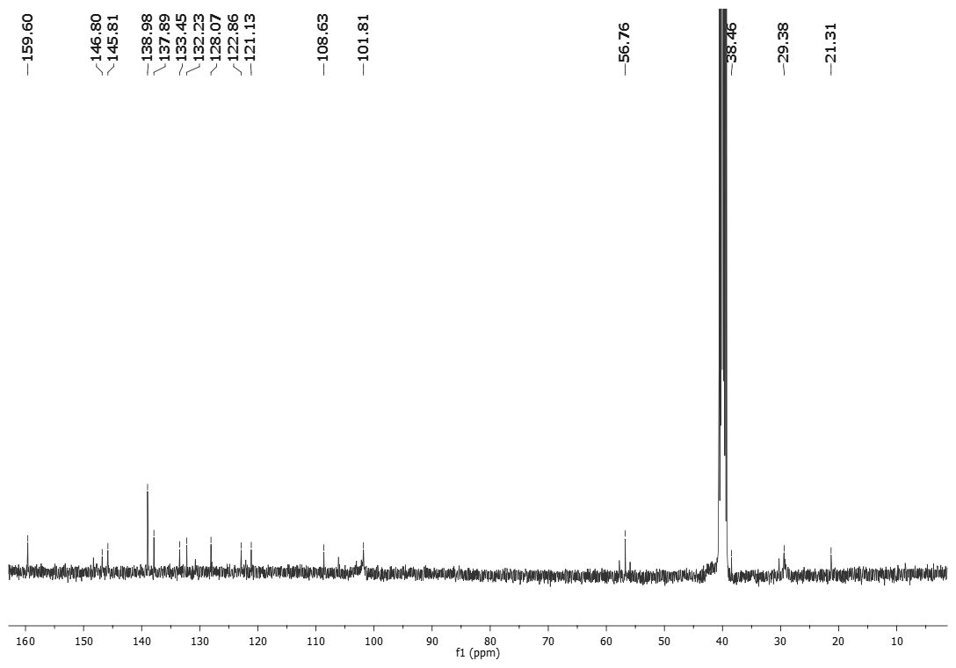
Figure S8. ¹³C NMR spectrum of 2 measured in DMSO-d6.
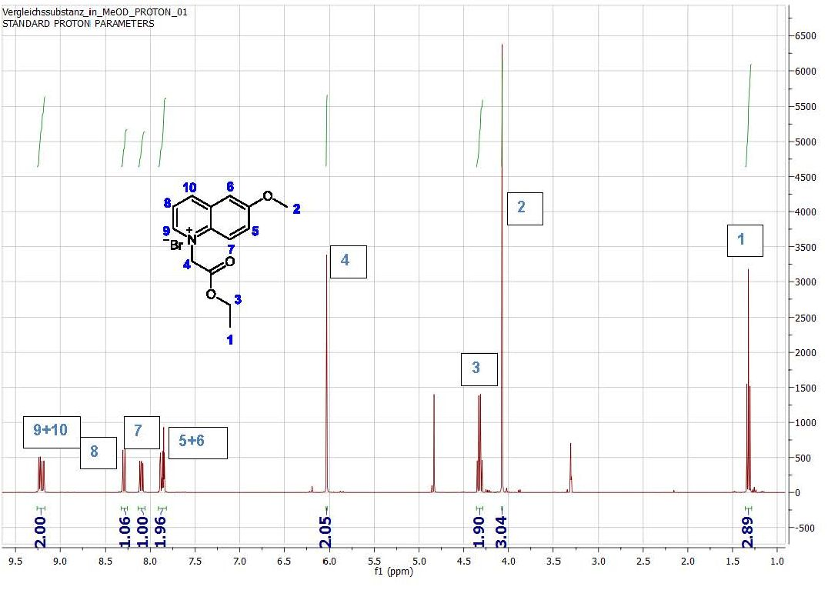
Figure S9. ¹H NMR spectrum of 3 measured in CD₃OD.
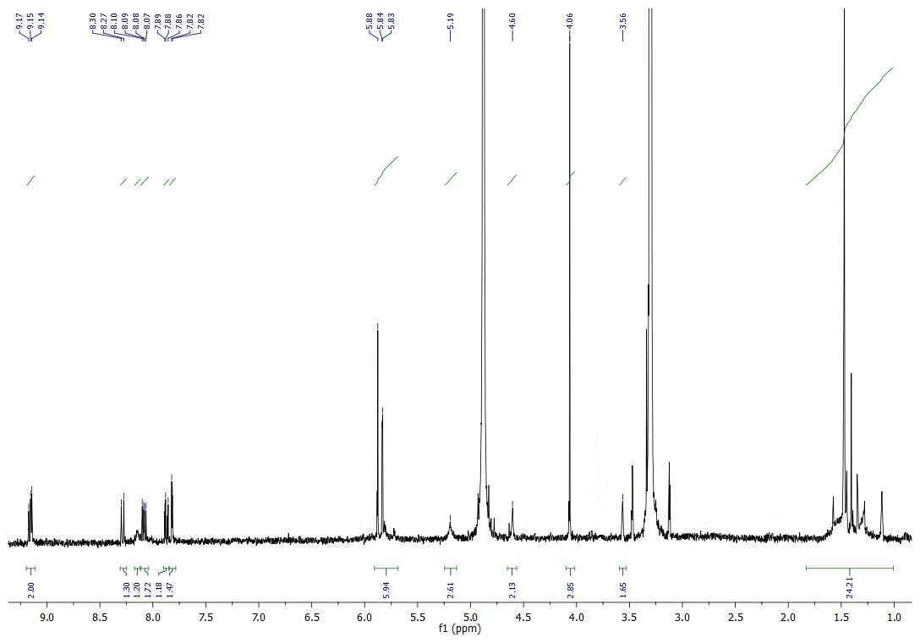
Figure S10. ¹H NMR spectrum of 4 measured in CD₃OD.
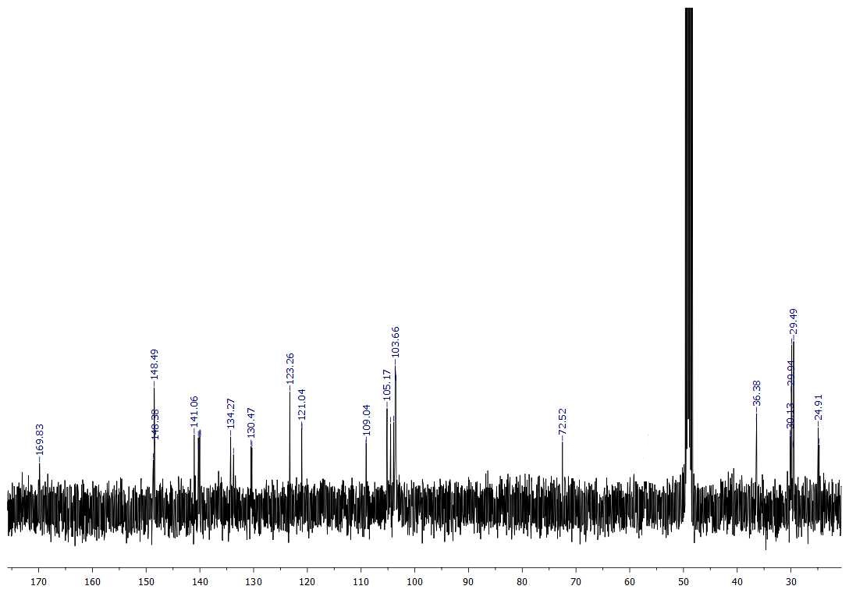
Figure S11. ¹³C NMR spectrum of 4 measured in CD₃OD.

Dilution experiments
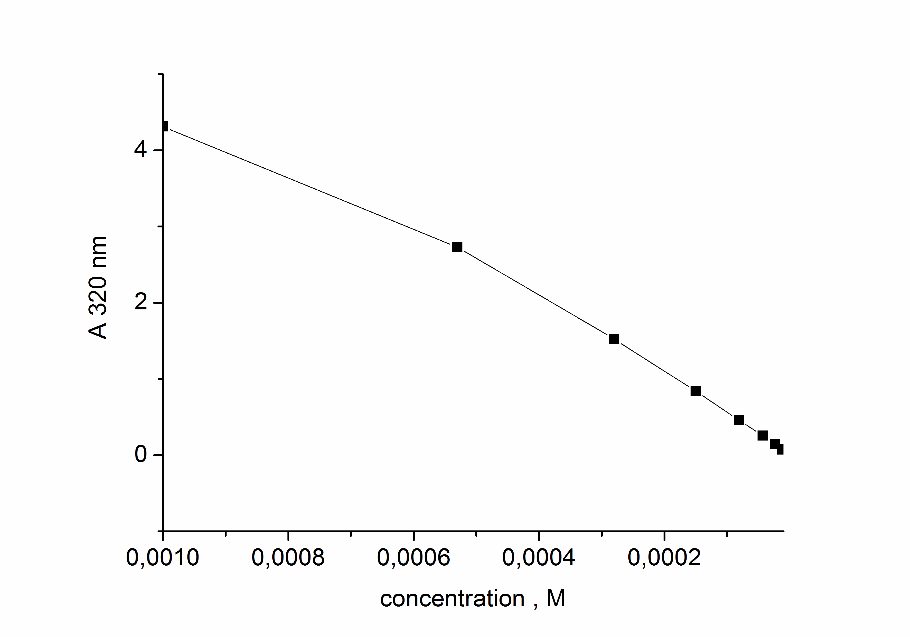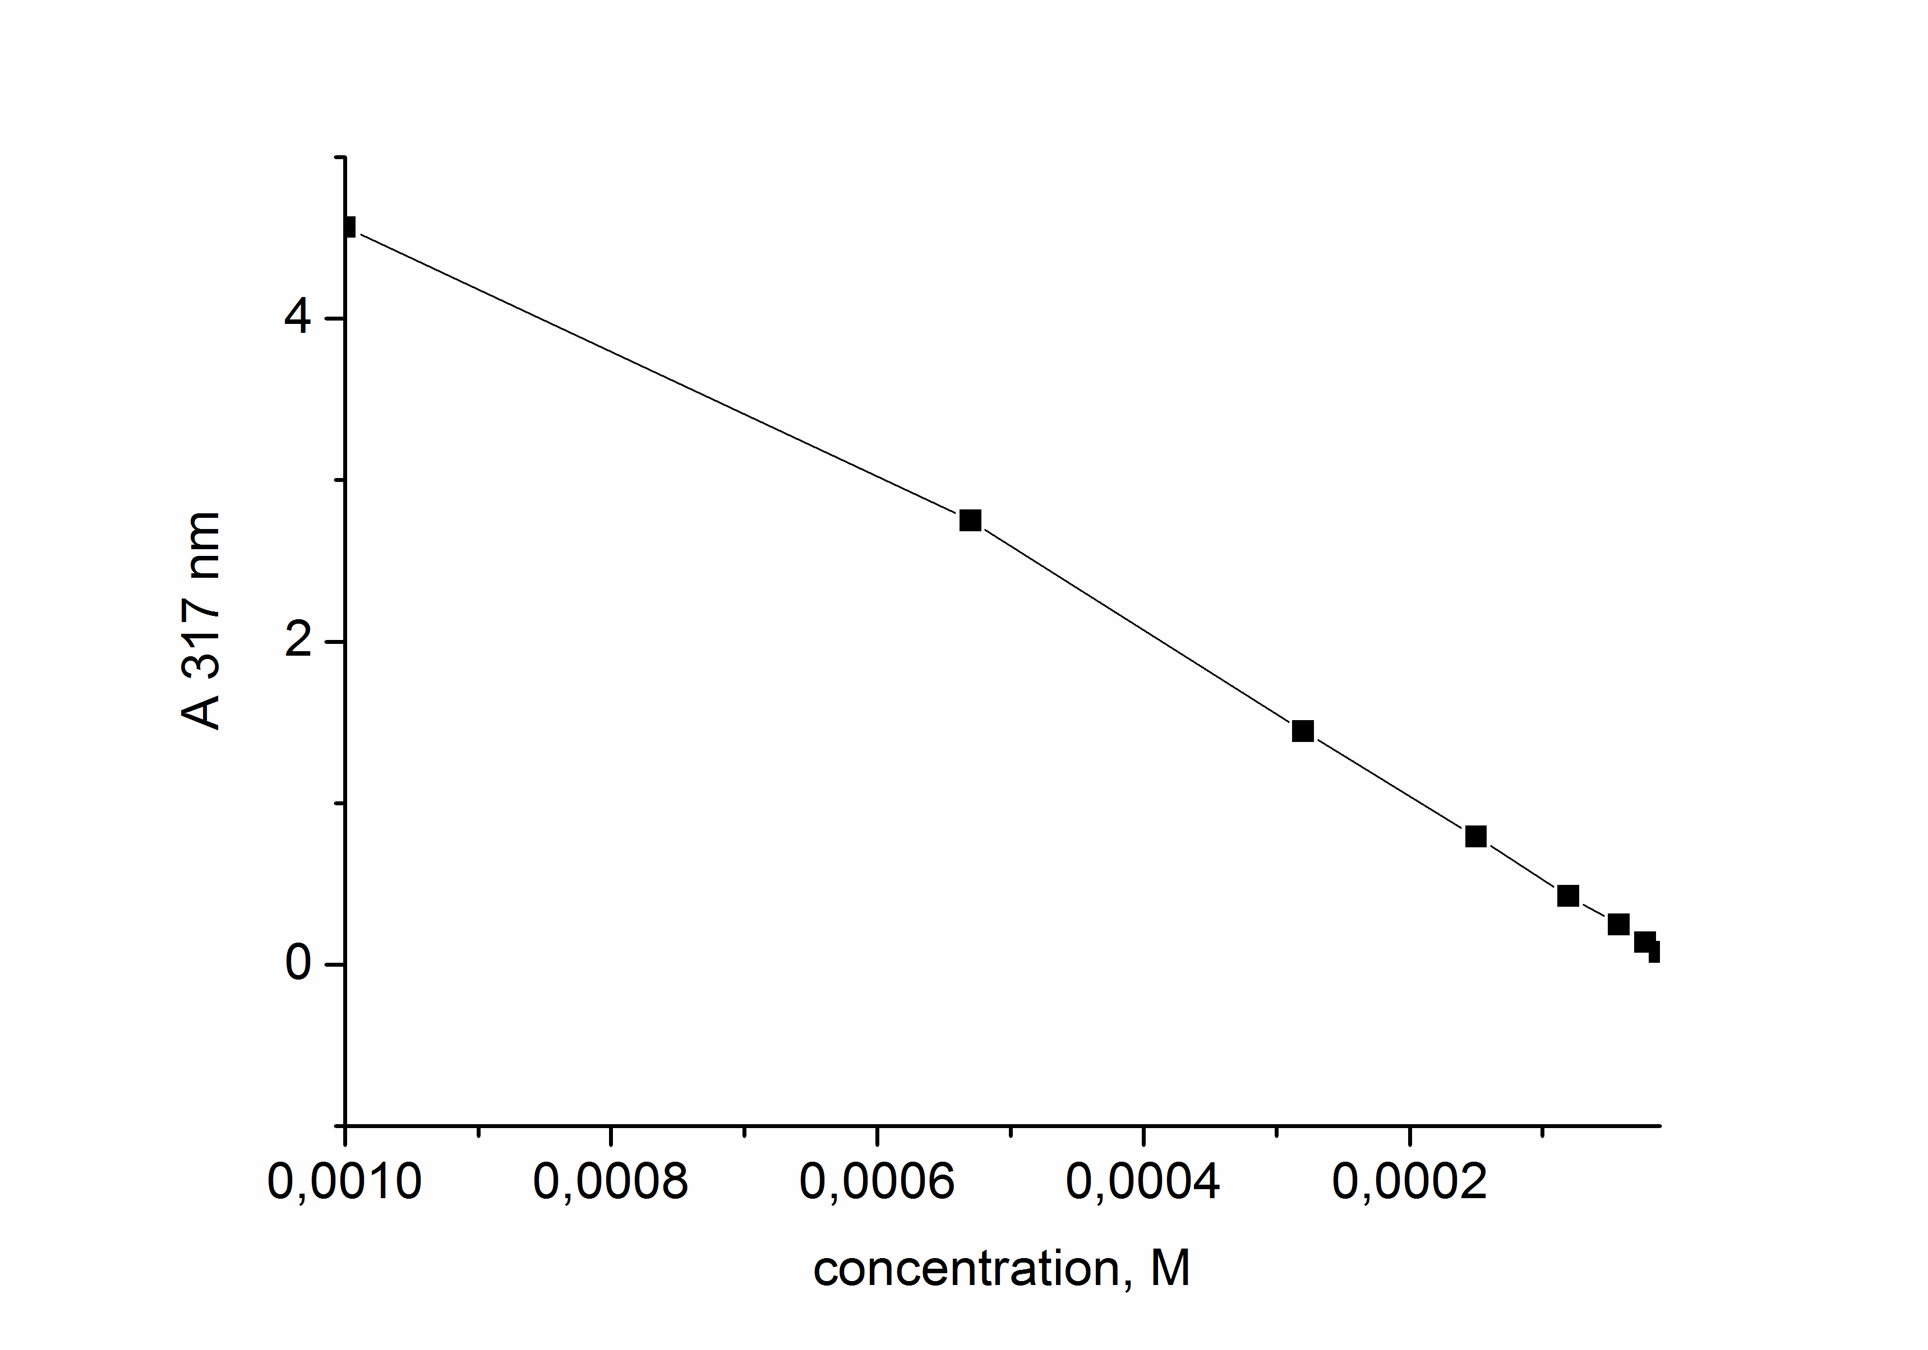
Figure S12. Changes in absorption (A) of receptor 1(left) and 2(right) depending on their concentration in a methanol-water 1:1 mixture.
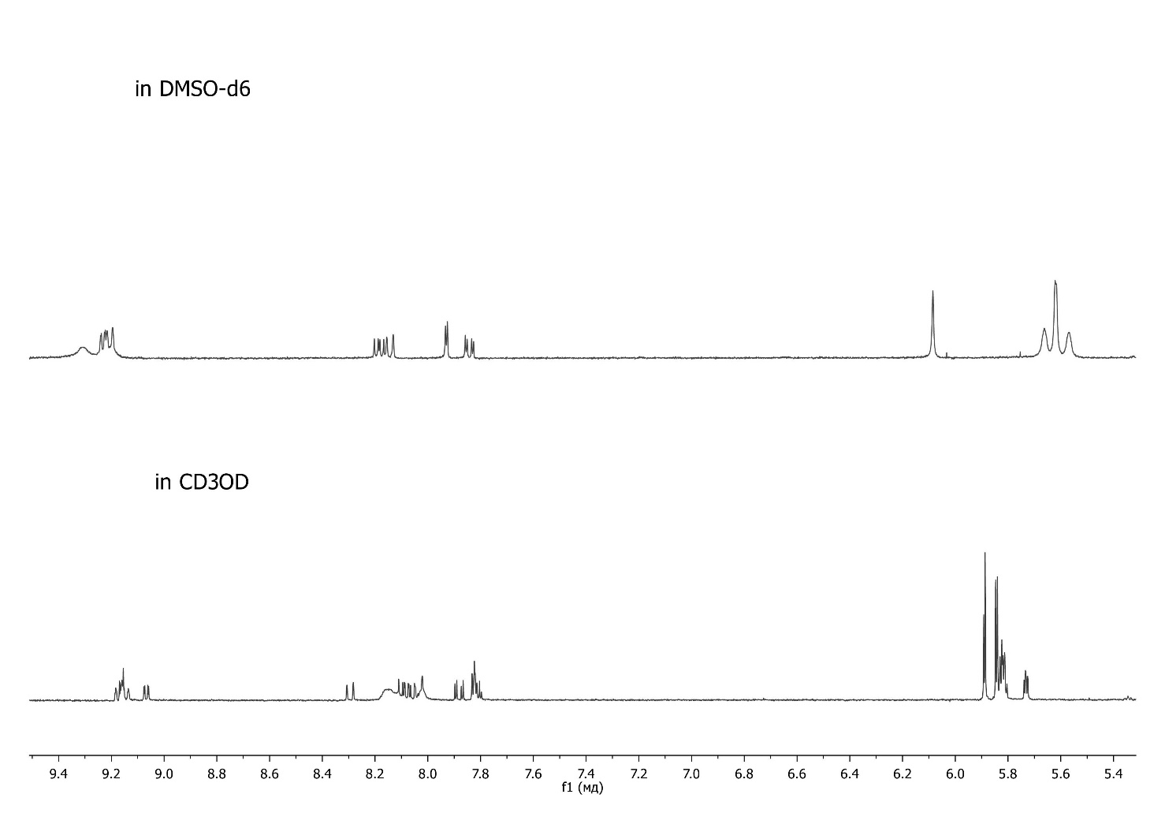
Figure S13. Comparison of ¹H NMR spectra of receptor 1 recorded in DMSO-d6 and methanol-d4. The complex structure of signal in the spectrum measured in methanol-d4 indicates that the receptor forms aggregates.
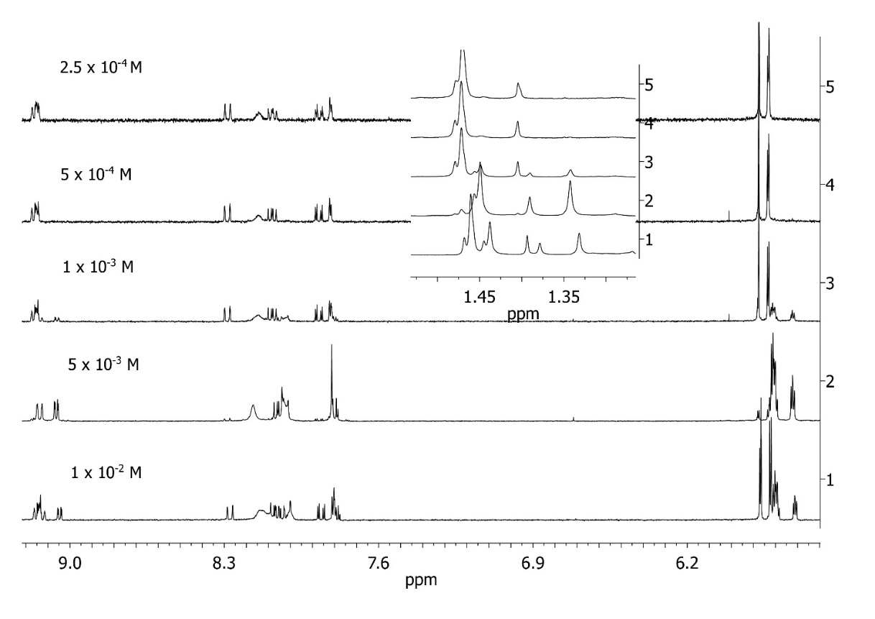
Figure S14. ¹H NMR spectra of receptor 1 in CD₃OD
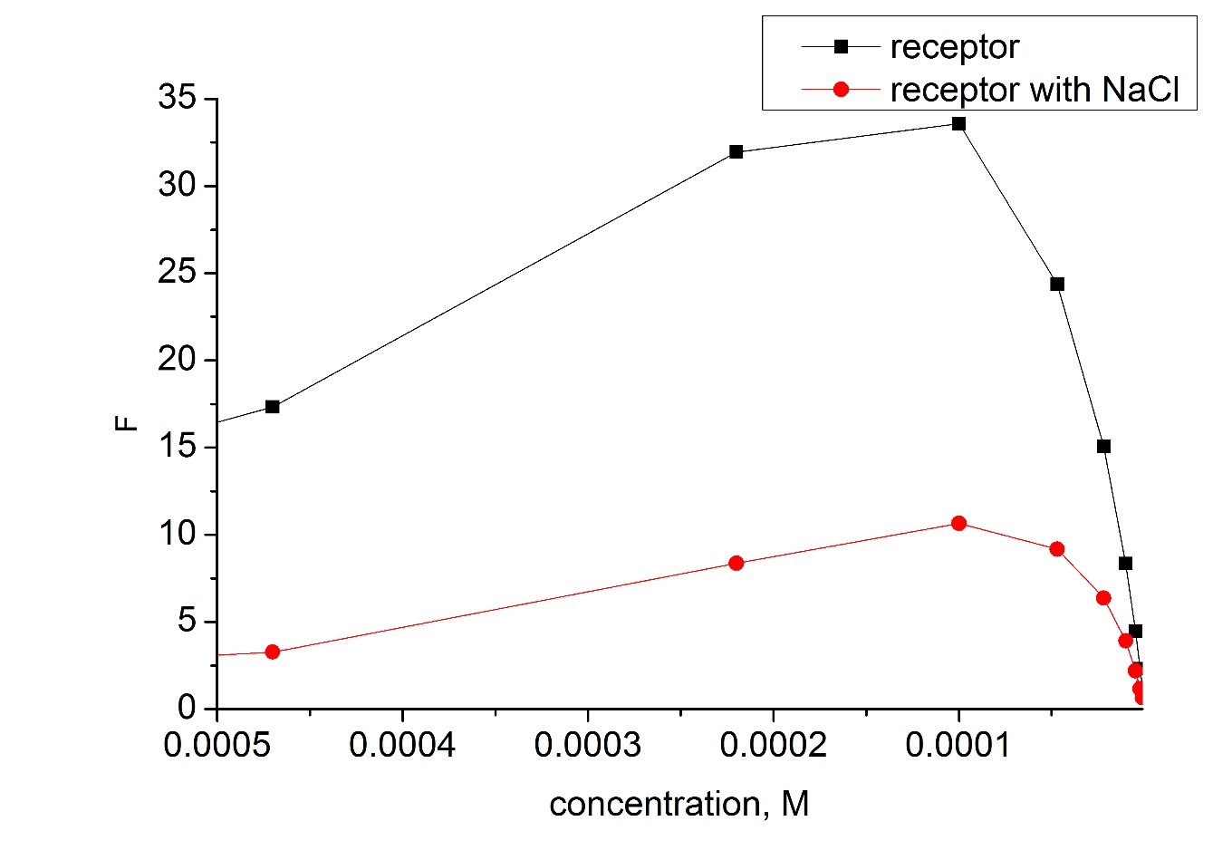
Figure S15. Changes in fluorescence of free receptor 1 and with 10 equiv. NaCl depending on their concentration in CH₃OH.

UV-Vis titrations
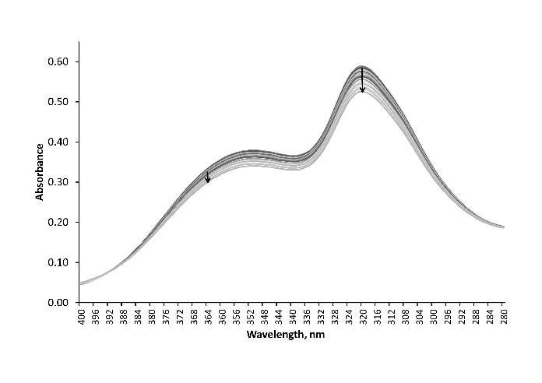 | 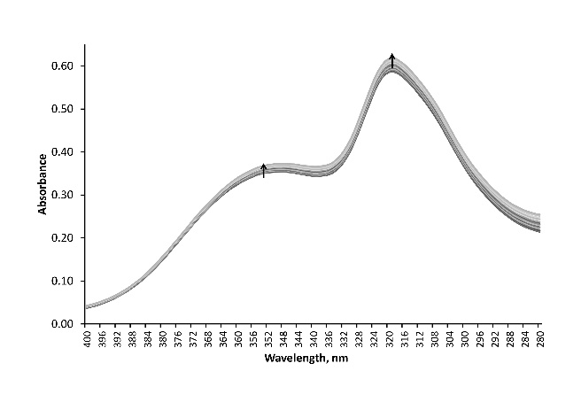
1+NaCl | 1+NaBr
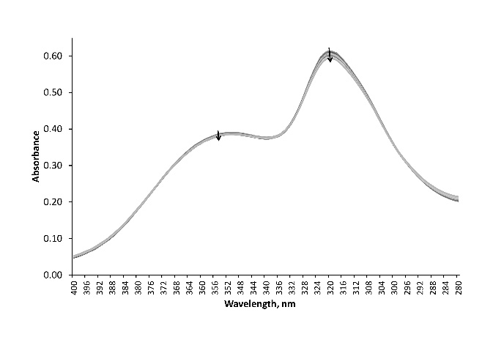 | 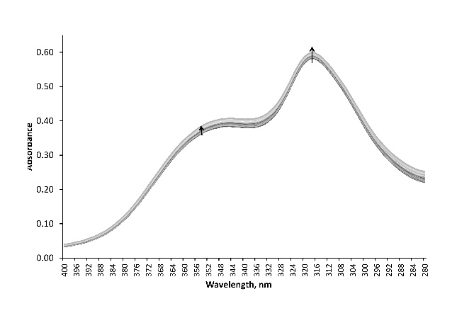
1+NaI | 2+NaI
Figure S16. Changes in UV-Vis spectra of receptors upon addition of anions.
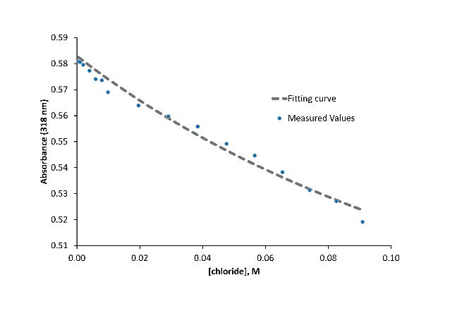 | 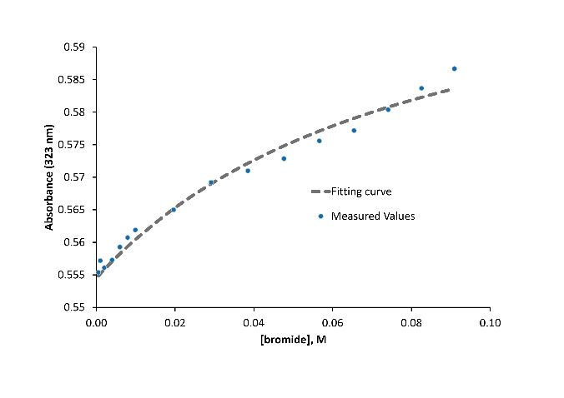
1+NaCl | 1+NaBr
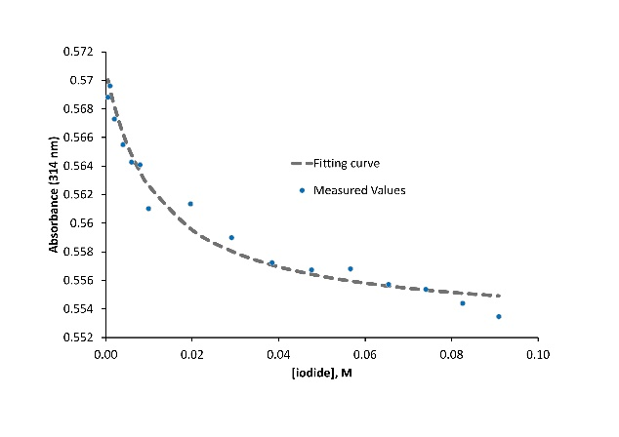 | 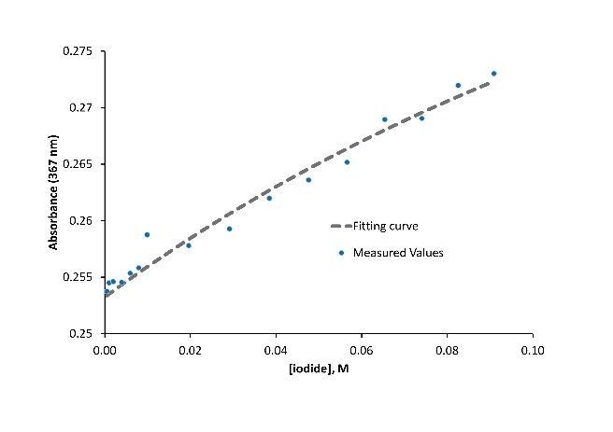
1+NaI | 2+NaI
Figure S17. Fitting of binding curves obtained in UV-Vis titraions.
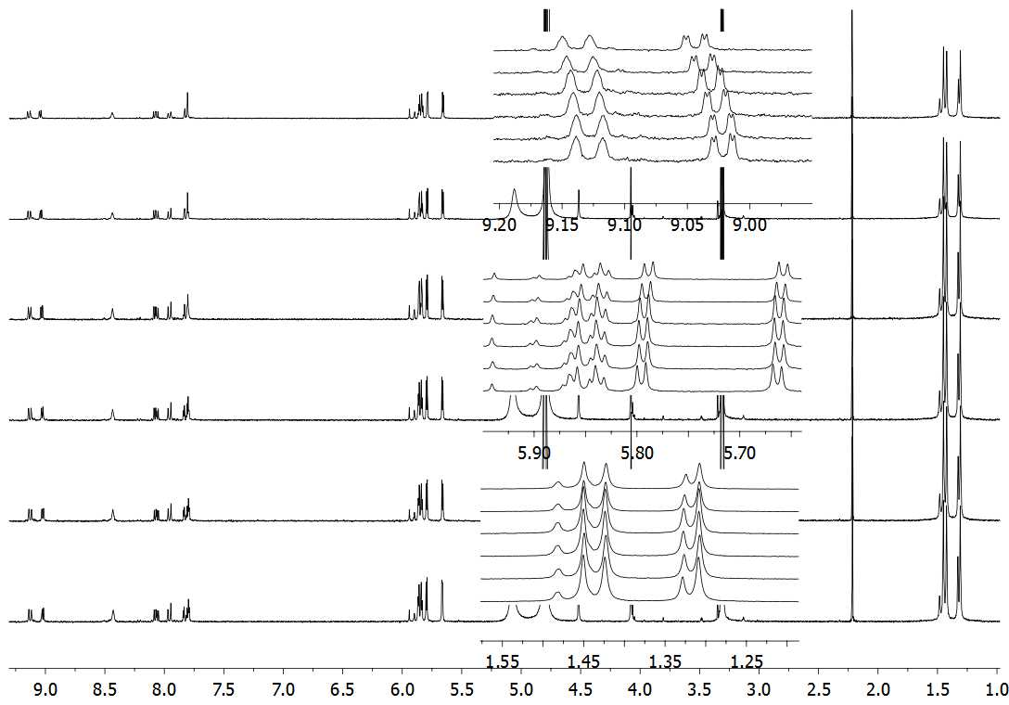
Figure S18. ¹H NMR titration of 1 (5 x 10⁻⁴ M) with NaCl (from the bottom: 0, 10, 20, 60, 120, 200 equivalents) in a 1:1 CD₃OD-D₂O solution.
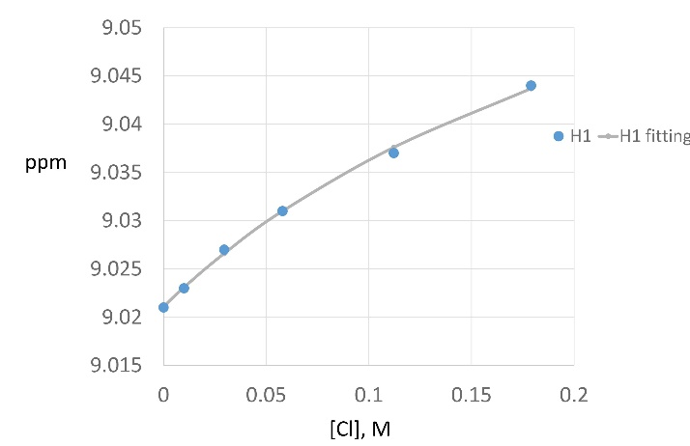 | 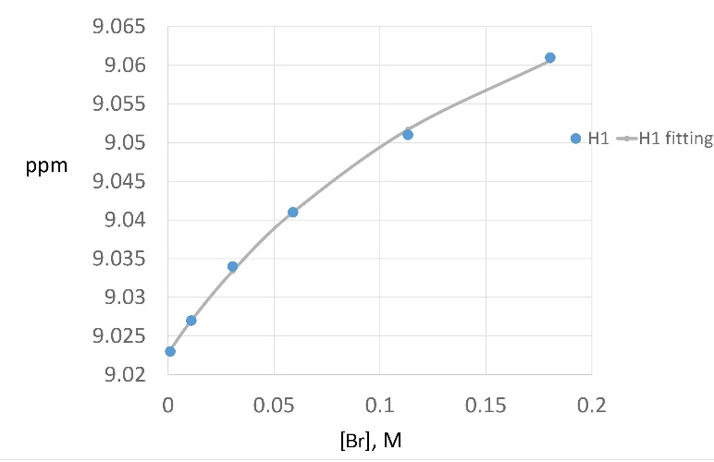
1+NaCl | 1+NaBr

Figure S19. Fitting of binding curves obtained in 1H NMR titration of compounds 1.

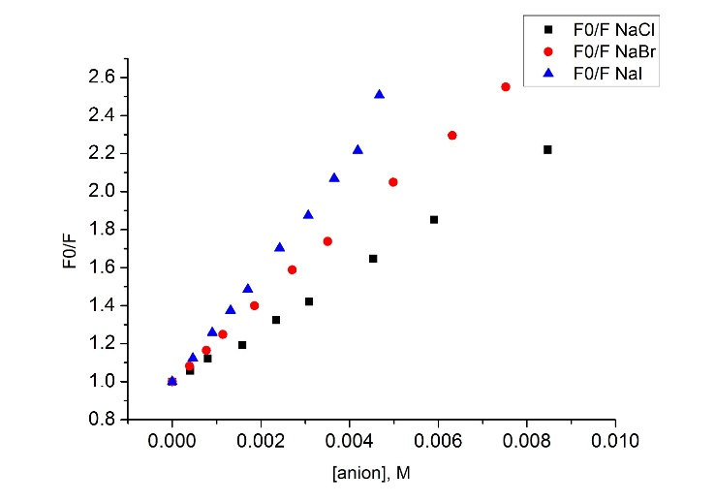
Figure S20. Quenching of fluorescence of receptor 4 by anions.

