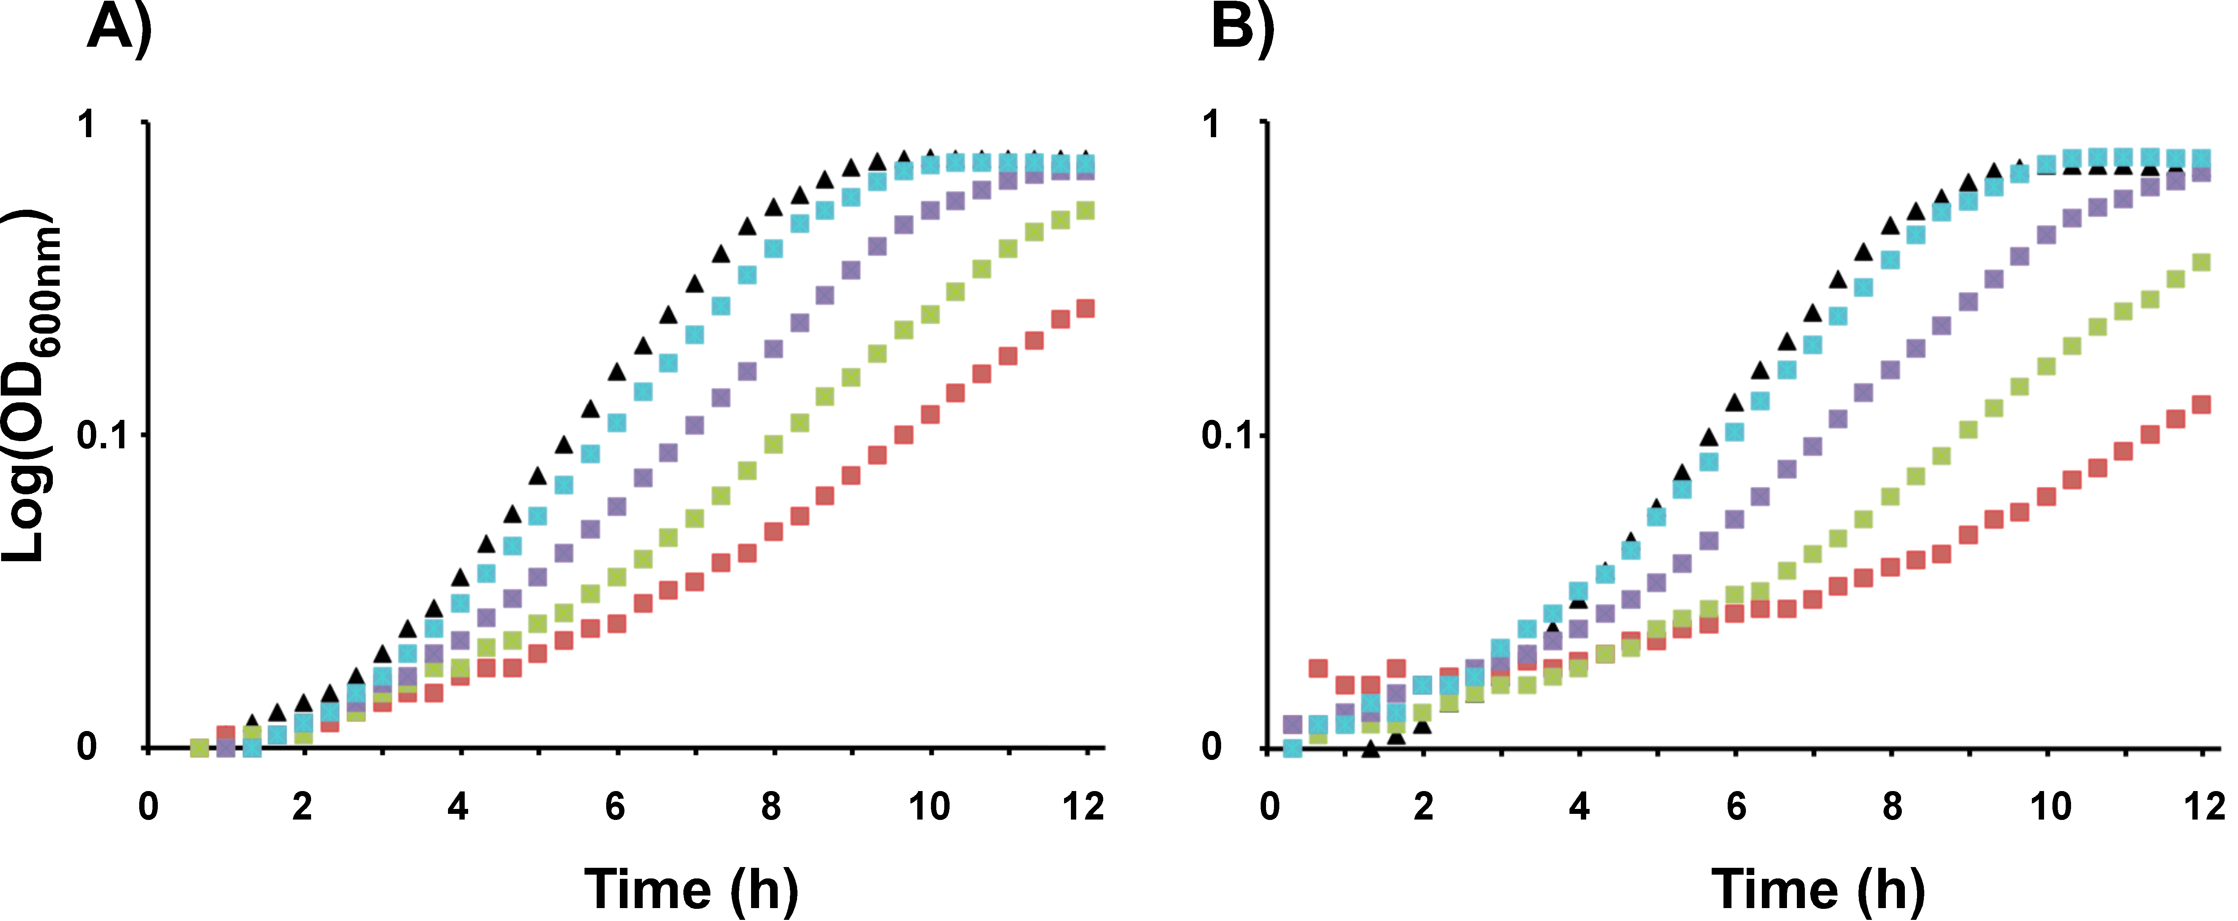

Fig. S1. Effect of the murine cathelicidin mCRAMP on bacterial growth. Overnight culture of the control strain L. lactis NZ9000/vec (A) or the L. lactis NZ9000/vecΩpilB strain expressing the GBS PilB protein (B) were diluted in M17 broth supplemented with glucose (1%) and erythromycin (5 µg/ml) to give approximately 10⁶ cfu/ml. The inoculated broths were distributed (150 µl) in 96 wells plate incubated at 30°C with constant shaking in a plate reader and the OD_{600nm} was recorded every 20 minutes for 12 hours. Blank values (M17-glucose-erythromycin) were subtracted from experimental values to eliminate background readings. , M17-glucose-erythromycin medium without peptide (sterile water was added instead); , presence of the mCRAMP drug at 5 (light blue), 10 (violet), 20 (green), and 40 (red) µg/ml , respectively. These results are representative of three independent experiments.

