Instructions: ARS-Media for Excel

Contents
What ARS-Media for Excel does 2
How to start (based on Excel 2013) 2
An Infeasible Solution 9
An Undesirable Solution 11
Forced Selection or Omission of Specific Salts 15
Further Questions 17

What ARS-Media for Excel does
ARS-Media for Excel calculates the salts/acids/bases (herein referred to as “salts”) that results in a recipe to achieve a solution with the specified ion concentrations. The calculation uses Excel’s “Solver Add-in”.

How to start (based on Excel 2013)
- Add the Solver Add-in to Excel. Here are the directions from Microsoft Office Support –
The Solver add-in is a Microsoft Excel add-in program that is available when you install Microsoft Office or Excel. To use it in Excel, however, you need to load it first.
- Click the File tab, and then click Options.
- Click Add-Ins, and then in the Manage box, select Excel Add-ins.
- Click Go.
- In the Add-Ins available box, select the Solver Add-in check box, and then click OK.
  - If Solver Add-in is not listed in the Add-Ins available box, click Browse to locate the add-in.
  - If you get prompted that the Solver add-in is not currently installed on your computer, click Yes to install it.
- After you load the Solver add-in, the Solver command is available in the Analysis group on the Data tab.

- Specify ion levels. Under “Target value, mM” enter the mM levels of all ions required to be in the solution (Figure 1).
Figure 1. Ion level entry. Ion mM levels are entered under “Target value”.
 |  | Ions | Target value mM | Used mM
 | 1 | NH₄⁺ | 0 | 0
 | 2 | NO₃⁻ | 0 | 0
 | 3 | PO₄³⁻ | 0 | 0
 | 4 | K⁺ | 0 | 0
 | 5 | Ca²⁺ | 0 | 0
 | 6 | Mg²⁺ | 0 | 0
 | 7 | SO₄²⁻ | 0 | 0
 | 8 | Cl⁻ | 0 | 0
 | 9 | Na⁺ | 0 | 0
 | 10 | Fe³⁺ | 0 | 0
 | 11 | Mn²⁺ | 0 | 0
 | 12 | Zn²⁺ | 0 | 0
 | 13 | BO₃³⁻ | 0 | 0
 | 14 | I⁻ | 0 | 0
 | 15 | Cu²⁺ | 0 | 0
 | 16 | MoO₄²⁻ | 0 | 0
 | 17 | Co²⁺ | 0 | 0
 | 18 | Al³⁺ | 0 | 0
 | 19 | Ni²⁺ | 0 | 0
 | 20 | Ag⁺ | 0 | 0
 | 21 | Si⁴⁺ | 0 | 0
 | 22 | EDTA⁴⁻ | 0 | 0
 | 23 | Citrate⁻ | 0 | 0
 | 24 | Tartrate⁻ | 0 | 0
 | 25 | Gluconate⁻ | 0 | 0

- Set Objective constraints. To the right of the Ion Entry section is a listing of the salts used in the calculation (Figure 2). Objective constraints weight the desirability of a salt. Because the Solver Parameters are set to minimize the solution, the larger the Objective constraint, the less likely that salt will be included in the formulation. Conversely, the lower the Objective constraint (negative values can be used), the more likely that salt will be included in formulation. For example, if low solubility is NOT desirable, then the Objective constraint of the low solubility salts, such as Ca(OH)₂, would be increased (e.g., 10). This does not prohibit the salt from being used, but does makes it more “expensive” to use.
Figure 2. Listing of salts. Objective constraints are entered in this section. If a solution is found after Solver is run, the amount (grams) for each salt will appear in the Salt (g) column.
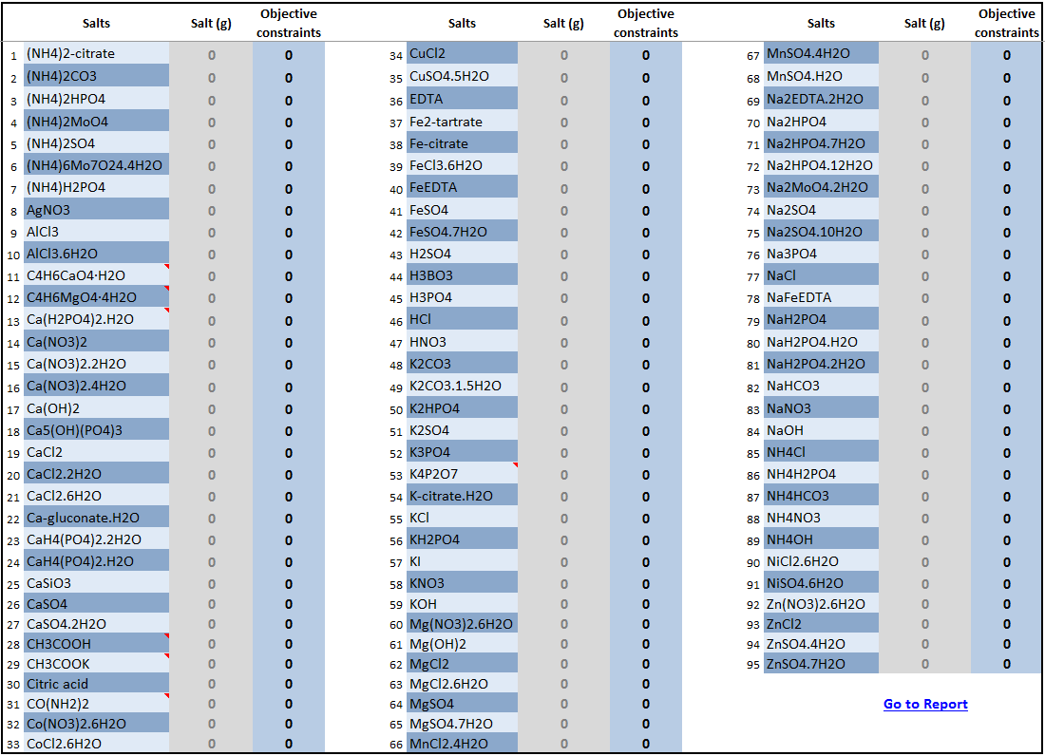

- Select the Solver Add-in and click Solve. A Solver Parameters screen will appear (Figure 3). Generally, it is not necessary to change any of the settings.
The Solver add-in is available under the Data tab in the Analysis group.
- Click the Data tab.
- Click on Solver in the Analysis group.
Figure 3. Solver Parameters screen. Parameters should not be changed.
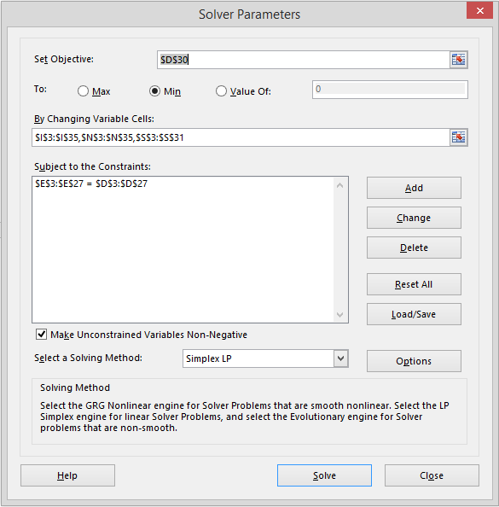
- Evaluate Solver Results. After clicking Solve in the Solver Parameters screen, the Solver Results screen will appear and indicate if a solution has been found. If a solution was found (Figure 4, top image), a report is generated that includes the salts required. If a solution is not found (Figure 4, bottom image), reexamine Target values and listing of salts (Figure 2) to determine the conflict. See Troubleshooting on how to correct infeasible solutions.

Figure 4. Solver Results screens. Solver Results will report either 1) “Solver found a solution”, or 2) “Solver could not find a feasible solution.”
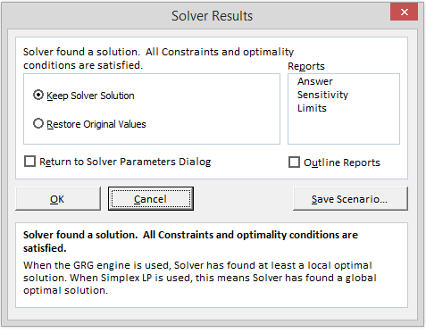
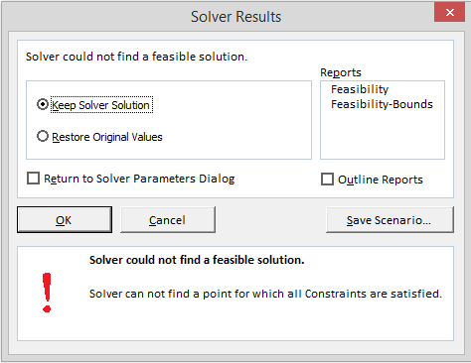

- View Report. If a feasible solution is found, the report can be viewed either by 1) clicking on Go to Report in the Listing of salts section (Figure 2) or, 2) clicking on the Report tab. The Report (Figure 5) lists the amounts, mg or g, of each salt required to make the ionic solution specified previously in the Ion level entry section (Figure 1).
Figure 5. Report of salts used in the recipe to achieve the ionic solution specified.
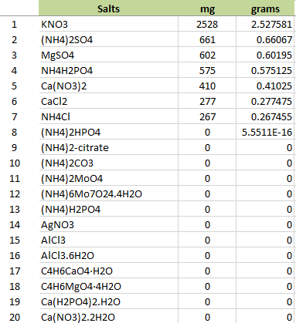

An Infeasible Solution
An infeasible solution occurs when there are no possible combinations of salts that will satisfy the ion levels specified in the Ion level entry section. Therefore, it is necessary to examine the specified ions, their levels, and compare to the available salts. To illustrate how this can occur, consider a desired ionic solution of 10 mM K⁺ and 20 mM I⁻ (Figure 6).
Figure 6. Ionic solution composed of 10 mM K⁺ and 20 mM I⁻.
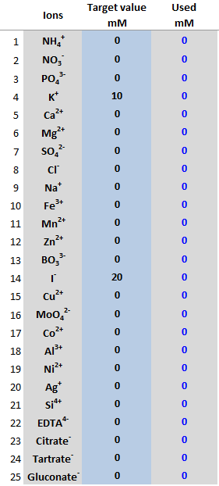

Running Solver on this ionic composition will result in “Solver could not find a feasible solution” (Figure 4, bottom image). Examine the salts potentially available for each of the specified ions. For K⁺, there are quite a few salts that can contribute K⁺. However, for I⁻ there is only one, KI. Solver was able to satisfy the 10 mM K⁺ and 10 mM of the 20 mM I⁻, but this left a remainder of 10 mM I⁻ and there were no other sources and, thus, no feasible solution. Now consider what would have occurred if the amounts were reversed, 20 mM K⁺ and 10 mM I⁻ (Figure 7). Solver satisfies the 10 mM I⁻ and 10 mM of the K⁺ using KI. The additional 10 mM K⁺ must then come from KOH. The final solution is 10 mM KI and 10 mM KOH.
Figure 7. Ionic solution composed of 20 mM K⁺ and 10 mM I⁻.
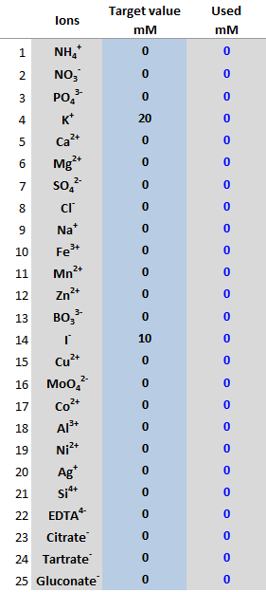

An Undesirable Solution
Infeasible solutions are rare, at least in culture medium applications such as plant and algal culture. However, undesirable solutions are common, at least until the objective constraints are set to yield acceptable solutions. Consider the ionic solution specified in Figure 8. Further, all Objective constraints are set to 0.
Figure 8. Ionic solution composed of NH₄⁺, NO₃⁻, PO₄³⁻, K⁺, Ca²⁺, Mg²⁺, SO₄²⁻, and Cl⁻.
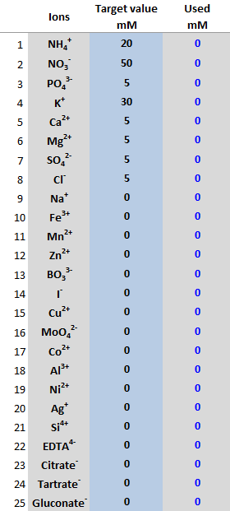

The Solver solution includes 3 acids, 1 base, 1 poorly soluble salt (Ca₅(OH)(PO₄)₃, and 1 poorly soluble base (Mg(OH)₂, Figure 9). Because the formulation will be used for a plant tissue culture medium, it is desired that the solution include soluble salts with minimal use of acids and bases. Therefore, the objective constraints are increased to 10 for all acids, bases, and poorly soluble salts (Figure 10), and Solver rerun. The new solution (Figure 11) is composed only of soluble salts and is a better solution. However, it is further desired that the hydrated forms of Ca(NO₃)₂, and MgSO₄ be used. Therefore, the objective constraints for Ca(NO₃)₂ and MgSO₄ are increased to 10, as are CaCl₂ and MgCl₂ to ensure the hydrated forms of Ca and Mg are used (Figure 12). Solver is rerun and results in an acceptable formulation (Figure 13).
Figure 9. Solver solution for ion targets specified in Figure 8.
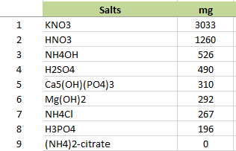

Figure 10. Objective constraints increased for salts not desired in the final solution, including acids, bases, poorly soluble, and organics.
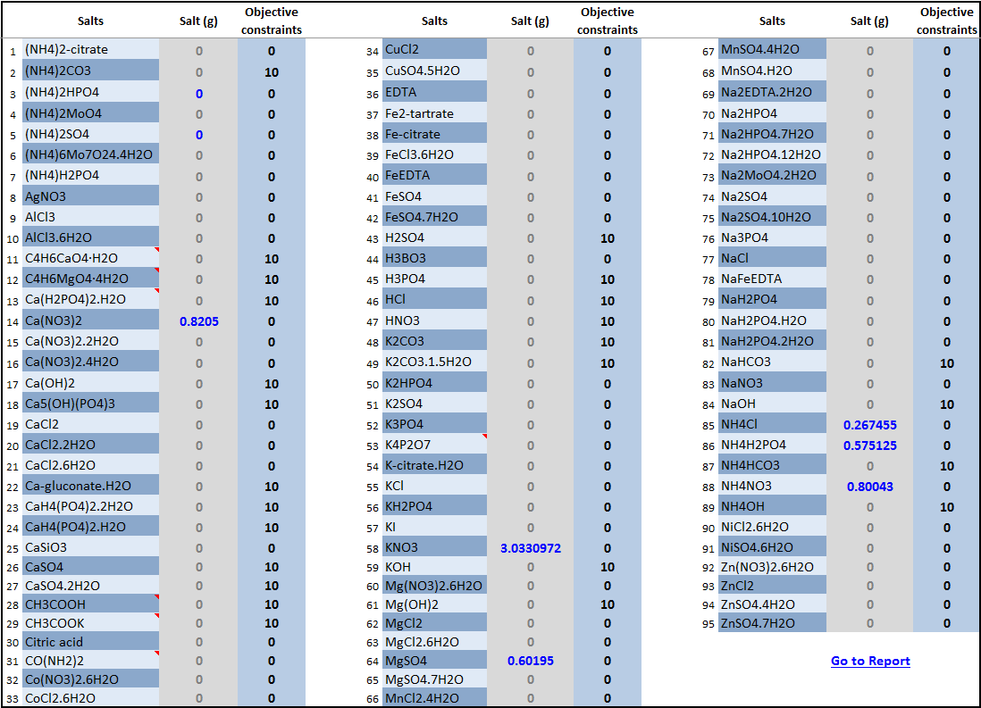

Figure 11. Report of salt formulation after objective constraints adjusted.
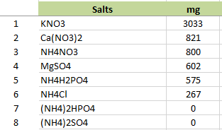

Figure 12. Objective constraints increased for non-hydrated salts of Ca and Mg.
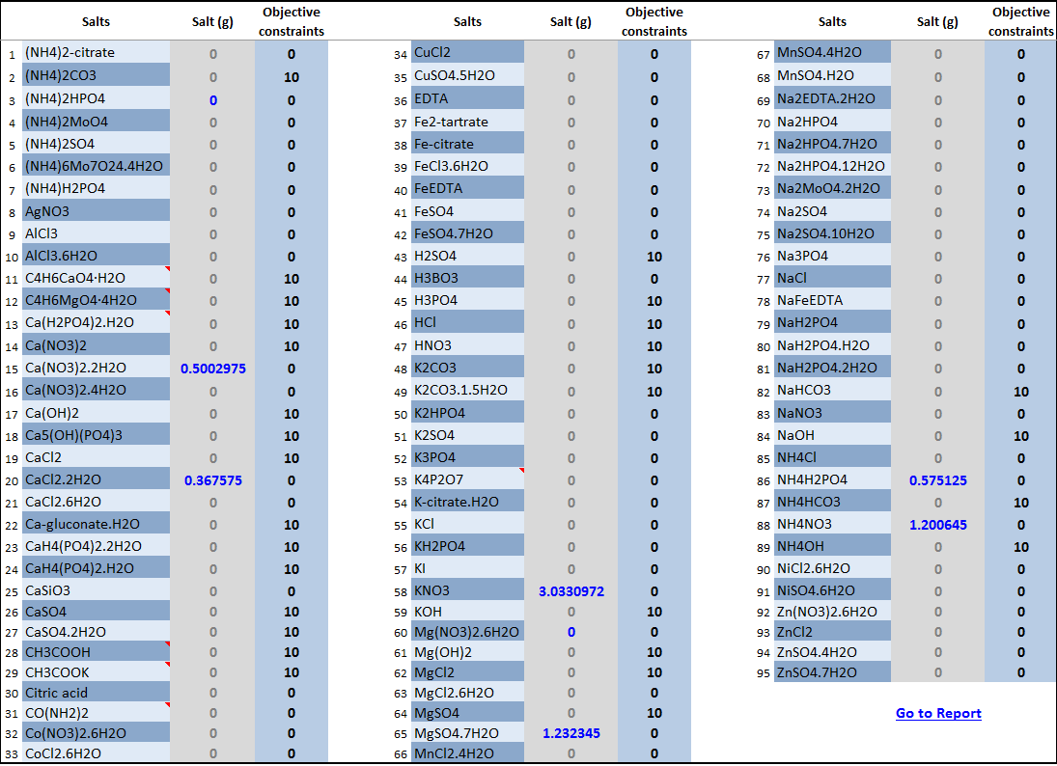

Figure 13. Report of salt formulation after objective constraints adjusted to select for hydrated salts of Ca and Mg.
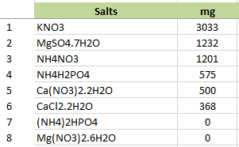

Forced Selection or Omission of Specific Salts
Which salts to use or not to use can generally be specified using the Objective constraints. However, forcing Solver to use or not use a specific salt can be specifically achieved by adding a constraint in the Solver Parameters screen. For example, consider the forced omission of KNO3 from the formulation in Figure 13. A new constraint is added, $N$27 = 0. $N$27 is the Salt (g) for KNO3. Solver will ignore KNO3 in the calculation. The resulting formulation omits KNO3 (Figure 15.)
Figure 14. Constraint added to Solver Parameters screen to force Solver to use 0 g KNO3.
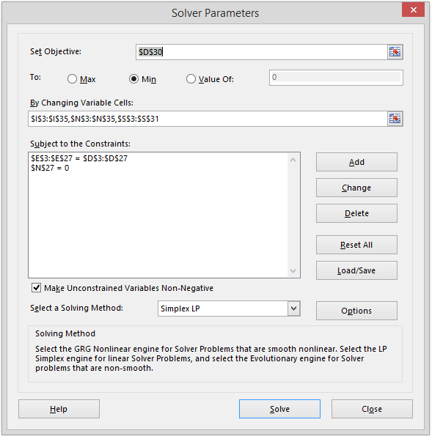

Figure 15. Report of salt formulation after KNO3 was omitted from the Solver calculation by adding a constraint to the Solver Parameters screen.
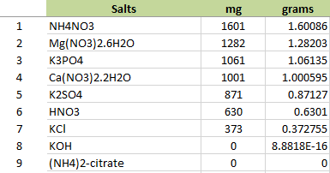

Further Questions
Randall P. Niedz, Ph.D.
Research Geneticist
U.S. Dept. of Agriculture
Agricultural Research Service
U.S. Horticultural Research Laboratory
2001 South Rock Road
Ft. Pierce, FL 34945-3030

Office: 772-462-5919
Cell: 772-216-2278
Fax: 772-462-5986
Email: randall.niedz@ars.usda.gov

