SUPPORTING INFORMATIONS

Design and Synthesis of Nanostructured Porous SnO₂ with High Surface Areas and Their Optical and Dielectric Properties
Debraj Chandra, Nillohit Mukherjee, Anup Mondal and Asim Bhaumik*

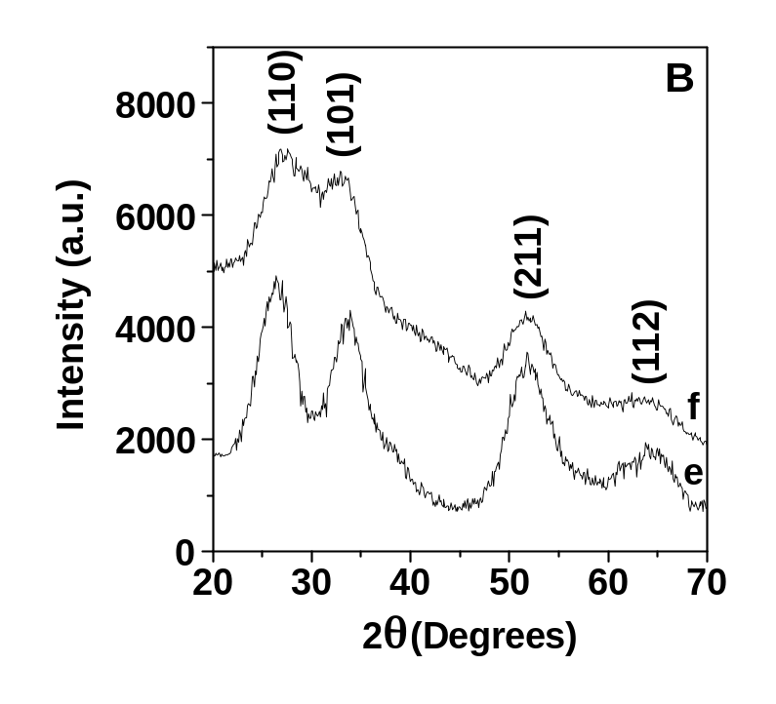
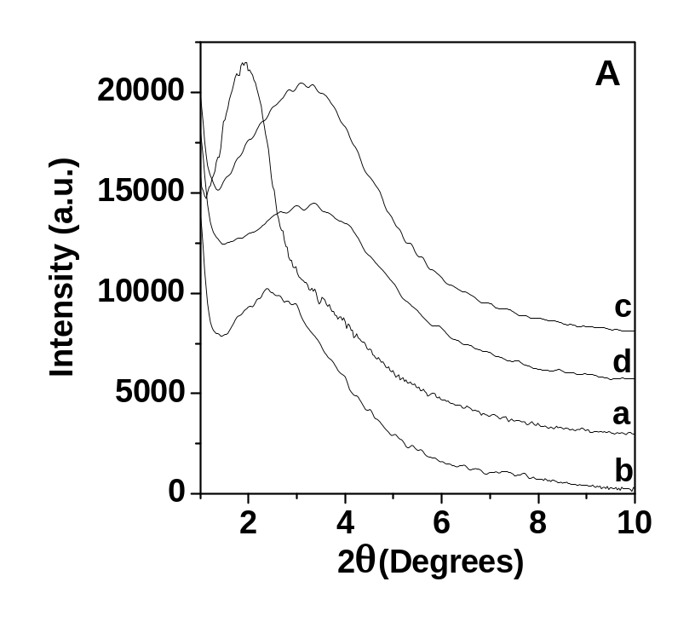
Figure S1: Small angle XRD patterns (A) of as-synthesized powder samples 1 (a) and 2 (c) and extracted powder samples 1 (b) and 2 (d). Wide angle XRD patterns (B) of as-synthesized powder samples 1 (e) and 2 (f).

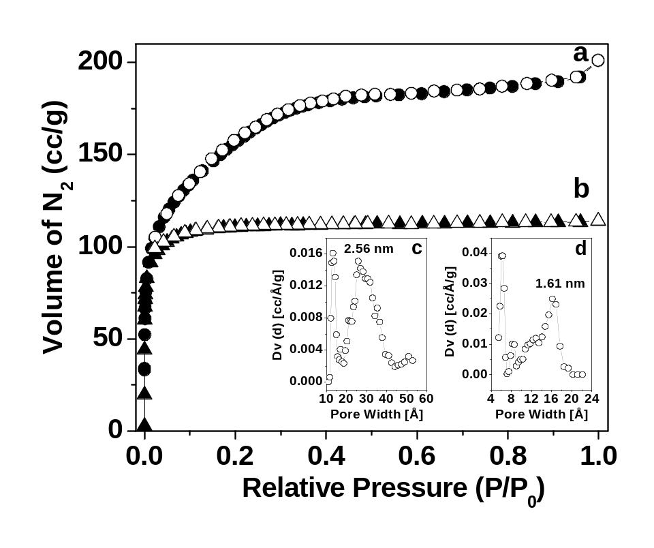
Figure S2: N₂ adsorption/desorption isotherms of samples 1 (a) and 2 (b) at 77 K. Adsorption points are marked by filled circles and desorption points by empty circles. Pore size distribution of samples 1 (c) and 2 (d) are shown in the inset.

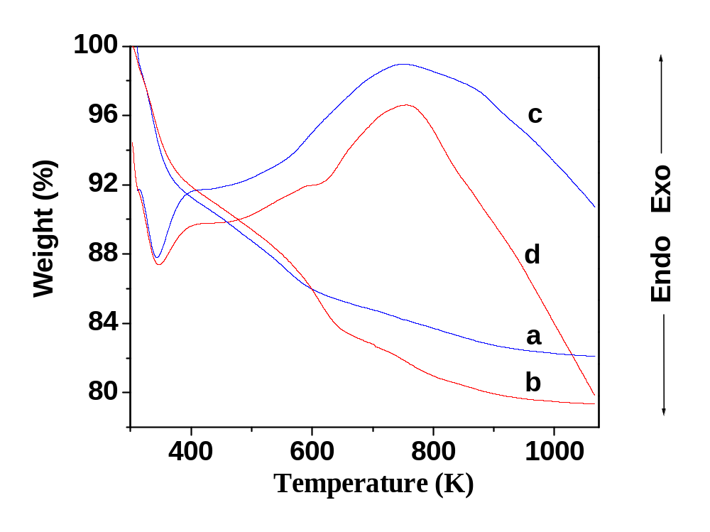
Figure S3: TGA plot for template-free samples 1 (a) and 2 (b) and their corresponding DTA plots 1 (c) and 2 (d).

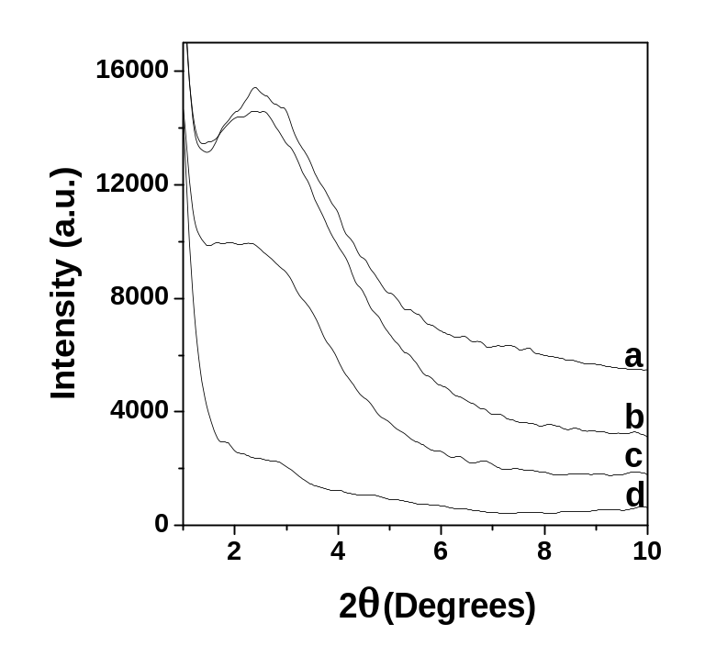
Figure S4: Powder XRD patterns of sample 1 heated at 473 (a), 523 (b), 573 (c) and 623 K (d).

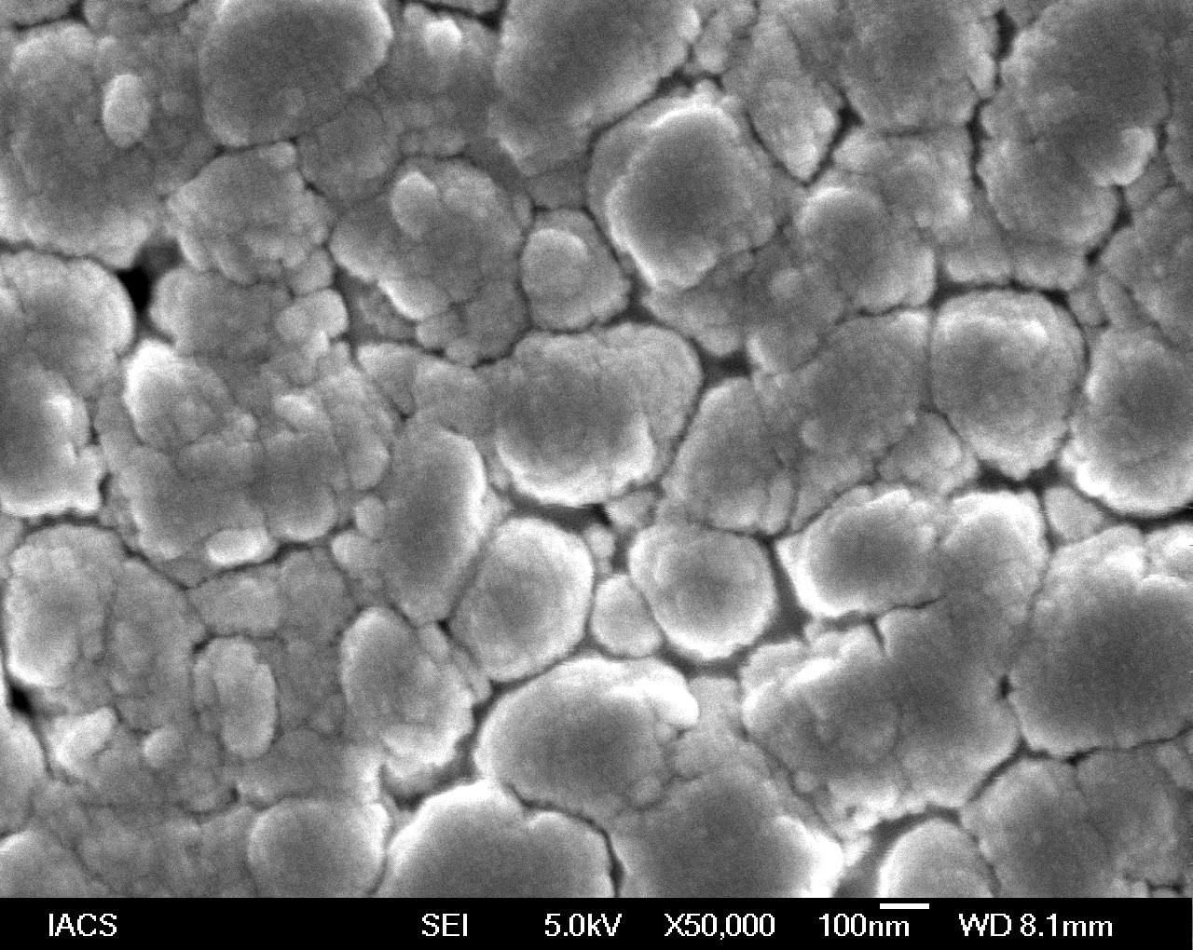

.

Figure S5: FE SEM image of sample 1 heated at 573 K.

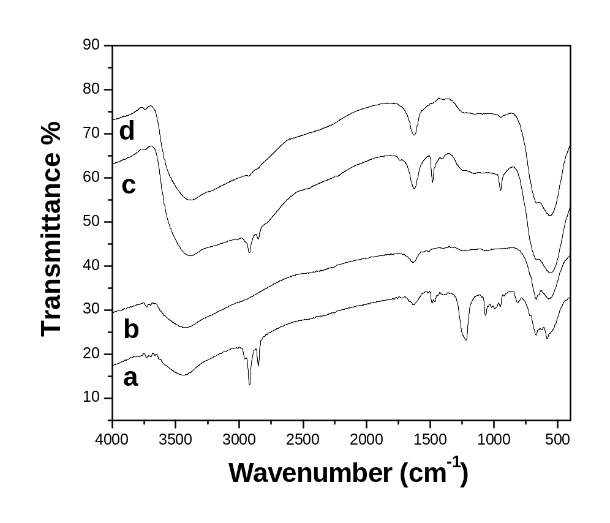
Figure S6: FT IR spectra of as-synthesized powder samples 1 (a) and 2 (c) and template-free samples 1 (b) and 2 (d).

