Supplemental Information for
Disubstituted Polyacetylene Brushes Grown via Surface-Directed Tungsten Catalyzed Polymerization
Sarav B. Jhaveri and Kenneth R.Carter*
Polymer Science and Engineering Department, University of Massachusetts – Amherst
Conte Center for Polymer Research, 120 Governors Drive, Amherst, MA 01003.
Email: krcarter@polysci.umass.edu

Supplemental Information
Experimental procedures, UV/Vis absorption spectra, AFM and XPS survey scan data are included as supplementary data.
Experimental
Materials. Unless specified, all reagents were used without further purification. O-(Propagyloxy)-N-(triethoxysilylpropyl)urethane, 90% (1) was purchased from Gelest, Inc. 5-Decyne (98%) and tungsten(VI) chloride (99.9+%) were purchased from Sigma-Aldrich Company. Tetraphenytin (97%) was purchased from Acros Organics. Silicon substrates (orientation 1-1-1, thickness 600-650 μm) were purchased from Wacker Siltronic Corp. All reactions were run under dry N₂ unless otherwise noted.
Instruments. The film thicknesses were measured using an F20 Filmetrics spectral reflectance thin film measuring system. The contact angles were measured using a VCA Optima surface analysis system with a drop size of 0.5 μL. AFM micrographs were recorded in tapping mode on a Nanoscope III from Digital Instruments. A SmithCreator Microwave Synthesizer by Personal Chemistry Inc. was used to carry out the polymerizations. X-ray photoelectron spectra (XPS) were recorded with a Perkin-Elmer Physical Electronics 5100 with Mg K_{α} excitation (15 kV, 400 W). Spectra were obtained at a takeoff angle of 15° and 75° (between the plane of the surface and the entrance lens of the detector optics). A Perkin Elmer LS50B luminescence spectrometer was used to measure the fluorescence emission.
Attachment of Silane Coupling Agent (1) to Silicon Substrate. The silicon wafer was cleaned under oxygen plasma for 15 minutes in a reactive ion etcher prior to use. Nitrogen was bubbled through 25 mL of toluene in a 50 mL round bottom flask for 15 minutes and 0.5 g of silane coupling reagent (1) was added. The clean silicon wafer was introduced to the flask and the reaction flask was heated at 80°C for 2 hours after which the flask was cooled to room temperature and the wafer was removed, washed excessively with toluene and acetone, and dried under a stream of air.
Polymer Brush Synthesis. General procedure for the microwave assisted surface polymerization of 5-decyne is described below. Substrate and catalyst manipulations were performed in a glove box. The silane (1) functionalized wafer, WCl₆ (37 mg, 0.093 mmol), Ph₄Sn (40 mg, 0.093 mmol) were added to a 5 mL microwave vial with a magnetic stirrer and sealed. The vial was removed from the dry box and 4 mL of toluene was added followed by addition of the monomer 5-decyne (250 mg, 1.81 mmol, 0.33 mL). The vial was heated under microwave irradiation at 150 °C for 30 min. The wafer was removed from solution and washed excessively with toluene, dichloromethane, water and acetone to remove any free polymer and salts. The thick polymer solution from the vial was decanted and diluted with 2 mL of toluene and precipitated by adding dropwise in excess methanol. The white powder was filtered and dried to obtain polymer (245 mg, 98%). GPC was carried out on the THF soluble fraction of the polymer. GPC (THF) :M_{n} = 52,617, PDI = 1.96.
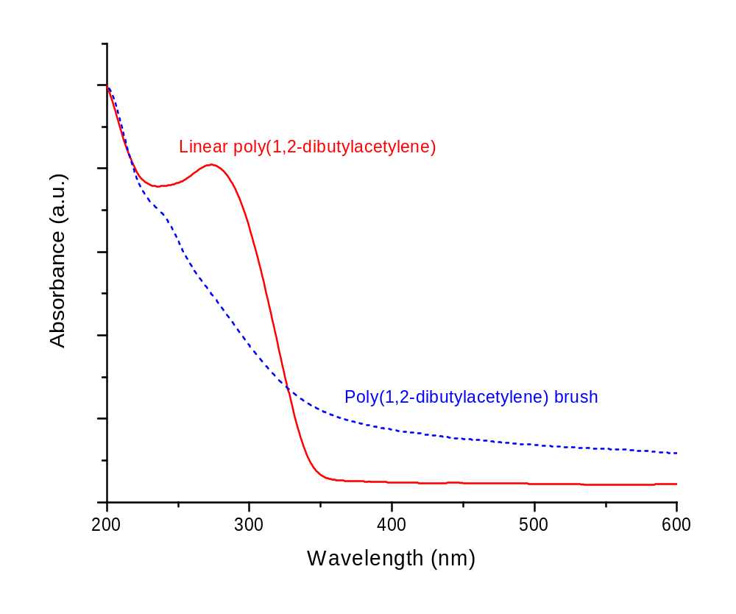
Figure S1. Normalized absorbance spectra of film of free polymer on quartz and polymer brushes grown from a quartz substrate.

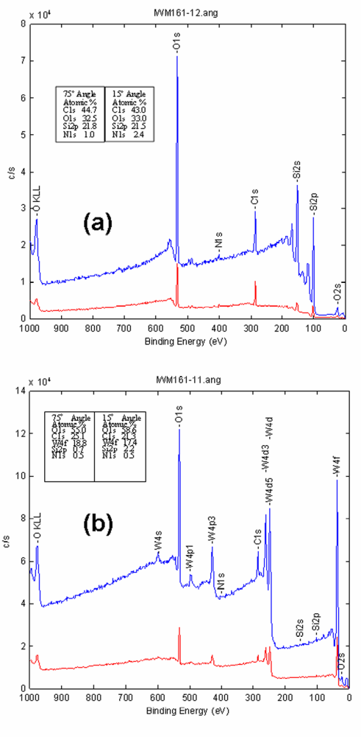
Figure S2. XPS survey spectra at 75° (top/blue) and 15° (bottom/red) of (a) silane functionalized silicon surface before brush growth and (b) surface after polyacetylene brush growth. The atomic composition is shown in the boxes at each angle.
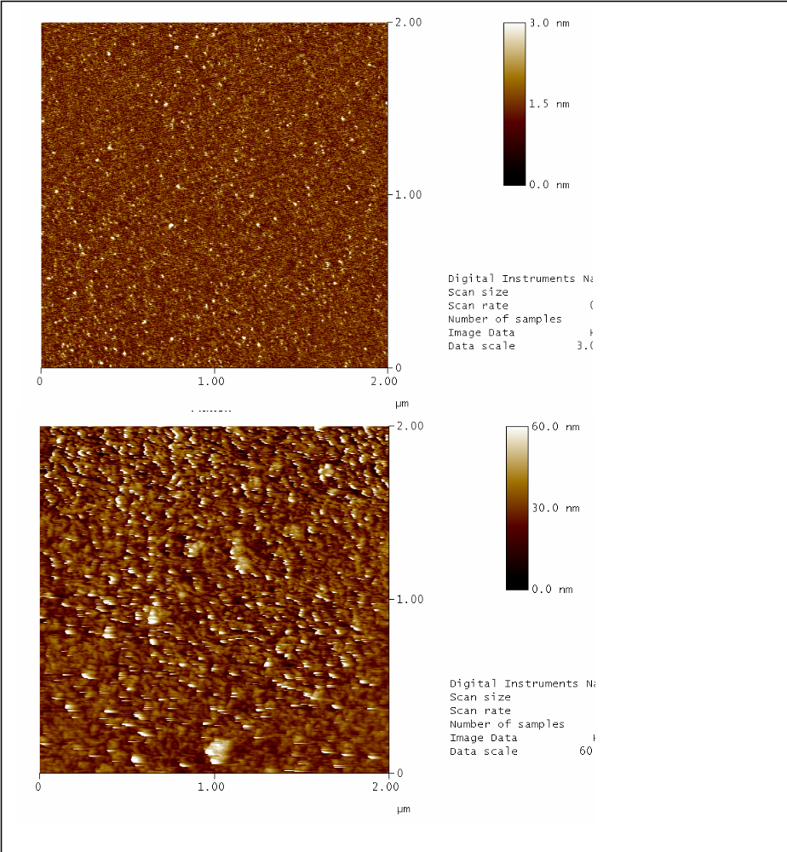
Figure S3. AFM images of an alkyne functionalized silicon surface before brush growth RMS = 0.3 nm (top), and the substrate surface after polyacetylene brush growth RMS = 6.3 nm (bottom).
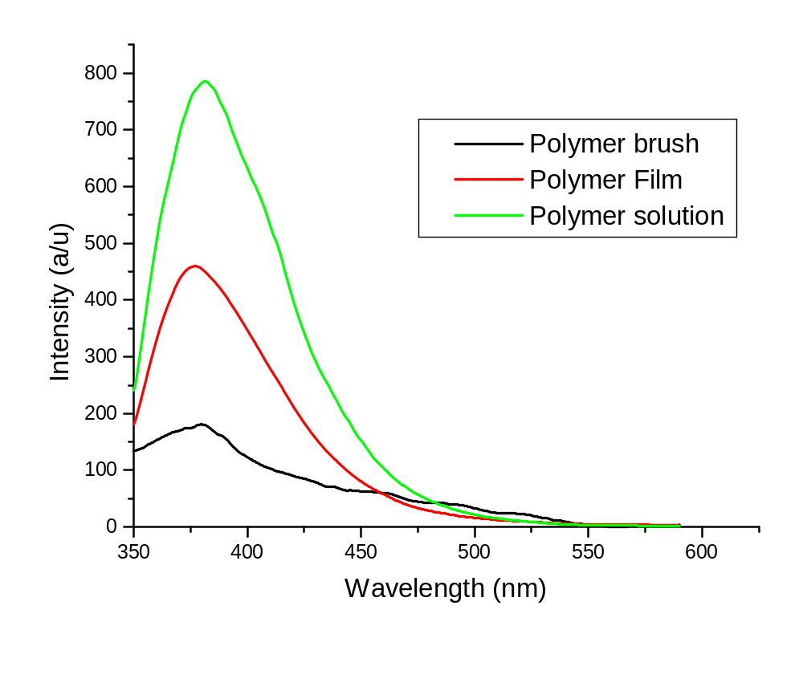
Figure S4. Fluorescence emission spectra of reflected fluorescence emitted from (a) silicon surface with polymer brushes (b) film of free polymer obtained from solution on glass (c) polymer solution in CHCl₃. (λ_{exc.} = 320 nm).

