Locations | Sandstone % | Channel belt % | Isolated channel % | Floodplain % | Max, average, min channel belt thickness (m) | Max channel belt width (km) | Amalgamat-ion ratio (%) | Facies architecture description | Representative architecture panel  (yellow = channel, brown = floodplain)
Bullfrog (proximal, outside the belt of U concentration) | 75 | 66.7 | 1.8 | 29.9 | 26 , 9.1, 1.8 | > 5 | 38 | Successions dominated by large scale amalgamated channel-belt deposits. Limited preservation of floodplain material, but when present it rarely extends the length of the outcrop. | 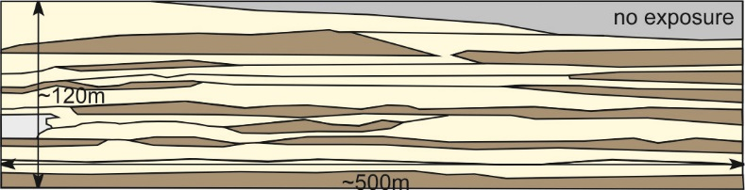
Atkinson Creek  (medial, within the belt of U concentration) | 48 | 27.8 | 1.8 | 69.6 | 8, 4.5, 0.7 | 1.3 | 12 | Succession contains channel-belt deposits that are seperated by distinctive floodplain deposits that do extend the length of the outcrop. Channel-belt deposits intermittently amalgamate. | 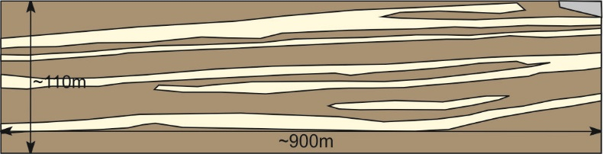
Little Park  (distal, outside the belt of U concentration) | 39 | 16.3 | 9.9 | 69.6 | 9.5, 3.8, 3.7 | 0.8 | 0 | Channel-belt deposits are largely absent, and isolated channel deposits become more frequent. Little to no amalgamation of channel deposits. | 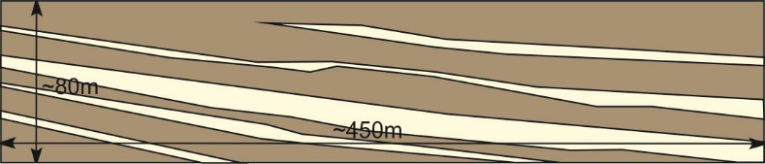

Table S2. Sandstone, channel belt, isolated channel and floodplain percentages taken from Owen et al. (2015b) for proximal, medial and distal locations. Channel belt amalgamation was calculated by dividing the length of amalgamation along a sandstone body by total length of the sandstone body and multiplying by 100 to gain a percentage. Note the change in architecture from proximal to medial. Uranium is found to be concentrated in the heterolithic medial zone where channel belt deposits are separated by floodplain fines.

