Supplementary Data (SD) for

A plant-wide energy model for WWTPs: application to AnMBR technology

R. Pretel*, A. Robles, M.V. Ruano, A. Seco and J. Ferrer

List of Tables

Table S1. Standard molar enthalpy of formation (ΔHº_{F}) at 298K in Kcal·mol⁻¹ and coefficients (A, B, C, D y E) of the molar heat capacity at constant pressure [36] for solids, liquids and gaseous substances in BNRM2.

List of Figures

Figure S1. Example of a window extracted from the energy tool included in DESASS: (a) design properties of the gas blower; and (b) design properties of the anaerobic MBR.

Table S1.

Solids and liquids substances | ΔHº_{F,} Kcal·mol⁻¹ | A | B | C | D | E
CH₄(l) | -17.79 | 6.5708x10¹ | 3.8883x10⁴ | -2.5795x10² | 6.1407x10² | ---
C₂H₄O₂(l) | -103.37 | 1.3964x10⁵ | -3.2080x10² | 8.9850x10⁻¹ | --- | ---
C₃H₆O₂(l) | -108.31 | 2.1366x10⁵ | -7.0270x10² | 1.6605 | --- | ---
C₄H₆O₂(s) | -54.21 | 1.1600x10⁵ | --- | --- | --- | ---
C₆H₁₀O₅(s) | -244.09 | 2.08x10⁵ | --- | --- | --- | ---
C₁₂H₂₂O₁₁(l) | -530.62 | 2.6565x10⁵ | 6.9779x10² | --- | --- | ---
CO₂(l) | -94.05 | -8.3043x10⁶ | 1.0437x10⁵ | -4.3333x10² | 6.0052x10⁻¹
HNO₃(l) | -32.07 | 1.3125x105 | -1.2190x10² | 1.7040x10⁻¹ | --- | ---
H₂CO₃(l) | -146.64 | 5.5x10² | 4.27x10² | --- | --- | ---
H2(l) | --- | 2.256x10⁴ | -1.9859x10³ | 1.1547x10² | -1.2598
H₂O(l) | -57.8 | 2.7637x10⁵ | -2.0901x10³ | 8.1250 | -1.4116x10⁻² | 9.3701x10⁻⁶
H₂SO₄(l) | -175.57 | 5.983x10⁴ | 3.9520x10² | -5.2067x10⁻¹ | 3.1220x10⁻⁴ | -7.0570x10⁻⁸
H₂S(l) | -4.92 | -3.749x10⁶ | -5.5411x10⁴ | 2.7765x10² | -4.631x10⁻¹ | ---
H₃PO₄(l) | -299.54 | 5.5228x10⁴ | 3.0125x10² | --- | --- | ---
HPO₃(s) | 8.3532 | 41.727 | 0.3925 | -0.0003 | --- | ---
NH₄(l) | -10.96 | 3.0094x10⁶ | -4.3692x10⁴ | 2.4114x10² | -5.8560x10⁻¹ | 5.2953x10⁻⁴
NO₂(l) | 4.924 | 9.1934x104 | 1.7086x102 | -4.3000x10⁻³ | --- | ---
N2(l) | --- | -3.34x10⁴ | 3.507x10³ | -4.67x10¹ | 2.127x10⁻¹ | ---
O₂(l) | --- | 6.8337x10⁴ | -6.1354x10² | 7.928 | -3.168x10⁻² | ---
Gaseous substances
H₂S(g) | -4.92 | 3.3288x10⁴ | 2.6086x10⁴ | 9.1340x10² | -1.7979x10⁴ | 9.4940x10²
N₂(g) | --- | 2.9105x10⁴ | 8.6149x10³ | 1.7016x10³ | 1.0347x10² | 9.0979x10²
CO₂(g) | -94.05 | 2.937x10⁴ | 3.454x10⁴ | -1.428x10³ | 2.6400x10⁴ | 5.88x10²
CH₄(g) | -17.79 | 3.3298x10⁴ | 7.9933x10⁴ | 2.0869x10³ | 4.1602x10⁴ | 9.9196x10²
H₂(g) | --- | 2.7617x10⁴ | 9.5600x10³ | 2.466x10³ | 3.7600x10³ | 5.6760x10²
NH₃(g) | -10.96 | 3.3480x10⁴ | 4.8200x10⁴ | 9.5189x10² | -3.0100x10⁴ | 1.0560x10³
O₂(g) | --- | 2.9103x10⁴ | 1.0040x10⁴ | 2.5265x10³ | 9.356x10³ | 1.1538x10³

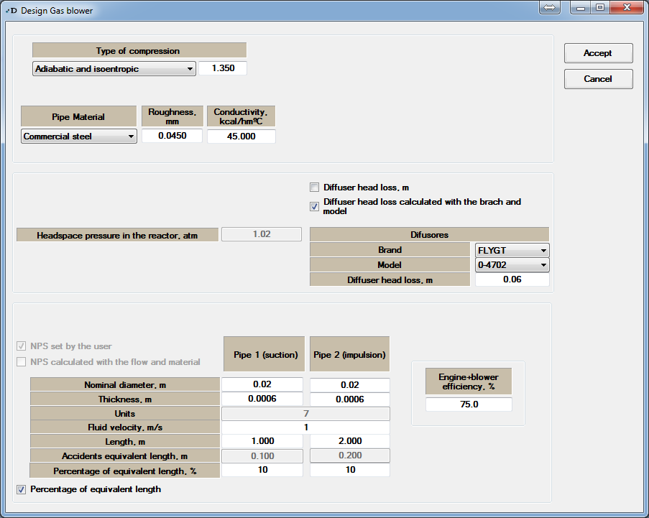

(a)

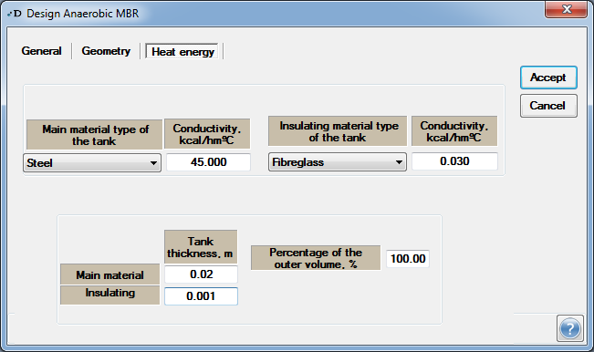

(b)
Figure S1.

