SYNTHESIS AND PROPERTIES OF A STERICALLY CROWDED TRIARYLPHOSPHINE BEARING AN ESTER GROUP

Shigeru Sasaki,*,1 and Masaaki Yoshifuji1,2

¹ Department of Chemistry, Graduate School of Science, Tohoku University
6-3 Aramaki Aza-Aoba, Aoba-ku, Sendai 980-8578, Japan
² Present address: Department of Chemistry, The University of Alabama, Tuscaloosa, AL 35487-0336, USA

E-mail: ssasaki@m.tohoku.ac.jp
Supplemental Materials
¹H, ¹³C, and ³¹P NMR, IR, and FT-ICR-MS spectra of triarylphosphine 5
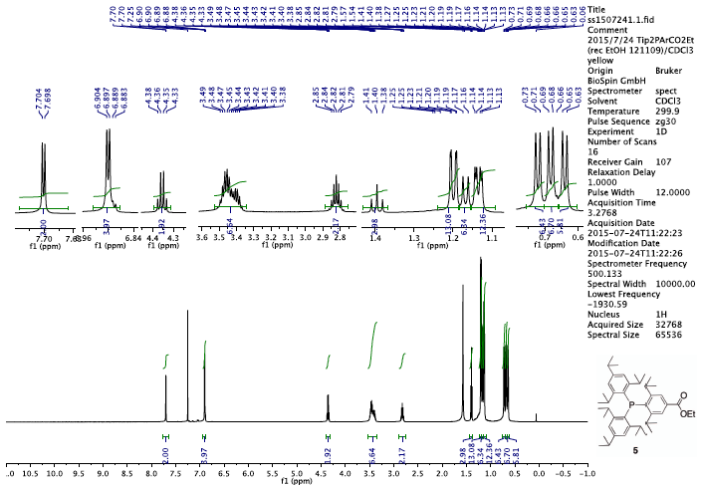
Figure S 1. ¹H NMR (500 MHz, CDCl₃, 299.9 K) spectrum of ester 5.
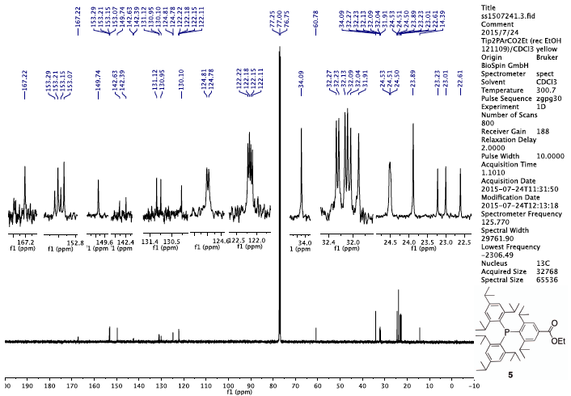
Figure S 2. ¹³C NMR (126 MHz, CDCl₃, 300.7 K) spectrum of ester 5.
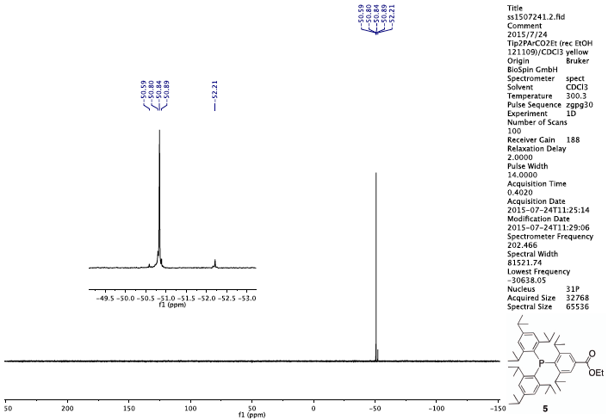
Figure S 3. ³¹P NMR (202 MHz, CDCl₃, 300.3 K) spectrum of ester 5.

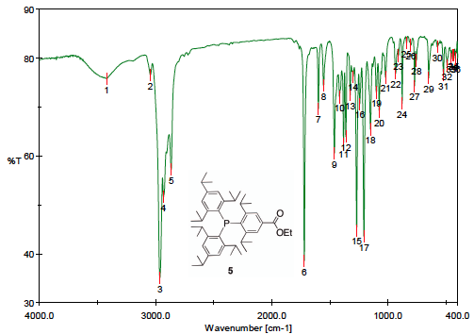
Figure S 4. IR spectrum of ester 5 (KBr pellet).
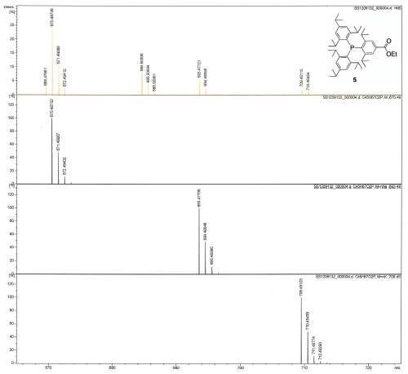
Figure S 5. FT-ICR-MS (ESI, positive) spectrum of ester 5. An observed spectrum and simulated spectra for [M]⁺, [M+Na]⁺, and [M+K]⁺ from the top to the bottom..

