Supporting Information

**Thiol-Ene Crosslinking Polyamidoamine Dendrimer-Hyaluronic Acid Hydrogel System for Biomedical Applications**

Xiangdong Bia*, Aiye Lianga, Yu Tanb, Panita Maturavongsaditc, Ashley Higginbothema, Togor Gadoa, Abigail Gramlinga, Hanna Bahna, Qian Wangc

a Department of Physical Sciences, Charleston Southern University, Charleston, South Carolina, United States

b Department of Bioengineering, Clemson University, Clemson, South Carolina, United States

c Department of Chemistry and Biochemistry, University of South Carolina, Columbia, South Carolina, United States

* To whom correspondence should be addressed. Tel.: (1-843) 863-8086; Fax: (1-843) 863-7290; e-mail: [xbi@csuniv.edu](mailto:xbi@csuniv.edu).

1. **1H-NMR (D2O, 400 MHz) spectra of RGD functionalized PAMAM dendrimers 9-13**
2. **MALDI-TOF Spectra of PAMAM dendrimers 3, 5-8**

1H-NMR (D2O, 400 MHz) spectra of RGD functionalized PAMAM dendrimers **9-13**

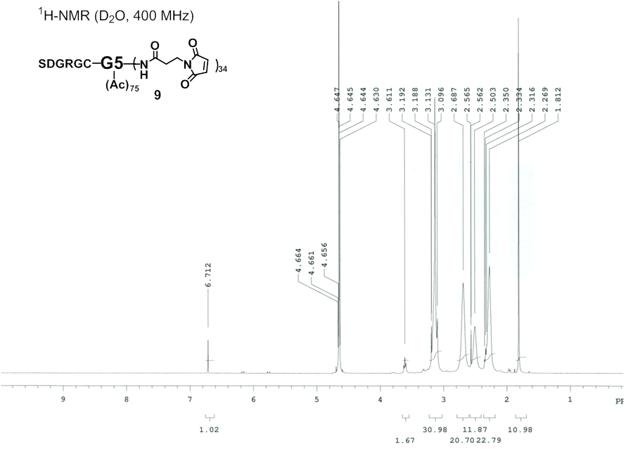

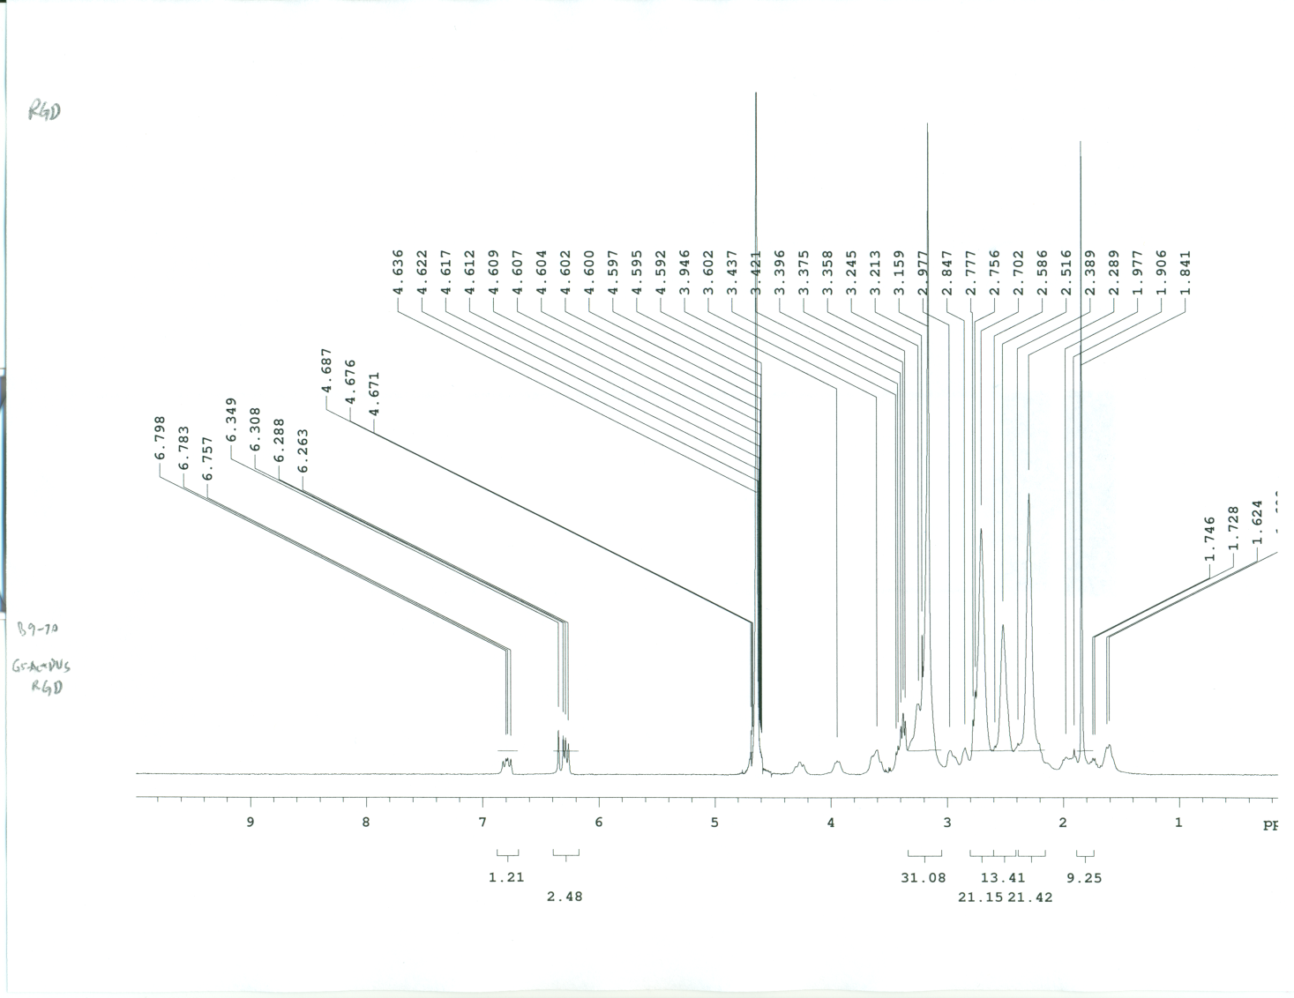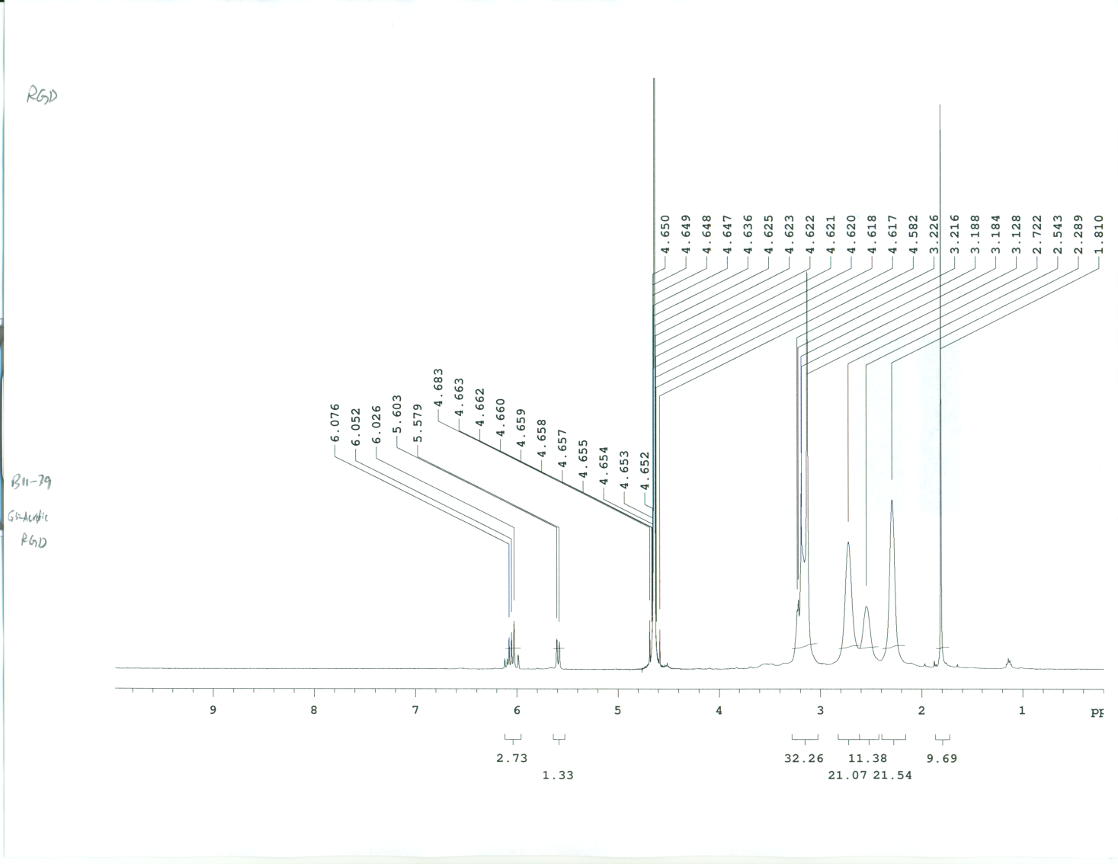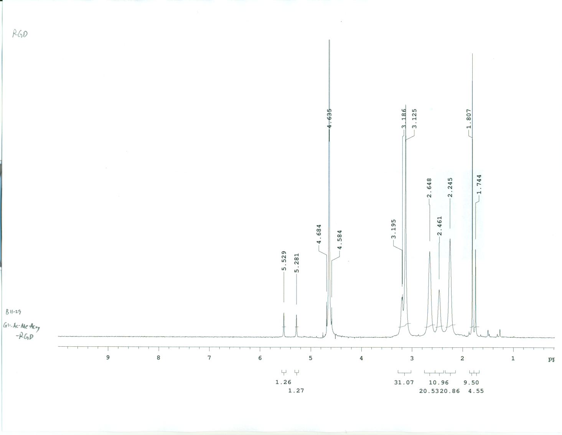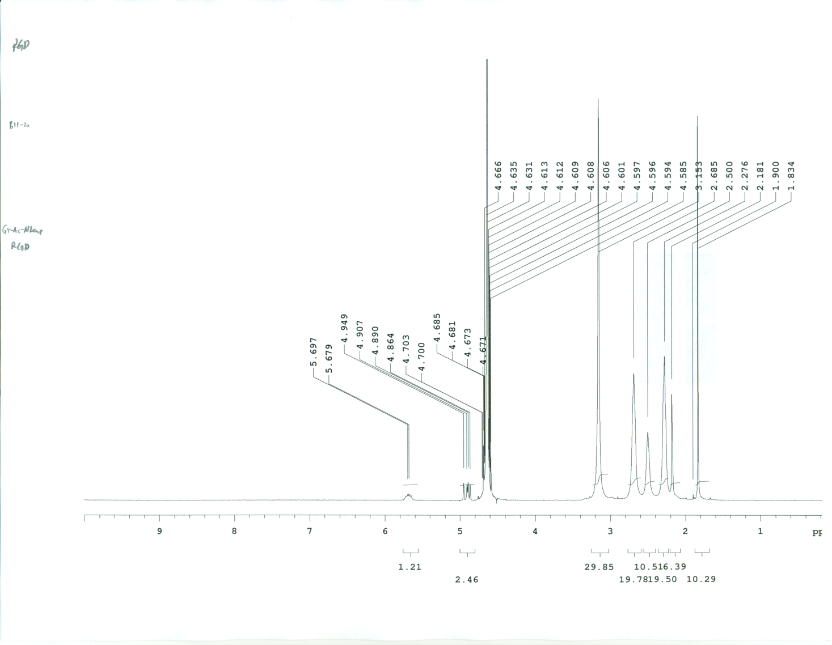

MALDI-TOF Spectra of PAMAM dendrimers **3** and **5-8**

G5-Ac(75)-BMPS(35) (**3**)



G5-Ac(75)-DVS(35) (**5**)



G5-Ac(75)-Acrylic(35) (**6**)



G5-Ac(75)-MeAcrylic(35) (**7**)



G5-Ac(75)-Alkene(35) (**8**)

