Supplemental material

Table and figure captions:
Table S1. Summary of the sample names and their obtainment.

Figure S1. GC profiles of the TMS derivatives of glycosides generated after acid hydrolysis of TB-EPS total sample (A) and both polysaccharidic sub-samples, water-soluble (TB-PS-aq) (B) and low water-soluble (TB-PS-inter) (C). Erythritol was used as internal reference.

Figure S2. Elution HPGPC profiles, monitored by RI detector, of LB-PS–aq and -inter in comparison to TB-PS-aq and -inter.

Figure S3. Percentage (w/w) of each ion exchange chromatography fraction eluted from TB-PS-inter (A) and TB-PS-aq (B) by increasing sequentially the NaCl concentration.

Figure S4. ¹H–NMR spectra of TB-PS-inter 0 M (PS I) (A) and TB-PS-aq 0.4 M (mainly PS II) (B).

Figure S5. ¹H–NMR spectra of TB-PS-inter 0.8 M (PGG).

Figure S6. Comparative OD evolution at 600 nm, related to bacteria growth in MB medium, for 3 strains, in absence and in presence of polysaccharide enriched-fractions: TB-PS-inter 0 M (PS I) (A), TB-PS-aq 0.4 M (mainly PS II) (B).
Figure S7. Elution HPGPC profiles, monitored by RI detector, of Sol-PS-aq,TB-PS-aq and TB-PS-inter isolated or extracted from planktonic cultures of P. ulvae TC14.

Table S1. Summary of the sample names and their obtainment.
Sample abbreviation | Corresponding sample | Obtainment
TB-EPS | Tightly bound exopolymers | Extraction from biofilms
- TB-EPS-inter | Low water-soluble exopolymers recovered in the interphase | CHCl₃/MeOH/H₂O partition of TB-EPS
- TB-PS-inter | Low water-soluble polysaccharide-enriched fraction | Removing of lipids and proteins from low water-soluble exopolymers
- TB-PS-inter 0 M (PSI)* | Neutral low water-soluble polysaccharide-enriched fraction  containing PSI as main component | Ion exchange chromatography. Fraction eluted with 0 M NaCl from TB-PS-inter
- TB-PS-inter 0.8 M (PGG)* | Acidic low water-soluble polysaccharide-enriched fraction  containing PGG as main component | Ion exchange chromatography. Fraction eluted with 0.8 M NaCl from TB-PS-inter
- TB-EPS-aq | Water-soluble polymers recovered in the aqueous phase | CHCl₃/MeOH/H₂O partition of TB-EPS
- TB-PS-aq | Water-soluble polysaccharide-enriched fraction | Removing of lipids and proteins from water-soluble exopolymers
- TB-PS-aq 0.4 M (PSII)* | Acidic low water-soluble polysaccharide-enriched fraction containing PSII as main component | Ion exchange chromatography. Fraction eluted by 0.4 M NaCl from TB-PS-aq
Note: TB: tightly bound; PS: polysaccharide; inter: interphase; aq: aqueous phase; PGG: poly(glutamyl glutamate). *PSI, PSII and PGG were the main components of each fraction

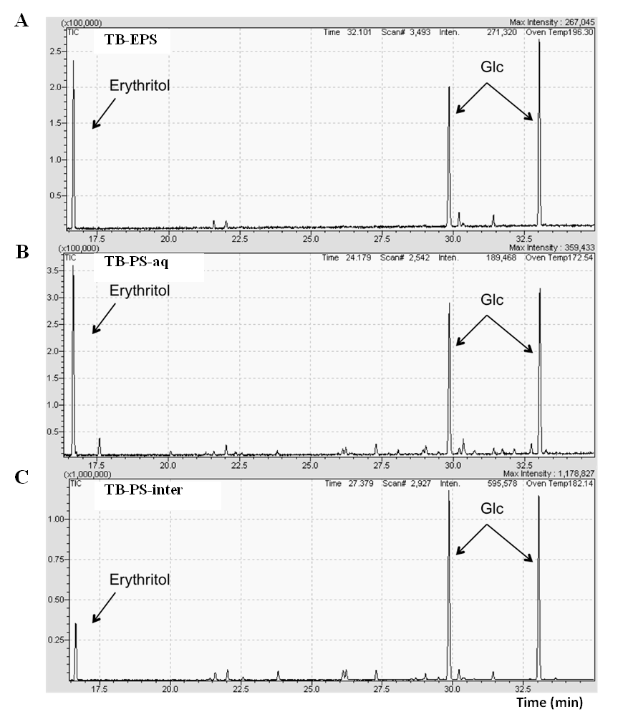
Figure S1. GC profiles of the TMS derivatives of glycosides generated after acid hydrolysis of TB-EPS total sample (A) and both polysaccharidic sub-samples, water-soluble (TB-PS-aq) (B) and low water-soluble (TB-PS-inter) (C). Erythritol was used as internal reference.

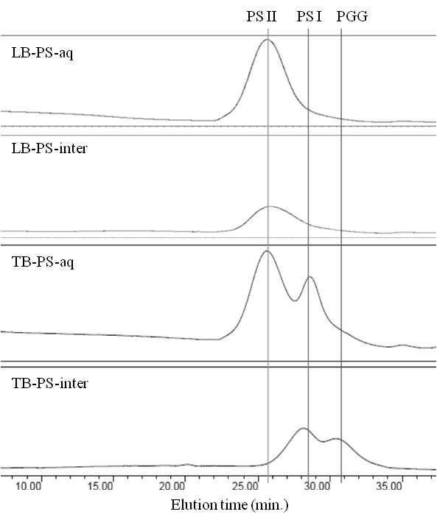
Figure S2. Elution HPGPC profiles, monitored by RI detector, of LB-PS–aq and -inter in comparison to TB-PS-aq and -inter.

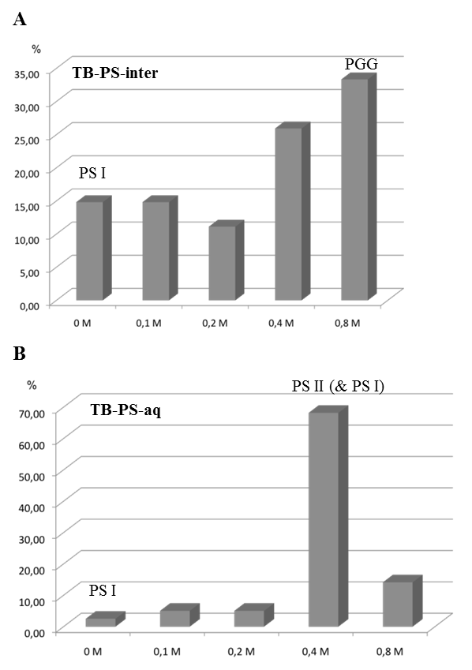
Figure S3. Percentage (w/w) of each ion exchange chromatography fraction eluted from TB-PS-inter (A) and TB-PS-aq (B) by increasing sequentially the NaCl concentration.
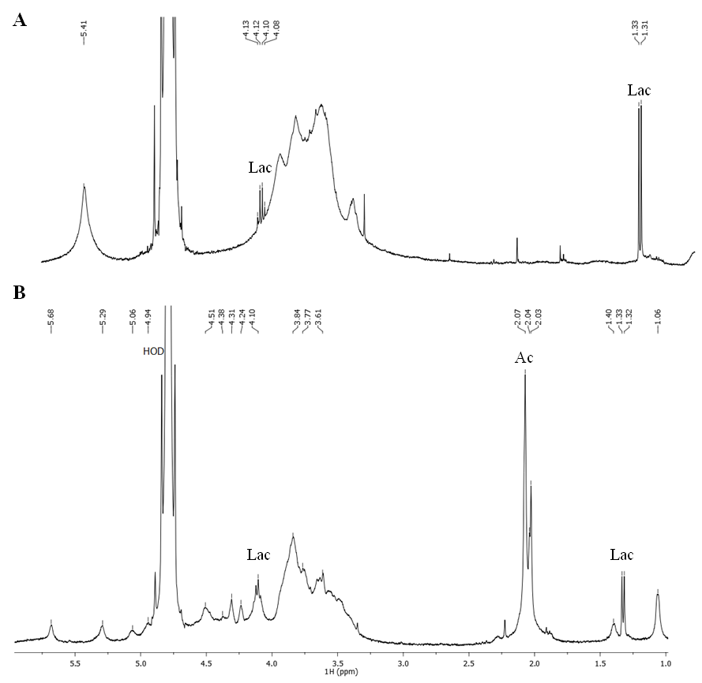
Figure S4. ¹H–NMR spectra of TB-PS-inter 0 M (PS I) (A) and TB-PS-aq 0.4 M (mainly PS II) (B).

Figure S5. ¹H–NMR spectra of TB-PS-inter 0.8 M (PGG).

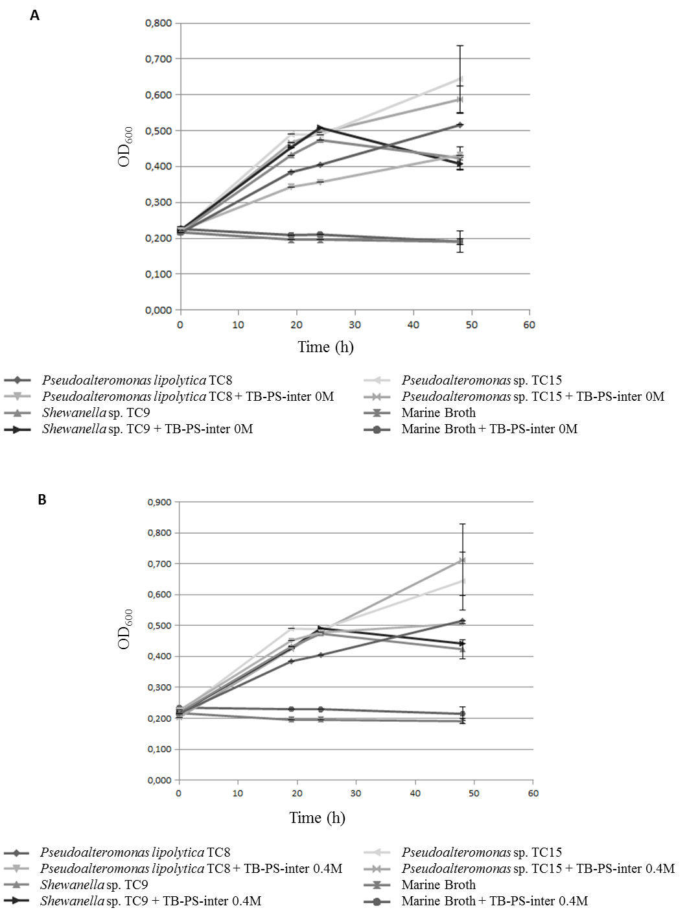

Figure S6. Comparative OD evolution at 600 nm, related to bacteria growth in MB medium, for 3 strains, in absence and in presence of polysaccharide enriched-fractions: TB-PS-inter 0 M (PS I) (A), TB-PS-aq 0.4 M (mainly PS II) (B). Bars represent means ± standard errors for six replicates.

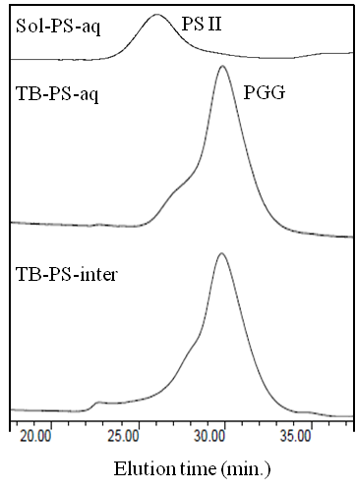
Figure S7. Elution HPGPC profiles, monitored by RI detector, of Sol-PS-aq, TB-PS-aq and TB-PS-inter isolated or extracted from planktonic cultures of P. ulvae TC14.

