Figure S1. Relationship of solenodon mitochondrial genomes to those of other mammals. The maximum likelihood tree of laurasiatherian mammals showing the position of solenodons was generated in RAxML version 8.2.4 (Stamatakis 2014), using the GTR+I+G substitution model and 1000 rapid bootstrap replicates. Full mitochondrial genome sequences (excluding control region and regions of poor alignment) from the taxa on the tree were used to generate the phylogeny. Letters indicate the nodes for which fossil calibration dates and inferred molecular dates are described in Table S3.

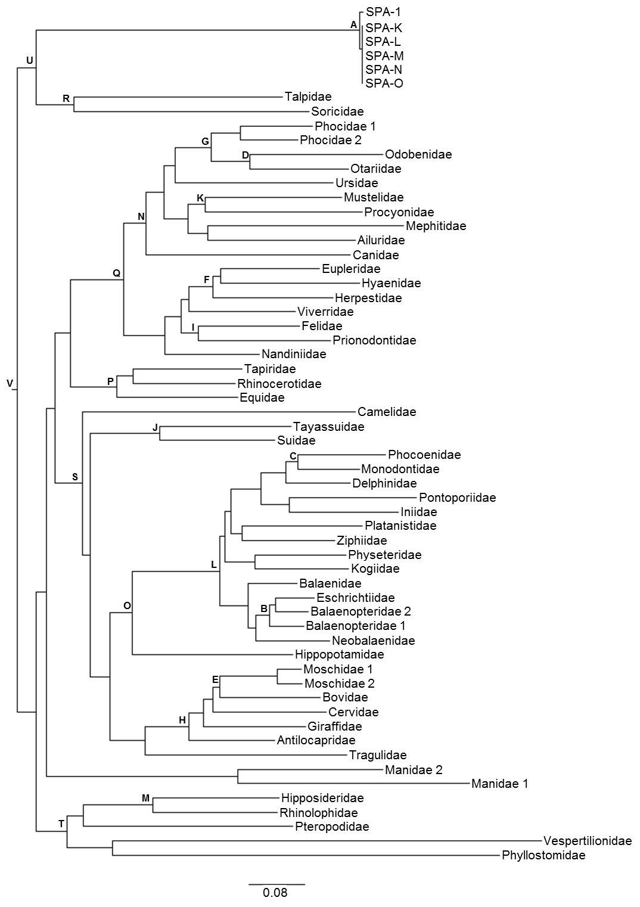
Figure S2. Phylogeny of laurasiatherian mammals showing the position of Solenodon paradoxus. The tree was generated using the full mitogenome sequences except that regions of poor alignment were excluded, as was the control region, which is unreliable for the deep time scales involved (Ingman et al. 2000). The relationships among taxa were not constrained to those established using the fossil record or nuclear genetic relationships, since in some circumstances mitogenomic relationships may be incongruent with the true species tree (Petit and Excoffier 2009). For molecular dating, previously well-established fossil calibrations (Meredith et al. 2011) were incorporated into an analysis conducted using the software BEAST v1.8.2 software (Drummond et al. 2012). At eulipotyphlan nodes, the Bayesian posterior probability and maximum likelihood bootstrap support are listed above, while below are listed dates of divergence with 95% credibility intervals in parentheses. The time at which the solenodon mitogenome diverged from that of other mammals was estimated as 78.2 Mya (95% CI: 62.1-98.6 Mya). The point estimate for the divergence time between solenodons and other mammals is similar to previous estimates ranging from 73-76 Mya, based upon analysis of datasets largely comprised of nuclear sequences (Roca et al. 2004, Meredith et al. 2011).

Table S1. Radical mutations in mitochondrial protein coding genes of S. paradoxus in comparison to those of reference species. Mutations are shown in this format: position, amino acid in the reference mitogenome, amino acid in S. paradoxus. Scores were calculated with PROVEAN using a stringent threshold for listing the radical mutations of -4.1. Entries are vertically aligned with regard to preceding insertion and deletion events.
Gene | Reference species
 | Talpa europaea |  | Sorex araneus |  | Felis catus |  | Homo sapiens
ATP6 | 125,L,T | -4.525 | 125,L,T | -4.478 | 125,L,T | -4.537 | 33,T,H  125,L,T | -4.310  -4.453
ATP8 | 27,K,A  34,P,T  62,L,H | -5.702  -4.805  -5.634 | 27,K,A  34,P,T  62,L,H | -5.677  -4.792  -5.016 | 24,F,L  27,K,A  34,P,T  39,P,L  62,L,H | -4.253  -5.755  -4.690  -4.293  -4.682 | 27,K,A  34,H,T | -5.993  -4.171
COX1 | — | — | — | — | — | — | — | —
COX2 | 39,H,G | -7.301 |  |  | 39,H,G | -7.099 | 151,P,T | -5.157
COX3 | — | — | — | — | — | — | — | —
CYTB | — | — | — | — | — | — | — | —
ND1 | 252,P,S  308,P,H | -4.615  -6.980 | 252,P,S  308,P,H | -5.249  -7.014 | 252,P,S  308,P,H | -5.008  -6.881 | 250,P,S  306,P,H | -5.384  -7.051
ND2 | 46,M,T  243,W,G  244,N,S  254,L,T  313,M,T  314,F,L | -4.480  -10.996  -4.510  -4.230  -4.258  -4.986 | 20,G,S  41,M,T  96,P,I  147,Y,M  202,P,Q  238,W,G  239,N,S  308,M,T  309,F,L | -4.458  -4.937  -5.200  -5.460  -6.613  -10.116  -4.366  -4.449  -5.164 | 25,G,S  101,P,I  152,Y,M  207,P,Q  243,W,G  244,N,S  313,M,T  314,F,L | -4.367  -5.685  -6.104  -6.447  -10.578  -4.544  -4.215  -5.218 | 22,G,S  43,M,T  149,Y,M  153,P,N  204,P,Q  240,W,G  241,N,S  295,N,S | -5.039  -4.721  -5.543  -5.191  -6.187  -10.553  -4.500  -4.223
ND3 | 27,L,P | -4.797 | 27,L,P | -5.226 | 27,L,P | -4.965 | 27,L,P | -5.285
ND4 |  |  |  |  |  |  | 4,H,M  5,S,Y  185,G,S | -4.380  -4.341  -4.427
ND4L | — | — | — | — | — | — | — | —
ND5 | 62,S,Y  154,G,S  349,N,A  431,G,K  435,F,S  446,P,K  450,N,K  469,N,Y  510,K,M  578,Q,N | -4.845  -4.377  -6.467  -4.196  -5.564  -5.870  -4.681  -4.690  -4.121  -4.282 | 62,S,Y  154,G,S  349,N,A  431,G,K  446,P,K  450,N,K  469,N,Y  510,K,M  514,P,K  578,Q,N | -4.857  -4.401  -6.734  -4.371  -5.925  -4.558  -4.226  -4.451  -4.402  -4.335 | 62,S,Y  154,G,S  349,N,A  435,F,S  450,N,K  469,N,Y  510,K,M  514,P,K  578,Q,N | -4.745  -4.377  -6.467  -5.562  -4.681  -4.560  -4.244  -4.325  -4.282 | 60,S,Y  347,N,A  429,G,K  433,F,S  444,P,K  448,N,K  467,N,Y  508,K,M  512,P,K  576,Q,N | -4.623  -6.667  -4.393  -5.628  -5.883  -4.691  -4.369  -4.423  -4.544  -4.294
ND6 | 106,Y,C  138,E,G | -4.909  -4.758 | 106,Y,C | -4.378 | 106,Y,C  138,E,G | -4.945  -4.775 | 106,W,C  162,F,V | -5.745  -5.011

Table S2. Taxa used for comparison of S. paradoxus to other mammals.
Order | Family | Taxon | GenBank accession code
Eulipotyphla | Solenodontidae | SPA-1 | KU697358
Eulipotyphla | Solenodontidae | SPA-K | KU697359
Eulipotyphla | Solenodontidae | SPA-L | KU697360
Eulipotyphla | Solenodontidae | SPA-M | KU697361
Eulipotyphla | Solenodontidae | SPA-N | KU697362
Eulipotyphla | Solenodontidae | SPA-O | KU697363
Eulipotyphla | Soricidae | European shrew | NC_027963
Eulipotyphla | Talpidae | European mole | NC_002391
Cetartiodactyla | Antilocapridae | Pronghorn | NC_020679
Cetartiodactyla | Balaenidae | Southern right whale | NC_006930
Cetartiodactyla | Balaenopteridae 1 | Pygmy Bryde's whale | NC_007938
Cetartiodactyla | Balaenopteridae 2 | Humpback whale | NC_006927
Cetartiodactyla | Bovidae | Domestic cattle | NC_006853
Cetartiodactyla | Camelidae | Bactrian camel | NC_009628
Cetartiodactyla | Cervidae | Reindeer | NC_007703
Cetartiodactyla | Delphinidae | Heaviside's dolphin | NC_020696
Cetartiodactyla | Eschrichtiidae | Grey whale | NC_005270
Cetartiodactyla | Giraffidae | Giraffe | NC_024820
Cetartiodactyla | Hippopotamidae | Pygmy hippopotamus | NC_020697
Cetartiodactyla | Iniidae | Amazon river dolphin | NC_005276
Cetartiodactyla | Kogiidae | Pygmy sperm whale | NC_005272
Cetartiodactyla | Monodontidae | Narwhal | NC_005279
Cetartiodactyla | Moschidae 1 | Anhui musk deer | NC_020017
Cetartiodactyla | Moschidae 2 | Siberian musk deer | NC_013753
Cetartiodactyla | Neobalaenidae | Pygmy right whale | NC_005269
Cetartiodactyla | Phocoenidae | Finless porpoise | NC_026456
Cetartiodactyla | Physeteridae | Sperm whale | NC_002503
Cetartiodactyla | Platanistidae | Indus River dolphin | NC_005275
Cetartiodactyla | Pontoporiidae | La Plata dolphin | NC_005277
Cetartiodactyla | Suidae | Domestic pig | NC_000845
Cetartiodactyla | Tayassuidae | Collared peccary | NC_012103
Cetartiodactyla | Tragulidae | Water chevrotain | NC_020714
Cetartiodactyla | Ziphiidae | Ginkgo-toothed beaked whale | NC_027593
Perissodactyla | Equidae | Horse | NC_001640
Perissodactyla | Rhinocerotidae | White rhinoceros | NC_001808
Perissodactyla | Tapiridae | Malayan tapir | NC_023838
Carnivora | Ailuridae | Red panda | NC_009691
Carnivora | Canidae | Domestic dog | NC_002008

Table S2. Continued.
Order | Family | Taxon | GenBank accession code
Carnivora | Eupleridae | Narrow-striped mongoose | NC_027828
Carnivora | Felidae | Domestic cat | NC_001700
Carnivora | Herpestidae | Indian mongoose | NC_006835
Carnivora | Hyaenidae | Spotted hyena | NC_020670
Carnivora | Mephitidae | Striped skunk | NC_020648
Carnivora | Mustelidae | American marten | NC_020642
Carnivora | Nandiniidae | African palm civet | NC_024567
Carnivora | Odobenidae | Atlantic walrus | NC_004029
Carnivora | Otariidae | California sea lion | NC_008416
Carnivora | Phocidae 1 | Harp seal | NC_008429
Carnivora | Phocidae 2 | Weddell seal | NC_008424
Carnivora | Prionodontidae | Spotted linsang | NC_024569
Carnivora | Procyonidae | Raccoon | NC_009126
Carnivora | Ursidae | Giant short-faced bear | NC_011116
Carnivora | Viverridae | Servaline genet | NC_024568
Chiroptera | Hipposideridae | Great roundleaf bat | NC_018540
Chiroptera | Phyllostomidae | Common vampire bat | NC_022423
Chiroptera | Pteropodidae | Large flying fox | NC_026542
Chiroptera | Rhinolophidae | Big-eared horseshoe Bat | NC_026460
Chiroptera | Vespertilionidae | Red bat | NC_016873
Pholidota | Manidae 1 | Tree pangolin | NC_026780
Pholidota | Manidae 2 | Malayan pangolin | NC_026781

Table S3. Laurasiatherian fossil calibration dates and inferred molecular dating.
Group | Node | Fossil* | Estimated | (95% CI) | Posterior probability | Bootstrap node support (%)
Base of S. paradoxus | A | - | 0.60 | (0.33-0.94) | 1.00 | 100
Megaptera-Eschrichtius | B | 7.3-23.03 | 10.74 | (7.69-14.02) | 1.00 | 100
Phocoenidae-Monodontidae | C | 12.1-28.5 | 16.10 | (11.52-20.40) | 1.00 | 100
Otariidae-Odobenidae | D | 15.97-34 | 20.84 | (15.83-25.67) | 1.00 | 100
Bovidae-Moschidae | E | 18-34 | 21.05 | (16.49-25.54) | 1.00 | 31
Herpestidae-Eupleridae | F | 15.97-34 | 23.43 | (18.44-28.85) | 1.00 | 100
Phocidae-(Otariidae+Odobenidae) | G | 20.43-34 | 29.36 | (24.93-34.06) | 1.00 | 100
Giraffidae-Antilocapridae | H | 17.8-34 | 30.55 | (25.80-35.39) | 1.00 | 100
Felidae-Prionodontidae | I | 28.3-40.6 | 32.27 | (27.29-37.10) | 1.00 | 99
Suidae-Tayassuidae | J | 15.97-37.3 | 32.37 | (35.55-41.13) | 1.00 | 100
Procyonidae-Mustelidae | K | 27.6-40.6 | 32.61 | (27.50-37.43) | 1.00 | 96
Cetacea | L | 33.8-48.8 | 37.80 | (33.27-42.18) | 1.00 | 100
Hipposideridae-Rhinolophidae | M | 37.1-56 | 43.28 | (34.18-52.18) | 1.00 | 100
Canidae-Arctoidea | N | 37.1-56 | 50.38 | (45.25-55.75) | 1.00 | 100
Whippomorpha | O | 52.5-61.1 | 54.80 | (50.85-58.73) | 1.00 | 100
Base of Perissodactyla | P | 55.5-61.1 | 57.33 | (54.11-60.58) | 1.00 | 100
Base of Carnivora | Q | 37.1-65.8 | 57.78 | (52.11-63.57) | 1.00 | 100
Talpidae-Soricidae | R | - | 67.96 | (47.83-95.82) | 0.99 | 98
Base of Cetartiodactyla | S | 52.5-65.8 | 67.46 | (52.67-72.57) | 1.00 | 100
Base of Chiroptera | T | - | 76.09 | (66.57-85.48) | 1.00 | 100
Base of Eulipotyphla | U | - | 78.16 | (62.07-98.61) | 0.79 | 99
Base of Laurasiatheria | V | - | 92.61 | (80.06-119.48) | 1.00 | -
*Fossil calibration dates are as described previously (Meredith et al. 2011).

