**Supporting information**

Different oxidation mechanisms of MnII(polyphosphate)n by the radicals NO2∙ and CO3∙-

AMIR MIZRAHI*, ISRAEL ZILBERMANN*, ERIC MAIMON, HAIM COHEN and DAN MEYERSTEIN*

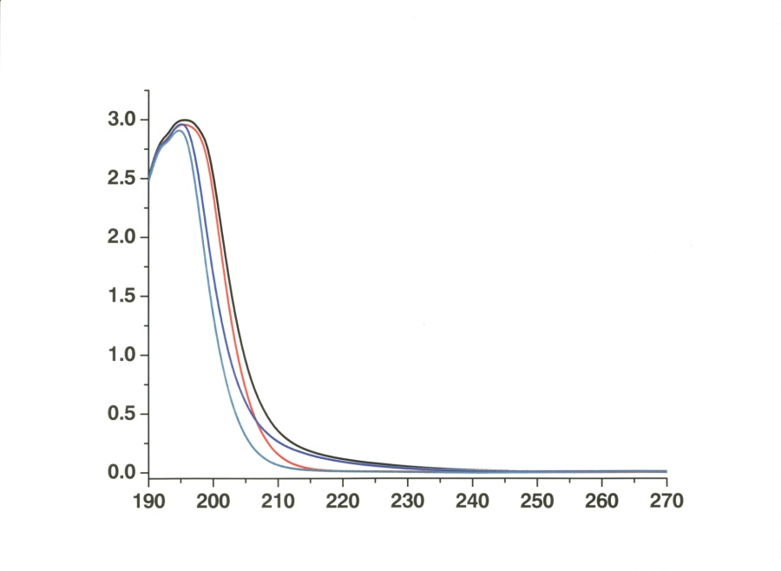

λ (nm)

O.D (a.u)

Figure S1. black – UV spectrum of 1.0 mM MnCl2 + 50 mM Na4P2O7. Red - 50 Mm Na4P2O7. Blue – 1.0 mM MnCl2 + 50 mM Na5P3O10. Cyan - 50 mM Na5P3O10. pH of all the solutions 8.3±0.2 (the visible region of the spectrum is omitted for clarity since no absorption bands are observed in this region).

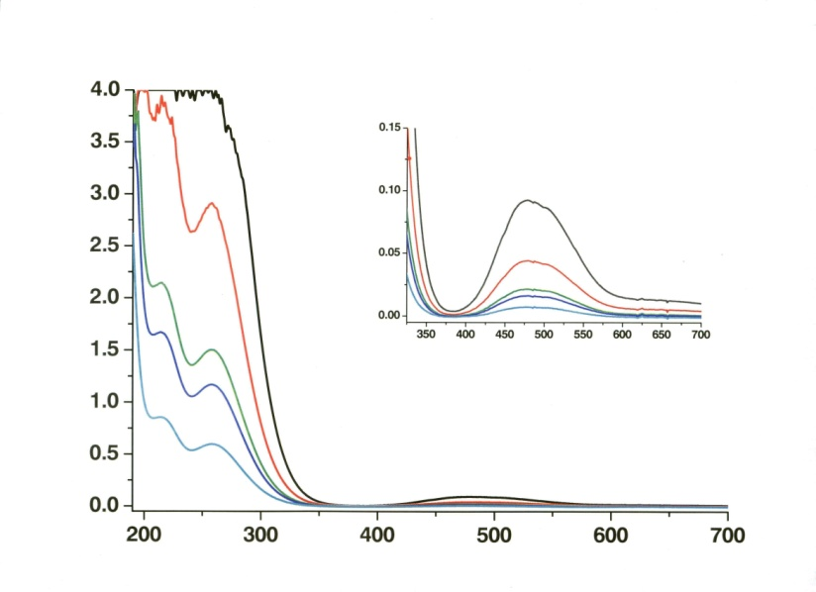

**O.D (a.u)**

**λ (nm)**

λ (nm)

O.D (a.u)

Figure S2. UV-Vis spectra of MnIII(HmP2O7)n3-(4-m)n.

Solution composition: pH 7.6±0.1, 0.1 M Na4P2O7. Black – 1.0 mM, Red – 0.50 mM, Green - 0.25 mM, Blue - 0.20 mM, Cyan - 0.10 mM. (Solutions containing low concentrations of MnIII(HmP2O7)n3-(4-m)n were prepared by diluting solutions containing 1.0 mM with 0.1M Na4P2O7). Inset: enlargement of the absorption band at 479 nm.

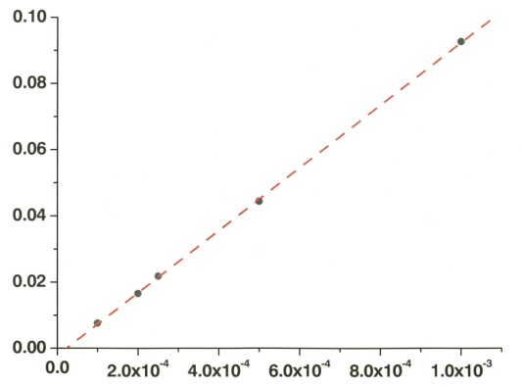

[HmMnIII(P2O7)n3-(4-m)n] M (M)

y = 95x

R2 = 0.99

O.D (479 nm)

Figure S3. Dependence of the absorbance at 479 nm on [MnIII(HmP2O7)n3-(4-m)n].

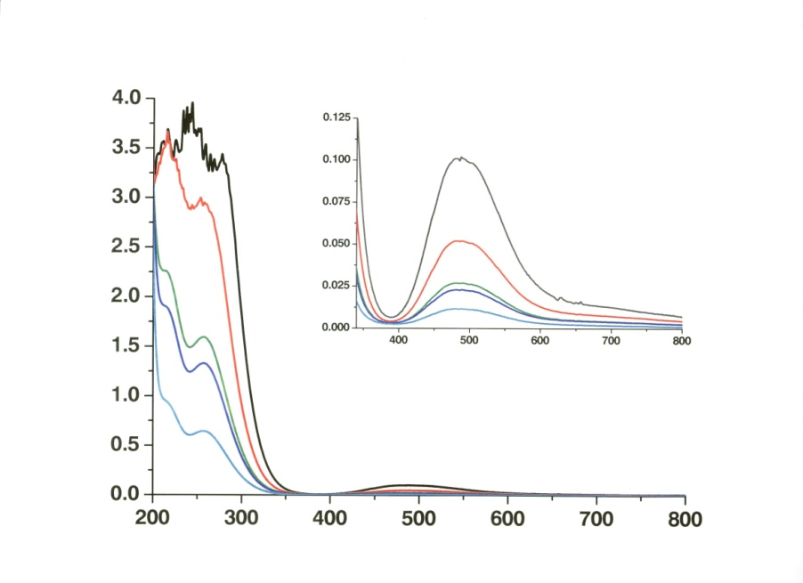

O.D (a.u)

λ (nm)

**λ (nm)**

**O.D (a.u)**

Figure S4. UV-Vis spectra of MnIII(HmP3O10)n3-(5-m)n.

Solution composition: pH 7.3±0.1, 0.1 M Na5P3O10. Black – 1.0 mM, Red – 0.50 mM, Green - 0.25 mM, Blue - 0.20 mM, Cyan - 0.10 mM. (Solutions containing low concentrations of MnIII(HmP3O10)n3-(5-m)n were prepared by diluting solutions containing 1.0 mM with 0.1M Na5P3O10). Inset: enlargement of the absorption band at 488 nm.

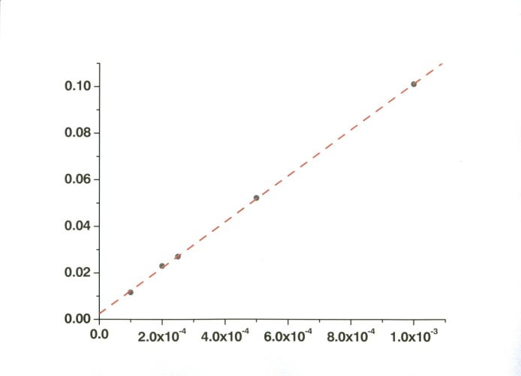

[MnIII(HmP3O10)n3-(5-m)n]M (M)

O.D (488 nm)

y = 99x

R2 = 0.99

Figure S5. Dependence of the absorbance at 488 nm on [MnIII(HmP3O10)n3-(5-m)n].

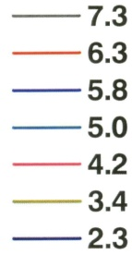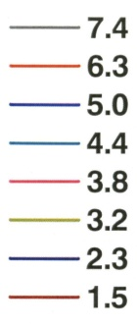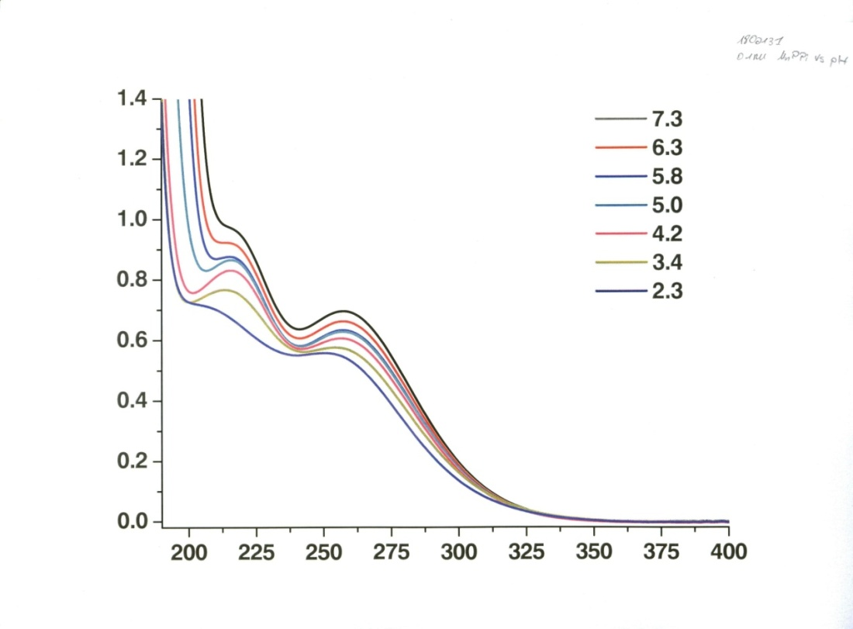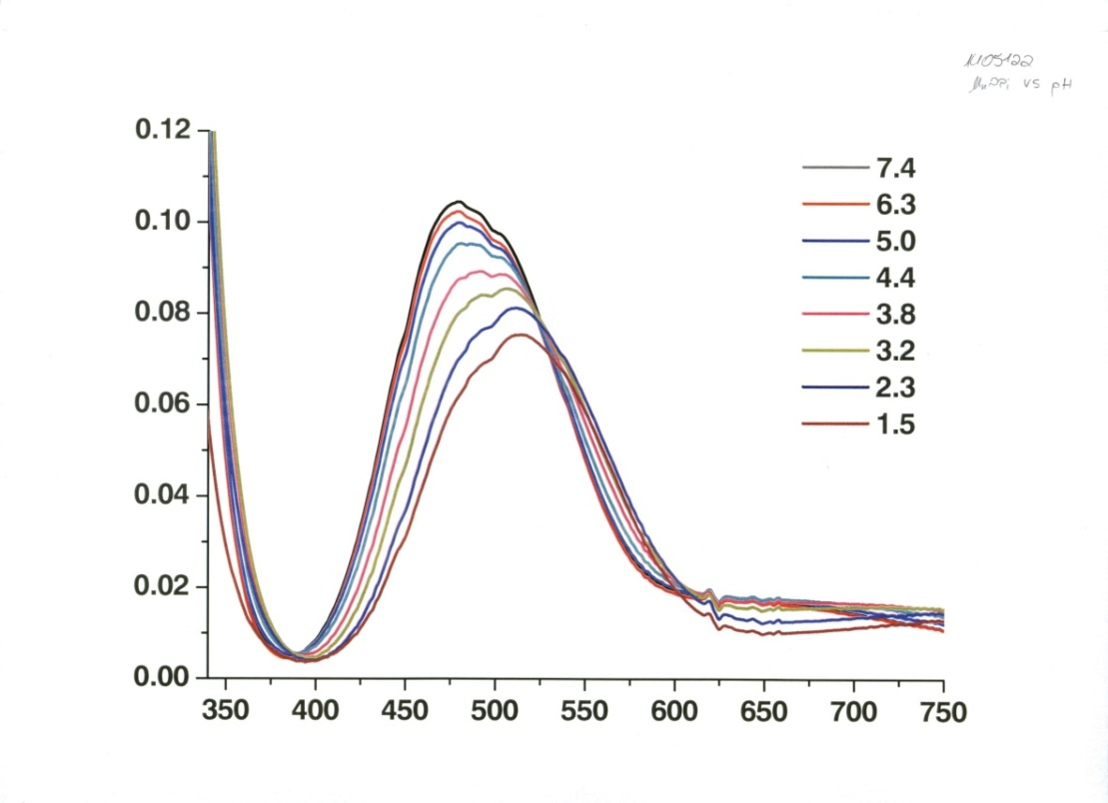

(a)

(b)

O.D (a.u)

O.D (a.u)

λ (nm)

λ (nm)

Figure S6. UV-Vis spectra of MnIII(HmP2O7)n3-(4-m)n at different pH's. 0.1M Na4P2O7. (a) 1.0 mM complex.(b) 0.10 mM complex.

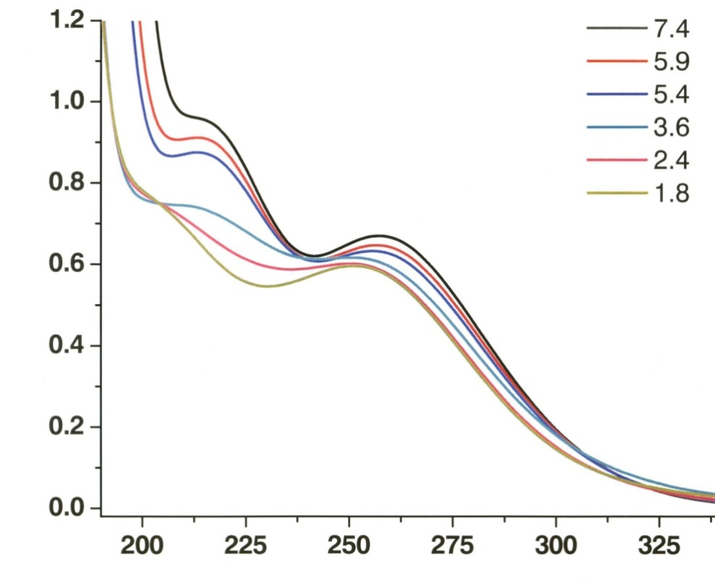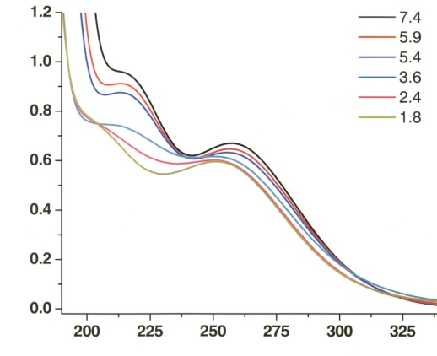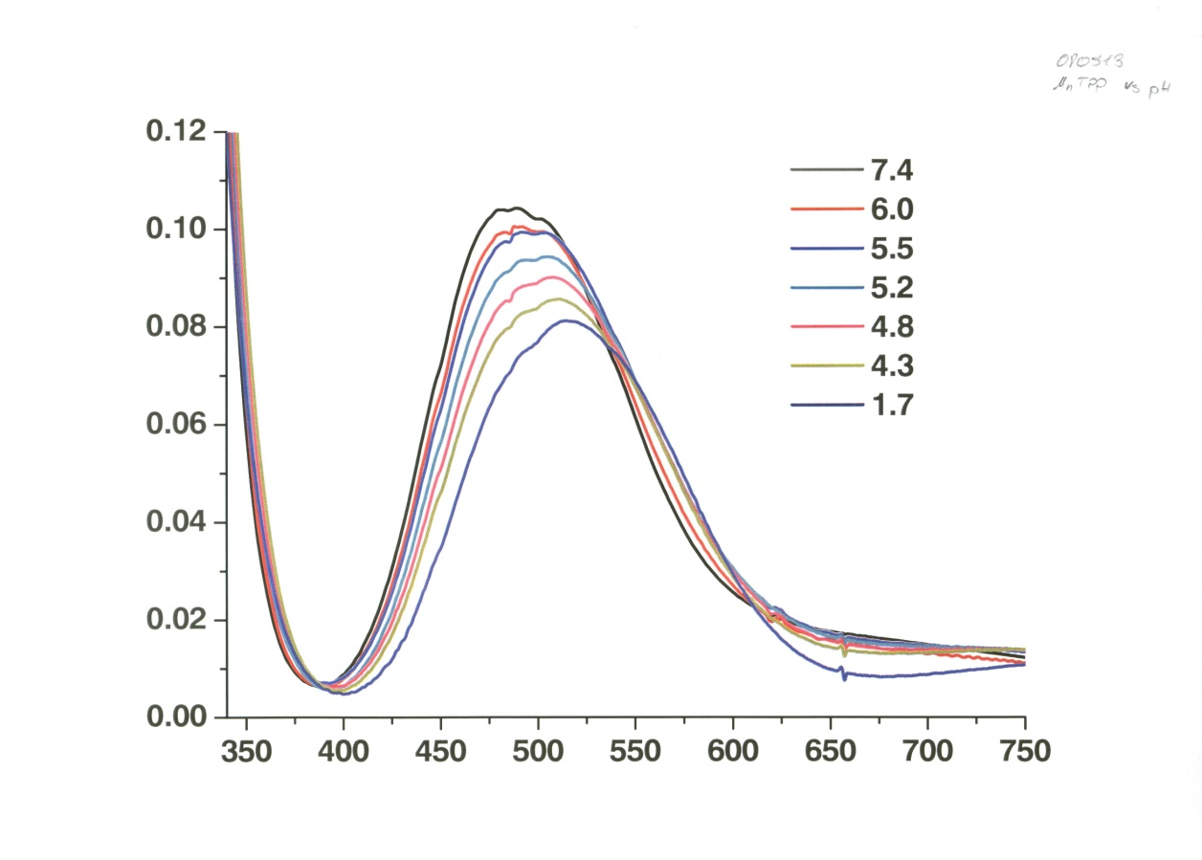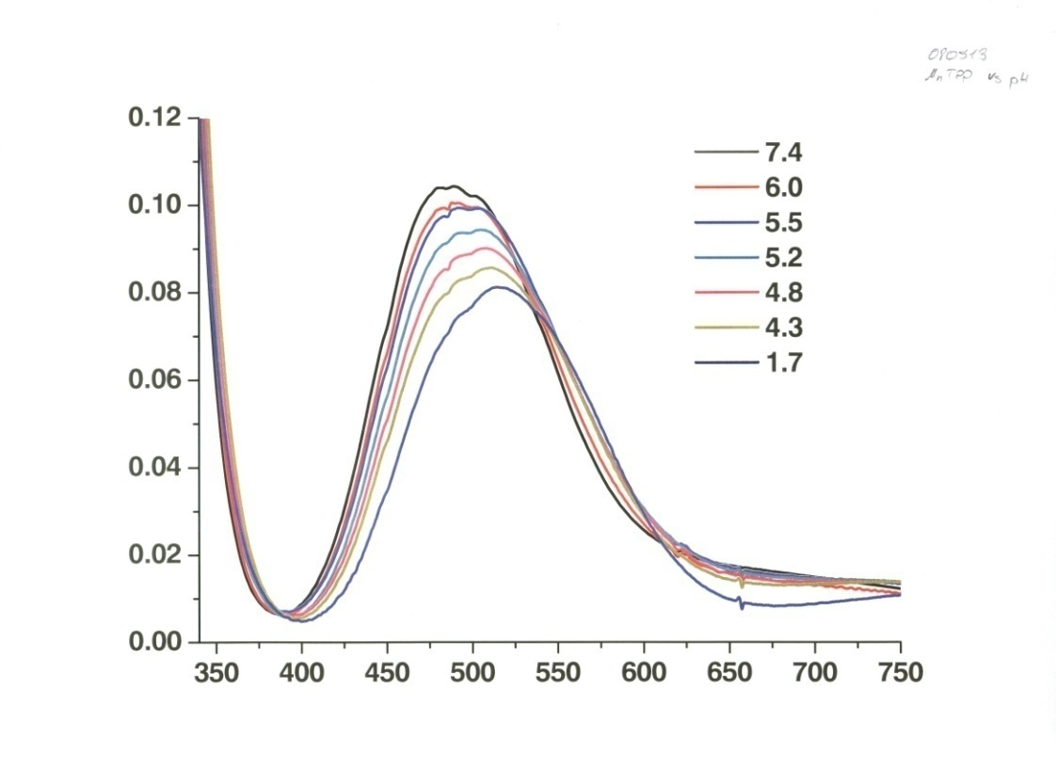

O.D (a.u)

λ (nm)

λ (nm)

O.D (a.u)

(b)

(a)

Figure S7. UV-Vis spectra of MnIII(HmP3O10)n3-(5-m)n at different pH's.

0.05 M Na5P3O10.(a) 1.0 mM complex.(b) 0.10 mM complex.



[MnIILn](M)

**y = 1.5x106 x + 74**

**R2 = 0.99**

**y = 3.4x106 x + 40**

**R2 = 0.99**

kobs (sec-1)

Figure S8. Linear dependence of the observed rate constants on [MnII-polyphosphate]. Black squares: 10 mM Na4P2O7. Red circles: 10 mM Na5P3O10. Solution composition: 0.25 M NaHCO3, pH 8.4 ± 0.2, N2O saturated, 600 nm, irradiated 10 Gy.

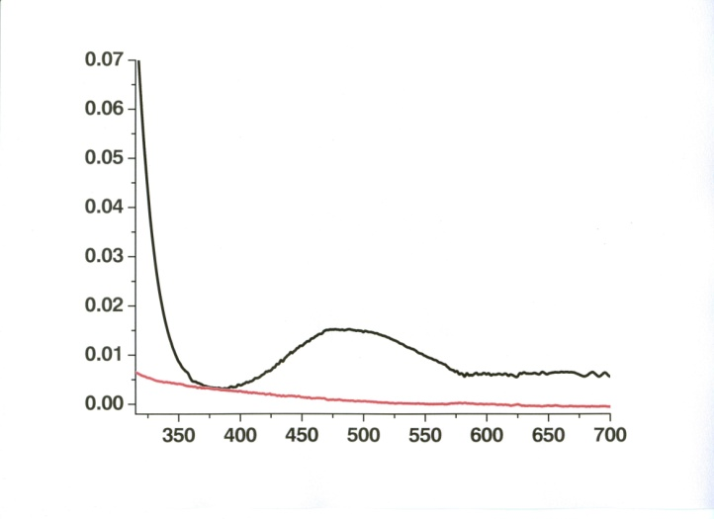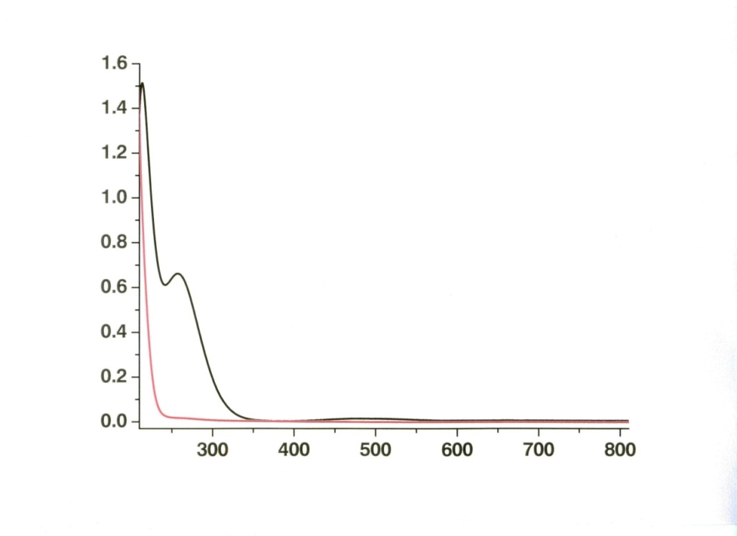

O.D (a.u)

λ (nm)

O.D (a.u)

λ (nm)

Figure S9. Difference spectra of MnIII(HmP3O10)n3-(5-m)n after continuous radiolysis. Red spectrum – solution before irradiation, Black spectrum – solution after irradiation. Solution composition: 1.0 mM MnCl2, 5.0 mM Na4P2O7, 0.25 M NaHCO3, pH 8.3 ± 0.1, N2O saturated, 330 Gy. Inset: enlargement of the absorption band in the visible region.



Figure S10. Reactions observed in the CO3∙-/MnII(HmP3O10)n2-(5-m)n system at 310 nm. Solution composition: 1.0 mM MnCl2, 10 mM Na5P3O10, 0.25M NaHCO3, N2O saturated, pH 8.4±0.2, irradiated 11 Gy.



Figure S11. Dependence of the kinetics of the second reaction observed on [Na4P2O7].

Solution composition: 0.20 mM MnCl2, 0.25 M NaHCO3, pH 8.3 ± 0.1, N2O saturated, 310 nm, irradiated 11 Gy.

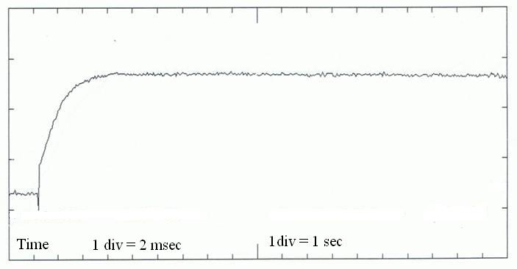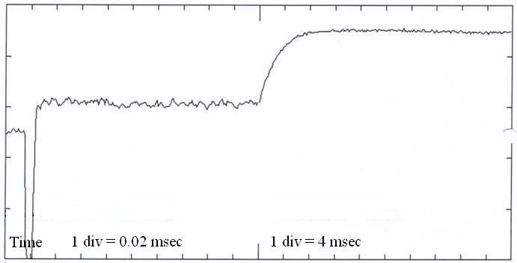

(b) 50mM Na5P3O10

1. 10mM Na4P2O7

Figure S12. Reactions observed in the NO2∙ / MnII(HmP3O10)n2-(5-m)n/MnII(HmP2O7)n2-(4-m)n system. Solution composition: 1.0 mM MnCl2, 2.0 mM NaNO2, N2O saturated, 310 nm, pH 8.4±0.2, 22 irradiated Gy.



kobs (sec-1)

[MnIILn]

y (P3O105-) = 1.4x105 x + 46

y (P2O74-) = 4.7x105 x + 210

Figure S13. Linear dependence of the observed rate constants on [MnII(polyphosphate)].

Solution composition: 10 mM Na4P2O7/Na5P3O10, 2.0 mM NaNO2, pH 8.5 ± 0.1, N2O saturated, 310 nm, irradiated 10/22 Gy (respectively).

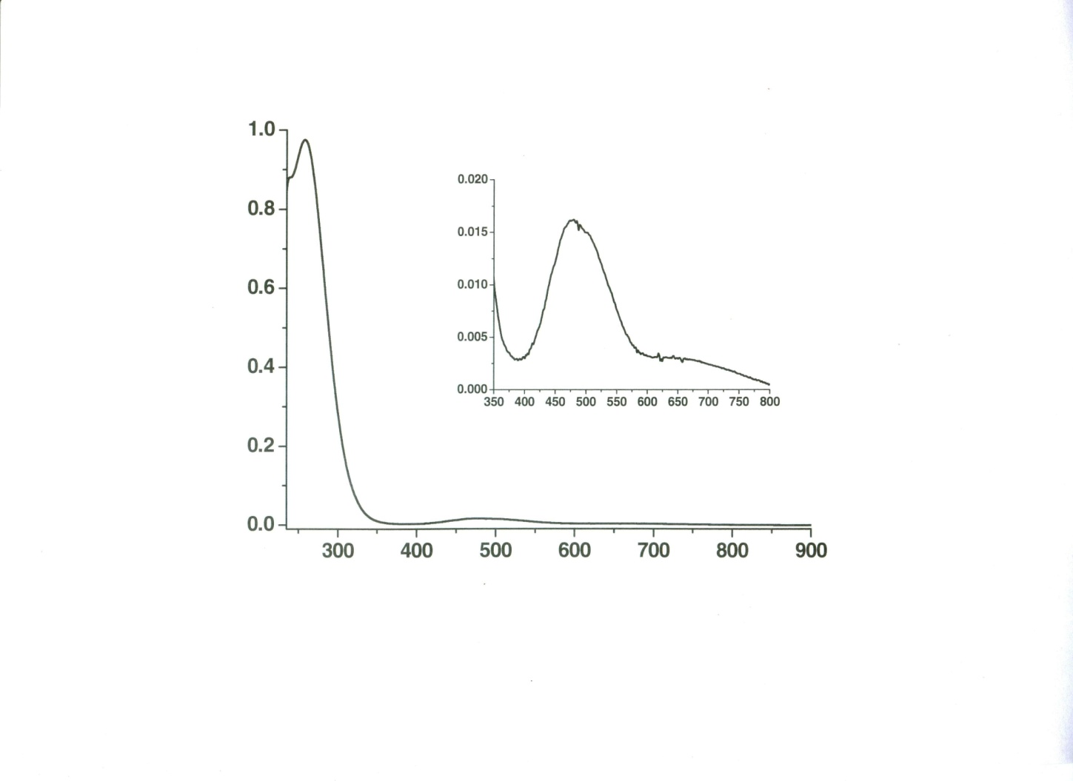

λ (nm)

O.D (a.u)

λ (nm)

O.D (a.u)

Figure S14. Difference spectra of MnIII(HmP2O7)n3-(4-m)n after continuous radiolysis.

Solution composition: 1.0 mM MnCl2, 5.0 mM Na4P2O7, 2.0 mM NaNO2, pH 8.5 ± 0.1, N2O saturated, irradiated 330 Gy. Inset: enlargement of the absorption band in the visible region.

Table S1. MnIII(HmP3O10)n3-(5-m)n absorbance after reaction of MnII(HmP3O10)n2-(5-m)n with NO2∙ at different nitrite concentrations.

Solution composition: 10 Mm Na5P3O10, pH 8.5±0.1, N2O saturated, 310 nm, irradiated 22 Gy.

|  |  |  |
| --- | --- | --- |
| 4 mM NaNO2  (O.D) | 2 mM NaNO2  (O.D) | [MnII(P3O10)n2-5n]  (mM) |
| 0.0127 | 0.0295 | 0.10 |
| 0.026 | 0.0555 | 0.25 |
| 0.036 | 0.0760 | 0.50 |
| 0.051 | 0.0985 | 1.0 |
| 0.062 | 0.1160 | 2.0 |



[MnII(P3O10)n3-5n]

y = 1.2x104 x + 8.1

R2 = 0.98

kobs (sec-1)

Figure S15. Linear dependence of the observed rate constant on [MnII(HmP3O10)n2-(5-m)n]. Solution composition: 2.0 mM Na5P3O10, 2.0 mM NaNO2, pH 8.5 ± 0.1, N2O saturated, 310 nm, irradiated 22 Gy.