My primary performance area is to provide research support services for the IUPUI campus. I have met the criteria for excellence by creating two new services within the library - research data services and research metrics services – and by being actively engaged in other Library services.

Research Data Services (RDS)
I provide research data services to faculty, staff, and student researchers across the IUPUI campus. Services take the form of online content, infrastructure, and workshops and consultations. The topics addressed include federal funding agency data management plan (DMP) support, effective research data management practices, student focused data information literacy instruction, and data sharing requirements from publishers and funding agencies. My goals for the first four years of the data services program were to: 1) support compliance with funder and publisher data requirements; 2) develop regular training opportunities on good research data practices for faculty, staff, and students; 3) develop and manage the institutional data repository to enable research data preservation, sharing, reuse, and demonstration of impact; and, 4) build collaborative relationships with other core research support services on the IUPUI campus and across the IU system (see Figure 1). I maintain content related to RDS that includes seven data support pages on the University Library Center for Digital Scholarship website, a comprehensive research data management guide for students, the core curriculum (see Appendix A.2.a) from which workshops are developed, activities that can be used for independent or classroom learning, and institution-wide research data guidance (see Appendix A.6).

Data management curriculum: In 2013, I submitted a proposal to the ICPSR Sloan Foundation Challenge Grants program. Though it was not funded, it was the seed from which my data management curriculum grew. This curriculum was informed by an in-depth literature review of data management and handling practices across a variety of disciplines – statistics, computer science, ecology, clinical data management, and library and information science. I developed a robust list of practical strategies for data management that forms the basis of the curriculum. These strategies support key principles of good scientific research: data integrity, responsible conduct of research, and reproducibility. I then developed a series of active learning exercises based on the strategies identified. Finally, I mapped the exercises to a research life cycle model and a data management plan template to link the content to the research process. I have openly shared much of the instructional content through Slideshare, a widely used open platform for sharing presentations on topics from education to business (see Section 08, Table 3). A key product that has proven to be popular is the data outcomes mapping exercise and example, which helps new researchers plan for data management. The activity guides students to think through how research design affects the data collection, processing, management, analysis, and write-up phases of their project. Students new to the research process have found it particularly helpful for identifying the implications of their design choices before starting the project, when adjustments are still possible.

Data management training and instruction:
Since January 2012, I have provided regular training opportunities for faculty, staff, and students to address funding agency requirements and learn practical strategies for managing their research data effectively. These workshops have directly reached more than 180 people across 15 IUPUI schools as well as IU Bloomington. In 2015, I was invited to collaborate with a faculty member in the School of Public Health to include data management instruction in his National Institutes of Health (NIH) R15 training grant proposal. As a consultant, I contributed to the narrative and provided a letter of support. Also in 2015, I began collaborating with the Head of Sciences, IU Bloomington Libraries and the UITS Research Storage group to develop a data documentation template and workshop. Our goal was to address two key challenges in research data management – data loss due to poor storage or archiving practices, and improper use of the Scholarly Data Archive (SDA) for archiving research files. Since November 2015, I have repeated this workshop for the IUPUI School of Liberal Arts, the Regenstrief Institute Data Core, and the College Information Technology Office at the College of Arts and Sciences at IU Bloomington.

IUPUI DataWorks: I began building the institutional data repository (IUPUI DataWorks) in 2012. It is a tool for data sharing, registration, and citation that also facilitates compliance with funder data sharing policies and publisher data availability requirements. I coordinated implementation of the IUPUI EZID membership, which allows the Library to create DOI for the scholarly products deposited in our repositories and open access journals. DOI are a crucial technical element of the publishing ecosystem that authors and others to track engagement with and use of scholarly products.

IU Research Data Policy: Since 2015, I have led an informal working group of university-wide administrators and staff in reviewing other institutional research data policies to develop the structure and content for a comprehensive research data policy and (draft) guidance for Indiana University.

Research metrics services
The second new service I have developed is supporting faculty in gathering and using citation metrics, altmetrics, and other forms of evidence for use in promotion and tenure dossiers by providing workshops (in collaboration with other IUPUI librarians) and individual consultations. Since 2012, I have taught nine workshops reaching more than 190 faculty and consulted with nine faculty individually. The workshop series guides faculty through creating and maintaining an online scholarly identity, disseminating scholarly products, gathering evidence of impact for all scholarly products, and visualizing such evidence. During consultations, I provide customized advice and help faculty gather and present evidence of impact for use in their dossiers. Several faculty members approached me early in their tenure-track. These consultations are ongoing discussions about proactively developing strategies for disseminating their work to target audiences and tracking evidence of impact.

Public Health
I was asked to take on the additional responsibility of subject librarian for the newly established Richard M. Fairbanks School of Public Health in 2012. My role is to provide instruction, research, and materials in support of the school’s research and teaching missions. I routinely provide classroom instruction and individual consultations to students and faculty, and purchase materials such as books, periodicals, and films. As part of a library-wide effort, I developed a curriculum map for integrating information literacy instruction into the masters in public health (MPH) program. I created three online tutorials to help students navigate library and web-based resources to succeed in their coursework. My information retrieval expertise was requested by two faculty members to support funded projects. In one case, I developed an extensive search strategy that was carried out by two graduate assistants. This literature review was instrumental in developing a coding scheme that has been presented at a national conference and discussed in a manuscript. The second consultation involved support for a federal contract. I developed and executed a broad search strategy of literature and data that informed the report to guide the agency’s research policy on populations of vulnerable workers.

Future Plans
I will continue to expand research data services and research metrics services, by embedding support within graduate courses and undergraduate research programs. In alignment with University Library efforts to develop a coordinated instruction and assessment program, I will support subject librarians in integrating data literacy competencies into discipline specific information literacy instruction.
Position Description (2015) – PLACEHOLDER FOR PDF

Table 1: Research Data Services Timeline
Semester-Year | Research Data Services Events & Milestones
Fall 2011 | Conduct environmental scan of research data support services at IUPUI and IU  Meet with OVCR to discuss support for NSF Data Management Plan requirement  Develop web content about research data services  Program conceptualization and development  Begin development of institutional data repository
Spring 2012 | Graduate Office Student Success Series - Good Data Practices (workshop)  Meeting the NSF DMP Requirement: What you need to know (workshop)  NSF Data Policies webinar (sponsored by Center for Teaching & Learning)  Meeting the NSF DMP Requirement: What you need to know (workshop)  Librarian Roles in Data Curation – present to the SETN team of subject librarians  Begin discussions with Purdue representative about EZID service
Summer 2012 | Data Services and Libraries in Practice @ Purdue (University of Illinois, Notre Dame, Indiana University, Purdue University)  Meeting the NSF DMP Requirement: What you need to know (workshop)
Fall 2012 | SPEA V600 Capstone: Data management instruction sessions (2)  Meeting the NSF DMP Requirement: What you need to know (workshop)  Invited guest presentation to SLIS S604: Data Management (Instructor: Jingfeng Xia)  Invited guest presentation to SLIS S604: Scholarly Communication (Instructor: Kristi Palmer)  Tools for organizing your articles and creating citations (workshop)
Spring 2013 | Soft launch of IUPUI DataWorks  Indiana University Responsible Conduct of Research Education Series: Data Management - invited panel speaker  SPEA V600 Capstone: Data management sessions (2)  DLP Brown Bag: University-wide Data Management Services: Cross-campus Collaborations at Indiana University (seminar)  Data Management Boot Camp for IU Librarians & RDMI workshop  Meeting the NSF DMP Requirement: What you need to know (workshop)
Summer 2013 | Data Management Lab Pilot planning  Create NSF DMP tutorial  Campus agreement with Purdue for EZID service finalized
Fall 2013 | Data Management Lab Pilot planning  Graduate Office Student Success Series: Streamlining your research workshop
Spring 2014 | Data Management Lab: Pilot (workshop)  IU School of Dentistry: Overview of data storage options (seminar)  Data Management Lab: Health & Social Science Graduate Students (workshop series)  What you need to know about the NIH Data Sharing Policy (workshop)
Summer 2014 | Full launch of IUPUI DataWorks  IUPUI Data Management Bootcamp (workshop)
Fall 2014 | Data Topics Series: Practical data management planning (workshop)  Data Topics Series: Preventing data loss – storage & organization (workshop)  Data Topics Series: Ensuring data quality (workshop)
Spring 2015 | RISE/MURI Data Management session (workshop)  Data Topics: Documenting your data with codebooks & data dictionaries (workshop)  Data Topics: NIH Data Sharing workshop  Data Topics: Documenting your data with protocols & procedures manuals (workshop)  Meeting the NSF DMP Requirement: What you need to know (workshop)  Meeting the NSF DMP Requirement: What you need to know (workshop)
Summer 2015 | RISE/MURI Data Management session (workshop)  dSpace upgrade for IUPUI DataWorks completed & EZID implemented to mint DOI
Fall 2015 | Practical Data Management Plans & Planning (workshop)  Finding Data (workshop)
Spring 2016 | Create your online scholarly profile (workshop)  Share your scholarship (workshop)  Increasing the reach of your scholarship (workshop @ IUPUC)  Visualizing evidence for your P&T dossier (workshop)

Figure 1: IUPUI Schools & IU Units served by Research Data Services
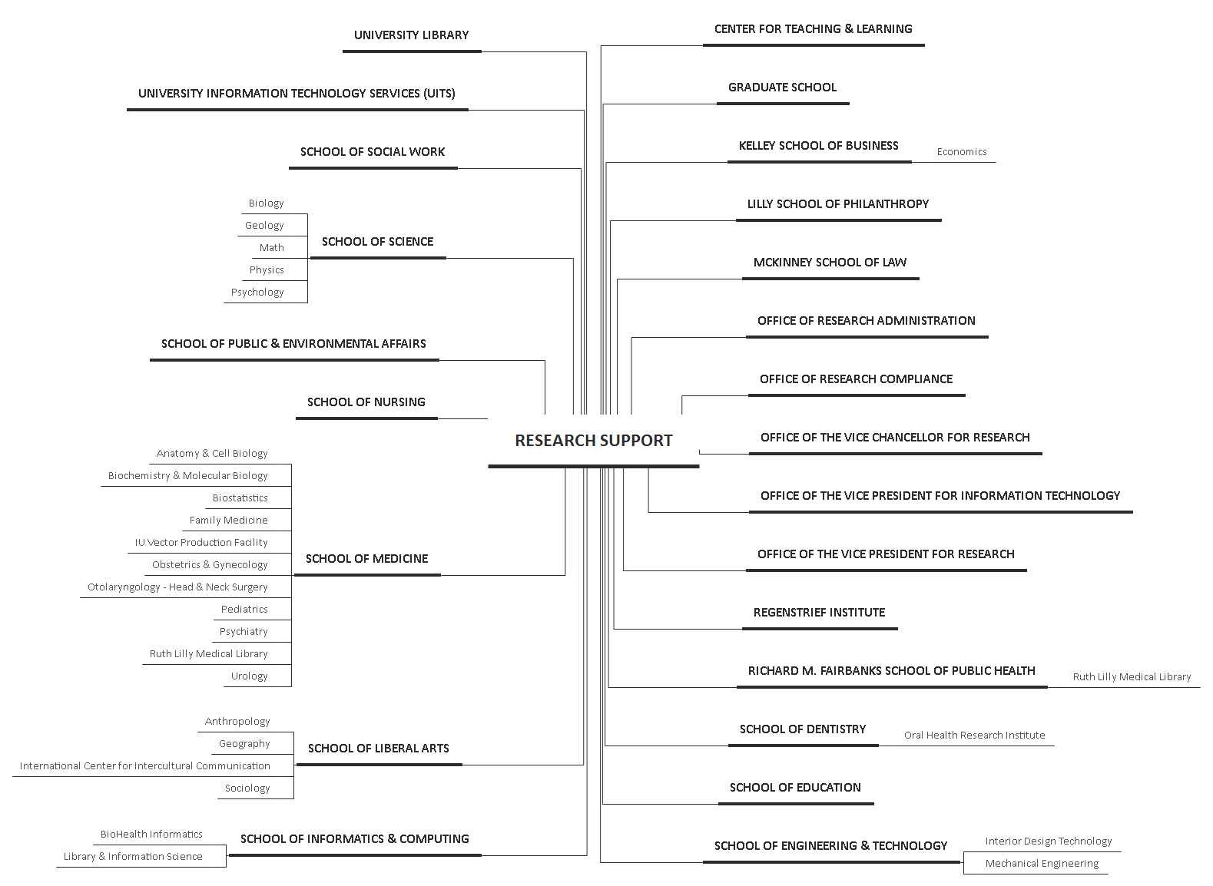

Figure 2: NSF Data Management Plan Requirement Workshops (2012-2015) Evaluation Summary
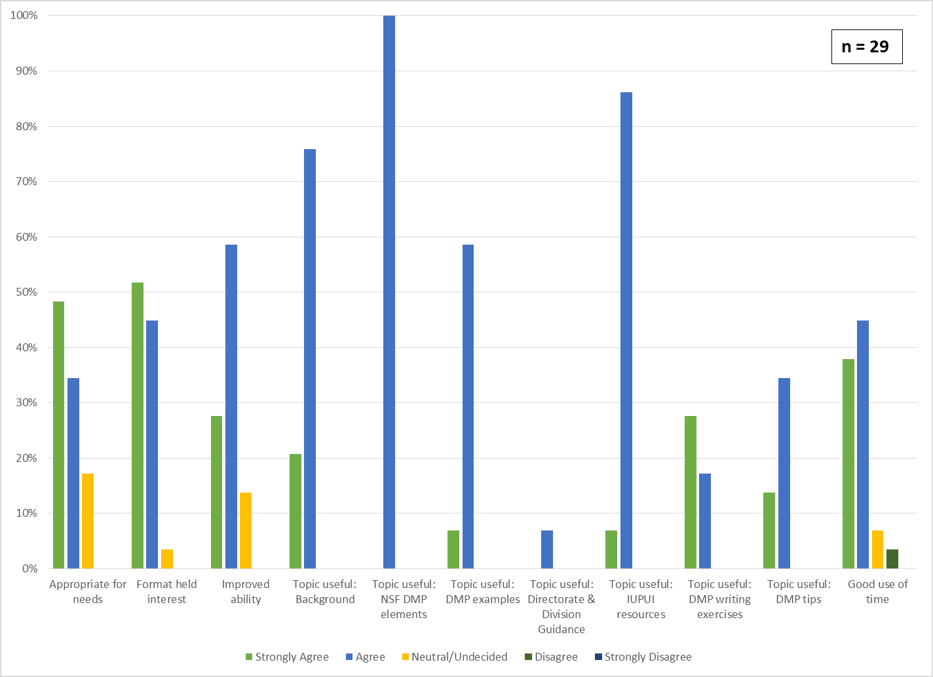

Table 2: National Science Foundation Data Management Plan Workshops (2012-2015) Evaluation Comments
Date | Comments
3/7/2012 | - N/A. This is my first NSF proposal so this is all very new.  - It was good, but not relevant to my specific needs.  - More discussions about real DMPs. Involving participants in the discussion.  - More general "best practices" with respect to data management in a variety of disciplines.  - I am a SLIS student so have questions pertaining to librarians role.  - Step through development of a DMP using a form - could then indicate where one would access tools  - Move to 1.5 hr format to cover more examples in detail
10/16/2012 | - Slower/more time? A ton of info…too much for short time period.
5/7/2013 | - But need higher levels of specificity for disciplines  - This was excellent. Thank you.  - Skip examples, options, some background, laser focus on what is required  - I think it can be shorter  - More examples of different types of data management plans
10/18/2013 | - Make it upfront as to who it will benefit. I was already aware of much of this. I'm working hard to increase awareness of this issues in our field.  - expand the time to make the workshop
3/4/2015 | - This needs to be in a quieter room - too much adjacent noise

Figure 3: SPEA V600 Data Management (Spring 2013) Session summary ratings
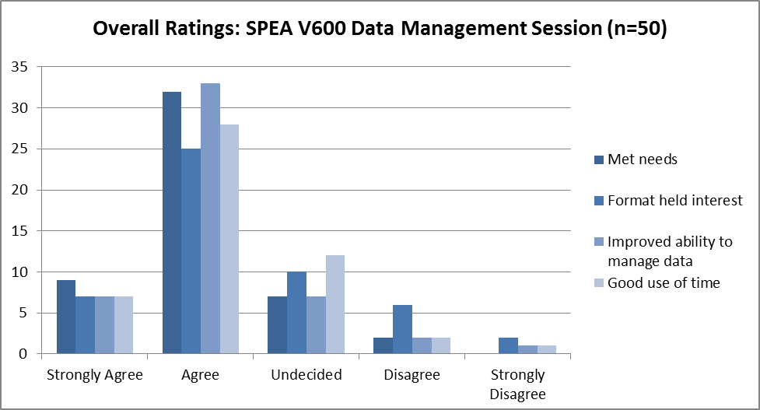

Figure 4: SPEA V600 Data Management (Spring 2013) Session Pre & Post skill ratings
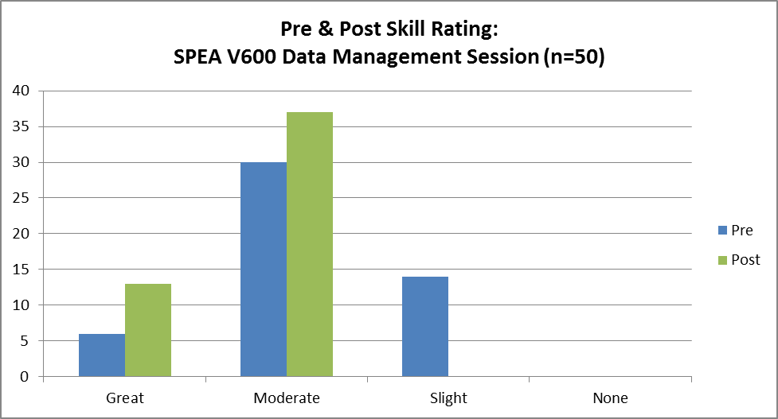

Table 3: SPEA V600 Data Management (Spring 2013) Student comments about the most valuable segment of the session
Most Valuable Segment (free text responses)
- how to track/not lose documents; resources - websites for SPEA related; format to save for Word docs because I have a Mac and it hates PCs and the feeling is mutual  - we aren't sure where we are in our data mining, so we aren't sure what we need  - documenting data planning process (2)  - very last slide  - data storage and security  - learning about IU's version of drop box  - research tips/data management tips  - search tools; using resources (3)  - data management (3)  - naming and organizing files (2)  - project management  - SPEA librarian portion (3)  - the search on PASI  - organizing and analyzing data  - data analysis & visualization (3) | - gave tips on report writing style  - data management - good habits and sources for finding data, resources  - practical tips for data management, introduction to library  - where to find data - useful links (5)  - suggestions for data storage/naming conventions (2)  - I enjoyed the overview of the process, understanding how data management fits into the process.  - data mgmt role sheets (2)  - project mgmt sheets  - last part -> watching a search be done. List of search engines  - everything about data (formatting, cleaning, label, etc.) (2)  - software to use (2)  - example of search best practices and database examples

Table 4: Research Data Services Workshops Offered 2012-2016
Date | Workshop Title | Attendees
01/25/12 | Meeting the NSF Data Management Requirement: What you need to know | 57
06/13/12 | Meeting the NSF Data Management Requirement: What you need to know | 13
10/16/12 | Meeting the NSF Data Management Requirement: What you need to know | 7
05/07/13 | Meeting the NSF Data Management Requirement: What you need to know | 7
10/08/13 | Meeting the NSF Data Management Requirement: What you need to know | 6
03/25/14 | Data Management Lab | 12
03/27/14 | Meeting the NSF Data Management Requirement: What you need to know | 14
10/01/14 | Practical Data Management Plans & Planning | 5
11/12/14 | Ensuring Data Quality | 8
02/24/15 | What you need to know: NIH policy on data sharing | 3
10/06/15 | Practical Data Management Plans & Planning | 13
11/03/15 | Keep your research data safe: Storage and archiving resources | 8
11/04/15 | Finding data for your research project | 6
12/07/15 | Keep your research data safe: Storage and archiving resources (presentation to Data Core at Regenstrief Institute) | 20
04/29/16 | Keep your research data safe: Storage and archiving resources (for CITO at IUB) | 10
 |  | 189
Figure 5: Data Management Lab Pilot: Summary Evaluations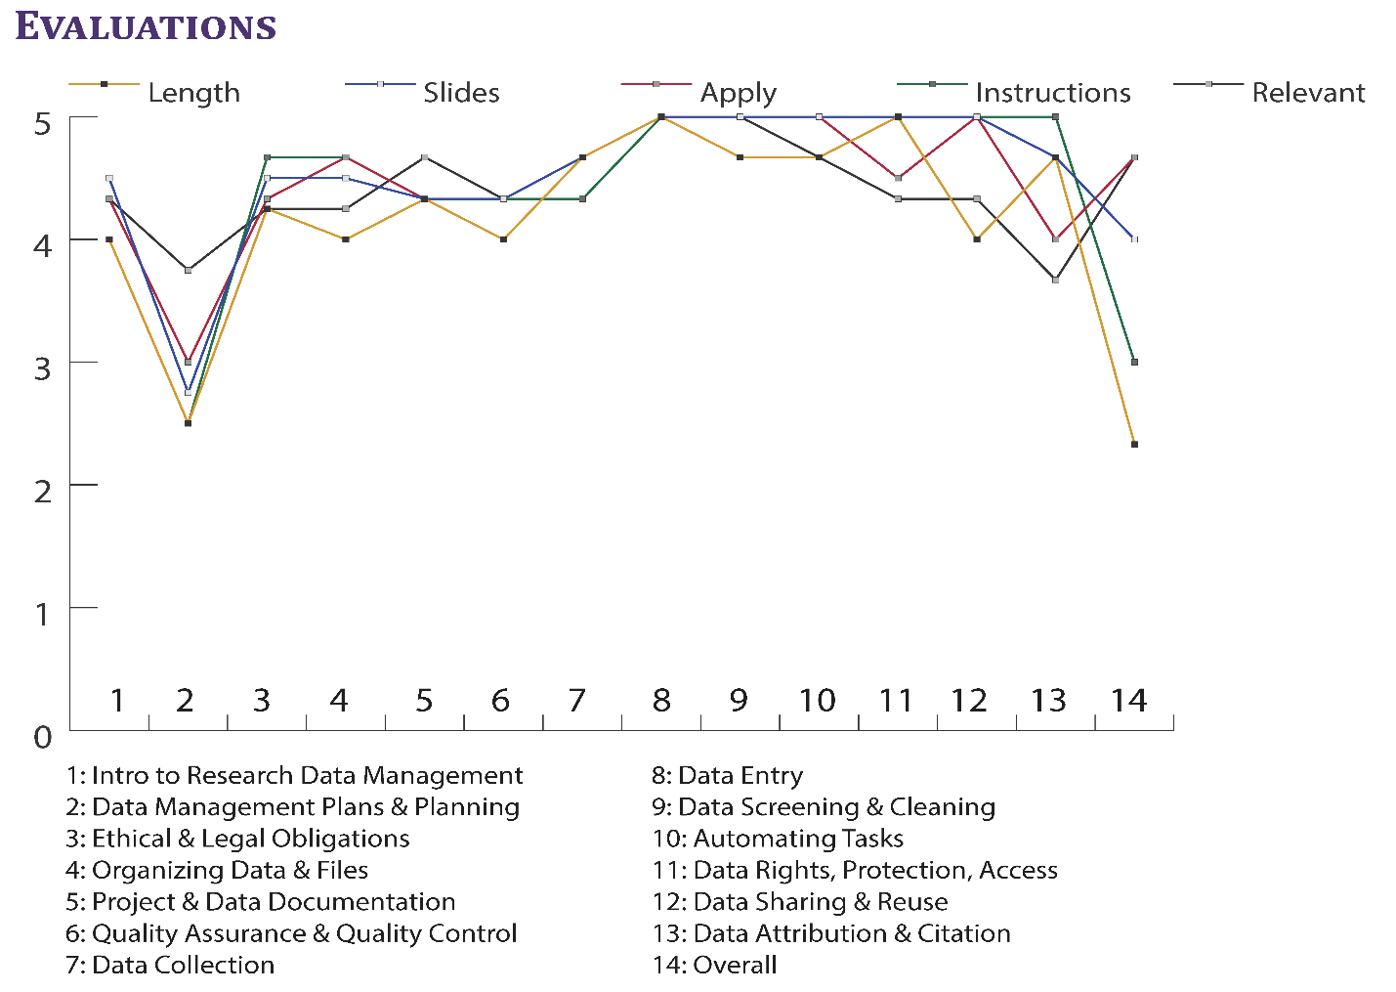
Source: Coates, H. L. (2014). Improving data management in academic research: Assessment results for a pilot lab. Poster presented at the annual meeting of the Medical Library Association, Chicago, IL. [Available at http://hdl.handle.net/1805/4.]
Table 5: Spring 2014 Data Management Lab: Pre-registration survey
What do you want to get out of this workshop series?
- Better skills for data management, especially setting up for dissertation and research beyond that
- Efficient management of raw data
- To better prepare and organize my information to write my paper.
- Gain a better understanding of data management strategies
- Learn everything I am supposed to know
- Effective data management techniques
- advanced data management skills
- direction and guidance
- Learning how to transfer this information in my research
- Experience to use in the workplace
- Better understanding of what steps I can begin taking while in graduate school to be best prepared when I enter a doctoral program
- Enhance my existing skills and learn new approaches or ideas.
- Increased knowledge on data research, management and organization to avoid future stress and anxieties.
- A plan for digital data management.
- Anything about Data Management would be valuable for me.
- Data Management Skills
- Practical data management for my dissertation
- a concrete way to manage and define my data found in the field
- Knowledge on professional data management
- An understanding of what to do with the data once collected.
- Learn how to deal with practical data
- Skills to build a robust data management plan for funding and everything else...
- Stronger data management skills for both finishing up my thesis, my job as a graduate research assistant, and my future career

Figure 6: Data Management Lab (Spring 2014) Summary Evaluations
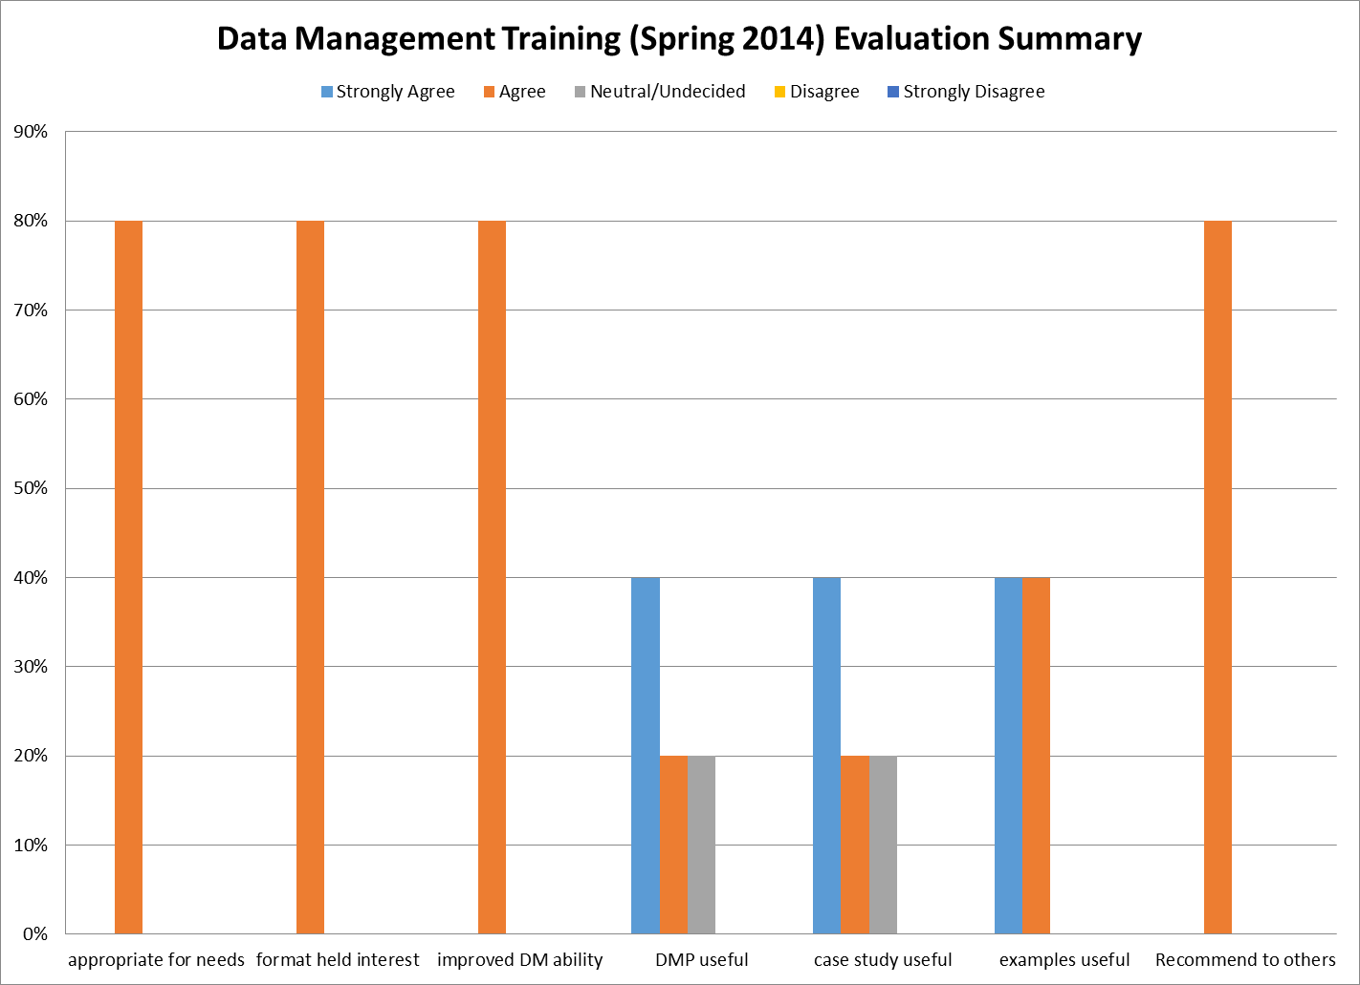

Table 6: Data Management Training (Spring 2014) Comments & Suggestions
Most Valuable | Improvements | Comments & Other Workshops
- Data management plans, and data citation and storage  - Storage/ backup plan  - All of session 1  - links, tools, and resources -- i am all about examples. | - I think ghese types of sessions should be the focus of seminars in the Public Health graduate program. The sessions and resources are outstanding. I plan to share this with our program leaderdhip.  - There might be a separate workshop for those who are conducting qualitative research. I think it would be most helpful for those who already have a research topic in mind, which was not my case.  - Hope to have it at a better time. Hope to have more discussions.  - This was a great session. I think you are really on to something that many people need. I love the idea of working on a data mgt plan, but was not quite ready. You could plan a simulation for those not ready to work on their own plans... I am going to suggest this and other topics you could teach in our program at the FSPH! | - Great job  - I'm glad I signed up for this workshop. The information will be useful in my career.  - You did a great job!

Table 7: Data Management Training (Spring 2014) Topic Usefulness
Topic | Attendees Found It Useful (%)
Introduction to Research Data Management | 80%
Data Management Plans & Planning | 80%
Ethical & legal obligations | 80%
Storage | 80%
Documentation | 80%
Organizing data & files | 80%
QA/QC | 80%
Data collection | 60%
Data coding | 60%
Data entry | 60%
Data screening & cleaning | 60%
Automation | 60%
Ethical & legal obligations | 60%
Data protection, rights, access | 60%
Data sharing & reuse | 60%
Data attribution & citation | 60%

Figure 7: Data Management Training (Fall 2014, Spring 2015, Fall 2015) Summary Evaluations
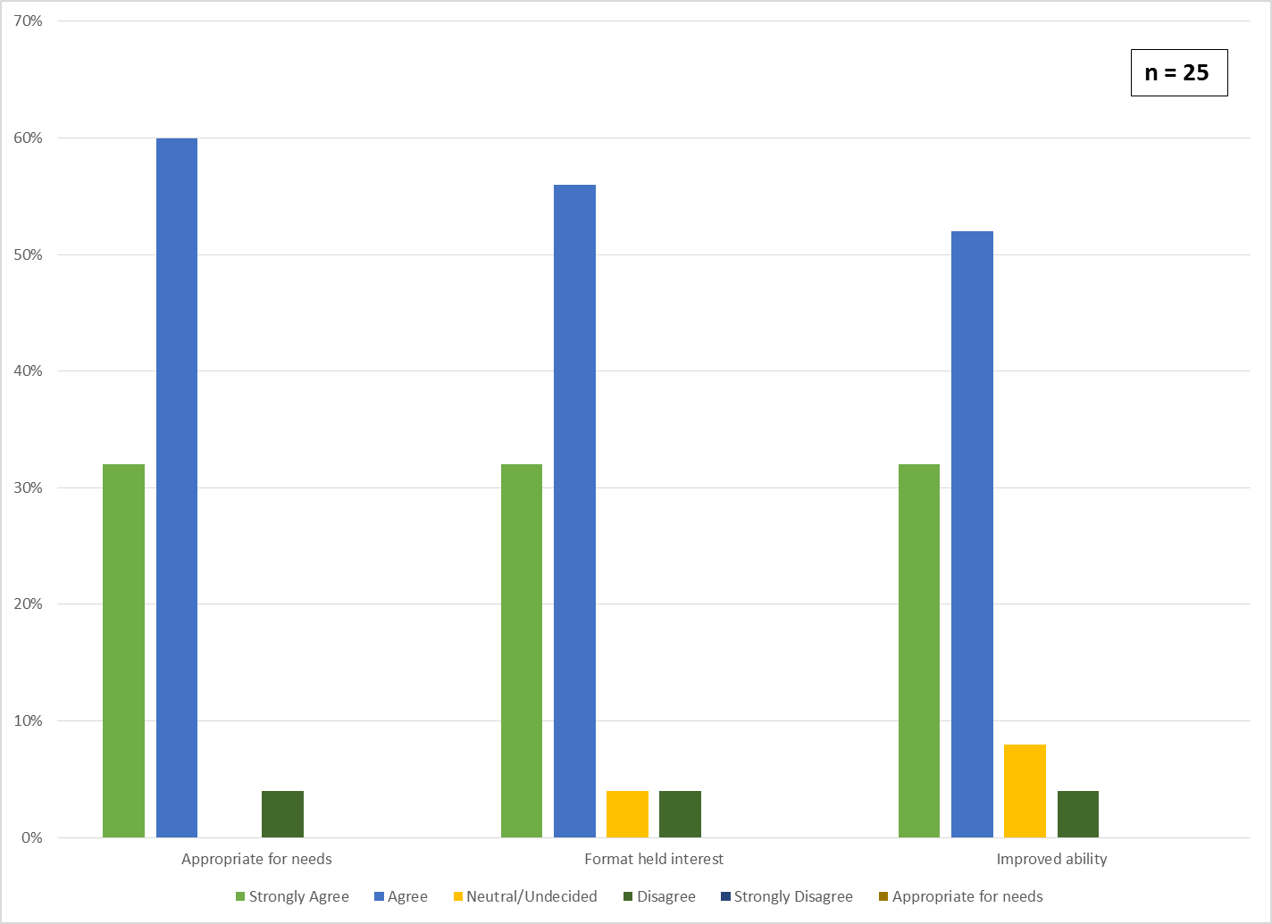

Table 9: Data Management Training (Fall 2014, Spring 2015, Fall 2015) Comments & Suggestions
Most Valuable | Improvements | Comments & Other Workshops
- the data inventory  - open discussion  - all of it  - open discussion  - many (unreadable) | - I think Heather does a great job with the series. Hopefully she will be able to collaborate with the Research Integrity Office to reach a broader research audience with her excellent content.  - Distance accessible.  - good fit for my needs  - already very well done  - Might have been me, but I'm not sure I understood a real distinction between codebooks and dictionaries... other than that dictionaries are generally meant for machines? also, I seemed to hear a distinction being made between applications of different data documentation for hard sciences vs social sciences but it sounded more like a distinction being made between quantitative and qualitative research?  - should be longer; I would like to have more help/advice in how to cleanly collect and store data with having multiple RAs work on the data.  - Information about DMP requirements was informative. Resources listed will be helpful. The activities in groups weren't that helpful. Since we have already thought a lot about what we are currently doing.  - Having it more targeted based on the participants (i.e., coordinator vs. administrator)  - longer - lots of info; Workshop gave great information, but not relevant to study I oversee. | - I don't know (yet) what I don't know yet  - attending data series  - Quality assurance, IRB documents, drafting, IU SOPs, and consenting workshops  - How to coordinate "Big Data" projects/research studies.  - data storage

Table 10: Summary of Research Metrics Workshops & Consultations
Workshops |  |  | Consultations  (# of Faculty)
Date | Workshop Title | Attendees
September-12 | Gathering Evidence to Demonstrate Impact & Reputation | 33 | Herron School of Art (1)  Richard M. Fairbanks School of Public Health (5)  School of Education (1)  School of Liberal Arts – English (1)  School of Liberal Arts – History (1)  School of Medicine: Department of Family Medicine (2)
September-13 | Documenting Impact and Reputation in Research in the Health Professions, Science, and Technology | 36
March-14 | Documenting Impact and Reputation in the Humanities | 24
November-14 | Impact Story webinar | 3
November-14 | Altmetrics for Public Scholarship & Civic Engagement | 22
March-15 | Altmetrics for Team Science/Collaborative/Translational Research (Adobe Connect Live) | 25
November-15 | Research metrics: Gathering evidence of impact | 22
February-16 | Create your online scholarly profile | 5
April-16 | IUPUC Increasing the reach of your scholarship workshop | 18
April-16 | Visualizing evidence for your P&T dossier | 7
Total Attendees |  | 195
Figure 8: Research Metrics Workshop (Fall 2015) Evaluation Summary
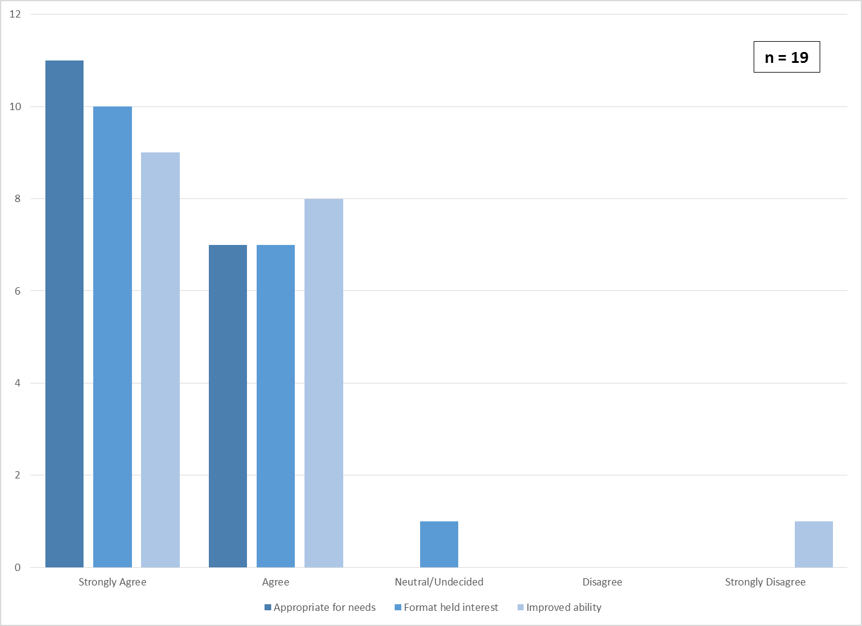

Figure 9: Research Data Services Web Content: Aggregated Page Views
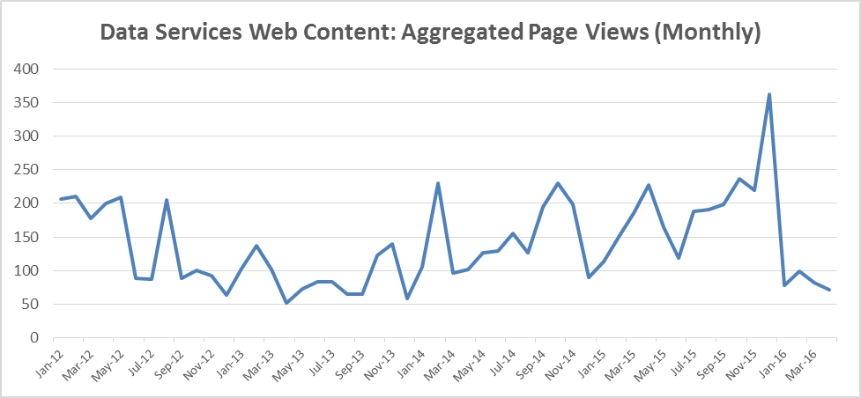
Table 11: Summary Statistics for Research Data Services Web Content by Page (January 2012 - April 2016)
Pages | Pageviews | Unique Pageviews | Avg. Time on Page (s)
/dataservices | 3145 | 2231 | 115.10
/datapreservation | 1275 | 786 | 175.88
/dataservices/ | 765 | 574 | 129.34
/nihdata | 213 | 191 | 310.05
/datasets | 149 | 149 | 129.86
/datasupport | 85 | 85 | 51.62
/dataservices?refsrc=email | 43 | 21 | 53.14
/datasets/ | 43 | 43 | 169.02
/publicaccessplansdata | 21 | 21 | 0.00
/nsfdmp | 2146 | 1403 | 144.75
 | 7842 | 5461 | 128 (average)

Table 12: Summary of service provided to the Richard M. Fairbanks School of Public Health (July 2012-April 2016)
Year | Course Instruction | Student Consultations | Faculty Consultations
2012 | N/A | N/A | N/A
2013 | PBHL H775: Doctoral Research Seminar in Health Policy and Management and Management  [8 students; 2 sessions]  PBHL A318: Environmental Health Science  [45 students; 2 session] | 67 | 2
2014 | PBHL H775: Doctoral Research Seminar in Health Policy and Management and Management  [8 students; 1 session]  Bridge Section EXPL1 [30 students; 2 sessions]  Bridge Section EXPL2 [30 students; 1 session]  PBHL S617 Health Promotion & Disease Prevention  [15 students, 1 session]  Design & Creation of 3 tutorials for the MPH program | 16 | 2 (multiple sessions)
2015 | PBHL 318 Introduction to Environmental Health  [55 students; 2 sessions]  PBHL H775: Doctoral Research Seminar in Health Policy and Management and Management  [10 students; 1 session]  PBHL 318 Introduction to Environmental Health  [55 students; 2 sessions]  PBHL S501: Social & Behavioral Aspects of Public Health  [40 students; 1 session] | 8 | 2 (multiple sessions)
2016 | E711 Applied Epidemiologic Research Methods  [7 students; 1 session] | 2 | 0

Figure 10: LibGuides Usage Statistics for Public Health Research Guides
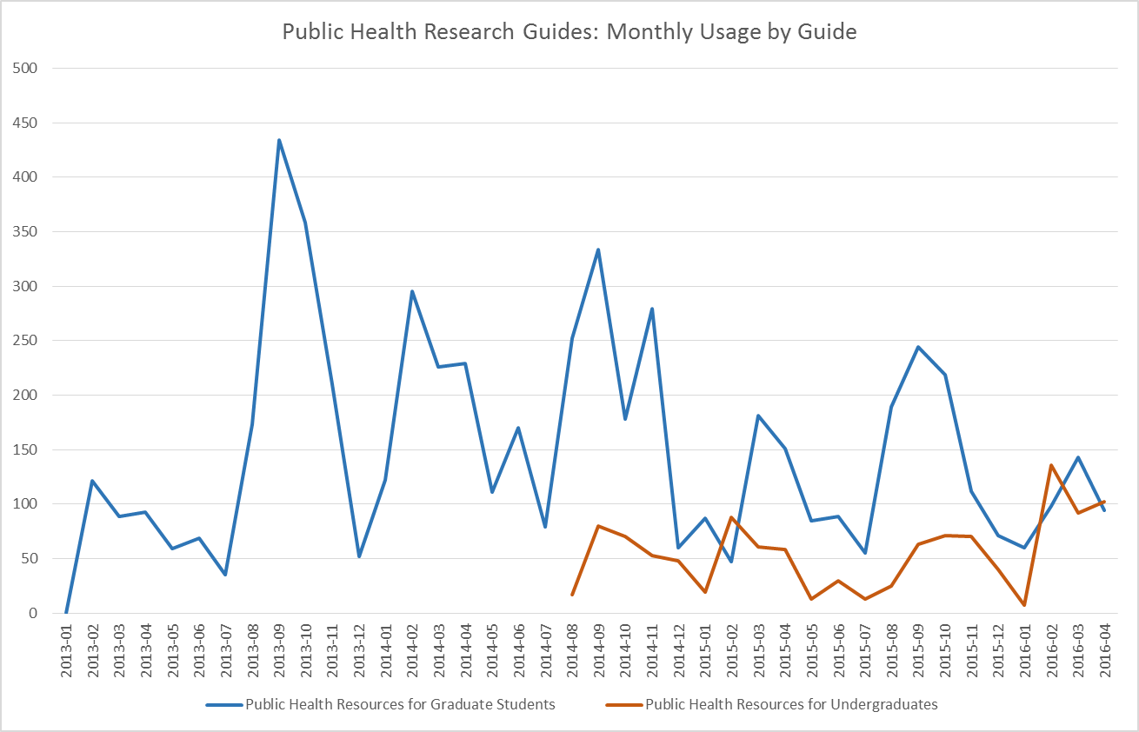
Total Views
Graduate 5,953
Undergraduate 1,156

