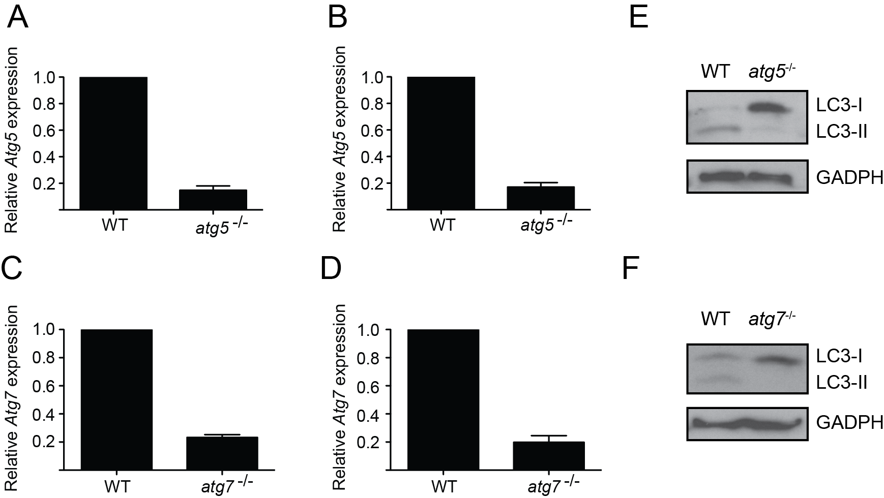

Figure S1. Relative expression of Atg5 and Atg7 in BMDMs. (A, B) Atg5 mRNA levels were assessed by real time PCR in CSF1- (A) and CSF2- (B) derived BMDMs using Hprt as a housekeeping control gene to allow for comparison. (C, D) Atg7 mRNA levels were assessed by real time PCR in CSF1- (C) and CSF2- (D) derived BMDMs using Hprt as a housekeeping control gene. (E, F) Expression levels of LC3-I and LC3-II in untreated CSF2-derived atg5^{-/-}(E) and atg7^{-/-} (F) BMDMs and their respective controls. Positions of LC3-I and LC3-II are indicated.

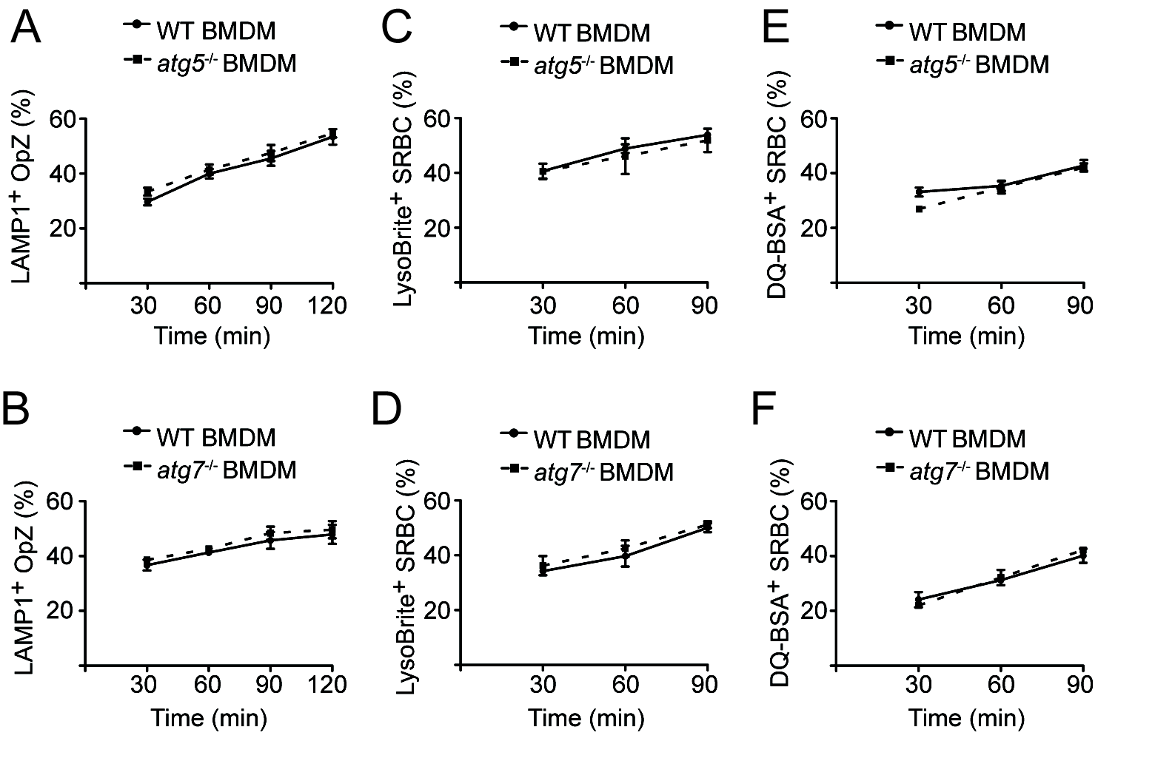

Figure S2. Phagosome maturation of IgG-coated particles is unaffected in autophagy-deficient CSF2-differentiated BMDMs. (A, B) CSF2-derived BMDMs were challenged with OpZ and fixed at 30, 60, 90, or 120 min, then stained for LAMP1 and OpZ. The percentage of LAMP1⁺ OpZ was enumerated in WT and atg5^{-/-} (B) and WT and atg7^{-/-} (C) BMDMs. At least 300 OpZ were counted per condition. (C, D) CSF2-derived BMDMs were incubated with LysoBrite for 30 min and then challenged with SRBC for 30, 60 or 90 min. The percentage of LysoBrite⁺ SRBC was enumerated in WT and atg5^{-/-}(C) and WT and atg7^{-/-} (D) BMDMs. At least 50 SRBC were counted per condition. (E, F) CSF2-derived BMDM were pulsed with DQ-BSA for 1 h, chased for 1 h in regular medium, then challenged with SRBC for 30, 60 or 90 min and imaged live. The percentage of DQ-BSA⁺ SRBC was enumerated in WT and atg5^{-/-}(E) and WT and atg7^{-/-} (F) BMDMs. At least 50 SRBC were counted per condition.

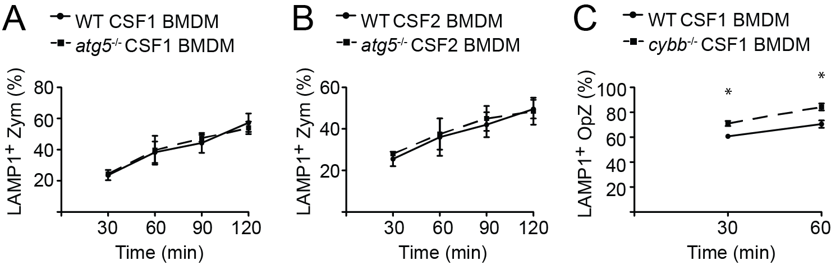

Figure S3. Phagosome maturation in Atg5-deficient and Cybb-deficient BMDMs. (A, B) CSF1- (A) and CSF2- (B) derived BMDMs were challenged with uncoated zymosan and fixed at 30, 60, 90, or 120 min, then stained for LAMP1. The percentage of LAMP1⁺ zymosan was enumerated in WT and atg5^{-/-} BMDMs. At least 300 zymosan particles were counted per condition. The experiment was performed twice (B). (C) CSF1-derived BMDMs were challenged with IgG-coated zymosan and fixed at 30 or 60 min, then stained for LAMP1 and zymosan. The percentage of LAMP1⁺ zymosan was enumerated in WT and cybb^{-/-} BMDMs. At least 100 OpZ were counted per condition. A p-value of less than 0.05 was considered statistically significant and is denoted by an asterisk (*).

