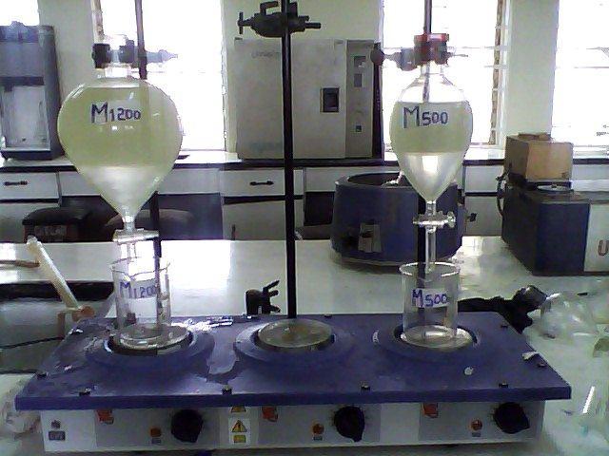
Plate 1 Washing of Biodiesel

