Supplemental Information (SI)

Deagglomeration testing of airborne nanoparticle agglomerates—stability analysis under varied aerodynamic shear and relative humidity conditions
Yaobo Ding¹, Burkhard Stahlmecke², Heinz Kaminski², Yunhong Jiang ³, Thomas A.J. Kuhlbusch^{2,4}, Michael Riediker^{1,5}
¹Institute for Work and Health (IST), Universities of Lausanne and Geneva, Route de la Corniche 2,
CH-1066 Epalinges, Switzerland
² Institut für Energie- und Umwelttechnik (IUTA), Bliersheimer Straße 58-60, 47229, Duisburg, Germany
³ Institute of Particle Science and Engineering, University of Leeds, LS2 9JT Leeds, UK
⁴ CENIDE, Center for Nanointegration of the University of Duisburg-Essen, Carl-Benz-Str. 199, 47057 Duisburg, Germany
⁵ SAFENANO, IOM Singapore, 30 Raffles Place, #17-00 Chevron House, Singapore, 048622, Singapore

Corresponding author: Michael Riediker; Tel: +65 6809 6249; E-mail address: Michael.Riediker@alumni.ethz.ch

Figures: 5
Tables: 1
Pages: 5

(a)
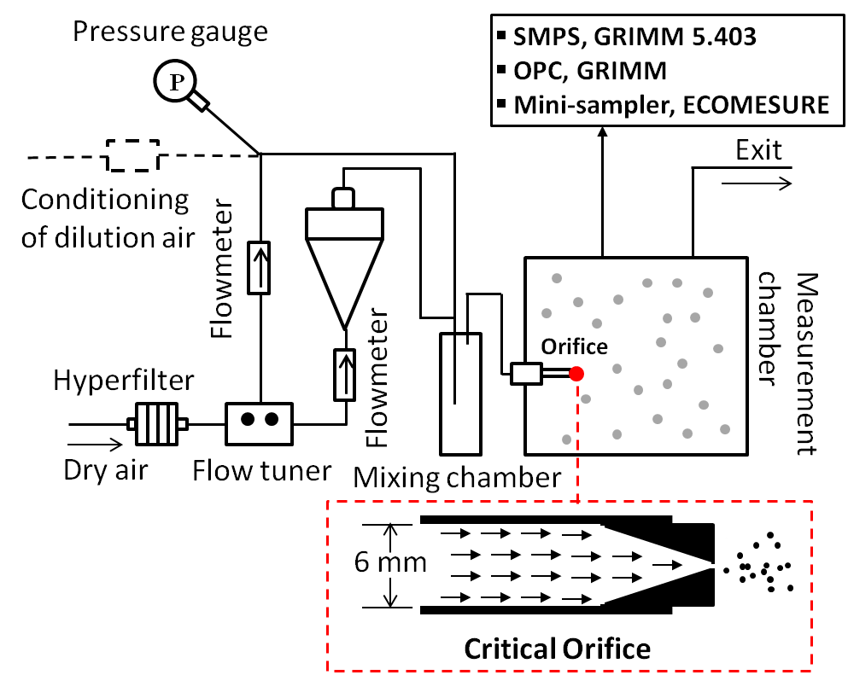
(b)
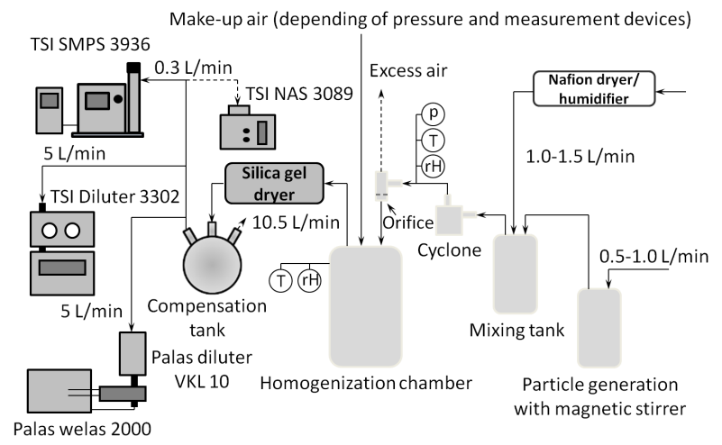
Figure S1. Schematic diagrams of the funnel (a) and the stirrer systems (b) used for the deagglomeration tests
 | Hydrophobic TiO₂ |  | Hydrophilic TiO₂
RH/∆P | r_{s} | p | r_{s} | p
0 | -0.9418 | <0.0001 | -0.9383 | <0.0001
25% | -0.942 | <0.0001 | -0.6913 | 0.0004
50% | -0.942 | <0.0001 | -0.8727 | <0.0001
75% | -0.8425 | <0.0001 | -0.9304 | <0.0001
0 kPa | -0.0664 | 0.7322 | 0.8638 | <0.0001
50 kpa | 0.9684 | <0.0001 | 0.9055 | <0.0001
100 kpa | 0.8633 | <0.0001 | 0.9463 | <0.0001
r_{s}, Spearman’s rank coefficient, positive correlation (+) and negative correlation (-); p, statistical significance.
Table S1. Correlations of mean particle size to pressure drop under four different RH values (Figure 3 a,b) and correlations of mean particle size to RH under the three pressure drop conditions (Figure 3 i,j).

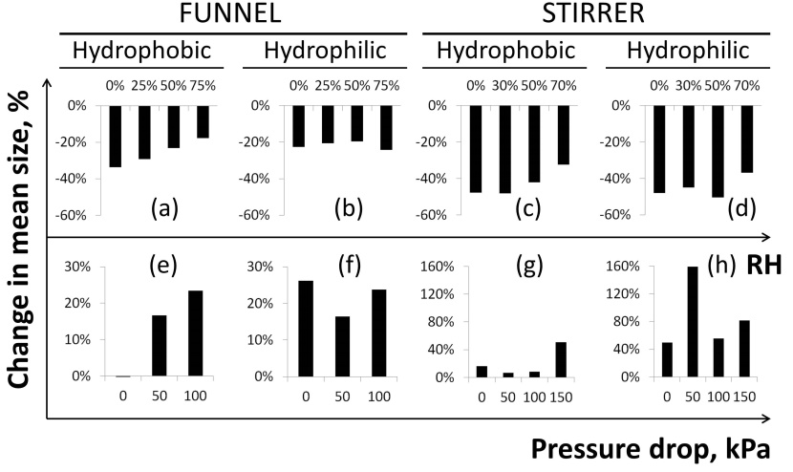
Figure S2. Influence of relative humidity (a–d) and pressure drop (e–h) on change in mean particle size. The results show the increase (+) or reduction (-). Charts a–d: total reduction in particle size by increasing pressure drop from 0 to 100 (funnel) or to 150 kPa (stirrer), under different humidity conditions; e-h: total increase of particle size by increasing relative humidity from 0 to 75% (funnel) or 70% (stirrer), under different pressure drops.
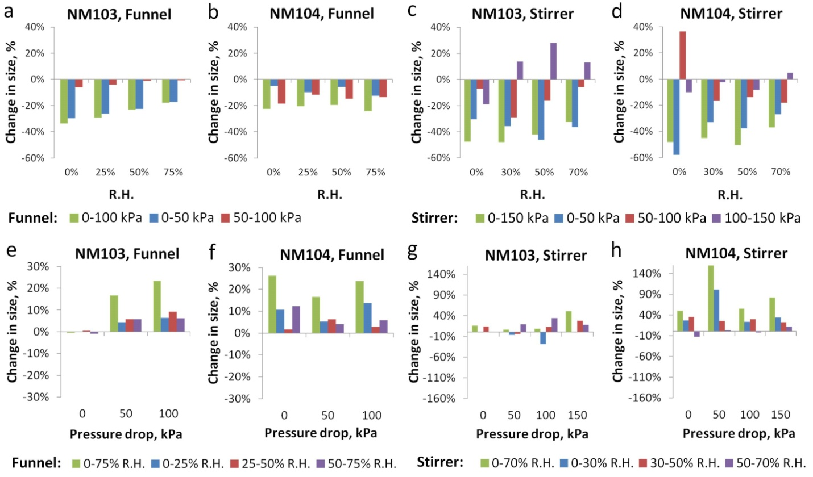
Figure S3. Influence of pressure drop and relative humidity on mean particle size. The results show the relative change of mean particle size (in % between indicated pressure drop or RH conditions)
Figure S3: For hydrophilic TiO₂ NM-103 particles in the funnel system, the effects of a pressure drop from 0 to 50 kPa were much more significant than the effects from 50 kPa to 100 kPa (a, comparing blue to red rectangles). However, for hydrophobic TiO₂ NM-104 particles in the funnel system, average mean particle sizes decreased more with a pressure drop from 50 to 100 kPa than with one from 0 to 50 kPa (b, comparing blue to red rectangles). In the stirrer system, the pressure drop effects for both materials were most prominent in the 0–50 kPa range (c and d, comparing blue to red or purple rectangles). The analysis shows that in order to achieve the same degree of size reduction, the hydrophilic particles require a higher pressure drop than for the hydrophobic ones. This is the case for the aerosol particles generated in the funnel system. For larger particles obtained from the stirrer system, most of the size reduction effect could already be observed in the 0 to 50 kPa pressure drop range, for both two materials.
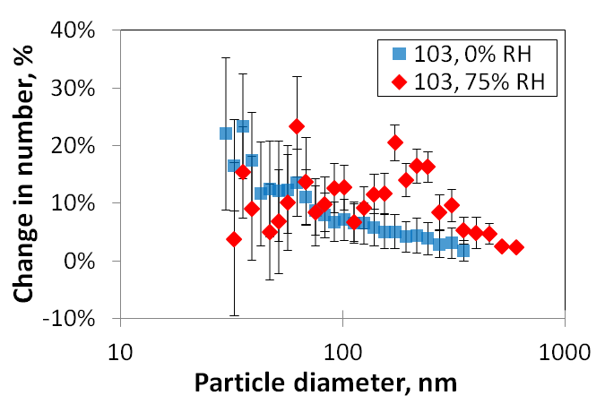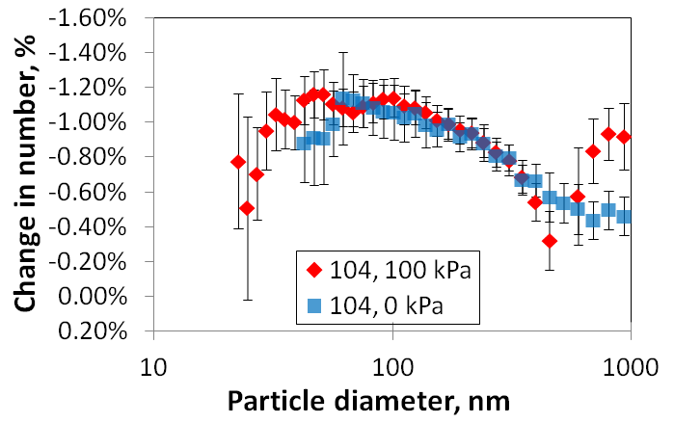
Figure S4. Comparison of changes in particle number in individual size channels (measured by SMPS) by increasing pressure drop at 0% and 75% RH conditions (left) and by increasing relative humidity at 0 and 100 kPa conditions (right). Only statistically significant values are plotted (p < 0.05). Error bars represent 95% confident intervals. Data are from the funnel system for the hydrophobic (NM-103) and hydrophilic (NM-104) TiO₂ aerosols.

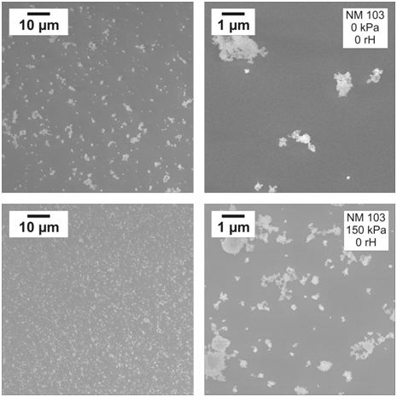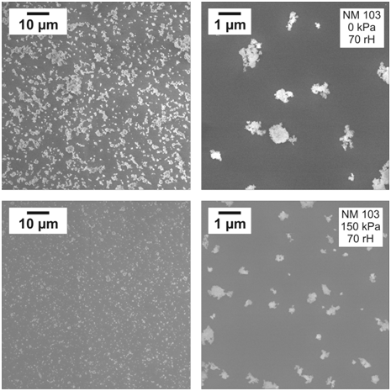
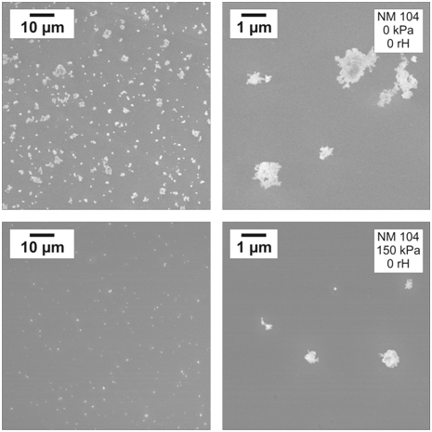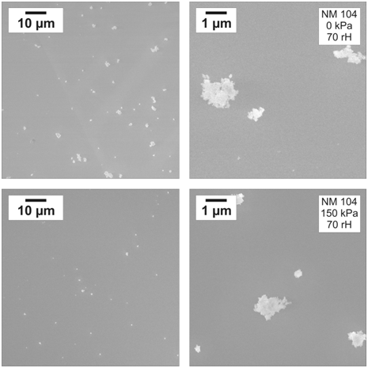
Figure S5. Scanning electron microscope observations of particle morphology in the stirrer system.

