Supplementary
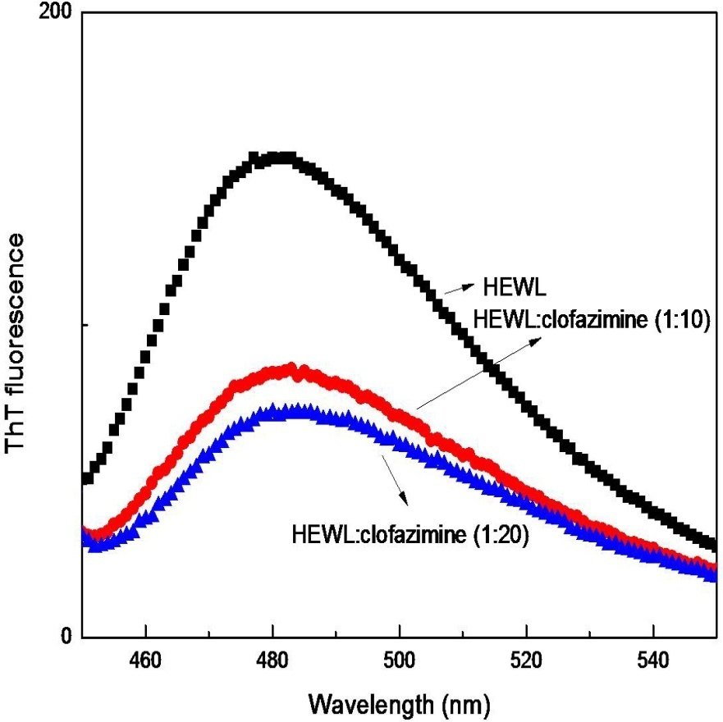
Figure S1: Inhibition of thermally induced amyloid formation in HEWL by clofazimine. ThT fluorescence intensity profile in the absence and in the presence of increasing concentrations of clofazimine, clofazimine to HEWL molar ratio of 10 and 20. At pH 7.4.

