Krzywoszynska, A., Buckley, A., Birch, H., Watson, M., Chiles, P., Mawyin, J., Holmes, H., and Gregson, N. (2016). Co-producing energy futures: the impacts of participatory modelling. Building Research & Information. DOI:

SUPPLEMENTARY DATA: Appendices A & B

Appendix A:
The Five Pathways

Details of the work within five thematic visions for local energy futures in Stocksbridge, UK developed by the residents and academics
- ‘Sustainable transport’ group: developing electric vehicle public transport.
This group engaged in a re-imagining of the local public transport system. The motivation for this groups was a perceived poor connectivity between Stocksbridge and Sheffield; the challenges the topography of Stocksbridge (steep sided valley) presented to older residents; an interest in increasing cycling infrastructure. The group explored how the local transport system could be improved through the use of renewable energy, and it saw some involvement from the local industry representatives. The ideas explored by the group over the duration of the project included:
- The use of electric bicycles with renewable energy charging stations;
- Introduction of renewable energy charging station for electric vehicles;
- Renewable energy powered community-owned bus;
- Renewable energy powered and community-owned volunteer taxi system.
No coherent vision for a future renewable-energy powered transport in Stocksbridge emerged out of these discussions. In time the participants’ interest in this initiative waned; the transport theme was continued by a new participant with a pre-existing interest in revitalising the rail link between Stocksbridge and Sheffield (http://donvalleyrailway.org/). This proposal was included in the final vision and included in the scale model. See also poster ‘Stocksbridge by train’.
- ‘Meals from steel’ group: local food production.
Participants involved in this group explored ways of producing food locally, in a sustainable manner, and for the benefit of the wider community. The ideas explored by this group focused on a revitalisation of non-productive industrial land through greenhouse and hydroponic cultivation. Technological involvement initially focused on semi-transparent photovoltaic panels, but was later replaced by the re-use of waste heat from the local steelworks. This group saw a strong involvement of the steelworks representatives, and produced detailed plans of desirable food production scenarios. However the composition of the group changed over time, and the food focus was in time down-played. The utilisation of waste heat was instead incorporated into the visions of the ‘energy balance’ group (see below). See also poster ‘Recovering heat from TATA Steel’.
- ‘Sustainable community buildings’ group: increasing sustainability of local community buildings.
This group engaged with the theme of increasing energy sustainability of local community buildings, specifically community halls. The work of this group was influenced by the closure and subsequent volunteer takeover of the local leisure centre. The participants in this group decided to focus their efforts on a small community hall (the Inman Pavillion) near the leisure centre, and to use it as a testing ground for visioning energy sustainability solutions in order to both improve the sustainability of the hall, and provide useful ideas to the leisure centre volunteers. The participants in this group involved the committee responsible for the upkeep of the Inman Pavillion, and engaged a group of University of Sheffield MA level architecture students to further help with the visioning process (https://www.sheffield.ac.uk/architecture/march/liveprojects). Eventually one of the participants took lead in translating these ideas into reality and became actively involved in the regeneration and running of the community hall. See also poster ‘The Inman Initiative’ and ‘Sustainable Leisure Centre’.
- ‘Energy balance’ group: meeting local energy demand through renewable energy generation.
Meeting local energy demand through sustainable and locally produced energy was a key interest for the participants involved in this group. The group explored the use of local natural (wind, rivers, sun, biomass) and technological (waste heat from a local steel works, heat from flooded mine shafts, local reservoir) resources for energy generation and conservation, with the aim of achieving energy independence for Stocksbridge, and increasing equitable access to energy in the town. The visions of this group was modelled using a series of numerical scenarios (see supplemental material), and their work formed the backbone of the physical model of the town. Key participants in this group went on to form Renewable Upper Don Energy, a community group which continues work on energy issues in Stocksbridge at the time of writing (https://www.facebook.com/Rude2u/). See also posters ‘How can Stocksbridge become more energy independent?’, ‘What is biomass?’, ‘Ground heating’; ‘Community hydro power’; ‘Electricity from the sun’; ‘Electricity from wind power’ and ‘Zero Carbon Homes’.
- ‘Education’: sustainability education in Stocksbridge.
This group was concerned with enhancing awareness and practices of energy sustainability in Stocksbridge through adult and child education. Early on in the project the participants of this group redefined their role as exploring the potential for communicating the visions being developed in the other four projects.

Appendix B:
Modelling community energy:
the energy independence model

A numerical model to investigate the potential for locally generated electricity from wind and solar PV to fulfill local electricity demand was created. Representative half hourly time series of electricity generation for different wind and PV installations (constituted with different turbine sizes) were constructed. Half hourly wind speed and irradiance data were taken from the local UK Royal Meteorological Office ground based weather measurement station. State of the art load factors (for photovoltaic panels) (Taylor, Leloux, Everard, Briggs, & Buckley, 2013) and empirical algorithms for turbine performance (Deshmukh & Deshmukh, 2008; Karki, Hu, & Billinton, 2006) converted the raw resource data into representative power generation time series. Wind speed was also adjusted for the hub height using the algorithms of De Chant (2005), and a temperature dependence of the wind shear coefficient (the rate at which the wind speed increases with altitude) taken from Rehman et al. (2005).
Half hourly local aggregated commercial and domestic electricity demand data for Stocksbridge were simulated using standard UK domestic and commercial demand time series and assuming a total yearly demand in Stocksbridge of 27 GWh (DUKES, 2013). The assignment of demand between commercial and domestic sectors followed government records (ibid.). Subtracting the demand from the generation for each half hour of the year gives a time series of either underproduction, over production or precise matching between generation and demand. The resilience of the local renewable energy generation was then characterized hour by hour by both under production and overproduction. The total number of hours of underproduction in the year were summed to give the index “loss of load proportion” (LOLP), and the total number of hours of overproduction were summed to give the index “loss of energy proportion”, (LOEP). The overall resilience of the local electricity system was then characterized as the independence proportion (IP):

$IP=1-LOLP-LOEP$ [1]

IP was calculated for different PV and wind deployment scenarios (see Table 1) with varied locations, technologies and mix of solar and wind generation. Alternative resilience indices using integrated energy either not-used or not-produced can also be calculated, but for community based resilience it was deemed more appropriate to calculate the proportion of time, rather than energy for which the system is independent.
However, in addition to the deployment of solar and PV, battery (Lead acid (PBA) and Lithium ion (LION)) and pumped hydro storage was incorporated into the model. Building on existing resources indicated by the participating residents, the pumped hydro storage was proposed through the adaptation of a cylindrical water storage tank sited at the top of the steep south-facing slope of the Stocksbridge valley (see location D in figure S1). In the case of storage being included, a time step simulation was used where half hourly overproduction of energy was stored for use at times of under production. Loss of load and loss of energy then occur only once the battery is either depleted or fully charged. The additional energy losses for the charging and discharging processes were calculated as appropriate for the particular storage technologies (self-citation to be inserted after review).

The incorporation of energy storage brought the additional problem of how to optimize the size of storage for a particular deployment scenario (see table S1). Optimization was done by considering the overall lifecycle energy costs (the embodied energy of a particular scenario) compared with the local energy generated and then used in a particular scenario. For different deployment scenarios and different storage sizes, along with the calculation of independence proportion (IP), the lifecycle data was used to calculate an energy return on investment (EROI) for the particular scenario.

$EROI=\frac{E_{used}}{E_{in}n_{G}}$ [2]

Where E_{used} is the energy used locally, E_{in} is the lifecycle embodied energy and n_{G} is the average efficiency of the EU-25 electricity grid (Raugei, Fullana-i-Palmer, & Fthenakis, 2012) (to scale the embodied energy used to produce the technology appropriately; the scaling does not affect the size of the storage capacity determined through the optimization).

Figure S1. Aerial photograph of Stocksbridge town showing different deployment locations. A – Locations for PV roofs, B – locations for wind turbines, C- locations for PV fields, D – location of pumped hydro storage. Reproduced from Google maps.

Table S1. Technology deployment scenarios. The maximum possible deployment capacity of the different available technologies are shown, however the actual deployment of the technology mix was optimized for each scenario for different capacities and storage contributions as described in the text and table 2.

Maximum capacities  Scenarios | Wind / MWp | PV roofs / MWp | PV fields / MWp | Total land use / Ha | Total capacity / MWp
Wind 1: Small 100 kW turbines | 7.2 | 2 | 0 | 49 | 9.2
Wind 2: Medium 500 kW turbines | 10 | 2 | 0 | 50 | 12
Wind 3: Large 1.2 MW turbines | 7.2 | 2 | 0 | 34 | 9.2
PV (only): Roofs and fields | 0 | 2 | 54 | 40 | 56
Hybrid: PV roofs, fields and 500 kW turbines | 10 | 2 | 13 | 60 | 25

Table S2. Operating characteristics of the different storage technologies considered.

 | Lead acid  (PbA) | Lithium ion  (Li-ion) | Pumped hydro (PHS)
Efficiency | 75% ¹ | 90% | 75%
Depth of discharge / % | 50% ² | 90% | 100%
Embodied energy kWh/kWh | 321 ³ | 454 | 104+0.007E * ⁴
Lifetime / years | 4 ¹ | 15 | 60 ⁴
¹ Ryadh et al. (2005), ² Kaldellis (2007), ³ Barnhart et al. (2013), ⁴ Denholm (2004), * where E is the energy cycled over full lifetime in kWh

Table S3. Operating characteristics of the different wind turbines considered.
 | Small 100 kW  Air 19/100 | Medium 500 kW  Nordtank NTK | Large 1.2 MW  Autoflug A 1200
Hub Height / m | 25 | 35 | 60
Blade diameter / m | 19 | 37 | 61
Cut-in wind speed / m/s | 3.5 | 4 | 4
Rated wind speed / m/s | 14 | 15 | 13
Cut-out wind speed / m/s | 24 | 25 | 25
Maximum number of turbines in locations B (figure 1) | 72 | 29 | 6

The product IP and EROI was then used to optimize the storage capacity for each scenario. Since IP increases towards a limit with increasing storage capacity, and EROI reduces to zero with increasing storage capacity (self-citation to be inserted after review) the product reaches a maximum when an optimum compromise between storage and embodied energy investment is reached.

Five different scenarios (and different storage technologies) were investigated using the numerical simulation. These scenarios reflected discussions within the ‘energy balance’ group concerning the use of both wind and PV power in Stocksbridge. The south facing slope was identified as a potentially effective space to deploy solar fields (locations C in figure S1), while there is already a substantial penetration of PV roofs (locations A in figure 1) in the town. An upper limit of 12% penetration was place on rooftop PV. The northern ridge (locations B in figure S1) bounding Stocksbridge with Barnsley parish has already been exploited by local farmers for wind turbines, and while opposition to the expansion of wind was voiced by some members of the collaboration, on balance we chose to include three different turbine sizes across these locations in the simulation work. The performance characteristics of the different sized turbines are detailed in table 2. The final land use in the scenarios is a pumped hydro storage system deployed between upper and lower artificial lakes from the valley floor to the ridge top (vertical drop of 100 m). An existing pipeline between the steelworks in the valley floor and a water storage facility on the ridge was discussed in the ‘energy balance’ group sessions and the location D in figure 1 is an expansion of this existing infrastructure.

Figure S2 shows the resulting independence proportion (IP) as a function of the total generation capacity for the different scenarios and different storage technologies at the EROI.IP optimized storage capacities. The wind based scenarios lead to higher independence at lower installed capacities than the PV dominant scenarios. There is not a substantial difference in independence between the small, medium or large turbines. Interestingly, looking at table 4, the energy return on investment of the small turbine scenario (EROI ~ 28) is around 20% lower than the large turbine (EROI ~ 38) scenario. The hybrid scenarios have maximum independence proportion slightly higher than the wind dominated systems and the very best IP is for the hybrid scenario with pumped hydro storage. Importantly, a local energy independence of 73% is achieved meaning a very significant contribution to the overall local energy demand through a very achievable deployment plan. The PV only scenario does not show a maximum value for IP and further deployment continues to improve independence. We believe that the increasing PV deployment and high storage capacity starts to achieve day-night energy balancing into the shoulder seasons when PV generation starts to reduce. The significant over-production in the summer must be outweighed by the increased independence in the shoulder seasons. However (Table 4) the EROI when the PV component is increased drops markedly (from approximately 30 to less than 10). In terms of both high independence and high energy return on investment, wind dominated scenarios are significantly better than solar.

Table S4. Results of optimized deployment scenarios for the three different storage technologies.
Scenario | Generation capacity / MW | EROI | IP | Storage capacity  / MWh | Storage technology
Wind 1 – small | 6.6 | 38.5 | 0.45 | 74 | PbA
Wind 2 – med | 7.2 | 27.8 | 0.42 | 98 | PbA
Wind 3 – large | 7.8 | 26.5 | 0.44 | 123 | PbA
PV only | 18.2 | 5.5 | 0.43 | 184 | PbA
Hybrid | 13.6 | 13.7 | 0.56 | 172 | PbA
Wind 1 – small | 6.6 | 38.6 | 0.49 | 37 | Li-ion
Wind 2 – med | 7.8 | 26.2 | 0.49 | 61 | Li-ion
Wind 3 – large | 7.8 | 26.7 | 0.49 | 61 | Li-ion
PV only | 23.7 | 5.5 | 0.51 | 86 | Li-ion
Hybrid | 13.6 | 14.6 | 0.59 | 74 | Li-ion
Wind 1 – small | 7.8 | 40.2 | 0.67 | 108 | PHS
Wind 2 – med | 8.4 | 30.4 | 0.61 | 120 | PHS
Wind 3 - large | 8.8 | 31.6 | 0.61 | 108 | PHS
PV only | 18.2 | 6.1 | 0.45 | 96 | PHS
Hybrid | 13.6 | 15.8 | 0.67 | 132 | PHS

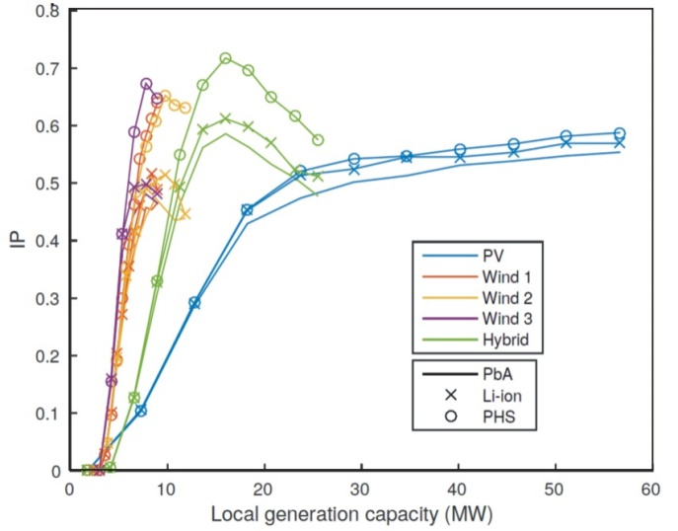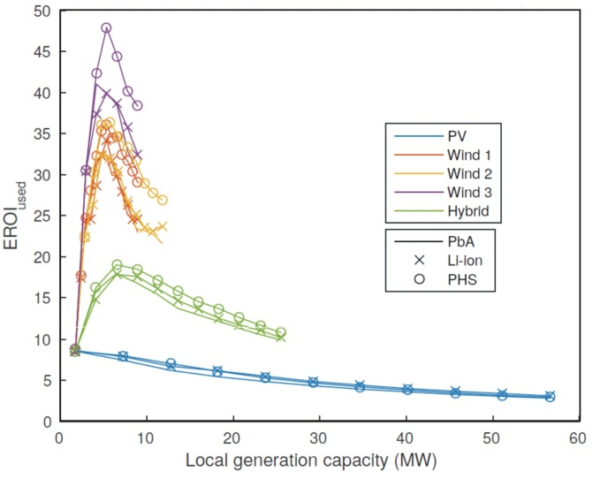

Figure S2. The relationship between the independence proportion (IP), energy used return on investment (EROI) and the total installed capacity for particular deployment scenarios and storage technologies.
Left: The higher storage capacity of pumped hydro (at lower energy cost) leads to higher overall independence. Wind dominated scenarios reach higher independence at lower installed capacities dues to higher load factors. Right: Significantly higher EROI is reached by wind dominant scenarios.

References
De Chant, L. J. (2005). The venerable 1/7th power law turbulent velocity profile: a classical nonlinear boundary value problem solution and its relationship to stochastic processes. Applied Mathematics and Computation, 161(2), 463-474.
Deshmukh, M., & Deshmukh, S. (2008). Modeling of hybrid renewable energy systems. Renewable and Sustainable Energy Reviews, 12(1), 235-249.
Karki, R., Hu, P., & Billinton, R. (2006). A simplified wind power generation model for reliability evaluation. Energy conversion, IEEE Transactions on, 21(2), 533-540.
Raugei, M., Fullana-i-Palmer, P., & Fthenakis, V. (2012). The energy return on energy investment (EROI) of photovoltaics: Methodology and comparisons with fossil fuel life cycles. Energy policy, 45, 576-582.
Rehman, S., & Al-Abbadi, N. M. (2005). Wind shear coefficients and their effect on energy production. Energy Conversion and Management, 46(15), 2578-2591.
Taylor, J., Leloux, J., Everard, A. M., Briggs, J., & Buckley, A. (2013). Monitoring thousands of distributed PV systems in the UK: Energy production and performance.

