Journal of the American Chemical Society

Selective Anion Binding by a Macrocycle

with Convergent Hydrogen Bonding Functionality

Kihang Choi and Andrew D. Hamilton*

Department of Chemistry, Yale University, New Haven, Connecticut 06520

Supporting Information

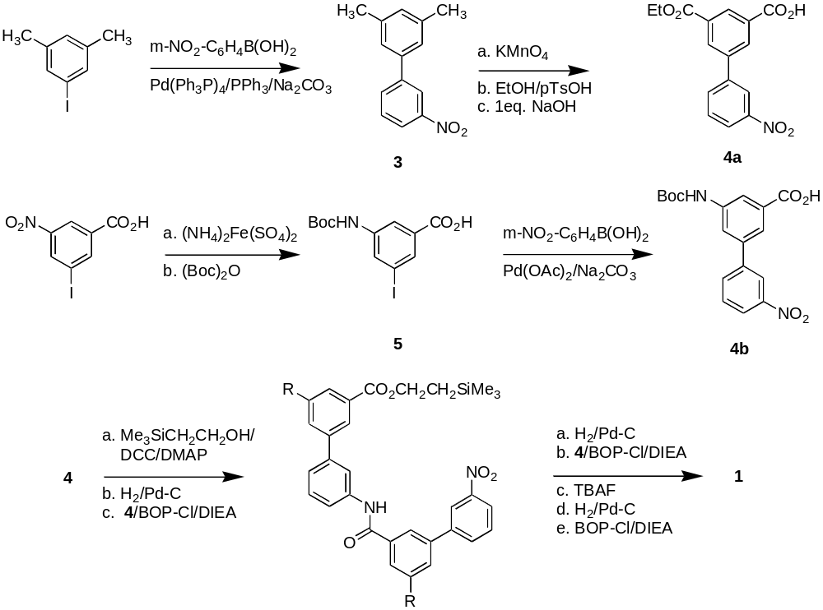

3,5-Dimethyl-3’-nitro-1,1’-biphenyl (3). 3-nitrophenylboronic acid (3.65g, 1.06 eq) was dissolved in 50ml toluene/15ml EtOH. 3,5-dimethyliodobenzene (3ml, 20.6 mmol) and Na₂CO₃ solution (2N in H₂O, 25ml) were added and then followed by Pd(Ph₃P)₄ (0.80g, 3.3 mol%). The reaction mixture was refluxed for 3hr and then allowed to cool down to RT. The mixture was partitioned between ether and water. The organic layer was washed with sat. NaHCO₃ sol. and brine and dried over anhydrous Na₂SO_{4.} After filtering off the solid, the solvent was removed by evaporation. The residue was purified by SiO₂ chromatography (hexane:EtOAc 19:1) to give the product 3 as a white solid (4.4g, 94%). ¹H NMR (300 MHz, CDCl₃) δ 8.44(m, 1H), 8.16-8.20(m, J³ = 8.0, 1H), 7.89-7.92(m, J³ = 7.8, 1H), 7.56-7.61(m, 1H), 7.24(s, 2H), 7.08(s, 1H), 2.41(s, 6H).

5-(Ethoxycarbonyl)-3’-nitro-1,1’-biphenyl-3-carboxylic acid (4a). Compound 3 (4.4g, 19.3 mmol) was dissolved in 40ml pyridine/20ml H₂O by heating. KMnO₄ (24.8g, 8eq) was added portionwise while the mixture was refluxing. The mixture was refluxed for additional 6hr and then allowed to cool down to RT. After overnight stirring, the mixture was filtered through Celite pad and the filtrate was evaporated. 1N NaOH solution was added to the residue and the undissolved material was removed by filtration. The filtrate was acidified with conc.HCl in an ice-water bath and extracted with EtOAc (x3). Combined EtOAc layers were washed with 0.1N HCl solution and brine and then dried over Na₂SO₄. The solvent was removed by evaporation and the residue was further dried under vacuum to give the crude dicarboxylic acid (4.57g). This dicarboxylic acid and p-toulenesulfonic acid (0.30g, 0.1eq) were dissolved in EtOH (300ml). The mixture was refluxed overnight. After cooling down, the solution volume was reduced to 1/3 by evaporation. The residue was diluted with THF and washed with 5% NaHCO₃ solution and brine. The organic layer was dried over Na₂SO₄ and the solvent was removed by evaporation. The residue was purified by recrystallization (EtOAc/hexane) to give the diester (50%, two steps). This diester was dissolved in 60ml THF/20ml EtOH. To the solution, NaOH (1.0eq) in 20mL H₂O was added slowly and the stirring was continued overnight. The mixture was extracted with ether and the aqueous layer was acidified with 2N HCl. The resulting mixture was extracted with CH₂Cl₂ and the organic layer was dried over Na₂SO₄. The solvent was removed by evaporation and the residue was purified by SiO₂ chromatography (MeOH:CH₂Cl₂ 2:98) to give the product 4a as a white solid (1.58g, 52%). ¹H NMR (400 MHz, CDCl₃) δ 8.82(m, 1H), 8.53-8.58(m, 3H), 8.29-8.32(m, J³ = 8.1, 1H), 8.01-8.04(m, J³ = 7.6, 1H), 8.69-8.73(m, 1H), 4.49(q, J = 7.1, 2H), 1.47(t, J = 7.1, 3H). ¹³C NMR (100 MHz, CDCl₃) δ 169.14, 165.24, 148.87, 140.66, 139.65, 133.19, 133.09, 132.69, 132.26, 131.04, 130.60, 130.21, 123.13, 122.16, 61.87, 14.38.

3-[(tert-butoxycarbonyl)amino]-5-iodobenzoic acid (5). 3-iodo-5-nitrobenzoic acid (1.36g, 4.6mmol) was dissolved in 20ml conc.NH₃/H₂O. To the solution, ammonium iron(II) sulfate hexahydrate (10.6g, 5.8eq) in 20ml H₂O was added. After refluxing for 10min, the mixture was filtered through Celite pad and the filtrate was cooled down in an ice-water bath. The pH was adjusted to ≈4 with conc.HCl and the mixture was extracted with EtOAc (x3). The combined organic layers were washed with brine and dried over Na₂SO_{4.} The solvent was removed by evaporation to give the aniline product (1.07g, 88%) This aniline compound (0.94g, 3.6mmol) was dissolved in 4ml 1,4-dioxane and 4ml 2N KOH/H₂O. To the solution, (Boc)₂O (1.58g, 2.0eq) was added and stirring was continued overnight. After removing dioxane by evaporation, the mixture was diluted with 1N KOH 6ml and washed with ether. The aqueous layer was cooled in an ice-water bath and neutralized with 6N HCl. The precipitate was collected by filtration and dried under vacuum (1.04g, 80%). ¹H NMR (500 MHz, DMSO-d₆) δ 13.2(br s, 1H), 9.68(s, 1H), 8.08(s, 1H), 8.07(s, 1H), 7.80(s, 1H), 1.48(s, 9H).

5-[(tert-butoxycarbonyl)amino]-3’-nitro-1,1’-biphenyl-3-carboxylic acid (4b). Compound 5 (0.97g, 2.7mmol) and 3-nitrophenylboronic acid (0.45g, 1.0eq) were dissolved in 8ml DMF. To the solution, Na₂CO₃ solution (1.6N in H₂O, 4ml) was added and followed by Pd(OAc)₂ (18mg, 3mol%). The mixture was then stirred at 80ºC for 4hr, after which it was cooled down to RT and 20ml H₂O was added. The mixture was acidified (pH ≈ 4) by adding 2N HCl, and then it was extracted with EtOAc (x3). The combined organic layers were washed with brine and dried over Na₂SO₄. The solvent was removed by evaporation and the residue was purified by SiO₂ chromatography (MeOH:CH₂Cl₂ 4:96) to give the product as a white solid (0.79g, 83%). ¹H NMR (500 MHz, DMSO-d₆) δ 9.72(s, 1H), 8.37(m, 1H), 8.25-8.27(m, J³ = 8.2, 1H), 8.19(s, 1H), 8.10-8.12(m, J³ =7.8, 1H), 8.05(s, 1H), 7.86(s, 1H), 7.78-7.81(m, 1H), 1.50(s, 9H). ¹³C NMR (125 MHz, DMSO-d₆) δ 166.97, 152.83, 148.45, 140.97, 140.75, 138.66, 133.29, 132.37, 130.80, 122.70, 121.28, 121.13, 120.45, 118.78, 79.71, 28.10.

General procedure for 2-(trimethysilyl)-ethyl ester synthesis. The carboxylic acid was dissolved in CH₂Cl₂/THF (4:1). To the solution, 4-dimethylaminopyridine (0.2eq) and 2-(trimethylsilyl)-ethanol (1.0eq) were added and followed by dicyclohexylcarbodiimide (1.0eq). The mixture was stirred overnight and filtered to remove the urea byproduct. The filtrate was evaporated and purified by SiO₂ chromatography (hexane/EtOAc).

General procedure for 2-(trimethysilyl)-ethyl ester cleavage. The ester was dissolved in THF and 1M tetrabutylammonium fluoride/THF (3eq) was added. After 4hr, conc. NH₄Cl was added and the mixture was diluted with EtOAc and washed with brine. The organic layer was dried over Na₂SO₄ and purified by SiO₂ chromatography (MeOH/CH₂Cl₂).

General procedure for nitro group hydrogenation. The nitro compound was dissolved in MeOH/EtOAc (1:1). 10% Pd-C was added to the solution and the mixture was shaken under H₂ (40psi) until the starting material was disappeared on TLC. The catalyst was removed by filtration. The solvent was evaporated and the residue was dried under vacuum.

General procedure for amide bond formation. The carboxylic acid and aniline compounds were dissolved in THF. To the mixture, bis(2-oxo-3-oxazolidinyl)phosphinic chloride (1.2eq) and diisopropylethylamine (2.5eq) were added and stirring was continued overnight. The mixture was diluted with EtOAc and washed with sat. NaHCO₃ and brine. The organic layer was dried over Na₂SO₄ and purified by SiO₂ chromatography (hexane/EtOAc). The cyclization of the linear trimer with the same procedure under dilute condition(1mM) gave macrocycle 1 in 40-60% yield.

Macrocycle 1a. ¹H NMR (400 MHz, 5 % DMSO-d₆/CDCl₃) δ 10.17(s, 3H), 8.69(s, 3H), 8.48(s, 3H), 8.42-8.44(m, 6H), 7.75(s, 3H), 7.44-7.50(m, 6H), 4.37(q, J = 7.1, 6H), 1.37(t, J = 7.1, 9H). ¹³C NMR (100 MHz, 5 % DMSO-d₆/CDCl₃) δ165.25, 164.60, 140.16, 139.01, 138.88, 135.21, 131.40, 130.18, 129.40, 128.68, 128.38, 122.37, 120.37, 118.20, 60.89, 13.79. MS (FAB) m/z 824.3(M + Na⁺), 840.2(M + K⁺). Anal. Calcd for C₄₈H₃₉N₃O₉.H₂O: C, 70.32; H, 5.04; N, 5.13. Found: C, 70.10; H, 4.98; N, 5.15.

Macrocycle 1b. ¹H NMR (500 MHz, DMSO-d₆) δ 10.56(s, 3H), 9.70(s, 3H), 8.26(d, J³ = 7.9, 3H), 8.09(s, 3H), 8.01(s, 3H), 7.95(s, 3H), 7.87(s, 3H), 7.52-7.56(m, 3H), 7.38(d, J³ = 7.9, 3H), 1.52(s, 27H). ¹³C NMR (125 MHz, DMSO-d₆) δ165.56, 152.88, 140.64, 140.43, 140.21, 139.62, 136.21, 129.65, 122.35, 120.47, 119.45, 119.30, 119.05, 117.21, 79.56, 28.15. MS (FAB) m/z 953.4(M + Na⁺), 969.3(M + K⁺). Anal. Calcd for C₅₄H₅₄N₆O₉.H₂O: C, 68.34; H, 5.95; N, 8.86. Found: C, 68.17; H, 6.22; N, 8.63.

Linear triamide 2. ¹H NMR (500 MHz, DMSO-d₆) δ 10.73(s, 1H), 10.67(s, 1H), 10.42(s, 1H), 8.60(s, 1H), 8.57(s, 1H), 8.55(s, 1H), 8.54(s, 1H), 8.40-8.41(m, 2H), 8.22-8.23(m, 2H), 7.94-8.02(m, 4H), 7.80(d, J³ = 7.7, 2H), 7.52-7.63(m, 7H), 7.39(m, 2H), 7.14(t, J³ = 7.4, 1H), 3.97(s, 3H), 3.96(s, 3H). ¹³C NMR (125 MHz, DMSO-d₆) δ 165.66(3C), 164.52, 164.37, 140.88, 140.75, 140.02, 139.73, 138.86, 138.81, 138.70, 136.29, 136.06, 134.75, 131.69, 130.78, 130.73, 130.36, 130.34, 129.75, 129.65, 129.62, 129.59, 128.64, 128.41, 127.65, 127.49, 127.43, 123.98, 122.59, 122.24, 120.60, 120.40, 120.15, 118.96, 118.69, 52.65, 52.63.

Titration of 1b with pTsO⁻ at 296K in different DMSO-d6/CDCl₃ solvents.
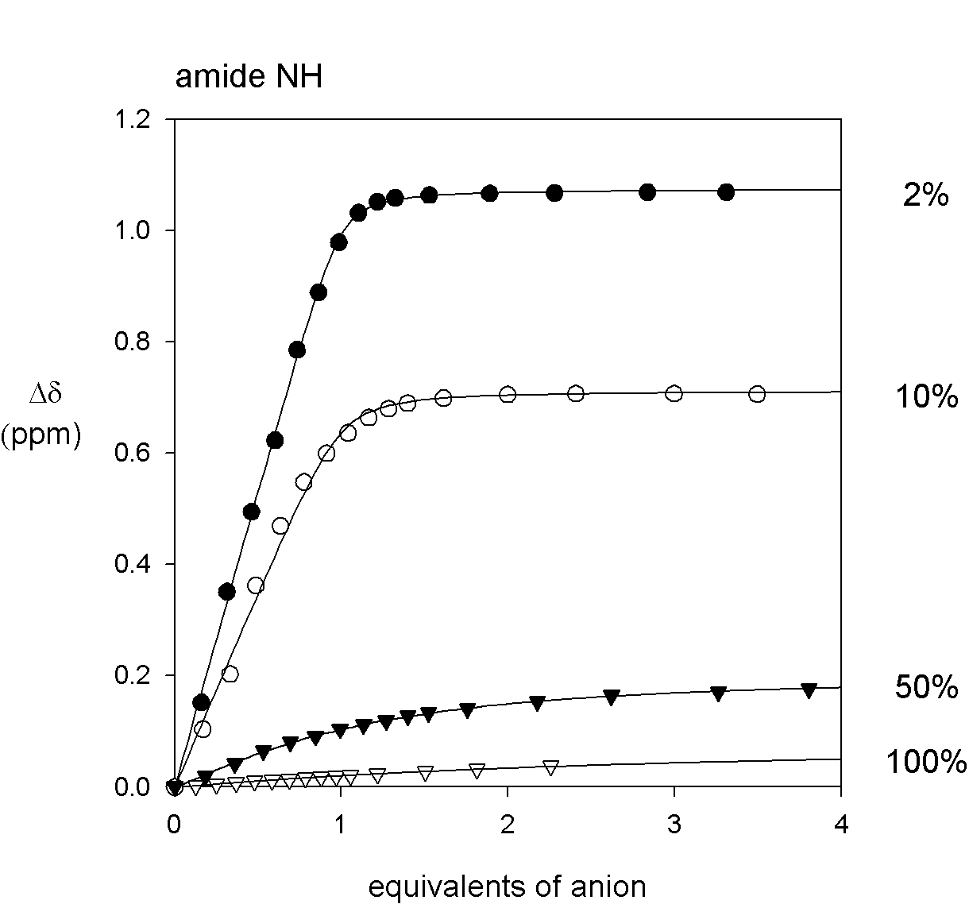
% of DMSO | Association Constant (M⁻¹)
2 | 2.1 x 10⁵
10 | 8.2 x 10⁴
50 | 3.3 x 10³
100 | 780

Job plot of 1b + pTsO⁻ ( in 2% DMSO-d6/CDCl₃ )

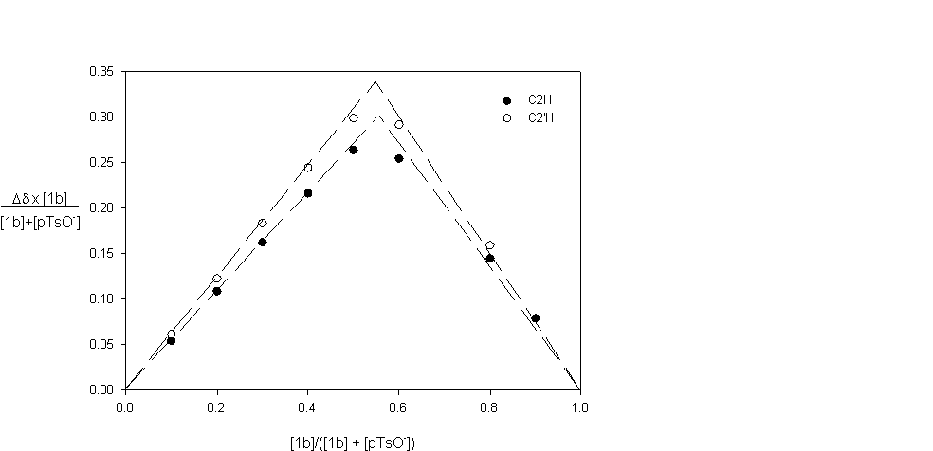

Titration of 1b (0.75mM in 2% DMSO-d₆/CDCl₃) with I⁻ at 296K.

association constant for MI ( M + I ⇌ MI) : 1.2 x 10⁵ M⁻¹
association constant for M₂I ( MI + I ⇌ M₂I) : 9.0 x 10³ M⁻¹
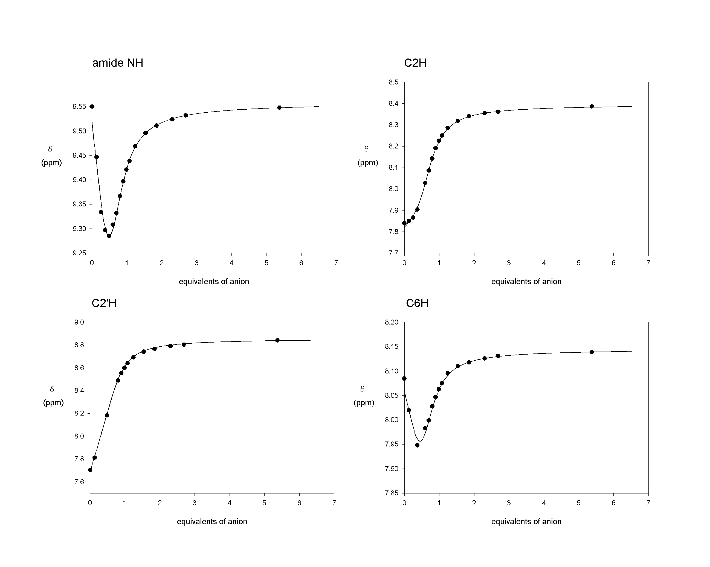

Titration of 1a (0.5mM in 2% DMSO-d₆/CDCl₃) with HSO₄⁻ at 296K.

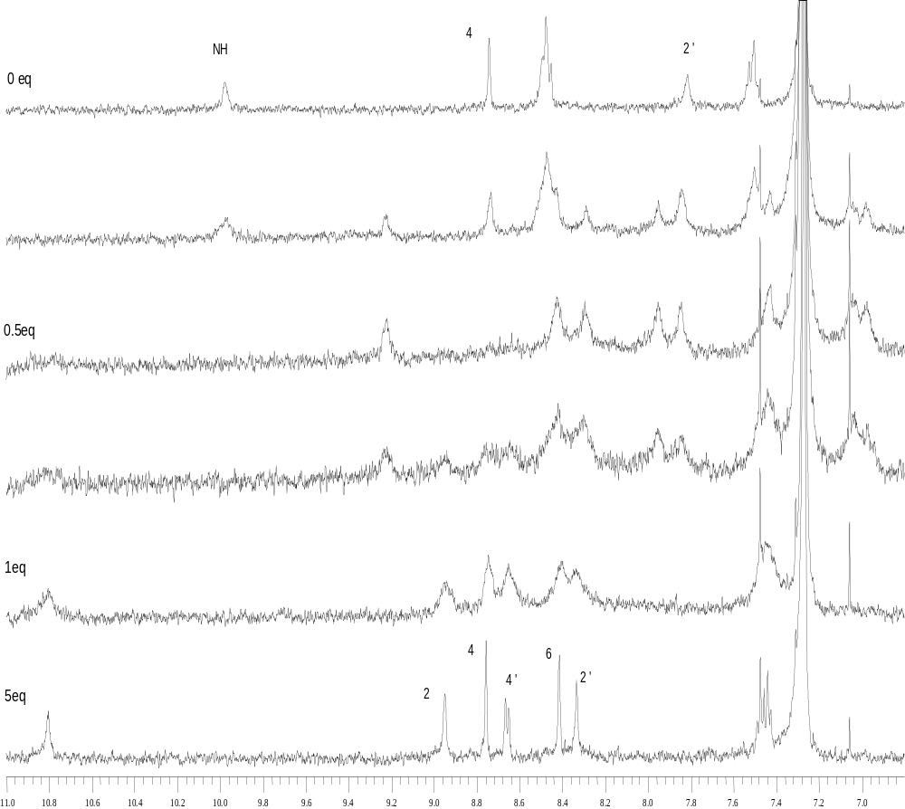

Titration of 1b (1.0mM in DMSO-d₆) with HSO₄⁻ at 296K.

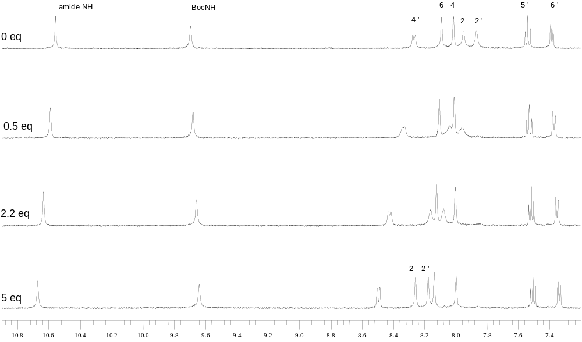

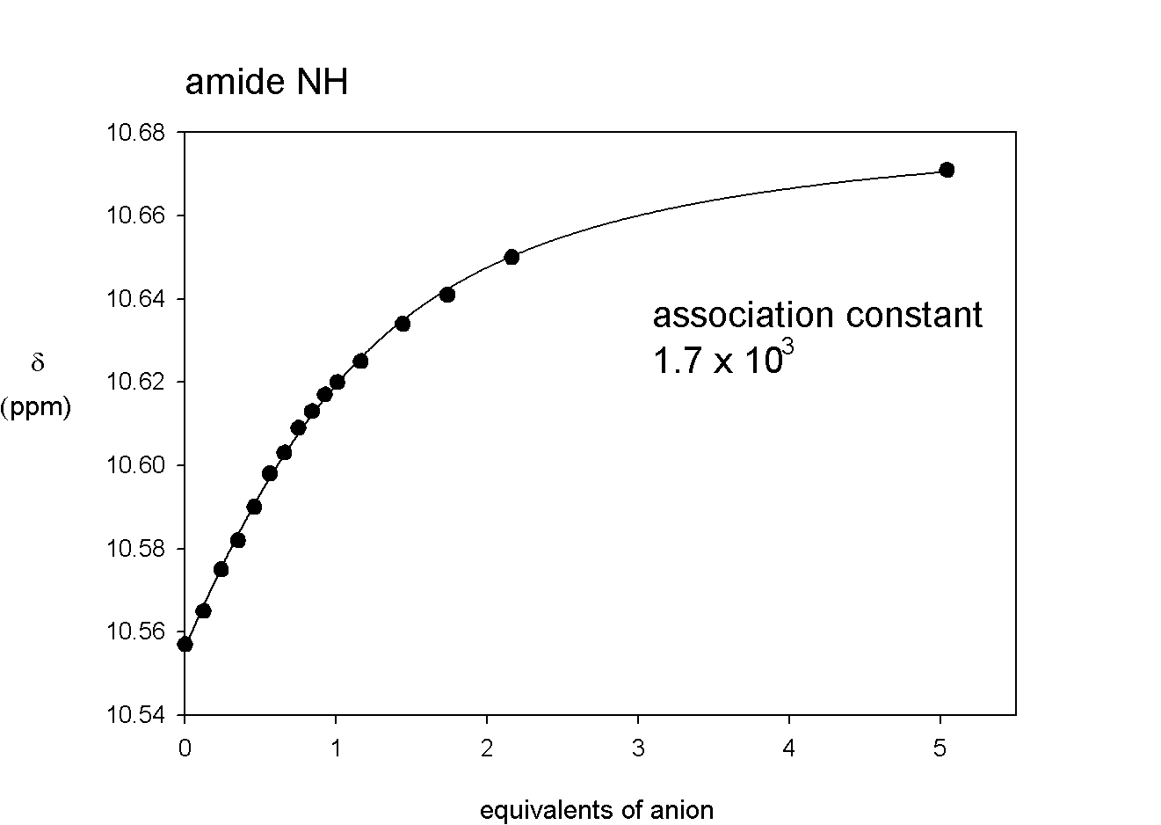

Titration of 2 (0.5mM in 2% DMSO-d₆/CDCl₃) with NO₃⁻ at 296K.



