Supplemental Material

Long-term Outcomes in Patients with Very-Early Onset Autosomal Dominant Polycystic Kidney Disease

Kristen L Nowak, Ph.D., MPH, Melissa A. Cadnapaphornchai, M.D., Michel Chonchol, M.D., Robert W. Schrier, M.D., Berenice Gitomer, Ph.D.

Supplemental Table Headings
Supplemental Table 1. Median time to events for included very-early onset (VEO) and non-VEO patients with autosomal dominant polycystic kidney disease. htTKV, height-corrected total kidney volume; eGFR, estimated glomerular filtration rate. N/A = the median estimate could not be calculated because the failure probability never exceeded 0.5. Hazard ratios and p-values are for unadjusted Cox proportional hazards analysis comparing VEO to non-VEO.

Supplemental Table 1
Event | N (%) VEO | Median Age VEO | N (%) Non-VEO | Median Age Non-VEO | Hazard Ratio (95% CI) | P-Value
htTKV >300 mL/m | 15 (63%) | 15 | 16 (48%) | 21 | 4.00 (1.83-8.74) | <0.001
30% decline in eGFR | 19 (38%) | 26 | 10 (20%) | N/A | 1.23 (0.50-3.10) | 0.65

Supplemental Figure Legends
Supplemental Figure 1. Patient selection diagram for inclusion in the study.
Supplemental Figure 2. Kaplan-Meier curve of height-adjusted total kidney volume (htTKV) > 300 mL/m) (panel A) and 30% decline in estimated glomerular filtration rate (eGFR) (panel B). VEO patients were more likely to progress to htTKV >300 mL/m, but not to have a 30% decline in eGFR.

Supplemental Figure 1.

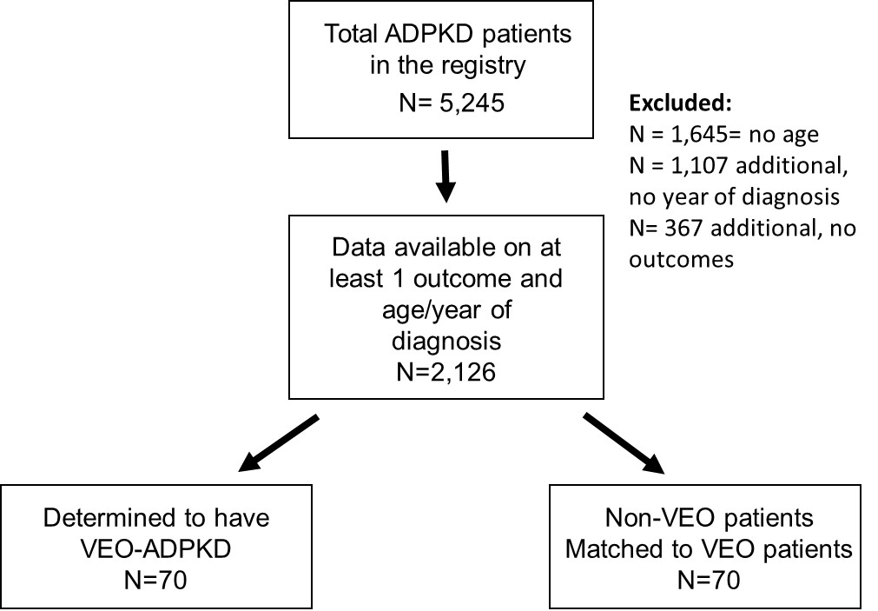

Supplemental Figure 2.
A
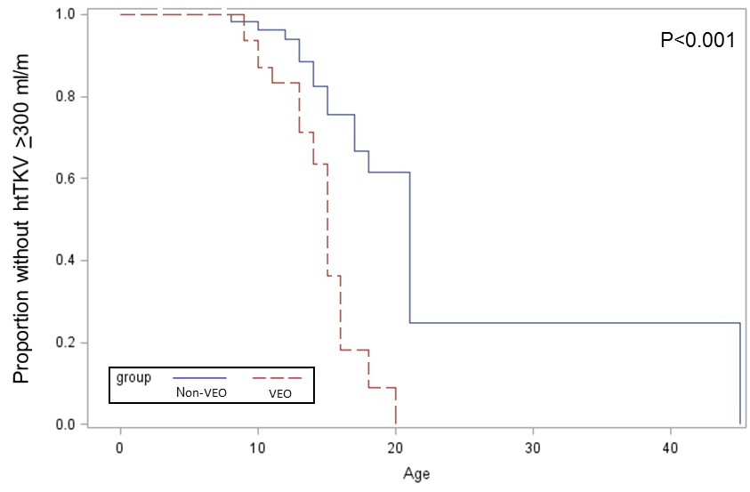
B
