Electronic Supplementary Materials

A novel energy savings to multiple stressors in birds: The ultradian regulation of body temperature

###### Glenn J. Tattersall1*, Damien Roussel2, Yann Voituron2, and Loïc Teulier2

1Department of Biological Sciences, Brock University, St. Catharines, ON, L2S3A1, Canada

2 Université de Lyon, UMR 5023 Écologie des Hydrosystèmes Naturels et Anthropisés, Université Lyon 1, ENTPE, CNRS, F - 69622 Villeurbanne, France 7

doi: 10.1098/rspb.2016.1551

*Corresponding author

E-mail: [gtatters@brocku.ca](mailto:gtatters@brocku.ca)

This document includes:

Supplementary Methods and Results: Spectral Analysis of Tb

Supplementary Results: Association between Short and Long-Term Tb Fluctuations

Supplementary Discussion: Critique of Tb Measurements

Supplementary Figures 1-3

Supplementary Statistical Tables 1-18

# Supplementary Methods

## Spectral Analysis of Tb

For visual comparison to time based variability assessments, spectral analysis was also performed on the 4 days worth of Tb data for each animal within each condition to ascertain the spectral density (°C2·hour) at respective cycle periods (from 0.5 to 48 hours). Spectral entropy within each condition was used as a mea­­sure of unpredictability in the Tb measurements; spectral analysis was performed using the stats and ForeCA packages in R [33, 41].

# Supplementary Results

## Association between Short and Long-Term Tb Fluctuations

We further explored the body temperature variations by examining the relationship between the longer-term amplitudes and the short-term variations in Tb. Working from a premise of short-term variation having more proximate basis to impart causality to long-term, *Amplitude* data were modelled (LMM) as a function of ADT, allowing individual bird ID to exhibit distinct intercept and slope with respect to ADT (Supplementary Figure 2). A distinctly negative relationship emerged between *Amplitude* and ADT (B = -2.91, P<0.0001, AICcn = 15).

## Spectral Analysis of Tb

Spectral analysis revealed the expected dominant 1 day period signal in the Tb data (Supplementary Figure 3) under all conditions and acclimation temperatures. Fasted birds demonstrated much higher spectral densities at 1 day cycle periods, and in the case of cold acclimated birds, demonstrated clearly reduced variation at the shorter periods. Spectral entropy was ~0.85 for fed birds and fell to ~0.65 during fasting.

# Supplementary Discussion

## Critique of the Tb Measurement

Assessing Tb via an ingestion-based approach has inherent risks associated with core Tb assessment since feeding or drinking may lead to transient changes in gizzard temperature. That concern can be allayed since when fasting (*i.e.*, no food intake) the Tb estimate declines in a manner similar to previous studies in other birds [7, 8]. If fasting led to higher water intake, then some of the change in Tb estimates could have been driven by drinking. The only association between the odds of drinking and Tb was a weak one where higher Tb was associated with a higher probability of drinking; this trend is the opposite to what would be expected if gizzard temperature was simply measuring influx of cold water. Finally, when we examined the drinking behaviour data with respect to feeding condition, fasted ducklings were less likely to drink than *ad libitum* fed or re-fed ducklings, which is opposite to a trend expected by potentially confounded Tb estimates.

Supplementary Materials: Figures

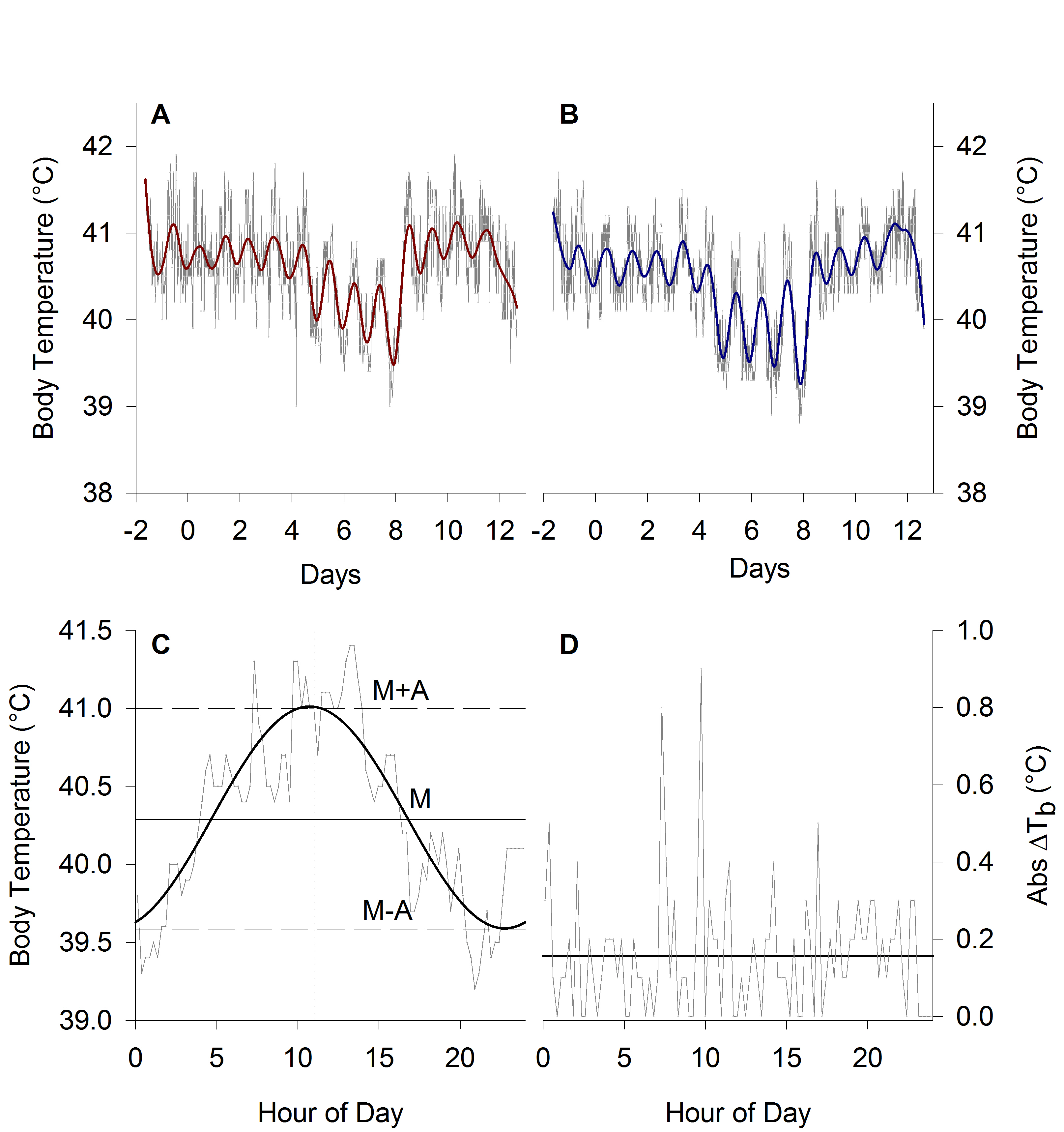

**Supplementary Figure 1.** Sample Tb time series from thermoneutral (A) and cold-acclimated (B) ducklings**.**  Tb measurements were logged every 15 minutes (grey dots) for the duration of the study. Data loggers were fed to the ducklings 2 days prior to commencement of the study. Daily Tb plots from each duckling was analysed using Cosinor analysis (B) and an absolute difference in Tb method (D). The daily (M) and *Amplitude* (A=peak fit Tb minus *Mesor*) are extracted by fitting a cosine wave through the 24 hours of data.

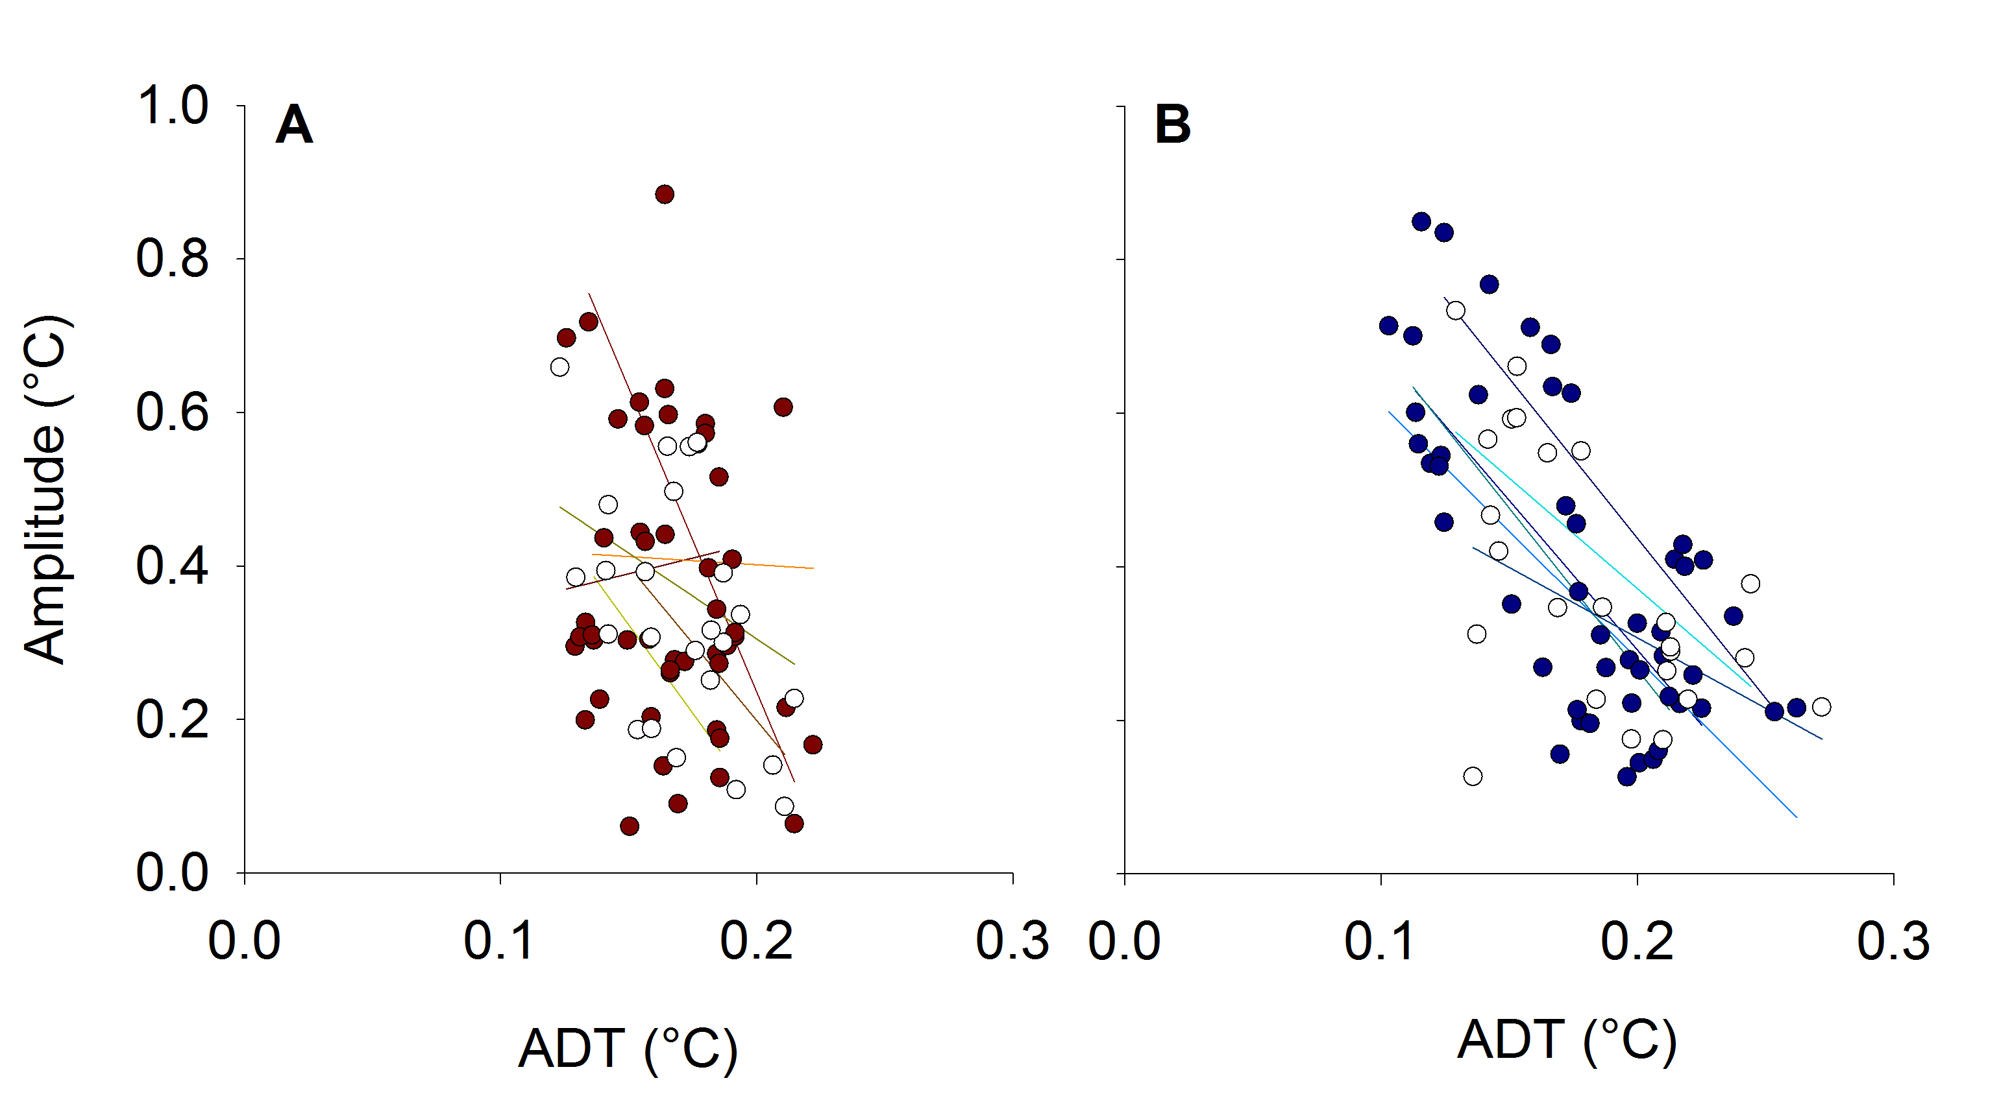

**Supplementary Figure 2**. Average daily variation in body temperature (*Amplitude*) induced by changes in the feeding regime is inversely correlated with average short term variation in body temperature (ADT) in ducklings. Data were fitted using linear mixed models, allowing each bird to vary with its own intercept and slope (other main effects were purposely omitted). The overall trend can be explained by an estimated *r*2 of 0.35, although the groups are separated by acclimation temperature for clarity. TN ducklings are shown in A, CA ducklings are shown in B; fasted birds are plotted with open symbols, fed birds in filled symbols.

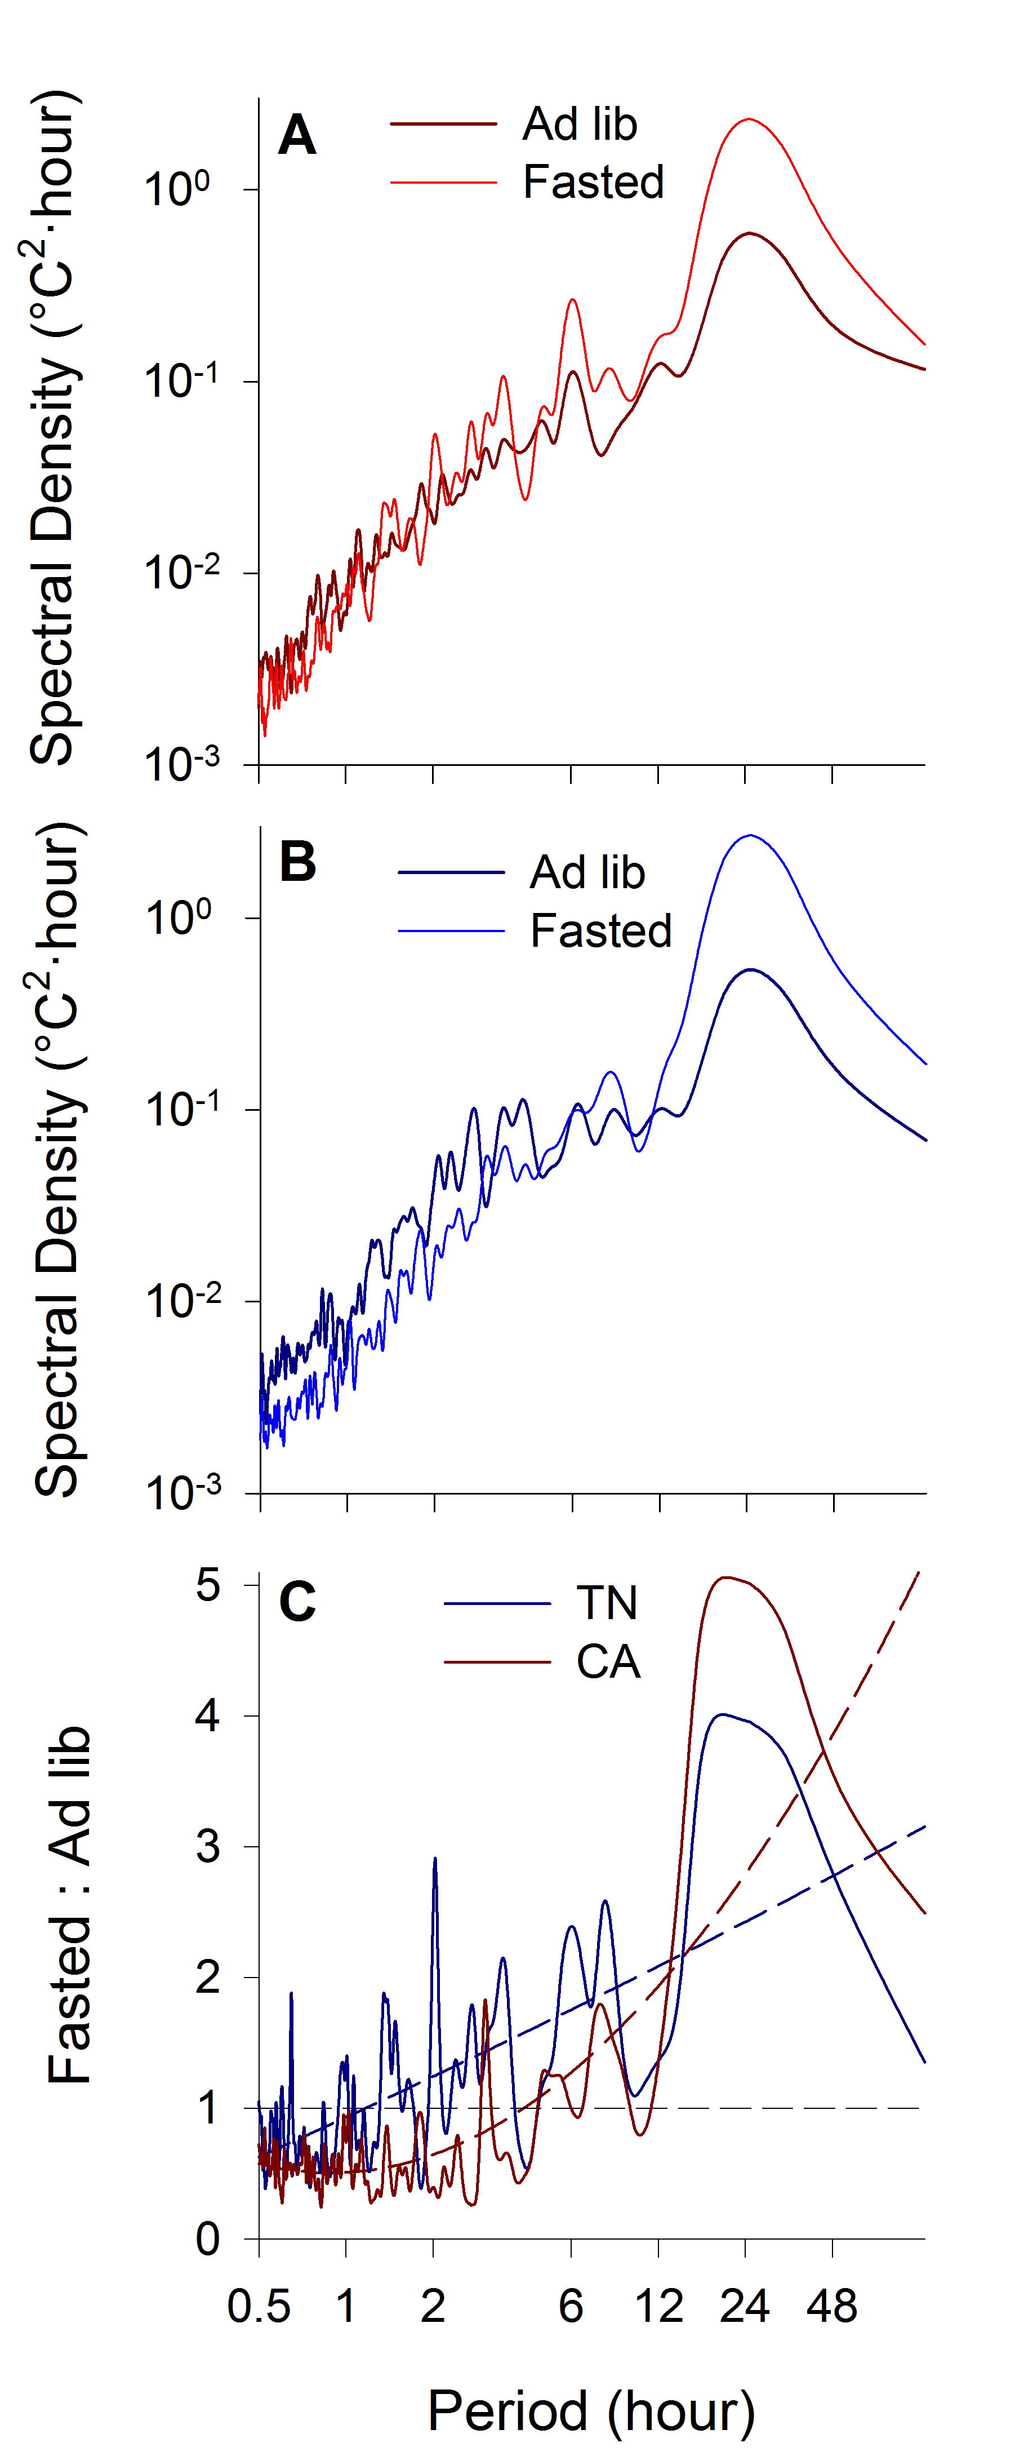

**Supplementary Figure 3.** Spectral density (mean density curves from N=6 per experimental group) from 4 days of Tb measurements during *ad* *libitum* feeding, followed by a further 4 days during fasting in thermoneutral (A) and cold acclimated (B) ducklings. Spectral density of Tb is typically highest at long periods, decreasing at shorter periods (similar to 1/fx – like pink noise). Ratio of fasting to *ad libitum* fed Tb spectral densities (C) shows that CA ducklings exhibit relatively more spectral energy in at long periods, and lower than unity (<1; horizontal dotted line) spectral energy at shorter periods (dotted curves reflect quadratic regressions to emphasize the overall trends).

Supplementary Materials: Statistical Results

# Akaike’s second-order information criterion results from the global model: Mass ~ ATemp * Cond * Day + (1 | ID)

| **Model** | **Intercept** | **Deviance** | **K** | **AICc** | **ΔAICc** | **ω** |
| --- | --- | --- | --- | --- | --- | --- |
| ~ATemp + Cond + Day + ATemp:Cond + ATemp:Day + Cond:Day + ATemp:Cond:Day | 1057 | 1650 | 14 | 1681 | 0.000 | 0.408 |
| ~ATemp + Cond + Day + ATemp:Cond + Cond:Day | 1060 | 1659 | 11 | 1682 | 0.958 | 0.253 |
| ~ATemp + Cond + Day + ATemp:Cond + ATemp:Day + Cond:Day | 1065 | 1657 | 12 | 1684 | 2.198 | 0.136 |
| ~ATemp + Cond + Day + Cond:Day | 1065 | 1665 | 9 | 1684 | 2.851 | 0.098 |
| ~Cond + Day + Cond:Day | 1015 | 1668 | 8 | 1685 | 3.763 | 0.062 |
| ~ATemp + Cond + Day + ATemp:Day + Cond:Day | 1070 | 1664 | 10 | 1686 | 4.508 | 0.043 |
| ~1 | 1249 | 2049 | 3 | 2055 | 373.462 | 0.000 |

Model ranking was performed by ranking AICc values. The highest ranked and/or most inclusive model with a ΔAICc < 2 was chosen for model parameter estimation. Animal identity (ID) was included to model the random effect and account for repeated measurements.

# Parametric bootstrapped coefficients from the model: Mass ~ ATemp + Cond + Day + ATemp:Cond + ATemp:Day + Cond:Day + ATemp:Cond:Day + (1 | ID)

| **Parameter** | **B** | **SE** | **LDL** | **UDL** | **ProbB** |
| --- | --- | --- | --- | --- | --- |
| (Intercept) | 1057.0957 | 40.885 | 976.885 | 1137.331 | <0.0001 |
| ATempCA | -84.2379 | 57.462 | -198.583 | 29.671 | 0.1426 |
| CondF | 531.6120 | 25.294 | 481.100 | 581.577 | <0.0001 |
| CondR | -74.4922 | 25.528 | -124.557 | -24.276 | 0.0042 |
| Day | 89.3142 | 5.490 | 78.340 | 100.173 | <0.0001 |
| ATempCA.CondF | -33.8271 | 35.977 | -104.432 | 34.880 | 0.3402 |
| ATempCA.CondR | -76.6529 | 36.410 | -148.596 | -6.525 | 0.0344 |
| ATempCA.Day | -2.4027 | 7.773 | -17.540 | 12.702 | 0.7490 |
| CondF.Day | -192.6760 | 9.580 | -211.469 | -173.818 | <0.0001 |
| CondR.Day | 55.6330 | 9.636 | 36.651 | 74.447 | <0.0001 |
| ATempCA.CondF.Day | -0.2716 | 13.583 | -26.921 | 26.482 | 0.9758 |
| ATempCA.CondR.Day | 32.6683 | 13.714 | 6.255 | 59.812 | 0.0176 |

Parameter estimates (B) ± standard errors (SE) represent the coefficients from linear mixed or generalized linear mixed models. Animal identity (ID) was included as a random effect in all models to account for repeated measurements. The 95% highest density interval for each parameter is indicated by LDL and UDL. ProbB is the two-tailed equivalent probabilty that the B differs from zero, based on 10000 simulations, where the minimum probability is 1/10000.

# Akaike’s second-order information criterion results from the global model: Drinking ~ ATemp * Cond * Day + (1 | ID)

| **Model** | **Intercept** | **Deviance** | **K** | **AICc** | **ΔAICc** | **ω** |
| --- | --- | --- | --- | --- | --- | --- |
| ~Cond + Day + Cond:Day | -2.08 | 289 | 7 | 303 | 0.000 | 0.292 |
| ~ATemp + Cond + Day + ATemp:Cond + Cond:Day | -2.40 | 283 | 10 | 304 | 0.243 | 0.259 |
| ~Cond + Day | -2.81 | 295 | 5 | 305 | 1.580 | 0.133 |
| ~ATemp + Cond + Day + ATemp:Cond | -3.14 | 289 | 8 | 305 | 1.836 | 0.117 |
| ~ATemp + Cond + Day + Cond:Day | -2.03 | 289 | 8 | 305 | 1.995 | 0.108 |
| ~ATemp + Cond + Day + ATemp:Cond + ATemp:Day + Cond:Day | -2.34 | 283 | 11 | 306 | 2.342 | 0.091 |
| ~1 | -1.81 | 312 | 2 | 316 | 12.497 | 0.001 |

Model ranking was performed by ranking AICc values. The highest ranked and/or most inclusive model with a ΔAICc < 2 was chosen for model parameter estimation. Animal identity (ID) was included to model the random effect and account for repeated measurements.

# Parametric bootstrapped coefficients from the model: Drinking ~ Cond + Day + Cond:Day + (1 | ID)

| **Parameter** | **B** | **SE** | **LDL** | **UDL** | **ProbB** |
| --- | --- | --- | --- | --- | --- |
| (Intercept) | -2.093796 | 0.9855 | -4.0099 | -0.1575 | 0.0328 |
| CondF | -3.339803 | 1.5670 | -6.4244 | -0.2834 | 0.0342 |
| CondR | 0.358643 | 1.0764 | -1.7216 | 2.4676 | 0.7446 |
| Day | 0.007272 | 0.4570 | -0.8948 | 0.8953 | 0.9934 |
| CondF.Day | 1.023683 | 0.5783 | -0.1044 | 2.1544 | 0.0764 |
| CondR.Day | 0.181003 | 0.4888 | -0.7790 | 1.1282 | 0.7124 |

Parameter estimates (B) ± standard errors (SE) represent the coefficients from linear mixed or generalized linear mixed models. Animal identity (ID) was included as a random effect in all models to account for repeated measurements. The 95% highest density interval for each parameter is indicated by LDL and UDL. ProbB is the two-tailed equivalent probabilty that the B differs from zero, based on 10000 simulations, where the minimum probability is 1/10000.

# Akaike’s second-order information criterion results from the global model: Mesor ~ ATemp * Cond * Day + (1 | ID)

| **Model** | **Intercept** | **Deviance** | **K** | **AICc** | **ΔAICc** | **ω** |
| --- | --- | --- | --- | --- | --- | --- |
| ~ATemp + Cond + Day + ATemp:Day + Cond:Day | 40.6 | -196 | 10 | -174 | 0.00 | 0.671 |
| ~ATemp + Cond + Day + ATemp:Cond + ATemp:Day + Cond:Day + ATemp:Cond:Day | 40.7 | -203 | 14 | -172 | 2.19 | 0.224 |
| ~ATemp + Cond + Day + ATemp:Cond + ATemp:Day + Cond:Day | 40.6 | -197 | 12 | -170 | 3.73 | 0.104 |
| ~1 | 40.5 | 140 | 3 | 146 | 320.13 | 0.000 |

Model ranking was performed by ranking AICc values. The highest ranked and/or most inclusive model with a ΔAICc < 2 was chosen for model parameter estimation. Animal identity (ID) was included to model the random effect and account for repeated measurements.

# Parametric bootstrapped coefficients from the model: Mesor ~ ATemp * Cond * Day + (1 | ID)

| **Parameter** | **B** | **SE** | **LDL** | **UDL** | **ProbB** |
| --- | --- | --- | --- | --- | --- |
| (Intercept) | 40.711585 | 0.06934 | 40.57581 | 40.847571 | <0.0001 |
| ATempCA | 0.040614 | 0.09849 | -0.15407 | 0.232880 | 0.6732 |
| CondF | -0.494176 | 0.08087 | -0.65491 | -0.335278 | <0.0001 |
| CondR | -0.032560 | 0.08204 | -0.19288 | 0.127731 | 0.6852 |
| Day | 0.004773 | 0.02104 | -0.03700 | 0.045442 | 0.8138 |
| ATempCA.CondF | 0.248980 | 0.11587 | 0.02078 | 0.479879 | 0.0318 |
| ATempCA.CondR | 0.258977 | 0.11520 | 0.03223 | 0.485190 | 0.0238 |
| ATempCA.Day | -0.006800 | 0.02956 | -0.06419 | 0.051608 | 0.8076 |
| CondF.Day | -0.085175 | 0.02965 | -0.14276 | -0.026130 | 0.0054 |
| CondR.Day | 0.043772 | 0.02985 | -0.01400 | 0.101975 | 0.1404 |
| ATempCA.CondF.Day | -0.090385 | 0.04227 | -0.17419 | -0.008819 | 0.0292 |
| ATempCA.CondR.Day | -0.085444 | 0.04165 | -0.16771 | -0.004819 | 0.0394 |

Parameter estimates (B) ± standard errors (SE) represent the coefficients from linear mixed or generalized linear mixed models. Animal identity (ID) was included as a random effect in all models to account for repeated measurements. The 95% highest density interval for each parameter is indicated by LDL and UDL. ProbB is the two-tailed equivalent probabilty that the B differs from zero, based on 10000 simulations, where the minimum probability is 1/10000.

# Akaike’s second-order information criterion results from the global model: Amplitude ~ Day * Cond * ATemp + (1 | ID)

| **Model** | **Intercept** | **Deviance** | **K** | **AICc** | **ΔAICc** | **ω** |
| --- | --- | --- | --- | --- | --- | --- |
| ~Cond + Day + Cond:Day | 0.286 | -317.7 | 8 | -301 | 0.000 | 0.408 |
| ~ATemp + Cond + Day + Cond:Day | 0.267 | -319.3 | 9 | -300 | 0.671 | 0.292 |
| ~ATemp + Cond + Day + ATemp:Cond + Cond:Day | 0.284 | -323.2 | 11 | -299 | 1.449 | 0.198 |
| ~ATemp + Cond + Day + ATemp:Day + Cond:Day | 0.260 | -319.5 | 10 | -298 | 2.757 | 0.103 |
| ~1 | 0.375 | -77.2 | 3 | -71 | 229.634 | 0.000 |

Model ranking was performed by ranking AICc values. The highest ranked and/or most inclusive model with a ΔAICc < 2 was chosen for model parameter estimation. Animal identity (ID) was included to model the random effect and account for repeated measurements.

# Parametric bootstrapped coefficients from the model: Amplitude ~ ATemp + Cond + Day + Cond:Day + (1 | ID)

| **Parameter** | **B** | **SE** | **LDL** | **UDL** | **ProbB** |
| --- | --- | --- | --- | --- | --- |
| (Intercept) | 0.26733 | 0.033060 | 0.20198 | 0.33280 | <0.0001 |
| ATempCA | 0.03746 | 0.029795 | -0.02204 | 0.09623 | 0.2070 |
| CondF | 0.21835 | 0.038640 | 0.14287 | 0.29230 | <0.0001 |
| CondR | 0.13098 | 0.038502 | 0.05563 | 0.20708 | 0.0004 |
| Day | -0.01111 | 0.009832 | -0.03041 | 0.00788 | 0.2574 |
| CondF.Day | 0.04768 | 0.014068 | 0.02072 | 0.07524 | 0.0006 |
| CondR.Day | -0.04708 | 0.014058 | -0.07453 | -0.01938 | 0.0008 |

Parameter estimates (B) ± standard errors (SE) represent the coefficients from linear mixed or generalized linear mixed models. Animal identity (ID) was included as a random effect in all models to account for repeated measurements. The 95% highest density interval for each parameter is indicated by LDL and UDL. ProbB is the two-tailed equivalent probabilty that the B differs from zero, based on 10000 simulations, where the minimum probability is 1/10000.

# Akaike’s second-order information criterion results from the global model: AbsDiffTb ~ Day * Cond * ATemp + (1 | ID)

| **Model** | **Intercept** | **Deviance** | **K** | **AICc** | **ΔAICc** | **ω** |
| --- | --- | --- | --- | --- | --- | --- |
| ~ATemp + Cond + Day + ATemp:Cond + Cond:Day | 0.186 | -691 | 11 | -667 | 0.000 | 0.491 |
| ~ATemp + Cond + Day + ATemp:Cond + ATemp:Day + Cond:Day | 0.181 | -693 | 12 | -666 | 0.808 | 0.328 |
| ~ATemp + Cond + Day + ATemp:Cond + ATemp:Day + Cond:Day + ATemp:Cond:Day | 0.172 | -696 | 14 | -665 | 1.993 | 0.181 |
| ~1 | 0.174 | -570 | 3 | -564 | 103.346 | 0.000 |

Model ranking was performed by ranking AICc values. The highest ranked and/or most inclusive model with a ΔAICc < 2 was chosen for model parameter estimation. Animal identity (ID) was included to model the random effect and account for repeated measurements.

# Parametric bootstrapped coefficients from the model: AbsDiffTb ~ ATemp + Cond + Day + ATemp:Cond + Cond:Day + (1 | ID)

| **Parameter** | **B** | **SE** | **LDL** | **UDL** | **ProbB** |
| --- | --- | --- | --- | --- | --- |
| (Intercept) | 0.186021 | 0.008818 | 0.168866 | 0.2032129 | <0.0001 |
| ATempCA | 0.033136 | 0.007419 | 0.018335 | 0.0475475 | <0.0001 |
| CondF | 0.005760 | 0.011765 | -0.017360 | 0.0290030 | 0.6248 |
| CondR | -0.048485 | 0.011905 | -0.071703 | -0.0254180 | <0.0001 |
| Day | -0.003169 | 0.002844 | -0.008647 | 0.0024412 | 0.2670 |
| ATempCA.CondF | -0.056930 | 0.008911 | -0.074535 | -0.0394033 | <0.0001 |
| ATempCA.CondR | -0.006049 | 0.008900 | -0.023425 | 0.0114109 | 0.5006 |
| CondF.Day | -0.008384 | 0.003989 | -0.016282 | -0.0004495 | 0.0374 |
| CondR.Day | 0.013527 | 0.004050 | 0.005609 | 0.0214484 | 0.0006 |

Parameter estimates (B) ± standard errors (SE) represent the coefficients from linear mixed or generalized linear mixed models. Animal identity (ID) was included as a random effect in all models to account for repeated measurements. The 95% highest density interval for each parameter is indicated by LDL and UDL. ProbB is the two-tailed equivalent probabilty that the B differs from zero, based on 10000 simulations, where the minimum probability is 1/10000.

# Akaike’s second-order information criterion results from the global model: Amplitude ~ AbsDiffTb + (1 + AbsDiffTb | ID)

| **Model** | **Intercept** | **Deviance** | **K** | **AICc** | **ΔAICc** | **ω** |
| --- | --- | --- | --- | --- | --- | --- |
| ~AbsDiffTb | 0.884 | -123 | 6 | -110.4 | 0.0 | 1 |
| ~1 | 0.365 | -106 | 5 | -95.2 | 15.2 | 0 |

Model ranking was performed by ranking AICc values. The highest ranked and/or most inclusive model with a ΔAICc < 2 was chosen for model parameter estimation. Animal identity (ID) was included to model the random effect and account for repeated measurements.

# Parametric bootstrapped coefficients from the model: Amplitude ~ AbsDiffTb + (1 + AbsDiffTb | ID)

| **Parameter** | **B** | **SE** | **LDL** | **UDL** | **ProbB** |
| --- | --- | --- | --- | --- | --- |
| (Intercept) | 0.8849 | 0.07756 | 0.733 | 1.038 | 0 |
| AbsDiffTb | -2.9157 | 0.40690 | -3.716 | -2.120 | 0 |

Parameter estimates (B) ± standard errors (SE) represent the coefficients from linear mixed or generalized linear mixed models. Animal identity (ID) was included as a random effect in all models to account for repeated measurements. The 95% highest density interval for each parameter is indicated by LDL and UDL. ProbB is the two-tailed equivalent probabilty that the B differs from zero, based on 10000 simulations, where the minimum probability is 1/10000.

# Akaike’s second-order information criterion results from the global model: Tbill.TN ~ Drinking + Day * Cond + (1 | ID)

| **Model** | **Intercept** | **Deviance** | **K** | **AICc** | **ΔAICc** | **ω** |
| --- | --- | --- | --- | --- | --- | --- |
| ~Cond + Day + Drinking + Cond:Day | 31.6 | 1119 | 9 | 1138 | 0.00 | 0.942 |
| ~Cond + Drinking | 34.0 | 1132 | 6 | 1144 | 6.23 | 0.042 |
| ~Cond + Day + Drinking | 33.7 | 1131 | 7 | 1146 | 8.19 | 0.016 |
| ~1 | 29.8 | 1233 | 3 | 1239 | 101.54 | 0.000 |

Model ranking was performed by ranking AICc values. The highest ranked and/or most inclusive model with a ΔAICc < 2 was chosen for model parameter estimation. Animal identity (ID) was included to model the random effect and account for repeated measurements.

# Parametric bootstrapped coefficients from the model: Tbill.TN ~ Cond + Day + Drinking + Cond:Day + (1 | ID)

| **Parameter** | **B** | **SE** | **LDL** | **UDL** | **ProbB** |
| --- | --- | --- | --- | --- | --- |
| (Intercept) | 31.6096 | 2.0676 | 27.608 | 35.6124 | <0.0001 |
| Drinking1 | -9.4572 | 0.9839 | -11.372 | -7.5363 | <0.0001 |
| Day | 1.1482 | 0.9148 | -0.631 | 2.9475 | 0.2088 |
| CondF | 0.4719 | 2.4232 | -4.164 | 5.3382 | 0.8566 |
| CondR | -1.7827 | 2.2868 | -6.258 | 2.7542 | 0.4256 |
| Day.CondF | -2.4190 | 1.0447 | -4.494 | -0.3942 | 0.0186 |
| Day.CondR | -0.1310 | 1.0282 | -2.141 | 1.8965 | 0.8944 |

Parameter estimates (B) ± standard errors (SE) represent the coefficients from linear mixed or generalized linear mixed models. Animal identity (ID) was included as a random effect in all models to account for repeated measurements. The 95% highest density interval for each parameter is indicated by LDL and UDL. ProbB is the two-tailed equivalent probabilty that the B differs from zero, based on 10000 simulations, where the minimum probability is 1/10000.

# Akaike’s second-order information criterion results from the global model: Tbill.CA ~ Drinking + Day * Cond + (1 | ID)

| **Model** | **Intercept** | **Deviance** | **K** | **AICc** | **ΔAICc** | **ω** |
| --- | --- | --- | --- | --- | --- | --- |
| ~Cond + Day + Drinking + Cond:Day | 21.1 | 1269 | 9 | 1288 | 0.0000 | 0.432 |
| ~Cond + Drinking | 15.6 | 1276 | 6 | 1288 | 0.0579 | 0.419 |
| ~Cond + Day + Drinking | 15.3 | 1276 | 7 | 1290 | 2.1269 | 0.149 |
| ~1 | 17.4 | 1309 | 3 | 1315 | 27.3511 | 0.000 |

Model ranking was performed by ranking AICc values. The highest ranked and/or most inclusive model with a ΔAICc < 2 was chosen for model parameter estimation. Animal identity (ID) was included to model the random effect and account for repeated measurements.

# Parametric bootstrapped coefficients from the model: Tbill.CA ~ Cond + Day + Drinking + Cond:Day + (1 | ID)

| **Parameter** | **B** | **SE** | **LDL** | **UDL** | **ProbB** |
| --- | --- | --- | --- | --- | --- |
| (Intercept) | 21.134 | 2.991 | 15.4027 | 27.0362 | <0.0001 |
| Drinking1 | -7.201 | 1.439 | -10.0150 | -4.3559 | <0.0001 |
| Day | -2.756 | 1.367 | -5.4607 | -0.1682 | 0.0360 |
| CondF | -4.270 | 3.594 | -11.3978 | 2.6472 | 0.2354 |
| CondR | -1.978 | 3.389 | -8.7089 | 4.6762 | 0.5656 |
| Day.CondF | 2.706 | 1.557 | -0.3071 | 5.7739 | 0.0804 |
| Day.CondR | 3.824 | 1.539 | 0.8502 | 6.8475 | 0.0104 |

Parameter estimates (B) ± standard errors (SE) represent the coefficients from linear mixed or generalized linear mixed models. Animal identity (ID) was included as a random effect in all models to account for repeated measurements. The 95% highest density interval for each parameter is indicated by LDL and UDL. ProbB is the two-tailed equivalent probabilty that the B differs from zero, based on 10000 simulations, where the minimum probability is 1/10000.

# Akaike’s second-order information criterion results from the global model: qdot ~ Cond * ATemp + Mass + (1 | ID)

| **Model** | **Intercept** | **Deviance** | **K** | **AICc** | **ΔAICc** | **ω** |
| --- | --- | --- | --- | --- | --- | --- |
| ~ATemp + Cond + Mass + ATemp:Cond | -0.184 | -426 | 9 | -406 | 0 | 1 |
| ~1 | 0.429 | -225 | 3 | -219 | 187 | 0 |

Model ranking was performed by ranking AICc values. The highest ranked and/or most inclusive model with a ΔAICc < 2 was chosen for model parameter estimation. Animal identity (ID) was included to model the random effect and account for repeated measurements.

# Parametric bootstrapped coefficients from the model: qdot ~ ATemp + Cond + Mass + ATemp:Cond + (1 | ID)

| **Parameter** | **B** | **SE** | **LDL** | **UDL** | **ProbB** |
| --- | --- | --- | --- | --- | --- |
| (Intercept) | -0.183860 | 0.04264 | -0.26726 | -0.100102 | <0.0001 |
| CondF | -0.033763 | 0.01595 | -0.06493 | -0.002665 | 0.0338 |
| CondR | -0.045967 | 0.01637 | -0.07820 | -0.014220 | 0.0038 |
| ATempCA | 0.087013 | 0.01872 | 0.04963 | 0.122855 | <0.0001 |
| Mass | 0.478679 | 0.03088 | 0.41845 | 0.539638 | <0.0001 |
| CondF.ATempCA | -0.115409 | 0.02233 | -0.15791 | -0.071193 | <0.0001 |
| CondR.ATempCA | -0.005377 | 0.02279 | -0.04960 | 0.039142 | 0.8170 |

Parameter estimates (B) ± standard errors (SE) represent the coefficients from linear mixed or generalized linear mixed models. Animal identity (ID) was included as a random effect in all models to account for repeated measurements. The 95% highest density interval for each parameter is indicated by LDL and UDL. ProbB is the two-tailed equivalent probabilty that the B differs from zero, based on 10000 simulations, where the minimum probability is 1/10000.